Industry Subcommittee
Summary of Work Plans Recommended for Quantification
Work Plan  No. | Work Plan Name | Annual Results (2020) |  |  | Cumulative Results (2009-2020)
Work Plan  No. | Work Plan Name | GHG Reductions  (MMtCO₂e) | Costs  (Million $) | Cost-Effectiveness  ($/tCO₂e) | GHG Reductions  (MMtCO₂e) | Costs  (NPV, Million $) | Cost-Effectiveness  ($/tCO₂e)
1 | Coal Mine Methane (CMM) Recovery | 0.57 | -$5.9 | -$10.3 | 6.38 | -$51.8 | -$8.03
2 | Industrial Natural Gas and Electricity Best Management Practices | 5 | -$348 | -$68 | 25 | -$972 | -$38
3 | Reduce Lost and Unaccounted for Natural Gas | 0 | -$11 | -$84 | 1 | -$48 | -$55
Sector Total After Adjusting for Overlaps |  | 6 | -$365 | -$62 | 33 | -$1,072 | -$33
Reductions From Recent State and Federal Actions |  | 0.0 | $0.0 | $0.0 | 0.0 | $0.0 | $0.0
Sector Total Plus Recent Actions |  | 6 | -$359 | -$61 | 33 | -$1,072 | -$33
GHG = greenhouse gas; MMtCO₂e = million metric tons of carbon dioxide equivalent; $/tCO₂e = dollars per metric ton of carbon dioxide equivalent; NPV = net present value.
Negative values in the Cost and the Cost-Effectiveness columns represent net cost savings.
The numbering used to denote the above work plans is for reference purposes only; it does not reflect prioritization among these important work plans.

Figure 1. Contributions to Total Industry Sector Reductions from Each Industry Workplan

Industry 1. Coal Mine Methane Recovery

Strategy Name: Coal Mine Methane Recovery

Lead Staff Contact: Robin G. Lighty (717-783-9588), email: rolighty@state.pa.us

Initiative Background: The release of methane gas to the atmosphere is a major component of Greenhouse Gas emissions. Methane gas is a fossil fuel and energy source, commonly known as natural gas, which occurs in various geologic formations in Pennsylvania, including coal formations. When coal is mined and processed for use, substantial amounts of methane gas are released. Coal bed methane (CBM) is methane contained within coal formations and may be extracted by gas exploration methods or released as part of coal mining operations. This work plan deals with coal mine methane (CMM), the methane within the coal that can be vented or recovered prior to mining the coal, during mining, and immediately after mining as some gas escapes to the surface through post-mining vents or boreholes. Methane gas that remains sequestered within an abandoned underground coal mine does not contribute to Greenhouse Gas emissions, but could be and sometimes is recovered by subsequent gas exploration operations.

The federal Mine Safety and Health Administration (MSHA) definition of a gassy mine, as defined in 30 CFR § 27.2 (g), is that a “Gassy mine or tunnel means a mine, tunnel, or other underground workings in which a flammable mixture has been ignited, or has been found with a permissible flame safety lamp, or has been determined by air analysis to contain 0.25% or more (by volume) of methane in any open workings when tested at a point not less than 12 inches from the roof, face, or rib.” MSHA records coal mine methane readings with concentrations of greater than 50 parts per million (ppm) methane. Readings below this threshold are considered non-detectable.

Currently and in recent years approximately 85% of the methane gas released during the mining of coal in Pennsylvania occurs from mining in longwall underground mines. The five large longwall underground coal mines now operating in Pennsylvania extract approximately 60% of the 68 million tons of coal mined each year within Pennsylvania. These high amounts of longwall mine production and the fact that the longwall mines recover coal from greater depths than other mines make longwall mining the predominant current source of coal mine methane release and an important contributor to Greenhouse Gas emissions. In recent years several mining companies have begun to capture and utilize methane gas within longwall underground mines, resulting in a reduction of methane Greenhouse Gas emissions.

Surface mining of coal currently releases about 9% of all coal mine methane emissions in Pennsylvania. However, with the continuing decline in surface mining production as recorded over the past two decades and the ultimate depletion of the state’s shallow coal reserves, it is possible that by 2025 there could be a 70% reduction of surface coal mine methane emissions simply as a result of lower production.

Other Involved Agencies: Not applicable

Possible New Measures:

Surface Mines and Nongassy Underground Mines
There are no specific measurements of methane gases released from mining at individual surface coal mines in Pennsylvania. This analysis uses the most recently published U.S. EPA emission factors for surface mining of coal in Pennsylvania. In this analysis the same emission factors used for surface mines are also used for low-methane nongassy room and pillar underground coal mines. These are underground coal mines that have no methane levels routinely reported by MSHA. The U.S. EPA emission factor is 119.0 cubic feet of methane released per ton of coal mined and an additional 19.3 cubic feet of methane released from post-mining processing of the coal. These factors are published within Annex 3 Section 3.3 “Methodology for Estimating CH4 Emissions from Coal Mining” of the U.S. EPA report “Inventory of U.S. Greenhouse Gas Emissions and Sinks 1990-2007,” published April 15, 2009, as document EPA 430-R-09-004, and is available on the Internet at the website:
http://www.epa.gov/climatechange/emissions/usinventoryreport.html

Gassy Underground Mines
Methane levels reported by MSHA for gassy underground mines indicate two basic categories: gassy room and pillar mines and gassy longwall mines. Emission factors developed for these two types of gassy underground mines represent an estimate of the total methane released from the entire mining process, including pre-mining degassing and post-mining venting, as well as that liberated by ventilation systems. For both types of gassy underground mines this analysis uses the U.S. EPA emission factor of 45.0 cubic feet of methane per ton of coal to account for methane released as a result of post-mining processing of the coal on the surface. This post-mining factor is published in the 2009 EPA Report referenced previously. The total emission factor used for gassy room and pillar underground mines is 165 cubic feet of methane per ton of coal mined and processed on the surface. During the past few years, approximately 20% of Pennsylvania’s room and pillar mines have been gassy, with these mines accounting for approximately 33% of the total coal production from room and pillar mines. The average methane concentrations reported for these mines during the past few years, when compared to tons of coal mined, is 120 cubic feet of methane per ton of coal mined. Room and pillar underground mines were assumed, on average, to operate 310 days per year and longwall mines to operate 330 days per year. These emission factors represent an estimate for all methane released before, during, and after the mining of coal in these gassy underground mines. The total longwall underground mine emission factor is 445 cubic feet of methane per ton of coal mined and processed on the surface. Estimates of coal mine methane released during longwall mining are based on methane liberation and capture measurements, on horizontal degassing and capture measurements, and on pre-mining and post-mining surface drill hole degassing measurements recorded and provided by the coal industry and by MSHA. These methane concentration measurements were correlated with tonnages of coal mined. The average coal mine methane emission level reported for the five active longwall mines, when compared to tons of coal mined, is 400 cubic feet of methane per ton of coal mined. This is an average of measurements made over several years. CONSOL provided data for three longwall mines for the years 2000 through 2006 and Foundation Coal provided data for two longwall mines for the years 2004 through 2008.

This Coal Mine Methane Recovery Initiative would encourage owners/operators of current longwall mines, and of any new gassy underground coal mines that are mined by any method, to capture 10% of the estimated total coal mine methane that is released into the atmosphere before, during, and immediately after mining operations. At this time it is not feasible to capture methane liberated by high velocity ventilation systems, therefore the proposed and encouraged 10% capture of total coal mine methane from gassy underground coal mines would have to be realized from pre-mining surface drill holes, horizontal drill holes within the mine, or for a brief time from surface drill holes into the post-mining gob area.

Projected 2025 Reduction (Million Metric Tons of CO₂ Equivalents):
Concentrations of released methane are expressed as cubic feet per ton (2,000 lbs) of coal mined. This analysis considers methane to be 21 times more powerful than CO₂ in warming the atmosphere as a Greenhouse Gas. One million cubic feet of methane is equal to 404.5 metric tons of CO₂ equivalent Greenhouse Gas. Estimates of coal mine methane released during mining are based on methane liberation and capture measurements recorded and provided by the coal industry and by the federal Mine Health and Safety Administration (MSHA), and on emission factor estimates published in the 2009 U.S. EPA report “Inventory of U.S. Greenhouse Gas Emissions and Sinks: 1990-2007.” For all types of coal mines, the release of methane determined and predicted in this analysis is expressed as cubic feet of methane per ton of coal mined. Total annual methane concentrations are also expressed as metric tons of CO₂ equivalent.

Coal mine production for the years 2000 through 2008, and also for years 1985-1999 used to determine 2025 estimates through trend analysis, are based on actual tonnages reported quarterly and annually to the Pennsylvania DEP Bureau of Mining and Reclamation. Coal mine production information is available to the public for the years 1980 through 2008 on the DEP Bureau of Mining and Reclamation website:
http://www.dep.state.pa.us/dep/deputate/minres/bmr/historicalminingreports/index.html

Trend charts for annual coal production and mining permits issued are presented on the DEP Bureau of Mining and Reclamation website:
http://www.dep.state.pa.us/dep/deputate/minres/bmr/annualreport/2008/Coal_Mining_Trend_Charts_001.htm.

(Tables of Estimates and Projections for 2000 and 2025 are presented at end of this document.)

- Year 2000 Estimated Emissions (no Methane Capture): 10,347,409 metric tons CO₂ equivalent

- Year 2025 Estimated Emissions (no Methane Capture): 8,092,018 metric tons CO₂ equivalent (21.8% decrease)

- Year 2025 Estimated Emissions (with 10% Methane Capture in Gassy Underground Coal Mines): 7,372,008 metric tons CO₂ equivalent (28.8% decrease)

0.72 MMtCO₂e Reduction (with 10% Methane Capture in Gassy Underground Coal Mines)

Economic Cost: This initiative would be purely industry driven.

Implementation Steps: This Coal Mine Methane Recovery Initiative would encourage owners/operators of current longwall mines, and of any new gassy underground coal mines that are mined by any method, to capture 10% of the estimated total coal mine methane that is released into the atmosphere before, during, and immediately after mining operations. This could be accomplished by pre-mining gas exploration into the coal formation to be mined, capturing methane from pre-mining vertical degas holes, capturing methane by horizontal drilling within active underground mines, or possibly capturing methane from post-mining areas of underground mines, where for a brief period of time gas is still making its way to the surface through existing boreholes. PA DEP annual coal production numbers and MSHA gas liberation numbers will be reassessed annually, as well as new technological developments, with changes made to trend forecasts on future coal production and revisions to estimates of methane gas released per ton of coal mined.

Table 1-1. Summary of Estimated and Projected Coal Mine Methane Emissions from Pennsylvania Coal Mines* - 2000 Levels with No Capture in Gassy Underground Mines
 | Methane  Emission Factor  (ft³/t) | 2000  (tons) | 2000  (ft³ CH₄) | 2000  MMtCO₂e
Anthracite Underground Mines | 138.3 | 220,462 | 30,489,895 | 12,333
Anthracite Surface Mines | 138.3 | 2,332,828 | 322,630,112 | 130,504
Bituminous Surface Mines | 138.3 | 14,936,924 | 2,065,776,589 | 835,607
Room & Pillar Bituminous Underground Mines |  | 8,665,475
Room & Pillar Mines with Low Methane | 138.3 | 5,805,868 | 802,951,579 | 324,794
Room & Pillar Mines with High Methane | 165.0 | 2,859,607 | 471,835,114 | 190,857
Longwall Bituminous Underground Mines | 445.0 | 49,184,398 | 21,887,057,110 | 8,853,315
Totals for Coal Mining in Pennsylvania |  | 75,340,087 | 25,580,740,399 | 10,347,409
*All methane emission factors include U.S. EPA 2009 published emission factors for post-mining processing of coal on the surface.

Table 1-2. Summary of Estimated and Projected Coal Mine Methane Emissions from Pennsylvania Coal Mines* - 2025 Levels with No Capture in Gassy Underground Mines
 | Methane  Emission Factor  (ft³/t) | 2025  (tons) | 2025  (ft³ CH₄) | 2025  MMtCO₂e
Anthracite Underground Mines | 138.3 | 100,000 | 13,830,000 | 5,594
Anthracite Surface Mines | 138.3 | 800,000 | 110,640,000 | 44,754
Bituminous Surface Mines | 138.3 | 4,400,000 | 608,520,000 | 246,146
Room & Pillar Bituminous Underground Mines |  | 10,000,000
Room & Pillar Mines with Low Methane | 138.3 | 6,666,667 | 922,000,046 | 372,949
Room & Pillar Mines with High Methane | 165.0 | 3,333,333 | 549,999,945 | 222,475
Longwall Bituminous Underground Mines | 445.0 | 40,000,000 | 17,800,000,000 | 7,200,100
Totals for Coal Mining in Pennsylvania |  | 55,300,000 | 20,004,989,991 | 8,092,018
*All methane emission factors include U.S. EPA 2009 published emission factors for post-mining processing of coal on the surface.

Table 1-3. Summary of Estimated and Projected Coal Mine Methane Emissions from Pennsylvania Coal Mines* - 2025 Levels with 10% Capture In Gassy Underground Mines
 | Methane  Emission Factor  (ft³/t) | 2025  (tons) | 2025  (ft³ CH₄) | 2025  MMtCO₂e
Anthracite Underground Mines | 138.3 | 100,000 | 13,830,000 | 5,594
Anthracite Surface Mines | 138.3 | 800,000 | 110,640,000 | 44,754
Bituminous Surface Mines | 138.3 | 4,400,000 | 608,520,000 | 246,146
Room & Pillar Bituminous Underground Mines |  | 10,000,000
Room & Pillar Mines with Low Methane | 138.3 | 6,666,667 | 922,000,046 | 372,949
Room & Pillar Mines with High Methane | 165.0 | 3,333,333 | 549,999,945 | 222,475
Longwall Bituminous Underground Mines | 445.0 | 40,000,000 | 16,020,000,000 | 6,480,090
Totals for Coal Mining in Pennsylvania |  | 55,300,000 | 18,244,989,991 | 7,372,008
*All methane emission factors include U.S. EPA 2009 published emission factors for post-mining processing of coal on the surface.

Table 1-4. Summary of Estimated and Projected Coal Mine Methane Emissions from Pennsylvania Coal Mines* - CONSOL’s PA Longwall Coal Mines
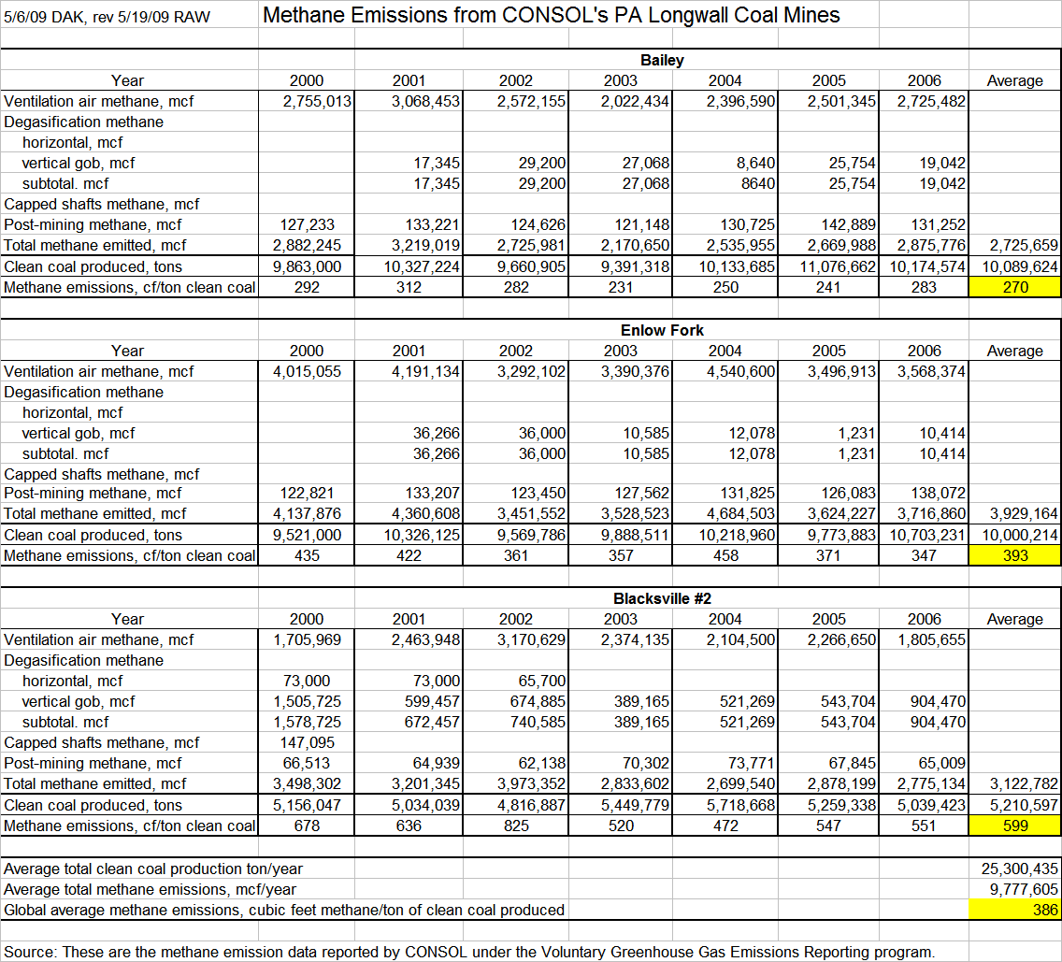
*All methane emission factors include U.S. EPA 2009 published emission factors for post-mining processing of coal on the surface.

Quantification Approach and Assumptions

The following inputs were used in the analysis of coal mine methane GHG reductions and costs. Three cost & performance sensitivities were conducted (the summary table able only report the central estimate).

PA specific data inputs were used for the following parameters
- Coal mining emissions for longwall mining (ft³ CH₄ per ton coal mined)
- Number of CONSOL’s PA longwall mines
- Gob gas production shares from CONSOL’s and Foundation Coal longwall mines
- Methane capture target from longwall mines

National data inputs were used for the following parameters:
- Natural gas wellhead price in the Northeast (source: EIA’s AEO2009 supplemental tables)
- Cost and performance assumptions (source: USEPA as noted below)
- Share of methane as a fraction of gob gas (source: USEPA as noted below)
Table 1-5. Quantification Assumptions
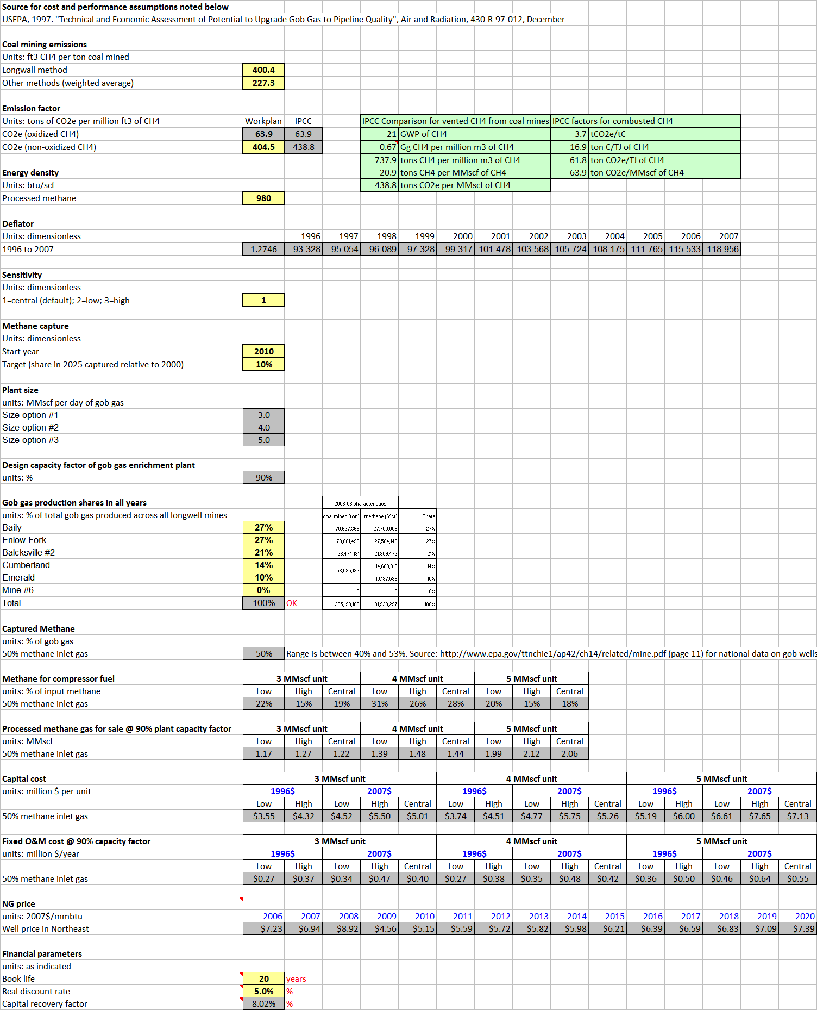

Workplan Cost and GHG Reduction:
Table 1-6. Quantification Results
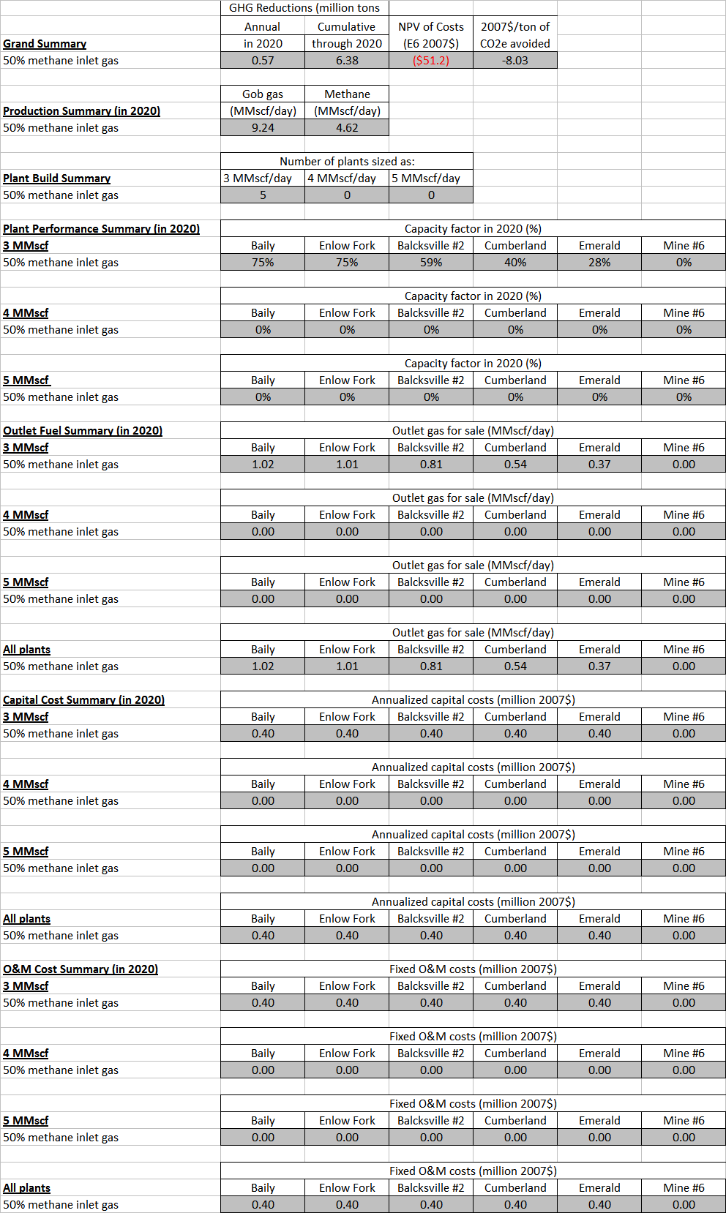

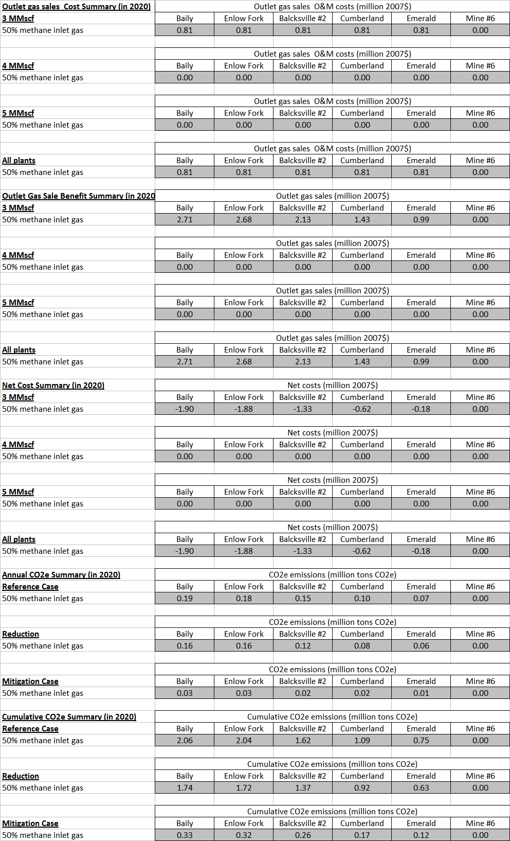
Industry 2. Industrial Natural Gas and Electricity Best Management Practices Work Plan for Potential GHG Reduction Measure

Lead Staff Contact: Richard Illig (717) 772-5834

Summary: Implement DOE Industrial Technology Program (ITP) Best Management Practices (BMPs) to process heating and steam system operation to reduce the consumption of natural gas or other fossil fuels, such as coal and oil by 5-15% per year for industrial steam systems, and 5-25% for process heating systems. Electricity efficiency reductions are targeted for 20% of sales by 2031, consistent with the supply of industrial electricity efficiency resources identified in the ACEEE (2009) report.

Programs are assumed to begin in January 2012. Implementation of energy efficiency is assumed to occur at a rate of 1% of sales per year for both natural gas and electricity measures.

Other Involved Agencies: U.S. DOE and PADEP

Background: Industrial gas and electricity consumption in Pennsylvania are expected to change by -6.5% and 13% from 2008-2020 respectively. This change in consumption is also influenced by the relative growth and decline in particular industries over the planning period. Industries that show a relative increase in electricity and natural gas consumption between 2008 and 2025 are chemical manufacturing and petroleum and coal products manufacturing. The largest declines are expected in primary metal manufacturing.
Figure 2-1. Industrial Electricity Consumption Forecast

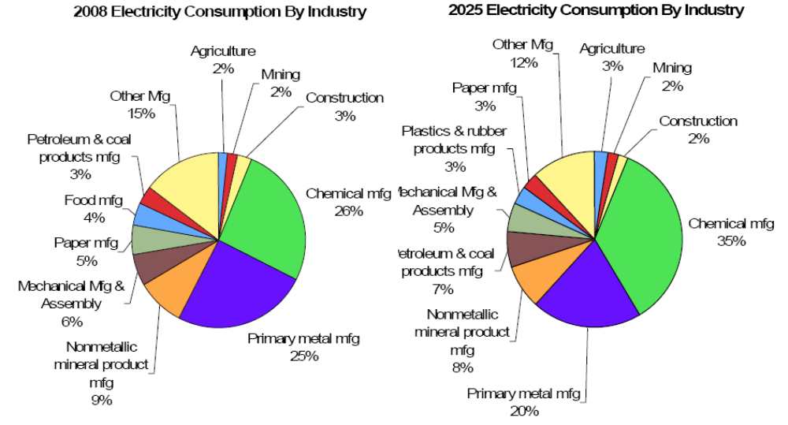

Figure 2-2. Industrial Natural Gas Consumption Forecast
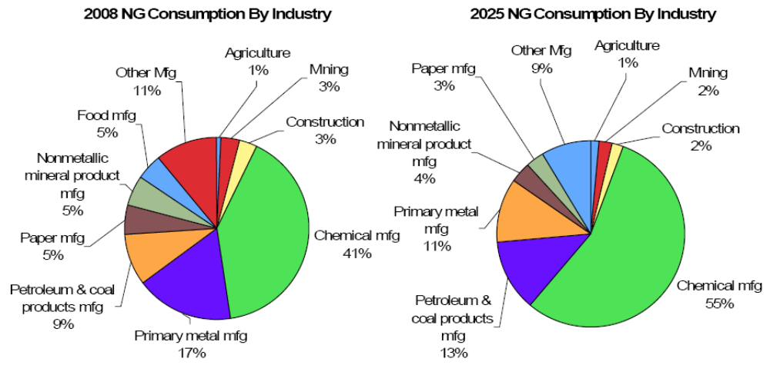
Savings Identified by ACEEE Energy Assessment
The ACEEE et al (2009) report identifies significant energy efficiency opportunities in Pennsylvania’s industrial sector. Industrial electricity supplies are estimated at 16% of 2025 sales, and industrial gas supplies are estimated at 17% (pp. 30-31). These estimates do not include site specific process heating measures, on which ACEEE states:
We anticipate an additional economic savings of 5–10%, primarily at large energy-intensive manufacturing facilities. The overall economic industrial efficiency resource opportunity is on the order of 22–27%. Therefore, the total economic potential for natural gas savings in the industrial sector in 2025 would be about 52,660 Btu. P. 31.

The ACEEE report is somewhat contradictory on the supply of industrial GWh electricity reductions available to the state in 2025. On page 14 these are estimated for non-CHP measures at ~13,000 GWh, but on page 30 supplies are estimated at 9,297 GWh in 2025. This workplan targets approximately 7,900 GWh electricity reductions by 2025 which is less than both of the ACEEE estimates. CHP measures pose an additional ~11,000 GWh reductions.

Possible New Measures: By implementing DOE BMPs, the DEP expects efficiency improvements between 5% to 25% and between 5% to 15% can be achieved in industrial process heating and steam systems, respectively.

The direct combustion of fossil fuel such as natural gas, fuel oil, and coal comprise 92% of the energy used in industrial process heating systems. The thermal efficiency of process heating equipment varies broadly between 15% and 80%. This large range in efficiency allows fuel reduction opportunities between 5% to 25% through the application of ITP best operational practices.

The direct combustion of fossil fuels such as natural gas, fuel oil, and coal comprise at least 71% of the boiler fuels used to raise steam for industrial processes. The inclusion of propane and waste fuels is estimated to increase this percentage to at least 85%. The thermal efficiency of industrial steam systems reportedly range from 65% to 85%. This range in efficiency allows fuel reduction opportunities between 5% and 15% through the application of ITP BMPs.
Table 2-1. Industrial Electricity Measure Savings and Costs
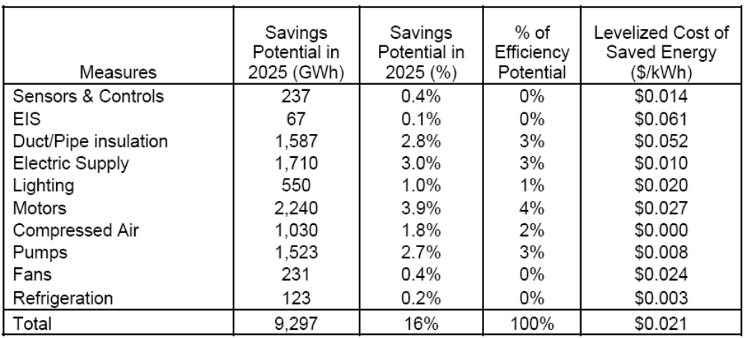

Table 2-2. Natural Gas Measure Savings and Costs
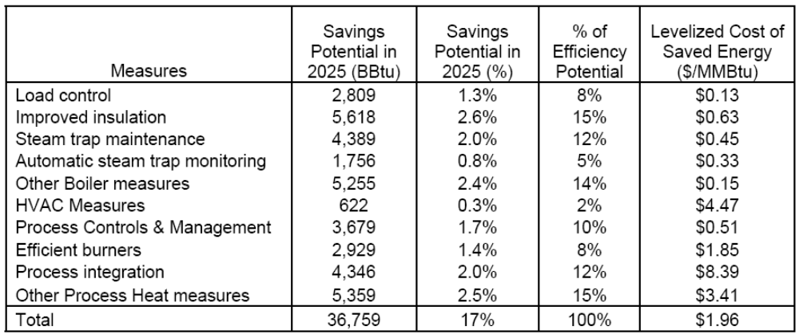

Workplan Cost and GHG Reduction:

Table 2-3. Quantification Results
Work Plan  No. | Work Plan Name | Annual Results (2020) |  |  | Cumulative Results (2009-2020)
Work Plan  No. | Work Plan Name | GHG Reductions  (MMtCO₂e) | Costs  (Million $) | Cost-Effectiveness  ($/tCO₂e) | GHG Reductions  (MMtCO₂e) | Costs  (NPV, Million $) | Cost-Effectiveness  ($/tCO₂e)
Industry 2 | Industrial Natural Gas and Electricity Best Management Practices | 5.3 | -$377 | -$71 | 26.3 | -$1,180 | -$45

The 2020 GHG reduction of 5.3 MMtCO₂e are estimated to be split between gas at 0.90 and electricity at 4.4 MMtCO₂e.
Notes: The cost estimates (colums 3 and 6) are incremental costs of energy efficient measures including capital cost, operating and maintenance, and labor, above baseline measure costs. The cost estimates are calculated as the costs less avoided energy expenditures. Also, the difference between the 2020 cost effectiveness (column 4) and the cumulative cost effectiveness (column 7) is due, in part, to the effects of discounting the net cash flows over the analysis period of 2009-2020.
- Efficiency improvement costs (that result in fuel savings up to 10%) are very low and often part of routine maintenance costs
- 10% to 15% fuel savings may result from small to medium cost system improvements
- Fuel savings greater than 20% may result from medium to high cost system improvements
- Energy savings pay back time frames are typically very good.

Quantification Approach and Assumptions

- Reductions from the workplan are assumed to begin in 2012 and are implemented at a rate of 1% of sales each year through the end of the planning period.
- Energy efficiency costs are expressed as levelized costs over the life of the energy efficiency options. The incremental costs (typically incurred in the first year of program implementation) are spread over all future years of the life of the energy efficiency measures.
- The costs of the workplan are calculated by estimating the annual costs of energy efficiency (capital, O&M, labor) less avoided fuel savings.
- These cash flows are then discounted at a real rate of 5%.
  - The net present value of cash flows is calculated beginning in 2009 through 2020.
- All prices are in $2007 as per the Center for Climate Strategies Quantification Memo.
- The levelized cost of electric efficiency measures is $26.03/MWh, the levelized cost of natural gas efficiency measures is $2.11 MMBTU.
  - This figure includes all utility and participant costs as commonly performed in a total resource cost test.
  - Program fixed costs are assumed to be part of each measure’s capital cost, These include administrative, marketing, and evaluation costs of 5%.
- Avoided electricity prices are $70 over the planning period, and avoided fuel costs are $11.72 MMBTU. [placeholder]
- The GHG savings potential does not evaluate differentiate between natural gas utility and transporter distribution.
- Electricity transmission and distribution losses are assumed to be 7% over the analysis period. Natural gas transmission and distribution losses are assumed to be immaterial for this workplan but rather are quantified under Industry #3.
- To estimate emission reductions from workplans that are expected to displace conventional grid-supplied electricity (i.e., energy efficiency and conservation) a simple, straightforward approach is used. We assume that these policy recommendations would displace generation from an “average thermal” mix of fuel-based electricity sources of coal and gas. This mix is based on the sources of forecasted generation in PA over the planning period. 90% coal, 10% gas for all years 2009-2030 based on EIA 2006 State Electricity Profile data.
  - The average thermal approach is preferred over alternatives because sources without significant fuel costs would not be displaced—e.g., hydro, nuclear, or renewable generation.
    - Similarly, a “marginal” approach is not possible in Pennsylvania because the natural gas share of the annual generation portfolio (13.5 million MWh) of total generation (218 million MWh in 2006) is only about 6%. This small amount does not provide enough be “backed down” due to the energy efficiency deployment in the workplan.
  - This approach provides a transparent way to estimate emission reductions and to avoid double counting (by ensuring that the same MWh from a fossil fuel source are not “avoided” more than once). The approach can be considered a “first-order” approach; it does not attempt to capture a number of factors, such as the distinction between peak, intermediate, and baseload generation; issues in system dispatch and control; impacts of nondispatchable and intermittent sources, such as wind and solar; or the dynamics of regional electricity markets. These relationships are complex and could mean that policy recommendations affect generation and emissions (as well as costs) in a manner somewhat different from that estimated here. Nonetheless, this approach provides reasonable first-order approximations of emission impacts and offers the advantages of simplicity and transparency that are important for stakeholder processes.

Implementation Steps
- Conduct DOE workshops that advance best practice implementation for process heating and steam systems.
- Advance the use of DOE process heating and steam system analysis tools.
- Require assessment and benchmarking of all process heating and steam systems utilizing state and federal assessment resources.

- Require review, and implementation when cost effective, of best practices for all large natural gas systems.
- Curtail service to any large un-assessed process heating or steam system in an emergency.
- Partner with utilities to develop energy use reduction programs for large energy users.

Potential Overlap
- Lost and Unaccounted for Natural Gas, Landfill Methane Capture, Recycling, Solid Waste, etc.
- Act 129, Reduced and Stabilized Load Growth workplans
Industry 3. Reduce Lost and Unaccounted for Natural Gas Work Plan for Potential GHG Reduction Measure

Lead Staff Contact: Mark Hand (717) 787-9377

Summary: Reduce lost and unaccounted (L&U) for natural gas from retail operations by 15% by the year 2020. The program begins in January, 2010 and fugitive emissions are assumed to be implemented linearly at a rate of 1.5% per year until the 15% target is reached in 2019.

Other Involved Agencies: PUC, U.S. Department of Transportation, and EPA Gas STAR Program

Baseline Activities and Assumptions

Natural Gas Consumers in Pennsylvania in 2005 – 2,839,282
- Residential – 2,600,574 (91%)
- Commercial – 233,132 (8%)
- Industrial – 5,576 (0.2%)

Pennsylvania Natural Gas Consumption by End User in 2005:
- Residential – 245 Bcf (40%)
- Commercial – 145 Bcf (24%)
- Industrial – 185 Bcf (30%)
- Electric Power Generation – 33 Bcf (6%)

Natural gas (NG) companies report L&U natural gas to the Public Utility Commission. The American Gas Association defines L&U as the difference between the total gas available from all sources, and the total gas accounted for as sales, net interchange, and company use. It is important to reduce natural gas losses because natural gas (methane) is approximately 21 times more powerful greenhouse gas emission than carbon dioxide.

NG is released to the atmosphere through fugitive and vented emissions. Fugitive emissions are methane leaks often through pipeline and system components (such as compressor seals, pump seals, and valve packing). Vented emissions are methane leaks from a variety of equipment and operational practices directly attributed to an organization’s actions (e.g., purge and blow down activities from operation) or accidental line breaks/thefts.

Table 3-1 indicates that reported L&U natural gas in 2005 was 19.6 billion cubic feet.
Table 3-1. Lost & Unaccounted-for Natural Gas for Major Pennsylvania Gas Distribution Utilities⁺
Company | Total Lost & Unaccounted-for (mcf) | Total Deliveries (mcf) | Percent L & U |  |  | Assume 15% of  L & U is Preventable
Columbia | 1,252,493 | 112,953,730 | 1.1% |  | 15% | 2,939,754.90
Dominion - Peoples | 4,767,103 | 93,059,502 | 5.1% |  | MMtCO₂e** | 161,143
Equitable | 6,871,103 | 67,142,740 | 10.2%
National Fuel | 163,550 | 53,079,559 | 0.3% |  | ** At equivalent 120.593 lb/mcf
PECO Gas | 2,493,685 | 87,908,874 | 2.8%
PG Energy * | 119,512 | 48,117,054 | 0.2%
Phila. Gas Works | 3,106,403 | 91,469,723 | 3.4%
PPL Gas | 1,203,005 | 27,642,650 | 4.4%
UGI - Gas* | -378,488 | 95,817,773 | -0.4%
Totals | 19,598,366 | 677,191,605 | 2.9%
+ There are no PUC standards for lost and unaccounted for gas
* Both companies, owned by UGI, report in a way that results in little or even negative lost gas. The PUC staff has proposed that reporting be standardized.

However, the reported L&U values are not accurately estimating gas companies’ individual contributions to fugitive or vented emissions for the following reasons:
- End-use consumer meters (likely to be residential sector meters) do not accurately measure delivered volumes. This is because some meters do not accurately account for temperature and pressure sensitivities. It is thought that consumer meters are approximately + or – 3% in measurement accuracy.
- Natural gas companies use a portion of their product in various stages of the transmission process (i.e. compressors), which is not separately quantified.
- Gas theft may also be occurring, although it is assumed to be a relatively minor loss with regard to L&U reporting.
- The PUC does not have standardized calculation/reporting procedures for L&U. Some utilities report gains instead of losses in L&U. This means that it is not possible to draw conclusions from the PUC’s statewide L&U statistics.
- The PUC indicates there are approximately 6,000 line breaks per year due to accidents (i.e. digging-up a line during construction). These individual accidents that cause releases have not been quantified.

Therefore there are three primary areas that need to be addressed to improve our understanding L&U natural gas:
- Accurate measurement and reporting;
- Operations and maintenance improvements (or replacements) to lines and aging parts; and
- Minimization of accidental losses through line breaks.

The table below indicates there is not a direct relationship between cast iron and unprotected steel pile with Lost and Unaccounted for Gas. For this workplan, pipeline replacements are not assumed to be performed solely due to the GHG benefits under this measure, but rather due to other regulatory requirements and business operations decisions.

Table 3.2: Pennsylvania Distribution Sector – Report on Cast Iron and Unprotected Steel
Company | Miles of  Cast Iron | Miles of  Unprotected  Bare Steel | Total Miles  Distribution | % of Statewide  Total Cast Iron | % of Statewide  Total Unprotected  Bare Steel
Columbia Gas of PA | 74 | 2,188 | 7,260 | 2.3% | 25%
Dominion Peoples | 66 | 1,908 | 6,566 | 2.0% | 21%
Equitable Gas | 47 | 830 | 3,307 | 1.4% | 9%
National Fuel Gas | 93 | 1,051 | 4,916 | 2.8% | 12%
PECO | 836 | 369 | 6,614 | 25.5% | 4%
UGI Penn Natural | 82 | 305 | 2,562 | 2.5% | 3%
PGW | 1,624 | - | 3,019 | 49.5% | 0%
PPL Gas | 28 | 661 | 3,619 | 0.9% | 7%
T.W. Phillips | - | 1,295 | 2,955 | 0.0% | 15%
UGI | 428 | 300 | 5,012 | 13.1% | 3%

GHG Emissions Reductions from Lost and Unaccounted For Emissions
Reduce lost and unaccounted for natural gas from retail operations by 15% through various actions such as: improved operation and maintenance, replacement of inaccurate metering, reducing the number of accidental line breaks and thefts, and requiring more accurate reporting of L&U natural gas.

The US EPA Gas Star program is a voluntary initiative to reduce fugitive emissions from all aspects of natural gas production, transmission and distribution. Much of the industry’s knowledge regarding the supply and costs of mitigating fugitive methane emissions comes from this program. The 2007 results from this program indicate that the preponderance of the emissions reductions occurred at the production level, leaving plenty of low hanging fruit for Pennsylvania’s transmission and distribution firms.
Figure 3.1: Reductions from Natural Gas Star partners by sector
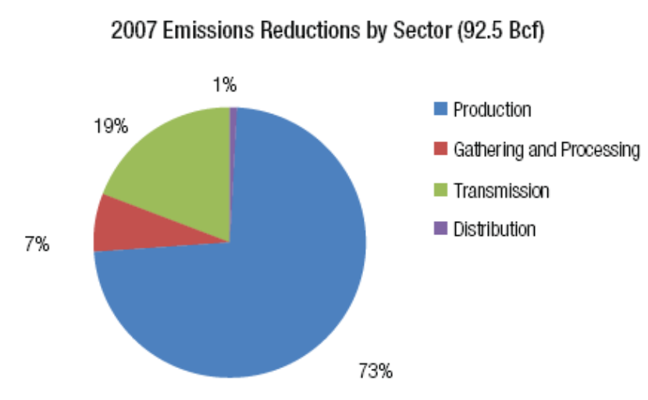

The types of technologies used to reduce fugitive emissions vary by sector. The following two graphs highlight these differences fore the transmission and distribution sectors.

Figure 3.2: Natural Gas Star Transmission Sector Reductions
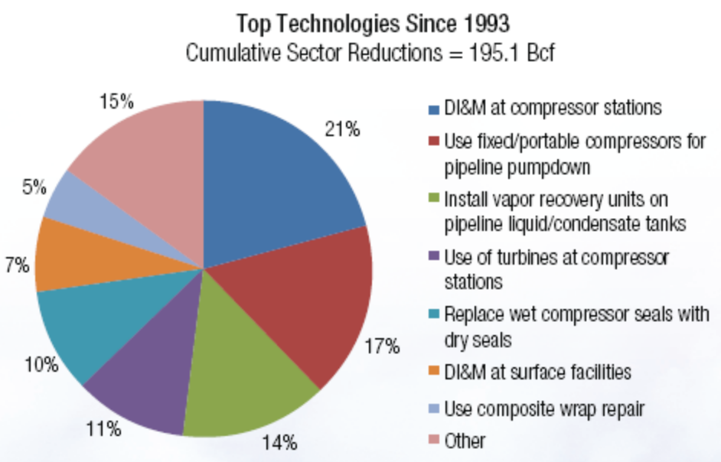

Figure 3.3: Natural Gas Star Distribution Sector Reductions

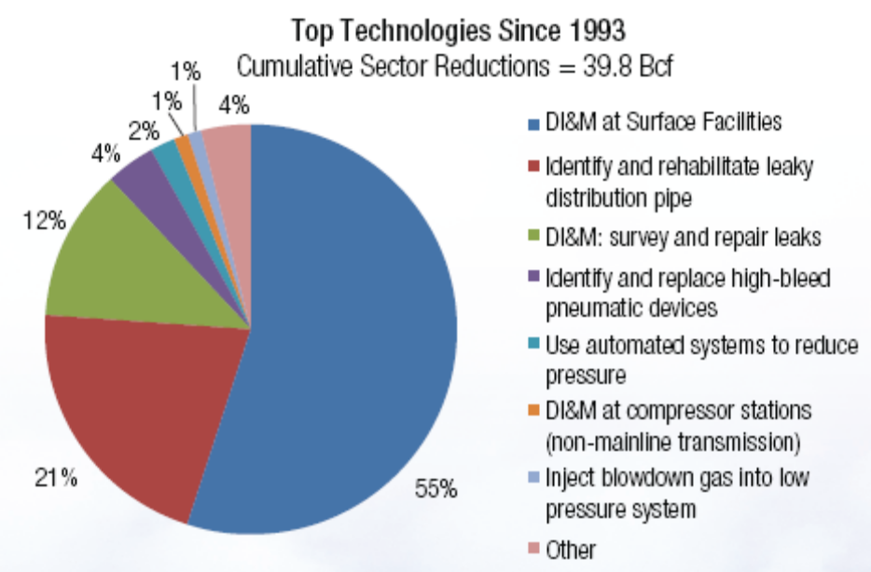

Residential measures for Pennsylvania include replacing all customer meters with “temperature and pressure compensated” meters may cost $100 per meter (PUC estimate). There are about 2.6 million households using natural gas (not including commercial and industrial consumers which may have temperature/pressure meters). This will result in improved metering and a reduction in the measuring of L&U.

Other measures include:
- Improved reporting requirements from all utilities on L&U losses. This would require PUC staff to develop standardized accurate reporting methods.
- Reduce accidental line breaks throughout Pennsylvania. Stricter enforcement of the Pennsylvania One Call System could help reduce these losses. This could require additional staff time to enforce, but may be offset by fines and penalties.
- Encourage utilities to participate in existing voluntary industry programs. EPA’s Natural Gas STAR Program is focused on reducing methane emissions through technology transfer using best practices in operation and maintenance. Natural Gas STAR provides analytical tools and services to assist in calculating companies methane emissions.

Quantification Approach and Assumptions
The actual mitigation projects undertaken by Pennsylvania gas distributors will vary depending on the types and age of equipment installed, existing monitoring and reporting protocols, etc. To quantify the costs and reductions associated with this workplan, the representative mitigation approaches are taken from actual Natural Gas Star partner experiences. Of the many possible projects possible, three are taken as representative. These are chosen because they are among the largest mitigation sources listed in Figures 3.2 and 3.3 above. The technologies or practices include:
- Direct inspection at gate stations and surface facilities-- Implementing a directed inspection and maintenance (DI&M) program is a proven, cost-effective way to detect, measure, prioritize, and repair equipment leaks to reduce methane emissions. A DI&M program begins with a baseline survey to identify and quantify leaks. Repairs that are cost-effective to fix are then made to the leaking components. Subsequent surveys are based on data from previous surveys, allowing operators to concentrate on the components that are most likely to leak and are profitable to repair.
- Replace wet seals with dry Seals in centrifugal compressors-- Centrifugal compressors are widely used in production and transmission of natural gas. Seals on the rotating shafts prevent the high-pressure natural gas from escaping the compressor casing. Traditionally, these seals used high-pressure oil as a barrier against escaping gas. Natural Gas STAR partners have found that replacing these “wet” (oil) seals with dry seals significantly reduces operating costs and methane emissions.
- Connecting the blowdown vent lines to the fuel gas system for baseload compressors when offline--This option involves adding piping and valves to bleed gas from an idle compressor into the compressor station’s fuel gas system. Facility modification costs range between $900 and $1,600 per compressor. Reduces fugitive methane losses by 1.275 Mcf/hr (91%).

The cost and performance assumptions for the three technologies are listed in Table 3.3:

Table 3.3 Technologies to Reduce Lost and Unaccounted for Natural Gas Emissions
Direct Inspection at Gate Stations and Surface Facilities
Expected Life Yrs | 1
Annual Cost of Inspections | $20,413
Net O&M costs (savings) | $0
Net Cost/ yr | $ 20,413
Fuel Savings/yr MMBTU | 123,289,042
$/MMBTU Saved | $0.0002
Replace Wet Seals with Dry Seals
Initial Incremental Capital Cost | $180,000
Expected Life Yrs | 5
Levelized Capital Cost | $43,167
Net O&M costs (savings) | -$63,000
Net Cost/ yr | -$19,833
Fuel Savings/yr MMBTU | 46,518,720
$/MMBTU Saved | -$0.0004
Connecting blowdown vent lines to the fuel gas system
Initial Incremental Capital Cost | $1,250
Expected Life Yrs | 5
Levelized Capital Cost | $300
Net O&M costs (savings) | $0
Net Cost/ yr | $300
Fuel Savings/yr MMBTU | 213,417
$/MMBTU Saved | $0.0014
Weighted Average Costs | $0.0004

- The cost of conserved gas is calculated by: 1) estimating the annual financial costs (savings) of each measure and dividing this by annual natural gas savings to estimate a $/MMBTU cost. 2) The costs of the three measures are then averaged (unweighted) to arrive at a workplan level cost in MMBTU.
- The weighted average cost for the suite of three efficiency measures is estimated at $.0004/MMBTU over the planning period.
- The NET cost of the workplan is calculated by subtracting the assumed wholesale price of natural gas from the cost of the efficiency measures.
  - The wholesale prices of natural gas are assumed to be $4.29 over the planning period. This figure comes from the May 18th, 2009 settlement price for natural gas on the NYMEX futures exchange.
- These cash flows are then discounted at a real rate of 5%.
  - The net present value of cash flows is calculated beginning in 2009 through 2020.
- All prices are in $2007 as per the Center for Climate Strategies Quantification Memo.

Table 3.4 Quantification Results
Work Plan  No. | Work Plan Name | Annual Results (2020) |  |  | Cumulative Results (2009-2020)
Work Plan  No. | Work Plan Name | GHG Reductions  (MMtCO₂e) | Costs  (Million $) | Cost-Effectiveness  ($/tCO₂e) | GHG Reductions  (MMtCO₂e) | Costs  (NPV, Million $) | Cost-Effectiveness  ($/tCO₂e)
Industry 3 | Reduce Lost and Unaccounted for Natural Gas | 0.1 | -$11 | -$84 | 0.9 | -$48 | -$55

Notes: The cost estimates (colums 3 and 6) are incremental costs of energy efficient measures including capital cost, operating and maintenance, and labor, above baseline measure costs. The cost estimates are calculated as the costs less avoided energy expenditures. Also, the difference between the 2020 cost effectiveness (column 4) and the cumulative cost effectiveness (column 7) is due, in part, to the effects of discounting the net cash flows over the analysis period of 2009-2020.

Implementation Steps:
- Encourage utilities to regularly perform self-assessments and report (to the PUC) operation and maintenance practices that have resulted in environmental savings.
- Require improved and standardized reporting to the PUC on L&U, so that atmospheric system losses can be better understood and separated from non-atmospheric losses.
- Investigate the savings from increased enforcement of the Pennsylvania One Call system.
- Possible phase-out of older metering devices with more accurate “pressure and temperature compensated” metering.

Potential Overlap:
- Demand Side Management – Natural Gas
- Increased Use of Landfill Methane

APPENDIX A. Workplan Design Memo

Memorandum

To: CCAC Industry and Waste Subcommittee
From: Center for Climate Strategies, Hal T. Nelson, Ph.D.
Re: Industrial Energy Efficiency Best Practices Workplan Design
Date: April 24, 2009

On the April 17, 2009 call, I was asked to bring forward information about recommendations for optimizing the design elements of the industrial gas efficiency program. There was interest during the call for information on natural gas efficiency supplies. Also requested was information on public/private relationships and the ramp-in time for the workplan. The following summarizes research based on comments from that call as well as information on exemplary industrial efficiency programs nationwide.
On the April 24th call the Industry and Waste Subcommittee decided that electricity efficiency should also be included in the workplan. This memo was revised to include electricity and to update the potential implementation schedule at the end of the document.

Supplies of Industrial Energy Efficiency

Energy efficiency opportunities in the industrial sector include the implementation of technologies and best practices that are cost effective. For a technology or best practice to be cost effective, capital costs, operation and maintenance costs, and installation costs must be less that the benefits from reduced energy use and/or more efficient production techniques. The ACEEE (2009) study recently quantified the supply of these cost effective industrial energy efficiency for natural gas usage in Pennsylvania. The study estimates non-process natural gas efficiency supplies at 12% of 2008 sales. Process – specific measures were not estimated, but ACEEE anticipates additional cost effective efficiency supplies of 5-10% of sales from process – specific measures. Thus, total gas efficiency supplies for Pennsylvania are estimated at 17-22% (p. 164). These resource estimates are similar to those found for industrial gas users in other states. A natural gas efficiency study for NY concluded that cost effective industrial gas supplies at almost 22% of 2016 forecasted load. Individual measures savings range from 3% of end user demand to 20%. A study for Iowa found 18% of industrial gas demand reductions to be cost effective. For California, KEMA estimated economic potential for natural gas reductions to be 13% of demand.

For electricity, ACEEE (2009) estimates that 16% of non-process industrial electricity can be cost effectively conserved in Pennsylvania. Process – specific measures were not estimated, but ACEEE anticipates additional cost effective efficiency supplies of 5-10% of sales from process – specific measures. Thus, total electricity efficiency supplies for Pennsylvania are estimated at 21-26% (p. 164).

Guiding principles for Workplan Design

Industrial energy efficiency improvements are diverse, even within the same industry because of differences in plant age, layout, process equipment, boiler efficiencies, etc.
- Industrial efficiency efforts thus need to be highly customized to the customers’ needs.
- Onsite assessments are often required, which tend to be expensive
- Because of the high costs of assessments, electricity (and water) efficiency options should also be evaluated simultaneously

Best Practices Design Elements

Customized design—NYSERDA’s FlexTech program provides large customers with consultants who present a detailed scope of work based on site specific customer efficiency opportunities. The scope of works are evaluated and approved following staff technical review. The Energy Trust of Oregon assigns a highly skilled, industry-specific specialist with considerable expertise to develop each customer scope of work.

Customized incentives—CenterPoint Energy’s custom process rebate program gives rebates for the purchase of increased efficiency equipment based on the savings expected. Program achieved savings at approximately $2.65/million cubic feet (mcf). FlexTech specifies the percent of funding that will come from the state systems benefit charge. The Energy Trust program funds up to 50% of total project costs or $0.15/kWh whichever us less, up to $500,000 annually per site.

Customer best practices dissemination—Focus On Energy’s industrial program has a specialized best practice training system based on DOE guidelines and has distributed “Energy Best Practices Handbooks” to customers via relationships with state industry organizations. Program achieved energy savings at benefit cost ratio of 11.9 (total resource cost (TRC) test). This program has a ½ day Practical Energy Management “starter” seminar on facilities energy management. Surveys have indicated that over 60% of participants have used the approach in the six months after the seminar.

Dedicated program staff—The recommendation that efficiency equipment and incentives are customizable requires that the program staff have skills to evaluate and quantify the program. Similarly, the workshops and best practices handbook, although based on DOE material, require technical skills on behalf of the program staff.

Integrated delivery—Pacific Gas and Electric’s Heavy Industry and Manufacturing Energy Efficiency Program included demand response and self-generation opportunities along with energy efficiency recommendations based on particular market segments for both gas and electricity and water. The program’s benefits cost ratio is 3.8 (TRC test). The program also includes industrial retrocommissioning.

Workforce support—Essential to the success of the efficiency program is the development of a private sector workforce (ESCOs, utilities, etc) that can perform the assessments and benchmarking as well as vendors to install the energy efficiency equipment. Also, Focus on Energy trains and incentivizes compressed air equipment vendors to identify other energy efficiency opportunities such as leak detection and overall system analysis at the their customers’ facilities.

Focus on process improvements—the Energy Trust program focuses on fundamental process changes that yield not only energy savings but also improved production efficiencies. Connecticut Light and Power’s PRIME program teaches manufacturers “Lean Manufacturing” techniques that do more with existing resources by eliminating non-value add activities (Kaizen technique of continuous improvement). Benefit cost ratio for this program is 1.29.

Summary and Implications for the Design of Natural Gas Efficiency Workplan

The elements above indicate that a top industrial efficiency program cannot be built overnight. Evaluating and selecting allies, training staff, developing workshop materials and best practices guidebooks, developing technology and funding protocols all take time. Most of the successful industrial efficiency programs listed above started small and grew because of their ability to deliver gas reductions. However, the Office of Energy and Technology Deployment (OETD) is already performing many of these functions as of 2009. Similarly, federal funding could help accelerate the development of this industrial energy efficiency program. Pennsylvania will receive $373 million to promote energy independence under the American Recovery and Reinvestment Act.

The following is a possible timeline for workplan implementation:
- 2009-2010: Program authorization and development of training material, protocols and vendor selection.
- 2011: Pilot phase introduction
- 2012: Beginning of full program and assumption of linear implementation of program targets.
Appendix B. Overlap Analysis
Workplan | Potentially Overlaping Workplan | Overlap Adjustment To | Notes | Resolution
Electricity -3 Stabilized Load Growth | Industry-2 Industrial Gas and Electricity | Electricity -3 | Industry 2 targets 9% industrial efficiency by 2020 while Electricity-3 is only 7%. The issue for the interaction between these workplans is not overlaps, but assurance that in combination they do not exceed industrial electric efficiency supplies in PA. By 2020, the combined GWh of both workplans exceeds by approximately 350 GWh the linear implementation of the two 2025 industrial estimates in ACEEE et al (2009) of 9,900 and 13,000 GWh (pp. 14, 30). | 2020 reductions of electric industrial energy efficiency are reduced by 350 GWh (10% of industrial electric efficiency reductions under Electricity 3).
Industry-2 Industrial Gas and Electricity | RC-10 Gas DSM | None | RC-10 applies only to residential and commercial buildings | None required
Electricity-9 Combined Heat and Power | Industry-2 Industrial Gas and Electricity | None | Industry 2 does not target CHP specifically. In addition, the ACEEE et al (2009) report identifies between 10,000-13,000 GWh of non-CHP electricity efficiency in the industrial sector by 2025. The 2025 target under Industry 2 is only 7,900 GWh. This means that the state can fulfill the targets under Industry 2 without including overlaps for CHP from the electricity CHP workplan. | None required

The natural gas demand side reductions from the Energy Independence and Security Act (EISA) of 2007 are assumed to be in the baseline forecast because the growth figures are projected from EIA Annual Energy Outlook which has accounted for the 2007 law. The electricity reductions from Industry-2 are assumed to be net of the EISA as these impacts were considered by ACEEE et al (2009) when developing the energy efficiency resource assessment.

Source: Placeholder
Source: ACEEE et al. (2009). Energy Efficiency, Demand Response, and Onsite Solar Energy Potential in Pennsylvania. April. P. 29. http://www.aceee.org/pubs/e093.htm
Statistics taken from U.S. DOE Energy Information Administration
See http://www1.eere.energy.gov/industry/bestpractices/pdfs/em_proheat_bigpict.pdf
See http://industrial-energy.lbl.gov/files/industrial-energy/active/0/Steam%20Sourcebook.pdf.
Source: ACEEE et al. (2009).
Source: ACEEE et al. (2009) p. 49.
Source: Placeholder values from ACEEE et al (2009) report
Gas Consumers and Gas Consumption information was provided through an American Gas Association query - 2005 Data.
Developed by the PUC using U.S. Department of Transportation Data
US EPA. (2007). Project Opportunities Study for Partner X. Natural Gas Star Program.
EPA. (2007). Natural Gas STAR Program Accomplishments. http://www.epa.gov/gasstar/documents/ngstar_accomplishments_2007.pdf
http://www.epa.gov/gasstar/documents/ll_dimgatestat.pdf
http://www.gastool.methanetomarkets.org/m2mtool/files/docs/ll_wetseals.pdf
http://www.gastool.methanetomarkets.org/m2mtool/files/docs/ll_compressorsoffline.pdf
For the July, 2009 futures contract. http://www.nymex.com/ng_fut_cso.aspx
American Council for an Energy Efficient Economy. (2009). Potential For Energy Efficiency, Demand Response, and Onsite Solar Energy in Pennsylvania. April. ACEEE report E093.
Optimal. (2006). Natural Gas Energy Efficiency Resource Development Potential In New York. October. Pp. 4-30 to 4-32. http://www.nyserda.org/energy_information/otherdocs.asp
Quantec LLC, Summit Blue Consulting, Nextant, Inc., A-TEC Energy Corporation, and Britt/Makela Group. February 2008. Assessment of Energy and Capacity Savings Potential in Iowa: Final Report, vol. I. Prepared for the Iowa Utility Association. (No Web link available.)
KEMA. (2006). California Industrial Existing Construction Energy Efficiency Potential Study. http://www.calmac.org/publications/PGE_PotentialStudy_Vol1_05242006.pdf
http://www.nyserda.org/programs/Technical_Assistance/flextechprocess.asp
ACEEE rated honorable mention program. http://aceee.org/pubs/u081/ind-process.pdf p. 9-17+
ACEEE rated honorable mention program. http://aceee.org/pubs/u081/ind-process.pdf p. 9-6+
ACEEE rated exemplary program. http://aceee.org/pubs/u081/ind-process.pdf p. 9-5+
ACEEE rated honorable mention program. http://aceee.org/pubs/u081/ind-process.pdf p. 9-10+
ACEEE rated honorable mention program. http://aceee.org/pubs/u081/ind-process.pdf p. 9-15+
http://www.recovery.pa.gov/portal/server.pt?open=514&objID=505976&mode=2

