INSTRUCTIONS FOR THE ON-LINE APPLICATION
The Alternative Fuels Incentive Grant Application must be submitted through the Department of Community and Economic Development’s (DCED) Electronic Single Application website. Paper and faxed copies will not be accepted. This change allows DEP to expedite the review process. The link to the on-line application can be found at:
https://www.esa.dced.state.pa.us/Login.aspx
User Tips

- Electronic Single Application works best when accessed through Internet Explorer.
- If you allow your screen to sit idle for more than 30 minutes, you will lose the data entered since last save and will have to re-enter it.
- Save frequently.
- When completing the application, fields with a “ ” are required fields. If a required field is skipped, you will be notified later in the application to return to the affected section to complete the field.
- Do not use special characters in the fields such as \, /, *, &, %, #, etc.
- You do not need to send the signature page and/or any further documentation to the Grants Center. All the information needed is contained in your on-line submission.
- If you have questions completing the application, please call the DCED Customer Service Center at 1-800-379-7448. They are open 8:30 am-5:00 pm EST Monday thru Friday.

- Registration and Login
  - If you are a first-time user, click the “REGISTER” button on the left.
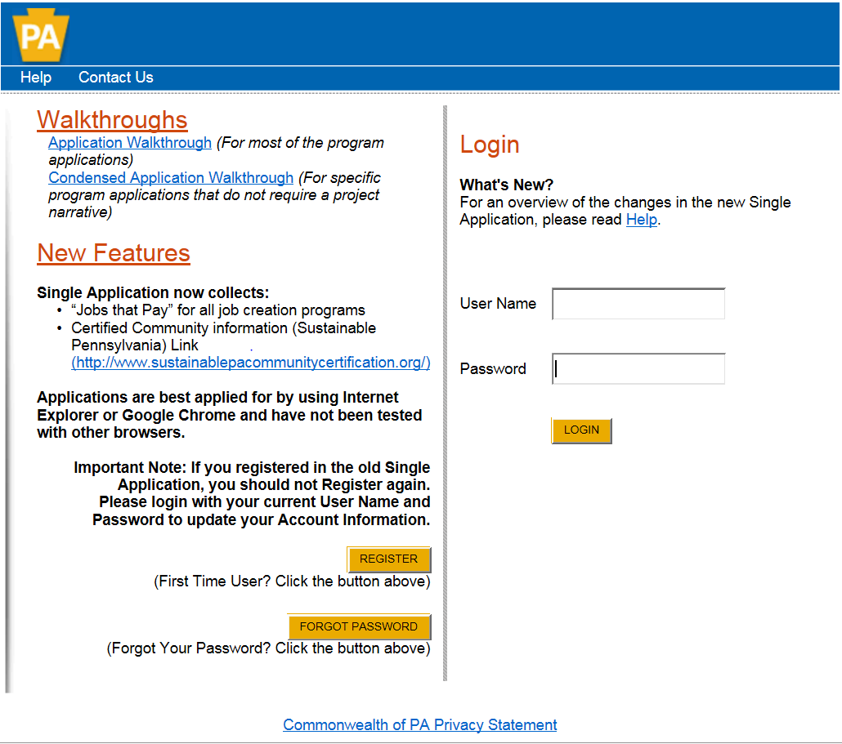
Click to Register
- Write down and save the User name and Password you have chosen. You will need this later for your grant documents.

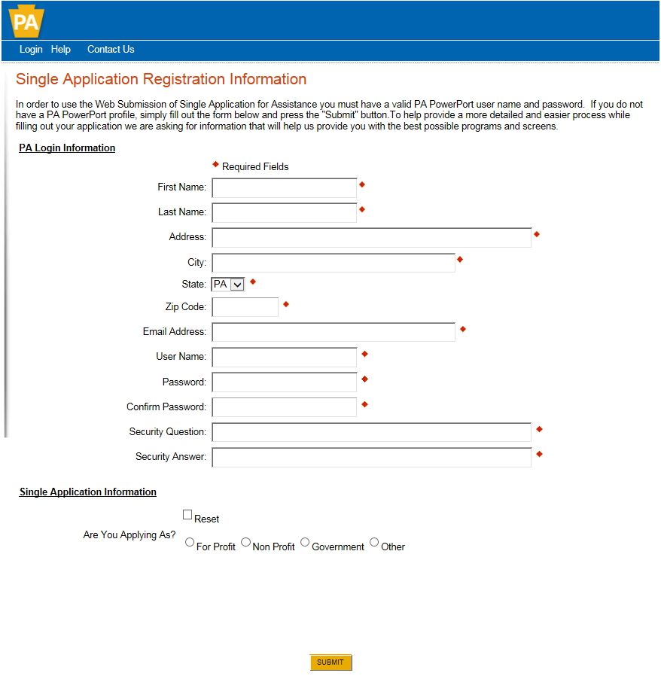
- Complete all the required fields (denoted with a red diamond)
- E-mail address – Used to forward forgotten password when requested. An email address cannot be used twice.
- User Name - Must be unique to all the user accounts within PA Login system
- Password – Case sensitive and requires a minimum of 8 characters passwords must include at least one of each of the following: uppercase letter, lowercase letter, number and symbol
- Security Question/Answer – protects the identity of account
  - Security answer is case sensitive
  - Information used to reset password
  - Used by Customer Service Center to verify user and reset password
- Single Application Information “Are you Applying As?” – Allows the Applicant to set-up Single Application Account Information and is used to display applicable programs.
- Choose appropriate entity type

- Click the orange SUBMIT button – when you have completed all the fields. You should be at the Login screen and proceed to enter User Name and Password. Click Login button.

- Begin a New Application
- Project Name – Choose and enter a name for your project.
- Do you need help selecting your program – Select “Yes”
- Click on “CREATE A NEW APPLICATION”

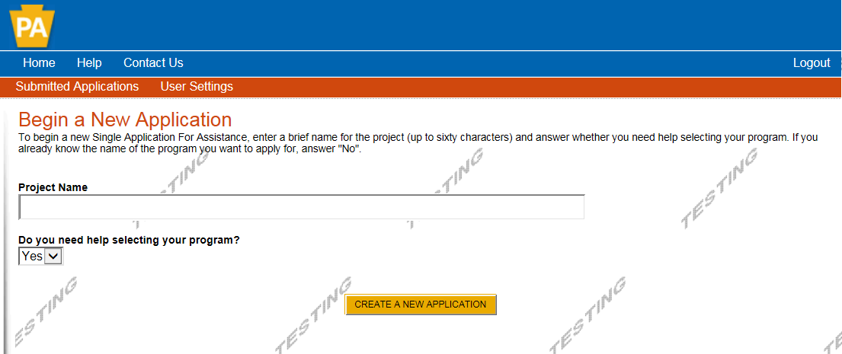

- Select Program
  - Under “Agencies”, click on DEP.
  - Scroll down and click “SEARCH”
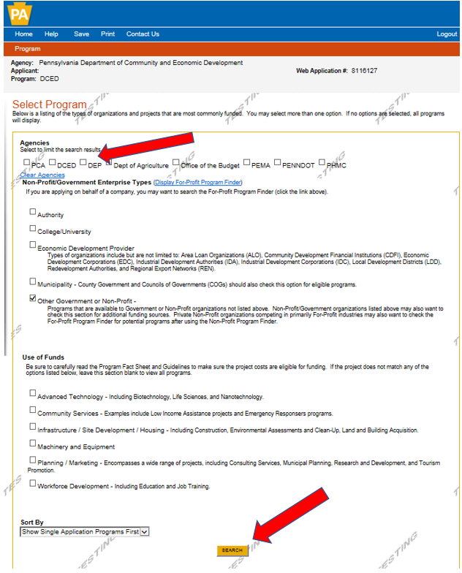
- Apply

- Scroll down through the various grant offerings, locate “AFIG” and click on the “apply link” for the specific project type that you would like to apply for.
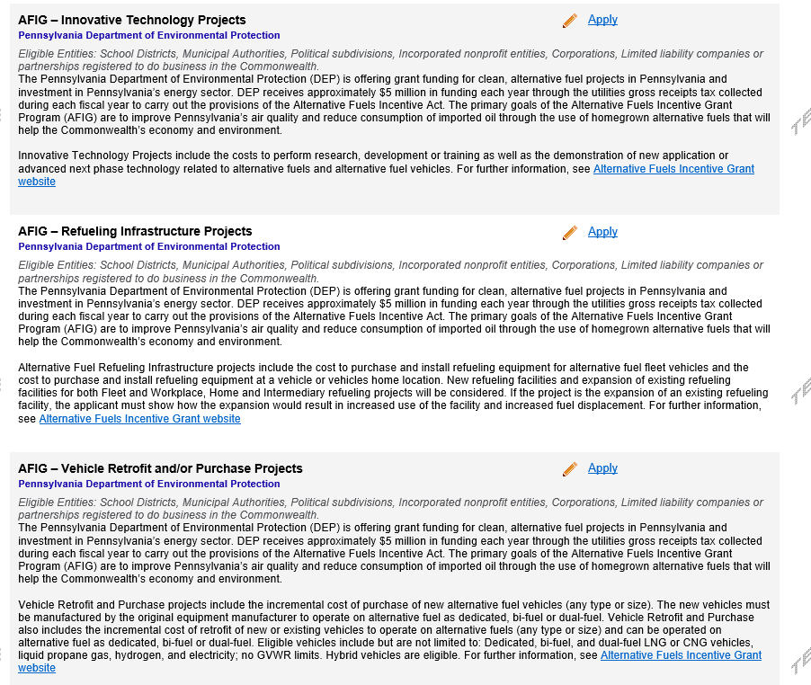

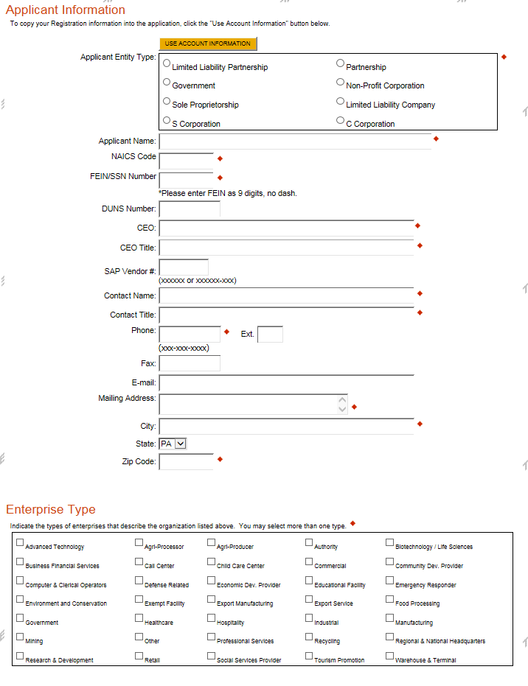
- Applicant Information

- The Applicant Information section requires data related to the County for which the application is being submitted.
- Applicant Entity Type – Select Appropriate Entity Type of your Organization
- Applicant Name – Enter the legal Entity name, the name under which the county legally conducts business.
- NAICS Code - From the dropdown box, select Business, Professional Labor, Political, and Similar Organizations. The NAICS code will auto-populate for you.
- FEIN/SSN Number - Enter the Federal Tax ID number for the legal County name (no dashes).
- DUNS Number – Leave blank.
- CEO – In this block, enter the authorized representative of the organization.
- CEO Title – Enter the title of the authorized representative.
- SAP Vendor# - Leave blank.
- Contact Name – Enter the primary contact name for this project.
- Contact Title – Enter the primary contact title for this project.
- Phone and Fax – Enter the phone and fax numbers for the primary contact title for this project.
- E-mail – Enter the e-mail for the primary contact title for this project.
- Mailing address, City, State and Zip Code – Enter this information for the primary contact for this project.
- Enterprise Type – Select Appropriate type for the organization.
- Click on “Continue” at the bottom right.

- Project Overview
- Project Name – The project name will auto-populate.
- Is this project related to another previously submitted project – Select “Yes” if appropriate.
- Have you contacted anyone at DEP about your project – If so, please indicate “yes” and indicate who you spoke to.
- Site Locations – Enter as many sites that are applicable for your project.
The rest of the information in the Project Overview section is not required and does not need to be filled out.
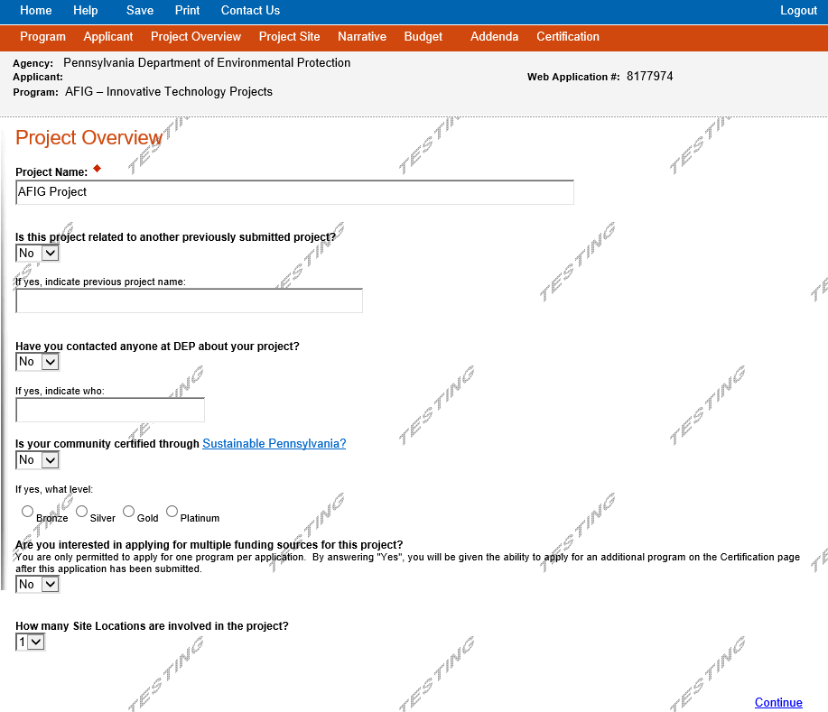Click on “Continue”

- Project Site

- Address – Enter the project location site. P.O. Boxes are not acceptable.
- City, State and Zip Code – Enter this information.
- County – Select county from the dropdown box.
- Municipality – Select municipality from the dropdown box.
- PA House, Senate and US House – These fields will auto-populate based on county and municipality. If a Legislator is not auto-populated, please visit http://www.legis.state.pa.us/cfdocs/legis/home/findyourlegislator/
- Designated Areas – Leave blank.

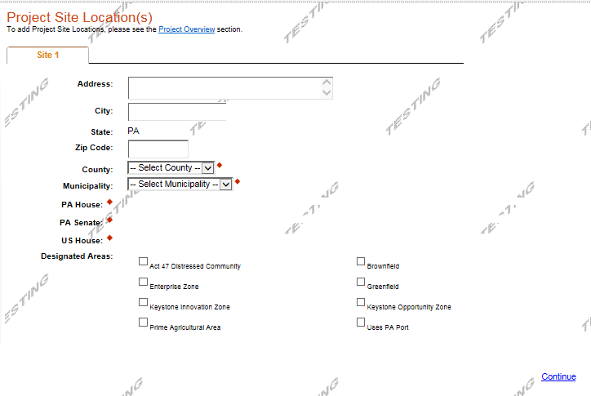
Click on “Continue”

- Project Narrative
  - Complete the project narrative section.
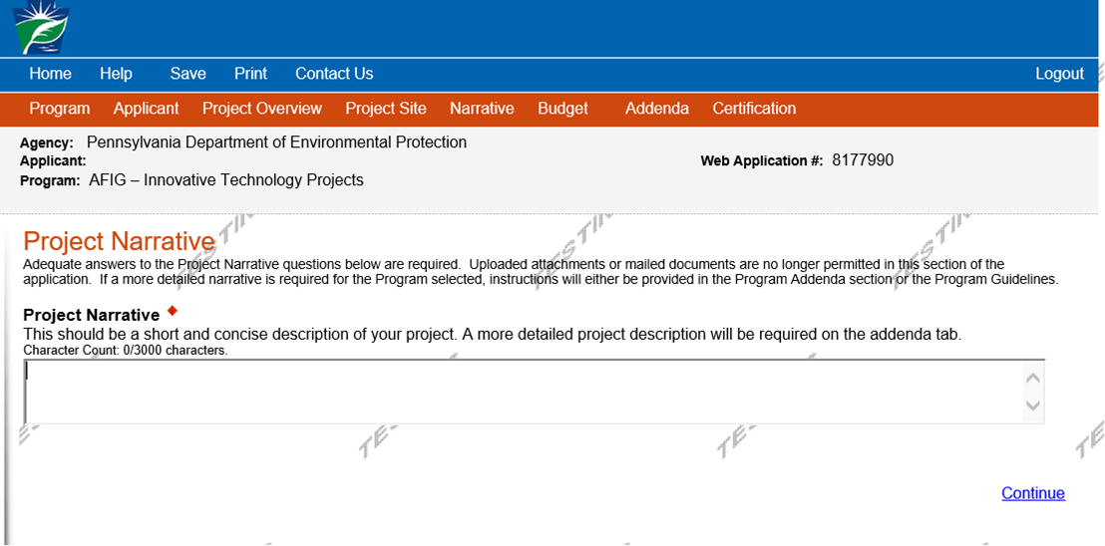

Click on “Continue”
- Program Budget
Spreadsheet Tab
- Click on the Spreadsheet tab.
- In the first column, enter the amount of funding you are requesting from DEP in the appropriate categories.
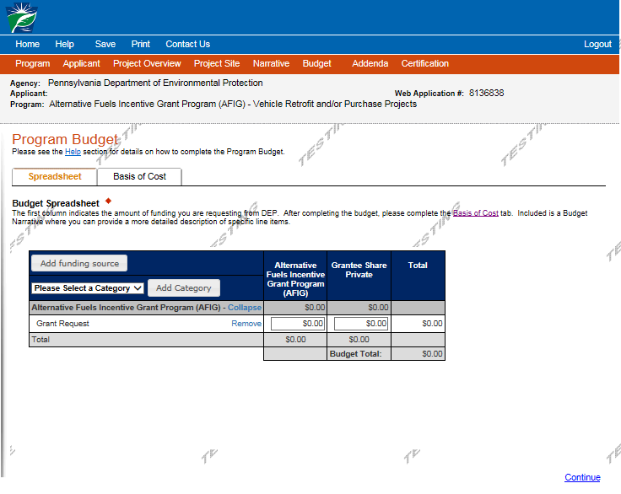
Click on “Continue”

Basis of Cost Tab
- The Basis of Cost tab will pre-populate. Nothing in this section needs to be filled out.

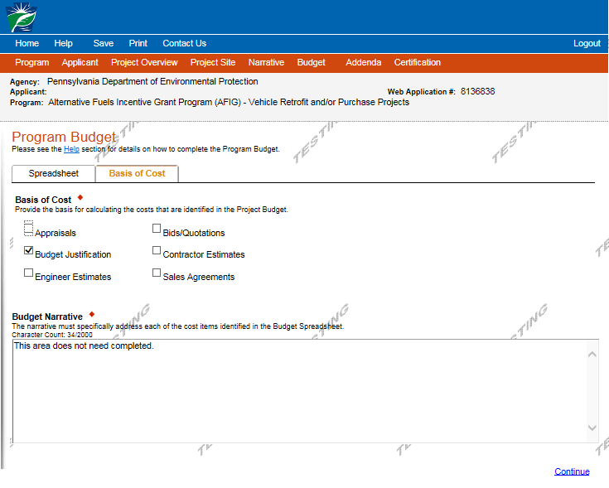

Click on “Continue”

- Program Addenda
- Program Addenda will vary based on the Grant Type you selected. Please refer to the AFIG Program Specific Instructions for step-by-step instructions to complete and upload the required forms for your project type.
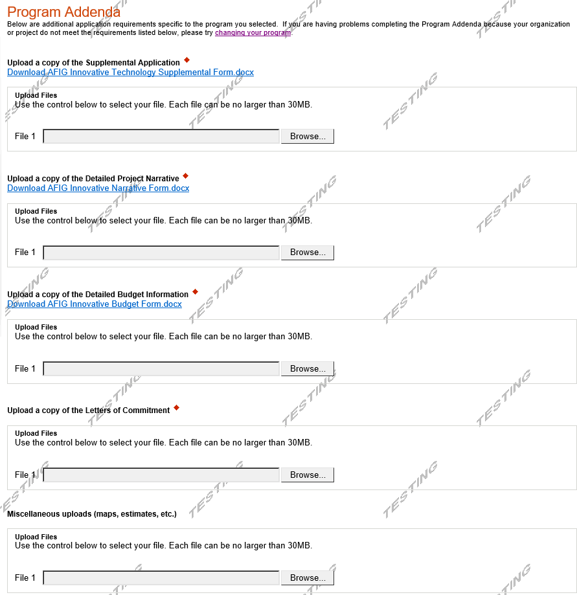

- Certification and Submission
- If there is any missing information in your application, your screen will look similar to the following example.
- Under the orange “Application Certification” heading, it will state, “The following sections are incomplete. All required fields marked with a red diamond must be completed before you are able to submit this application”.
- To add/correct the information on your application, click on the section heading to return to the page.
If your application is complete, your screen will look like this:
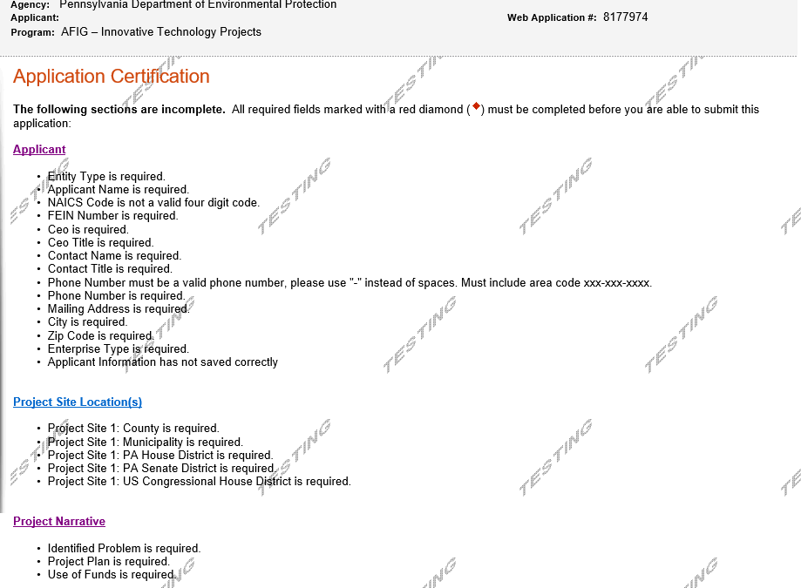

Complete the following fields:
- Indicate certification of application information by checking the related checkbox under the Electronic Signature Agreement.
- Indicate identity as one of the following:
  - I am the applicant
  - I am an authorized representative of the company, organization or local government.
  - I am a “Certified” Partner representative
- Type your name in the “Type Name Here” block. This will serve as your official e-signature and authorizes your application.
- Check the “Electronic Attachment Agreement” box.
- Click on “Submit Application”.

- Application Receipt Verification
- If you want a copy of your application, click the “Print Entire Applications with Signature Page” link. You will always be able to access your application with the user name and password you created at the beginning of the application.
- Make sure to note the Single Application ID#. All future correspondence from the Department will reference this number.
- You do not need to send the signature page and/or any further documentation to the Grants Center. All the information needed is contained in your on-line submission.
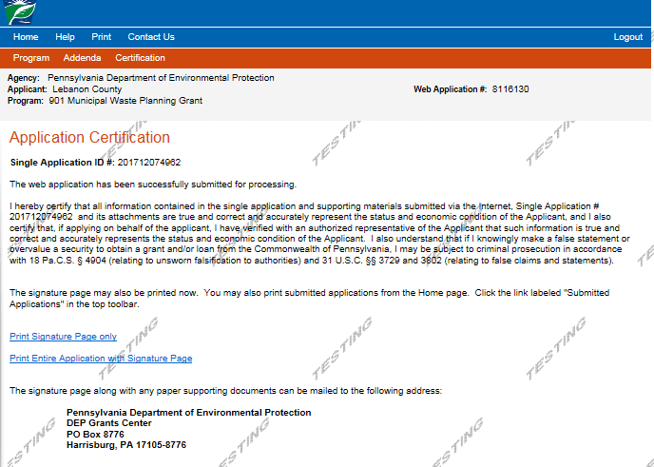

- Congratulations! You have completed the on-line application. You will be notified of your application status and subsequent steps in the next few weeks.

