User’s Manual for the Quick Domenico Groundwater Fate-and-Transport Model
28 Feb 2014

A4.1. Example Problem: UST Site

A4.1.1. Synopsis
Fate and transport modeling is commonly required for petroleum releases at underground storage tank facilities. In this example, Quick Domenico is applied to contaminants in a dissolved gasoline plume to assess how far the plume might travel and what downgradient properties might need to be covered under an environmental covenant.

A4.1.2. Site Description and Background
A retail gasoline and service station operated on the property since at least the 1980s. The facility had three registered 10,000-gal gasoline USTs, as well as diesel and used motor oil tanks. All tanks were removed a few years ago when the business closed. Evidence of a release was first discovered at that time with groundwater sampling. Contaminated soil and groundwater was removed, but there was no further remediation. There are six onsite monitoring wells screened from 10′ to 20–50′ depth (Figure A4.1-1). A seventh downgradient well is located across the street from the station; it is screened at 36–46′ depth. Quarterly sampling was performed for 5 yr There are no drinking water wells within at least 1000′ of the facility.

The soil is described as clay and silty clay that transitions to weathered bedrock. Underlying competent bedrock (Baltimore Gneiss) was not encountered in the well bores. The depth to water is generally ~20–40′. Groundwater flows to the southeast, with a gradient of ~0.07 ft/ft. The nearest surface water is a creek located ~2000′ to the west (upgradient). Slug tests were performed at two wells with results of 2.7 and 4.4 ft/day, but one consultant considered some alternative solutions to the data at longer times which gave much lower values, ~0.1 ft/day.

The principal contaminants of concern are benzene and MTBE, which consistently exceeded Statewide health standard MSCs in several wells. Measurable free product was intermittently found in one well, MW-5. The downgradient offsite well (MW-7) had five rounds of nondetect results.

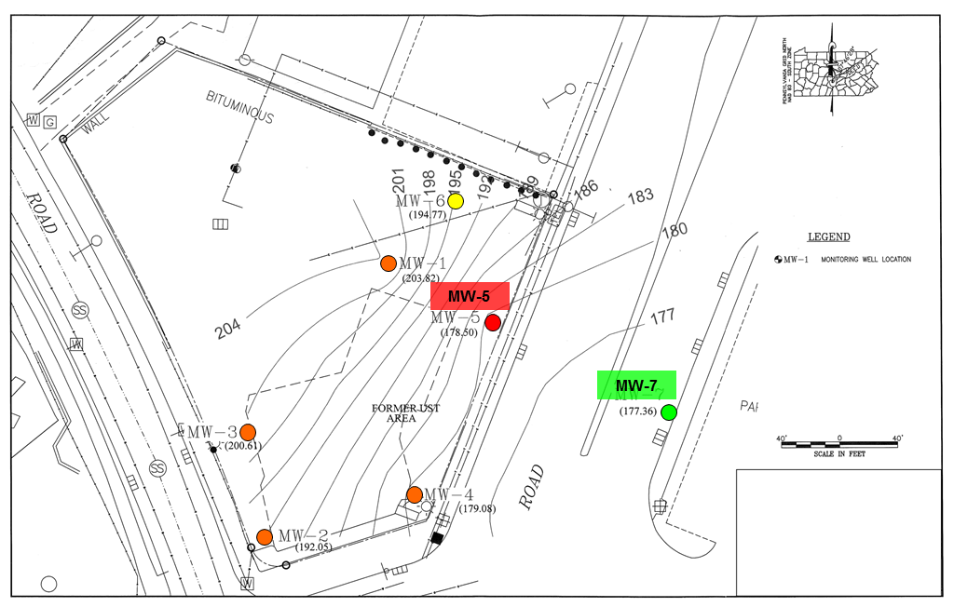
Figure A4.1-1. Site map. Potentiometric surface contours are shown. Wells are color-coded with respect to the general level of benzene and MTBE contamination, decreasing from red to orange to yellow to green. MW-7 has remained below Statewide health standard MSCs for five sampling rounds.

A4.1.3. Data Analysis
The highest contaminant concentrations have been observed in MW-5. This is the source well in the model. The only well available for calibration is MW-7, which is across the road and 135′ downgradient from MW-5. No contamination was detected in MW-7, with method detection limits of 1 μg/L for benzene and MTBE. We use average analytical results over about the last 2 yr of observations to characterize the source and calibration well concentrations.

Table A4.1-1. Average well concentrations
Well | Benzene (mg/L) | MTBE (mg/L)
MW-5 | 9.9 | 2.5
MW-7 | 0.001 | 0.001

There is no evidence of source decay at this site, probably because LNAPL continues to be present to supply the dissolved phase plume.

A4.1.4. Model Parameter Values
We select the following baseline parameter values for the QD models.

Table A4.1-2. Input parameter values
Parameter | Symbol | Value | Comments
Source concentration | C₀ | 9.9 mg/L  2.5 mg/L | benzene average  MTBE average
Longitudinal dispersivity | α_{x} | 1–65′ | variable
Transverse dispersivity | α_{y} | α_{x}/10 | estimate
Vertical dispersivity | α_{z} | 0.001′ | minimized for 2-D transport
Source width | Y | 20′ | site characterization
Source depth (thickness) | Z | 10′ | site characterization
Hydraulic conductivity | K | ~0.3–30 ft/day | variable
Hydraulic gradient | i | 0.07 ft/ft | based on well data
Effective porosity | n_{e} | 0.3 | estimate
Density | ρ_{b} | 1.49 g/cm³ | estimate
Organic carbon coefficient | K_{oc} | 58 L/kg | benzene | DEP Ch. 250  Table 5A values
 |  | 12 L/kg | MTBE
Fraction of organic carbon | f_{oc} | 0.001 | estimate
Degradation coefficient | λ | ~0.00096 day^{–1}  ~0.0019 day^{–1} | benzene, variable  MTBE, variable

We focus on three variables in the modeling: α_{x}, K, and λ.

• The longitudinal dispersivity scales with the plume length, but the length is uncertain because concentrations at MW-7 are nondetect. We choose an initial value equal to 10% of the distance from the source to MW-7, the calibration point (α_{x} = 13′). The uncertainty is an order of magnitude. We select a range of one-tenth to five times the baseline value.

• The initial value of the hydraulic conductivity is taken from the average slug test results. It is uncertain by a factor of 10 in consideration of the stratigraphic variability.

• The starting estimates for the degradation rates are DEP’s Ch. 250 Table 5A values. They are uncertain by at least an order of magnitude, and λ is the primary variable for calibrating the models.

Therefore, we model the following parameter space, varying λ in each simulation to best fit the observed nondetect results at the calibration point.

Table A4.1-3. Model parameter ranges
Model | K (ft/day) | α_{x} (ft)
01 | 3.0 | 13
02 | 3.0 | 1
03 | 3.0 | 65
04 | 0.3 | 13
05 | 0.3 | 1
06 | 0.3 | 65
07 | 30 | 13
08 | 30 | 1
09 | 30 | 65

The calibration time is 1767 days (4.8 yr), the time elapsed between the discovery of contamination and the last round of well sampling. This is the shortest duration possible as the release may have occurred years before. If the plume is in steady state at 5 yr, then the models won’t be sensitive to this choice. If the plume is not in steady state, then a longer calibration time would require a higher degradation rate to achieve the same concentration at MW-7. Hence using a short calibration time is more conservative (i.e., results in worst-case predictions).

Figure A4.1-2 depicts the input screen for the baseline benzene Model 01.

Figure A4.1-2. Quick Domenico screenshot of data input worksheet for benzene Model 01.

A4.1.5. Quick Domenico Model Calibration and Results
We visually calibrate the solution by varying λ for each model to match benzene and MTBE data at MW-7. Because the concentrations at this well were nondetect, we calibrate to the method detection limit, 1 μg/L, for both benzene and MTBE. The best-fit degradation rates (λ) values are given below.

Table A4.1-4. Model calibration results (t = 1767 days)
Model | K (ft/day) | α_{x} (ft) | Benzene | MTBE | Comments
 |  |  | λ (day^{–1}) | λ (day^{–1})
01 | 3.0 | 13 | 0.060 | 0.056 | baseline model
02 | 3.0 | 1 | 0.039 | 0.040
03 | 3.0 | 65 | 0.14 | 0.12
04 | 0.3 | 13 | 0.0060 | 0.0057
05 | 0.3 | 1 | 0.0019 | 0.0034 | not steady state
06 | 0.3 | 65 | 0.014 | 0.012
07 | 30 | 13 | 0.60 | 0.57
08 | 30 | 1 | 0.39 | 0.40
09 | 30 | 65 | 1.4 | 1.2

Calibration results for the two contaminants are shown in Figures A4.1-3 and A4.1-4.

Steady state is normally achieved by <5 yr in these models. The exception is Model 05, with low hydraulic conductivity and low dispersivity. Because transport is so slow, the plume does not reach steady state until 20 yr for benzene and 10 yr for MTBE. To match the calibration point, degradation is inferred to be much slower than in the other models.

We have defined and calibrated unique models that reflect the range of uncertainty in our knowledge of contaminant fate and transport. Next we run the calibrated solutions to steady state (e.g., 30 yr) and evaluate the distance at which the centerline concentration drops to the Statewide health standard MSCs (5 μg/L for benzene and 20 μg/L for MTBE). The results are tabulated below.

Table A4.1-5. Model prediction results (at steady state)
Model | K (ft/day) | α_{x} (ft) | Benzene | MTBE | Comments
 |  |  | x_{SHS} (ft) | x_{SHS} (ft)
01 | 3.0 | 13 | 110 | 81 | baseline model
02 | 3.0 | 1 | 112 | 84
03 | 3.0 | 65 | 108 | 75
04 | 0.3 | 13 | 110 | 81
05 | 0.3 | 1 | 220 | 98 | worst-case model
06 | 0.3 | 65 | 108 | 75
07 | 30 | 13 | 110 | 81
08 | 30 | 1 | 112 | 84
09 | 30 | 65 | 108 | 75
All but one of the predictive solutions cluster at x_{SHS} ≈ 110′ for benzene and ~80′ for MTBE. These models were in steady state at the calibration time, and the concentration–distance curves are all very similar. Model 05 is distinct because it requires considerably more time to achieve steady state. The result is that advection dominates degradation, concentrations increase with time, and the future plume length can be significantly longer (Figures A4.1-5 and A4.1-6). The predicted plume extends onto, but not beyond, the property across the road (Figure A4.1-7).

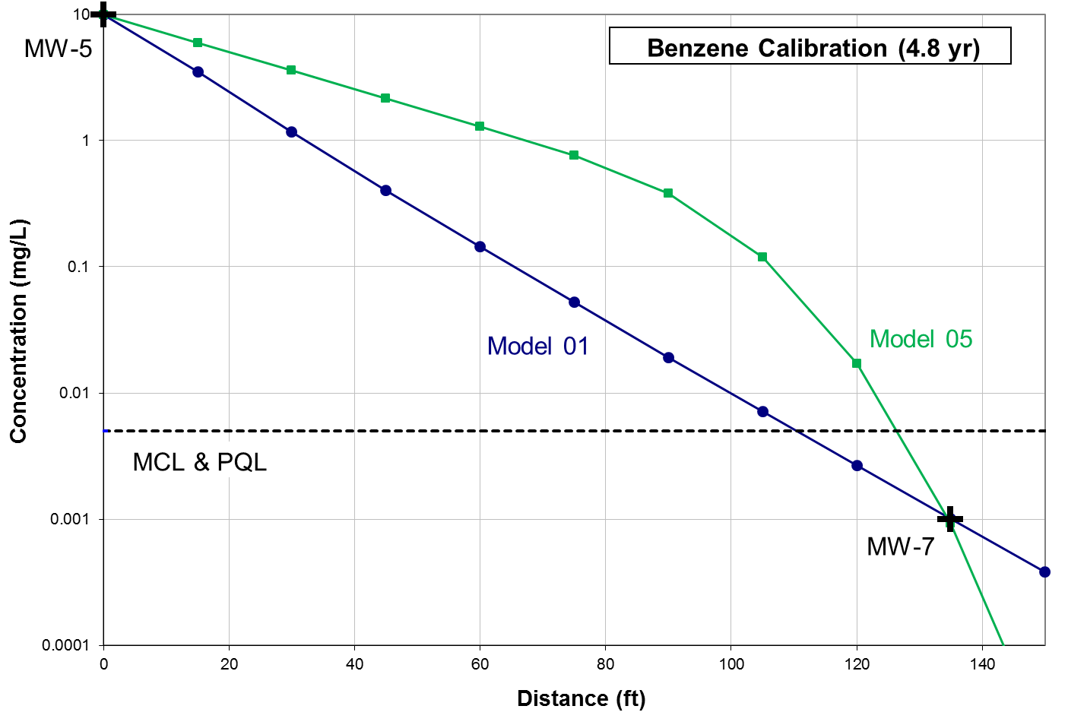
Figure A4.1-3. Quick Domenico calibrations for benzene Models 01 and 05.

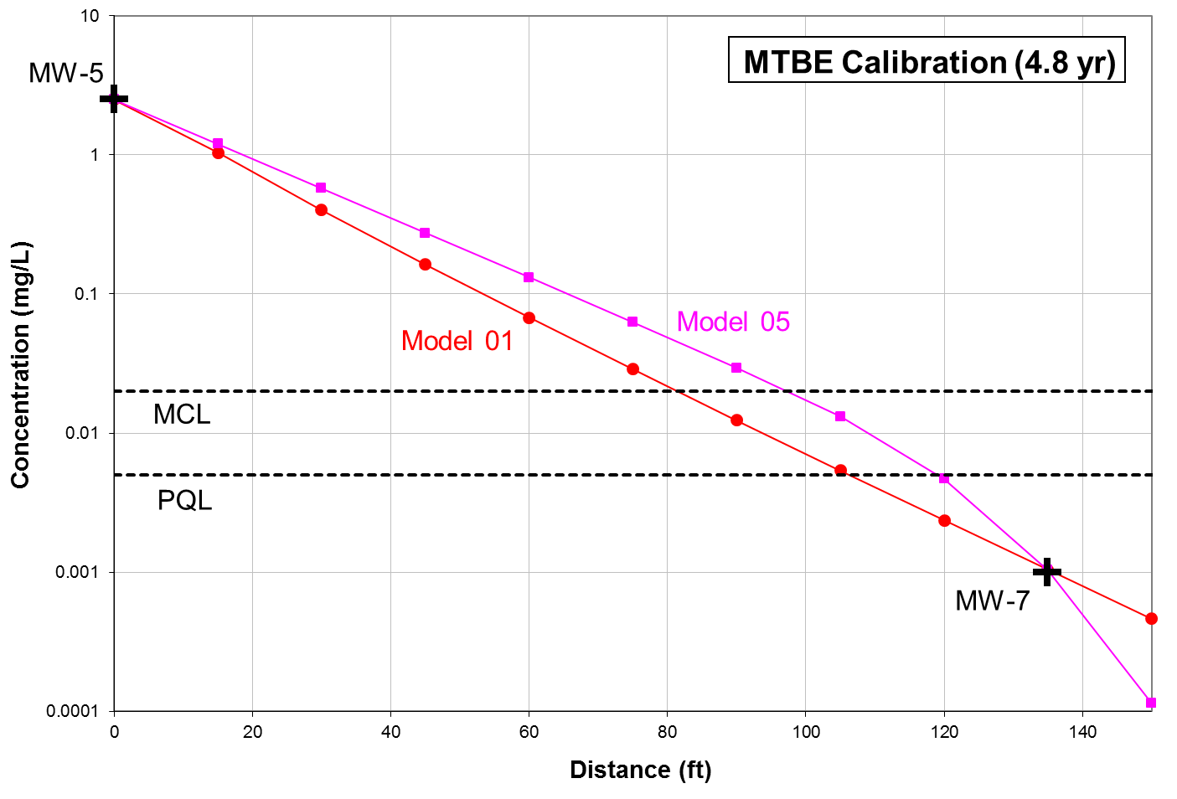
Figure A4.1-4. Quick Domenico calibrations for MTBE Models 01 and 05.

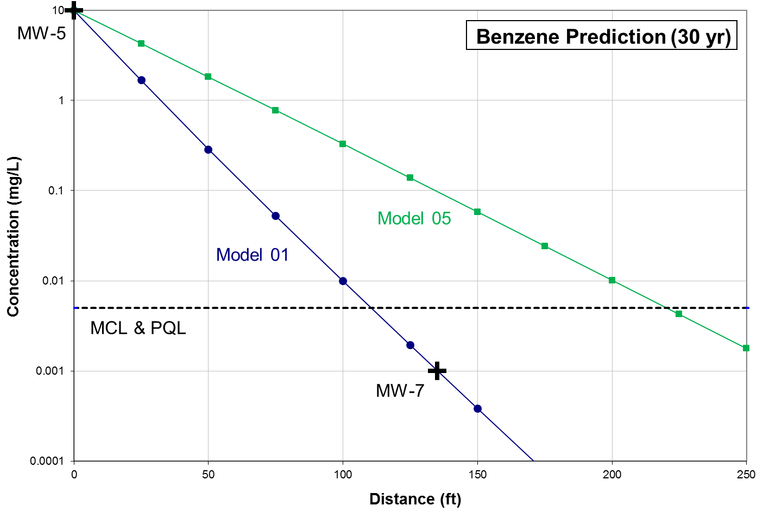
Figure A4.1-5. Quick Domenico predictive results for benzene Models 01 and 05. (Note the well data is shown at the calibration time and the models are plotted at 30 yr.)

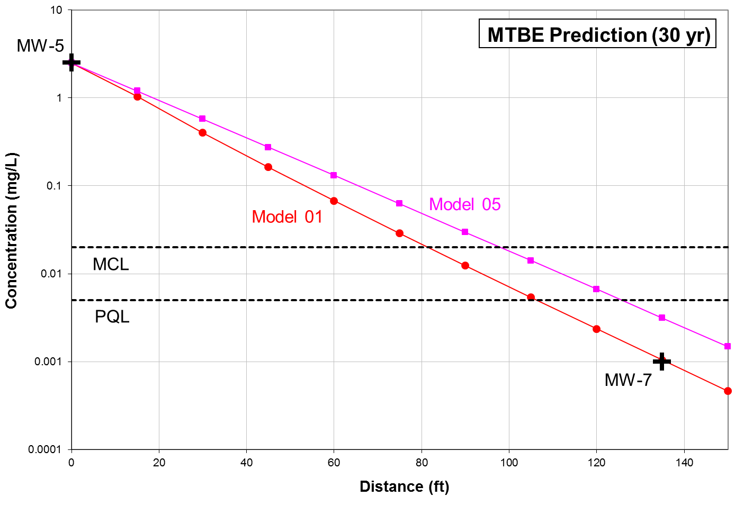
Figure A4.1-6. Quick Domenico predictive results for MTBE Models 01 and 05. (Note the well data is shown at the calibration time and the models are plotted at 30 yr.)

A4.1.6. Quick Domenico Model Conclusions
This example illustrates a basic approach to evaluating site data and conducting fate-and-transport modeling through an analysis of parameter uncertainty and sensitivity. Although the calibrated model results are fairly consistent for most parameter ranges, a low hydraulic conductivity and dispersivity yield a much longer plume. This result is counterintuitive, and it emphasizes the importance of modeling the full range of feasible parameter values. A single model using “average” or typical values would not have identified this possible end-member solution.

Because the analytical data at the MW-7 calibration point were nondetect, we don’t know if the plume will in fact ever reach that distance. In this case, the degradation rate could be higher, and the plume scale might be similar to the other models. But the conditions of Model 05 remain possible as long as there’s no calibration point with detectable contamination. One way to resolve this uncertainty would be to install a new downgradient monitoring well closer to the source. Alternatively, pump tests between the facility and MW-7 could be performed to better establish the hydraulic conductivity. Or the wells could be sampled longer to better constrain the plume extent. Model 05 predicts that both benzene and MTBE will increase at MW-7 by at least a factor of 10 in less than a year, so if contamination isn’t detected soon the degradation rates must be higher and the inferred plume length shorter.
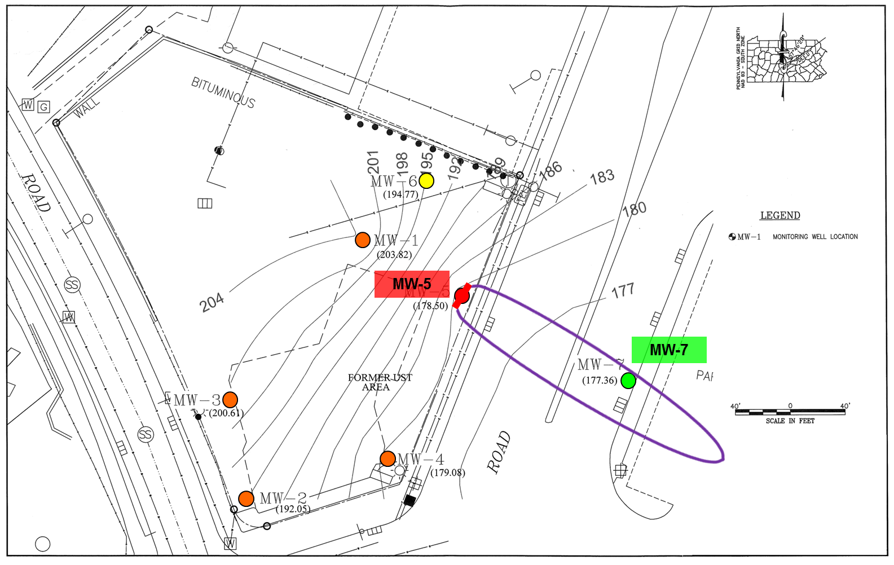
Figure A4.1-7. Model 05 predicted benzene plume edge (5 μg/L) at 30 yr.

