

**Office of Oil and Gas Management**

**ePermitting User Enrollment Guide for Oil and Gas Online Applications**

**December 16, 2021**

**Version 1.0**

**Contents**

**GreenPort Account New User Registration** 3

**How to Enroll in ePermitting** 4

**Screen Control Processing Buttons** 6

**Step 1: Identify the Program** 6

**Step 2: What Type of Submitter are You?** 7

**Step 3: Company Identification** 8

**Starting a draft ePermitting application while waiting on Access ID information.** 8

**Step 4: Verify Information** 10

**Step 5: Review Security Agreement** 10

**Step 6: Sign the Security Agreement** 11

**Step 7: Review, Submit and Get Started!** 11

**Starting a Permit in ePermitting** 12

**Change History** 13

# **Contacting the Office of Oil and Gas Planning and Program Management**

If you have any issues or questions with the GreenPort enrollment process please contact the Bureau of Oil and Gas Planning and Program Management at 717-772-2199 or email [RA-ep-BOGMOGRE@pa.gov](mailto:RA-ep-BOGMOGRE@pa.gov). Office hours are Monday through Friday 8:00am to 4:00pm.

# **Purpose**

This guide is intended to assist the User’s request to their company’s EFA to gain access to the ePermitting application. Once the User has requested access, the company’s EFA will be notified via email to grant the User’s access rights for assigned Operator or Company.

With the new updated Wizard enrollment process, a User can begin working on a draft permit application while awaiting EFA approval.

# **GreenPort Account New User Registration**

To access the ePermitting application you must have a registered Keystone GreenPort account. To register for a new GreenPort Account go to [https://greenport.uat.pa.gov/gpl](https://greenport.uat.pa.gov/gpl%20) and click on the Register button and enter the required information as prompted.

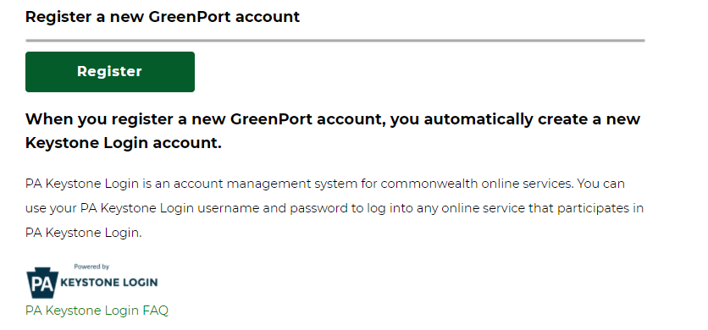

When you have registered your GreenPort account or already have a GreenPort account, enter your Username and Password and click Login!

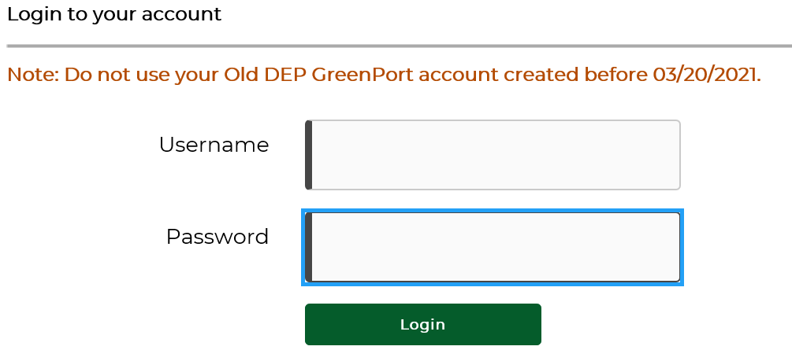

# **How to Enroll in ePermitting as a User**

Once a GreenPort account has been successfully registered, you will log into GreenPort using the Username and Password you created during the registration process. Once logged in, select the Request Access button to begin if you are not currently enrolled.

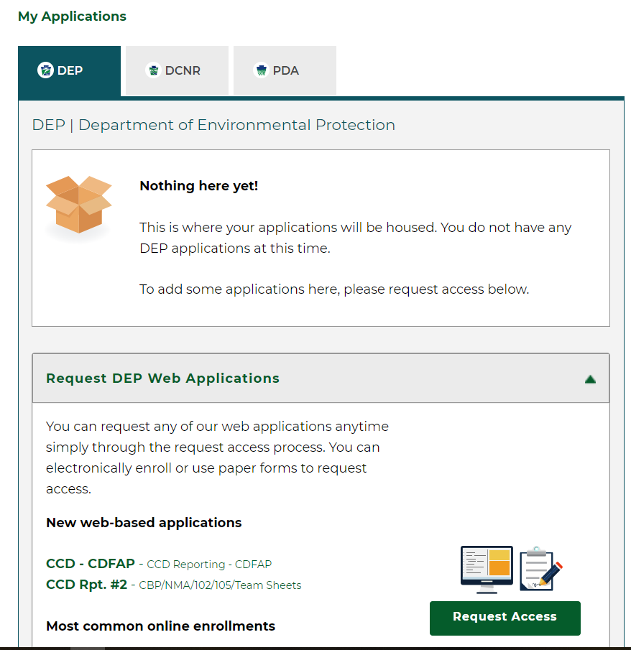

On the Online Enrollment tab, Click the Enroll button for ePermitting

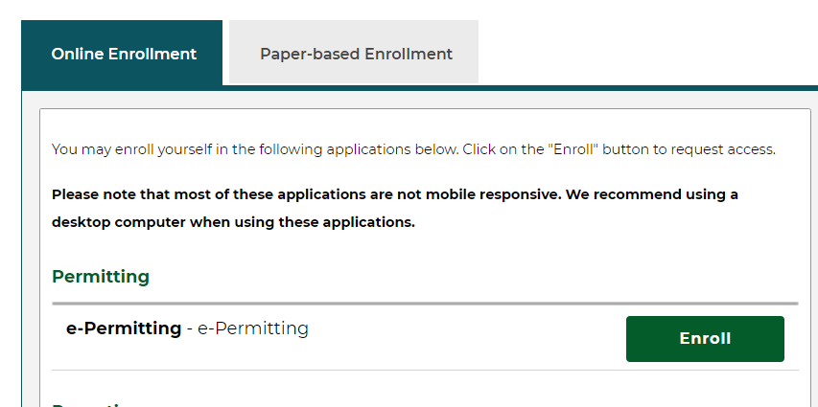

The ePermitting Home Page will open, the User will click on the Enrollment Dashboard Icon to start a New Enrollment. Additionally, in the Enrollment Dashboard the User will also be able to view additional enrollments they may have requested.

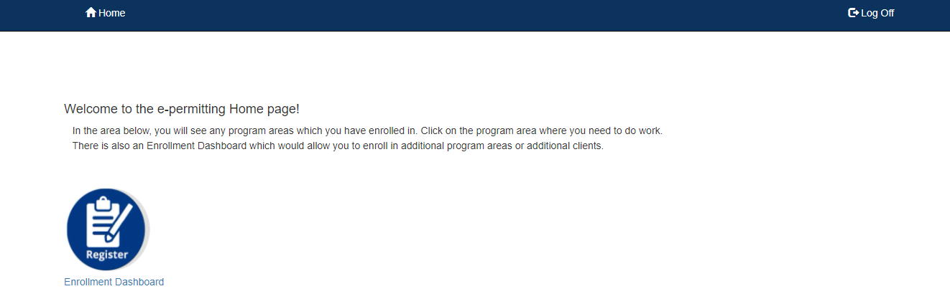

To start a new enrollment, click the Start a New Enrollment button.

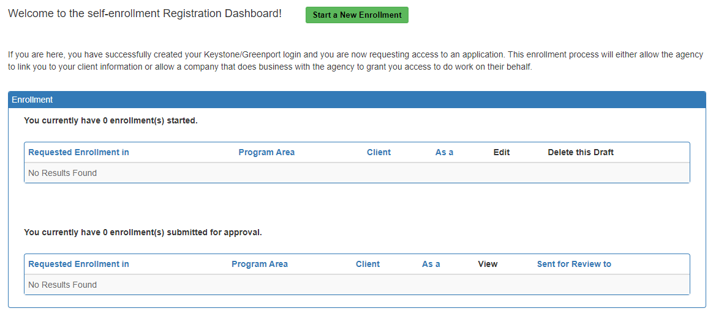

The Start a New Enrollment is a 7 Step Wizard process. All 7 steps must be completed and submitted to gain proper access to the ePermitting application.

**The following guidance outlines the steps necessary to complete to submit and enrollment request.**

# **Screen Control Processing Buttons**

The Wizard process has Screen Control buttons that will allow the user to navigate through the 7 Step Process. Any data entered will be saved during the enrollment process.

 will continue enrollment, all previously entered data will be saved.

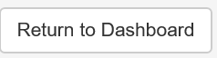 Will return user to Start new enrollment screen.

 will return user to previous screen, all previously entered data will be saved.

## **Step 1: Identify the Program**

Select Office of Oil and Gas Management Program. A list of permits that can be submitted for the Program Area selected will display under the Program Area you are requesting access for. If the permit you wish to gain access to is not listed, you may need to select access to a different Program Area.

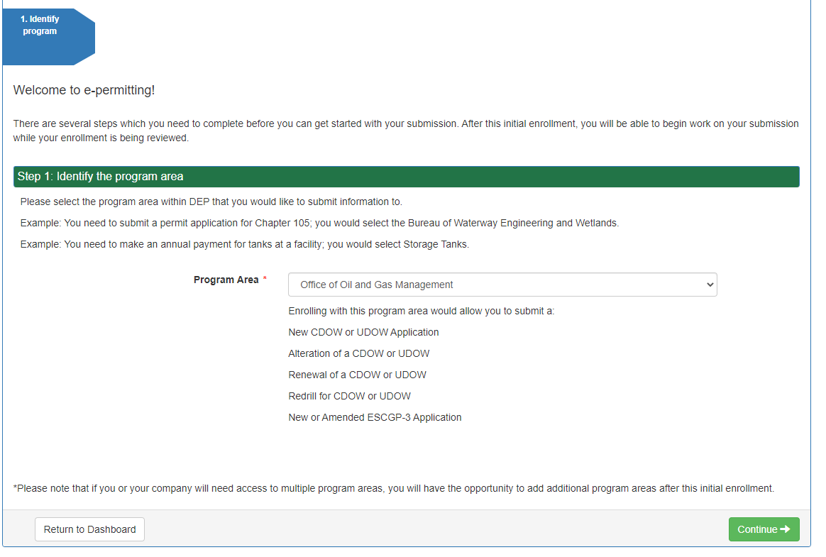

The current applications available for the Oil and Gas Program are:

* New CDOW or UDOW Application
* Alternation of a CDOW or UDOW
* Renewal of a CDOW or UDOW
* Redrill for CDOWR or UDOWR
* New or Amended ESCGP-3 Application.

## **Step 2: What Type of Submitter are You?**

Select the relationship to DEP that best describes your access.

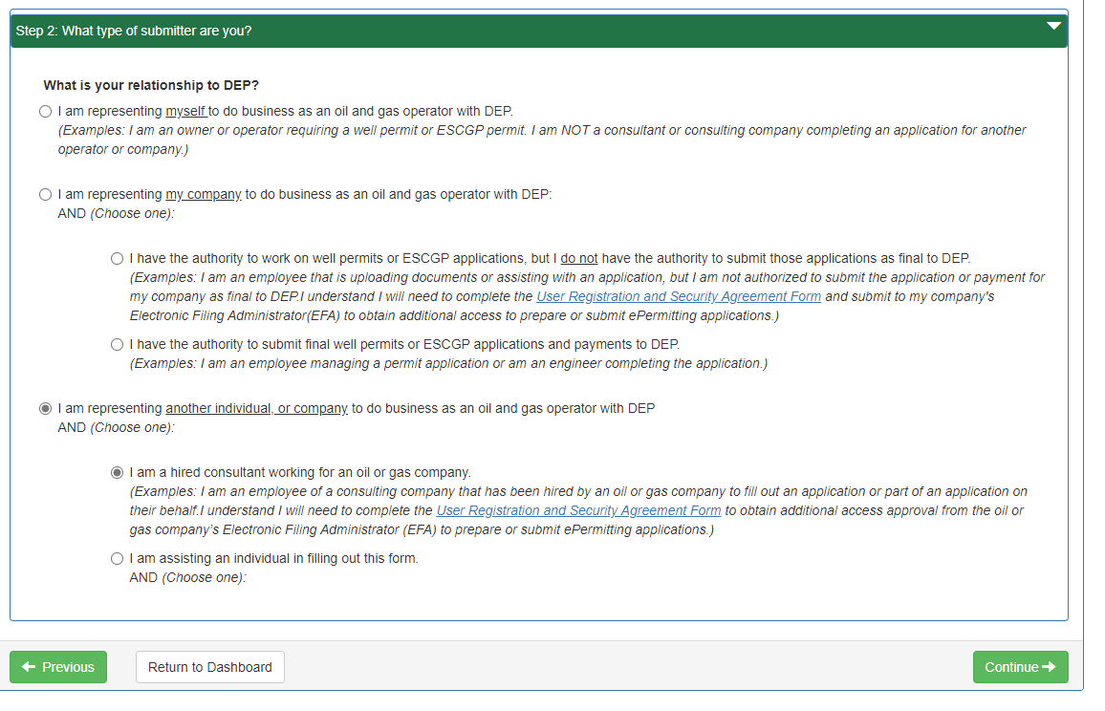

User access requires the company’s EFA to grant final access to ePermitting as either a Preparer or Master preparer.

* A **Preparer** role will allow a User to access ePermitting and start a new draft application or view an already started draft application for the Operator or Company the User has requested access to.
* A **Master Preparer** roll will allow a User to access ePermitting and start a new application, view an already started draft application and submit and make payment to DEP for the Operator or Company the User has requested access to.

The EFA will determine the User Role as either Preparer or Master Preparer.

## **Step 3: Company Identification**

Enter the Access ID for the Operator you are requesting access to. For Oil and Gas this will be the OGO number of the Operator you are requesting access to. Enter the OGO number in the format “OGO-XXXXX”. If you know the Access ID number, enter it here and continue to Step 4.

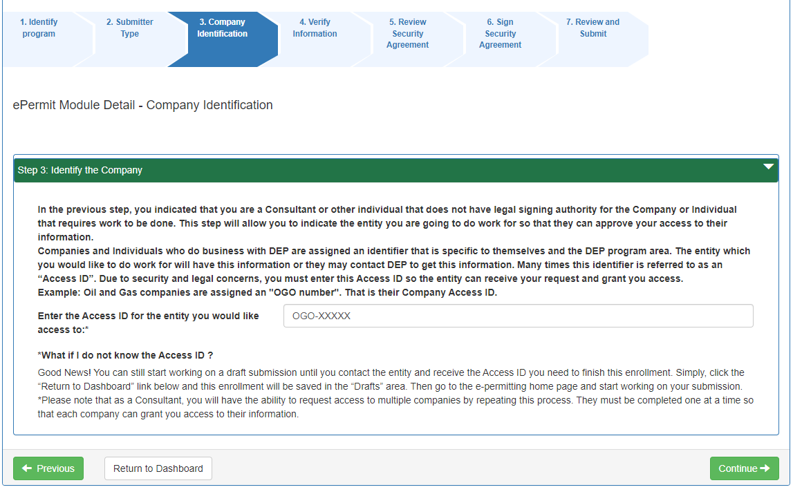

***NOTE:*** *If you do not know the Access ID/OGO number, contact your EFA for that information. You can come back later to enter the OGO number. If you do not know it at the time of enrollment, select Return to Dashboard button. All previously entered data will be saved to this point.*

### **Starting a draft ePermitting application while awaiting on Access ID information.**

1. Return to the ePermitting Home page and you can begin a draft application by selecting the Program Icon while you are waiting on Access ID information.

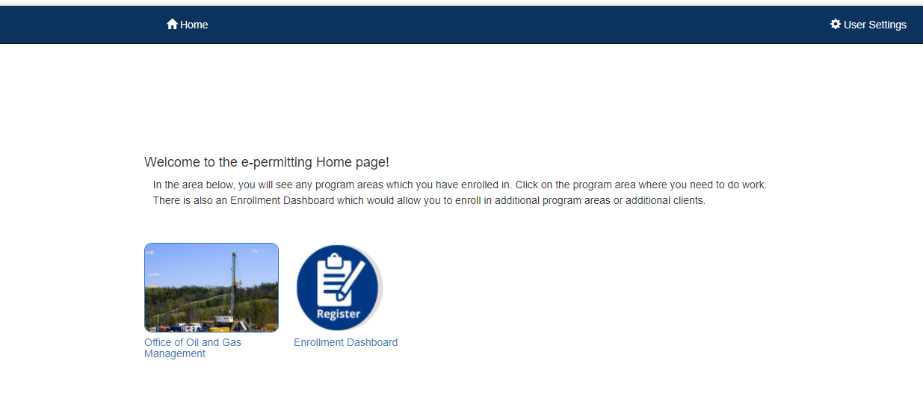

1. In the ePermitting Dashboard you will see in the Access ID window a GP number Pending Approval. Select the GP_number Pending Approval and then Click on the Create button and select the permit type you wish to start.

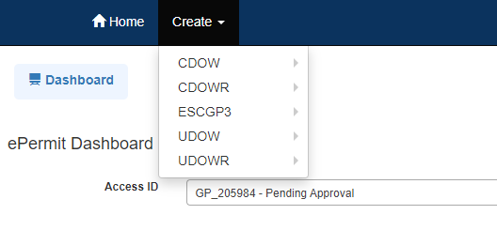

1. Once you have the Access ID information return to the Enrollment Dashboard by clicking on the Enrollment Dashboard icon in the ePermtting Home Page and select the Edit icon to complete your Enrollment process.

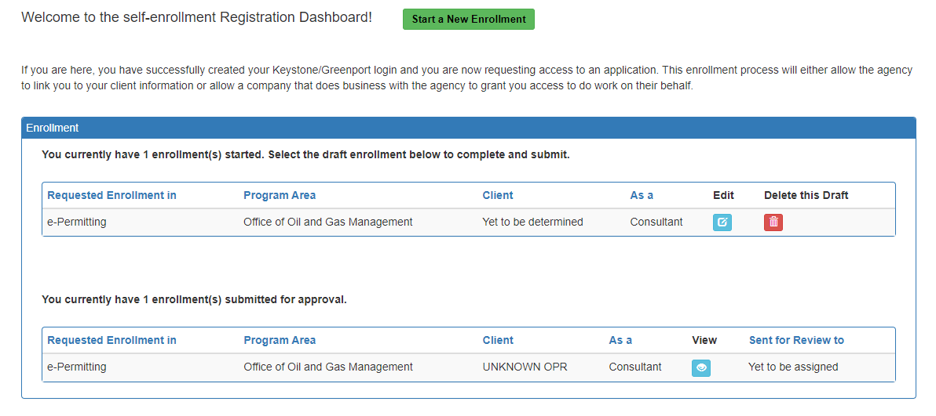

## **Step 4: Verify Information**

Verify your information. You may edit or re-enter information here. If everything appears correct select Continue.

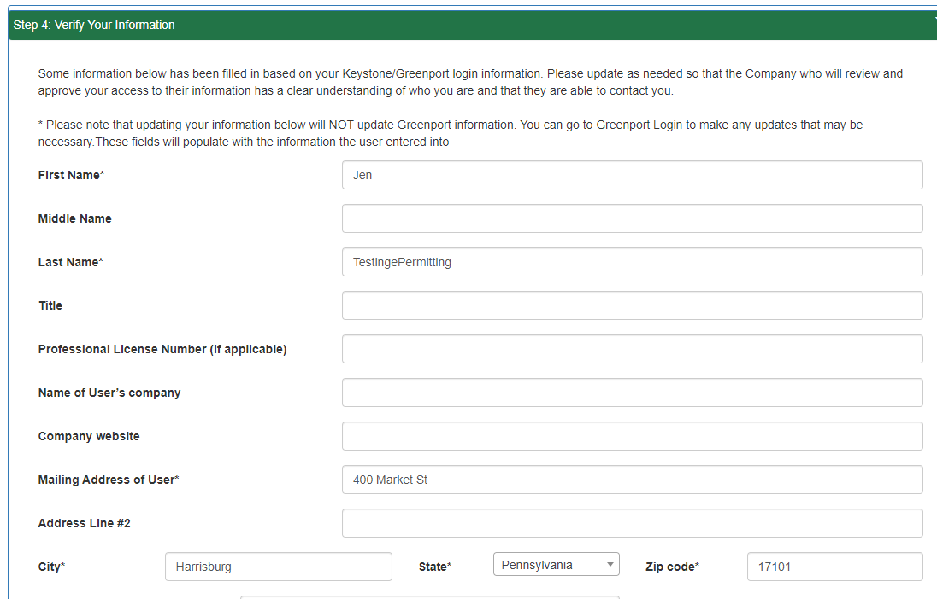

## **Step 5: Review Security Agreement**

Review the Security Agreement to understand the terms and conditions of your access to the Department of Environmental Protection (DEP’s) ePermitting system.

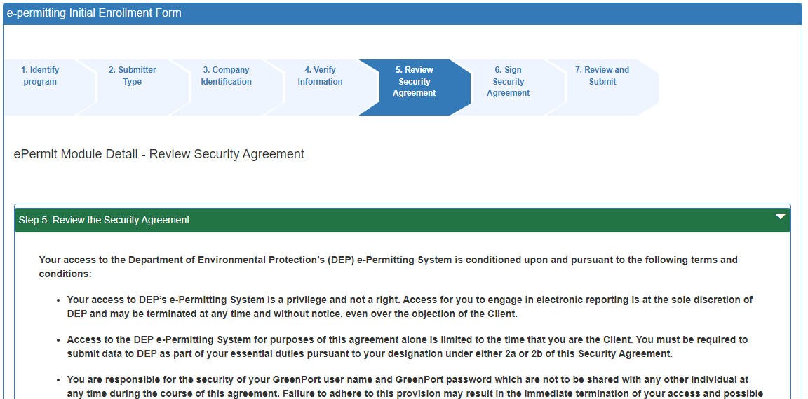

## **Step 6: Sign the Security Agreement**

Sign the Security Agreement. **Be sure to check the block that you agree to the terms of the Security Agreement**. If you agree, check the block, enter your name and date and select Continue.

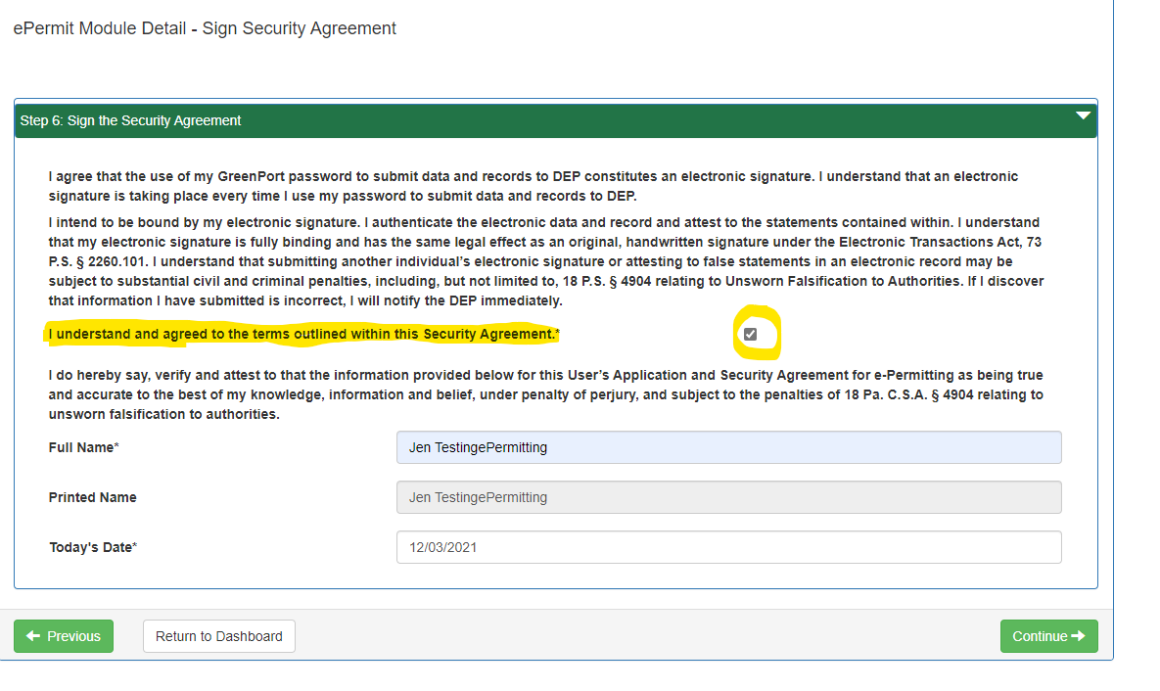

## **Step 7: Review, Submit and Get Started!**

You can review your information by selecting the hyperlink in the window. If your information appears correct, click the Submit button. Your EFA will be notified that you have requested access to the ePermitting Application. You can now start a draft application in ePermitting while awaiting EFA approval.

*NOTE: You may begin a draft application, however your application will not be able to be submitted as final or reviewed by others until your EFA has granted you the necessary access.*

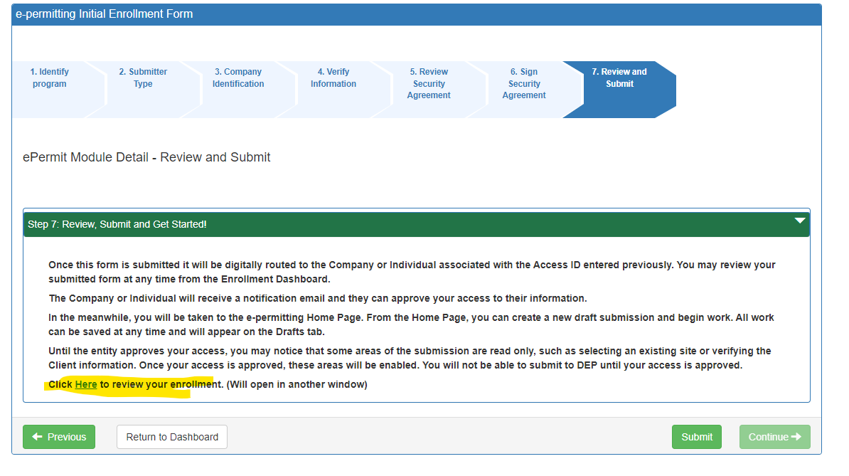

# **Starting a Permit in ePermitting**

After submitting your enrollment request, you should be re-directed to the ePermitting dashboard. If you are not automatically directed to the ePermitting Home Page, select the  button in the top left of screen.

In the ePermitting Home Page you now should see the program icon for which you requested access for. Click on the program icon to begin a new permit application in ePermitting dashboard.

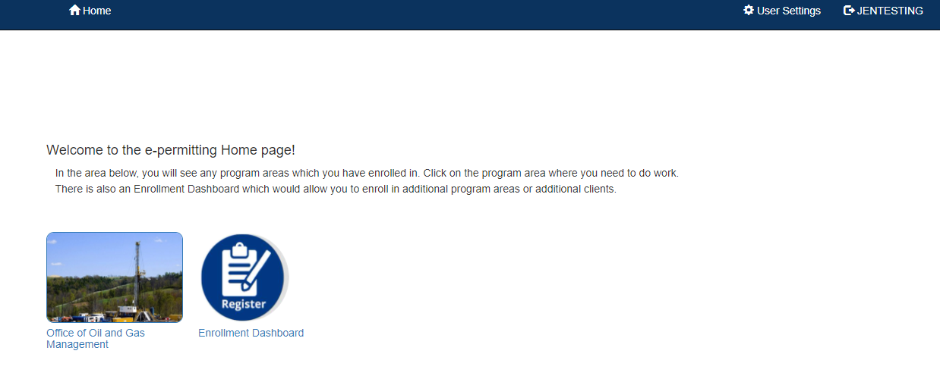

Once your EFA has granted you access you will see the Operator/OGO number in the Access ID window. If the EFA has not granted access yet you can still start a draft application, but you will see a GP_Number in the Access ID window instead of the OGO number. If you have multiple enrollments you will see them in the drop down in the Access ID window. Select the Access ID you wish to begin an application for.

To begin, select the  button to select the type of permit you wish to start working on

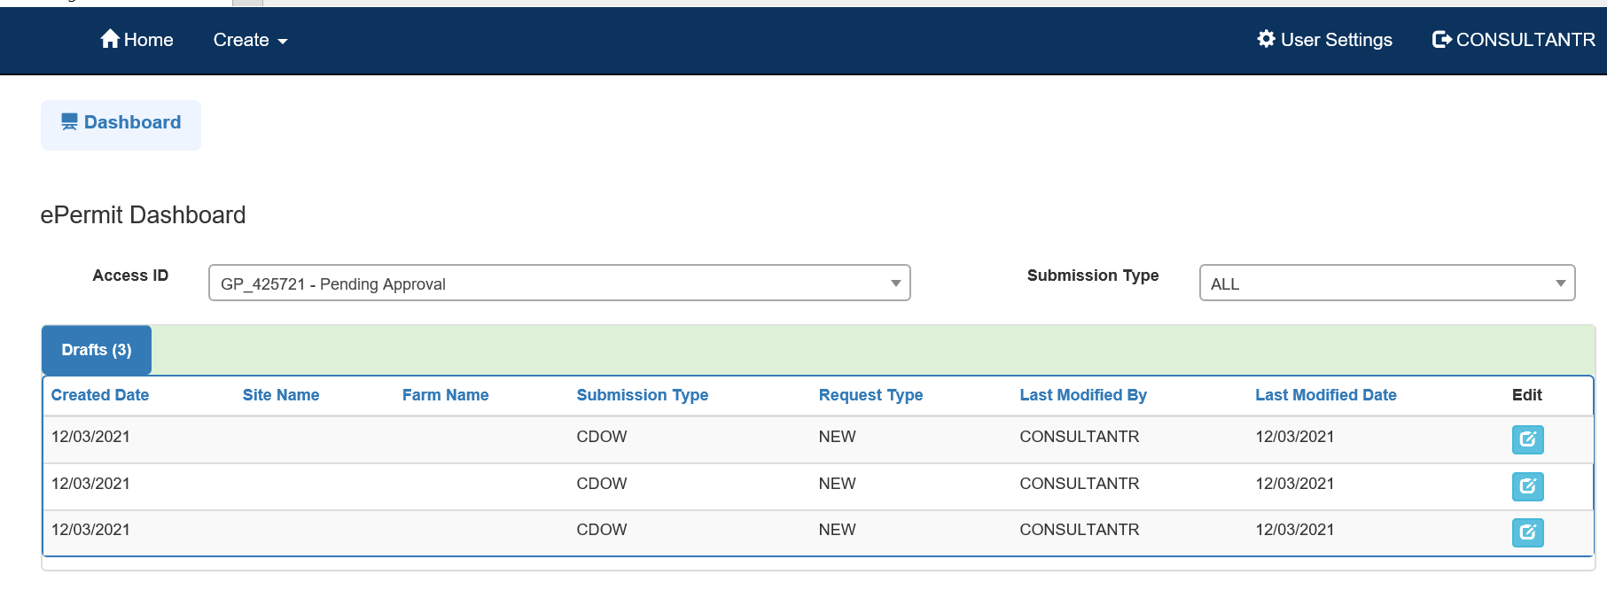

If you have any questions or issues with the GreenPort Registration or accessing the ePermitting application, please contact the Office of Oil and Gas Planning and Program Management.

# **Change History**

|  |  |  |
| --- | --- | --- |
| **Version** | **Date** | **Revision Description** |
| 1.0 | December 3, 2021 | Creation of User Enrollment Guide |