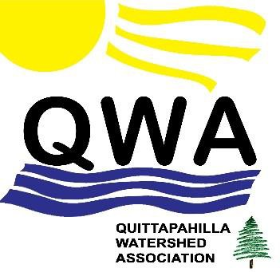

Mr. Joseph J. Buczynski, PE

Waterways & Wetlands Program Manager Department of Environmental Protection Northeast Regional Office

2 Public Square

Wilkes-Barre, PA 18701

Re: DEP’s Chap. 105 Water Obstruction & Encroachment Permit for

Williams/Transco Atlantic Sunrise Pipeline – FERC Docket No. CP15-138

Date: 31 July 2016

Dear Mr. Buczynski,

The Quittapahilla Watershed Association harbors grave and serious misgivings and concerns

regarding the proposed stream and wetlands crossings of the proposed Atlantic Sunrise pipeline project. The Federal Energy Regulatory Commission’s Draft Environmental Impact Statement on this project is inadequate and incomplete, as both the federal EPA and Department of the Interior have recently emphasized. This is the case not only for Quittapahilla Creek but for the other proposed 326 stream and river crossings and 251 wetlands crossings of the proposed pipeline project.

Our grave misgivings prompt us to urge the DEP to reject the Chapter 105 permit application

submitted by Williams/Transco.

According to the proposed plan submitted by Williams/Transco, most all of the waterway and

wetlands crossings will utilize an open-trench, dam-and-pump, or a flume method. In our view, this constitutes building the pipeline “on the cheap,” using the least expensive but most environmentally deleterious method available. The resulting erosion from the construction process, and the permanent loss of riparian buffers along most of these 327 rivers and streams, would have a substantially negative impact on the water quality of not only these hundreds of Pennsylvania waterways, but on the Susquehanna River and ultimately on the Chesapeake Bay.

To cite the case we know best: since the year 2000, the DEP’s Growing Greener grants have

allocated well over $1 million to restoring the channel, banks, and tributaries of Quittapahilla Creek, effectively reducing erosion and improving the aquatic habitat on this highly impaired waterway. Williams/Transco’s proposed crossing of Quittie Creek is just downstream of the restored areas. If DEP were to approve Williams/Transco’s application, it would be working directly against a series of successful and expensive efforts to improve this impaired creek’s water quality.

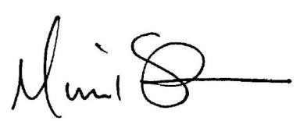

At minimum, we urge the DEP to require Williams/Transco to utilize the boring method

underneath Pennsylvania waterways and wetlands, including Quittie Creek, which would be more expensive for the company but have far fewer negative environmental consequences.

We urge you to adhere to your mission – to protect the environment in the Commonwealth of

Pennsylvania – and to adhere to Article 1, Section 27 of the Pennsylvania Constitution: *“The people have a right to clean air, pure water, and to the preservation of the natural, scenic, historic, and esthetic values of the environment. . . As trustee of these resources, the Commonwealth shall conserve and maintain them for the benefit of all the people.”*

For all these reasons and more, we urge you to reject Transco/Williams’ Chapter 105

application.

Sincerely,

Michael Schroeder

David Lasky

Michael Schroeder and David Lasky, Co-Presidents

Quittapahilla Watershed Association 8 East High Street

Annville PA 17003

[www.quittapahillawatershedassociation.org](http://www.quittapahillawatershedassociation.org/)