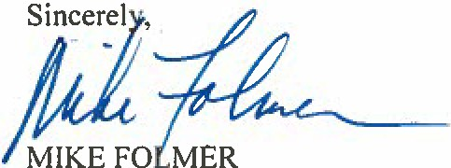

MIKE FOLMER

COMMITTEES

SENATE PO _..OX 203048 THE STATE CAPITOL

HARRISBURG, PA 17120•3048 717·787·5708 FAX:717•787·34!15

EDUCATION, CHAIR LABOR a INDUSTRY, VICE CHAIR

COMMUNICATIONS a TECHNOLOGY

INTER·GOVERNIIIENTAL OPERATIONS RULES a EXECUTIVE NOMINATIONS

STATE GOVERNMENT UR.,.AN AFFAIRS a HOUSING

101 MUNICIPAL BUILDING

400 SOUTH 8TH STREET LEBANON, PA 17042

717·274·11735

FAX: 717•274·7702

TOLL FREE: I •877·222·I 897

SENATE POLICY COIIIIIIITTEE

E·IIIAIL: mfolmerOpasen.gov

we:" siTE: senatorfolmer.com

cnatc of Pcnnsyluania

48TH SENATORIAL DISTRICT

May 26, 2016

Scott Williamson

Waterways and Wetlands Program

PA Department of Environmental Protection Southcentral Regional Office

909 Elmerton Avenue

Harrisburg, PA 17110

Dear Mr. Williamson:

Many of my Lebanon County constituents have valid concerns regarding the proposed Atlantic

Sunrise Pipeline Project. You are in the process of reviewing an Application for a Water Obstruction and Encroachment Permit (No. E38-195).

I would like to request a public hearing in Lebanon County on the permit so these constituents

can have their comments and questions on record. Realizing the public comment period ends on May 31, please consider an extension of time for comments in order to hold this hearing.

This is one of several pipeline projects to go through Lebanon County. Giving people adequate

time to review and question these projects is the responsible thing to do.

Thank you for the important work you do every day. I look forward to your prompt response.

MJF/mtt