417 Walnut Street
Harrisburg, PA 17101
717 255-3252 / 800 225-7224
FAX 717 255-3298
www.pachamber.org

Mr. Joseph Buczynski, P.E. June 26, 2017
Environmental Program Manager
Waterways and Wetlands Program
Department of Environmental Protection
Northeast Regional Office
2 Public Square
Wilkes-Barre, PA 18701

Mr. David Garg, P.E.
Environmental Program Manager
Waterways and Wetlands Program
Department of Environmental Protection
North-central Regional Office
208 West Third Street, Suite 101
Williamsport, PA 17701

RE: Transcontinental Gas Pipe Line Company, LLC’s Chapter 105 Water Obstruction and Encroachment Permit Applications and Chapter 102 Erosion and Sediment Control General Permit for Earth Disturbance Associated with Oil and Gas Exploration, Production, Processing or Treatment Operations or Transmission Facilities (ESCGP-2) for the Atlantic Sunrise Project

On behalf of the Pennsylvania Chamber of Business and Industry (PA Chamber), the largest, broad-based business advocacy group in the Commonwealth, I am writing in support the Transcontinental Gas Pipe Line Company LLC’s Chapter 105 Water Obstruction and Encroachment permit applications and Chapter 102 Erosion and Sediment Control General Permit for Earth Disturbance Associated with Oil and Gas Exploration, Production, Processing or Treatment Operations or Transmission Facilities (ESCGP-2) Notice of Intent, as published in the Pennsylvania Bulletin on May 27, 2017 (47 Pa.B. 2982), for the Atlantic Sunrise Project. These comments supplement my oral remarks at the Department’s June 12 hearing in Lancaster on the same matter.

The PA Chamber thanks the Department for their thorough, thoughtful and extensive review of this project and urges a final determination, granting these permits and authorizing construction for this important project, be made as quickly as possible.

Pennsylvania’s Chapter 105 regulations (relating to waterways and wetlands encroachments) note in particular that an application will be approved provided the Department finds “that the public benefits of the proposed project outweigh the harm to the environment and public natural resources.” These benefits may include protection of public health and safety, development of energy resources, creation or preservation of significant employment, provision of public utility services, and other essential social and economic development which benefits a substantial portion of the public (§ 105.16(b)).

With respect to any impacts to the environment, as they relate to waterways and wetlands, the PA Chamber supports and agrees with the findings of the Federal Energy Regulatory Commission in its final Environmental Impact Statement. FERC’s FEIS notes that:

- “No long-term impacts on groundwater are anticipated form construction and operation of the Project because disturbance would be temporary, erosion controls would be implemented, natural ground contours would be restored, and the right-of-way would be revegetated. Implementation of Transco’s ECP and Spill Plan, as well as [FERC’s recommendations] would limit impacts from construction on groundwater resources.” (4-52)

- “No long-term effects on surface waters are anticipated as a result of construction and operation of the Project. No designated water uses would be permanently affected because the pipeline would be buried beneath the bed of the water bodies, erosion controls would be implemented during construction, and streambanks and streambed contours would be restored as close as possible to preconstruction condition. Operation of the Project would not result in any surface water effects[.]” (4-72)

- “While minor adverse and long-term effects on wetlands would occur, with adherence to Transco’s ECP and Procedures, we conclude that construction and operation of the Project would result in minor effects on wetlands that would be appropriately mitigated and reduced to less than significant levels. In addition, impacts on wetlands, including exceptional value wetlands, would be further mitigated through Transco’s implementation of an agency-approved PRM Plan.” (4-78)

Transco’s application materials to DEP further delineate and describe the extent to which the project’s construction will satisfy relevant regulatory criteria, such as properly avoiding, minimizing and mitigating wetlands impacts, minimizing earth disturbance, preventing stormwater runoff, complying with the state’s anti-degradation requirements and avoiding, minimizing and mitigating impacts to wildlife, including migratory birds. The applications also note the company will employ full-time environmental inspectors during construction to oversee and ensure these BMPs comply with Pennsylvania’s regulations and permit conditions. The applications also note that, in addition to adjustments to in-field routing, Transco has taken great strides to appropriately avoid and minimize wetlands impacts, with no net loss of wetland acreage occurring. Wetlands in the rights-of-way will be preserved, and new wetlands outside of the rights-of-way will be created, restored and enhanced, appropriately mitigating against any deleterious cumulative impact. With respect to threatened and endangered species, it is our understanding the U.S. Fish and Wildlife Service concurred with Transco that the project will not adversely affect bald eagles and will sufficiently avoid and minimize impacts to the bog turtle.

In regard to the social and economic benefits as they relate to Chapter 105.16(b), beyond the FERC Certificate of Public Convenience that found this project to be in the public interest, the PA Chamber submits for the record the economic analysis conducted by researchers at Penn State University in 2015, attached as an electronic submission to this comment letter. The economic analysis notes that additional utility cost savings for consumers, economic growth and environmental progress will be secured with the Atlantic Sunrise Project. The Atlantic Sunrise Project is expected to support 2,300 jobs, with an additional 3,700 induced jobs and $1.6 billion in economic activity, in the ten Pennsylvania county area for the project. Had Atlantic Sunrise been in place during the winters of 2012, 2013 and 2014, the economic analysis notes that Mid-Atlantic consumers would have saved $2.6 billion in utility costs. These benefits are substantial, and fall within the relevant categories of public benefits that § 105.16(b) authorizes the Department to consider in balance to any environmental impact. The PA Chamber urges that the Department find these benefits to outweigh any impacts – impacts which FERC has noted to be in large part minor, temporary and appropriately mitigated.

Given the significant economic and public health benefits that will be realized with the construction and operation of this project, which will be managed using appropriate environmental measures and in compliance with relevant state and federal requirements, I urge you to grant final approval of these Chapter 102 and 105 permits for this project.

Sincerely,
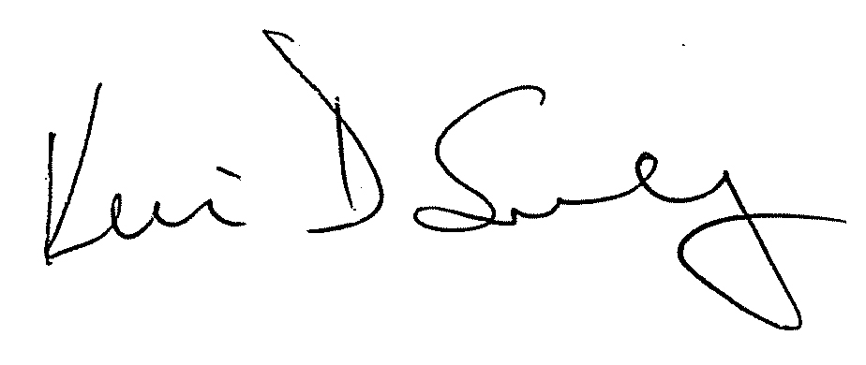
Kevin Sunday
Director, Government Affairs
Pennsylvania Chamber of Business and Industry

Final Environmental Impact Statement, Volume 1: Atlantic Sunrise Project Docket CP15-138-000. Federal Energy Regulatory Commission, December 2016. https://www.ferc.gov/industries/gas/enviro/eis/2016/12-30-16-FEIS/volume-I-part-1.pdf
Economic Impacts of the Atlantic Sunrise Project. Pennsylvania State University, Jan. 9, 2015. http://atlanticsunriseexpansion.com/wp-content/uploads/2015/03/AtlanticSunrise_EconomicImpactStudy.pdf

