CHAPTER 105 FEE(S) CALCULATION WORKSHEET
Additional information can be found at 25 PA Code §105.13 (relating to regulated activities – information and fees),
the General Permit Registration (3150-PM-BWEW0500), the Joint Permit Application (3150-PM-BWEW0036)
and the Dam Permit Application (3140-PM-BWEW0001)
Federal, State, county or municipal agencies or municipal authorities: EXEMPT from fees
These entities are exempt from these fees. If the applicant falls into one of these categories, please check the box above and provide only the first page of this worksheet with the project application or registration.
ALL OTHERS:
- Please place an “X” in the box next to all authorizations that apply to the project and complete the fee information below those authorization(s). Projects may require multiple authorizations and fees, further clarification and examples are included below and at the end of this document.
- Total each authorization, Section, and Part. Part One is for Water Obstructions and Encroachment authorizations, Part Two is for Dam Safety authorizations.
- Please provide this completed worksheet (page 1 and page 2 and/or page 3, as is appropriate to the project) and a check for the applicable fee(s) with the project application or registration. The check should be made payable to the “Commonwealth of Pennsylvania Clean Water Fund” OR “Dauphin County Conservation District Clean Water Fund”, whichever is the reviewing entity.
NOTES:
Per 25 PA Code §105.13(c)(2)(iii) Disturbance review fees are calculated by individually adding all of the permanent and temporary impacts to waterways, floodways, floodplains and bodies of water including wetlands to the next highest tenth acre and multiplying the permanent and temporary impacts by the respective fees and then these amounts are added to the other applicable fees.
Entities proposing structures or activities to occupy a Submerged Lands of the Commonwealth must obtain a Submerged Lands License Agreement (SLLA) and pay the appropriate annual charge. The applicant will be contacted if this charge applies to the project.
Floodway – The channel of the watercourse and portions of the adjoining floodplains which are reasonably required to carry and discharge the 100-year frequency flood. Unless otherwise specified, the boundary of the floodway is as indicated on maps and flood insurance studies provided by FEMA. In an area where no FEMA maps or studies have defined the boundary of the 100-year frequency floodway, it is assumed, absent evidence to the contrary, that the floodway extends from the stream to 50 feet from the top of the bank of the stream.
Wetland and Stream Clarification:
Wetlands
Streams
Floodplains
One Resource Crossing
Two Resource Crossings
¹ In many instances, wetlands are located within the floodplain of a stream. These resources for the purposes of calculating disturbance fees are considered co-located or overlapping and the area of disturbance would only be used once.
² In the case of GP-5, GP-7 and GP-8 fees are charged per structure per resource crossing and the following also applies to the disturbance fees:
  - A crossing of the stream and the floodplain with wetlands present within the floodplain is considered one resource crossing.
  - When the crossing traverses a stream and the floodplain and a wetland that is located outside of the floodplain or a wetland that extends out beyond the floodplain, it is considered two resource crossings.

PART ONE: WATER OBSTRUCTIONS AND ENCROACHMENTS
SECTION A. APPLICATION FEES
WATER OBSTRUCTION AND ENCROACHMENT PERMIT (Joint Permit Application)
Some activities or structures within a project may also qualify for an accumulation of General Permit fees, please mark the box above indicating an Individual Water Obstruction and Encroachment Permit AND the corresponding fee(s) in the General Permit section below those. Activities or structures not qualifying for a General Permit fee must include a disturbance fee.
Administrative Filing Fee¹ | $ 1,750 +
Temporary Disturbance ($400/0.1ac) 6.6 acres x $4,000 = | $ 26,400 +
Permanent Disturbance ($800/0.1ac) 8.1 acres x $8,000 = | $ 64,800 = $ 92,950
WO&E FEE subtotal (a) $ 92,950
GENERAL PERMIT(S) (select activity/structure(s) below, see page 4 for “#” explanation)
Some activities or structures within a project requiring an Individual Water Obstruction and Encroachment Permit may qualify for an accumulation of General Permit fees, please mark the corresponding fee(s) below but not the box above indicating a General Permit.
GP-1 Fish Habitat Enhancement Structures | $ 50 = $
GP-2 Small Docks and Boat Launching Ramps (#) x | $ 175 = $
GP-3 Bank Rehabilitation, Bank Protection and  Gravel Bar Removal (#) x | $ 250 = $
GP-4 Intake and Outfall Structures (#) x | $ 200 = $
GP-5 Utility Line Stream Crossings² (#) x (#) x | $ 250 = $
GP-6 Agricultural Crossings and Ramps (#) x | $ 50 = $
GP-7 Minor Road Crossings² (#) x | $ 350 = $
GP-8 Temporary Road Crossings² (#) x | $ 175 = $
GP-9 Agricultural Activities | $ 50 = $
GP-10 Abandoned Mine Reclamation | $ 500 = $
GP-11 Maintenance, Testing, Repair, Rehabilitation, or  Replacement of Water Obstructions and Encroachments¹ | $ 750 +
Temporary Disturbance ($400/0.1ac) . acres x $4,000 = | $ +
Permanent Disturbance ($800/0.1ac) . acres x $8,000 = | $ = $
GP-15 Private Residential Construction in Wetlands¹ | $ 750 +
Temporary Disturbance ($400/0.1ac) . acres x $4,000 = | $ +
Permanent Disturbance ($800/0.1ac) . acres x $8,000 = | $ = $
GP(s) FEE subtotal (b) $
PART ONE: SECTION A. APPLICATION FEE(S) subtotal (a+b=c) $ 92,950
SECTION B. OTHER FEES
Environmental Assessment for Waived Activities (§105.13(c)(2)(iv)) | $ 500 $
Amendment to Water Obstruction and Encroachment Permit
Major Amendment¹ | $ 500 +
Temporary Disturbance . acres x $4,000 = | $ + $
Permanent Disturbance . acres x $8,000 = | $ = $
Minor Amendment | $ 250 $
Transfer of Water Obstruction and Encroachment Permit
WITH Submerged Lands License Agreement | $ 200 $
WITHOUT Submerged Lands License Agreement | $ 100 $
PART ONE: SECTION B. OTHER FEE(S) subtotal (d) $
PART ONE: FEE(S) TOTAL (c+d=e) $ 92,950

DEP USE ONLY
FEE TOTAL: |  | Permit / Authorization Number (s):
Correct Amount: |  | Check #:
Check Amount: |  | Payable to:

PART TWO: DAM SAFETY (USE ONE FEE SHEET PER DAM)
SECTION A. APPLICATION FEES
DAM PERMIT APPLICATION – NEW DAM
Size A Hazard 1 $26,500 Hazard 2 $26,500 Hazard 3 $25,500 Hazard 4 $23,500 $
Size B Hazard 1 $19,000 Hazard 2 $19,000 Hazard 3 $18,500 Hazard 4 $17,000 $
Size C Hazard 1 $10,500 Hazard 2 $10,500 Hazard 3 $10,000 Hazard 4 $ 8,000 $
STAGED CONSTRUCTION
NO. OF STAGES BEYOND INITIAL STAGE X APPLICATION FEE X 0.90 (90%) $
DAM PERMIT APPLICATION – MODIFICATION OF DAM
Size A Hazard 1 $18,500 Hazard 2 $18,500 Hazard 3 $18,500 Hazard 4 $18,000 $
Size B Hazard 1 $12,000 Hazard 2 $12,000 Hazard 3 $12,000 Hazard 4 $11,500 $
Size C Hazard 1 $ 7,500 Hazard 2 $ 7,500 Hazard 3 $ 7,500 Hazard 4 $ 7,500 $
STAGED CONSTRUCTION
NO. OF STAGES BEYOND INITIAL STAGE X APPLICATION FEE X 0.85 (85%) $
DAM PERMIT APPLICATION – OPERATION & MAINTANANCE OF EXISTING DAM
Size A Hazard 1 $12,500 Hazard 2 $12,500 Hazard 3 $12,000 Hazard 4 $10,000 $
Size B Hazard 1 $10,000 Hazard 2 $10,000 Hazard 3 $ 9,500 Hazard 4 $ 8,500 $
Size C Hazard 1 $ 7,000 Hazard 2 $ 7,000 Hazard 3 $ 6,500 Hazard 4 $ 6,000 $
PART TWO: SECTION A. APPLICATION FEE(S) subtotal (a) $
SECTION B. OTHER FEES
Letter of Amendment or Authorization
Major (≥$250,000)
Size A $14,700 |  | Size B $ 8,700 |  | Size C $ 4,400 $
Minor (<$250,000)
Size A $ 1,300 |  | Size B $ 1,000 |  | Size C $ 650 $
Major Dam Design Revision
Size A $ 4,700 |  | Size B $ 3,200 |  | Size C $ 1,700 $
Environmental Assessment
Environmental Assessment for Dam Removal (§105.12(a)(16)) |  |  |  | $ 500 $
Non-Jurisdictional Dams |  |  |  | $ 900 $
Letter of Amendment or Authorization
Size A $ 1,400 |  | Size B $ 1,000 |  | Size C $ 900 $
Transfer of Dam Permit
No Proof of Financial Responsibility $ 550 |  |  | Proof of Financial Responsibility $300 $
Annual Registration
Hazard 1 $ 1,500 | Hazard 2 $ 1,500 |  |  | Hazard 3 $ 800 $
PART TWO: SECTION B. OTHER FEE(S) subtotal (b) $
PART TWO: FEE(S) TOTAL (a+b=c) $

DEP USE ONLY
FEE TOTAL: |  | Permit / Authorization Number (s):
Correct Amount: |  | Check #:
Check amount: |  | Payable to:

GP Fee Explanation (#):
GP # | Description | Fee | Fee Explanation (#)
GP-1 | Fish Habitat Enhancement Structures | $ 50 | Fee is assessed per project not per individual structure.
GP-2 | Small Docks and Boat Launching Ramps | $175 | Fee is assessed per individual dock or boat ramp. The fee is the number of docks and ramps totaled times the fee.
GP-3 | Bank Rehabilitation, Bank Protection and Gravel Bar Removal | $250 | Fee is assessed per project and not individual bank or gravel bar removal locations. Only one single and complete project along a continuous stream reach not exceeding 500 feet measured down centerline of stream. Additional projects or areas must be separately registered and the fee would apply to each registration.
GP-4 | Intake and Outfall Structures | $200 | Fee is assessed per individual intake or outfall structure. The fee is the total number of structures times the fee.
GP-5² | Utility Line Stream Crossings² | $250 | Fee is assessed per individual utility line or conduit crossing (a wetland and stream crossing may be separate crossings even if adjacent). The fee is the total number of utility lines times the number of resource crossings times the fee.
GP-6 | Agricultural Crossings and Ramps | $ 50 | Fee is assessed per individual crossing or ramp structure. The fee is the total number of crossings and ramps times the fee.
GP-7² | Minor Road Crossings² | $350 | Fee is assessed per individual minor road crossing (a wetland and stream crossing may be separate crossings even if adjacent). The fee is the total number of road crossings times the fee.
GP-8² | Temporary Road Crossings² | $175 | Fee is assessed per individual temporary road crossing (a wetland and stream crossing may be separate crossings even if adjacent). The fee is the total number of temporary road crossings times the fee.
GP-9 | Agricultural Activities | $ 50 | Fee is assessed per project not per individual structure or activity. Multiple projects can be registered under a single registration and as such the fee is applied to each project and then totaled.
GP-10 | Abandoned Mine Reclamation | $500 | Fee is assessed per project not per individual activity. Multiple projects can be registered under a single registration and as such the fee is applied to each project and then totaled.
GP-11¹ | Maintenance, Testing, Repair, Rehabilitation, or Replacement of Water Obstructions and Encroachments¹ | $750 | Fee is assessed for each registration package (can include multiple activities or structures) and is added to the permanent and temporary disturbance review fees calculated for each registration package respectively.
GP-15¹ | Private Residential Construction in Wetlands¹ | $750 | Fee is assessed for each registration package (can include multiple activities or structures) and is added to the permanent and temporary disturbance review fees calculated for each registration package respectively.
Water Obstruction and Encroachment Examples:
- GP-7 Minor Road Crossing: Minor road crossing of a stream that qualifies for BDWM GP-07.
GENERAL PERMIT(S) (select activity/structure(s) below)
Some activities or structures within a project requiring an Individual Water Obstruction and Encroachment Permit may qualify for an accumulation of General Permit fees, please mark the corresponding fee(s) below but not the box above indicating a General Permit.
GP-7 Minor Road Crossings 1 (#) x | $ 350 | = $ 350
GP(s) FEE subtotal (b) |  |  | $ 350
2. Joint Permit Application for Individual Water Obstruction Encroachment Permit: The project proposes to construct an access road requiring the placement of fill in 0.27 acres of wetlands as part of a residential subdivision.
Administrative Filing Fee | $ 1,750 | +
Temporary Disturbance ($400/0.1ac) 0.0 acres x $4,000 = | $ 0 | +
Permanent Disturbance ($800/0.1ac) 0.3 acres x $8,000 = | $ 2,400 | = $ 4,150
WO&E FEE subtotal (a) |  |  | $ 4,150

3. Joint Permit Application for Individual Water Obstruction Encroachment Permit: The project proposes to construct an access road and utility line through a wetland and stream. The road will require placement of fill in 0.28 acres of wetlands, placement of a 45 foot long x 36 inch CMP in the stream and placement of fill in the floodway for road approaches to the culvert (east approach 35 feet wide x 4 feet deep x 50 feet long and west approach 35 feet wide x 2 feet deep x 15 feet). The utility line is 30 inch diameter steel pipe carrying petroleum products. The utility line will be open trenched through the wetland with a permanent right of way of 50 feet x 350 feet and an additional construction right of way 25 feet x 350 feet. The utility line will be open trenched traversing through the entire floodway and stream with a permanent right of way totaling 50 feet x 68 feet (east floodway 50 feet x 50 feet, stream 50 feet x 3 feet and west floodway 50 feet x 15 feet) and an additional construction right of way 25 feet x 68 feet.
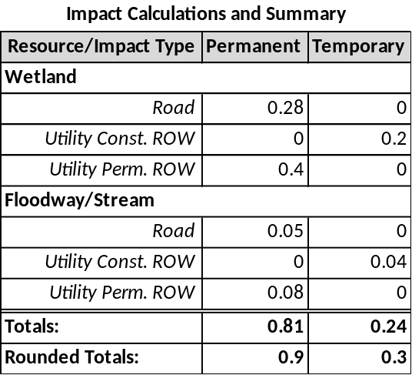
25 foot construction ROW
50 foot ROW and utility line
35 foot wide road

Administrative Filing Fee | $ 1,750 | +
Temporary Disturbance ($400/0.1ac) 0.3 acres x $4,000 = | $ 1,200 | +
Permanent Disturbance ($800/0.1ac) 0.9 acres x $8,000 = | $ 7,200 | = $10,150
WO&E FEE subtotal (a) |  |  | $10,150

4. Joint Permit Application for Individual Water Obstruction Encroachment Permit: The project proposes to construct a building, two minor road crossings that qualify for BDWM GP-07 and place three separate utility lines through a wetland and a separate stream that qualify for BDWM GP-05. The building will require placement of fill in 0.17 acres of wetlands.
Administrative Filing Fee | $ 1,750 | +
Temporary Disturbance ($400/0.1ac) 0.0 acres x $4,000 = | $ 0 | +
Permanent Disturbance ($800/0.1ac) 0.2 acres x $8,000 = | $ 1,600 | = $ 3,350
WO&E FEE subtotal (a) |  |  | $ 3,350
GENERAL PERMIT(S) (select activity/structure(s) below)
Some activities or structures within a project requiring an Individual Water Obstruction and Encroachment Permit may qualify for an accumulation of General Permit fees, please mark the corresponding fee(s) below but not the box above indicating a General Permit.
GP-5 Utility Line Stream Crossings 6 (#) x | $ 250 | = $ 1,500
GP-7 Minor Road Crossings 2 (#) x | $ 350 | = $ 700
GP(s) FEE subtotal (b) |  |  | $ 2,200
PART ONE: SECTION A. APPLICATION FEE(S) subtotal (a+b=c) |  |  | $ 5,550

Dam Safety Examples:
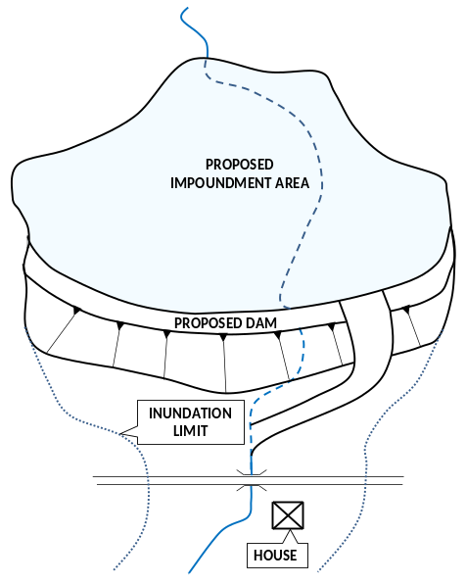
5. New Dam Permit Application: This project proposes to construct a 25-foot high dam that has a maximum storage of 500 acre-feet of water. This dam would be classified as a size category “C” dam per §105.91. There is one home and one roadway within the inundation area downstream of the dam. This dam would have a hazard classification of “2”. All stream and wetland impacts are covered under the Dam Permit Application. An Environmental Assessment is required as part of the Dam Permit Application, but a separate fee is not required.

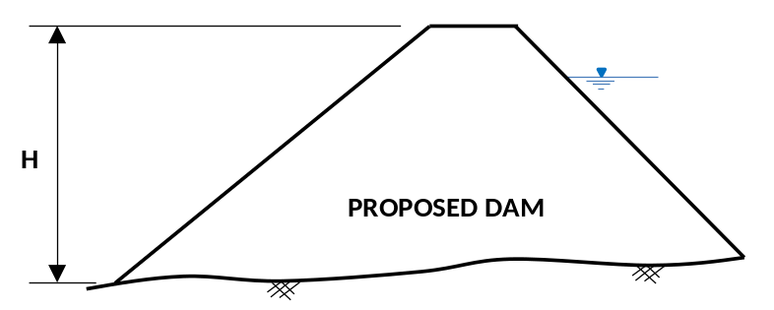

DAM SAFETY APPLICATION FEES
(TO BE FILED WITH DAM SAFETY WITH THE DAM PERMIT APPLICATION)
DAM PERMIT APPLICATION – NEW DAM
Size C Hazard 1 $10,500 Hazard 2 $10,500 Hazard 3 $10,000 Hazard 4 $8,000 | $ 10,500
DAM SAFETY FEE total | $ 10,050

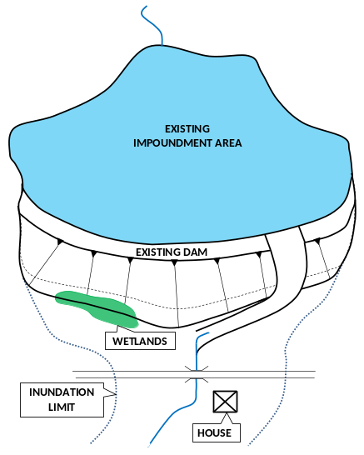
6. Letter of Authorization with Environmental Assessment: This project proposes to modify a 25-foot high dam that has a maximum storage of 500 acre-feet of water. This dam would be classified as a size category “C” dam per §105.91. The proposed modification involves buttressing the downstream slope of the dam with soil to improve the stability. The total project cost will be $100,000. A small wetland area will be impacted near the toe of the buttress. An Environmental Assessment will be required to assess the impacts to the wetland.
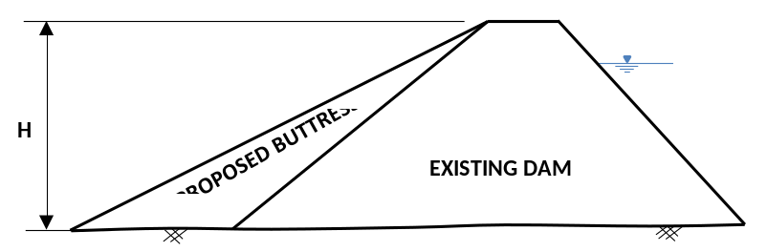

DAM SAFETY FEES
Letter of Amendment or Authorization
Minor (<$250,000)
Size A $ 1,300 | Size B $ 1,000 | Size C $ 650 | $ 650
Environmental Assessment
Letter of Amendment or Authorization
Size A $ 1,400 | Size B $ 1,000 | Size C $ 900 | $ 900
DAM SAFETY FEE total |  |  | $ 1,550

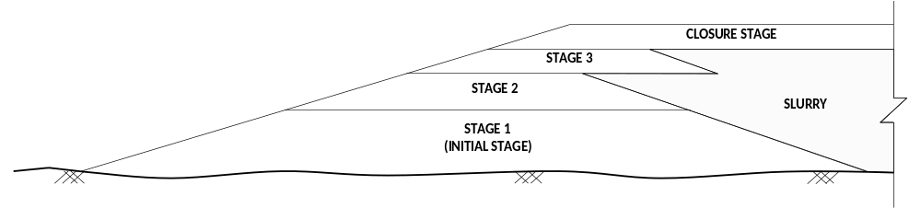
7. New Dam Permit Application with Staged Construction and Disturbance Review Fees: The project proposes to construct a staged construction, high hazard dam, to be utilized for containing a slurry impoundment. There will also be a refuse pile constructed adjacent to the slurry impoundment impacting 1000 linear feet of stream, causing a permanent disturbance to the 3-foot wide stream and 50 feet of floodway on either side of the stream [1000 x (50+3+50)]. A refuse stockpile will also impact 200 linear feet of stream, causing a permanent disturbance to the 3-foot wide stream and 50 feet of floodway on either side of the stream [200 x (50+3+50)]. The Dam Safety Application Fee will include the application fee for the applicable size and hazard classification of the dam. The Dam Safety Application Fee will also include a fee equal to 90% of the original application fee for each stage beyond the initial stage, including any closure stages.

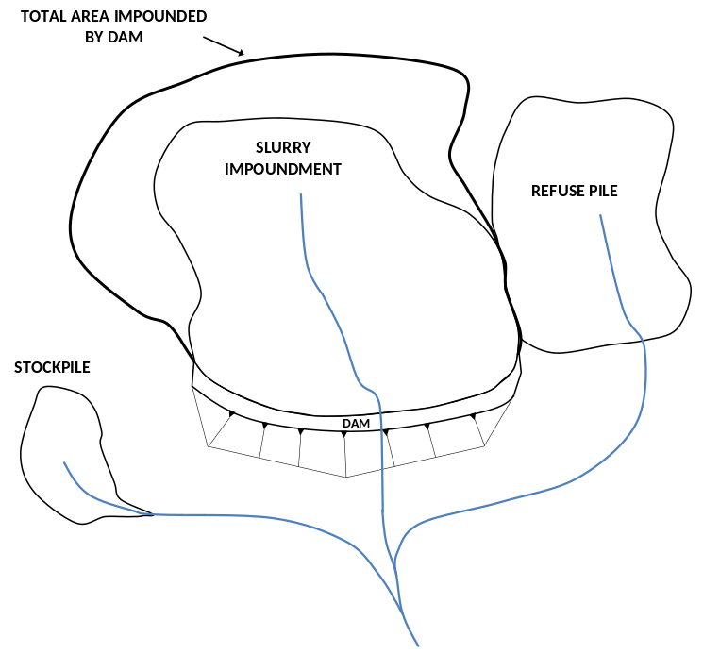

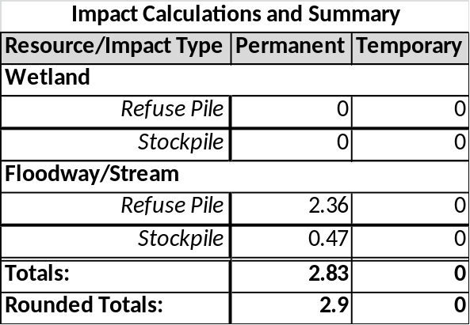

WATER OBSTRUCTION AND ENCROACHMENT FEES
(TO BE FILED WITH DEP REGIONAL OFFICE, COUNTY CONSERVATION OFFICE, OR DISTRICT MINING)
Administrative Filing Fee | $1,750
Temporary Disturbance ($400/0.1ac) 0.0 acres x $4,000 =
Permanent Disturbance ($800/0.1ac) 2.9 acres x $8,000 = | $23,200
WO&E FEE total | $24,950

DAM SAFETY APPLICATION FEES
(TO BE FILED WITH DAM SAFETY WITH THE DAM PERMIT APPLICATION)
DAM PERMIT APPLICATION – NEW DAM
Size A Hazard 1 $26,500 Hazard 2 $26,500 Hazard 3 $25,500 Hazard 4 $23,500 | $ 26,500
STAGED CONSTRUCTION
No. OF STAGES BEYOND INITIAL STAGE 3 X APPLICATION FEE $26,500 X 0.90 (90%) | $ 71,550
DAM SAFETY FEE total | $ 98,050

8. New Dam Permit Application with Staged Construction: The project proposes to construct a staged construction, high hazard dam, to be utilized for containing a slurry impoundment and refuse pile. A refuse stockpile will also impact 200 linear feet of stream, causing a permanent disturbance to the 3-foot wide stream and 50 feet of floodway on either side of the stream [200 x (50+3+50)]. The Dam Safety Application Fee will include the application fee for the applicable size and hazard classification of the dam. The Dam Safety Application Fee will also include a fee equal to 90% of the original application fee for each stage beyond the initial stage, including any closure stages.

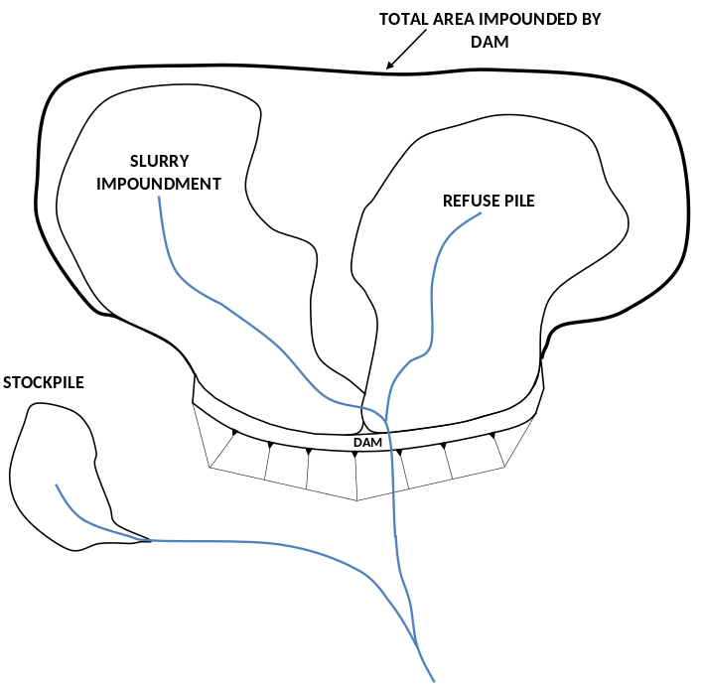

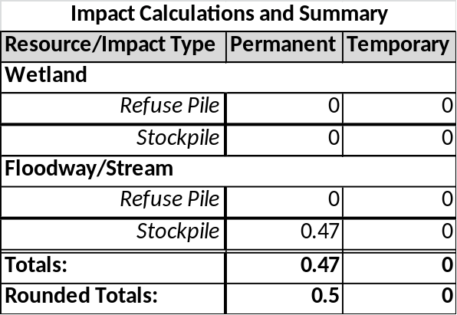

WATER OBSTRUCTION AND ENCROACHMENT FEES
(TO BE FILED WITH DEP REGIONAL OFFICE, COUNTY CONSERVATION OFFICE, OR DISTRICT MINING)
Administrative Filing Fee | $1,750
Temporary Disturbance ($400/0.1ac) 0.0 acres x $4,000 =
Permanent Disturbance ($800/0.1ac) 0.5 acres x $8,000 = | $4,000
WO&E FEE total | $5,750

DAM SAFETY APPLICATION FEES
(TO BE FILED WITH DAM SAFETY WITH THE DAM PERMIT APPLICATION)
DAM PERMIT APPLICATION – NEW DAM
Size A Hazard 1 $26,500 Hazard 2 $26,500 Hazard 3 $25,500 Hazard 4 $23,500 | $ 26,500
STAGED CONSTRUCTION
No. OF STAGES BEYOND INITIAL STAGE 3 X APPLICATION FEE $26,500 X 0.90 (90%) | $ 71,550
DAM SAFETY FEE total | $ 98,050

