ePermitting Electronic Administrator
User's Guide

Prepared by: | Business Support Services
Version: | 1.2
Date: | October 11, 2019

Table of Contents
Disclosure Information 3
Change History 3
Purpose 3
Applications Support Help Desk Team 3
DEPGreenport Self-Registration 4
Creating a DEPGreenport Self-Registration Account 4
Enrolling into the e-permitting Application 7
DEP New Client Registration 9
Client Identification 10
Security Agreement for Owner and EFA 11
Approving / Denying an Enrollment Request 12
Approving an Enrollment Request 12
Denying an Enrollment Request 16
Modifying Access for a User 19
Modifying Security Roles 19
Limiting Access to Modules for a User 22
Modifying Module Restrictions 22
ePermit Dashboard 23
Accessing the ePermit Dashboard 23
Working Through a Draft Permit Application 25
Types of Data Fields 25
Entering Data into Your Draft Application 26
Submitting a Permit Application 27
Verify Facility Information 27
Mass Contact Update 27
Paying a Registration Fee 28
Pay by Telecheck 28
Printing a Certificate 29

Disclosure Information
The information in this document may not be changed without the express written agreement of the Department of Environmental Protection.

Change History
Version | Date | Revision Description
1.0 | February 28, 2018 | Version for user review
1.1 | August 15, 2019 | Updated for formatting, etc.
1.2 | October 11, 2019 | Updated for Instant Access Functionality

Purpose
Welcome to the guide to user administration for the e-permitting website via the DEPGreenPort website.
This guide provides information on how to successfully administer eDMR users on the DEPGreenPort website and use the functions available through the e-permitting Application.

Applications Support Help Desk Team
Help Desk Support Line
Number: (717) 787-HELP (4357)
Hours: Monday to Friday 8:00 am to 4:30 pm
Business Support Help Desk Team
The Applications Support Help Desk Team includes helpdesk specialists, trainers, web masters, on-line help developers, and testing engineers working together to provide complete end-user support for eFACTS and other applications.
Applications Support Help Desk Team's Services
- Applications Training
- Formalized Classroom Training
- Small Group Training
- One-on-One Training
- Participate in meetings to provide application guidance
- Telephone Support Help Desk
- Application Web Page Development and Maintenance
- Publish articles identifying solutions to common problems
- Application Testing
- Documentation Development
- Application On-Line Help Development and Maintenance

DEPGreenport Self-Registration
For most DEP electronic applications users have completed a Request for Security Access form and DEP has provided a username and password to access the DEPGreenPort. However, DEP has some electronic applications that allow users to self-register. If you are sure that the application, you wish to access is on the list of applications which allow users to self-register you may begin the self-registration process.

Creating a DEPGreenport Self-Registration Account
- Go to the https://www.depgreenport.state.pa.us website.
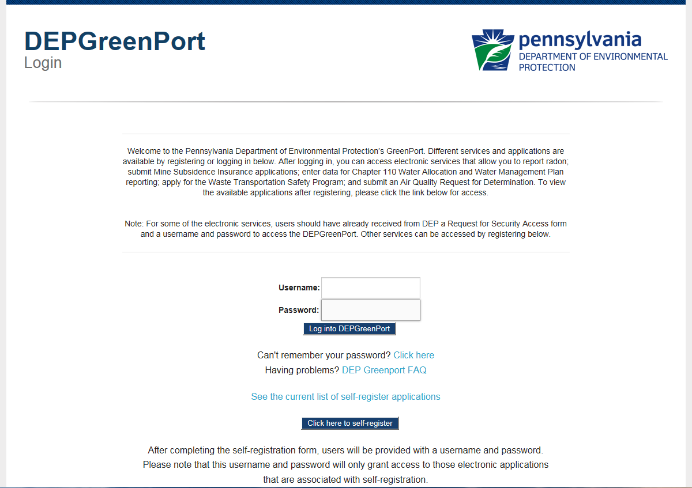
- The DEPGreenPort Login screen will display.

- Select the Click here to Self-Register button.
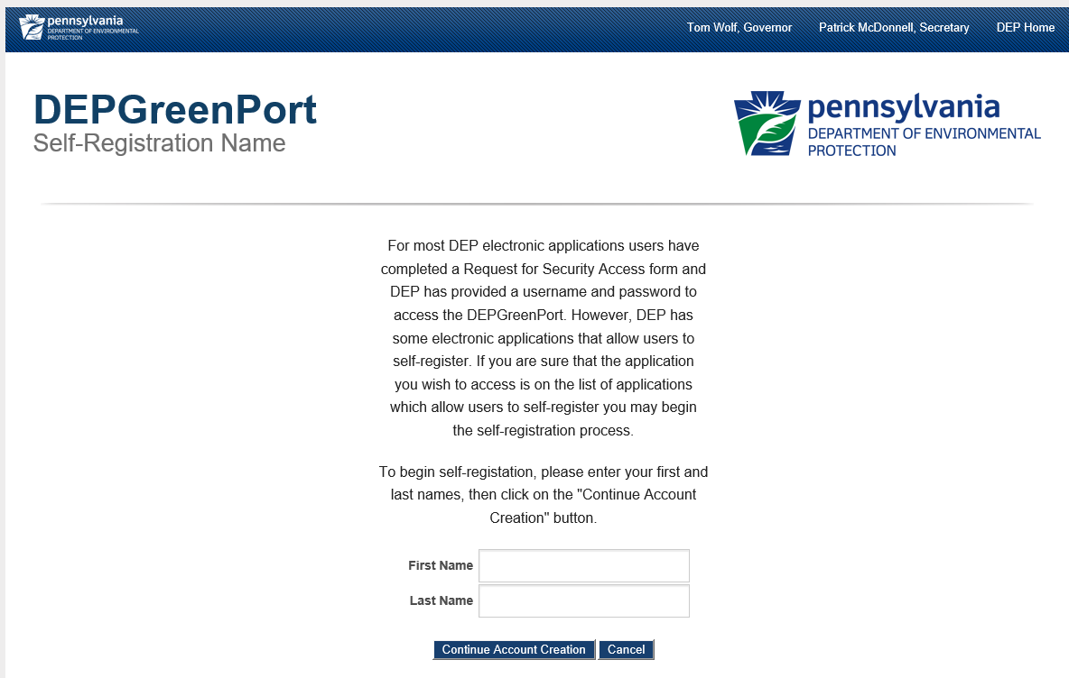
- The DEPGreenPort Self-Registration screen will display.
- Enter your First Name in the First Name field.
- Enter your Last Name in the Last Name field.
- Click on the Continue Account Creation button.
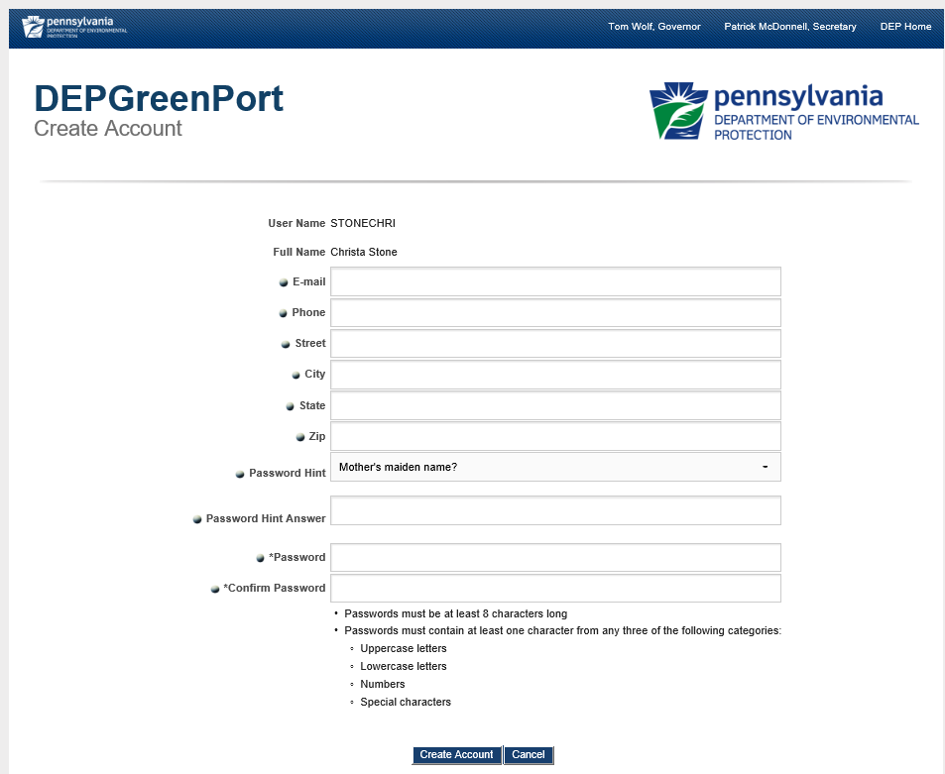
- The DEPGreenPort Create Account screen will display.
- The User Name and Full Name will auto populate based on the information entered in the DEPGreenPort Self-Registration Name screen.
- Enter the following information:
  - e-mail address
  - Telephone Number
  - Street Address
  - City
  - State
  - Zip Code
- Select a Password Hint using the Password Hint drop-down menu.
- Enter a Password Hint Answer into the Password Hint Answer field.
- Enter a Password into the Password field.
  - Passwords must be at least 8 characters long.
  - Passwords must contain at least one character from any three of the following categories:
    - Uppercase Letters
    - Lowercase Letters
    - Numbers
    - Special Characters
- Select the Create Account button. If you select the ‘Cancel’ button, all information will be erased, and you will be directed back to the previous screen.
Once the DEPGreenPort Self-Registration account has been created, an e-mail notification will be sent to the e-mail address entered when setting up the DEPGreenPort Self-Registration account.

Enrolling into the e-permitting Application
After a user is registered, the user must sign into DEPGreenPort to Enroll into the e-permitting Application.
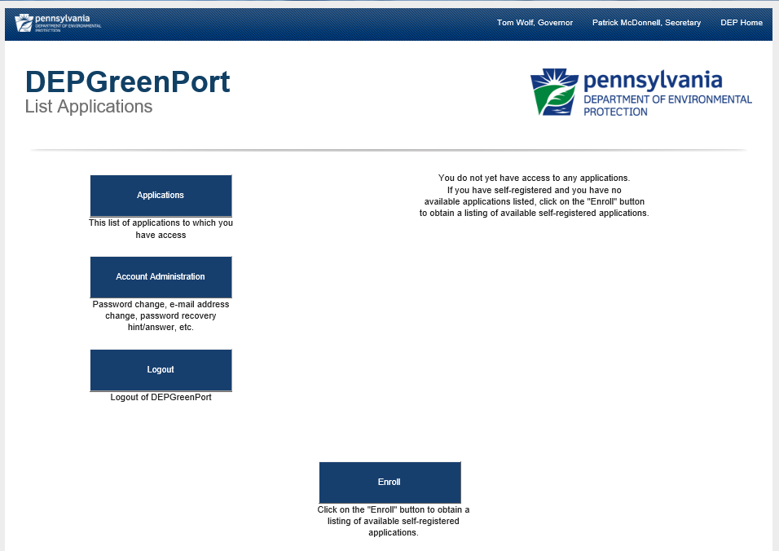
- Select the Enroll button.

- The DEPGreenPort List Applications screen will display.
- Under the Permitting header, select the e-permitting button.
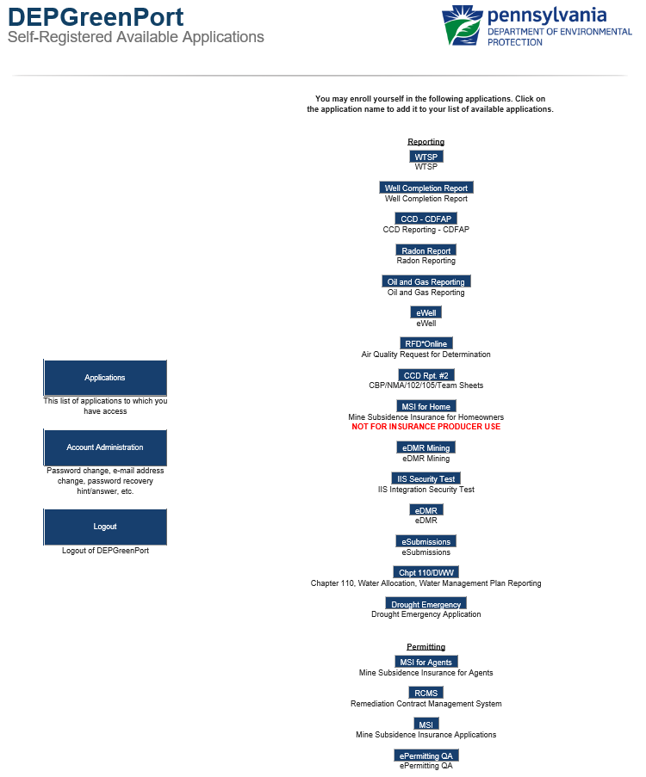
- The user will be taken to the DEPGreenPort Additional Data Required for access to e-permitting screen.

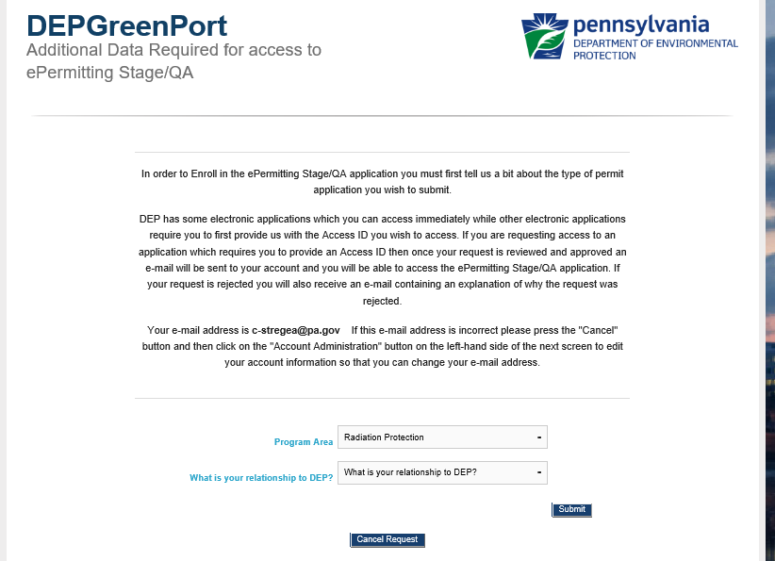
- Select Radiation Protection from the Program Area drop-down list.
- Select one of the following options to act as an EFA:
  - I am representing myself to do business with DEP
  - I am representing my company/entity/organization, and the follow up option of I have the authority to submit work/payments to DEP
  - I am representing someone else, and the follow up option of I am assisting an individual in filling out this form.

Note: If the Applicant is working for someone else, the existing Greenport process will remain, and the company will give access to the consultant.
- Select the Submit button.

DEP New Client Registration
Currently, Radiation Protection functionality will be limited to users making payment on an existing invoice. If there are no existing invoices to be paid at this time, please contact the Bureau of Radiation Protection at 717-787-3720.
Applicants are given the ability to upload documentation as needed.

Client Identification
The user will have the ability to Search for an existing registration number by entering a valid registration number. The user may add additional facility registration numbers, if necessary.
When a registration number is entered incorrectly, a notification message will display indicating verification of the registration number and ask the user to re-enter the number.
Upon entry of a valid registration number, the Client Search Name and Facility address will display. Once the user validates the information that was returned from the system is accurate, the user will select to proceed by selecting the Continue button.
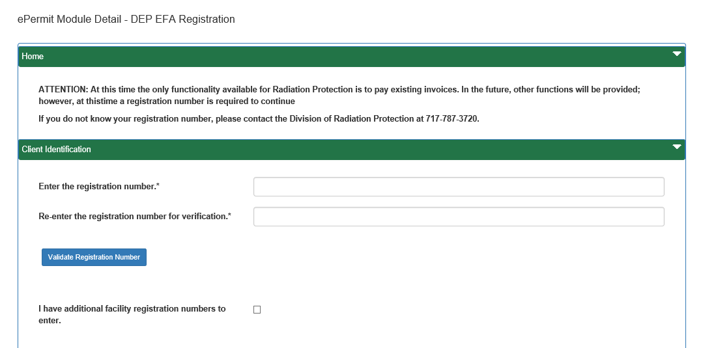

Security Agreement for Owner and EFA
The applicant is required to select the Terms outlined within this Agreement, additional required information will be entered by the applicant as applicable, and the date the agreement was signed prior to the save and submission of this form. The Signature page will only display when an invoice # is provided.

Once the user selects to save and submit the form, the Security Agreement for Owner and EFA will display.
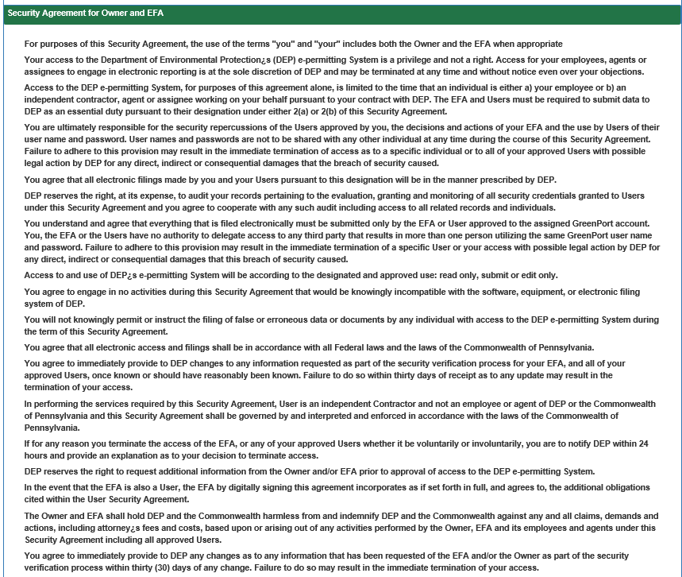
The applicant will have the ability to upload documentation as required.
Once the form has been submitted, an E-mail notification will be sent to the E-mail Address entered when setting up the DEPGreenPort Self-Registration account.
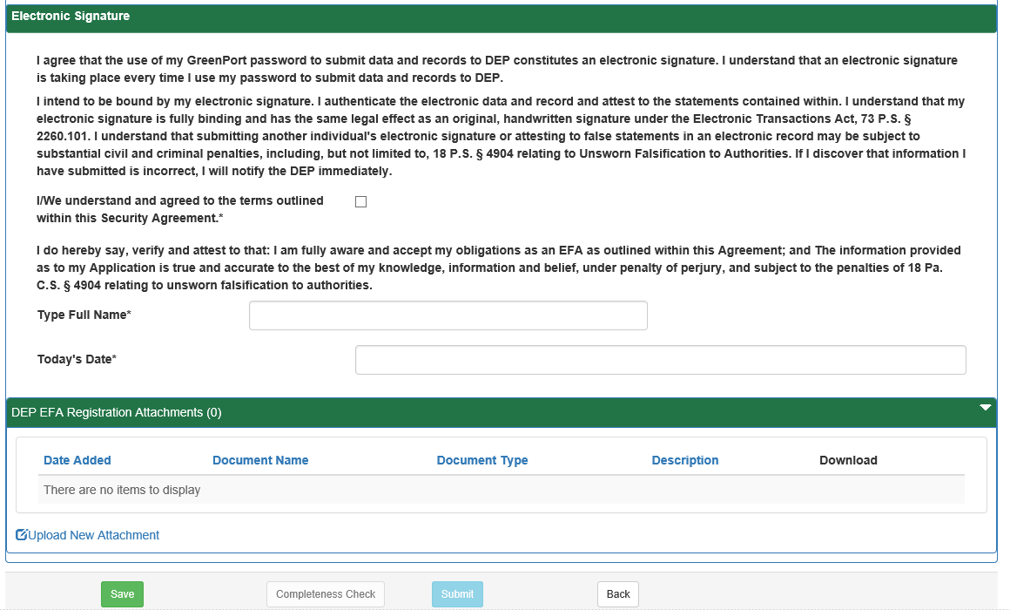
Upon success of the submission, the user will be navigated to their e-permitting dashboard where they can pay pending registrations

Approving / Denying an Enrollment Request
The e-permitting application has been integrated with the DEPGreenPort website to provide a single portal sign-on for users to access. Users have the ability to enroll in the ePermitting application to complete Authorization Applications electronically.
e-permitting Electronic Filing Administrators (EFAs) have the ability to grant access for any user requesting access to prepare, view, or submit authorization requests electronically. EFAs may approve, deny, or revoke access for each user.

Approving an Enrollment Request
- Open Internet Explorer.
- In the URL Address Bar type in https://www.depgreenport.state.pa.us.
- The DEPGreenPort website will display.
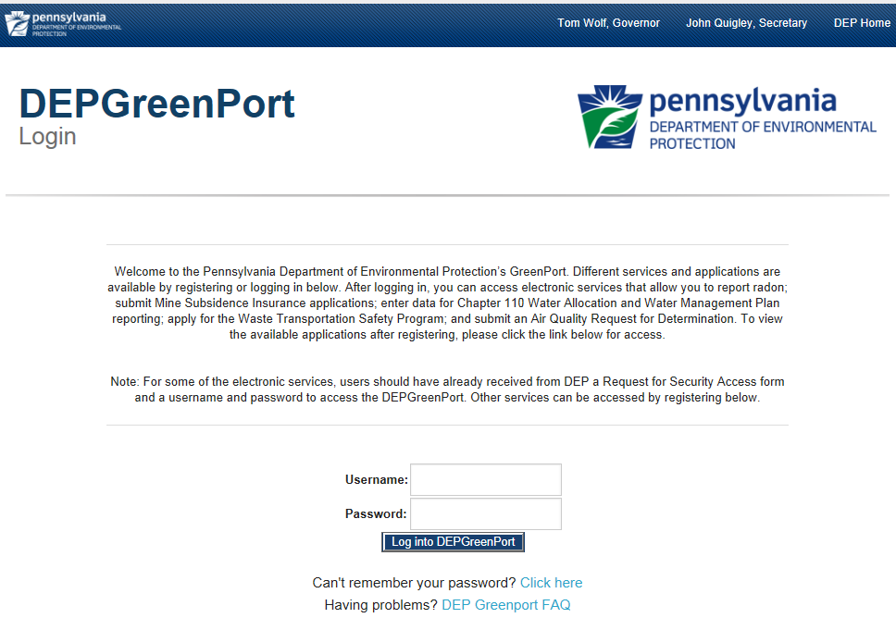
- Enter your username into the Username field.
- Enter your password into the Password field.
- Click the Log into DEPGreenPort button.
- The List Applications Screen will display.
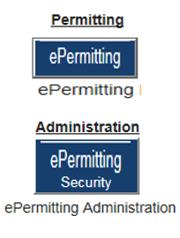
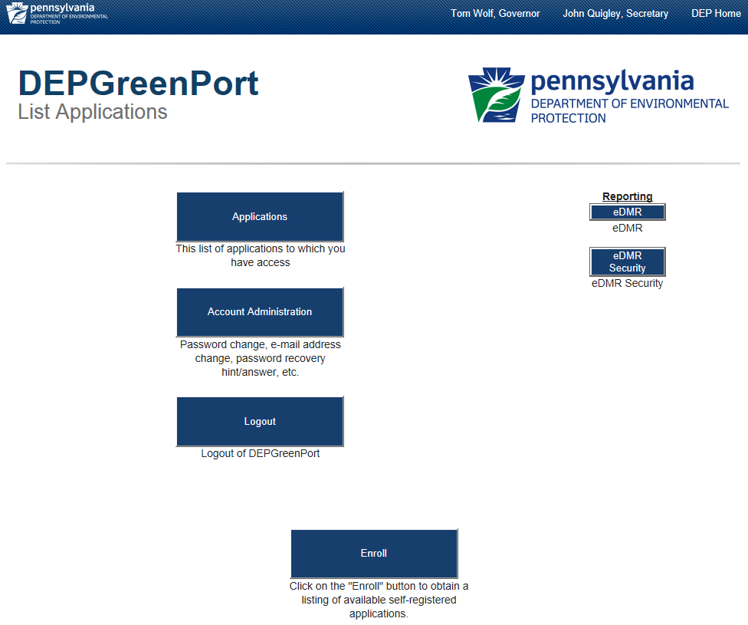
- Click the ePermitting Security button.
- The ePermitting Security Pending User Request webpage will display.
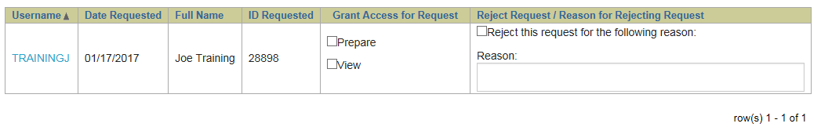
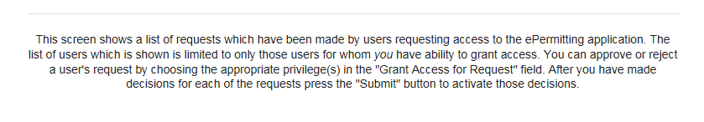
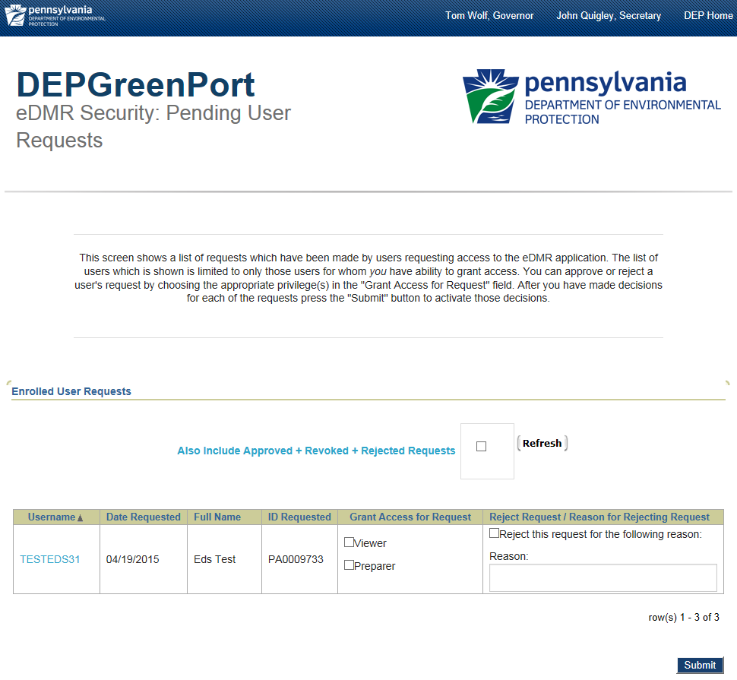
- Select the security options to be granted for the desired user in the Grant Access for Request column.
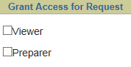

- Click the Submit button to confirm the selection.
The user requesting access will receive an email stating that the enrollment for the requested License number was successful.

Denying an Enrollment Request
- Open Internet Explorer.
- In the URL Address Bar type in https://www.depgreenport.state.pa.us.
- The DEPGreenPort website will display.
- Enter your username into the Username field.
- Enter your password into the Password field.
- Click the Log into DEPGreenPort button.
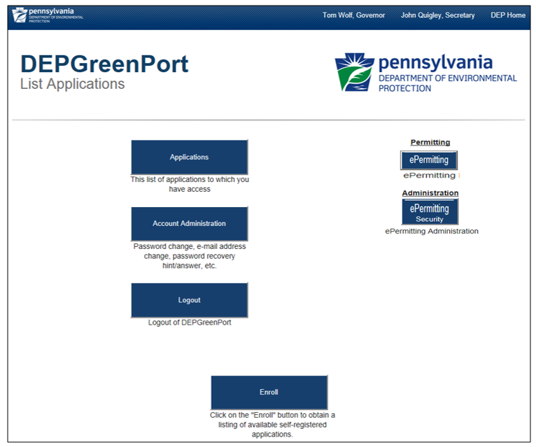
- The List Applications Screen will display.
- Click the ePermitting Security button.
- The ePermitting Security Pending User Request webpage will display.
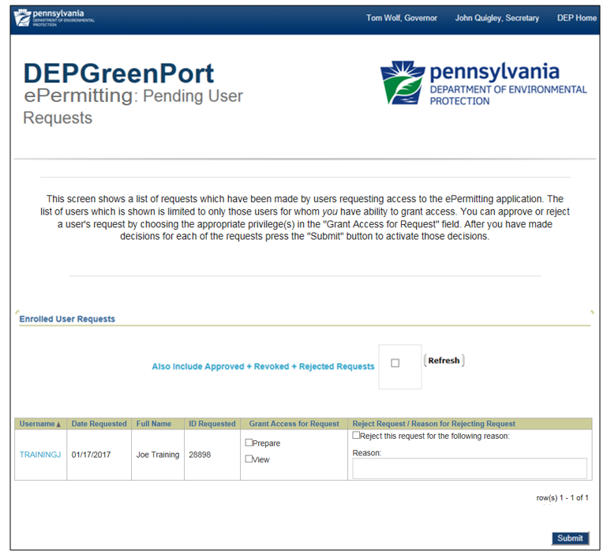
- Click the Checkbox for the appropriate user to be rejected.
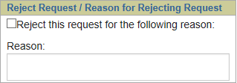

- Enter a rejection reason in the Reason field.
- Click the Submit button to confirm the selection.
The user requesting access will receive an email stating that the enrollment request has been rejected and provide the reason that the administrator entered.

Modifying Access for a User
ePermitting EFAs have the ability to modify individual access for any user that the EFA has access to. Modifying access can be completed on a role by role basis so that granular user administration can be completed and is done within the ePermitting Application itself.
Once approved through DEPGreenPort, the user will still be unable to access the ePermitting Application until the EFA sets up the individual permissions within the ePermitting Application itself.

Modifying Security Roles
- Open Internet Explorer.
- In the URL Address Bar type in https://www.depgreenport.state.pa.us.
- The DEPGreenPort website will display.
- Enter your username into the Username field.
- Enter your password into the Password field.
- Click the Log into DEPGreenPort button.
- The List Applications Screen will display.

- Click the ePermitting button.
- The ePermit Dashboard webpage will display.
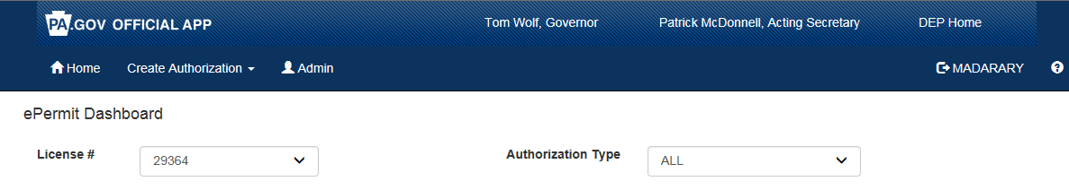
If you have access to more than one License, you will need to make sure to select the approriate Lincese from the dropdown list.
- Click the Admin button.
- The ePermit User Administration Overview page will display.
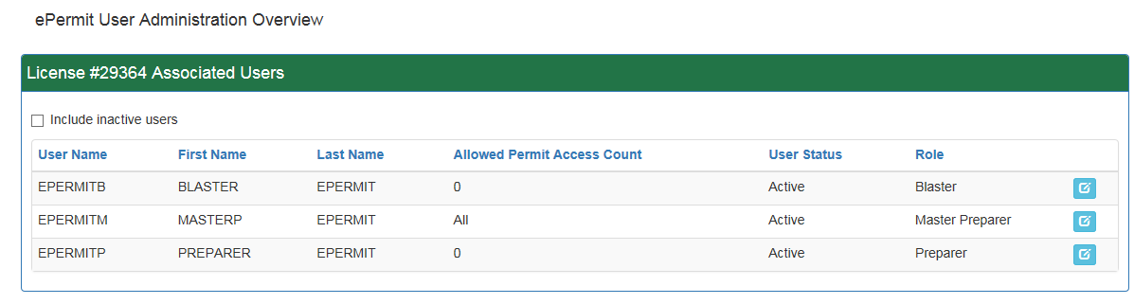

New users will display with a User Status of <No Access>.
- To create the access for a new user, or to edit the access of any user click the Edit button.
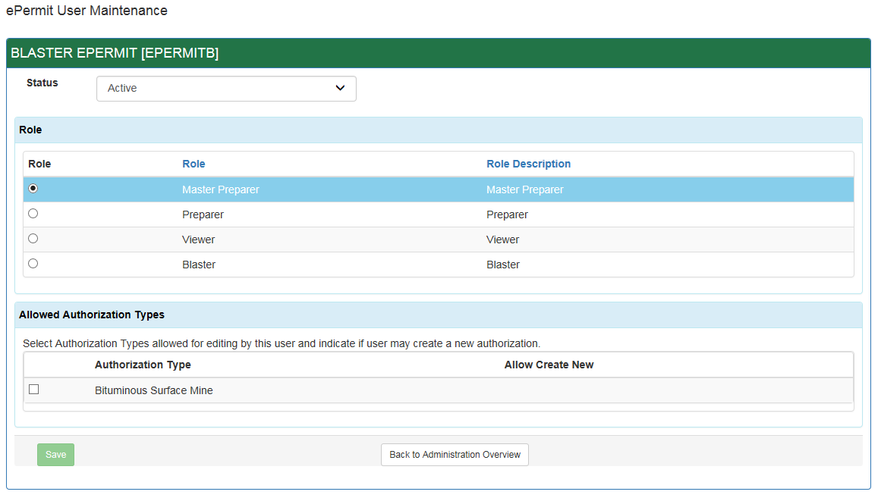
- The ePermit User Maintenance Page will display.

- Set the Status to Active (or Inactive for a user that needs to be deactivated).
- Select the appropriate Role by clicking the radio button next to the desired Role.
- The Roles available in the ePermitting Application are defined as follows:
  - Master Preparer – Any user who will have access to any draft permit, correction required permit, or previously submitted permit for the license they are associated with. The Master Preparer will also have the ability to create new draft permits.
  - Preparer – Any user who will require individual access to draft permits, or correction required permits for the license they are associated with. Once a draft permit is created, a Preparer must be given access to the submission before they are able to work on it.
  - Viewer – Any user who will have the ability to view draft permits, or correction required permits for the license they are associated with. Once a draft permit is created, a Viewer must be given access to the submission before they are able to view it.
- Select the Allowed Authorization Types by clicking the checkbox next to the type and also select if the user is authorized to create new draft permits of this type.
- Click the Save button.

Limiting Access to Modules for a User
ePermitting EFAs have the ability to limit individual access for certain modules within the ePermitting Application for Master Preparer, Preparer, and Viewer Roles.
Any user given Master Preparer, Preparer, or Viewer Roles will have access to all modules by default. If you want to limit the access, then restrictions must be placed on each module.

Modifying Module Restrictions
- From within the ePermitting Application, access the ePermit User Maintenance page for a user that will require module restrictions.
- Select the Authorization Type from the Allowed Authorization Types dropdown list.
- Select the module that access restrictions need to be placed against from the dropdown list.
- Select the access level to restrict the access to.
- Click the Add button.
- Click the Save button.

ePermit Dashboard
ePermitting users access the ePermit Dashboard to create, view, modify and/or delete draft authorization applications or previously submitted authorizations based on security roles given by the Electronic Filing Administrator (EFA). Users can view applications that are Draft, Submitted, Correction Required, Approved, and Withdrawn/Denied.

Accessing the ePermit Dashboard
- Open Internet Explorer.
- In the URL Address Bar type in https://www.depgreenport.state.pa.us
- The DEPGreenPort website will display.

- Enter your username in the Username field.
- Enter your password into the Password field.
- Click the Log into DEPGreenPort button.
- The List Applications Screen will display.

- Click the ePermitting button.
- From within the ePermitting application, the ePermit Dashboard is the Home page. It can be accessed at any time by clicking the Home button.
- Authorized users will see various links based on the programs they have been given access to.
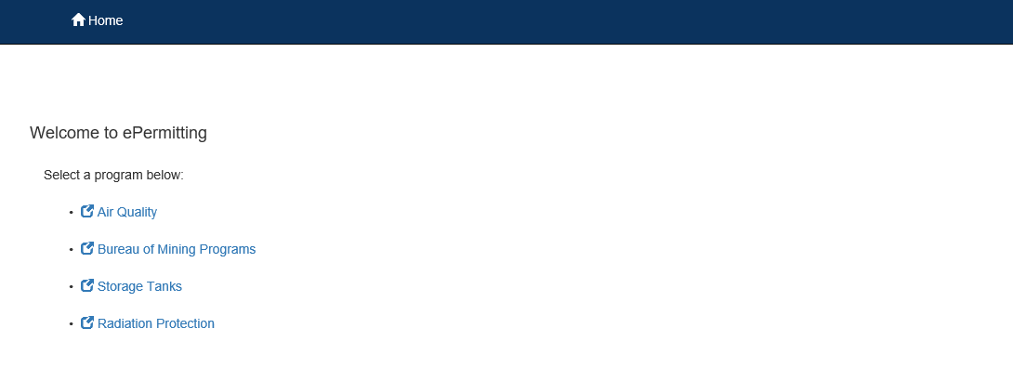

If users only have access to one program, this page is skipped, and the user is taken directly to their dashboard for that program.
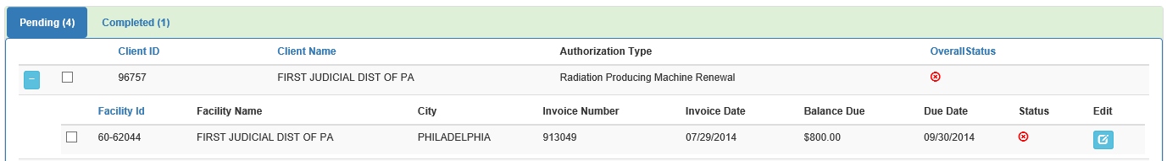

Working Through a Draft Permit Application
Authorized ePermitting users have the ability to create draft permit applications by completing modules and saving them at any time within the ePermitting Application.

Types of Data Fields
Users will encounter several different types of data field types when working through their applications. Some samples of these types of data fields are below.
- Checkbox – a checkbox is clicked to select the value next to it. You may click it a second time to deselect it.
Example: 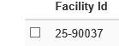
- Text Box – a textbox is a box where users can enter text manually or paste text that was copied from another application.
Example:
- Radio Button – a radio button is used to select one item from a series of items. Only one button in the grouping can be selected.
Example:
- Dropdown menu – a dropdown menu is a menu you click on to display a list of items. You will click the item you wish to select from the list for it to display as the selected item from the list.
Example: 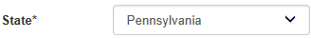
- Button – a button is used to operate the command shown on the button. In the example below, the Save button saves the data that had been entered onto the screen.
Example:

Entering Data into Your Draft Application
The ePermitting Application is a dynamic application which means it can change based on the information entered into it. Users may notice that, depending on the answers given in some areas, the application will add additional questions or perhaps even require additional modules.
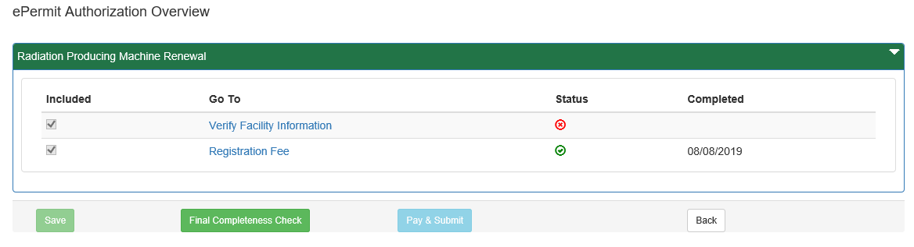

- While working in a draft application in the ePermitting application, click the link for an unfinished module.
- Complete all data fields in the module, including all required fields.
Required fields: A required field is indicated by an asterisk * to the right of the field title. The module will not be consisdered complete until all required fields have been completed.
- Click the Save button to save your changes at any time while working on the module. You can return to the module to complete it at another time.
You may encounter an error message when saving a module if something was entered incorrectly.
You will see a message indicating if the module was saved successfully or not.
- Click the Completeness Check button to verify all required information has been completed for the module.
If a module is not complete, you will see a list of items that need to be finished before the module can be considered complete.
- Click the Close button.

Submitting a Permit Application
Authorized ePermitting users have the ability to submit permit applications after completing all the appropriate required and non-required/optional modules.

Verify Facility Information
- From within the ePermitting Application, access the ePermit Dashboard page.
- Select clients or facilities to verify facility information is correct. A user can select multiple clients and facilities by selecting the checkboxes to the left of the records listed in the Pending tab.
- To verify multiple facilities, click on the Verify Selected Facilities button at the bottom of the page.
- To verify an individual facility, click on the Edit button beside the facility record.
- The ePermit Module Detail-Verify Facility Information will display. Verify the Tank Owner Information and Facility Information is correct by selecting the check box to indicate their accuracy. If they are not accurate, follow the instructions on the page.
- Responsible Official Contact Information and Billing Contact Information is updateable.
- When finished working on the module, click the button and the Completeness Check button to verify the module is complete.
- Select the back button to return to the Dashboard.
A green status should appear beside the client/facility record.

Mass Contact Update
Clients with multiple facilities have the ability to update contact information for more than one facility at a time.
- At the bottom of the Verify Facility Information module, select the Mass Contact Update button.
- Select the Contact to Copy from the drop-down options.
- Select the Facility(ies) to copy the contact information to and select the Copy button.
- When finished, select the Back to Verify Facility Information button to return to the module.
- Complete the module, save, and return to the dashboard.

Paying a Registration Fee
Payment can only be made once client/facility information is verified and a green icon appears in the status column on the dashboard.

Pay by Telecheck
You will now be taken to the ‘Payeezy’ page to enter your payment information. When finished, click the ‘Pay with Your Credit Card’ button.
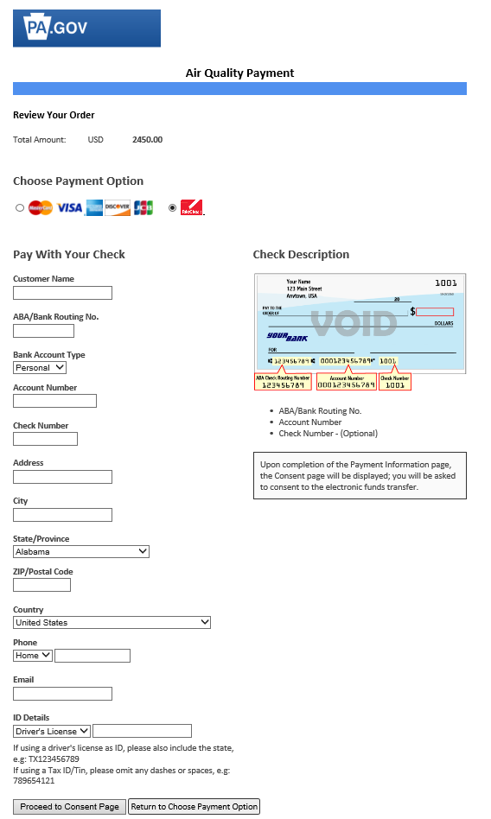

If payment is accepted, the user will receive a message indicating the payment is processed successfully and the user will be returned to the ePermit Dashboard.
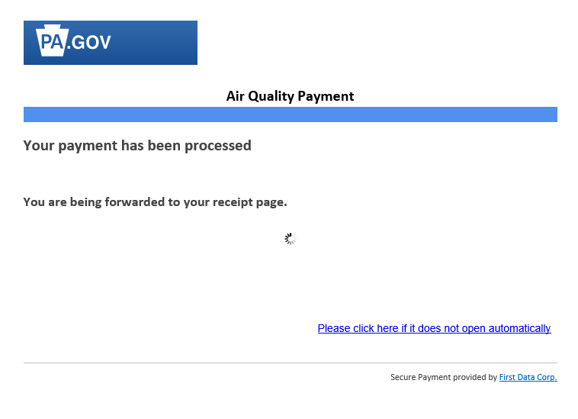

If payment is not successful, a message will display on the ‘Payeezy’ screen indicating the payment was not processed.

Printing a Certificate
- To view paid registrations, select the Completed tab from the ePermitting dashboard.
- The user may view and print a Temporary Registration Certificate by selecting the View Temporary Certificate link

