Microsoft Power BI Functionality

(Reading View)

  - Understand how to view and explore insights more efficient from Power BI Visualizations
- Adjust View of Power BI Report
Change the page view setting allow you to display the report page with appropriate Size. By default, this report page is displayed using the Fit to Page setting. In this case, Fit to Page displays the report page without scrollbars, but some of the detail and titles are too small to read. You can adjust to view like the following:
Select drop down view on the top-left menu
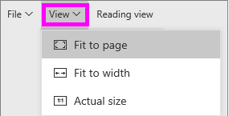
Choose size you prefer to adjust the view of the report page
To save your view setting, simply go to File (first tab of the menu) and click Save from drop down.
- Filtering, Highlight, and Visualization Interactions in a Power BI report
Filters remove all but the data you want to focus on. Highlighting is not filtering since it does not remove data but instead highlights a subset of the visible data; the un-highlighted data remains visible but dimmed
There are many ways you can filter reports in Power BI
Slicing: filter to the data you want by select one or more values from report slicers.
Filters pane: At the top right side of Reading View, you can interact with any filters that already exist in the report and save the selections you make. Type of Filter include:
visual level filter: the filter will only affect the visual.
Page level filter: the filter will affect the entire page, all the visuals on that pages will be filtered to that context.
Drill through filter: Drill through filter enables you to drill through to another focused report page to get the details that are filtered to that context by right-click on a data point.
Report level filter: the filter will affect the entire report, all the pages in the report will be filtered to that context.
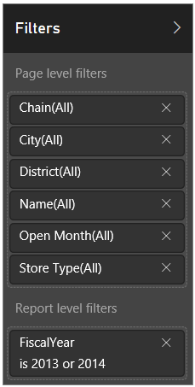
The above example is a filter pane, which has 6 page-level filters and 1 report level filter. You can click on each filter to set up filter conditions based on your choice.

Interactions
Except for Filters and Slicers, Visual, table and Matrix can also be used to interact with (cross-filter or cross-highlight) other visuals, table and Matrix.
You can cross-filter or cross-high-light other visual by clicking on the one or more elements (data objects or data points) on a visual (such as a bar, line, or bubble, rows from table, groups & rows from matrix). Other visuals will response the clicking activity by users and filter or highlight the information accordingly based on business requirement (Can also set interaction to None which means no change for this visual when a data region object is selected from another visual).
By selecting multiple elements, rows, or groups, you can click the object while holding Ctrl Key.

- Drill mode in Power BI visualization
When a visual has a hierarchy, you can drill down to reveal additional details from parent-level information to child level information. By default, the visualization shows top – level (or parent-level) information. But, because it has a hierarchy, selecting one of the visual elements, would display an increasingly more-detailed picture (child), like selecting the aquatics element to see data for swimming, diving, and water polo, etc.
If you see these drill controls in the top corners, your visualization has a hierarchy.
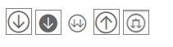

There are two types of drill on a power BI visual
- Drill down
Drill down takes you to the next level in the hierarchy, so if you're looking at the Territory level, you can drill down to city level as next level.
The example below shows a tree map for a hierarchy (Territory <- City <- Zip <- Name). Each step in the path shows you new information.
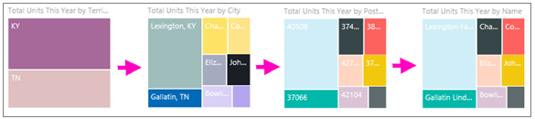
- Extend
Expand adds an additional hierarchy level to the current view. So, if you are looking at the Territory level, you can expand and add city, postal code, and name detail to your visual. In the below example, the path shows you the same information and adds on one level of new information.
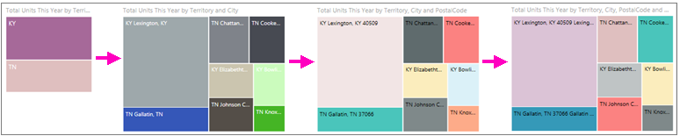

Also, Drill mode in Power Bi offers two ways of drill down:
- Drill down one field at a time
This method used the drill down icon that appears in the top right corner of the visualization itself. Click the drill down icon to turn it on, then you have the option of drilling down one field at a time.
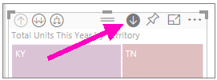
Click on an element (leaf) on the visual. (ex. like TN, you Tree map will display all the cities in TN.)
Or right click on the element and select “Drill Down” from the list.
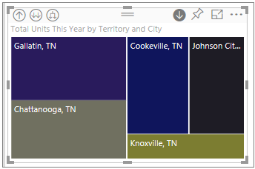

Besides, you can expand all and expand one field at a time. Make sure you drill down is still turned on, and select expend icon , Your tree map now shows some additional detail; instead of only showing city and state it now also shows postal code.

- Drill down all fields at a time
To drill down all fields at once, select the double arrow in the upper-left corner of the visualization , It will show next level of hierarchy. The below tree map shows the city data for Kentucky and Tennessee after Drill down all field at once from top level territory, KY and TN.
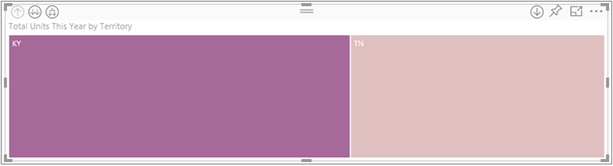
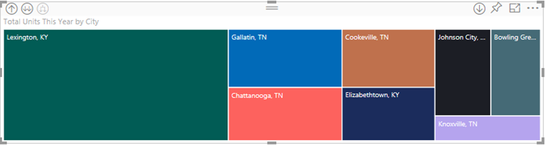

To drill back up, select the up arrow in the upper-left corner of the visualization 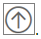.
You can also use Explore at top left menu to perform Drill actions by selecting drill actions from the List after selecting the visual to drill.

- Focus mode in Power BI
Focus mode lets you expand (pop out) content to see more detail. Instead of showing all the visuals on a page, you can choose focus mode for a visual if you want to only focus and analyze on one visual. In addition, you can also edit the filter pane along with the visual you are pulling from.
1. Hover over the report visual and select 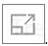icon at the right upper corner.
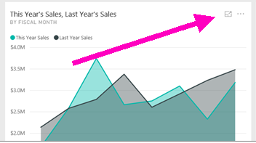
2. In focus mode, you can also edit the filters at the right side.
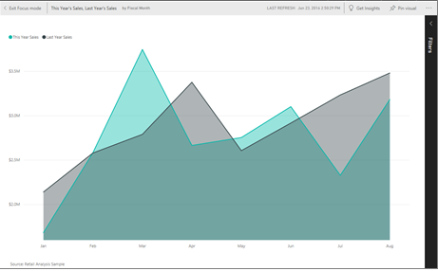

- Export Data, Show Data, Spotlight and Sorting
Select the ellipses I at the top right corner of the visual.
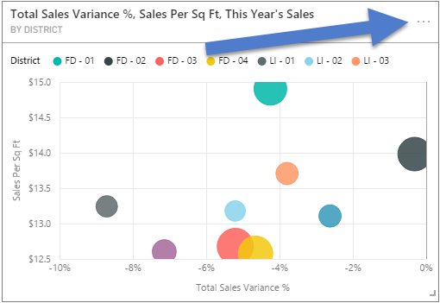

Export data: If you'd like to see or do further analysis on the data in Excel that is used to create a visualization in Power BI, you can export that data to a .csv file and open it in Excel. If the visual is filtered, then the downloaded data will also be filtered.
Show data: Show data option allows you to displays both the visual and the textual representation of the data. In the horizontal view, the visual is displayed on the top half of the canvas, and the data is shown on the bottom half. You can toggle between the horizontal view and a vertical view by selecting the icon in the upper-right corner of the canvas.
You can use Explore on the top left menu to select see data from the list.
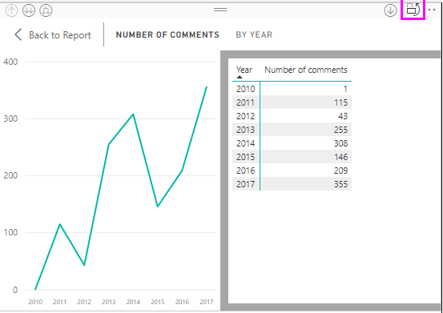
(Example of vertical view of Show data)

Spotlight: Hightlight the current visual only.
Sorting: Sort the fields that are used on the visual.

