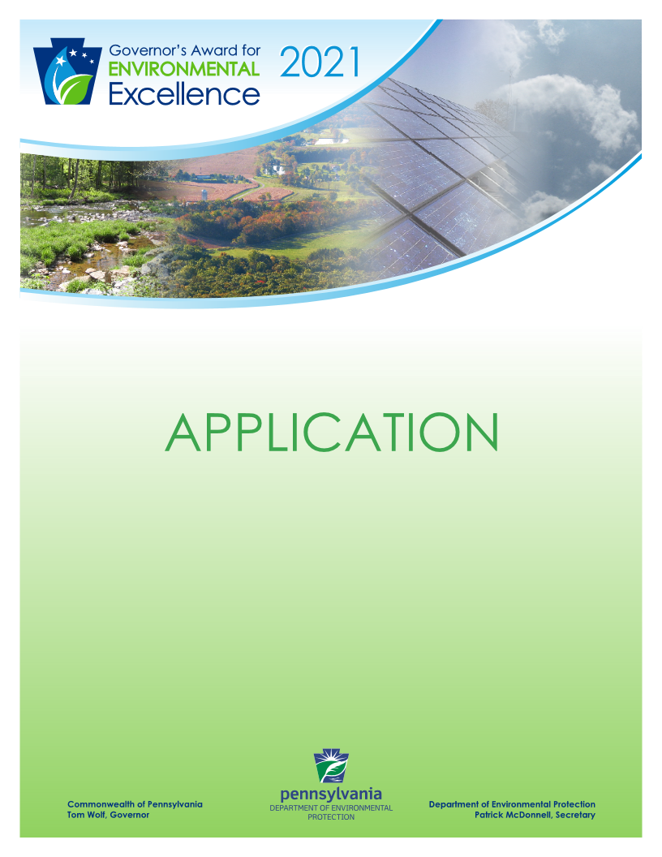
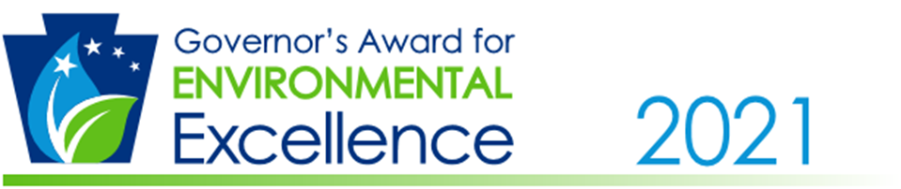

Project Application Form
NOTE: This application may not exceed four (4) pages (excluding cover sheet).

- Name of organization:

- Brief paragraph about the organization:

- Title of project:

- Have you/your organization applied for a Governor’s Award for Environmental Excellence previously? If so, provide the year(s), project title(s) and indicate whether an award was received.

- Provide a description of the project including, characteristics, objectives, goals, benefits and outstanding attributes:

- What results did your project achieve to improve Pennsylvania’s environment?

- How does this project serve the public’s best interest and provide environmental protection?

- In what ways did the project involve community members, government officials, and/or employees?

- How does this project use innovative technology or solutions to achieve results?

- In what ways does this project educate people about environmentally responsible practices?

- Can you describe the potential economic impact your project created (e.g., total project costs, long-term cost savings, potential job creation)?

- How does this project address sustainability, climate change, pollution prevention, and/or environmental justice?

*Please submit the project application form and any supplemental documents online at http://www.ahs.dep.pa.gov/GovernorsAwardsApplication by
Monday, December 21, 2020 at 5:00 p.m.

