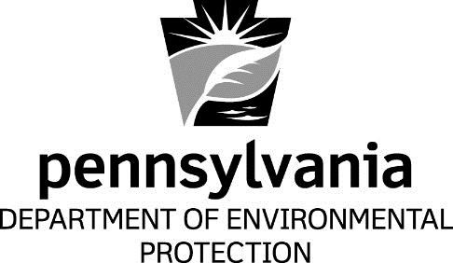

Attachment A

DEP RACT Rules Compared to New Hampshire and Other State RACT Rules

Bureau of Air Quality
Department of Environmental Protection

[This page intentionally left blank.]

