Attachment A: Support Document - Cross Reference Document for Pennsylvania’s Comparison of RACT requirements to RACT in other States
(Comparisons are made primarily to NH, with some references to NY, NJ, OH, and MI if needed due to NH not having a rule or to provide additional support of the PA RACT for specific rules.)

Links: Env-A 1200-1204 (state.nh.us) and 25 Pa. Code Chapter 129. Standards For Sources (pacodeandbulletin.gov)

Pennsylvania’s Miscellaneous Metal Parts Rule is consistent with New Hampshire’ s Miscellaneous Metal Parts rule which is approved as RACT by EPA
Standards are compared below.

Env-A 1212.03 – (New Hampshire) VOC Limits for Miscellaneous Metal Parts and Product Coating
Pennsylvania 25 Pa Code §129.52d – Miscellaneous Metal Parts Coatings

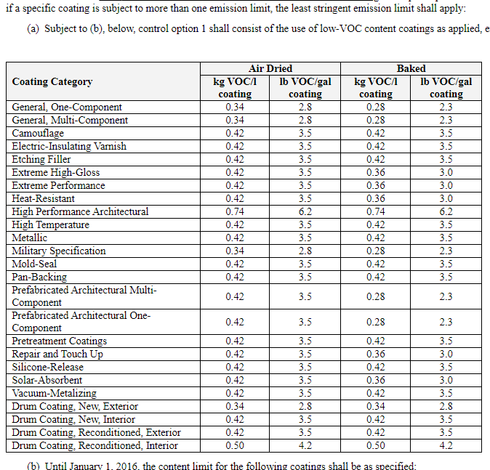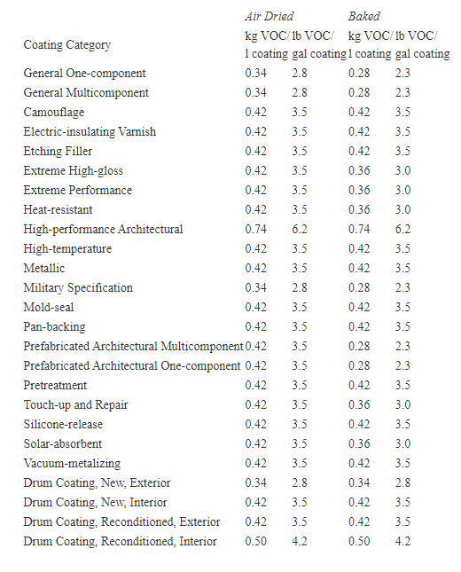

Pennsylvania’s Miscellaneous Metal Parts Rule is consistent with New Hampshire’ s Miscellaneous Plastic Parts rule which is approved as RACT by EPA
Standards are compared below.

Env-A 1212.06 ( New Hampshire) VOC Limits for Miscellaneous Plastic Parts and Products Coating

Pennsylvania 25 Pa Code §129.52d – Miscellaneous Plastic Parts Surface Coatings

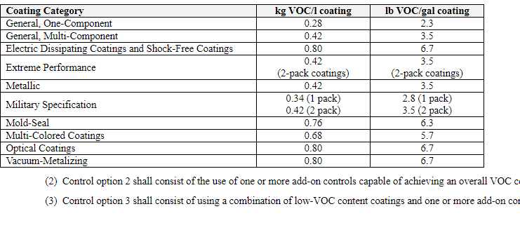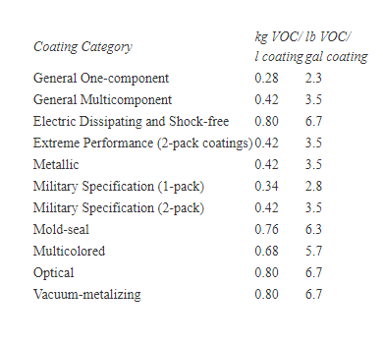

New Hampshire Env-A 1212.07 VOC Limits for Automotive/Transportation and Business Machine Plastic Part Coating
Pennsylvania 25 Pa Code §129.52d – Miscellaneous Plastic Parts Surface Coatings

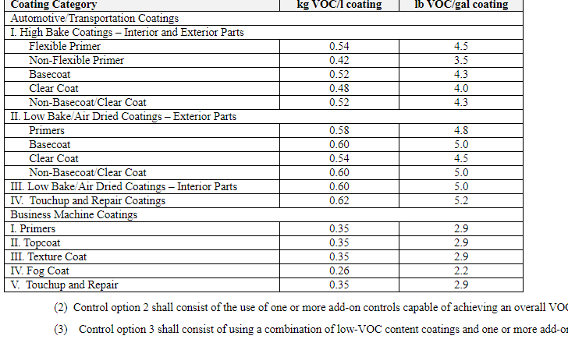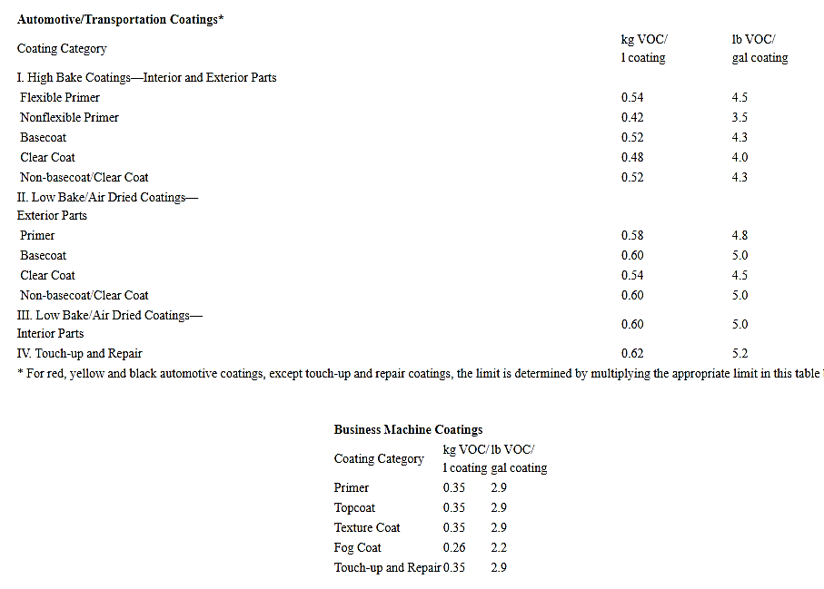

Env-A 1212.08 (New Hampshire) VOC Limits for Pleasure Craft Surface Coating

Pennsylvania 25 Pa Code §129.52d –Pleasure Craft Coatings

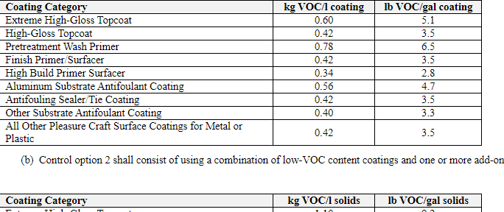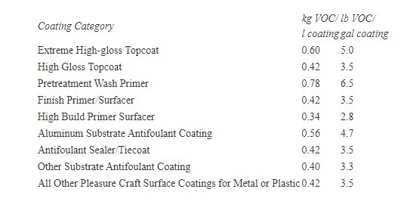

Env-A 1212.09 (New Hampshire) VOC Limits for Motor Vehicle Materials.

Pennsylvania 25 Pa Code §129.52d – Motor Vehicles Materials Surface Coating

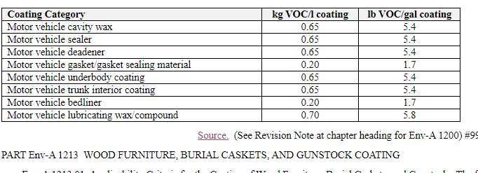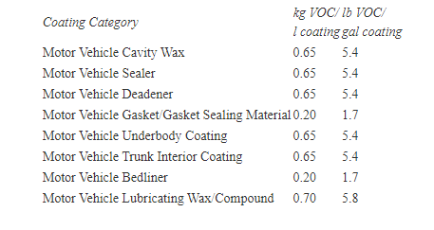
For all the source categories listed above Pennsylvania’s Surface Coating rules and standards are consistent with, equal to or more stringent than the New Hampshire rules. ( Pennsylvania’s rules use a more stringent applicability limit at 2.7 tons per year (tpy) which is more stringent than other states in most cases. Other states often use 3.0 tpy or in some cases 10 tpy for their VOC emissions applicability limits. )

Surface Coating Table 1, below:
Pennsylvania Surface Coating Reqiuirments 25 Pa Code Section 129.52 - Threshold for Applicability 2.7 Tons per year 15 pounds per day or 3 pounds per hour for following categories
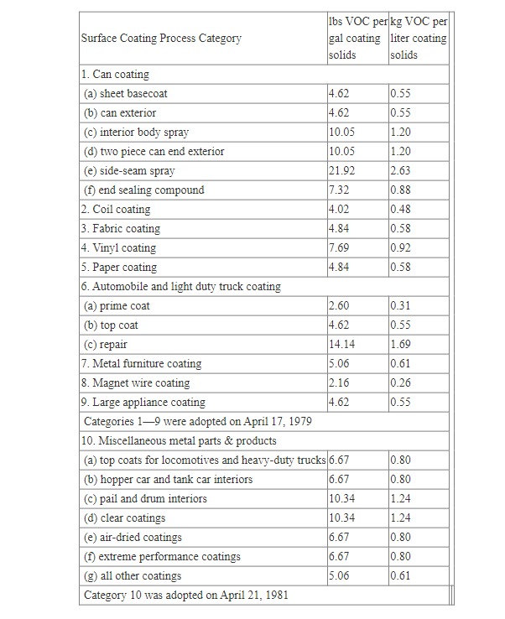

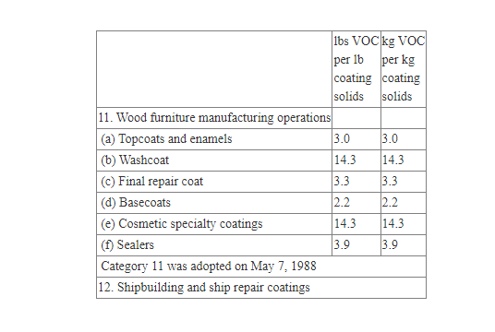

Shipbuilding and Repair Coatings Tables

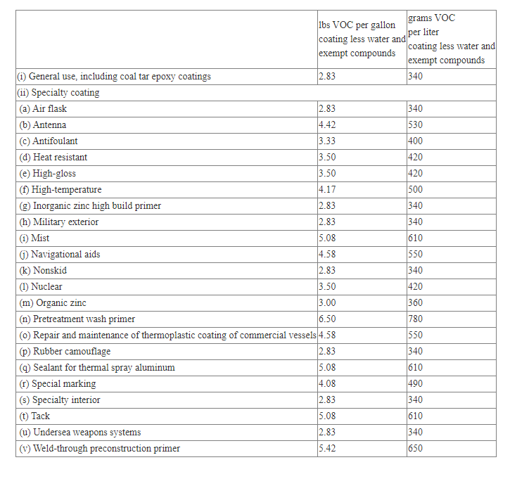
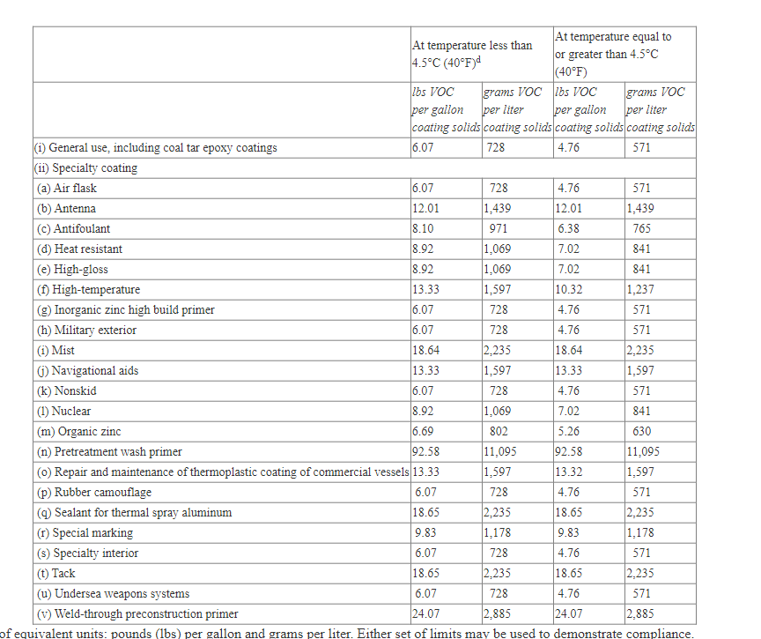

New Hampshire Surface Coating Rules ( Applicable PA rules are listed above in various tables.)
Env-A 1206.01 Applicability Criteria for Coating of Metal Cans – Applicability Threshold = 10 tons of VOC – PA has more stringent applicability threshold – 2.7 Tons.
Env-A 1206.02 Compliance Standards for Coating of Metal Cans –
(a) For use in interior or exterior sheet base-coating or over-varnish, or a 2-piece can exterior base coat or over-varnish, 0.34 kg VOC/l, equivalent to 2.8 lb VOC/gallon, of coating as applied, excluding water and exempt compounds or, for a source implementing add-on controls or a bubble to achieve compliance, the solids-based emission rate determined by the procedure described in Env-A 1205.01(d);

(b) For use in a 2-piece or 3-piece can interior body spray coating, or a 2-piece can exterior end spray or roll coating, 0.51 kg VOC/l, equivalent to 4.2 lb VOC/gallon, of coating, as applied, excluding water and exempt compounds;

(c) For use in 3-piece can side-seam spray operations, 0.66 kg VOC/l, equivalent to 5.5 lb VOC/gallon, of coating, as applied, excluding water and exempt compounds; or

(d) For use in end sealing compound operations, 0.44 kg VOC/l, equivalent to 3.7 lb VOC/gallon, of coating, as applied, excluding water and exempt compounds.

Example Conversion (PA sheet basecoat): 4.62 lbs of VOC / 7.36 lbs of VOC per gallon of solvent = 0.628 gallons solvent and 1 gallon of solids or 1.628 gallons coating total; .628 gallons of solvent / 1.628 gallons of coating = 0.386 gallons of solvent per gallon of coating ; [ 0.386 gallons of solvent per gallon of coating * 7.36 lbs of VOC per gallon of solvent ] = 2.84 lbs of VOC per gallon of coating ….. which rounds to 2.8 lbs of VOC per gallon of coating.

Example Conversion (PA sheet can end exterior and interior body): 10.05 lbs of VOC / 7.36 lbs of VOC per gallon of solvent = 1.365 gallons solvent and 1 gallon of solids or 2.365 gallons coating total; 1.365 gallons of solvent / 2.365 gallons of coating = 0.577 gallons of solvent per gallon of coating ; [ 0.577 gallons of solvent per gallon of coating * 7.36 lbs of VOC per gallon of solvent ] = 4.25 lbs of VOC per gallon of coating ….. which rounds to 4.3 lbs of VOC per gallon of coating.

Example Conversion (PA side seam): 21.92 lbs of VOC / 7.36 lbs of VOC per gallon of solvent = 2.978 gallons solvent and 1 gallon of solids or 3.978 gallons coating total; 2.978 gallons of solvent / 3.978 gallons of coating = 0.749 gallons of solvent per gallon of coating ; [ 0.749 gallons of solvent per gallon of coating * 7.36 lbs of VOC per gallon of solvent ] = 5.81 lbs of VOC per gallon of coating ….. which rounds to 5.8 lbs of VOC per gallon of coating.

Example Conversion (PA end sealing compound): 7.32 lbs of VOC / 7.36 lbs of VOC per gallon of solvent = 0.995 gallons solvent and 1 gallon of solids or 1.995 gallons coating total; 0.995 gallons of solvent / 1.995 gallons of coating = 0. gallons of solvent per gallon of coating ; [ 0.499 gallons of solvent per gallon of coating * 7.36 lbs of VOC per gallon of solvent ] = 3.67 lbs of VOC per gallon of coating ….. which rounds to 3.7 lbs of VOC per gallon of coating.

New Hampshire lists its Coating in terms of lbs. of VOC/Gallon of coating. Pennsylvania’s Metal Can Coating Rule standard in Table 1. is listed in terms of lbs. of VOC per gallon of solids. If Pennsylvania’s standards are converted back to lbs. of VOC per gallon of coating using a standard solvent density of 7.36 lbs. of VOC per gallon of solvent, Pennsylvania’s standards are similar to New Hampshire’s standards, with some likely rounding error variation. Pennsylvania’s limits are also similar to Ohio with the exception that Ohio’s rule requires the solid basis to be used in conjunction with control devices when using the lbs. of VOC per gallon of solids limit. Ohio, once again, allows standards similar to Pennsylvania, but requires controls to also be used. However, Pennsylvania’s applicability threshhold is more than three times lower than New Hampshires rule. Pennsylvania’s rule applies to all sources emitting 2.7 tpy or higher versus New Hampshire’s 10.0 tpy applicability threshold. Therefore, Pennsylvania’s use of solids by volume is justified as RACT even if conversions result in small variances. Pensylvania’s Metal Can Rule in 25 Pa. Code § 129.52 Table 1, Category 1 is consistent with and as stringent as New Hampshire’s Metal Can Coating Rule.

New Hampshire Env-A 1207.01 Applicability and Exemptions for Coating of Paper, Fabric, Film and Foil Substrates.

(a) Subject to (b), below, any source at which paper, fabric, film, and foil coating operations, including related cleaning activities, have combined actual emissions, before controls, during any consecutive 12-month period of 3.0 tons of VOCs or more shall be subject to this part.
Applicability - any source at which paper, fabric, film, and foil coating operations, including related cleaning activities, have combined actual emissions, before controls, during any consecutive 12-month period of 3.0 tons of VOCs or more – Note: PA has a slightly more stringent applicability threshold – Actual VOC Limit @ 2.7 TPY for Paper and Fabric. (Work Practice @ 2.7 TPY for Paper, Foil, Fabric and Film.)
Applicability - A paper, fabric, film, or foil coating operation that has a TPE equal to or greater than 10 tons per consecutive 12-month period, but less than 25 tons per consecutive 12-month period, shall be limited at all times to an emission rate of 0.35 kg VOC/l, equivalent to 2.9 lb VOC/gallon of coating .
Applicability - A paper, fabric, film, or foil coating operation that has a TPE equal to or greater than 25 tons per consecutive 12-month period, as applied, shall be limited at all times before January 1, 2016, to an emission rate of 0.35 kg VOC/l, equivalent to 2.9 lb VOC/gallon of coating.
Applicability - A paper, fabric, film, or foil coating operation that has a TPE equal to or greater than 25 tons per consecutive 12-month period, as applied, shall be limited at all times on and after January 1, 2016 to either the emission rates or control efficiency, as applied, as specified in table 1207-1, below:
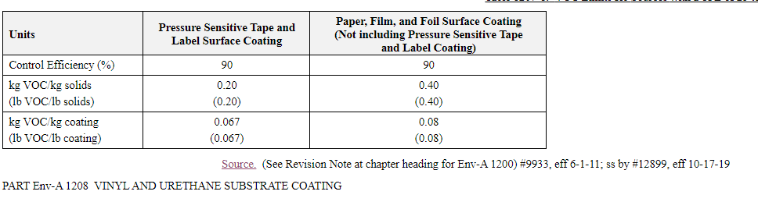

PA Limits in 25 PA Code Section 129.52b Control of VOC emissions from paper, film and foil surface coating processes.
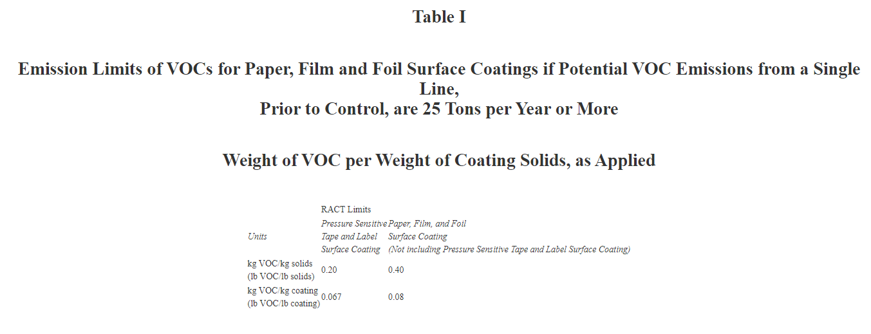
Table II
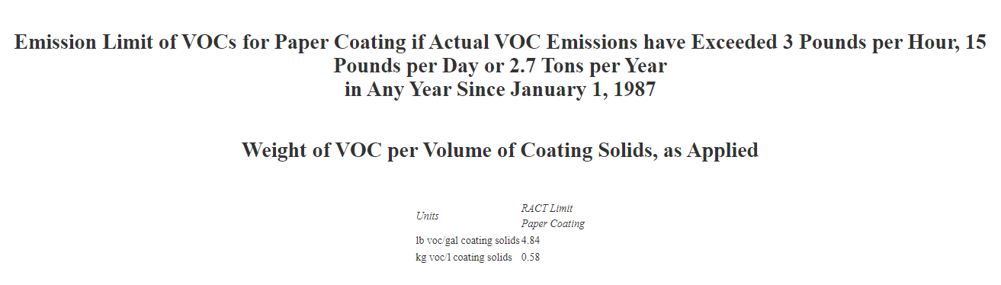
Conclusion: Pennsylvania’s paper, film and foil surface coating rule is as stringent and more stingent than New Hampshire’s EPA recent RACT approved rule.

Pennsylvania Potentail under 25 Tons of VOC per year for Paper (4.84), Fabric (4.84) .
Example Conversion (PA Paper and Fabric): 4.84 lbs of VOC / 7.36 lbs of VOC per gallon of solvent = 0.658 gallons solvent and 1 gallon of solids or 1.658 gallons coating total; .658 gallons of solvent / 1.658 gallons of coating = 0.397 gallons of solvent per gallon of coating ; [ 0.397 gallons of solvent per gallon of coating * 7.36 lbs of VOC per gallon of solvent ] = 2.92 lbs of VOC per gallon of coating ….. which rounds to 2.9 lbs of VOC per gallon of coating.

After 2011, Pennsylvania’s Paper, Film and Foil coating limits for sources with Potential to Emit 25 tons per year or greater are equivalent to New Hampshires limits, after 2016, for sources of 25 tons per year or greater for Paper, Film and Foil see PA Table I and NH Table above. New Hampshire has an applicability limt TPE for paper, fabric, film, and foil operations between 10 tons per year and 25 tons per year of 2.9 lb VOC/gallon, of coating, as applied prior to 2016. Pennsylvania has solids limits applied to units that emit 2.7 tons actual or more up to 25 tons of PTE for paper or fabric of 4.84 lbs of VOC per gallon of solids which converts to 2.9 lbs. of VOC per gallon of coating at standard solvent density of 7.36 lbs. per gallon. Fabric coating remains at that limit for all sources with the potential to emit over 25 tons per year . The paper limit also remains the same at 4.84 lbs. of VOC per gallon of solids per 129.52 Table 1 unless the PTE exceeds 25 tons per year for a paper operation and the emission limits in 129.52b Table I then apply for operations with a PTE above 25 TPY after January 1, 2012. In general, the limits in Pennsylvania and New Hampshire are consistent even though there are some differences in applicability and timing and the representation of the coating limits.

Pennsylvania’s limits are also comparable to Ohio with the exception that Ohio’s rule requires the solid based coatings to be used in conjunction with control devices when using the Lbs. of VOC per gallon of solids limit. Pennsylvania’s coating regulation includes the same standards as the EPA RACT approved New York surface coating limits at 6 CRR-NY 228-1.4 “Requirements for controlling VOC emissions using compliant materials” see 228-1.4 (d) Class D coating line.

New Hampshire PART Env-A 1208 VINYL AND URETHANE SUBSTRATE COATING
Applicability - Any source at which vinyl or urethane substrate coating operations have combined TPEs during any consecutive 12-month period of 10 tons of VOCs or more shall be subject to this part. PADEP applicability is more stringent at 2.7 tpy.
Standard - Any process applying a coating onto vinyl or urethane coated fabric, or vinyl or urethane sheets shall be limited at all times to an emission rate of 0.45 kg VOC/l, equivalent to 3.8 lb VOC/gallon, of coating,

Pennsylvania Vinyl Limits
25 Pa Section 129.52 Table 1
Surface Coating Process Category | lbs VOC per gal coating  solids | kg VOC per liter coating  solids

Vinyl coating | 7.69 | 0.92

Example Conversion: 7.69 lbs of VOC / 7.36 lbs of VOC per gallon of solvent = 1.044 gallons solvent and 1 gallon of solids or 2.044 gallons coating total; 1.044 gallons of solvent /2.044 gallons of coating = 0.5108 gallons of solvent per gallon of coating ; [ 0.5108 gallons of solvent per gallon of coating * 7.36 lbs of VOC per gallon of solvent ] = 3.759 lbs of VOC per gallon of coating ….. which rounds to 3.8 lbs of VOC per gallon of coating.

Pennsylvania’s Vinyl, coating limits apply for all sources above 2.7 tons expressed in terms of Lbs of VOC / gallon of solids whereas New Hampshire’s limits affect units 10 tons or greater and are expressed in lbs. of VOC per gallon of coating less exmption solvents and water. If Pennsylvania’s standards are converted back to lbs. of VOC per gallon of coating (about 3.76 lbs VOC per gallon of coating in this case) using a “standard solvent density of 7.36 lbs. of VOC per gallon of solvent”, Pennsylvania’s standards are similar to New Hampshire’s standards. Pa’s limits are also similar to Ohio’s with the exception that Ohio’s rule requires the solid basis to be used in conjunction with control devices when using the Lbs. of VOC per gallon of solids limit. Ohio, once again, allows standards simialr to PA but rquires controls to also be used. As Pennsylvania’s applicability threshold is more than three times lower than New Hampshire’s and applies to all sources emitting 2.7 tons or higher, Pennsylvania’s use of solids by volume is justified even if conversions result in small variances. Also Pa’s surface coating rule for vinyl adjusted for standrad solvent density is equivalent to New York’s EPA approved RACT rule at 6 CRR-NY 228-1.4 “Requirements for controlling VOC emissions using compliant materials” see 228-1.4 (d) Class D coating line. See calculation above. PA DEP’s applicability limit of actual emissions at 2.7 tons per year is likely more stringent than New Hampshire’s and New York’s potential to emit of 10 tons per year as such a standard may allow facilities to take permit limits below 10 tons to limit PTE.

New Hampshire PART Env-A 1209 METAL FURNITURE COATING
Any source at which metal furniture coating operations, including related cleaning activities, have combined actual emissions, before controls, during any consecutive 12-month period of 3.0 tons of VOCs or more;

New Hampshire Table 1209-1 VOC Emission Rates for Metal Furniture Coating

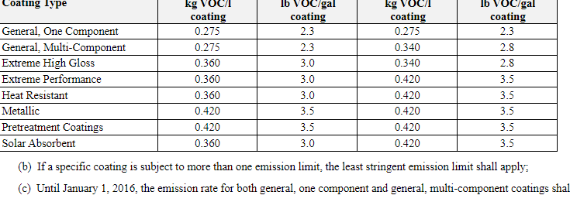

New Hampshire -Table 1209-2 VOC Emission Rates for Metal Furniture Coating Pennsylvania
Assuming VOC density of 7.36 pounds per gallon

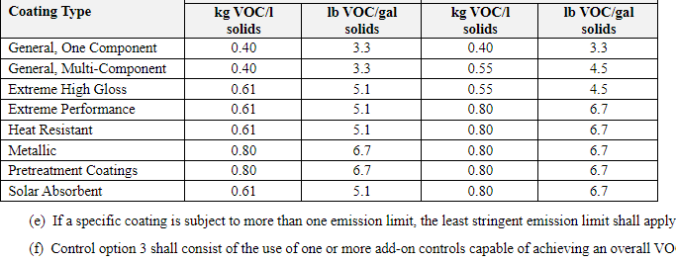
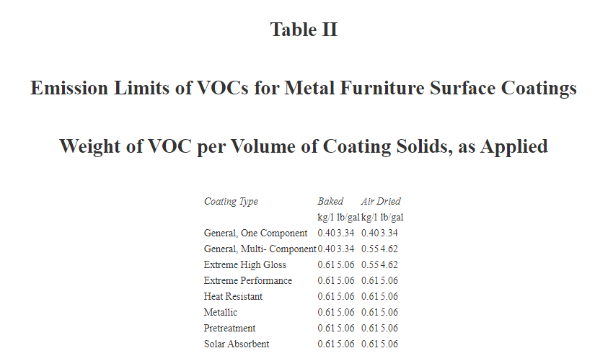
Pennsylvania’s Metal Furniture Surface Coating Rule is as stringent as New Hampshire’s rule with a 10% lower applicability threshold.

New Hampshire - PART Env-A 1210 MAGNETIC WIRE INSULATION COATING
Any source at which magnetic wire insulation coating operations have combined TPEs during any consecutive 12-month period of 10 tons of VOCs or more shall be subject to his part. A process applying a coating of electrically insulating varnish or enamel onto copper or aluminum wire or foil shall be limited at all times to an emission rate of 0.20 kg VOC/l, equivalent to 1.7 lb VOC/gallon, of coating, as applied, excluding water and exempt compounds.

25 Pa Section 129.52 Table 1
Surface Coating Process Category | lbs VOC per gal coating  solids | kg VOC per liter coating  solids

8. Magnet wire coating | 2.16 | 0.26
Example Conversion: 2.16 lbs of VOC / 7.36 lbs of VOC per gallon of solvent = 0.2935 gallons solvent and 1 gallon of solids or 1.2935 gallons coating total; 0.2935 gallons of solvent /1.2935 gallons of coating = 0.2269 gallons of solvent per gallon of coating ; [ 0.2269 gallons of solvent per gallon of coating * 7.36 lbs of VOC per gallon of solvent ] = 1.67 lbs of VOC per gallon of coating ….. which rounds to 1.7 lbs of VOC per gallon of coating.

In this case, Pennsylvania expresses its standard for Magnetic Wire Insulation Coating on a Lbs. of VOC per gallon of solids basis which is back calculated to be as stringent as the New Hampshire Rule and it has an applicability limit (2.7 TPY) which is three times lower than New Hampshire applicability limit.

New Hampshire - PART Env-A 1211 METAL COILS COATING
Any source at which metal coil coating operations have combined TPEs during any consecutive 12-month period of 10 tons of VOCs or more shall be subject to this part. A process applying a coating onto a metal coil substrate shall be limited at all times to an emission rate of 0.31 kg VOC/l, equivalent to 2.6 lb VOC/gallon, of coating, as applied, excluding water and exempt compounds.

25 Pa Section 129.52 Table 1
Surface Coating Process Category | lbs VOC per  gal coating  solids | kg VOC per  liter coating  solids

Coil coating | 4.02 | 0.48

Example Conversion: 4.06 lbs of VOC / 7.36 lbs of VOC per gallon of solvent = 0.5516 gallons solvent and 1 gallon of solids or 1.5516 gallons coating total; 0.516 gallons of solvent /1.5516 gallons of coating = 0.3555 gallons of solvent per gallon of coating ; [ 0.3555 gallons of solvent per gallon of coating * 7.36 lbs of VOC per gallon of solvent ] = 2.61 lbs of VOC per gallon of coating ….. which rounds to 2.6 lbs of VOC per gallon of coating.

In this case Pennsylvania expresses its standard on a Lbs. of VOC per gallon of solids basis back calculated based on standrad solvvent density is as stringent as the the New Hampshire Rule and it has an applicability limit (2.7 tpy) three times lower than New Hampshire applicability limit.

Large Appliance Coatings – (New Hampshire does not appear to have a separate rule for the Large Appliance Coatings source category)

Pennsylvania Table I
Emission Limits of VOCs for Large Appliance Surface Coatings
Weight of VOC per Volume of Coating Solids, as Applied
Coating Type | Baked |  | Air Dried
 | kg/l | lb/gal | kg/l | lb/gal
General, One Component | 0.40 | 3.34 | 0.40 | 3.34
General, Multi- Component | 0.40 | 3.34 | 0.55 | 4.62
Extreme High Gloss | 0.55 | 4.62 | 0.55 | 4.62
Extreme Performance | 0.55 | 4.62 | 0.55 | 4.62
Heat Resistant | 0.55 | 4.62 | 0.55 | 4.62
Metallic | 0.55 | 4.62 | 0.55 | 4.62
Pretreatment | 0.55 | 4.62 | 0.55 | 4.62

Example Conversion: 3.34 lbs of VOC / 7.36 lbs of VOC per gallon of solvent = 0.4538 gallons solvent and 1 gallon of solids or 1.4538 gallons coating total; 0.4538 gallons of solvent /1.4538 gallons of coating = 0.3121 gallons of solvent per gallon of coating ; [ 0.3121 gallons of solvent per gallon of coating * 7.36 lbs of VOC per gallon of solvent ] = 2.29 lbs of VOC per gallon of coating ….. which rounds to 2.3 lbs of VOC per gallon of coating.

Example Conversion: 4.62 lbs of VOC / 7.36 lbs of VOC per gallon of solvent = 0.6277 gallons solvent and 1 gallon of solids or 1.6277 gallons coating total; 0.6277 gallons of solvent /1.6277 gallons of coating = 0.3856 gallons of solvent per gallon of coating ; [ 0.3856 gallons of solvent per gallon of coating * 7.36 lbs of VOC per gallon of solvent ] = 2.84 lbs of VOC per gallon of coating ….. which rounds to 2.8 lbs of VOC per gallon of coating.

Ohio Large Appliance Coatings Limits VOC per volume of coating solids, as applied.
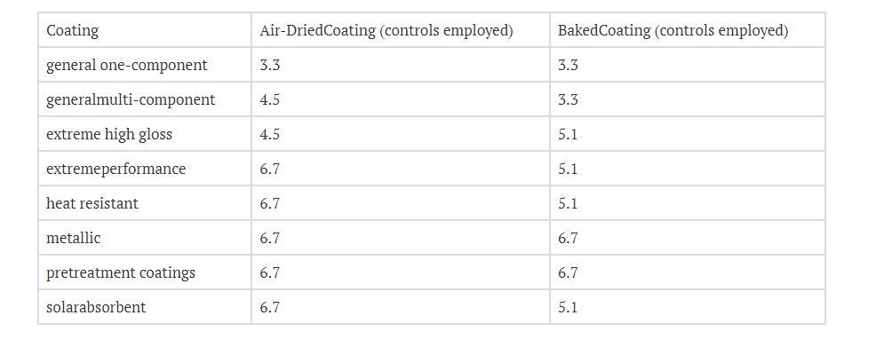
New York Large Appliance Coating
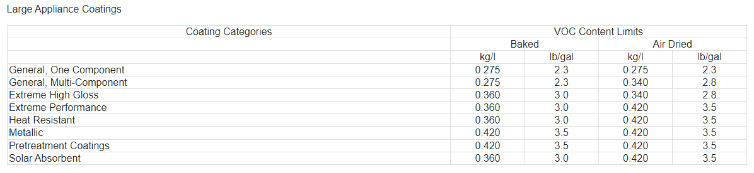

In this case Pennsylvania’s coating standards in Lbs. of VOC per Gallon of Solids is more stringent than Ohio’s Standards, although Ohio also requires controls to be employed at the higher standard. Pennsylvania’s solid’s-based coating standard after adjustment to standard solvent density is consistent with and equivalent to the EPA RACT approved New York large appliance standard.

New Hampshire PART Env-A 1213 WOOD FURNITURE, BURIAL CASKETS, AND GUNSTOCK COATING
See: Env-A 1213 WOOD FURNITURE, BURIAL CASKETS, AND GUNSTOCK COATING for various standards.
Env-A 1213.02 RACT Emission Rates for Wood Furniture and Burial Casket Finishing Operations.
(a) Except as specified in (b), below, a wood furniture or burial casket finishing operation, shall be limited at all times to the VOC RACT emission rates specified below:

(1) Using a topcoat with a VOC content no greater than 0.8 kg VOC/kg solids, equivalent to 0.8 lb VOC/lb solids, as applied; or

(2) Using a finishing system of topcoats and sealers with a VOC content no greater than the limits specified below:

a. For topcoats, 1.8 kg VOC/kg solids, equivalent to 1.8 lb VOC/lb solids, as applied; and

b. For sealers, 1.9 kg VOC/kg solids, equivalent to 1.9 lb VOC/lb solids, as applied.

(b) A wood furniture finishing operation using either acid-cured alkyd amino vinyl sealers or acid-cured alkyd amino conversion varnish topcoats shall be limited at all times to the VOC RACT emission rates specified below:

(1) Using a finishing system of topcoats and sealers consisting exclusively of acid-cured alkyd amino vinyl sealers and acid-cured alkyd amino conversion varnish topcoats with a VOC content no greater than the following:

a. For the sealers, 2.3 kg VOC/kg solids, equivalent to 2.3 lb VOC/lb solids, as applied; and

b. For the topcoats, 2.0 kg VOC/kg solids, equivalent to 2.0 lb VOC/lb solids, as applied;

(2) Using a finishing system of topcoats and sealers consisting of acid-cured alkyd amino conversion varnish topcoats and sealers other than acid-cured alkyd amino vinyl sealers with a VOC content no greater than the limits specified below:

a. For the sealers, 1.9 kg VOC/kg solids, equivalent to 1.9 lb VOC/lb solids, as applied; and

b. For the topcoats, 2.0 kg VOC/kg solids, equivalent to 2.0 lb VOC/lb solids, as applied; or

(3) Using a finishing system of topcoats and sealers consisting of acid-cured alkyd amino vinyl sealers and topcoats other than acid-cured alkyd amino conversion varnish topcoats with a VOC content no greater than the limits specified below:

a. For the sealers, 2.3 kg VOC/kg solids, equivalent to 2.3 lb VOC/lb solids, as applied; and

b. For the topcoats, 1.8 kg VOC/kg solids, equivalent to 1.8 lb VOC/lb solids, as applied.

See New York and PA wood furniture comparison next page.

Pennsylvania Standards are in 25 PA Code Section 129.102

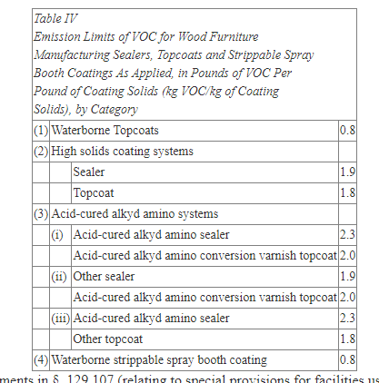

6 CRR-NY 228-1.4 228-1.4 Requirements for controlling VOC emissions using compliant materials. See 228-1.4 (c) Class C coating line, wood finishing.
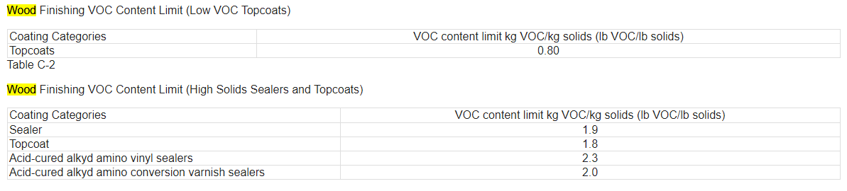

Pennsylvania’s Wood Furniture Manufacturing Operations Coating Rule is as stringent or more stringent than the EPA RACT approved New Hampshire rule. Pennsylvania’s rule is equivalent to and consistent with the EPA RACT approved New York’s Wood Finishing rule.

New Hampshire - PART Env-A 1214 FLAT WOOD PANELING COATINGS

A source whose flat wood paneling coatings operation, has combined actual emissions, before controls, during any consecutive 12-month period of 3 tons of VOCs or more shall be subject to this part.
(b) An emission limit of 2.9 pounds of VOC per gallon of solids, equivalent to 350 grams of VOC per liter of solids; or
(c) An emission limit of 2.1 pounds of VOC per gallon of material, equivalent to 250 grams of VOC per liter of material, excluding water and exempt compounds.

Pennsylvania’s Standards Flat Wood Coating Rule 25 Pa Code Section 129.52c
Applicability limit 15 Pounds per day.

Table I
Emission Limits of VOCs for
Flat Wood Paneling Surface Coatings
Weight of VOC per Volume of Coating Solids, as Applied
Surface Coatings, Inks or Adhesives Applied to the Following Flat Wood Paneling Categories | lbs VOC  per gallon  coating solids | grams VOC  per liter  coating solids
Printed interior panels made of hardwood plywood or thin particleboard | 2.9 | 350
Natural-finish hardwood plywood panels | 2.9 | 350
Class II finishes on hardboard panels | 2.9 | 350
Tileboard | 2.9 | 350
Exterior siding | 2.9 | 350

6 CRR-NY 228-1.4 228-1.4 Requirements for controlling VOC emissions using compliant materials. See 228-1.4 (b) Class B coating line, flat wood paneling

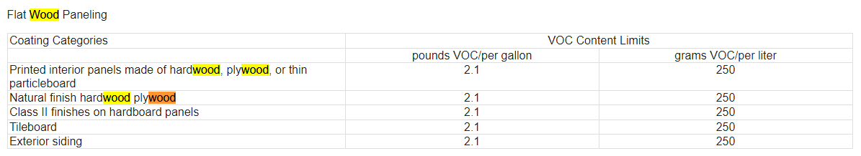

Example Conversion: 2.9 lbs of VOC / 7.36 lbs of VOC per gallon of solvent = 0.3940 gallons solvent and 1 gallon of solids or 1.3940 gallons coating total; 0.3940 gallons of solvent /1.3940 gallons of coating = 0.2826 gallons of solvent per gallon of coating ; [ 0.2826 gallons of solvent per gallon of coating * 7.36 lbs of VOC per gallon of solvent ] = 2..08 lbs of VOC per gallon of coating ….. which rounds to 2.1 lbs of VOC per gallon of coating.

Pennsylvania’s Flat Wood Paneling and Wood Paneling Surface Coating Rule is as stringent as the New Hampshire rule with a stricter applicability limit. It is as stringent as EPA’s TACT approved New York Rule for flat wood Paneling with a tighter applicability limit.

New Hampshire PART Env-A 1221 INDUSTRIAL CLEANING SOLVENTS

New Hampshire - Env-A 1221.05 Applicability Criteria for the Use of Industrial Cleaning Solvents.
Applicability
Except as provided in Env-A 1221.06, the owner or operator of a source that uses organic solvents in its cleaning activities and which has actual emissions, before controls, during any consecutive 12-month period of 3 tons of VOCs from the cleaning activities shall comply with the requirements in Env-A 1221.07 on and after January 1, 2016.
Standard
(b) Except as provided in (c) or (d), below, the owner or operator of a source subject to this section shall limit VOC emissions by using cleaning solvents with a maximum VOC content limit of 50 grams VOC per liter, equivalent to 0.42 lb/gal.

(c) As an alternative to the content limit in (b), above, an owner or operator shall either:

(1) Use a cleaning solvent with a composite vapor pressure of 8.0 millimeters or less of mercury (mm Hg), measured at 20ºC, equivalent to 68ºF; or

(2) Comply with the RACT order provisions in Env-A 1205.03 through Env-A 1205.06.

Pennsylvania Rule at 25 Pa Code § 129.63a. Control of VOC emissions from industrial cleaning solvents.

Applicability. This section applies to the owner and the operator of a facility at which an industrial cleaning solvent is used or applied in a cleaning activity at a cleaning unit operation, a work production-related work area or a part, product, tool, machinery, equipment, vessel, floor or wall.

The VOC emission limitations in subsection (e) and the work practice requirements in subsection (f) do not apply to the owner or operator of a facility subject to subsection (a) if the total combined actual VOC emissions from all subject cleaning unit operations at the facility are less than 2.7 tons (2,455 kilograms) per 12-month rolling period, before consideration of controls. An owner or operator claiming this exemption shall maintain records in accordance with subsection (h)(4).

Compliant solvents. The industrial cleaning solvent meets one of the following VOC limits:
(i) A VOC content less than or equal to 0.42 lb VOC/gal (50 g VOC/l) as applied.
(ii) A VOC composite vapor pressure less than or equal to 8 mm mercury at 68°F (20°C) as applied.
(2) VOC emissions capture system and add-on air pollution control device. The weight of VOCs emitted to the atmosphere from cleaning unit operation cleaning activities is reduced through the use of vapor recovery or incineration or another method that is acceptable under § 129.51(a) (relating to general). The overall emission reduction of a control system, as determined by the test methods and procedures specified in Chapter 139 (relating to sampling and testing), may be no less than 85% or may be no less than the equivalent efficiency as calculated by the following equation, whichever is less stringent:
7:27-16.24 Industrial cleaning (New Jersey Rule)
(a) Except as provided at (b) below, this section applies to industrial cleaning at a facility
that purchases for use more than 855 gallons of industrial cleaning solvents, in aggregate,
during any period of 12 consecutive months.
(b) This section does not apply to the use or purchase of industrial cleaning solvents at the
following source operations:
1. Mobile equipment repair and refinishing;
2. Stationary storage tank;
3. Open top tank and solvent cleaning;
4. Aerospace coating;
5. Auto and light-duty truck assembly;
6. Fiberglass boat manufacturing;
This is a courtesy copy of this rule. All of the Department’s rules are compiled in Title 7 of the New Jersey Administrative Code.
185
7. Flexible packaging printing;
8. Large appliance coating;
9. Letterpress printing;
10. Lithographic printing;
11. Metal and wood furniture coating;
12. Miscellaneous metal parts coating;
13. Paper coating;
14. Plastic parts coating;
15. Shipbuilding and repair coating;
16. Electrical and electronic component manufacturing;
17. Precision optics manufacturing;
18. Numismatic die manufacturing;
19. Research and development laboratory;
20. Medical device and pharmaceutical manufacturing;
21. Quality assurance testing for coatings, inks, and adhesives;
22. Architectural coating;
23. Metal container, closure, and coil coating;
24. Graphic arts printing and coating, except screen printing;
25. Magnet wire coating;
26. Semiconductor wafer fabrication manufacturing;
27. Flexible magnetic data storage disc manufacturing;
28. Rigid magnetic data storage disc manufacturing;
29. Stripping of cured inks, coatings, and adhesives;
This is a courtesy copy of this rule. All of the Department’s rules are compiled in Title 7 of the New Jersey Administrative Code.
186
30. Flat wood paneling and printed hardwood coating;
31. Coil coating;
32. Polyester resin operations;
33. Miscellaneous industrial adhesives;
34. Wood products coating; and
35. Marine vessel coating.
(c) The owner or operator of an industrial cleaning operation subject to this section, other
than at a digital printing operation, or at an adhesive, surface coating formulation, ink, or
resin manufacturing facility, shall implement at least one of the following VOC control
measures:
1. The use of only industrial cleaning solvents that meet the maximum VOC content
listed in Table 24A;
2. The use of only industrial cleaning solvents that have composite vapor pressures
equal to or less than eight millimeters of mercury (mmHg) at 20 degrees Celsius;
or
3. The installation, operation, and maintenance, in accordance with the
manufacturer’s recommendations, of air pollution control equipment that reduces
uncontrolled VOC emissions to the atmosphere from industrial cleaning by an
overall control efficiency of 85 percent or more.

TABLE 24A
MAXIMUM ALLOWABLE VOC CONTENT OF INDUSTRIAL CLEANING SOLVENTS
Type of Industrial Cleaning
Maximum Allowable VOC Content
(grams per liter)
Cleaning of equipment used in screen printing 500
All other types of industrial cleaning 50

Pennsylvania’s Industrial Cleaning Solvents Rule is consistent with and as stringent as EPA’s RACT approved New Hampshire’s rule. When Pennsylvania developed and evaluated its Industrial Cleaning Solvents rule it reviewed the New Hampshire rule as one of its RACT evaluation sources. Pennsylvania has also made a comparison to the New York Industrial Cleaning Solvent Rule in 226 Subpart 226-2. Pennsylvania’s requirements are consistent with New York States regulation however DEP does not allow a case by case evaluation for compliance which is allowed by New York. The standard DEP selected for screen printing was based upon industry comments and information provided during the comment period. New Hampshire has the same requirement. The Federal Agency exemptions in the Pennsylvania rule are also in New York’s and New Hampshire’s rules as well. Federal Agencies may require certain solvents to be used to protect public health and welfare. Requirements for solvents addressed in other rules were made part of the exemption list in the Pennsylvania Rule as they already have been determined to be RACT. DEP’s applicability threshold is 2.7 tons of NOx per year while New Hampshire’s and New York’s rule apply at is 3-tons per year thus Pennsylvania’s rule is slightly more stringent. Pennsylvania’s rule is also consistent with New Jersey’s Industrial Cleaning solvents rule.

New Hampshire PART Env-A 1221 INDUSTRIAL CLEANING SOLVENTS
Applicability
A cold cleaning machine that has an operating capacity of not more than one liter, equivalent to 0.26 gallon, of VOC shall be exempt from Env-A 1221.02.
An open top vapor degreaser with an open top area less than 1.0 square meter (m²) , equivalent to 10.8 square feet (ft²), shall be exempt from Env-A 1221.03 if the owner or operator uses appropriate work practices to reduce VOC emission and prevent solvent spillage including, but not limited to, keeping the cover closed on the machine at all times except when processing workloads through the degreaser and storing waste solvent in closed containers.
A conveyorized degreaser with an air/solvent interface area less than 2.0 m², equivalent to 21.6 ft², shall be exempt from Env-A 1221.04(a).
Env-A 1221.02 Compliance Standards for Cold Cleaning.
(a) The owner or operator of a cold cleaning process shall control such process by using the control techniques, operating requirements, and equipment described below:
(1) Control techniques shall include the following:
a. To prevent spillage, either:
1. A freeboard height that gives a freeboard ratio greater than or equal to 0.75 unless the machine is equipped with a cover that is kept closed except when parts are being placed into or being removed from the machine; or
2. A water cover at least 2.54 centimeter (cm), equivalent to 1 inch (in), deep, where the solvent is insoluble in and heavier than water;
b. If a solvent spray is used, the spray nozzle shall be capable of delivering a cohesive fluid stream, rather than a fine, atomized or shower type spray, operated according to (2)f., below; and
c. A permanent, legible, and conspicuous label, summarizing the operating requirements specified in (2), below, affixed to each solvent container or other location where it can be easily seen by the operator;
(2) Operating requirements shall be as follows:
a. Waste solvent shall be stored only in covered containers;
b. The degreaser cover shall be closed whenever parts in the cleaner are not being handled manually;
c. Cleaned parts shall be drained for at least 15 seconds or until dripping ceases, whichever is longer;
d. Solvent leaks shall be repaired immediately or the degreaser shall be shut down;
e. Drafts across the top of each cold cleaning unit shall be minimized;
f. Where a solvent spray is used, such spraying shall be:
1. Operated at a pressure which does not exceed 10 psig as measured at the pump outlet; and
2. Performed only within the confines of the degreasing unit;
g. Sponges, fabric, wood, leather, paper products, and other absorbent materials shall not be cleaned in a cold cleaning machine;
h. No solvent shall be used if it has a vapor pressure of 1.0 millimeters of mercury (mm Hg) or greater, measured at 20ºC, equivalent to 68ºF; and
i. The operator of a cold cleaning machine shall maintain for not less than 2 years and shall provide to the department, on request:
1. The information specified in (c)(1), below, in the form of an invoice, bill of sale, or certificate that corresponds to a number of sales; and
2. The material safety data sheet (MSDS) as specified in (c)(2), below; and
(3) If the cold cleaning machine can hold more than 7.5 liters, control equipment shall include the following:
a. A tank cover that is easily operated with one hand; and
b. An internally mounted drainage device that operates such that parts to be cleaned are enclosed under the cover while draining, except that the drainage device may be external for applications where an internal type cannot fit into the cleaning system.
(b) No person shall sell or offer for sale for use in a cold cleaning machine in New Hampshire any solvent having a vapor pressure of 1.0 mm Hg or greater, measured at 20ºC, equivalent to 68ºF.
(c) Any person who sells or offers for sale any solvent for use in a cold cleaning machine in New Hampshire shall provide, to the purchaser, the following written information:
(1) The name and address of the solvent supplier; and
(2) A MSDS listing the type of solvent, the product or vendor identification number, and the vapor pressure of the solvent measured in mm Hg at 20ºC, equivalent to 68ºF.

Pennsylvania 25 PA Code § 129.63. Degreasing operations.
(a) Cold cleaning machines. Except for those subject to the Federal National emissions standards for hazardous air pollutants (NESHAP) for halogenated solvent cleaners under 40 CFR Part 63 (relating to National emission standards for hazardous air pollutants for source categories), this subsection applies to cold cleaning machines that use 2 gallons or more of solvents containing greater than 5% VOC content by weight for the cleaning of metal parts.
(1) Immersion cold cleaning machines shall have a freeboard ratio of 0.50 or greater.
(2) Immersion cold cleaning machines and remote reservoir cold cleaning machines shall:
(i) Have a permanent, conspicuous label summarizing the operating requirements in paragraph (3). In addition, the label shall include the following discretionary good operating practices:
(A) Cleaned parts should be drained at least 15 seconds or until dripping ceases, whichever is longer. Parts having cavities or blind holes shall be tipped or rotated while the part is draining. During the draining, tipping or rotating, the parts should be positioned so that solvent drains directly back to the cold cleaning machine.
(B) When a pump-agitated solvent bath is used, the agitator should be operated to produce a rolling motion of the solvent with no observable splashing of the solvent against the tank walls or the parts being cleaned.
(C) Work area fans should be located and positioned so that they do not blow across the opening of the degreaser unit.
(ii) Be equipped with a cover that shall be closed at all times except during cleaning of parts or the addition or removal of solvent. For remote reservoir cold cleaning machines which drain directly into the solvent storage reservoir, a perforated drain with a diameter of not more than 6 inches shall constitute an acceptable cover.
(3) Cold cleaning machines shall be operated in accordance with the following procedures:
(i) Waste solvent shall be collected and stored in closed containers. The closed containers may contain a device that allows pressure relief, but does not allow liquid solvent to drain from the container.
(ii) Flushing of parts using a flexible hose or other flushing device shall be performed only within the cold cleaning machine. The solvent spray shall be a solid fluid stream, not an atomized or shower spray.
(iii) Sponges, fabric, wood, leather, paper products and other absorbent materials may not be cleaned in the cold cleaning machine.
(iv) Air agitated solvent baths may not be used.
(v) Spills during solvent transfer and use of the cold cleaning machine shall be cleaned up immediately.
(4) After December 22, 2002, a person may not use, sell or offer for sale for use in a cold cleaning machine any solvent with a vapor pressure of 1.0 millimeter of mercury (mm Hg) or greater and containing greater than 5% VOC by weight, measured at 20°C (68°F) containing VOCs.
(5) On and after December 22, 2002, a person who sells or offers for sale any solvent containing VOCs for use in a cold cleaning machine shall provide, to the purchaser, the following written information:
(i) The name and address of the solvent supplier.
(ii) The type of solvent including the product or vendor identification number.
(iii) The vapor pressure of the solvent measured in mm hg at 20°C (68°F).
(6) A person who operates a cold cleaning machine shall maintain for at least 2 years and shall provide to the Department, on request, the information specified in paragraph (5). An invoice, bill of sale, certificate that corresponds to a number of sales, Material Safety Data Sheet (MSDS), or other appropriate documentation acceptable to the Department may be used to comply with this section.
(7) Paragraph (4) does not apply:
(i) To cold cleaning machines used in extreme cleaning service.
(ii) If the owner or operator of the cold cleaning machine demonstrates, and the Department approves in writing, that compliance with paragraph (4) will result in unsafe operating conditions.
(iii) To immersion cold cleaning machines with a freeboard ratio equal to or greater than 0.75.

Batch vapor cleaning machines. Except for those subject to the Federal NESHAP for halogenated solvent cleaners under 40 CFR Part 63, this subsection applies to batch vapor cleaning machines that use solvent containing greater than 5% VOC by weight for the cleaning of metal parts.

In-line vapor cleaning machines. Except for those subject to the Federal NESHAP for halogenated solvent cleaners under 40 CFR Part 63, this section applies to in-line vapor cleaning machines that use solvent containing greater than 5% VOC by weight for the cleaning of metal parts.

Airless cleaning machines and airtight cleaning machines. Except for those subject to the Federal NESHAP for halogenated solvent cleaners under 40 CFR Part 63, this section applies to airless cleaning machines and airtight cleaning machines that use solvent containing greater than 5% VOC by weight for the cleaning of metal parts.

Alternative provisions for solvent cleaning machines. This section applies to all solvent cleaning machines used to process metal parts that use solvents containing greater than 5% VOC by weight. As an alternative to complying with subsections (b)—(d), the operator of a solvent cleaning machine may demonstrate compliance with paragraph (1) or (2). The operator shall maintain records sufficient to demonstrate compliance. The records shall include, at a minimum, the quantity of solvent added to and removed from the solvent cleaning machine, the dates of the addition and removal and shall be maintained for at least 2 years.

Pennsylvania’s degreasing operations rules are consistent with the EPA’s RACT approved New Hampshire’s Rule at PART Env-A 1221 INDUSTRIAL CLEANING SOLVENTS for all degreaser types. The cold cleaner degreaser portion of the rule is provided above which show consistency for that type of degreaser. Most degreasing is done by cold cleaning degreasers. NH-Section Env-A 1221.03 for Open Top Vapor Degreasing is consistent with PA Batch vapor decreasing and NH Conveyorized degreasing is consistent with PA In-line degreasing.

New Hampshire - PART Env-A 1219 FIBERGLASS BOAT MANUFACTURING
Applicability: On and after January 1, 2016, a source whose fiberglass boat manufacturing operations have combined actual emissions, before controls, during any consecutive 12-month period, which equal or exceed 3 tons of VOCs from the use of gel coats, resins, and materials used to clean application equipment, shall be subject to the provisions of this part.

Table 1219-1 Compliant Materials Monomer VOC Content Limits for Open Molding Resin and Gel Coat

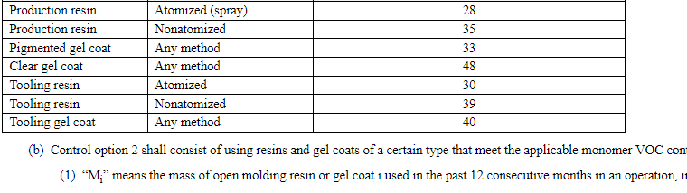
Pennsylvania § 129.74. Control of VOC emissions from fiberglass boat manufacturing materials.

Applicability: This section applies to the owner and operator of a facility that manufactures a hull or a deck of a boat or a related part from fiberglass, builds a mold or plug to make a fiberglass boat hull or deck or related part, or makes polyester resin putties for assembling fiberglass boat parts, when the total actual VOC emissions from fiberglass boat manufacturing operations identified in Table I are equal to or greater than 15 pounds (6.8 kilograms) per day or 2.7 tons per 12-month rolling period, before consideration of controls. The total actual VOC emissions include the actual VOC emissions from the manufacture of hulls or decks from fiberglass, fiberglass boat parts (including small parts such as hatches, seats and lockers), molds or plugs for fiberglass hulls, decks or boat parts, resin and gel coat mixing operations, resin and gel coat application equipment and related cleaning activities at the facility.
Open Molding Resin or  Gel Coat Material | Application  Method | Individual Monomer VOC Content or Weighted Average Monomer VOC Content (weight percent)
Production Resin | Atomized Spray | 28
Production Resin | Non-atomized | 35
Pigmented Gel Coat | Any Method | 33
Clear Gel Coat | Any Method | 48
Tooling Resin | Atomized Spray | 30
Tooling Resin | Non-atomized | 39
Tooling Gel Coat | Any Method | 40
Table I: Compliant Monomer VOC Content Limit for
Open Molding Resin and Gel Coat Materials

Pennsylvania’s Fiberglass boat manufacturing rule is consistent with and as stringent as the New Hampshire Rule. Pennsylvania also has a lower applicability limit in its rule. 2.7 tons per year vs. New Hampshire’s 3.0 tons per year. Also, note that a fiberglass boat manufacturing facility has not operated in Pennsylvania for many years. The last facility in Pennsylvania closed soon after Pennsylvania finalized the rule.

New Hampshire PART Env-A 1215 ROTOGRAVURE AND FLEXOGRAPHIC PRINTING

Except for flexible-packaging printing, a source whose rotogravure or flexographic printing operations have combined TPEs during any consecutive 12-month period which equal or exceed 50 tons of VOCs shall be subject to the provisions of sections Env-A 1215.02 through Env-A 1215.04.

VOC Content Standards for Rotogravure and Flexographic Printing
(a) Each ink, as it is applied to the substrate, less water and non-volatile organic compounds, shall contain no more than 40% by volume of VOCs;
(b) The volatile fraction of each ink, as it is applied to the substrate, shall contain no more than 25% by volume of VOCs and at least 75% by volume of water and non-volatile organic compounds; or
(c) For packaging rotogravure and flexographic printing only, each ink, as it is applied to the substrate, shall have a VOC content that is less than or equal to 0.5 kg VOC/kg, equivalent to 0.5 lb VOC/lb, coating solids.

Flexible packaging printing press
On and after January 1, 2016, the owner or operator of an individual flexible-packaging printing press with a TPE of 25 tons or more per year of VOCs from inks, coatings, and adhesives combined, shall comply…
Control option 1 shall consist of the use of low-VOC content materials or a combination of low-VOC content materials and add-on controls so as to comply with one of the following equivalent VOC content limits:
(1) 0.8 kg VOC/kg solids applied; or
(2) 0.16 kg VOC/kg materials applied;

Pennsylvania § 129.67. Graphic arts systems.
This section applies to the owner and operator of a facility whose rotogravure and flexographic printing presses by themselves or in combination with a surface coating operation subject to § 129.52, § 129.52a, § 129.52b, § 129.52c or § 129.52d or in combination with a flexible packaging printing press subject to § 129.67a (relating to control of VOC emissions from flexible packaging printing presses) have the potential to emit or have emitted VOCs into the outdoor atmosphere in quantities greater than 1,000 pounds (460 kilograms) per day or 100 tons (90,900 kilograms) per year during any calendar year since January 1, 1987.

A person may not permit the emission into the outdoor atmosphere of VOCs from a rotogravure or flexographic printing press subject to this section unless one of the following limitations is met:
(1) The volatile fraction of the ink, as applied to the substrate, contains 25% or less by volume of VOC and 75% or more by volume of water.
(2) The ink, as applied to the substrate, less water, contains 60% by volume or more of solid material.

Pennsylvania § 129.67a. Control of VOC emissions from flexible packaging printing presses.
Flexible packaging printing press
(1) Except as specified in paragraph (3) or (4), this section applies to the owner and operator of a flexible packaging printing press if one or more of the following apply:
(i) Potential VOC emissions. An individual flexible packaging printing press has potential emissions from the dryer, before consideration of add-on controls, of at least 25 tpy of VOCs from inks, coatings and adhesives combined. This section supersedes § 129.67 (relating to graphic arts systems).

The VOC content is equal to or less than one or both of the following limits:
(A) 0.16 lb VOC per lb material as applied.
(B) 0.8 lb VOC per lb material solids as applied.

ADDITIONAL RACT REQUIREMENTS FOR MAJOR SOURCES OF NOx AND VOCs (RACT II)- Major Source RACT
§ 129.96. Applicability.
(a) The NOx requirements of this section and § § 129.97—129.100 apply Statewide to the owner and operator of a major NOx emitting facility and the VOC requirements of this section and § § 129.97—129.100 apply Statewide to the owner and operator of a major VOC emitting facility that were in existence on or before July 20, 2012, for which a requirement or emission limitation, or both, has not been established in § § 129.51—129.52c, 129.54—129.63, 129.64—129.69, 129.71—129.75, 129.77, 129.101—129.107 and 129.301—129.310.

Pennsylvania’s requirements for Rotogravure and Flexographic printing presses are consistent with and as stringent as New Hampshire’s Flexible packaging printing press rule. Pennsylvania’s applicability VOC threshold is 100 tons of PTE vs. New Hampshire’s s 50 ton per year VOC threshold, but Pennsylvania also has a daily applicability threshold of 1000 lbs. /day. The VOC limits on the standards volatile fractions for the products used in the printing presses in both states is consistent. The state of Ohio has an applicability limit of 100 tons of VOC per year that is consistent with Pennsylvania’s applicability limit threshold. DEP does not rely on 25 PA Code § 129.67 exclusively for RACT purposes. Instead, Pennsylvania’s RACT II rule in 25 PA Code § 129.96 requires major sources of VOC ( those with the potential to emit over 50 tons of VOC per year) to meet major source RACT requirements for rotogravure and flexographic printing presses by themselves or in combination with a surface coating operation with the potential to emit 50 tons to 100 tons per year to meet RACT on a case-by-case basis. Effectively Pennsylvania’s rule is as stringent or more stringent than the New Hampshire and Ohio rules as case by case requirements can be more stringent than the New Hampshire requirements found in their rotogravure and flexographic printing rule. Graphic arts systems exceeding the VOC major source threshold are not exempted from doing a major source RACT analysis unless they meet 25 PA Code § 129.67. Only rotogravure and flexographic printing with the potential to emit over 100 tons are exempted from major the major source RACT requirements.

Pennsylvania’s rotogravure and flexographic printing operations rule and major source RACT requirements provide measures that are as stringent or more stringent then the New Hampshire rotogravure and flexographic printing rule.

Also;

Pennsylvania flexible packaging printing presses rule is consistent with and has the same standards as the New Hampshire Flexible packaging printing press rule. New Hampshire PART Env-A 1216 OFFSET LITHOGRAPHIC AND LETTERPRESS PRINTING

This part shall apply to any offset lithographic or letterpress printing operation, including related cleaning activities:
(1) Whose combined actual emissions, before controls, during any consecutive 12-month period equal or exceed 3 tons of VOCs;
(2) For a non-heatset printing operation, whose total volume of cleaning solution, fountain solution additives, and alcohol substitutes, purchased or used in any 30-day rolling period is greater than 64 gallons per month, or equivalently, 768 gallons in any 12-month rolling period; or
(3) For a heatset printing operation, whose total weight of heatset inks, cleaning solution, alcohol, and fountain solution additives purchased or used in any 30-day rolling period is greater than 450 pounds per month, or equivalently, 5400 pounds per 12-month rolling period.
(b) The provisions of Env-A 1216.03(a) shall apply on and after January 1, 2016 to any offset lithographic or letterpress printing operation that first becomes subject to this part on June 1, 2011.
(b) The following heatset ink presses shall be exempt from the requirements of (a), above:
(1) Book printing; and
(2) Presses with a maximum web width of 22 inches.
(c) The fountain solution used in a heatset web offset lithographic printing press shall be limited to one of the following:
(1) VOC content of 1.6% or less, by weight;
(2) VOC content of 3.0% or less, by weight, if the fountain solution is refrigerated to a temperature below 16C, equivalent to 60F; or
(3) VOC content of 5.0% or less, by weight, if the fountain solution contains no alcohol.
(d) The fountain solution used in a sheet-fed offset lithographic printing press shall be limited to either of the following:
(1) VOC content of 5.0% or less, by weight; or
(2) VOC content of 8.5% or less, by weight, if the fountain solution is refrigerated to a temperature below 16C, equivalent to 60F.
(e) The fountain solution used in a non-heatset web-fed offset lithographic printing process, including both newspaper and non-newspaper facilities, shall contain no alcohol and the concentration of total VOCs shall not exceed 5.0%, by weight, in the final solution.
(f) The control requirements for fountain solution in (c), (d), and (e), above, shall not be applied to sheet-fed presses with a maximum sheet size of 11 by 17 inches or smaller, or to any press with a total fountain solution reservoir of less than one gallon.

Pennsylvania Rule 25 PA § 129.67b. Control of VOC emissions from offset lithographic printing presses and letterpress printing presses.

DEP’s applicability threshold is 2.7 Tons of VOC per year and 450 lbs. VOC per month.
(c) Emission limits for cleaning solutions and fountain solutions used in or on printing presses subject to this section.
(1) Cleaning solutions. Beginning January 1, 2015, a person subject to subsection (a)(1)(i), (ii), (iii) or (iv) may not cause or permit the emission into the outdoor atmosphere of VOCs from cleaning solutions used in or on an offset lithographic printing press or a letterpress printing press unless the following conditions are met:
(i) The cleaning solutions used must meet one or both of the following VOC limits:
(A) A VOC composite partial vapor pressure less than 10 millimeters of mercury at 68°F (20°C).
(B) A VOC content less than 70% by weight.
(ii) The use of one or more cleaning solutions with a higher VOC composite partial vapor pressure or higher VOC content, or both, than is listed in subparagraph (i) is limited to 110 gallons per year, combined, of all cleaning solutions that exceed the limits in subparagraph (i).
(2) Fountain solutions. Except as specified in paragraph (3), beginning January 1, 2015, a person subject to subsection (a)(1)(i), (iii) or (iv) may not cause or permit the emission into the outdoor atmosphere of VOCs from a fountain solution used in an offset lithographic printing press unless the fountain solution meets one or more of the following VOC limits.
(i) For each heatset web offset lithographic printing press, the press-ready (as applied) fountain solution must meet one of the following limits:
(A) A VOC content of 1.6% or less by weight.
(B) A VOC content of 3% or less by weight if the fountain solution is refrigerated below 60°F (15.5°C).
(C) A VOC content of 5% or less by weight and no alcohol in the fountain solution.
(D) Another method that achieves a level of control of VOC emissions from the press-ready (as applied) fountain solution equal to or better than the methods listed in clauses (A)—(C).
(ii) For each sheet-fed offset lithographic printing press, the press-ready (as applied) fountain solution must meet one of the following limits:
(A) A VOC content of 5% or less by weight.
(B) A VOC content of 8.5% or less by weight if the fountain solution is refrigerated below 60°F (15.5°C).
(C) A VOC content of 5% or less by weight and no alcohol in the fountain solution.
(D) Another method that achieves a level of control of VOC emissions from the press-ready (as applied) fountain solution equal to or better than the methods listed in clauses (A)—(C).
(iii) For each non-heatset web offset lithographic printing press, the press-ready (as applied) fountain solution shall contain a VOC content of 5% or less by weight and no alcohol in the fountain solution.
(3) Fountain solution exceptions. The control requirements under paragraph (2) for a fountain solution do not apply to the owner or operator of either of the following:
(i) A sheet-fed offset lithographic printing press with maximum sheet size 11 x 17 inches or smaller.
(ii) An offset lithographic printing press with total fountain solution reservoir of less than 1 gallon.
(d) Emission limits for heatset web offset lithographic printing presses and heatset web letterpress printing presses.
(1) Except as specified in paragraph (2) or (3), beginning January 1, 2015, a person subject to subsection (a)(1)(i) may not cause or permit the emission into the outdoor atmosphere of VOCs from a heatset web offset lithographic printing press or a heatset web letterpress printing press, or both, unless the overall weight of VOCs emitted to the atmosphere from the heatset dryer is reduced through the use of vapor recovery or oxidation or another method that is authorized under § 129.51(a) (relating to general). The heatset dryer pressure must be maintained lower than the press room area pressure so that air flows into the heatset dryer at all times when the press is operating.
(i) The VOC control efficiency of an add-on air pollution control device for a heatset dryer, determined in accordance with subsection (h), must meet either of the following:
(A) At least 90% for an add-on air pollution control device whose first installation date was prior to January 1, 2015.
(B) At least 95% for an add-on air pollution control device whose first installation date is on or after January 1, 2015.
(ii) The first installation date is the first date of operation for a source or a control device. This date will not change if the source or control device is moved to a new location or if the control device is later used to control a new source.
(iii) The owner or operator of the printing press may request the Department’s approval for an alternative limitation if the following requirements are met:
(A) The request is submitted to the Department in writing.
(B) The request demonstrates one of the following:
(I) The inlet VOC concentration to the control device is so low that compliance with the 90% or 95% overall efficiency in subparagraph (i) is not achievable.
(II) The press is using a combination dryer and oxidizer or other control equipment configuration that does not have an inlet that meets the requirement for testing specified in subsection (h).
(C) The request demonstrates the minimum outlet VOC concentration that the unit can achieve, not to exceed 20 ppm as hexane (40 ppm as propane) on a dry basis.
(iv) The alternative limitation requested under subparagraph (iii) must be approved by the Department in a plan approval, operating permit or Title V permit.
(2) This subsection does not apply for one or a combination of the following circumstances:
(i) The press is used for book printing.
(ii) The press has a maximum web width of 22 inches or less.
(iii) The press is operated with one or a combination of the following inks, coatings or varnishes:
(A) Waterborne coatings.
(B) Ultra-violet light or electron beam radiation cured materials.
(C) Sheet-fed or non-heatset web inks.
(D) Sheet-fed or non-heatset web varnishes.

Pennsylvania’s offset lithographic printing presses and letterpress printing presses rule applies standards and requirements consistent with, as stringent as, and more stringent than due to a 10 % lower annual applicability threshold than the New Hampshire rule.

New Hampshire PART Env-A1217 VOL STORAGE AND TRANSFER
Env-A 1217.01 Applicability Criteria for Fixed-Roof Tank VOL Storage. Capacity between 150,000 and 1,600,000 liters (equivalent to between 40,000 and 420,000 gallons).
Any such tank used to store a VOL with a maximum true vapor pressure of less than 10.5 kPa (equivalent to 1.52 pounds per square inch atmospheric (psia)) under actual storage conditions, as verified by records maintained consistent with the provisions of Env-A 900.
(a) The tank shall be retrofitted with an internal floating roof equipped with a closure seal, or seals, to close the space between the roof edge and tank wall;

(b) Closure seals shall be maintained such that there are no visible holes, tears, or other openings in the seal(s) or any seal fabric or materials;

(c) All openings, except stub drains, shall be equipped with covers, seals, or lids that are kept closed at all times except when in actual use;

(d) Automatic bleeder vents shall remain closed at all times except when the roof is floated off or being landed on the roof leg supports;

(e) Rim vents, if provided, shall be set to open when the roof is being floated off the roof leg supports or at the manufacturer's recommended setting;

(f) For a tank equipped with a single-seal system, visual inspections shall be conducted:

(1) Of the internal floating roof and its closure seal(s) through roof hatches at least once every 12 months; and

(2) Of the internal floating roof, seal(s), gaskets, slotted membranes, and sleeve seals at least once every 10 years or each time the tank is emptied and degassed, whichever occurs first; and

(g) For a tank equipped with a double-seal system, visual inspections shall be conducted either:

(1) As specified in (f) above; or

(2) Of the internal floating roof, seal(s), gaskets, slotted membranes, and sleeve seals at least once every 5 years or each time the tank is emptied and degassed; whichever occurs first.

Env-A 1217.04 shall not apply to the following external floating roof tanks:

(1) Any external floating roof tank having a storage capacity between 150,000 and 1,600,000 liters, equivalent to between 40,000 and 420,000 gallons, which is used to store produced crude oil and condensate prior to lease custody transfer;

(2) Any such tank used to store a VOL with a maximum true vapor pressure of less than 10.5 kPa, equivalent to 1.52 psia, under actual storage conditions, as determined by methods described in API Chapter 19.2, "Evaporative Loss From Floating Roof Tanks", first edition, April 1997, and as verified by records maintained consistent with the provisions of Env-A 900;

Pennsylvania 25 PA Code § 129.56. Storage tanks greater than 40,000 gallons capacity containing VOCs.
No person may permit the placing, storing or holding in a stationary tank, reservoir or other container with a capacity greater than 40,000 gallons of volatile organic compounds with a vapor pressure greater than 1.5 psia (10.5 kilopascals) under actual storage conditions unless the tank, reservoir or other container is a pressure tank capable of maintaining working pressures sufficient at all times to prevent vapor or gas loss to the atmosphere or is designed and equipped with one of the following vapor loss control devices:
(1) An external or an internal floating roof. This control equipment may not be permitted if the volatile organic compounds have a vapor pressure of 11 psia (76 kilopascals) or greater under actual storage conditions.
(2) Vapor recovery system. A vapor recovery system, consisting of a vapor gathering system capable of collecting the volatile organic compound vapors and gases discharged and a vapor disposal system capable of processing such volatile organic vapors and gases so as to prevent their emission to the atmosphere. Tank gauging and sampling devices shall be gas-tight except when gauging or sampling is taking place. The vapor recovery system shall be maintained in good working order and recover at least 80% of the vapors emitted by such tank.
An external floating roof shall be fitted with a primary seal and a continuous secondary seal extending from the floating roof to the tank wall (rim-mounted secondary seal). The external floating roof shall meet the following equipment requirements:
(1) Seal closure devices shall meet the following requirements:
(i) There are no visible holes, tears or other openings in the seals or seal fabric.
(ii) The seals are intact and uniformly in place around the circumference of the floating roof between the floating roof and the tank wall.
(iii) For tanks with vapor-mounted primary seals, the accumulated area of gaps exceeding 1/8 inch in width between the secondary seal and the tank wall shall not exceed 1 square inch per foot of tank diameter. Compliance with this subsection shall be determined by physically measuring the length and width of gaps around the entire circumference of the secondary seal in each place where a 1/8 inch uniform diameter probe passes freely (without forcing or binding against the seal) between the seal and tank wall and by summing the area of the individual gaps.
(2) Openings in the external floating roof, except for automatic bleeder vents, rim space vents and leg sleeves, are as follows:
(i) Equipped with covers, seals or lids in the closed position except when the openings are in actual use.
(ii) Equipped with projections into the tank which remain below the liquid surface at all times.
(3) Automatic bleeder vents are closed at all times except when the roof is floated off or landed on the roof leg supports.
(4) Rim vents are set to open when the roof is being floated off the leg supports or at the recommended setting of the manufacturer.
(5) Emergency roof drains are provided with slotted membrane fabric covers or equivalent covers which cover at least 90% of the area of the opening.
(c) An internal floating roof shall be fitted with a primary seal and shall comply with the following equipment requirements:
(1) A closure seal or seals, to close the space between the roof edge and tank wall is used.
(2) There are no holes, tears or other openings in the seal or a seal fabric or materials.
(3) Openings except stub drains are equipped with covers, lids or seals such that:
(i) The cover, lid or seal is in the closed position at all times except when in actual use.
(ii) Automatic bleeder vents are closed at all times except when the roof is floated off or landed on the roof leg supports.
(iii) Rim vents, if provided are set to open when the roof is being floated off the roof leg supports or at the recommended setting of the manufacturer.
(d) This section does not apply to petroleum liquid storage vessels which:
(1) Are used to store waxy, heavy pour crude oil.
Pennsylvania’s Storage tanks greater than 40,000 gallons capacity containing VOCs rule applies standards and requirements consistent with and as stringent as than the New Hampshire rule. The inspections and maintenance requirements are also consistent with the New Hampshire requirements.

Pennsylvania 25 PA Code § 129.57. Storage tanks less than or equal to 40,000 gallons capacity containing VOCs.
The provisions of this section apply to above ground stationary storage tanks with a capacity equal to or greater than 2,000 gallons which contain volatile organic compounds with vapor pressure greater than 1.5 psia (10.5 kilopascals) under actual storage conditions. Storage tanks covered under this section shall have pressure relief valves which are maintained in good operating condition and which are set to release at no less than .7 psig (4.8 kilopascals) of pressure or .3 psig (2.1 kilopascals) of vacuum or the highest possible pressure and vacuum in accordance with state or local fire codes or the National Fire Prevention Association guidelines or other national consensus standards acceptable to the Department. Section 129.56(g) (relating to storage tanks greater than 40,000 gallons capacity containing VOCs) applies to this section. Petroleum liquid storage vessels which are used to store produced crude oil and condensate prior to lease custody transfer shall be exempt from the requirements of this section.

Beyond gasoline storage tanks, Pennsylvania has a rule for VOC Storage tanks under 40, 000 gallons. New Hampshire does not have a similar rule nor does Ohio. DEP includes this rule as it is part of the CTG source category-based rule for storage tanks 40,000 gallons or greater, thus it is adopted in addition to the rule in 25 PA Code § 129.56 for storage tanks greater than 40,000 gallons capacity containing VOCs. It provides for a more stringent RACT requirement than New Hampshire and Ohio rules and applies a PA rule or requirement for smaller tanks to sizes down to 2000 gallons. Other states do not seem to have an equivalent rule in place.

New Hampshire Env-A 1217.05 Applicability Criteria for Bulk Gasoline Loading Terminals A bulk gasoline loading terminal meeting the definition of Env-A 1202.22 on or after January 1, 1990 shall comply with the requirements of Env-A 1217.06 and Env-A 1217.07.
Env-A 1217.06 Control Techniques for Bulk Gasoline Loading Terminals.
(c) The bulk gasoline loading terminal shall be equipped with a vapor control system capable of complying with (a), above, and consisting of one of the following:

(1) An adsorber or condensation system which processes and recovers at least 90% by weight of all vapors and gases from the devices being controlled;

(2) A vapor collection system which directs all vapors to a fuel gas system and destroys at least 90% by weight all vapors and gases from the devices being controlled; or

(3) A control system demonstrated to have control efficiency equivalent to or greater than (1) or (2) above, and approved by the director in accordance with the procedures of Env-A 809.01.

Env-A 1217.07 Work Practice Standards for Bulk Gasoline Loading Terminals.

Pennsylvania 25 PA Code § 129.59. Bulk gasoline terminals.
A person may not cause or permit the loading of gasoline into a vehicular tank from a bulk gasoline terminal unless the gasoline loading racks are equipped with a vapor collection and disposal system capable of processing volatile organic vapors and gases so that no more than 0.0668 pounds (30.3 grams) of gasoline (measured as propane) are emitted to the atmosphere for every 100 gallons (380 liters) of gasoline loaded.
A person may not cause or permit the loading of gasoline into a vehicular tank from a bulk gasoline terminal unless the gasoline loading racks are equipped with a loading arm with a vapor collection adaptor and pneumatic, hydraulic or other mechanical means to force a vapor-tight seal between the adaptor and the hatch of the tank. A means shall be provided to prevent gasoline drainage from the loading device when it is not connected to the hatch, and to accomplish complete drainage before the removal. When loading is effected through means other than hatches, loading and vapor lines shall be equipped with fittings which make vapor-tight connections and which will be closed upon disconnection.
An owner or operator of a bulk gasoline plant shall maintain records of daily throughput. These records shall be retained for at least 2 years and shall be made available to the Department on request.

Pennsylvania’s Rule § 129.62. General standards for bulk gasoline terminals, bulk gasoline plants and small gasoline storage tanks.
Leaks from Gasoline Tank Trucks and Vapor Collection Systems is addressed directly by the Pennsylvania rule vs. the New Hampshire rule Env-A 1217.06.

New Hampshire’s Rule Env-A 1217.06 Control Techniques for Bulk Gasoline Loading Terminals.
(b) All equipment such as pumps, tanks, couplings, hoses, and seals, used in loading gasoline trucks and controlling VOC emissions during loading, shall be maintained in leak-tight condition, as determined through test and maintenance procedures specified in the following document published by EPA:

EVALUATION OF VAPOR LEAKS AND DEVELOPMENT OF MONITORING
PROCEDURES FOR GASOLINE TANK TRUCKS AND VAPOR PIPING
Document number EPA-450/3-79-018
Office of Air Quality Planning and Standards
U.S. Environmental Protection Agency
Research Triangle Park, NC 27711
April, 1979; and

Pennsylvania 25 P Code § 129.81. Organic liquid cargo vessel loading and ballasting.
The following provisions apply in the counties of Delaware and Philadelphia:
(1) A person may not cause or permit the loading of gasoline into an organic liquid cargo vessel unless the following exist:
(i) The VOC vapors displaced by the loading operation are processed through a vapor recovery or destruction device operated to reduce the VOCs by at least 90% by weight.
(ii) The vapor collection and transport system employed to carry VOCs to the vapor control system is maintained and operated so that it prevents the following: …

The combination of the Pennsylvania rules “Pennsylvania 25 PA Code § 129.59” Bulk gasoline terminals and “Pennsylvania 25 P Code § 129.81. Organic liquid cargo vessel loading and ballasting” provide requirements consistent with and as stringent as the New Hampshire rules mentioned above. Also, Pennsylvania’s rule 129.62 addresses leaks from Gasoline Tank Trucks and Vapor Collection Systems more thoroughly than the New Hampshire Rules do.

New Hampshire Env-A 1217.08 Applicability Criteria for Bulk Gasoline Plants.
(a) A source with a bulk gasoline plant meeting the definition of Env-A 1202.23 on or after January 1, 1990 shall comply with the requirements of Env-A 1217.09.

(b) "Stage I vapor balance system," for the purpose of Env-A 1217.09, means a closed system that allows the transfer of balancing of vapors, displaced during the loading or unloading of gasoline at a bulk gasoline plant, from the tank being loaded to the tank being unloaded.

New Hampshire Env-A 1217.09 Control Techniques for Bulk Gasoline Plants. (Stage 1) – see rule in NH code
A bulk gasoline plant, regardless of storage capability or average daily throughput, shall use the following VOC control techniques:

(1) The filling of a storage tank shall be restricted to the use of submerged fill;

(2) The loading of an outgoing gasoline tank truck shall be restricted to the use of submerged fill; and

(3) The bulk plant owner or operator and the owner or operator of each tank truck engaged in transfer operations at the bulk plant shall: …

Pennsylvania 25 PA Code § 129.60. Bulk gasoline plants.
(a) A person may not cause or permit the loading of gasoline into a vehicular receiving tank from a bulk gasoline plant unless the loading is:
(1) Bottom filled with the inlet flush with the receiving vehicular tank bottom.
(2) Top-submerged filled with the fill pipe extended to within 6 inches of the bottom of the receiving vehicular tank during top-submerged filling operations.
(b) A person may not cause or permit the loading of gasoline into the stationary tanks of a bulk gasoline plant from a tank truck delivering gasoline to the bulk gasoline plant unless a vapor balancing technique is employed. The displaced vapors from the storage tank shall be transferred to the dispensing delivery tank during loading operations, and these vapors shall be processed for disposal in accordance with § 129.59 (relating to bulk gasoline terminals). This subsection is not applicable to storage tanks which conform to § 129.56(a)(1) or (2) (relating to storage tanks greater than 40,000 gallons capacity containing VOCs).
(c) A person may not cause or permit the loading of gasoline from a bulk gasoline plant with a daily throughput since January 1, 1987 of greater than 4,000 gallons (15,200 liters) into a tank truck with a capacity greater than 250 gallons (950 liters) unless a vapor balance system is employed. The displaced vapors from the tank truck shall be transferred to the stationary tanks of the bulk gasoline plant during loading operations. A storage tank at a bulk gasoline plant which is controlled under § 129.56(a)(1) or (2) shall have a vapor recovery unit and process vapors from gasoline loading in accordance with § 129.59.
(d) An owner or operator of a bulk gasoline plant shall maintain records of daily throughput. These records shall be retained for at least 2 years and shall be made available to the Department on request.

25 PA Code § 129.61. Small gasoline storage tank control (Stage I control).
(a) Applicability. This section applies Statewide to the owner and operator of a gasoline storage tank with a capacity of greater than 2,000 gallons.
(b) Transfer requirements. A person may not transfer gasoline from a gasoline tank truck into a gasoline storage tank at a gasoline dispensing facility unless the displaced vapors from the storage tank are transferred to the dispensing tank of the gasoline tank truck through a vapor tight return line and unless the gasoline dispensing facility storage tank is equipped with a submerged fill pipe which extends from the filling orifice to within 6 inches of the bottom of the storage tank.
(c) Gasoline tank truck dispensing tank requirements. The dispensing tank of a gasoline tank truck must remain vapor tight at all times, except that the dispensing tank may be opened after the vapors are disposed of under § 129.59 or § 129.60(c).
(d) Additional requirements. An owner and operator of a gasoline storage tank subject to this section may also be subject to § 129.61a (relating to vapor leak monitoring procedures and other requirements for small gasoline storage tank emission control).

25 PA Code § 129.61a. Vapor leak monitoring procedures and other requirements for small gasoline storage tank emission control.
Applicability. Beginning March 26, 2022, this section applies to the owner and operator of a gasoline storage tank subject to § 129.61 (relating to small gasoline storage tank control (Stage I control)) if the gasoline storage tank is located in Allegheny, Armstrong, Beaver, Bucks, Butler, Chester, Delaware, Fayette, Montgomery, Philadelphia, Washington or Westmoreland County and, if one of the following is met:…

The combination of the Pennsylvania rules §§ 129.60, 129.61 and 129.61a provide for requirements consistent with and as stringent as the New Hampshire rules mentioned above for bulk gasoline plants.

New Hampshire PART Env-A 1218 CUTBACK AND EMULSIFIED ASPHALT

Env-A 1218.01 Applicability Criteria for Cutback and Emulsified Asphalt. A source using cut-back asphalt or emulsified asphalt in the paving of public roads or highways shall comply with the requirements of this part.

Env-A 1218.02 Compliance Standards for Cutback and Emulsified Asphalt.

(a) Cutback asphalt shall not be used in the paving and maintenance of public roads and highways during the months of June through September with the following exceptions:
(1) The use of medium curing cutback asphalts solely as penetrating primecoat for aggregate bases prior to paving;
(2) The use of medium curing cutback asphalts for the manufacture of long-term storage or stockpiling of patching mixes used in pavement maintenance; or
(3) The use of cutback asphalts for which the user can demonstrate, in accordance with (b), below, that minimal emissions shall occur under conditions of normal use.

(b) For a cutback asphalt user seeking an application permit during the months of June through September, an acceptable demonstration of minimal emissions shall be the submittal of distillation test data in accordance with ASTM D402-97, “Standard Test Method for Distillation of Cutback Asphaltic (Bituminous) Products”, showing that less than 5% of the total solvent has evaporated at temperatures up to and including 260C, equivalent to 500F.

(c) Emulsified asphalt used in the paving and maintenance of public roads and highways shall contain no petroleum solvents except for uses and with a maximum solvent content (MSC) as follows:
(1) For use as seal coats, the MSC shall be 3%;
(2) For use as chip seals when dusty or dirty aggregate is used, the MSC shall be 3%;
(3) For use as seal coats or chip seals when good particle coating cannot be attained with emulsions containing 3% or less solvent, by weight, when tested according to the ASTM D244-00 "Standard Test Methods for Emulsified Asphalts", Coatability Test, Sections 52 through 57, by the New Hampshire department of transportation (NHDOT) or an independently owned laboratory designated by the NHDOT, the MSC shall be 5%;
(4) For use as mixing with open graded aggregate that is not well washed, the MSC shall be 8%; or
(5) For use as mixing with dense graded aggregate, the MSC shall be 12%.

Pennsylvania 25 PA Code § 129.64. Cutback asphalt paving.
(a) After April 30, 1982, no person may permit the use or application of cutback asphalt for paving operations except when any of the following applies:
(1) Long-life stockpile is necessary.
(2) The use or application between October 31 and April 30, is necessary.
(3) The cutback asphalt is used solely as a tack coat, a penetrating prime coat, a dust palliative or precoating of aggregate.
(4) Skin patching is necessary during October. Skin patching shall be less than 500 feet continuous length, 1300 linear feet per mile or 1750 square yards per lane mile.
(b) After April 30, 1982, emulsion asphalts may not contain more than the maximum percentage of solvent as shown in Table 2
Emulsion Grade | Type | % Solvent, Max.
E-1 | Rapid Setting | 0
E-2 | Rapid Setting (Anionic) | 0
E-3 | Rapid Setting (Cationic) | 3
E-4 | Medium Setting | 12
E-5 | Medium Setting | 12
E-6 | Slow Setting (Soft Residue) | 0
E-8 | Slow Setting (Hard Residue) | 0
E-10 | Medium Setting (High Float) | 7
E-11 | High Float | 7
E-12 | Medium Setting (Cationic) | 8
Table 2

Pennsylvania Cutback Asphalt paving rule 25 Pa Code section 129.64 provides for requirements consistent with and as stringent as the New Hampshire Asphalt rule. Ohio also has similar standards. Although the names of applications are different in each state, the % Solvent contents allowed for the various asphalt types are consistent.

New Hampshire PART Env-A 1220 MISCELLANEOUS INDUSTRIAL ADHESIVES
Applicability: On and after January 1, 2016, a source whose miscellaneous industrial adhesive and adhesive primer application processes, including related cleaning activities, have combined actual emissions, before controls, during any consecutive 12-month period which equal or exceed 3 tons of VOCs shall be subject to this part.
Table 1220-1 VOC Content Limits for Adhesive and Adhesive Primer Application Processes
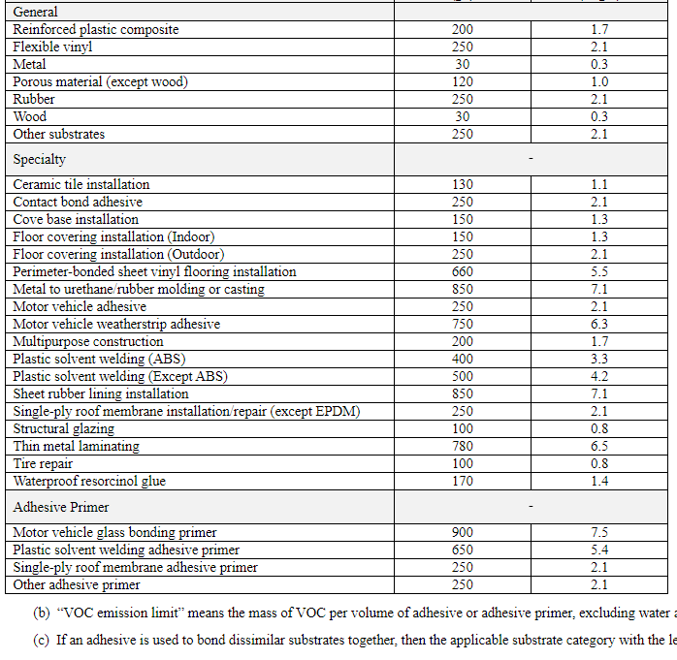

Pennsylvania 25 PA Code § 129.77. Control of emissions from the use or application of adhesives, sealants, primers and solvents.
Table V. VOC Content Limits for Adhesives, Sealants, Adhesive Primers and Sealant Primers, As Applied

Adhesive, sealant, adhesive primer or  sealant primer category | VOC content limit (pounds VOC per gallon, less water and exempt compounds)* | VOC content limit (grams VOC per liter, less water and exempt compounds)*
Adhesives
ABS welding | 3.3 | 400
Ceramic tile installation | 1.1 | 130
Computer diskette jacket manufacturing | 7.1 | 850
Contact bond | 2.1 | 250
Cove base installation | 1.3 | 150
CPVC welding | 4.1 | 490
Indoor floor covering installation | 1.3 | 150
Metal to urethane/rubber molding or casting | 7.1 | 850
Multipurpose construction | 1.7 | 200
Nonmembrane roof installation/repair | 2.5 | 300
Outdoor floor covering installation | 2.1 | 250
Perimeter bonded sheet vinyl flooring installation | 5.5 | 660
Plastic cement welding, other than ABS, CPVC or PVC welding | 4.3 | 510
PVC welding | 4.3 | 510
Sheet rubber installation | 7.1 | 850
Single-ply roof membrane installation/ repair | 2.1 | 250
Structural glazing | 0.8 | 100
Thin metal laminating | 6.5 | 780
Tire retread | 0.8 | 100
Waterproof resorcinol glue | 1.4 | 170
Sealants
Architectural | 2.1 | 250
Marine deck | 6.3 | 760
Nonmembrane roof installation/repair | 2.5 | 300
Roadway | 2.1 | 250
Single-ply roof membrane | 3.8 | 450
Other | 3.5 | 420
Adhesive Primers
Automotive glass | 5.8 | 700
Plastic cement welding | 5.4 | 650
Single-ply roof membrane | 2.1 | 250
Traffic marking tape | 1.3 | 150
Other | 2.1 | 250
Sealant Primers
Marine deck | 6.3 | 760
Nonporous architectural | 2.1 | 250
Porous architectural | 6.5 | 775
Other | 6.3 | 750
*The VOC content is determined as the weight of VOC per volume of product, less water and exempt compounds, as specified in subsections (bb) and (cc) or as the weight of VOC per volume of product, as specified in subsection (dd).

Table VI. VOC Content Limits for Adhesive or Sealant Products Applied to Particular Substrates, As Applied
Adhesive or Sealant Products  Applied to the Listed  Substrate | VOC content limit (pounds VOC per gallon, less water and exempt compounds)* | VOC content limit (grams VOC per liter, less water and exempt compounds)*
Fiberglass | 1.7 | 200
Flexible vinyl | 2.1 | 250
Metal | 0.3 | 30
Porous material | 1.0 | 120
Rubber | 2.1 | 250
Other substrates | 2.1 | 250

*The VOC content is determined as the weight of VOC per volume of product, less water and exempt compounds, as specified in subsections (bb) and (cc) or as the weight of VOC per volume of product, as specified in subsection (dd).
Pennsylvania Adhesives rule 25 Pa Code section 129.77 provides for requirements consistent with and as stringent as the New Hampshire Adhesives rule. Similar Applications have consistent standards Pennsylvania’s rule has many more categories of regulated products.
After this point New Hampshire does not have any other VOC CTG based Regulations for comparison.

Pennsylvania 25 Pa Code § 129.63b. Control of VOC emissions from large petroleum dry cleaning facilities.
New Hampshire does not appear to have a Petroleum Dry Cleaning Rule. DEP will compare its rule to Ohio’s rule.
Note:
Although Pennsylvania has a Large petroleum Dry Cleaning rule addressing RACT required for the CTG, Pennsylvania only has a small number of very small petroleum dry cleaners, whose solvent usage is in most cases, is less than 10 gallons per month which qualify them for general permits and require them to meet New Source Performance Standards. All new and future petroleum drycleaners, regardless of size, even those very small units mentioned using general permits, are subject to New Source Performance Standards. No “petroleum” dry cleaning facility in Pennsylvania currently is permitted to exceed 2.7 tons of VOC per year. If new petroleum drycleaners requiring permits for emissions exceeding 2.7 ton per year are built in PA, the RACT requirement in 129.63b would be evaluated and adjusted if necessary. As there are no current existing “Large Petroleum Dry Cleaning” facilities on which to base a new RACT evaluation, the current rule will remain in place. Additional RACT related VOC emission reductions potential for the handful of small facilities that exist in Pennsylvania is negligible.

Pennsylvania’s Rule 25 Pa Code Section § 129.63b. Control of VOC emissions from large petroleum dry cleaning facilities.
(a) Applicability. This section applies Statewide to the owner and operator of a petroleum solvent washer, dryer, solvent filter, settling tank, vacuum still and other containers and conveyors of petroleum solvent that are used in petroleum dry cleaning facilities that consume 123,000 liters (32,493 gallons) or more of petroleum solvent annually. …

Ohio’s Rule 3745-21-09 Section (BB) Petroleum dry cleaning facility.
(1) Except where exempted under paragraph (BB)(3) of this rule, no owner of operator of a petroleum dry cleaning facility may cause, allow or permit the cleaning of articles in petroleum solvent after the date specified in paragraph (C)(36) of rule 3745-21-04 of the Administrative Code unless the following is met:
(a) Any dryer for articles cleaned in petroleum solvent shall comply with one of the following:
(i) The dryer is a solvent recovery dryer which is operated in a manner such that the dryer remains closed and the solvent recovery phase continues until a final recovered solvent flow rate of 1.7 ounces per minute (fifty milliliters per minute) or less is attained.
(ii) The emission of VOC into the ambient air from the dryer does not exceed 3.5 pounds of VOC per one hundred pounds dry weight of articles cleaned, as determined under paragraph (L) of rule 3745-21-10 of the Administrative Code.
(b) Any solvent filter for petroleum solvent shall comply with one of the following:
(i) The solvent filter is a cartridge filter which is drained for at least eight hours in the filter's sealed housing before removal of any cartridge.
(ii) The filtration waste contains, before disposal and exposure to the ambient air, no more than 1.0 pound of VOC per one hundred pounds dry weight of articles cleaned, as determined under paragraph (M) of rule 3745-21-10 of the Administrative Code.
(c) Any bucket or barrel which contains petroleum solvent or petroleum solvent-laden waste shall be covered to minimize solvent evaporation.
(d) Any equipment associated with the use of petroleum solvent shall be visually inspected weekly to identify any liquid leaks of petroleum solvent.
(e) Any liquid or vapor leak of petroleum solvent shall be repaired within fifteen days after identifying the source of the leak, unless a necessary repair part is not on hand. If a repair part is not on hand, the repair part shall be ordered within three working days after identifying the source of the leak and the leak repaired within fifteen days following the delivery of the necessary repair part.
(2) Any owner or operator of a solvent recovery dryer subject to paragraph (BB)(1)(a) of this rule shall perform a test, in accordance with paragraph (N) of rule 3745-21-10 of the Administrative Code, to demonstrate the minimum length of time for operating the recovery cycle of the dryer.
(3) Paragraphs (BB)(1)(a), (BB)(1)(b), and (BB)(2) of this rule do not apply to any petroleum dry cleaning facility that meets either of the following:
(a) The total manufacturer's rated capacity of all petroleum solvent dryers is less than or equal to eighty-three pounds of articles, dry basis.
(b) The total annual consumption of petroleum solvent is less than or equal to four thousand seven hundred gallons.

Pennsylvania’s Rule for the Control of VOC emissions from large petroleum dry cleaning facilities has a higher applicability threshold than Ohio’s, but the standards are consistent with and are as stringent as Ohio’s rule. Since Pennsylvania has no existing facilities that meet its applicability threshold in Pennsylvania, nor does it have any existing facility that meets or exceeds Ohio’s current applicability threshold. Having no existing sources that currently need more than a general permit which also requires them to meet current New Sources Performance standards in 40 CFR 60 Subpart JJJ, any future petroleum dry cleaning facility will need to go through a Best Available Technology review if emissions exceed 2.7 tons of VOC per year. Such an analysis would inform DEP of the latest technology that needs to apply to this CTG category and would be used to determine and update Pennsylvania’s RACT rule including new applicability limits if needed. EPA has approved Pennsylvania as meeting a negative declaration under its proposed RACT disapproval action.

Pennsylvania 25 PA Code § 129.52. Surface coating processes. (Shipbuilding and Repair category.)
New Hampshire does not appear to have a Shipbuilding Rule. Pennsylvania made a comparison to Ohio’s Shipbuilding and Ship Repair Rule.

Pennsylvania’s Rule
Table 1. Category 12 Shipbuilding or Ship Repair

Weight of VOC per Volume of Coating Less Water and Exempt Compoundsª
 | lbs VOC per gallon  coating less water and  exempt compounds | grams VOC  per liter  coating less water and  exempt compounds
(i) General use, including coal tar epoxy coatings | 2.83 | 340
(ii) Specialty coating
(a) Air flask | 2.83 | 340
(b) Antenna | 4.42 | 530
(c) Antifoulant | 3.33 | 400
(d) Heat resistant | 3.50 | 420
(e) High-gloss | 3.50 | 420
(f) High-temperature | 4.17 | 500
(g) Inorganic zinc high build primer | 2.83 | 340
(h) Military exterior | 2.83 | 340
(i) Mist | 5.08 | 610
(j) Navigational aids | 4.58 | 550
(k) Nonskid | 2.83 | 340
(l) Nuclear | 3.50 | 420
(m) Organic zinc | 3.00 | 360
(n) Pretreatment wash primer | 6.50 | 780
(o) Repair and maintenance of thermoplastic coating of commercial vessels | 4.58 | 550
(p) Rubber camouflage | 2.83 | 340
(q) Sealant for thermal spray aluminum | 5.08 | 610
(r) Special marking | 4.08 | 490
(s) Specialty interior | 2.83 | 340
(t) Tack | 5.08 | 610
(u) Undersea weapons systems | 2.83 | 340
(v) Weld-through preconstruction primer | 5.42 | 650

Weight of VOC per Volume of Coating Solids^{c}
 | At temperature less than  4.5°C (40°F)^{d} |  | At temperature equal to  or greater than 4.5°C  (40°F)
 | lbs VOC  per gallon  coating solids | grams VOC  per liter  coating solids | lbs VOC  per gallon  coating solids | grams VOC  per liter  coating solids
(i) General use, including coal tar epoxy coatings | 6.07 | 728 | 4.76 | 571
(ii) Specialty coating
(a) Air flask | 6.07 | 728 | 4.76 | 571
(b) Antenna | 12.01 | 1,439 | 12.01 | 1,439
(c) Antifoulant | 8.10 | 971 | 6.38 | 765
(d) Heat resistant | 8.92 | 1,069 | 7.02 | 841
(e) High-gloss | 8.92 | 1,069 | 7.02 | 841
(f) High-temperature | 13.33 | 1,597 | 10.32 | 1,237
(g) Inorganic zinc high build primer | 6.07 | 728 | 4.76 | 571
(h) Military exterior | 6.07 | 728 | 4.76 | 571
(i) Mist | 18.64 | 2,235 | 18.64 | 2,235
(j) Navigational aids | 13.33 | 1,597 | 13.33 | 1,597
(k) Nonskid | 6.07 | 728 | 4.76 | 571
(l) Nuclear | 8.92 | 1,069 | 7.02 | 841
(m) Organic zinc | 6.69 | 802 | 5.26 | 630
(n) Pretreatment wash primer | 92.58 | 11,095 | 92.58 | 11,095
(o) Repair and maintenance of thermoplastic coating of commercial vessels | 13.33 | 1,597 | 13.32 | 1,597
(p) Rubber camouflage | 6.07 | 728 | 4.76 | 571
(q) Sealant for thermal spray aluminum | 18.65 | 2,235 | 18.65 | 2,235
(r) Special marking | 9.83 | 1,178 | 9.83 | 1,178
(s) Specialty interior | 6.07 | 728 | 4.76 | 571
(t) Tack | 18.65 | 2,235 | 18.65 | 2,235
(u) Undersea weapons systems | 6.07 | 728 | 4.76 | 571
(v) Weld-through preconstruction primer | 24.07 | 2,885 | 24.07 | 2,885

Ohio’s Rule 3745-21-20 | Control of volatile organic emissions from shipbuilding and ship repair operations (marine coatings).

See next page.
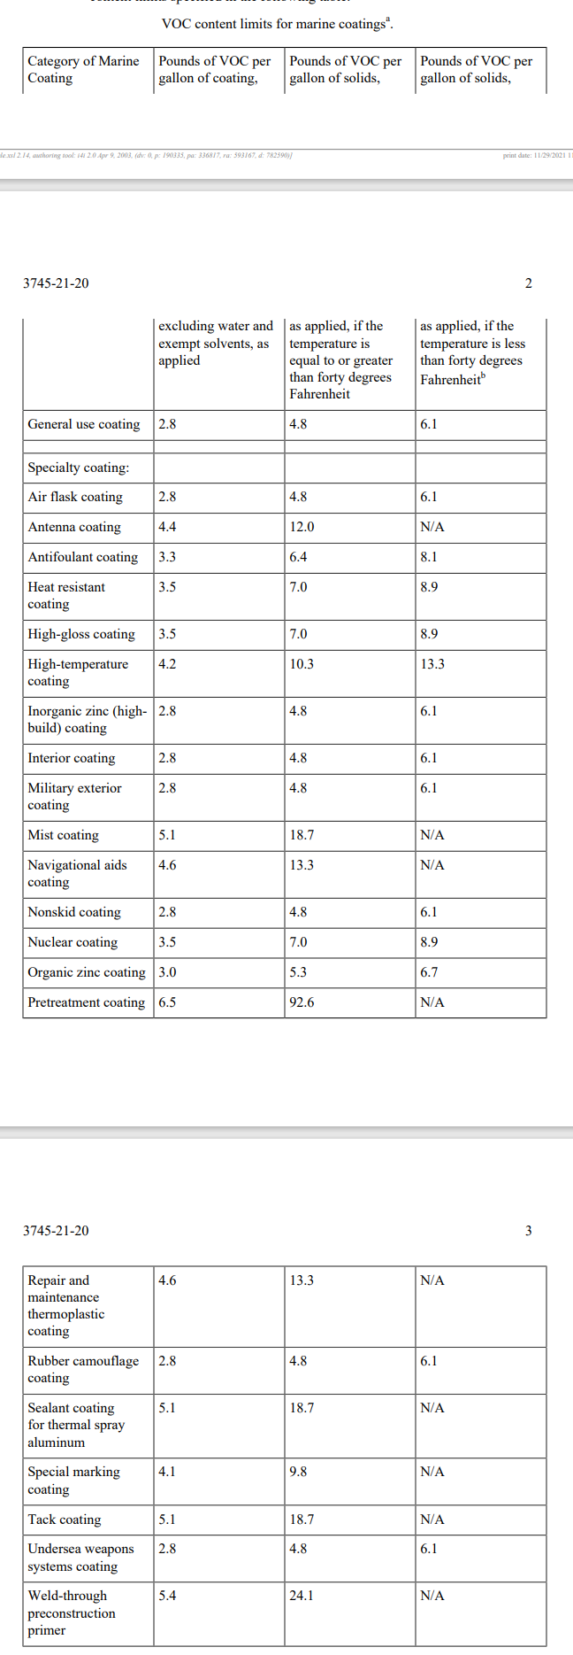

The Pennsylvania shipbuilding coating rule standards are is consistent with the Ohio ship building rule.

Note:
Prior to the 2000’s Pennsylvania had only 1 shipbuilding Facility in Philadelphia and the facility was covered under a City of Philadelphia Rule/Permit for RACT. When two additional ship building facilities in Erie and near Pittsburgh were permitted in the early 2000’s, the facilities met RACT through their permits. For the 2008 ozone NAAQS DEP did not have a specific RACT CTG rule in place for the facilities, even though they were meeting RACT requirements in permits that met or exceeded EPA’s CTG recommendations and were comparable to standards in other states as a result of the DEP permitting process. Pennsylvania the facilities permits as SIP revisions for 2008 ozone NAAQS RACT certification purposes. Pennsylvania, since then, has added a new category 12 called Ship Building and Ship repair category to the Table 1. in DEP’s 25 Pa Code Section 129.52 Surface Coating rule for RACT purposes to ensure that CTG RACT was addressed for any Shipbuilding and Ship repair facilities in the state. DEP through that rule making process did not find any new RACT requirements beyond those EPA recommended in the CTG. Federal NESHAP requirements do exist for Ship Building and Ship Repair facilities and are federal requirements, but they address Hazardous Air Pollutants and not just VOC’s, although there is some overlap. Ship Building and repair operations are also an outdoor surface coating processes subject to temperature swings throughout the year. The large size of ships also makes them not amenable to add on control equipment. None of the surface coating VOC emissions from any of these facilities exceeds the major source RACT threshold of 50 tons per year. Given the NESHAP overlap, which is a Maximum Available Control Technology (MACT) standard, the potential for additional RACT related VOC emission reductions at these facilities is unlikely. The most recent available emissions reported to DEP, [DonJon (Erie) – 12 tons of VOC in 2022.], [Heartland Fabrication _ Brownsville PA (near Pittsburgh )– 26 tons of VOC in 2022], and [Philadelphia Shipyard – 10 Tons VOC (Max) in 2021 and Philly Ship Repair – 7.5 Tons of VOC in 2021]. All these facilities are using compliant coatings and must meet record keeping and good solvent handling practices as required in 129.52.

New York’s EPA approved RACT rule for shipbuilding is found in New York Code Part 228: Part 226 Surface Coating Processes, Commercial and Industrial Adhesives, Sealants and Primers; Subpart 228: Commercial and Industrial Adhesives, Sealants and Primers. DEP was not able to find New York’s record used in EPA’s approval of this CTG based rulemaking as being consistent with Shipbuilding RACT to make a comparison. See EPA’s approval at 88 FR 77208 (November 9, 2023) for 2015 NAAQS and 82 FR 58347 (December 12, 2017) Also see page 3 of 4 in Appendix A in NY Attachment 1 “COMPLETE January 2021 RACT and ES SIP” Revision.20210128_0

Pennsylvania has developed a new rule which regulates the surface coatings identified in the Ship Building CTG It has two existing facilities that have the same conditions incorporated into the facilities permit. . New York’s rule is approved as RACT by EPA but does not regulate similar specific surface coatings per the Commercial and Industrial Adhesives, Sealants and Primers; Subpart 228 as part of its approval.

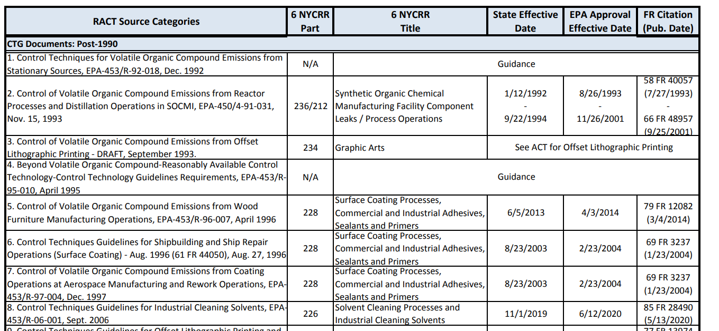

Pennsylvania’s Rule in 129.52 is as stringent as and is consistent with Ohio’s Shipbuilding and Ship Repair Rule 3745-21-20 and provides regulated categories that the EPA RACT approved NY rule does not.

Pennsylvania 25 PA Code § 129.52e. Control of VOC emissions from automobile and light-duty truck assembly coating operations and heavier vehicle coating operations.

New Hampshire did not have an equivalent regulation. DEP compared the Pennsylvania rule to Ohio‘s rule and to Michigan’s rule.

Ohio’s Rule 3745-21-29 | Control of volatile organic compound emissions from automobile and light-duty truck assembly coating operations, heavier vehicle assembly coating operations, and cleaning operations associated with these coating operations.

The Department has provided Michigan’s standards below.

Michigan’s Table 62 in R 336.1610 Existing coating lines; emission of volatile organic compounds from existing automobile, light-duty truck, and other product and material coating lines.

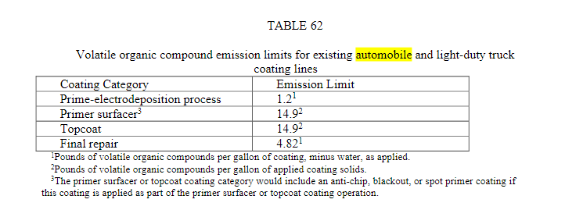

Pennsylvania 25 PA Code § 129.52e. Table I. VOC Content Limits for Primary Assembly Coatings
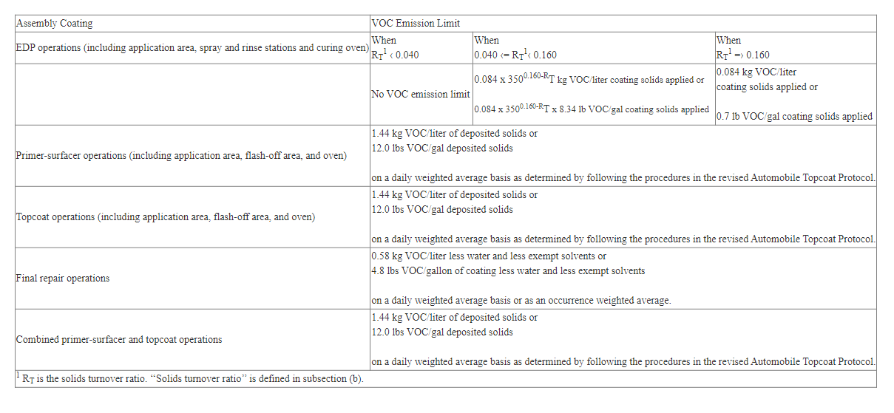
Pennsylvania 25 PA Code § 129.52e. Table II. VOC Content Limits for Additional Assembly Coatings
(grams of VOC per liter of coating excluding water and exempt compounds) as Applied
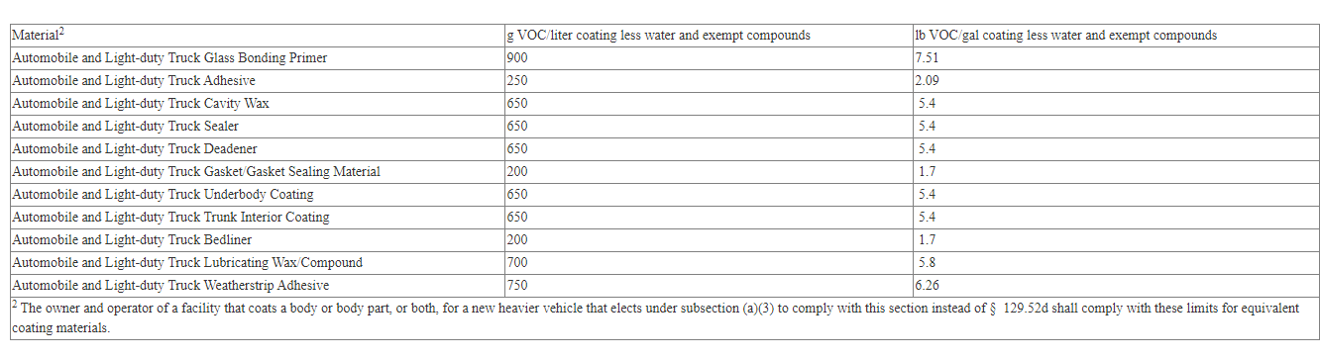

6 CRR-NY 228-1.4
228-1.4 Requirements for controlling VOC emissions using compliant materials.
(b) Class B coating line.
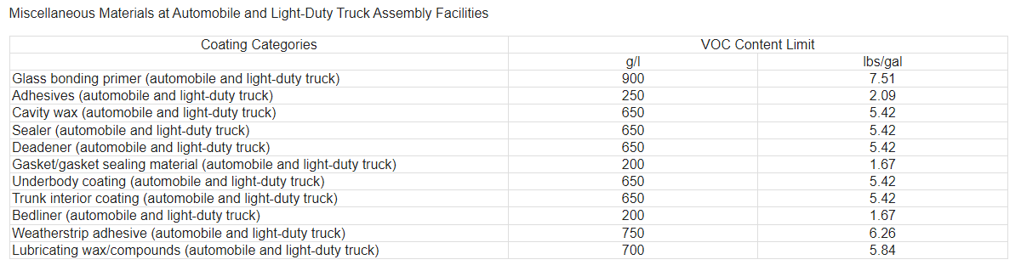

Pennsylvania’s 25 PA Code § 129.52e Control of VOC emissions from automobile and light-duty truck assembly coating operations and heavier vehicle coating operations is as stringent and more stringent and more comprehensive than Michigan’s automobile, light-duty truck, rule and it is consistent with and as stringent as Ohio’s Rule, referenced above, as well. Pennsylvania’s Coating standards are also consistent with the coating Content Limits for Additional Assembly Coatings in the EPA RACT approved New York rule.

Pennsylvania 25 PA Code § 129.55. Petroleum refineries—specific sources

New Hampshire did not have a rule for this type of refinery operation. Pennsylvania compared its regulation to 3 of Michigan’s rules covering the same CTG Category.

Pennsylvania compared its Regulations to Michigan’s Rules.

Michigan Rules
R 336.1615 Existing vacuum-producing systems at petroleum refineries.
R 336.1616 Process unit turnarounds at petroleum refineries.
R 336.1617 Existing organic compound-water separators at petroleum refineries.

Pennsylvania
§ 129.55. Petroleum refineries—specific sources.
(a) Wastewater separators. No person may permit the use of a compartment of a single or multiple compartment volatile organic compound wastewater separator which compartment receives effluent water containing 200 gallons a day or more of any volatile organic compound from equipment processing, refining, treating, storing or handling volatile organic compounds unless the compartment is equipped with one of the following vapor loss control devices—properly installed, in good working order, and in operation—as follows:
(1) A container having openings sealed and totally enclosing the liquid contents. Gauging and sampling devices shall be gas-tight except when gauging or sampling is taking place.
(2) A container equipped with a floating roof—consisting of a pontoon-type roof, double-deck-type roof or internal floating cover—which will rest on the surface of the contents and be equipped with a closure seal or seals to close the space between the roof edge and container wall. Gauging and sampling devices shall be gas-tight except when gauging or sampling is taking place.
(b) Pumps and compressors. Pumps and compressors handling volatile organic compounds with a vapor pressure of greater than 1.5 psi (10.3 kilopascals) at actual conditions shall have mechanical seals. For the purpose of determining vapor pressure, a temperature no greater than 100° F shall be used.
(c) Vacuum-producing systems. Vacuum producing systems shall conform with the following:
(1) The owner or operator of any vacuum-producing systems at a petroleum refinery may not permit the emission of volatile organic compounds from the condensers, hot wells or accumulators of the system.
(2) The emission limit under paragraph (1) shall be achieved by one of the following:
(i) Piping the vapors to a firebox or incinerator.
(ii) Compressing the vapors and adding them to the refinery fuel gas.
(iii) A method approved by the Department which recovers no less than 90% by weight of uncontrolled volatile organic compounds that would otherwise be emitted to the atmosphere.
(d) Process unit turnarounds. Purging of volatile organic compounds during depressurization of reactors, fractionating columns, pipes or vessels during unit shutdown, repair, inspection or startup shall be performed in such a manner as to direct the volatile organic vapors to a fuel gas system, flare or vapor recovery system until the internal pressure in such equipment reaches 19.7 psia (136 kilopascals).

6 CRR-NY 223.7
223.7 Volatile organic compound emissions.
(b) All non-condensable vapors from any vacuum-producing system shall be piped to a firebox or afterburner, or compressed and added to refinery fuel gas. All hot wells associated with contact condensers shall be covered and the vapors shall be treated with an afterburner.
(c) All forebays and separator sections which recover 200 gallons per day or more of volatile organic compounds shall be designed to prevent the escape of volatile organic compounds.
(d) During process unit turnaround, processing units shall be depressurized down to 5 psig and the volatile organic compounds shall be vented to a vapor recovery system or to the fuel gas system, or flared.
223.9 Monitoring of confined process emissions and operations. See requirements for pump and compressor monitoring.

Pennsylvania’s 25 PA Code § 129.55 Control of VOC emissions from Petroleum refineries—specific sources rule is consistent with Michigan’s 3 rules. Note: The New York rule has similar requirements for three of the categories in PA’s rule however it seems to do monitoring rather than require a mechanical seal at pumps and compressors.

Pennsylvania’s 25 PA Code § 129.58. Petroleum refineries—fugitive sources.

New Hampshire did not have a comparable rule. DEP will compare the Department’s rule with that of Michigan.

Michigan’s Rule - R 336.1622 Emission of volatile organic compounds from existing components of
petroleum refineries; refinery monitoring program.

(3) Except for the visual inspections required by subrule (2)(c) of this rule, all inspections
must be performed using equipment and procedures as specified in 40 CFR part 60, appendix A,
method 21, adopted by reference in R 336.1902. A component is leaking when a concentration of
more than 10,000 ppm, by volume, as methane or hexane, is measured by method 21.

Pennsylvania’s Rule
25 PA Code § 129.58. Petroleum refineries—fugitive sources
(2) Record leaking refinery components which have a VOC concentration exceeding 10,000 ppm when tested in accordance with the provisions of § 139.14 (relating to emissions of VOCs) and place an identifying tag on each refinery component consistent with the provisions in subsection (d)(3).

Pennsylvania’s Petroleum refineries—fugitive sources rule has the same leak threshold and is consistent with Michigan’s Rule. It also has the same leak threshold as the New York rule at 10,000 ppm. Action is required above the threshold. See 223.9 Monitoring of confined process emissions and operations. See requirements for pump and compressor monitoring mentioned above in Petroleum Refineries.

Pennsylvania’s Rule 25 PA Code § 129.68. Manufacture of synthesized pharmaceutical products.
New Hampshire does not appear to have a similar rule for comparison.

§ 129.68. Manufacture of synthesized pharmaceutical products.
(a) This section applies to synthesized pharmaceutical manufacturing facilities.
(b) The owner or operator of a synthesized pharmaceutical manufacturing facility subject to this section shall control the VOC emissions from reactors, distillation operations, crystallizers, centrifuges and vacuum dryers that emit 15 pounds per day or more of VOC. Surface condensers or equivalent controls shall be used if:
(1) Surface condensers are used, the condenser outlet gas temperature may not exceed:
(i) -25°C when condensing VOC of vapor pressure greater than 5.8 psi (40 kilopascals) when measured at 68°F.
(ii) -15°C when condensing VOC of vapor pressure greater than 2.9 psi (20 kilopascals) when measured at 68°F.
(iii) 0°C when condensing VOC of vapor pressure greater than 1.5 psi (10 kilopascals) when measured at 68°F.
(iv) 10°C when condensing VOC of vapor pressure greater than 1 psi (7 kilopascals) when measured at 68°F.
(v) 25°C when condensing VOC of vapor pressure greater than .5 psi (3.5 kilopascals) when measured at 68°F.
(2) Equivalent controls are used, the VOC emissions shall be reduced by an equivalent or greater amount than would be required in paragraph (1).
(c) The owner or operator of a synthetic pharmaceutical manufacturing facility subject to this section shall reduce the VOC emissions from air dryers and production equipment exhaust systems:
(1) By at least 90% if emissions are 220 pounds per day (100 kilograms per day) or more of VOC.
(2) To 33 pounds per day or less if emissions are less than 220 pounds per day of VOC.
(d) The owner or operator of a synthesized pharmaceutical manufacturing facility subject to this section shall enclose centrifuges, rotary vacuum filters and other filters having an exposed liquid surface, where the liquid contains VOC and exerts a total VOC vapor pressure of .5 psi (3.5 kilopascals) or more at 20°C.
(e) The owner or operator of a synthesized pharmaceutical facility subject to this section shall install covers on in-process tanks containing a VOC at any time. These covers shall remain closed, unless production, sampling, maintenance or inspection procedures require operator access.
(f) The owner or operator of a synthesized pharmaceutical manufacturing facility subject to this section shall repair leaks from which a liquid, containing VOC, can be observed running or dripping. The repair shall be completed the first time the equipment is off-line for a period of time long enough to complete the repair.

Michigan’s Rule - R 336.1625 Emission of volatile organic compound from existing equipment utilized in manufacturing synthesized pharmaceutical products.

Part 233 Pharmaceutical and Cosmetic Manufacturing Processes
6 CRR-NY 233.3
233.3 Control requirements.

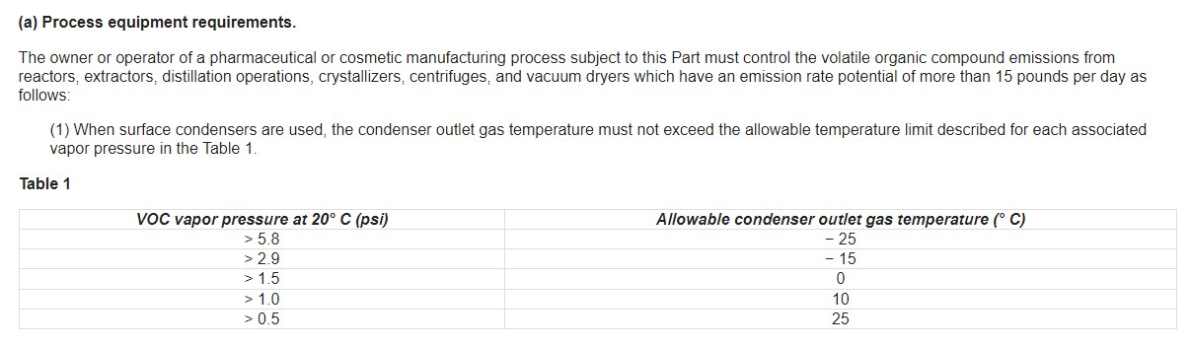

Pennsylvania’s manufacture of synthesized pharmaceutical products rule is consistent with and as stringent as the standards found in Michigan’s emissions of volatile organic compound from existing equipment utilized in manufacturing synthesized pharmaceutical products Rule. Pennsylvania’s rule is also consistent with EPA’s RACT approved New York Rule indicated above.

Pennsylvania 25 PA Code § 129.69. Manufacture of pneumatic rubber tires.
New Hampshire does not appear to have a Pneumatic rubber tire rule for comparison. DEP will compare rules with Ohio.

§ 129.69. Manufacture of pneumatic rubber tires.

(a) This section applies to pneumatic rubber tire manufacturing facilities. For purposes of this section, pneumatic rubber tire manufacturing means the production of pneumatic rubber passenger-type tires on a mass production basis. Passenger-type tires are agricultural, airplane, industrial, mobile home, light- or medium-duty truck or passenger vehicle tires with bead diameters up to 20 inches (50.8 centimeters) and cross-sectional dimensions up to 12.8 inches (32.5 centimeters). With prior written approval from the Department, the production of speciality tires for antique or other vehicles when produced on an irregular basis or with short production runs and when produced on equipment separate from normal production lines for passenger-type tires are exempt from the requirements of this section.
(b) The owner or operator of an undertread cementing, tread-end cementing or bead dipping operation subject to this section shall comply with the following:
(1) Install and operate a capture system designed to achieve maximum reasonable capture, of at least 85% by weight of VOC emitted, from undertread cementing, tread-end cementing and bead dipping operations. Maximum reasonable capture shall be consistent with the following documents:
(i) Industrial Ventilation, A Manual of Recommended Practices, 14th Edition, American Federation of Industrial Hygienists.
(ii) Recommended Industrial Ventilation Guidelines, United States Department of Human Services National Institute of Occupational Safety and Health.
(2) Install and operate a control device that meets the requirements of one of the following:
(i) A carbon adsorption system designed and operated in a manner so that there is at least a 95% removal of VOC by weight from the gases ducted to the control device.
(ii) An incineration system that oxidizes at least 90% of the nonmethane VOCs which enter the incinerator to carbon dioxide and water.
(c) The owner or operator of a green-tire spraying operation subject to this section shall implement one of the following means of reducing VOC emissions:
(1) Substitute water-based sprays for the normal solvent-based mold release compound.
(2) Install a capture system designed and operated in a manner that will capture and transfer at least 90% of the VOC emitted by the green-tire spraying operation to a control device that meets the requirements in subsection (b)(2).
(d) Notwithstanding the provisions of this section, the Department may allow a pneumatic rubber tire manufacturing facility to implement permanent and enforceable measures, including recordkeeping and reporting requirements, which are approved by the Department and the EPA as reasonably available control technology.

Ohio’s Rule 3745-21-09 Section (X) Rubber tire manufacturing facility.
(1) Except where exempted under paragraph (X)(2) of this rule, each owner or operator of a rubber tire manufacturing facility shall comply with the following no later than the date specified in paragraph (C)(31) of rule 3745-21-04 of the Administrative Code:
(a) Each undertread cementing, tread end cementing and bead dipping operation is to be equipped with a capture system and associated control system which are designed and operated with the following efficiencies for VOCs, as determined under paragraph (C) of rule 3745-21-10 of the Administrative Code:
(i) A capture efficiency which is at least eighty-five per cent by weight.
(ii) A control efficiency which is at least ninety per cent by weight.
(b) Except as otherwise provided in paragraph (X)(1)(c) of this rule, each green tire spraying operation is to be equipped with a capture system and associated control system which are designed and operated with the following efficiencies for VOCs, as determined under paragraph (C) of rule 3745-21-10 of the Administrative Code:
(i) A capture efficiency which is at least ninety per cent by weight.
(ii) A control efficiency which is at least ninety per cent by weight.
(c) Paragraph (X)(1)(b) of this rule does not apply to any green tire spraying operation in which the VOC content of the material sprayed, as determined in accordance with paragraph (B) of rule 3745-21-10 of the Administrative Code, is a maximum daily weighted average of six per cent or less by weight for material sprayed on the inside of a tire and eleven per cent or less by weight for material sprayed on the outside of a tire. …

Pennsylvania’s Manufacture of Pneumatic rubber tires rule is consistent with and as stringent as Ohio’s Rubber tire manufacturing rule.

Pennsylvania’s 25 Pa Code § 129.71. Synthetic organic chemical and polymer manufacturing—fugitive sources.
New Hampshire does not appear to have this type of SOCMI rule so Pennsylvania will compare its rule to Michigan

§ 129.71. Synthetic organic chemical and polymer manufacturing—fugitive sources.
(a) This section applies to surface active agent manufacturing facilities subject to § 129.72 (relating to manufacture of surface active agents) and to a facility with design capability to manufacture 1,000 tons per year or more of one or a combination of the following:
(1) Synthetic organic chemicals listed in 40 CFR 60.489 (relating to list of chemicals provided by affected facilities).
(2) Methyl tert-butyl ether.
(3) Polyethylene.
(4) Polypropylene.
(5) Polystyrene.
(b) Exempt from this section are systems operated entirely under a vacuum, or process fluids that contain less than 10% by weight of VOCs and systems in service handling compounds with vapor pressures less than 0.044 psia at 68° F.
(c) The owner or operator of a newly affected facility shall complete the following by May 24, 1993.
(1) Install a second valve, blind flange, plug, cap or other equivalent sealing system on open ended lines, except for safety pressure relief valves.
(2) Develop and initiate a leak detection program including liquid leaks for pumps, valves, compressors, vessels and safety pressure relief valves and a repair program for these components that cause a hydrocarbon detection instrument reading equal to or greater than 10,000 ppm. The leak detection and repair program shall include the following: …

Michigan’s Rule - R 336.1628 Emission of volatile organic compounds from components of existing process equipment used in manufacturing synthetic organic chemicals and polymers; monitoring program.
Rule 628. (1) A person shall not cause or allow the emission of a volatile organic compound from a component of existing manufacturing process equipment at a synthetic organic chemical and polymer manufacturing plant located in any of the following counties, unless the provisions of subrules (2) to (16) of this rule are met or unless an equivalent control method, as approved by the department under R 336.1602(2), including the control method described in “Standards of Performance for Equipment Leaks of VOC in the Synthetic Organic Chemicals Manufacturing Industry for which Construction, Reconstruction, or Modification Commenced After January 5, 1981, and on or Before November 7, 2006,” 40 CFR part 60, subpart VV adopted by reference in R 336.1902, is implemented: …

New York’s Part 236 Synthetic Organic Chemical Manufacturing Facility Component Leaks covers all of its SOCMI facilities

236.1 Definitions.
(10) Leak. The emission of a chemical listed in section 236.8, table 1, of this Part at a concentration greater than or equal to 10,000 parts per million by volume (ppmv) as shown by monitoring. An indication of liquids dripping shall also be considered a leak.

236.2 Applicability.
(a) Any owner or operator of a synthetic organic chemical manufacturing facility where such chemicals were being produced prior to the effective date of this Part, must:
(1) prepare a leak detection and repair plan in accordance with section 236.5 of this Part; and
(2) be in compliance with the provisions of this Part within 180 days of the effective date of this Part.
(b) Any owner or operator of a synthetic organic chemical manufacturing facility where such chemicals are first manufactured on or after the effective date of this Part is required to demonstrate compliance with this Part upon start-up.
(c) Components subject to Federal regulations which require either an equal or more stringent leak detection and repair program (i.e., equivalent or lower definition of leak and equivalent or more frequent monitoring requirements), or equal or more stringent equipment specifications, are deemed to be in compliance with the provisions of this Part contingent on the source owner or operator complying with such Federal regulations.

236.3 Control requirements.
(a) Any owner or operator of a synthetic organic chemical manufacturing facility must monitor each of the following process unit components for leaks, on a quarterly schedule:
(1) each pump in light liquid service;
(2) each compressor in gas/vapor service;
(3) each pressure relief valve in gas/vapor service;
(4) each valve in light liquid service; and
(5) each valve in gas/vapor service.
(b) Leaks detected in any of the monitored components must be repaired in accordance with the provisions set forth in section 236.4 of this Part.

Note: New York’s Part 236 Synthetic Organic Chemical Manufacturing Facility Component Leaks covers all of its SOCMI facilities is a general SOCMI Components leak rule to address all SOCMI facilities.

Pennsylvania and Michigan and New York have the same leak detection thresholds of 10,000 ppm. Pennsylvania’s rule is consistent with New York’s Michigan’s RACT rules for this CTG source category.

§ 129.71a. Control of VOC emissions from the synthetic organic chemical manufacturing industry—air oxidation, distillation and reactor processes.

New Hampshire has no comparable rule as it did a negative declaration on this CTG source category.

This Pennsylvania rule addresses Control of Volatile Organic Compound Emissions from Air Oxidation Processes in Synthetic Organic Chemical Manufacturing Industry and Control of Volatile Organic Compound Emissions from Reactor Processes and Distillation Operations in Synthetic Organic Chemical Manufacturing Industry. Pennsylvania developed a rule that uses EPA’s new source performance standards as the basis for the these CTG RACT regulations regulation by applying the NSPS language and requirements of 40 CFR 60 Subpart RRR, 40 CFR 60 Subpart NNN, and 40 CFR 60 Subpart III to all CTG Distillation, Reactor, and Air Oxidation processes and the associated chemicals listed in those CTGs. Since NSPS has a total resources effectiveness (TRE) index value higher than the TRE value indicated as a RACT threshold in the CTGs, the NSPS language applied across all of Pennsylvania’s existing units requires 98% control be applied to more units. This makes Pennsylvania’s current RACT for these processes more stringent than the proposed recommendations under the CTGs.
Ohio - Rule 3745-21-09 | Control of emissions of volatile organic compounds from stationary sources and perchloroethylene from dry cleaning facilities.
Section (EE) – Air oxidation processes that produce organic chemicals.
(EE) Air oxidation processes that produce organic chemicals.
(1) Except where exempted under paragraph (EE)(2) of this rule, no owner or operator of an air oxidation process that produces an organic chemical identified in appendix A to this rule may cause, allow or permit the discharge into the ambient air of VOC from any process vent stream after the date specified in paragraph (C)(39) of rule 3745-21-04 of the Administrative Code unless the process vent stream is vented to a combustion device that is designed and operated to do either of the following:
(a) To reduce the VOC emissions vented to the combustion device with an efficiency of at least ninety-eight per cent by weight.
(b) To emit VOC at a concentration less than twenty parts per million by volume, dry basis.
(2) Exemptions.
(a) Any process vent stream which is vented to a combustion device for which construction commenced prior to May 9, 1986, is exempt from paragraph (EE)(1) of this rule, provided the combustion device is operated and maintained in accordance with design specifications and good engineering practices. This exemption terminates for such process vent stream if the combustion device is replaced with new control equipment for which construction commenced on or after May 9, 1986.
(b) Any process vent stream or combination of process vent streams which has a total resource effectiveness value greater than 1.0 is exempt from paragraph (EE)(1) of this rule. If an air oxidation process has more than one process vent stream, the total resource effectiveness is based upon a combination of the process vent streams.

Ohio - Rule 3745-21-13 | Control of volatile organic compound emissions from reactors and distillation units employed in SOCMI chemical production.
(D) Determination of group status and halogen status for process vents of reactors and distillation units.
(1) (Group status) The owner or operator of a reactor or distillation unit shall determine the group status (i.e., group 1, group 2A, or group 2B) for each process vent based on flow rate, VOC concentration, and TRE index value in accordance with paragraphs (D)(3) to (D)(5) of this rule and the procedures contained in paragraph (E) of this rule. Group 1 process vents require control for VOC, and group 2A and group 2B process vents do not. Group 1 process vents require monitoring of control devices, except for boilers or process heaters specified under paragraphs (F)(1)(b) and (F)(1)(c) of this rule, and require monitoring of bypass lines. Group 2A process vents require monitoring of the associated recovery systems, and group 2B process vents do not require any monitoring.
(2) (Halogen status) The owner or operator of a group 1 process vent which is controlled (or to be controlled) by a combustion device shall determine the halogen status in accordance with the procedures specified in paragraph (E)(7) of this rule. Group 1 process vents that are halogenated process vents being discharged to a combustion device require halogen reduction control (either a pre-combustion or post-combustion).
(3) (Group 1) A process vent shall be group 1 if it meets at least one of the following specifications:
(a) The owner or operator designates the process vent as group 1.
(b) At representative operating conditions expected to yield the lowest TRE index value for the process vent, the TRE index value is less than or equal to 1.0, the flow rate is equal to or greater than 0.30 scfm, and the VOC concentration is equal to or greater than five hundred ppmv.
(4) (Group 2A) A process vent shall be group 2A if it is from a recovery system and if, at representative operating conditions expected to yield the lowest TRE index value for the process vent, the TRE index value is greater than 1.0 and less than or equal to 4.0, the flow rate is equal to or greater than 0.30 scfm, and the VOC concentration is equal to or greater than five hundred ppmv.
(5) (Group 2B) A process vent shall be group 2B if it meets any one of the following specifications:
(a) The process vent has a flow rate less than 0.30 scfm.
(b) The process vent has a VOC concentration less than five hundred ppmv.
(c) The process vent is not from a recovery system and, at representative operating conditions expected to yield the lowest TRE index value for the process vent, the TRE index value is greater than 1.0.
(d) The process vent is from a recovery system and, at representative operating conditions expected to yield the lowest TRE index value for the process vent, the TRE index value is greater than 4.0.

New York’s Part 236 Synthetic Organic Chemical Manufacturing Facility Component Leaks covers all of its SOCMI facilities

236.1 Definitions.
(10) Leak. The emission of a chemical listed in section 236.8, table 1, of this Part at a concentration greater than or equal to 10,000 parts per million by volume (ppmv) as shown by monitoring. An indication of liquids dripping shall also be considered a leak.

236.2 Applicability.
(a) Any owner or operator of a synthetic organic chemical manufacturing facility where such chemicals were being produced prior to the effective date of this Part, must:
(1) prepare a leak detection and repair plan in accordance with section 236.5 of this Part; and
(2) be in compliance with the provisions of this Part within 180 days of the effective date of this Part.
(b) Any owner or operator of a synthetic organic chemical manufacturing facility where such chemicals are first manufactured on or after the effective date of this Part is required to demonstrate compliance with this Part upon start-up.
(c) Components subject to Federal regulations which require either an equal or more stringent leak detection and repair program (i.e., equivalent or lower definition of leak and equivalent or more frequent monitoring requirements), or equal or more stringent equipment specifications, are deemed to be in compliance with the provisions of this Part contingent on the source owner or operator complying with such Federal regulations.

236.3 Control requirements.
(a) Any owner or operator of a synthetic organic chemical manufacturing facility must monitor each of the following process unit components for leaks, on a quarterly schedule:
(1) each pump in light liquid service;
(2) each compressor in gas/vapor service;
(3) each pressure relief valve in gas/vapor service;
(4) each valve in light liquid service; and
(5) each valve in gas/vapor service.
(b) Leaks detected in any of the monitored components must be repaired in accordance with the provisions set forth in section 236.4 of this Part.

Note: New York’s Part 236 Synthetic Organic Chemical Manufacturing Facility Component Leaks covers all of its SOCMI facilities is a general SOCMI Components leak rule to address all SOCMI facilities.

Pennsylvania’s rule is more stringent than the Ohio rules for Air Oxidation, Distillation and Reactor processes and provides for the correct RACT standards for Pennsylvania sources. EPA’s RACT approved NY SOCMI Rule - New York’s Part 236 Synthetic Organic Chemical Manufacturing Facility Component Leaks covers all of its SOCMI facilities in its 236.2 Applicability provides in subsection (c) Components subject to Federal regulations which require either an equal or more stringent leak detection and repair program (i.e., equivalent or lower definition of leak and equivalent or more frequent monitoring requirements), or equal or more stringent equipment specifications, are deemed to be in compliance with the provisions of this Part contingent on the source owner or operator complying with such Federal regulations. As indicated above PA has adopted the NSPS regulation as its RACT regulation and has applied it to all the chemicals and processes covered under the CTG recommendation. The only air oxidation unit installed prior to the mid 2000’s was Geo Specialties Chemical’s air oxidation process installed in the 1970’s. It currently emits 8 tons of VOC per year after controlling 95% of its emissions with a catalytic incinerator. The cost of reducing emissions by 5 tons per year at that facility would require tearing out and installing a new catalytic incinerator with a 98% efficiency. The capital cost of the new incinerator alone would be nearly 1 million dollars before any other costs are included. Assuming a zero percent interest rate the cost of control would be over 10, 000 dollars per ton. This is not RACT. Thus, DEP chose to exempt this and any similar sources from the 98% efficiency requirement in its SOCMI rule. It is still subject to all other requirements of the rule. Except for Geo Specialty Chemicals, DEP has determined that for the remaining air oxidation, reactors and distillation processes in Pennsylvania that RACT installed since the mid 2000’s and later and operating controls at 98% efficiency and above, the current requirements in NSPS are RACT. The newest air oxidation process at the Shell facility in western PA is subject to LAER which requires a control device efficiency of at least 99 %. EPA has approved the same NSPS requirements as RACT for New York and as RACT in the City of Philadelphia. Pennsylvania’s SOCMI rule is consistent with and as stringent as EPA’s RACT approved New York rule and EPA’s RACT approved Philadelphia rule.

Pennsylvania 25 PA Code § 129.73. Aerospace manufacturing and rework.

New Hampshire does not have a comparable regulation.
Ohio’s rule will be used for comparison. Ohio’s Rule 3745-21-19 | Control of volatile organic compound emissions from aerospace manufacturing and rework facilities.

Pennsylvania
(3) Beginning April 10, 1999, a person may not apply to aerospace vehicles or components, aerospace specialty coatings, primers, topcoats and chemical milling maskants including VOC-containing materials added to the original coating supplied by the manufacturer, that contain VOCs in excess of the limits specified in Table II.
(i) Aerospace coatings that meet the definitions of the specific coatings in Table II shall meet those allowable coating VOC limits.
(ii) All other aerospace primers, aerospace topcoats and chemical milling maskants are subject to the general coating VOC limits for aerospace primers, aerospace topcoats and aerospace chemical milling maskants.

Pennsylvania Table
TABLE II
Allowable Content of VOCs in Aerospace Coatings
Weight of VOC Per Volume of Coating (Minus Water and Exempt Solvents)

 | LIMIT
COATING TYPE | POUNDS  PER  GALLON | GRAMS  PER  LITER
Specialty Coatings
(1) Ablative Coating | 5.0 | 600
(2) Adhesion Promoter | 7.4 | 890
(3) Adhesive Bonding Primers:
(a) Cured at 250°F or below | 7.1 | 850
(b) Cured above 250°F | 8.6 | 1,030
(4) Adhesives:
(a) Commercial Interior Adhesive | 6.3 | 760
(b) Cyanoacrylate Adhesive | 8.5 | 1,020
(c) Fuel Tank Adhesive | 5.2 | 620
(d) Nonstructural Adhesive | 3.0 | 360
(e) Rocket Motor Bonding Adhesive | 7.4 | 890
(f) Rubber-Based Adhesive | 7.1 | 850
(g) Structural Autoclavable Adhesive | 0.5 | 60
(h) Structural Nonautoclavable Adhesive | 7.1 | 850
(5) Antichafe Coating | 5.5 | 660
(6) Chemical Agent-Resistant Coating | 4.6 | 550
(7) Clear Coating | 6.0 | 720
(8) Commercial Exterior Aerodynamic Structure Primer | 5.4 | 650
(9) Compatible Substrate Primer | 6.5 | 780
(10) Corrosion Prevention Compound | 5.9 | 710
(11) Cryogenic Flexible Primer | 5.4 | 645
(12) Cryoprotective Coating | 5.0 | 600
(13) Electric or Radiation-Effect Coating | 6.7 | 800
(14) Electrostatic Discharge and Electromagnetic Interference (EMI) Coating | 6.7 | 800
(15) Elevated Temperature Skydrol Resistant Commercial Primer | 6.2 | 740
(16) Epoxy Polyamide Topcoat | 5.5 | 660
(17) Fire-Resistant (Interior) Coating | 6.7 | 800
(18) Flexible Primer | 5.4 | 640
(19) Flight-Test Coatings:
(a) Missile or Single Use Aircraft | 3.5 | 420
(b) All Other | 7.0 | 840
(20) Fuel-Tank Coating | 6.0 | 720
(21) High-Temperature Coating | 7.1 | 850
(22) Insulation Covering | 6.2 | 740
(23) Intermediate Release Coating | 6.2 | 750
(24) Lacquer | 6.9 | 830
(25) Maskants:
(a) Bonding Maskant | 10.2 | 1,230
(b) Critical Use and Line Sealer Maskant | 8.6 | 1,020
(c) Seal Coat Maskant | 10.2 | 1,230
(26) Metallized Epoxy Coating | 6.2 | 740
(27) Mold Release | 6.5 | 780
(28) Optical Anti-Reflective Coating | 6.2 | 750
(29) Part Marking Coating | 7.1 | 850
(30) Pretreatment Coating | 6.5 | 780
(31) Rain Erosion-Resistant Coating | 7.1 | 850
(32) Rocket Motor Nozzle Coating | 5.5 | 660
(33) Scale Inhibitor | 7.3 | 880
(34) Screen Print Ink | 7.0 | 840
(35) Sealants:
(a) Extrudable/Rollable/Brushable Sealant | 2.0 | 240
(b) Sprayable Sealant | 5.0 | 600
(36) Self-Priming Topcoat | 3.5 | 420
(37) Silicone Insulation Material | 7.1 | 850
(38) Solid Film Lubricant | 7.3 | 880
(39) Specialized Function Coating | 7.4 | 890
(40) Temporary Protective Coating | 2.7 | 320
(41) Thermal Control Coating | 6.7 | 800
(42) Wet Fastener Installation Coating | 5.6 | 675
(43) Wing Coating | 7.1 | 850
Aerospace Primers, Aerospace Topcoats and Aerospace Chemical Milling Maskants
(1) Primers | 2.9 | 350
(2) Topcoats | 3.5 | 420
(3) Chemical Milling Maskants (Type I/II) | 1.3 | 160

Ohio Rule
(a) VOC content limits for primers, topcoats, and chemical milling maskants.
Type of coating | VOC content limit (pounds of VOC per gallon of coating, excluding water and exempt solvents, as applied)
Primer | 2.9
Primer for general aviation rework facility | 4.5
Exterior primer for large commercial aircraft (components or fully assembled) | 5.4
Topcoat | 3.5
Topcoat for general aviation rework facility | 4.5
Self-priming topcoat | 3.5
Self-priming topcoat for general aviation rework facility | 4.5
Chemical milling maskant, type I | 5.2
Chemical milling maskant, type II | 1.3

(b) VOC content limits for specialty coatings.
Type of specialty coating | VC content limit (pounds of VOC per gallon of coating, excluding water and exempt solvents, as applied)
Ablative coating | 5.0
Adhesion promoter | 7.4
Adhesive bonding primer cured above two hundred fifty degrees Fahrenheit | 8.6
Adhesive bonding primer cured at two hundred fifty degrees Fahrenheit or below | 7.1
Antichafe coating | 5.5
Bearing coating | 5.2
Bonding maskant | 10.3
Caulking and smoothing compounds | 7.1
Chemical agent-resistant coating | 4.6
Clear coating | 6.0
Commercial exterior aerodynamic structure primer | 5.4
Commercial interior adhesive | 6.3
Compatible substrate primer | 6.5
Corrosion prevention compound | 5.9
Critical use and line sealer maskant | 8.5
Cryogenic flexible primer | 5.4
Cryoprotective coating | 5.0
Cyanoacrylate adhesive | 8.5
Dry lubricative material | 7.3
Electric or radiation-effect coating | 6.7
Electrostatic discharge and electromagnetic interference (EMI) coating | 6.7
Elevated temperature Skydrol-resistant commercial primer | 6.2
Epoxy polyamide topcoat | 5.5
Fire-resistant (interior) coating | 6.7
Flexible primer | 5.3
Flight test coatings;all other | 7.0
Flight test coatings: missile or single use aircraft | 3.5
Fuel tank adhesive | 5.2
Fuel tank coating | 6.0
High temperature coating | 7.1
Insulation covering | 6.2
Intermediate release coating | 6.3
Lacquer | 6.9
Metallized epoxy coating | 6.2
Mold release | 6.5
Nonstructural adhesive | 3.0
Optical anti-reflective coating | 6.3
Part marking coating | 7.1
Pretreatment coating | 6.5
Rain erosion-resistant coating | 7.1
Rocket motor bonding adhesive | 7.4
Rocket motor nozzle coating | 5.5
Rubber-based adhesive | 7.1
Scale inhibitor | 7.3
Screen print ink | 7.0
Seal coat maskant | 10.3
Sealants: extrudable, rollable, or brushable sealant | 2.3
Sealants: sprayable sealant | 5.0
Silicone insulation material | 7.1
Solid film lubricant | 7.3
Specialized function coating | 7.4
Structural autoclave adhesive | 0.5
Structural nonautoclavable adhesive | 7.1
Temporary protective coating | 2.7
Thermal control coating | 6.7
Wing coating | 7.1
Wet fastener installation coating | 5.6

Pennsylvania’s Aerospace manufacturing and rework rule is consistent with, as stringent as or more stringent than Ohio’s Aerospace and rework rule.

Pennsylvania’s Rules § 129.121. through § 129.140

Pennsylvania’s Rules
CONTROL OF VOC EMISSIONS FROM UNCONVENTIONAL OIL AND NATURAL GAS SOURCES
129.121. General provisions and applicability.
129.122. Definitions, acronyms and EPA methods.
129.123. Storage vessels.
129.124. Natural gas-driven continuous bleed pneumatic controllers.
129.125. Natural gas-driven diaphragm pumps.
129.126. Compressors.
129.127. Fugitive emissions components.
129.128. Covers and closed vent systems.
129.129. Control devices.
129.130. Recordkeeping and reporting.

CONTROL OF VOC EMISSIONS FROM CONVENTIONAL OIL AND NATURAL GAS SOURCES
129.131. General provisions and applicability.
129.132. Definitions, acronyms and EPA methods.
129.133. Storage vessels.
129.134. Natural gas-driven continuous bleed pneumatic controllers.
129.135. Natural gas-driven diaphragm pumps.
129.136. Compressors.
129.137. Fugitive emissions components.
129.138. Covers and closed vent systems.
129.139. Control devices.
129.140. Recordkeeping and reporting.

Pennsylvania in its recent rule making submitted to EPA for EPA as a Revision to the Pennsylvania SIP evaluated its requirements against several state rules and relative to the EPA CTG requirements. The Department refers to its final regulatory analysis form (RAF) found on the Independent Regulatory Review Commission website at the following Link: 04_7-580_COG VOC_ECFO_RAF.pdf (state.pa.us). In question 11 DEP explains why its rule is more stringent than some of the CTG requirements. In question 12 on the RAF, DEP indicates the 2016 O&G CTG applies to affected sources in designated areas of nonattainment and the states and jurisdictions included in the OTR established by operation of law under the CAA. The Department contacted representatives from Maryland, New York, Ohio, Texas and West Virginia; all stated that they do not have affected sources. The remaining states in the OTR (Connecticut, Delaware, Maine, Massachusetts, New Hampshire, New Jersey, Rhode Island and Vermont, as well as the District of Columbia) also do not have affected sources.

Several states regulate VOC emissions from storage vessels used in the oil and natural gas industry. There are also a few states (e.g., California, Colorado and Montana) that have established specific regulations that control VOC emissions from emission sources in the oil and natural gas industry (e.g., compressors, pneumatic controllers and fugitive emission components). Also, The New Mexico Environment Department (NMED) proposed a regulation on May 6, 2021, to establish emissions standards for VOC and NOX for oil and gas production and processing sources located in areas where ozone concentrations are exceeding 95% of the NAAQS. DEP has a write up in the Regulation analysis form in question 12 labeled “COMPARISON OF THIS FINAL-OMITTED RULEMAKING WITH REGULATIONS IN OTHER STATES.”

The regulation to address EPA’s 2016 Oil and Natural Gas CTG is consistent with the CTG but was more stringent for areas where the DEP found it was technically justifiable and cost effect for PA specific requirements to be adopted as indicated by the RAF document referenced above. DEP’s Oil and Gas rule meets RACT specific to Pennsylvania.

List of links providing information on Pennsylvania’s RACT comparison to Other States:
25 Pa. Code Chapter 129. Standards For Sources (pacodeandbulletin.gov)
04_7-580_COG VOC_ECFO_RAF.pdf (state.pa.us)
Env-A 1200-1204 (state.nh.us)
https://www.regulations.gov/document/EPA-R01-OAR-2023-0188-0004
Rule 3745-21-09 - Ohio Administrative Code | Ohio Laws or https://codes.ohio.gov/ohio-administrative-code/rule-3745-21-09
guide48.pdf (ohio.gov) or https://epa.ohio.gov/static/Portals/27/engineer/eguides/guide48.pdf
https://ars.apps.lara.state.mi.us/AdminCode/DownloadAdminCodeFile?FileName=R%20336.1601%20to%20R%20336.1662.pdf&ReturnHTML=True
https://www.pacodeandbulletin.gov/Display/pacode?file=/secure/pacode/data/025/chapter129/s129.52.html&d=reduce
49fedreg37328.pdf (epa.gov)
Chapter 3745-21 - Ohio Administrative Code | Ohio Laws
Rule 3745-21-09 - Ohio Administrative Code | Ohio Laws
Air Laws and Rules (michigan.gov)
ars.apps.lara.state.mi.us/AdminCode/DownloadAdminCodeFile?FileName=R 336.1601 to R 336.1662.pdf&ReturnHTML=TrueNew Jersey Administrative Code Title 7, Chapter 27, Air Pollution Control, N.J.A.C. 7:27-1 through 34; See https://dep.nj.gov/aqm/rules/rules27/
6 NYCRR Chapter Index: New York's Environmental Regulations; Chapter III- Air Resources (Parts 200-317); See https://dec.ny.gov/regulatory/regulations/chapter-iii

https://www.regulations.gov/document/EPA-R01-OAR-2023-0188-0004
New Hampshire
