Air Quality – Fee Maintenance

Quick Pay Invoice Payment

Prepared by: | Business Support Services
Version: | 1
Date: | October 17th, 2023

Here is a link to the Bureau of Air Quality SharePoint for a short video on how to make an invoice payment.
Link – Quick Pay - AQ Fee Maintenance Making an Invoice Payment .mp4

The Steps to Make a Payment Using Invoice
- Access the Quick Pay link Quick Pay - Home Page - Quick Pay.
- The Welcome page includes Step 1 to make the payment stating, “Step 1: Select the Agency and Program/Invoice that you would like to pay today”.
- Select the Agency “Department of Environmental Protection” and Program “Air Quality Fee Maintenance Invoice” from the dropdown.
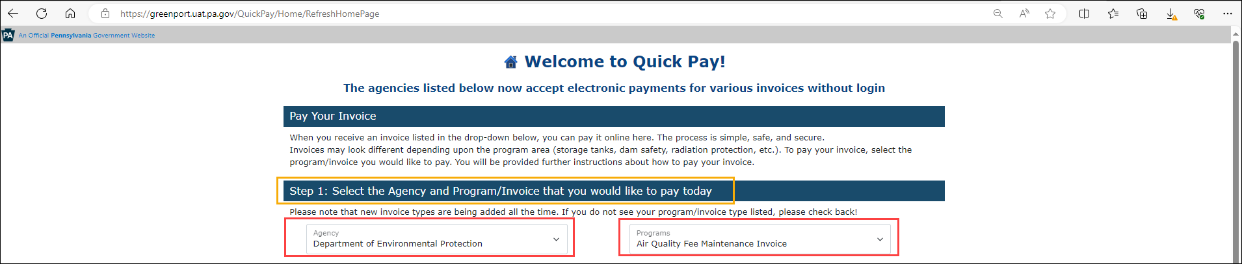
- Step 2 will display the small template of the Invoice that was sent to the customer/facility, highlighting the Client and Invoice number.
- Enter your Client ID number and Invoice number in the respective boxes, click on the verification captcha “I am not a robot and perform the required validation”
- Click on Search.

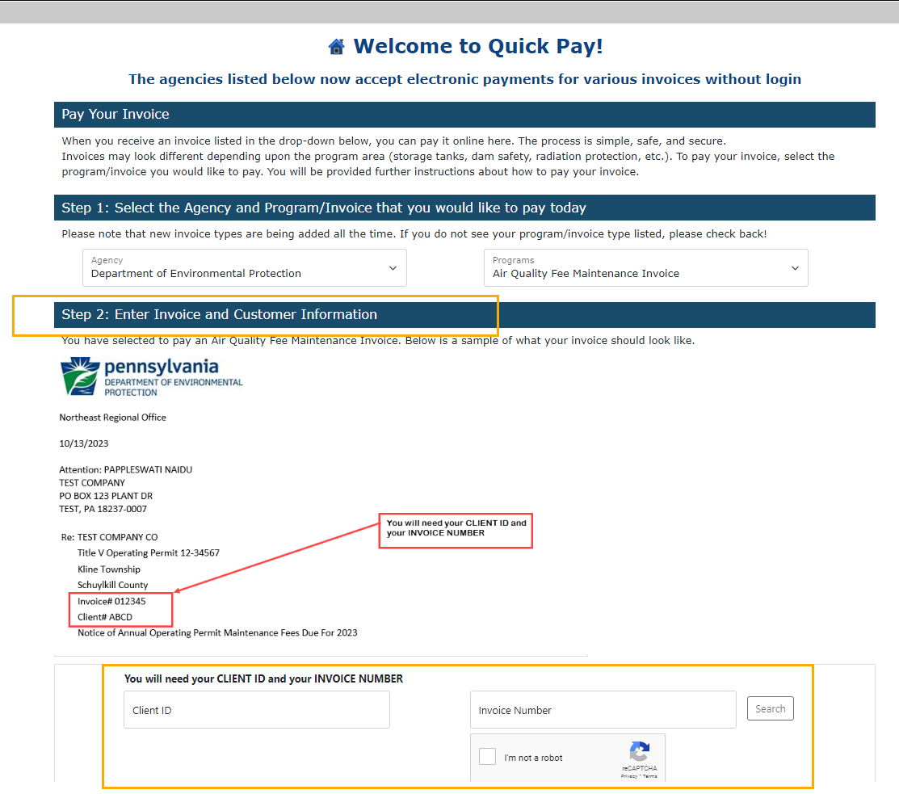
- Step 3 with the Client details grid will display. Note – For the clients with multiple facilities/pending invoices will show all the invoices that need to be paid.
  - Single Invoice -
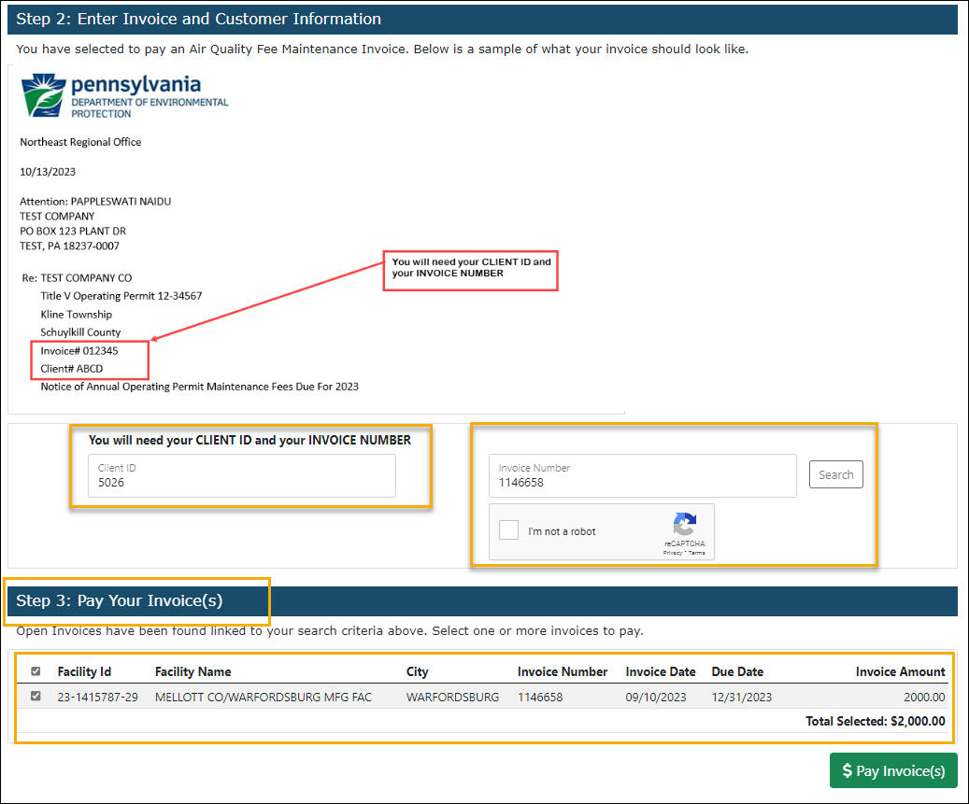

  - Multiple Invoices
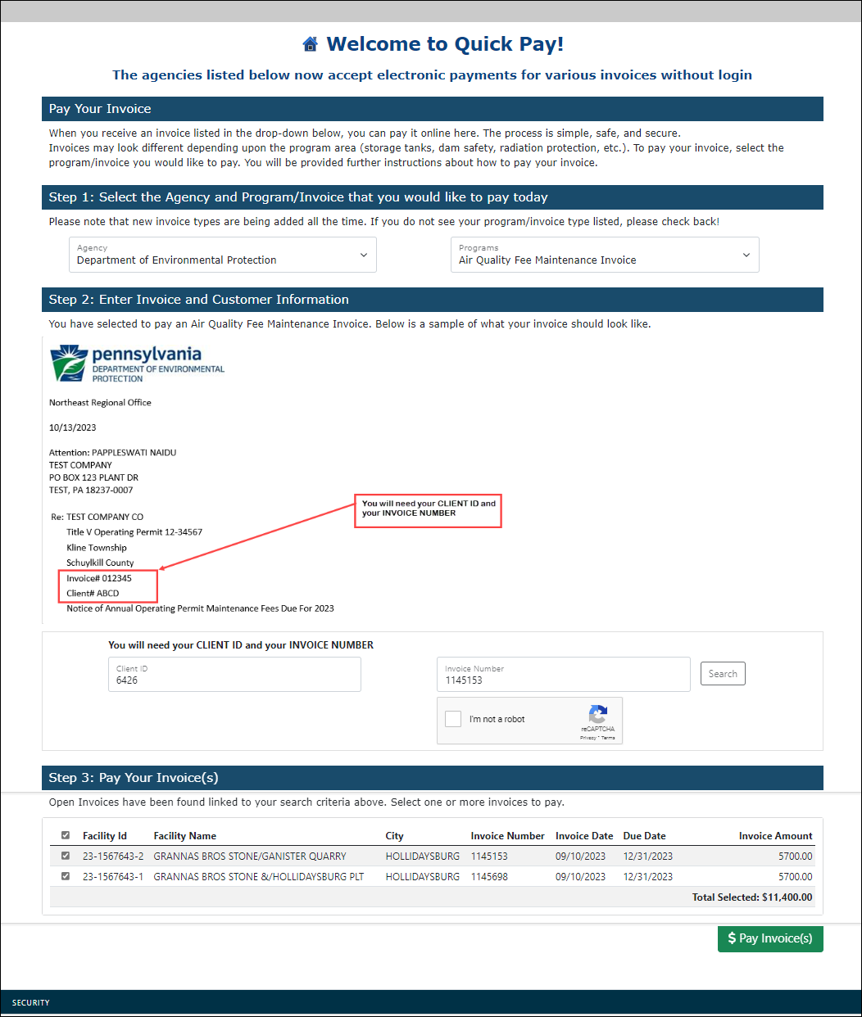
- Click on Pay Invoice.
- The System will direct to the First Data - Payeezy payment platform. Note that the Payeezy screen will include a review section with the invoice number and the invoice amount.
- Enter the payment information. (Credit Card or Telecheck). The email that is entered on this page will receive the Payeezy payment receipt.
- If it’s a credit card payment, click on pay with your Credit Card. If it’s a Telecheck payment, click on the Proceed to Consent page.
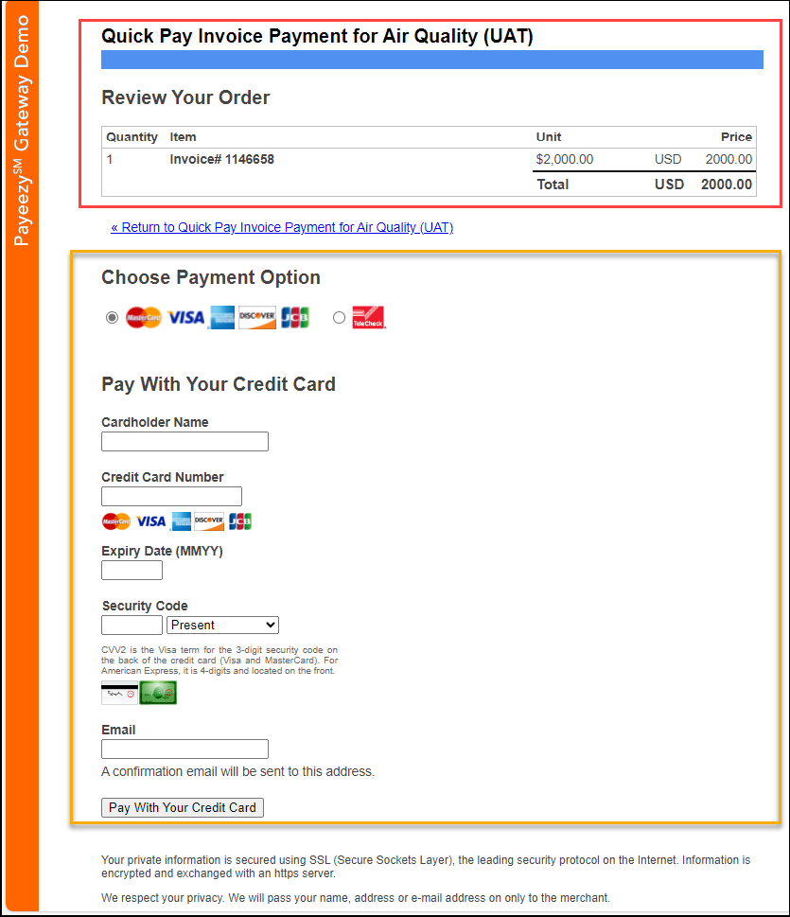
- During the payment processing, users will see the below spinning screen.
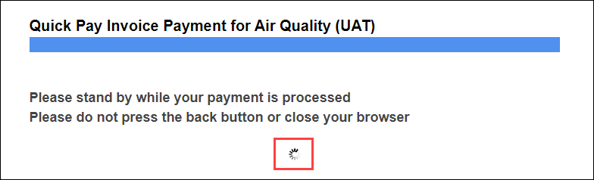
- Once the payment is complete, a payment receipt will appear.
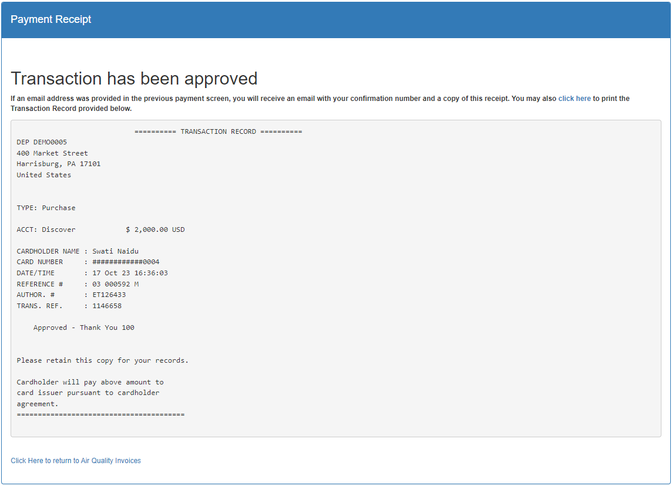
- Email confirmations are sent in 2 ways based on what email has been provided -
- E-Permitting Receipt.
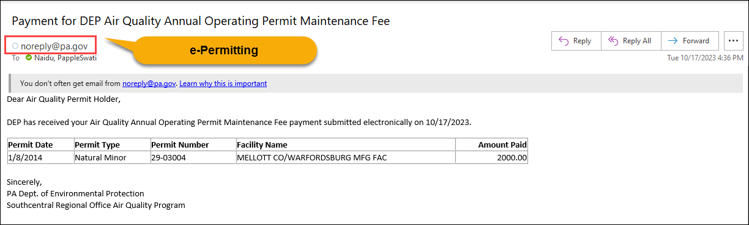
- Payeezy Receipt.
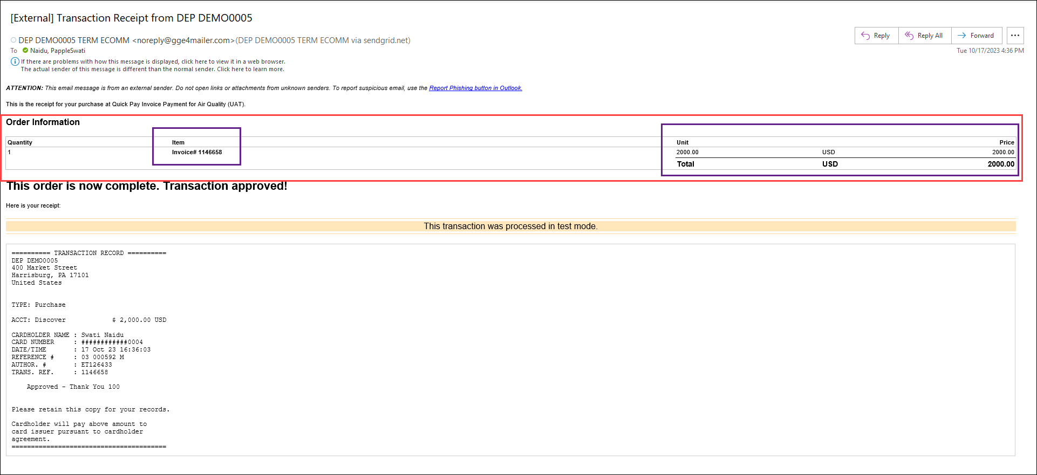

===============================================End==============================================

