e-permitting GreenPort
EFA
User's Guide

Prepared by: | Business Support Services
Version: | 2.1
Date: | April 26, 2019

Table of Contents
Disclosure Information 3
Change History 3
Purpose 3
Applications Support Help Desk Team 3
GreenPort Self-Registration and Enrollment 4
Creating a Greenport Account 4
EFA (Electronic Filing Administrator) Form 7
Enrolling into the ePermitting Application as an EFA 8
Approving / Denying an Enrollment Request 10
Approving an Enrollment Request 10
Denying an Enrollment Request 13
Modifying Access for a User 16
Modifying Security Roles 16
Limiting Access to Modules for a User 20
Modifying Module Restrictions 20
ePermit Dashboard 21
Accessing the ePermit Dashboard 21
Creating a Draft Permit Application 22
Working Through a Draft Permit Application 23
Types of Data Fields 23
Unlocking Non-Required/Optional Modules 23
Entering Data into Your Draft Application 23
Uploading Attachments 25
Submitting a Permit Application 27
Submitting Permit Applications 27
Paying and Submitting the Application 27
Pay by Credit Card 28
Pay by Telecheck 29
Reviewing and Modifying a Correction Required Permit Application 31
Reviewing and Completing a Correction Required Permit Application 31
Viewing a Previously Submitted Permit Application 33
Viewing Submitted Applications 33

Disclosure Information
The information in this document may not be changed without the express written agreement of the Department of Environmental Protection.

Change History
Version | Date | Revision Description
1.0 | January 12, 2017 | Version for user review.
2.0 | May 4, 2018 | Updates to user review.
2.1 | April 26, 2019 | Version for user review.

Purpose
Welcome to the guide to user administration for the ePermitting website via the DEPGreenPort website.
This guide provides information on how to successfully administer eDMR users on the DEPGreenPort website and use the functions available through the ePermitting Application.

Applications Support Help Desk Team
Help Desk Support Line:
Number: (717) 787-HELP (4357)
Hours: Monday to Friday 8:00 am to 4:30 pm
Applications Support Help Desk Team:
The Applications Support Help Desk Team includes helpdesk specialists, trainers, web masters, on-line help developers, and testing engineers working together to provide complete end-user support for eFACTS and other applications.
Applications Support Help Desk Team's Services:
- Applications Training
- Formalized Classroom Training
- Small Group Training
- One-on-One Training
- Participate in meetings to provide application guidance
- Telephone Support Help Desk
- Application Web Page Development and Maintenance
- Publish articles identifying solutions to common problems
- Application Testing
- Documentation Development
- Application On-Line Help Development and Maintenance

GreenPort Self-Registration and Enrollment
ePermitting Electronic Filing Administrators (EFA’s) will need to register for a Greenport account on https://www.depgreenport.state.pa.us in order to access the ePermitting application as well as the ePermitting Security section. Users must also submit the Electronic Filing Administrator (EFA) Form to DEP before they can use the ePermitting application.

Creating a Greenport Account
- Go to https://www.depgreenport.state.pa.us.
The ‘DEP GreenPort Login’ screen will display.
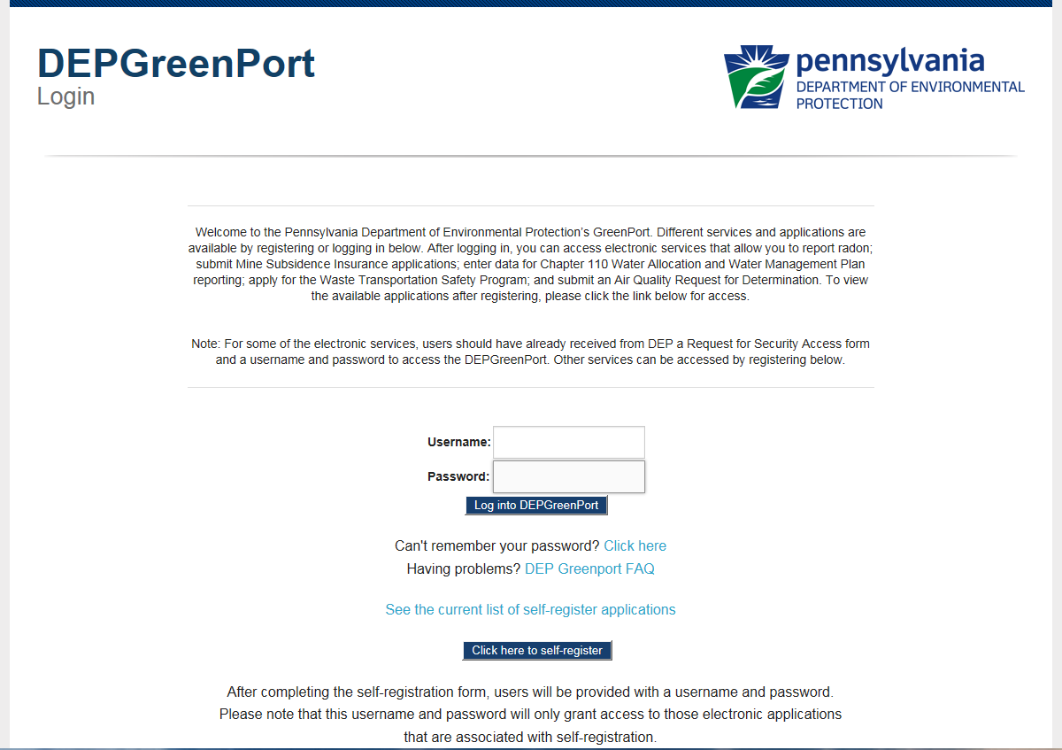

- Click the ‘Click here to self-register’ button.

The ‘Self Registration Name’ page will display.
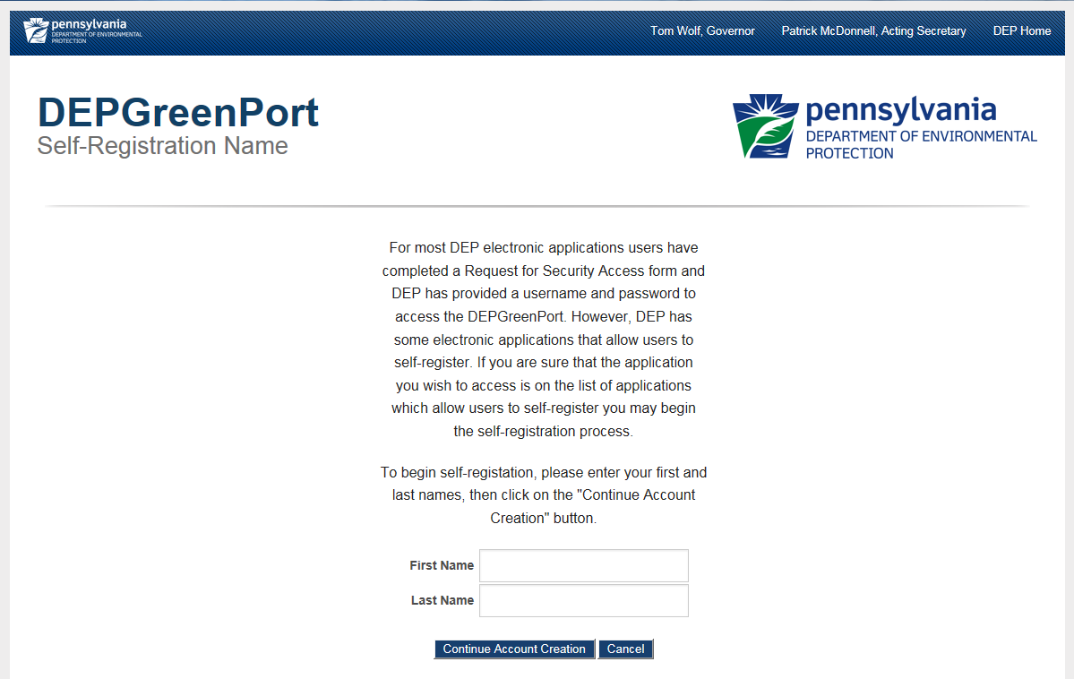

- Enter your First Name in the ‘First Name’ field.
- Enter your Last Name in the ‘Last Name’ field.
Note: Enter YOUR name not the name of the Operator or Company or institution. The name and contact information entered here must be the person who is applying for access and who is signing the EFA or User Agreement Form.
- Click on the ‘Continue Account Creation’ button.

The ‘Create Account” page will display.
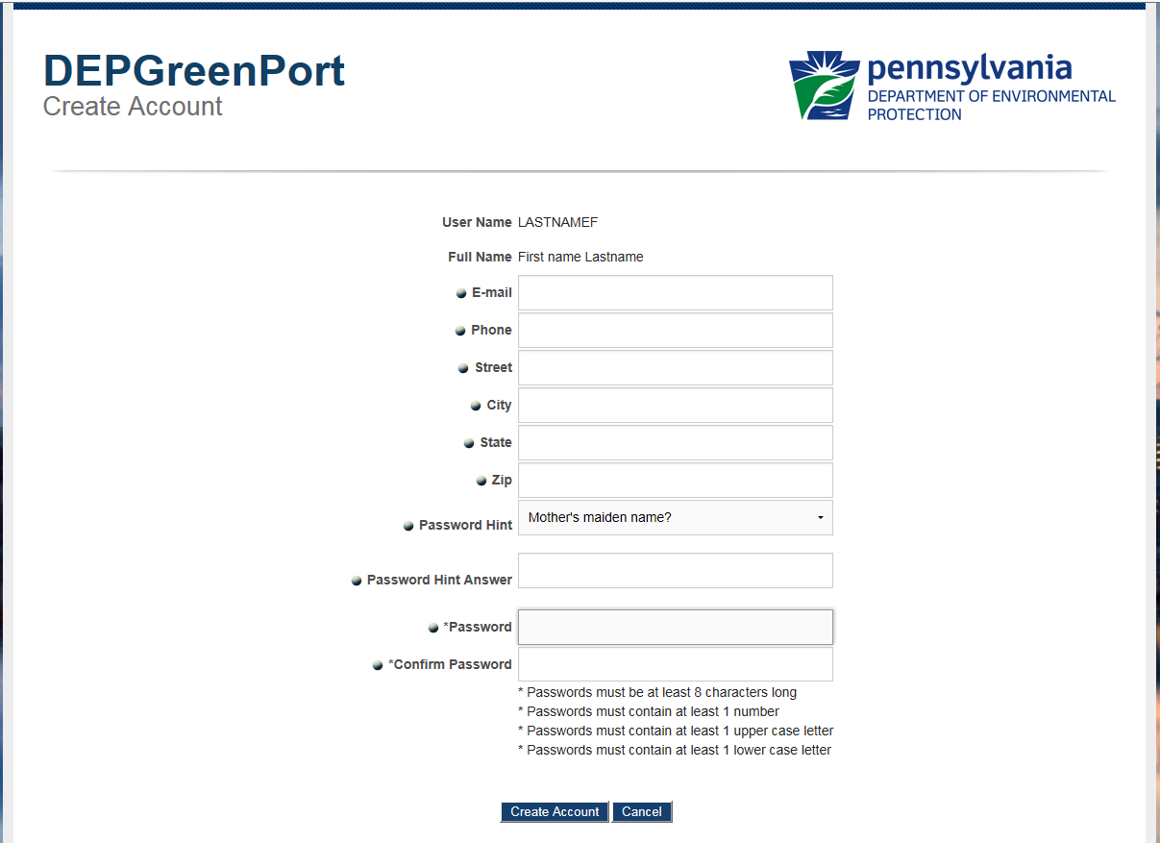
Your User Name

Note: Your User Name and Full Name is displayed at the top of this screen. The Name and Contact Information entered here must be the person who is applying for access and who is signing the EFA or User Agreement Form. The pre-populated username is based on the First and Last Name that was entered on the previous screen.
- Enter your E-mail Address in the ‘e-mail’ field.
- Enter your Telephone Number in the ‘Phone’ field.
- Enter your Street Address in the ‘Street’ field.
- Enter your City in the ‘City’ field.
- Enter your State in the ‘State’ field.
- Enter your Zip Code in the ‘Zip Code’ field.
- Choose a password hint by clicking on the drop-down arrow and selecting a password hint.
- Enter the answer to the Password Hint you had chosen in the ‘Password Hint Answer’ field.
- Enter your Password in the ‘Password’ field.
The Password must be at least:
    - 8 characters long
    - Contain at least 1 number (1, 2, 3…)
    - Contain at least 1 uppercase letter (A, B, C…)
    - Contain at least 1 lower case letter (a, b, c…)

- Confirm your Password by entering it again in the ‘Confirm Password’ field.
- Select the ‘Create Account’ button. If you select the ‘Cancel’ button all information will be erased, and you will be directed back to the previous screen.
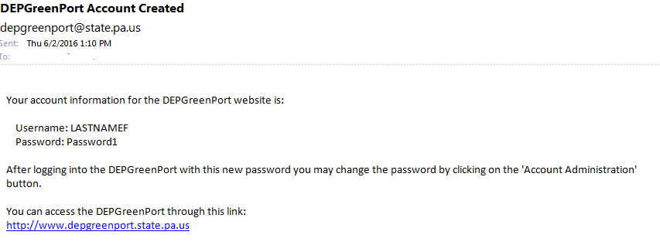
Note: After you click on the ‘Create Account’ button, you will be sent an email message similar to what is shown below.

It is strongly recommended that you record your Password and Username and keep it in an easily accessible and remembered location. If you lose or forget your Password or Username and cannot retrieve it using the “Can’t Remember Password” link, you will need to contact the Applications Support Help Desk to reset it.
Your Username and Password have now been created to access the DEP Greenport application. However, to access the ePermitting page you will need to complete the User Application & Security Agreement form, to be granted access.

EFA (Electronic Filing Administrator) Form
At least one representative for each operator must serve as the Electronic Filing Administrator (EFA). The EFA will be allowed to administer user access and make electronic submissions on behalf of the Applicant. The EFA must be a registered DEP GreenPort user, and must first go to the website below and follow the instructions in this guide to self-register, https://www.depgreenport.state.pa.us

Once registered, the EFA will need to complete the “Electronic Filing Administrator Registration Form” (EFA Form). The EFA Form is to be completed and filed with DEP for each individual who is applying for the EFA. Sharing of EFA Usernames will not be permitted.

DEP must approve the EFA application before the EFA will have access to their GreenPort account. Once DEP receives the EFA form and approves it, notification will be sent via email to the EFA of approval to access their GreenPort account. The EFA will then have the authority to make submissions on behalf of the Operator, as well as grant authority to individual users to work on behalf of the Operator.

When completing the EFA form, provide all the necessary information, initial each page where indicated and return all pages to DEP. The completed form may be scanned and emailed to ra-epair@pa.gov or mailed to the following address:

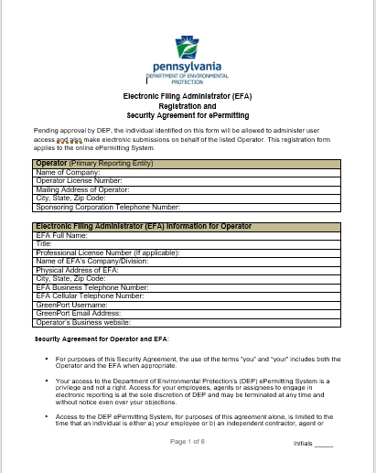
PA DEP
Bureau of Air Quality
Division of Permits
PO Box 8468
Harrisburg, PA 17105-8468

Enrolling into the ePermitting Application as an EFA
GreenPort Users are granted authorization by the EFA. Users must first self-register and fill out the User’s Application and Security Agreement Form and give the form to the EFA.
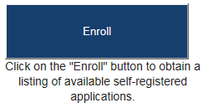
- After a user is registered, the user must sign into the GreenPort using their Username and Password, click on the ‘ENROLL’ button.

- The user will be taken to the ‘DEP GreenPort Self-Registered Available Applications’ page.
- Toward the bottom of the page, the user will click the ‘ePermitting’ button under the section of applications listed as ‘Permitting’.
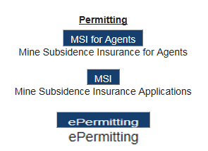
- The user will be taken to the ‘Additional Data Required for access to ePermitting’ page.
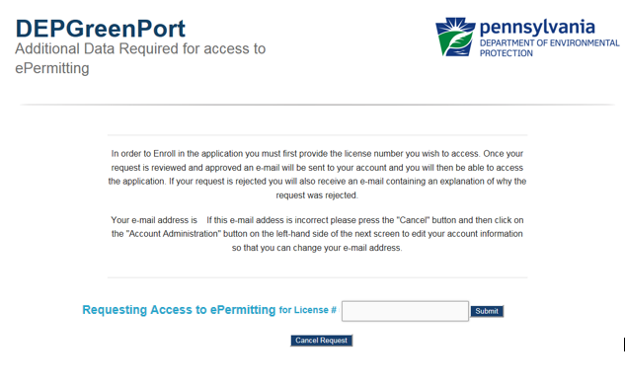

- The user must enter the ‘License #’ for the Operator that they are requesting to work on behalf of and click the ‘Submit’ button.

An electronic request will be sent to the EFA for the Operator. Once the User Application & Security Agreement Form has been completed and submitted to the EFA, the electronic request can be approved, and the user will be notified that their account has been given access to the ePermitting system.

Approving / Denying an Enrollment Request
The ePermitting application has been integrated with the DEPGreenPort website to provide a single portal sign-on for users to access. Users have the ability to enroll in the ePermitting application to complete Authorization Applications electronically.
ePermitting Electronic Filing Administrators (EFAs) for an operator have the ability to grant access for any user requesting access to prepare, view, or submit authorization requests electronically. EFAs may approve, deny, and/or revoke access for each user.

Approving an Enrollment Request
- Open Internet Explorer.
- In the URL Address Bar type in https://www.depgreenport.state.pa.us.
The ‘DEPGreenPort’ website will display.
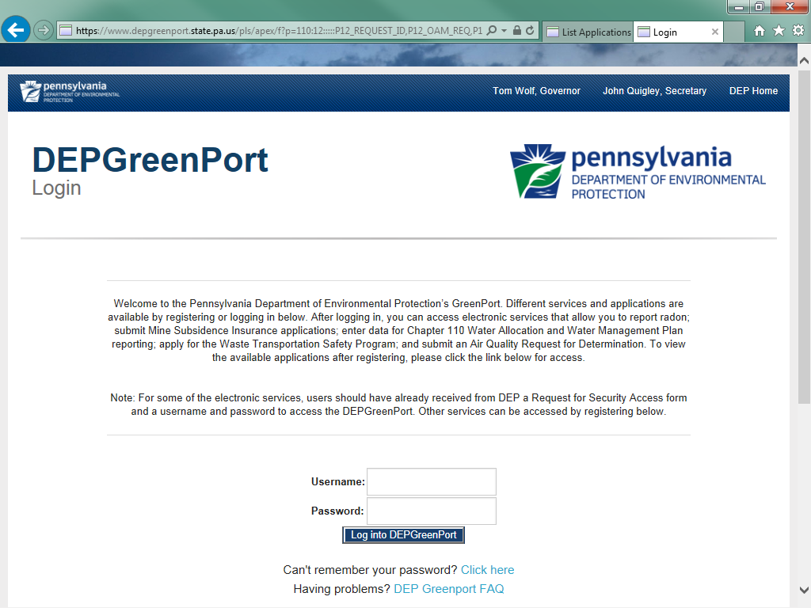
- Enter your User Name into the ‘User Name’ field.
- Enter your Password into the ‘Password’ field.
- Click the ‘Log into DEPGreenPort’ button.
The ‘List Applications’ screen will display.
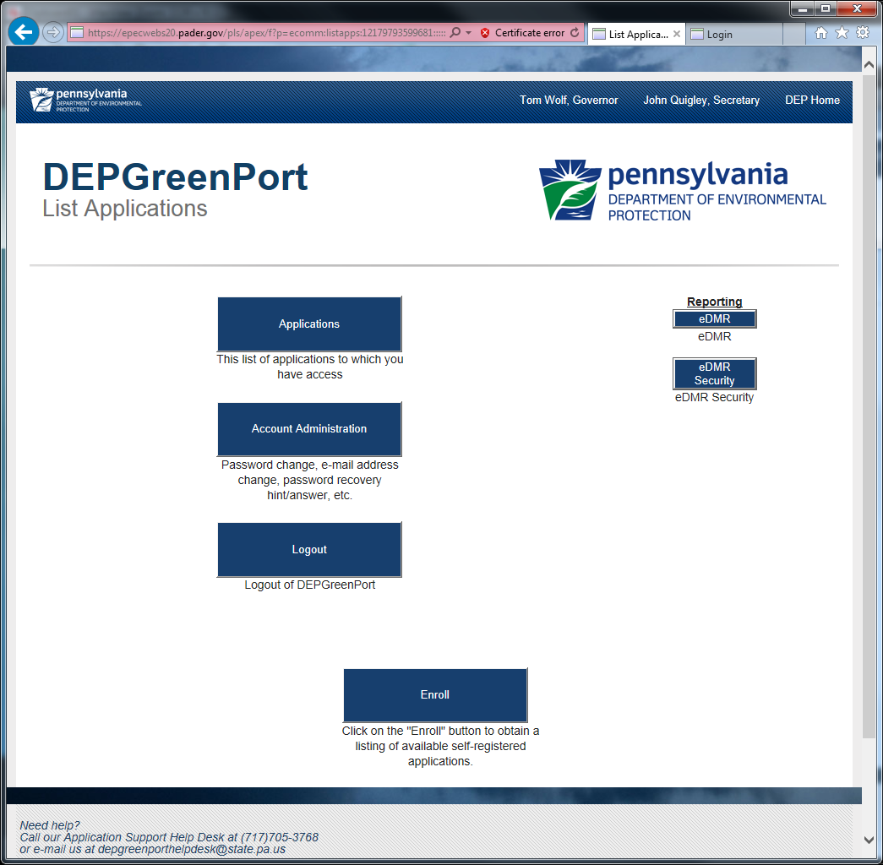
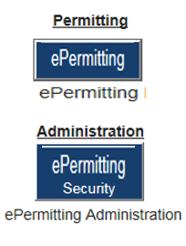

- Click the ‘ePermitting Security’ button.

The ‘ePermitting Security Pending User Request’ webpage will display.
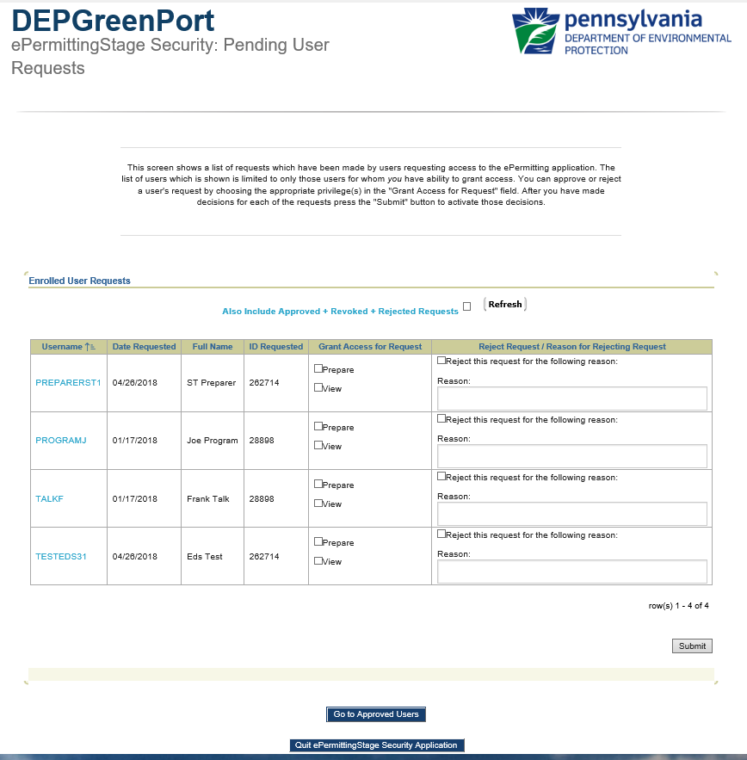

- Select the Security option(s) to be granted for the desired user in the ‘Grant Access for Request’ column.
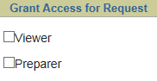

- Click the ‘Submit’ button to confirm the selection.
Note: The user requesting access will receive an email stating that the enrollment for the requested License number was successful.

Denying an Enrollment Request
- Open Internet Explorer.
- In the URL Address Bar type in https://www.depgreenport.state.pa.us.
The ‘DEPGreenPort’ website will display.

- Enter your User Name into the ‘User Name’ field.
- Enter your Password into the ‘Password’ field.
- Click the ‘Log into DEPGreenPort’ button.

The ‘List Applications’ screen will display.

- Click the ‘ePermitting Security’ button.

The ‘ePermitting Security Pending User Request’ webpage will display.

- Click the ‘Checkbox’ for the appropriate user to be rejected.
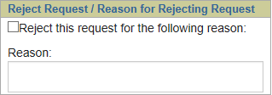

- Enter a ‘Rejection Reason’ in the ‘Reason’ field.
- Click the ‘Submit’ button to confirm the selection.
Note: The user requesting access will receive an email stating that the enrollment request has been rejected and provide the reason that the administrator entered.

Modifying Access for a User
ePermitting EFAs have the ability to modify individual access for any user that the EFA has access to. Modifying access can be completed on a role by role basis so that granular user administration can be completed and is done within the ePermitting Application itself.
Once approved through DEPGreenPort, the user will still be unable to access the ePermitting Application until the EFA sets up the individual permissions within the ePermitting Application itself.

Modifying Security Roles
- Open Internet Explorer.
- In the URL Address Bar type in https://www.depgreenport.state.pa.us.
The ‘DEPGreenPort’ website will display.

- Enter your User Name into the ‘User Name’ field.
- Enter your Password into the ‘Password’ field.
- Click the ‘Log into DEPGreenPort’ button.

The ‘List Applications’ screen will display.

- Click the ‘ePermitting’ button.
The ‘ePermit Dashboard’ webpage will display.
Note: If you have access to more than one License, you will need to make sure to select the approriate License.
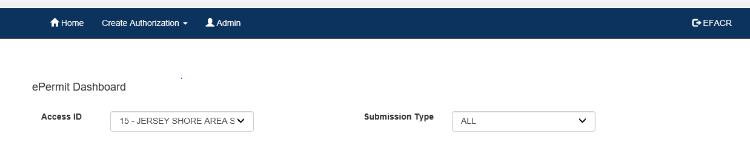

- Click the ‘Admin’ button.
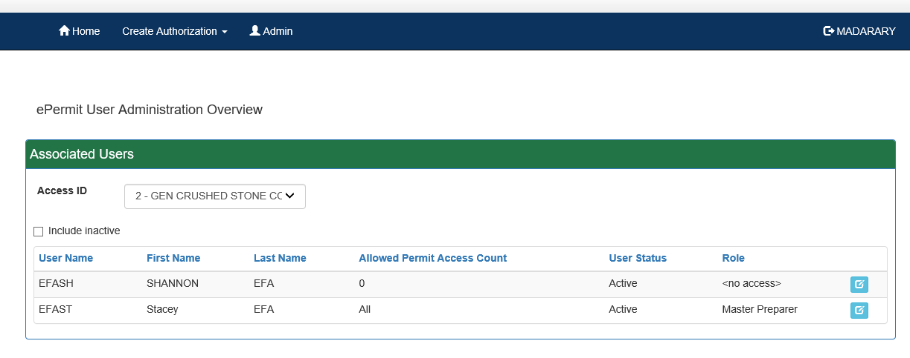
The ‘ePermit User Administration Overview’ page will display.

Note: New users will display with a User Status of <No Access>.
- To create the access for a new user, or to edit the access of any user click the ‘Edit’ button.
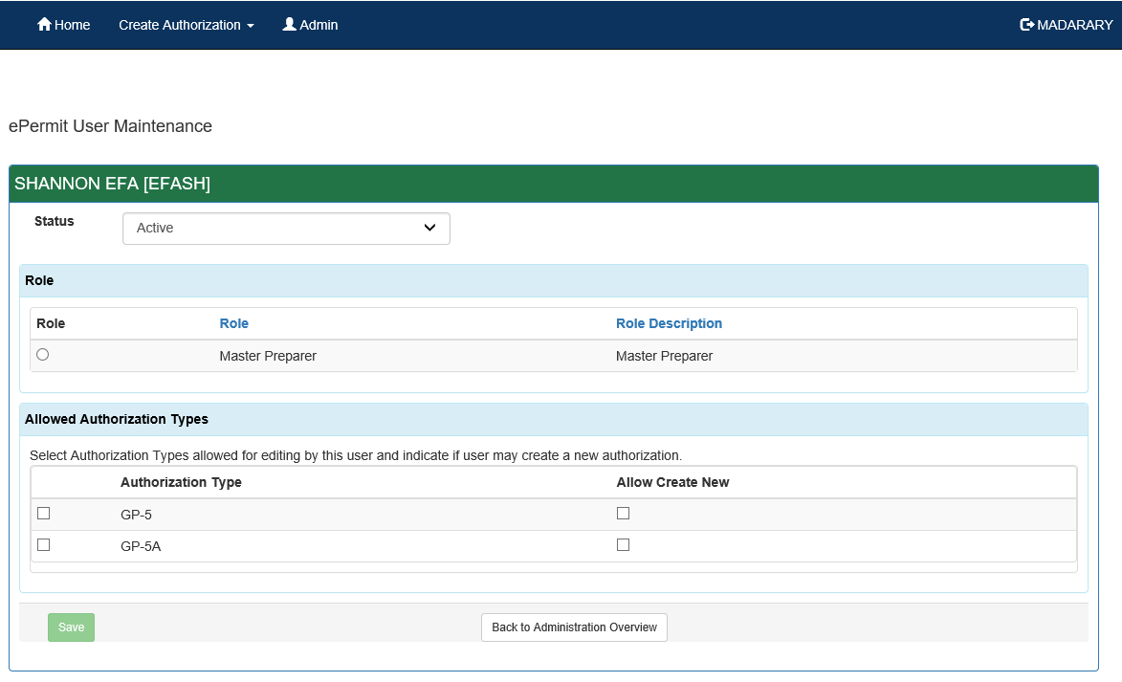
The ‘ePermit User Maintenance’ page will display.

- Set the Status to ‘Active’ (or Inactive for a user that needs to be Deactivated).
- Select the appropriate Role by clicking the ‘Radio’ button.

The Roles available in the ePermitting Application are defined as follows:
  - Master Preparer – Any user who will have access to any draft permit, correction required permit, or previously submitted permit for the license they are associated with. The Master Preparer will also have the ability to create new draft permits.
  - Preparer – Any user who will require individual access to draft permits, or correction required permits for the license they are associated with. Once a draft permit is created, a Preparer must be given access to the submission before they are able to work on it.
  - Viewer – Any user who will have the ability to view draft permits, or correction required permits for the license they are associated with. Once a draft permit is created, a Viewer must be given access to the submission before they are able to view it.
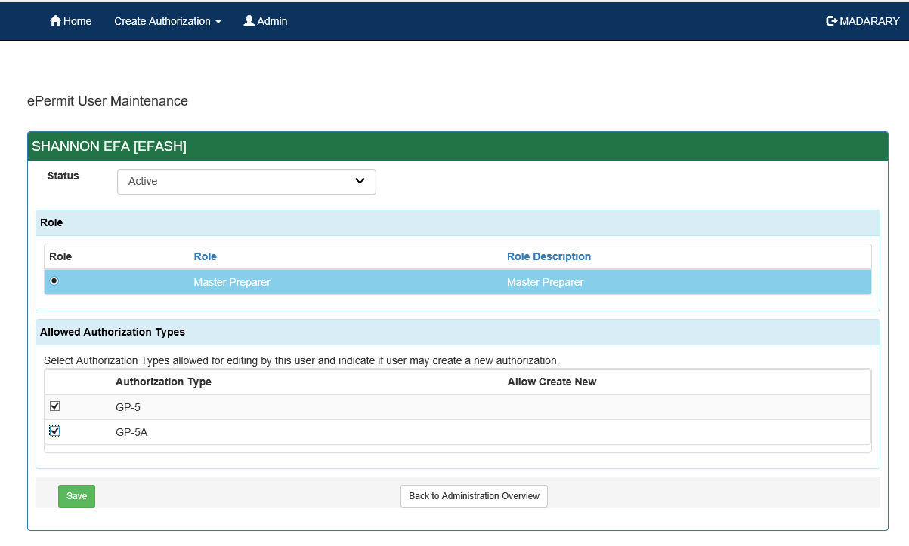
- Select the ‘Allowed Authorization Types’ by clicking the checkbox and select if the user is authorized to create new draft authorizations of this type.

- Click the ‘Save’ button.

Limiting Access to Modules for a User
ePermitting EFAs have the ability to limit individual access for certain modules within the ePermitting Application for Preparer, Viewer, and Blaster Roles.
Any user given Preparer, Viewer, or Blaster Roles will have access to all modules by default. If you want to limit the access, then restrictions must be placed on each module.

Modifying Module Restrictions
From within the ePermitting Application, access the ‘ePermit User Maintenance’ page for a user that will require module restrictions.

- Select the Authorization Type from the ‘Allowed Authorization Types’ dropdown list.
- Select the Module that access restrictions need to be placed against from the dropdown list.
- Select the access level to restrict the access to.
- Click the ‘Add’ button.
- Click the ‘Save’ button.

ePermit Dashboard
ePermitting users access the ePermit Dashboard to create, view, modify and/or delete draft authorization applications or previously submitted authorizations based on security roles given by the Electronic Filing Administrator (EFA). Users can view applications that are Draft, Submitted, Correction Required, Approved and/or Withdrawn/Denied.

Accessing the ePermit Dashboard
- Log into Greenport. You will see ePermitting from your list of available applications.
- Click the ‘ePermitting’ button.
The ePermit Dashboard is the ‘Home’ page. It can be accessed at any time by clicking the ‘Home’ button.
Authorized users will see various tabs based on the applications that they have been given access to. In addition, the tabs are only displayed when applications have been submitted that fall into the specific tab category.
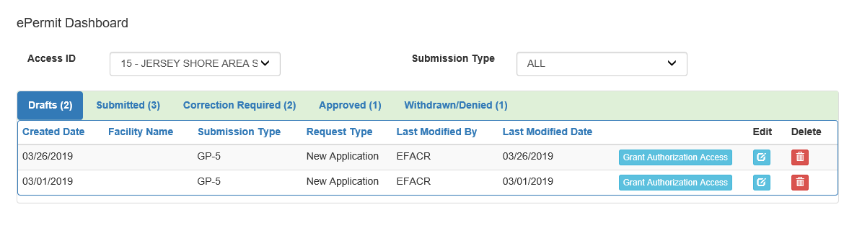

Creating a Draft Permit Application
Authorized ePermitting users can create a new draft permit application from the ePermit Dashboard within the ePermitting application.
From within the ePermitting Application, access the ePermit Dashboard.
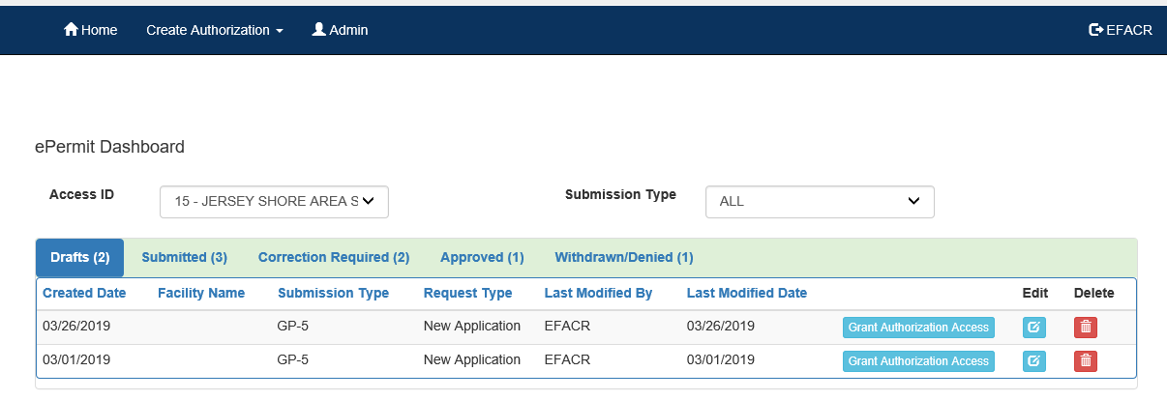
- Click the ‘Create Authorization’ button.

- Mouse over the ‘Authorization Type’ and click the ‘New Application’ button.
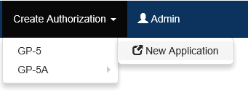

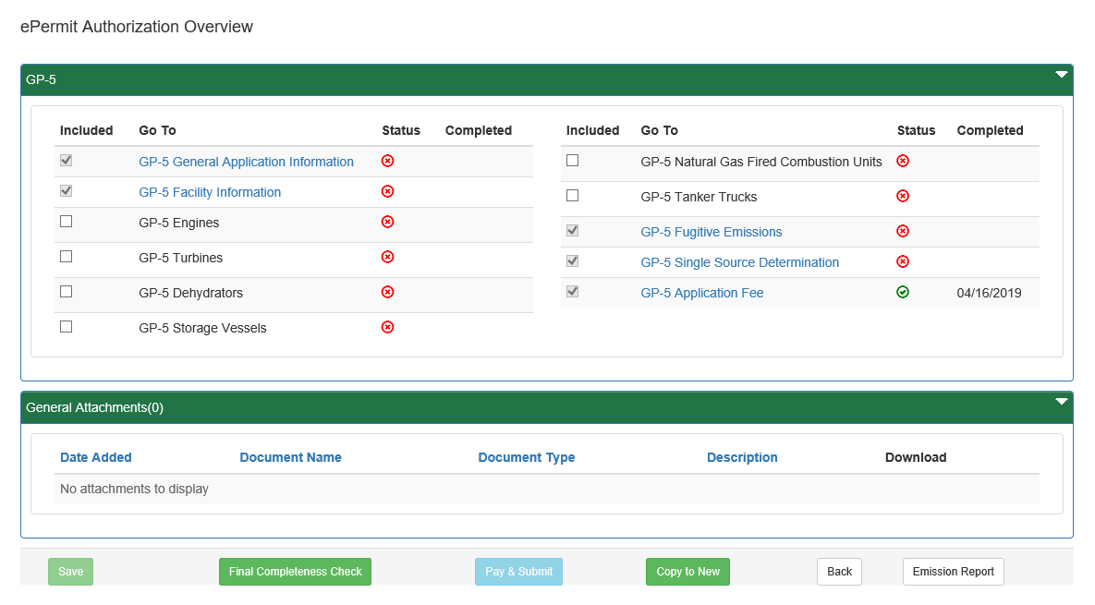
The ‘ePermit Authorization Overview’ page will display.

- Click the ‘Link’ for the Module you wish to open and work on.
- When finished working on the module, click the ‘Save’ button.

Working Through a Draft Permit Application
Authorized ePermitting users have the ability create draft permit applications by completing modules and saving them at any time within the ePermitting Application.

Types of Data Fields
Users will encounter several different types of data field types when working through their applications. Some samples of these types of data fields are below.
- Checkbox – a checkbox is clicked to select the value next to it. You may click it a second time to deselect it.
Example:
- Text Box – a textbox is a box where users can enter text manually or paste text that was copied from another application.
Example:
- Radio Button – a radio button is used to select one item from a series of items. Only one button in the grouping can be selected.
Example:
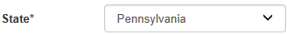
- Dropdown Menu – a dropdown menu is a menu you click on to display a list of items. You will click the item you wish to select from the list for it to display as the selected item from the list.
Example:
- Button – a button is used to operate the command shown on the button. In the example below, the Save button saves the data that had been entered onto the screen.
Example:

Unlocking Non-Required/Optional Modules
The ePermitting Application allows authorized users the ability to add additional, non-required information to the application by unlocking optional modules from the ePermit Authorization Overview page.
- From the Authorization Overview page for a draft permit in the ePermitting application, click the ‘checkbox’ beside the optional module under the Included column to unlock the module.
- Click the ‘Save’ button.
- Click the ‘name’ of the module under the ‘Go To’ column to view and complete the module.

Entering Data into Your Draft Application
The ePermitting Application is a dynamic application which means it can change based on the information entered it. Users may notice that, depending on the answers given in some areas, the application will add additional questions or perhaps even require additional modules.
- While working in a draft application in the ePermitting application, you will select the the link of an unfinished module.
- Complete all data fields in the module, including all required fields.
Required fields – a required field is indicated by an asterisk * to the right of the Field Title. The module will not be considered complete until all required fields have been entered.
- Upload all ‘required’ attachments.
Missing Required Attachments – certain modules require attachments to be uploaded to the application. They will be listed in the “Missing General Attachments” grid.
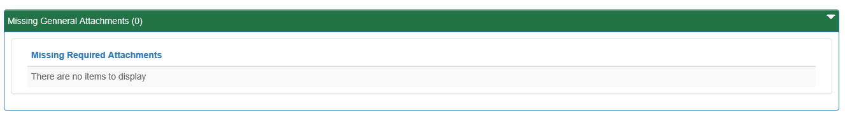

- Click the ‘Save’ button to save your changes at any time while working on the module. You can return to the module to complete it at another time.
You may encounter an error message when saving a module if something was entered incorrectly.
- You will see a message indicating if the module was saved successfully or not.

- Click the ‘Completeness Check’ button to verify all required information has been completed for the module.
Note: When a module is not complete, you will see a list of items needed to be finished before the module can be considered complete.
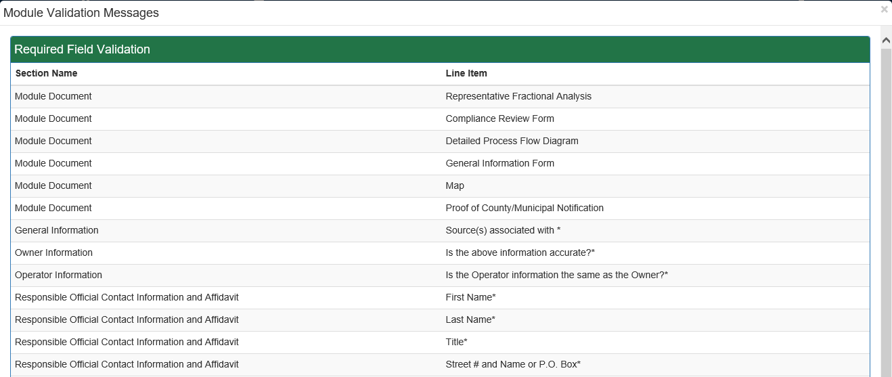
- Click the ‘Close’ button.
- Click the ‘Back’ button to return to the ‘Authorization Overview’ page.
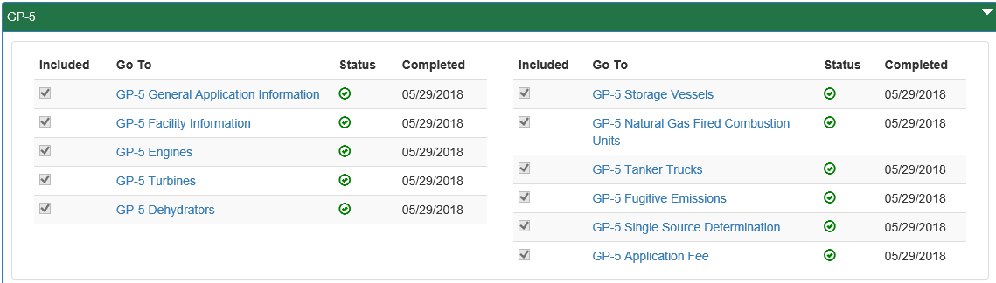
- Click the next module on which you would like to work until all required and selected modules have been completed.

Uploading Attachments
Several modules within the ePermitting application require attachments to be included with the submission. Authorized users will need to include these attachments for the module to be considered complete. Authorized users are also able to add additional, non-required attachments to their submission.
- Click the ‘Upload New Attachment’ button in the ‘General Information Attachments’ section or select to Attach the document(s) in the ‘Missing General Attachments’ section.
- The ‘Upload Attachment' window will open.
Note: When the user selects to ‘Attach’ the document(s) in the ‘Missing General Attachments’ section, the ‘Document Type’ field will be prepopulated with the name of the document.
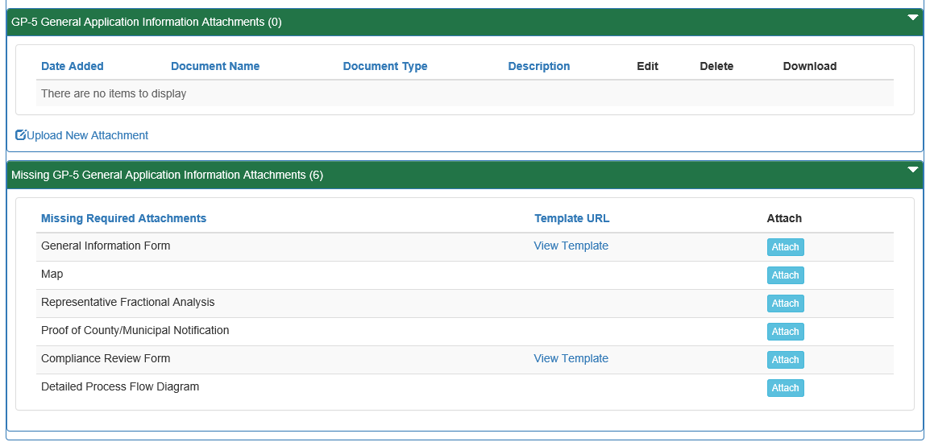

- Select the ‘Attachment Type’ from the ‘Document Type’ dropdown menu.
- Select the ‘Browse’ button to open a ‘Windows Explorer’ window to browse and select the file.
- Enter a ‘Document Name’ and ‘Description’ as needed.
- Click the ‘Upload and Save’ button.
Note: A user may chose the ‘Reset’ button to clear the contents of all fields and start over.

Submitting a Permit Application
Authorized ePermitting users have the ability to submit permit applications after completing all the appropriate required and non-required/optional modules.

Submitting Permit Applications
- From within the ‘ePermitting’ application, complete all required and selected optional modules.
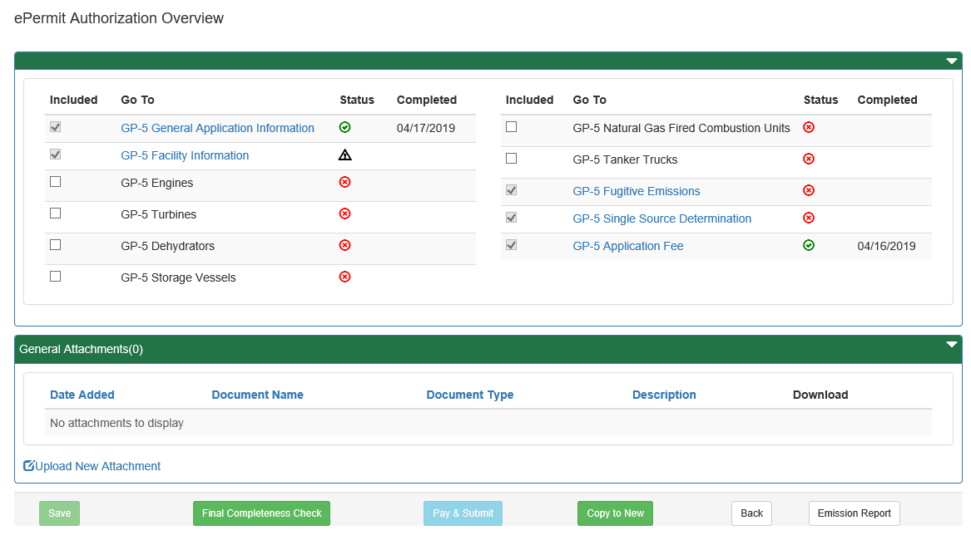

- After all modules have been completed, you will need to complete the ‘Application Fee’ module to submit the application for payment.

Paying and Submitting the Application
- Click the ‘Application Fee’ module.
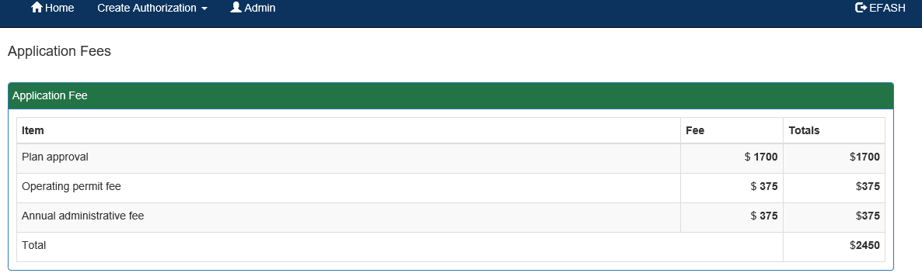
- Enter the appropriate fees (if any) for the modules listed.

- Click the ‘Back to Overview’ button.
- Click the ‘Pay & Submit’ button.

Pay by Credit Card
You will now be taken to the ‘Payeezy’ page to enter your payment information. When finished, click the ‘Pay with Your Credit Card’ button.
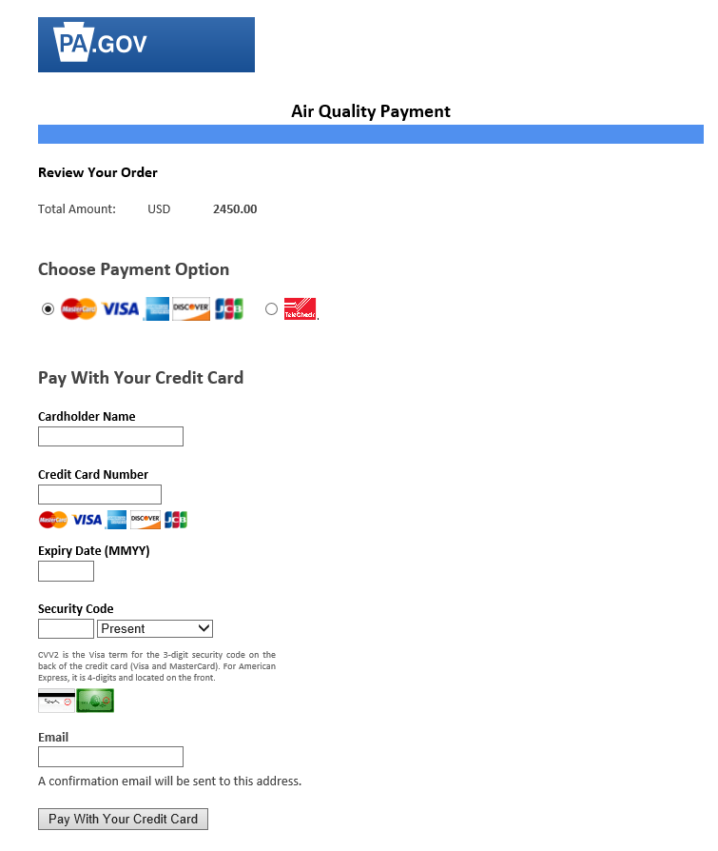

Pay by Telecheck
You will now be taken to the ‘Payeezy’ page to enter your payment information. When finished, click the ‘Pay with Your Credit Card’ button.
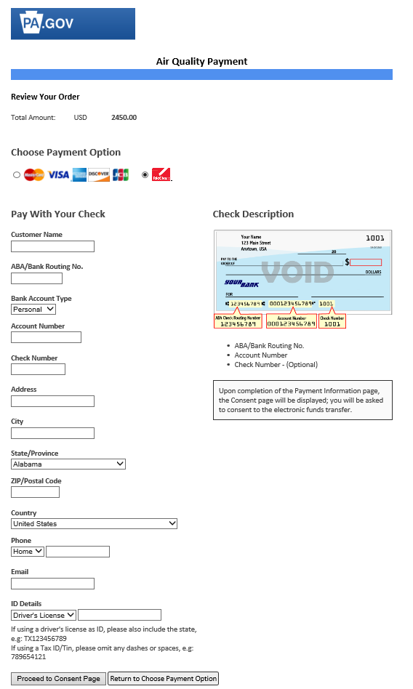
If payment is accepted, the user will receive a message indicating the payment is processed successfully and the user will be returned to the ePermit Dashboard.
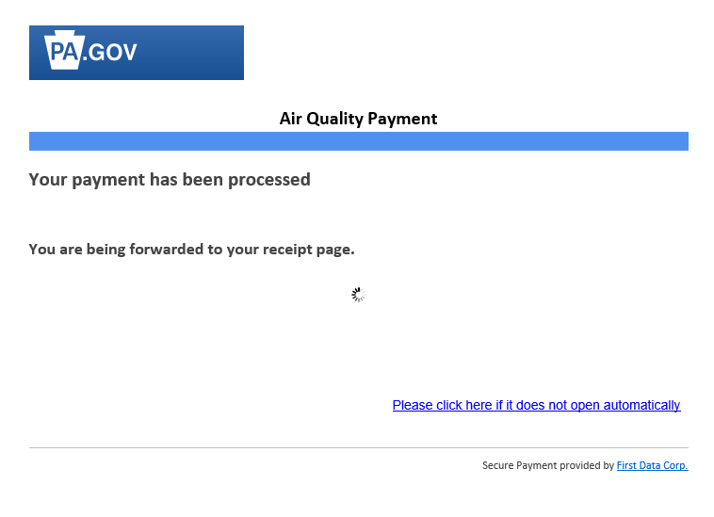

If payment is not successful, a message will display on the ‘Payeezy’ screen indicating the payment was not processed. The user will then be returned to the ‘ePermit Authorization Overview’ screen.

Reviewing and Modifying a Correction Required Permit Application
Authorized ePermitting users will see a Correction Required tab on the ePermit Dashboard if a previously submitted application is in need of a correction(s).

Reviewing and Completing a Correction Required Permit Application
- From within the ePermitting application, click the ‘Correction Required’ tab on the ePermit Dashboard to display the list of Correction Notices.
- Click the ‘View Document’ Link under the ‘Pending Corrections’ header.
- Click the item under ‘Module/Area’ to work on.
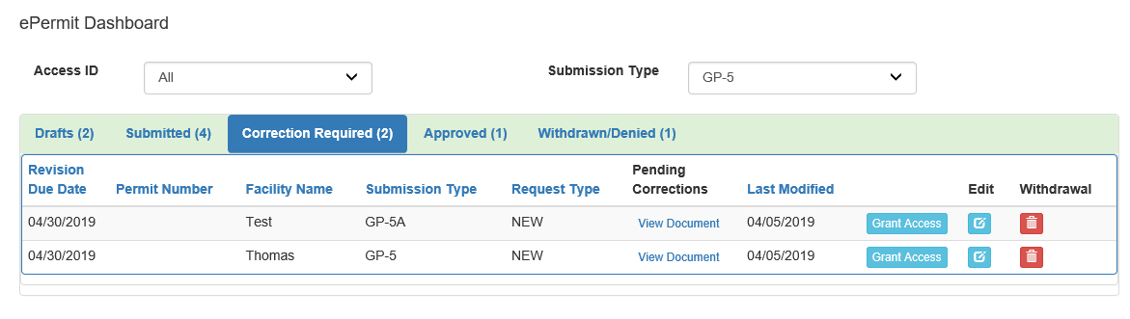

The appropriate ‘Module/Area’ will display.
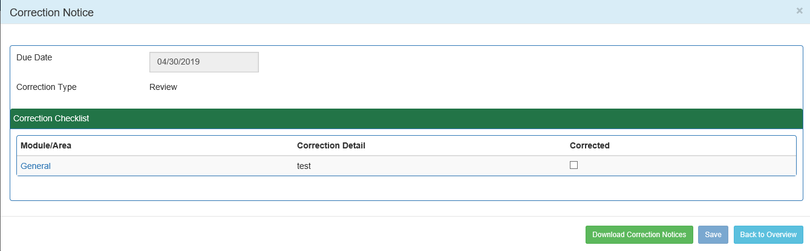

- Correct the indicated items, and click the ‘Save’ button. Click the ‘Back to Overview’ button to return to the ‘ePermit Authorization Overview’ screen.
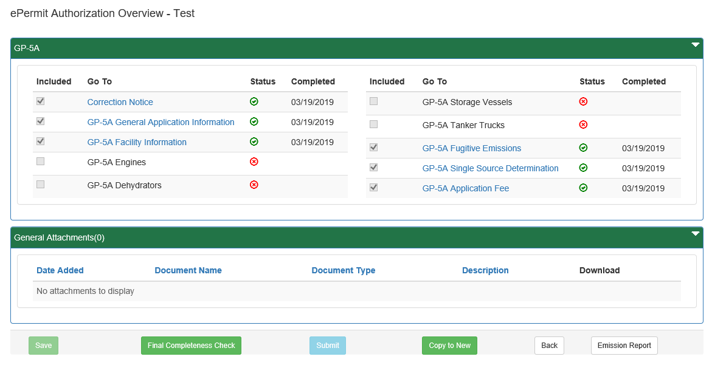

- Click the ‘Corrections Required’ tab from the ePermit Dashboard to mark the item(s) as Corrected.

- Click the ‘Correct’ Checkbox, to indicate the corrections have been made.
- Click the ‘Save’ button.

Viewing a Previously Submitted Permit Application
ePermitting users have the ability to view previously submitted Permit applications.

Viewing Submitted Applications
- From within the ‘ePermitting’ application, click the ‘Submitted’ tab on the ePermit Dashboard.
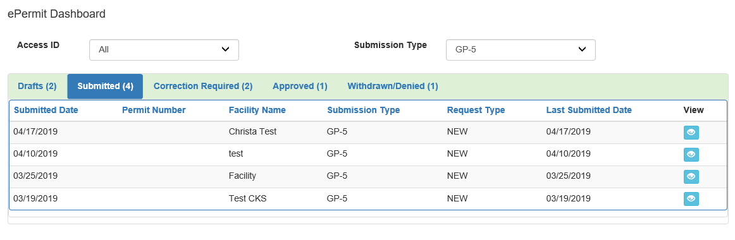

- Click the ‘View’ button to view the submitted Permit application.

