[Jurisdiction]

Climate Action Plan



Local Actions and Policies to Reduce [Jurisdiction]’s

Greenhouse Gas Emissions

Approved by [Local Authority]

Local

Government Seal

[Date Approved]

[Reference to Public Record]

[Reference to Further Information]

Produced by [Name of Lead Department or Task Force]

Through partnership with ICLEI – Local Government for Sustainability (ICLEI)

**How to Use this Template**

**Please Read & Remove the Following Pages from Your Report**

This **template Climate Action Plan** is intended for use by local governments taking action to reduce greenhouse gas emissions within their jurisdictions. To achieve significant overall reductions, a local government needs a bold vision, equitable process, smart implementation, and excellent communication with the public. This template is designed to speed the development of a custom Climate Action Plan document by reducing the time needed to create and publish content. This document may be useful for inspiration or reference in creating your own Plan.

Wording or portions as they are within this template may not reflect local circumstances or be appropriate for all jurisdictions. As such, please modify this template as needed to accommodate local goals, knowledge, commitments, laws, and the results of your local government’s emissions studies and planning process.

**Modify the Template**

Local governments are encouraged to use whatever information within this template they find useful. Sections may be added or removed or the layout changed altogether. The narrative language included here should be replaced or filled in as needed.

* Instructions in the document body are bold and highlighted. **Remove the instructions prior to release.**
* **Replace the words in brackets “[xxxxxx]”** found throughout the document.

The bracketed words function as placeholders for the name of your jurisdiction, a specific date of a local event, or other local information. To quickly find and replace these with local terms, use the functionality of your document editing software; for example, **use** **the Find and Replace function in Microsoft Word to search for common replaceable words like “[Jurisdiction]”** or for locating the brackets themselves “[”. **Searching for either an opening or closing bracket by itself “[” will allow you to find all of the replaceable words**, replace them, and verify that none remain.

**Start by finding and replacing (CTRL+F) the word “[Jurisdiction]” or “[City/County]” with the name of your local government.** This will allow you to quickly customize the sample text included here.

**Add your own greenhouse gas emissions inventory findings, forecast, and reduction target and change the document to describe your Climate Action Plan.** Use visual aids where possible – good figures and tables can go a long way toward concisely and elegantly expressing the Plan. Sample figures and tables have been included in this report as reference; please replace these with custom figures and tables.

How to Use this Template

**Remove This Page from Your Report**

* **If you need to delete a section or page break, click on the icon below to unhide them and enable editing.**



* **Template citations should be added.**

Your Climate Action Plan should reference the use of this template as follows: This Climate Action Plan was developed using a template provided by ICLEI – Local Governments for Sustainability, USA. The original template and its appendices were published in April 2018. The template was then edited by PA Department of Environmental Protection in December 2019.

* **Icons can be used freely.**

The icons are free to use under [Creative Commons Attribution 3.0 Unported](http://creativecommons.org/licenses/by/3.0/) license from Smashing Magazine.

* **This template contains sections for both mitigation and adaptation**

Some communities decide to combine both their mitigation and adaptation work into one action plan. It is ideal to make sure both are addressed and the co-benefits and overlap between the different sectors are tracked, but in some cases, some communities are not ready to address both due to resources/capacity. In this case, a community may want to take out the adaptation or mitigation sections as needed.

* **All references to IPCC 2014 should be updated when the 6th report is released in 2021.**
* **A final note about some of the content within this template:**

This template includes an additional means by which to illustrate your local government’s baseline emissions, forecast and reduction targets in the form of a “Sector Impacts” chart. Even if you have already completed your emissions inventory and forecast, you may not have created such an illustration. If you find it useful to include this chart in your plan, you may utilize the Excel file that accompanies this template. Instructions for utilizing the file to create the chart are included within the file itself.

Local governments structure their Climate Action Plans in a variety of ways. This document divides plan actions into sectors such as “Energy Production” or “Transportation” – through which government and community initiatives can be explained. **The specific sectors and projects used in this template are examples.** Good luck!

Credits and Acknowledgments

Local Government Officials and Staff

* [Acknowledgement – Name and Title]
* [Acknowledgement – Name and Title]
* [Acknowledgement – Name and Title]
* [Acknowledgement – Name and Title]
* [Acknowledgement – Name and Title]

External Agencies and Partners

* Student(s), University
* Heidi Kunka, Pennsylvania Department of Environmental Protection
* Calyn Hart, ICLEI – Local Governments for Sustainability USA
* Jesse Carpentier, ICLEI– Local Governments for Sustainability USA
* [Acknowledgement – Name and Title]
* [Acknowledgement – Name and Title]

Community Stakeholders

* [Acknowledgement – Name and Title]
* [Acknowledgement – Name and Title]
* [Acknowledgement – Name and Title]

Plan Contributors

* [Acknowledgement – Name and Title]
* [Acknowledgement – Name and Title]
* [Acknowledgement – Name and Title]
* [Acknowledgement – Name and Title]

This Climate Action Plan was made possible through a grant agreement between ICLEI – Local Governments for Sustainability and the PA Department of Environmental Protection, which was funded by the US Department of Energy State Energy Program. The template was developed by ICLEI – Local Governments for Sustainability, USA and was originally published in April 2018. It was later edited by PA Department of Environmental Protection in December 2019.

The icons are licensed under [Creative Commons Attribution 3.0 Unported](http://creativecommons.org/licenses/by/3.0/) from Smashing Magazine.

Table of Contents

**To save time, wait until the rest of the document is finalized to update the table of contents. When you are ready to update, right-click anywhere on the table of contents, choose “update field”, and then “update entire table”. If you wish to use a different format, go to the References tab and click “Table of Contents” to see your options.**

1. Introduction 7

Statewide Climate Action 8

Local and Regional Climate Policy 8

Purpose and Scope of the Climate Action Plan 8

Planning Process 10

Vision Statements and Objectives 13

2. Co-Benefits of Climate Action 16

1. Improving Public Health 16

2. Saving Money and Reducing Risk 16

3. Enhancing Resource Security 16

4. Creating Jobs 17

5. Fostering Social Equity 17

3. [Jurisdiction]’s GHG Emissions 18

[Jurisdiction] Community-Wide GHG Emissions 18

Forecasting [Jurisdiction’s] GHG Emissions 19

[Jurisdiction]’s GHG Reduction Target 20

The [Jurisdiction] Climate Action Plan 21

4. Taking Action 24

Emissions Reduction Potential 24

Evaluating Co-Benefits 24

Supporting Actions 25

New and Existing Actions 25

Consistency with Statewide Climate Action Plan 25

Climate Adaptation 25

5. Commercial Buildings 32

6. Residential Buildings 34

7. Energy Production 36

8. Waste, Composting, & Recycling 38

9. Water & Wastewater Management 40

10. Transportation 42

11. Agriculture & Forestry 44

12. Climate Adaptation 46

Anticipated Climate Impacts 46

Adaptive Greenhouse Gas Reduction Measures 47

13. Monitoring Plan 49

14. References 51

Appendix I: Methodology 52

Appendix II: Climate Change Science 53

Executive Summary

With seasonal variations and catastrophic natural disasters becoming more intense and frequent, climate change threatens the health, safety, and overall well-being of communities across the globe. The Commonwealth of Pennsylvania and [Jurisdiction] are no exception. The [Jurisdiction] recognizes a growing need to address its own contribution to climate change, as well as adapt to the impacts that will occur and be exacerbated, absent local greenhouse gas reduction. This Climate Action Plan includes an inventory of the [jurisdiction’s] greenhouse gas emissions (GHGs) from community-wide activities, establishes an emissions reduction target, and outlines feasible actions to achieve that target. In addition, the Plan identifies ways in which GHG reduction actions can further the [jurisdiction’s] ability to adapt to climate change impacts. While this plan is not focused on adaptation, it ensures that GHG measures are not counteractive to the [jurisdiction’s] future resilience and will hopefully be a catalyst for developing a robust strategy towards that end.

**Other suggested, community-specific information to include in the executive summary:**

* **Vision statements**
* **Major findings from the jurisdiction’s greenhouse gas inventory**
* **Projections of future emissions**
* **A summary of the actions within the plan**
* **If and how the CAP’s reduction target and actions are aligned with the** [**Commonwealth of Pennsylvania’s 2018 Climate Action Plan**](https://www.dep.pa.gov/citizens/climate/Pages/PA-Climate-Action-Plan.aspx)**.**

This Climate Action Plan [exceeds or meets] the reduction target outlined in the Commonwealth of Pennsylvania’s 2018 Climate Action Plan.

# Introduction

Climate change is the greatest environmental challenge of the 21st century, with overwhelming evidence in the past decade. It poses a serious threat not just to [Jurisdiction’s] natural resources, but also to our jobs and our health. Climate action also presents huge opportunities for creating a healthier, safer, and more equitable zero-carbon world. [Jurisdiction] has an unparalleled opportunity to make changes in ways that create jobs and benefit all residents. Scientists expect that with the current trends in fossil fuel use, Americans may see more intense heat waves, droughts, rainstorms, floods, wildfires and landslides in the future. These impacts could drag down our economy, stress our natural resources and worsen inequities facing many Americans. Action is required at all levels, and local governments have a unique role to play in building low-carbon communities. In Pennsylvania, temperatures have increased by more than 1.8°F since the early 20th century and are expected to increase by an additional 5.4°F by 2050. Similarly, annual precipitation in Pennsylvania has increased by approximately 10% since the early 20th century and is expected to increase by another 8% by 2050, with a 14% increase during the winter season (Shortle et al. 2015).

These impacts are caused by the accumulation of greenhouse gas (GHG) such as carbon dioxide (CO2) and methane (CH4) in the atmosphere, primarily resulting from burning fossil fuels and land use changes. Although the natural greenhouse effect is needed to keep the earth warm, a human enhanced greenhouse effect with the rapid accumulation of GHG in the atmosphere leads to too much heat and radiation being trapped. Carbon emissions from human activities have continued to rise in recent decades, reaching the highest rates in human history between 2000 and 2010 ( Intergovernmental Panel on Climate Change (IPCC), 2014). About half of all carbon dioxide emitted between 1750 and 2010 occurred in the last 40 years. The energy, industry and transportation sectors have dominated the rise in emissions. In Pennsylvania, the sectors responsible for the most GHG emissions are industrial at 31%, electricity production at 30%, and transportation at 23% (Pennsylvania Department of Environmental Protection (PA DEP), 2019). With the current trajectory of population growth, urbanization, and reliance on personal vehicles, emissions will only continue to rise. Given the critical impacts of climate change on humanity, the time to act to reduce GHG and our carbon footprint is now.

In addition to national and state efforts to make systemic changes that will reduce global emissions, local governments can play a powerful role in addressing climate change. The design of American communities—how we use our land, how we design our buildings, how we get around—greatly impacts the amount of energy we use and the volume of GHG emissions we produce. It is critical that communities like [Jurisdiction] demonstrate that it is possible to dramatically reduce GHG emissions while creating more vibrant and prosperous places to live and do business.

## Statewide Climate Action

**As new reports are released by the Commonwealth, be sure to update this paragraph and citations as necessary.**

In 2008, the Pennsylvania Climate Change Act was passed, and requires the Department of Environmental Protection (DEP) to (1) develop an inventory of GHG emissions and update it annually; (2) administer a Climate Change Advisory Committee; (3) set up a voluntary registry of GHG emissions; and (4) prepare a Climate Change Action Plan and Climate Impacts Assessment, both to be updated once every three years. The most recent Climate Impacts Assessment was updated in 2015, and the most recent Climate Action Plan, as well as greenhouse gas inventory, were released in 2019. These documents offer information and guidance for local climate action planning in the Commonwealth. The Climate Impacts Assessment provides a scientific basis for potential statewide impacts of global climate change, which can be used alongside available local data to inform community adaptation efforts. The PA Climate Action Plan summarizes statewide greenhouse gas emissions, sets an emissions reduction target, and describes potential mitigation and adaptation actions for residents and businesses, as well as local and state government. The reduction targets are 26% by 2025 and 80% by 2050 from 2005 levels, consistent with an executive order signed by Governor Wolf in 2019 (PA DEP, 2019).

To ensure consistency with the PA Climate Action Plan, [Jurisdiction’s] reduction targets [meet or exceed] the statewide targets. In addition, many of the statewide actions were incorporated into this plan, which is described further in Chapter 4: *Taking Action*.

## Local and Regional Climate Policy

**Add any other information about relevant local or regional policies, or delete this section if there are none.**

## Purpose and Scope of the Climate Action Plan

[Jurisdiction] is joining an increasing number of local governments committed to addressing climate change at the local level, in particular through its support to [insert any local campaigns here, if applicable]. Along with a cohort of 19 other jurisdictions in the Commonwealth of Pennsylvania, [jurisdiction] began the climate action planning process in 2019. College students were matched with staff from each jurisdiction and were trained by ICLEI USA on each component of the climate action planning process. They worked together to develop individual climate action plans. ICLEI’s technical guidance was enabled via a grant from US Department of Energy State Energy Program through the PA Department of Environmental Protection.

The [jurisdiction] recognizes the risk that climate change poses to its residents and businesses, and is acting now to reduce the GHG emissions of both its government operations and the community at-large through the innovative programs laid out in this Climate Action Plan. Furthermore, it is recognized that [Jurisdiction] needs to address existing climate risks such as [enter current climate hazards] and adapt its systems and infrastructure to new conditions. This Climate Action Plan takes advantage of common sense approaches and cutting-edge policies that our local government is uniquely positioned to implement – actions that can reduce energy use and waste, create local jobs, improve air quality, preserve our local landscape and history, reduce risk to people and property, and in many other ways benefit [Jurisdiction] for years to come.

### Purpose

By creating a clear course of action so that everyone has a role in creating and achieving climate and sustainability goals, our Climate Action Plan drives and coordinates local efforts toward a reduction in GHG emissions of [Base Year] levels by [XX Year] and [XX] percent below [Base Year] emission levels by [XX Year].

The Climate Action Plan is a framework for the development and implementation of actions that reduce [Jurisdiction]’s GHG emissions. The Plan provides guiding objectives and actions to realize [Jurisdiction]’s GHG reduction goal.

In addition to addressing mitigation concerns, the Climate Action Plan considers the vulnerability of [jurisdiction] to hazards that are and will continue to be exacerbated by climate change. The plan prioritizes GHG reduction measures that support climate adaptation and does not propose any actions that are maladaptive to foreseen climate change impacts.

### Scope

This Plan covers objectives and actions for reducing GHG emissions resulting from local government and community-wide activities within the [jurisdiction]. It addresses the major sources of emissions in [Jurisdiction] and sets forth objectives and actions in the following [XX] sectors that both the [jurisdiction] and community members can implement together to reduce greenhouse gas emissions:

**Modify accordingly.**

* Commercial Buildings
* Residential Buildings
* Energy Production
* Waste Management
* Water & Wastewater Management
* Transportation
* Agriculture & Forestry
* Other

The Plan creates a framework to document, coordinate, measure, and adapt efforts moving forward. In addition to listing actions, the Plan discusses how each action will be implemented via timelines, financing, and assignment of responsibilities to departments, staff, or community partners where known.

## Planning Process

While [Jurisdiction] has already begun to reduce greenhouse gas emissions and climate risk through a variety of actions, this plan is a critical component of a comprehensive approach to reduce the [Jurisdiction’s] emissions. The planning process was based on the following overarching framework, developed by ICLEI – Local Governments for Sustainability, USA (ICLEI), and known as the Five Milestones for Climate Mitigation.

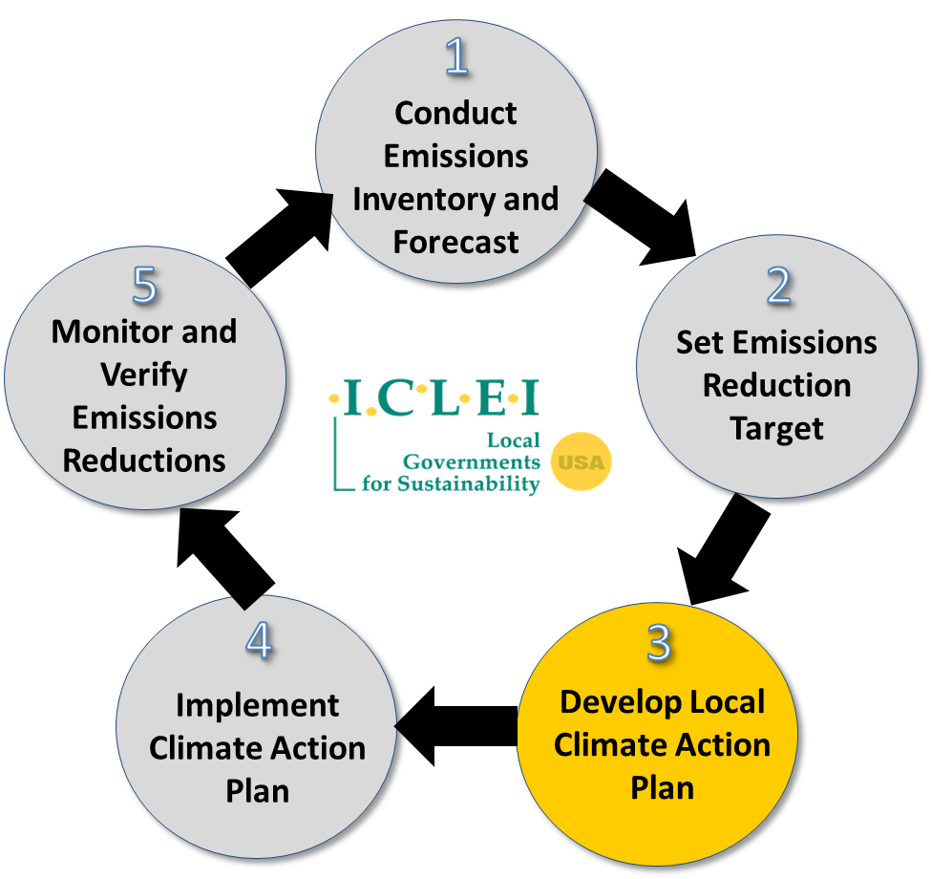

**Figure 1**: Five Milestones for Climate Mitigation

As indicated by the figure above, climate action planning is a continuing cycle and does not stop with the development of this document. However, this Climate Action Plan represents [jurisdiction’s] first planning cycle, including the completion of the first three milestones:

**Milestone 1:** Chapter 3 summarizes the emissions inventory and forecast

**Milestone 2:** Chapter 4 sets reduction targets

**Milestone 3:** Chapters 5-12 outline objectives and actions

Chapter 13 also describes the initial steps of milestones 4 and 5, monitoring and implementation.

**Update the chapters above if your plan is organized differently or you include other chapters.**

**Describe planning process, including the following:**

### Planning Team and Stakeholders

* **Describe the composition of the planning team, including names, titles, and department.**
* **List primary stakeholders and the organizations they represent.**
* **List the dates and content of meetings held with the planning team and stakeholders**

### Social Equity

Climate equity was a core component of the planning process and will continue to be through implementation. Climate Equity ensures the just distribution of the benefits of climate protection efforts and alleviates unequal burdens created by climate change. Implementation of this concept requires intentional policies and projects that simultaneously address the effects of and the systems that perpetuate both climate change and inequity. Under the status quo, however, not everyone is given the opportunity to participate and benefit.

Communities of color and low-income populations have historically been under-served by programs and investments and under-represented in decision-making, including for the development and implementation of climate policy. These exclusionary processes maintain or exacerbate disparities in public health; food, energy, and housing security; air and water quality; economic prosperity, and overall quality of life. These inequities primarily stem from ongoing institutional racial bias and historical discriminatory practices that have resulted in the inequitable distribution of resources and limited access to opportunities.

Climate change is likely to amplify the impacts of these existing inequities. Residents of frontline communities which often include lower income neighborhoods, communities of color, immigrants, unhoused, outdoor workers, the very young, and the elderly will disproportionately bear the burdens of climate change impacts. In addition, the many economic and health benefits of carbon reduction investments are not shared equitably across the city, especially among people of color and low-income communities.

To ensure an equitable climate action plan, the [Jurisdiction] had a community-driven process, which is described in the following section.

### Community-Driven Planning Process

**The best practice for equitable planning is to have a community-driven process. For more information, see the** [**Community-Driven Climate Resilience Planning: A Framework from the National Association of Climate Resilience Planners.**](https://kresge.org/sites/default/files/library/community_drive_resilience_planning_from_movement_strategy_center.pdf) **Other resources for understanding equity principles and how to incorporate them into your planning process:**

* [**U.S. Climate Resiliency Toolkit**](https://toolkit.climate.gov/topics/built-environment/social-equity)
* [**Equitable and Just National Climate Platform**](https://ajustclimate.org/)
* [**New York City Climate Action Plan**](https://gcc01.safelinks.protection.outlook.com/?url=https%3A%2F%2Fonenyc.cityofnewyork.us%2Fstrategies%2Fonenyc-2050%2F&data=02%7C01%7Calacevedo%40pa.gov%7C6072e7a2f42248f7754108d77213019d%7C418e284101284dd59b6c47fc5a9a1bde%7C0%7C0%7C637103298275761409&sdata=rKWh5u0OV2qfUx2sLHKa2gR50wG0xvNQ%2BZByf32auK0%3D&reserved=0)

**Some examples of how to ensure equity is a core component of your planning process include:**

* **Forming a Community Working Group made up of a diverse group of stakeholders from grassroots groups, business representatives, faith and spiritual communities, and neighborhoods.**
* **Include climate equity in the overall Climate Action Plan vision and objectives.**
* **Evaluate proposed actions on whether they help to uplift climate equity and reduce disparities.**
* **Determine climate equity metrics to help track the progress made on those actions.**

**Modify the following according to your specific planning process.**

In identifying which specific populations should be included in a community driven process, [Jurisdiction] consulted:

* The [Pennsylvania Department of Environmental Protection’s Environmental Justice Viewer](http://www.dep.pa.gov/EJViewer):
* The county planning commission
* The MPO/RPO
* Local community groups or processes

[Jurisdiction’s] community-driven process included the following steps:

* List the steps followed to ensure a community-driven process

#### Engagement Activities and Implications

* List dates and content of community meetings
* List other engagement opportunities
* Describe results/implications of these engagement activities

## Vision Statements and Objectives

**These vision statements and objectives should cover both mitigation and adaptation, unless you are planning on having a separate climate adaptation plan. If you have a separate adaptation planning document, note in the section below where adaptation will be addressed.**

**Your Climate Action Plan should have some guiding visions for the public. Research has shown that communities can relate better to vision statements than quantitative GHG reduction targets, so in an outward facing document like the Climate Action Plan, you should lead with vision statements describing the type of community you want to create. Examples include (keep, delete, or modify as necessary):**

1. Make [Jurisdiction] a leader in clean and local energy that comes from the sun, wind, or other innovative renewable technologies.
2. Transform our buildings into high-performing places to live, work, learn, and play.
3. Ensure the benefits of climate action are equitably distributed and empower historically underserved populations to participate in the process of transitioning to a carbon-free community
4. Transform [Jurisdiction] into a community where people walk, bike, take mass transit, or carpool for most trips in a safe, accessi­ble, and affordable transportation network.
5. Aggressively transition toward a clean, carbon-free transportation system that improves health and livability for the [Jurisdiction] community.
6. Become a leader in sustainable, smart transportation through innovative partnerships, policies, programs, and technology.
7. Understand potential climate-related risks and mitigate these risks while preparing our community for chronic and extreme weather events.

The Climate Action Plan offers a robust set of objectives and actions that will address the climate hazard vulnerabilities and aim for an [X%] reduction in GHG emissions by [Year]. Each action and objective was created and reviewed by a group of stakeholders who considered technology limitations, funding constraints, public support, feasibility of implementation, environmental justice considerations, and other barriers. **Revise based on your stakeholder engagement process**.

The [Jurisdiction] established the following targets to maintain a vibrant, healthy, and safe community for future generations, while improving the quality of life for those who live here today:

**SAMPLE MITIGATION OBJECTIVES**

**Please note that these are examples of objectives, which you can add to, keep, delete, or modify as necessary:**

### By 2025

* [Jurisdiction] will reduce energy use in its buildings by 10%

### By 2030

* [Jurisdiction] will reduce energy use in its buildings by 20%
* 100% of [Jurisdiction]’s electricity will come from renewable energy
* 9% of [Jurisdiction]’s commuters will carpool
* 8% of [Jurisdiction]’s commuters will bike to work
* 9% of [Jurisdiction]’s commuters will walk to work
* 16% of [Jurisdiction]’s commuters will use public transit
* 7% of [Jurisdiction]’s commuters will telecommute
* Electric Vehicles will be powered by 100% renewable energy
* [Jurisdiction] will incentivize Leadership in Energy & Environmental Design (LEED) certification and/or enforce net-zero building codes for new buildings
* At least 30% of new housing units within ¼ mile of high-frequency transit are designated affordable.
* A food outlet selling fresh produce is located within a 15 minute walk of every resident
* An emergency cooling center is located within a 10 minute walk for the most vulnerable residents (based on age, income and other factors)
* 20% of jobs in transit construction and renewable energy installation are provided to residents of low-income neighborhoods, or groups that face employment challenges.
* Miles of bike lane per resident in low-income neighborhoods is equal to that in higher-income neighborhoods
* Increase annual number of households reached by low-income weatherization programs 30%
* Decrease the energy costs of low-income residents 20%
* Install roof-top solar on homes of 1000 low and moderate income residents

### By 2050

* 70% of [Jurisdiction]’s households and businesses will participate in smart grid meter programs
* 90% of [Jurisdiction]’s existing buildings will complete energy-efficiency improvements
* 50% of [Jurisdiction]’s tenants will participate in a green lease program
* 50% of heating fuel derived from fossil-fuels (oil, natural gas and propane) will be switched to a low- carbon fuel source and/or electric heat
* 18% of [Jurisdiction]’s commuters will bike to work
* 15% of [Jurisdiction]’s commuters will walk to work
* 18% of [Jurisdiction]’s commuters will use public transit
* 100% of public transportation will be carbon free
* 80% of light-duty vehicles will be electric
* 100% of [Jurisdiction]’s light- and heavy- duty vehicles will be electric or fueled by carbon-free fuel
* 100% of transportation network companies’ cars (Taxis, Uber, Lyft, etc.) will be electric

# Co-Benefits of Climate Action

Greenhouse gas reduction and climate resilience are not the only beneficial outcomes of climate action plans. The following outcomes are referred to as “co-benefits,” and they illustrate how taking action on climate change results in a more prosperous community.

## Improving Public Health

Climate change mitigation activities, particularly those related to transportation, help to clean the air by reducing vehicle emissions and therefore improve public health. Mitigation activities help to engender a greater degree of choice for [Jurisdiction]’s residents. More transit options combined with transit-oriented development practices make for a more vibrant, livable community with shorter commute times and more opportunities for active transport. This creates more connected and resilient neighborhoods.

## Saving Money and Reducing Risk

In addition to addressing climate change, measures taken to reduce greenhouse gas emissions have other important benefits. The most obvious of these is the potential for significant cost savings. In [Year], [Jurisdiction] spent over [$$$$] on energy to power buildings and fuel its vehicle fleet. Many of the measures in this plan pay for themselves quickly by reducing direct costs, such as fuel or energy used, and also indirect costs such as maintenance. For instance, a “right-sized” vehicle fleet is less expensive to purchase and fuel, while also being less costly to maintain. **Add information here about the expected monetary cost/benefit of Climate Action Plan projects.** Encouraging energy efficiency, public transit use, building improvements, and other measures will also result in lower energy and water bills for residents and employers as well.

Acting now will also save on runaway costs on climate change, especially in the longer term. These costs range from infrastructure damage in extreme storms and pest control to industry losses, particularly for industries that depend on environmental conditions, such as winter sports.

## Enhancing Resource Security

A key strategic side benefit of climate change mitigation activities is enhanced energy security through reduction in total demand. This will put less strain on the energy system as a whole as we transition to clean renewable energy. Similarly, demand shifts can help with improving water and food security as well.

Many of the actions identified here to mitigate GHG emissions will also help [Jurisdiction]’s government, businesses, and residents to adapt to a changing climate. For example, extreme and prolonged heat waves can put considerable strain on the reliability of energy delivery in peak periods, possibly leading to service disruption during times when cooling is most needed. By increasing efficiency across the [Jurisdiction], such service disruptions are less likely and the [Jurisdiction] will be able to better cope with those situations. Similarly, climate actions can secure food and water sources and prevent damage and service disruptions to these systems from [drought, flooding, and fire].

## Creating Jobs

Renewable energy is a growing sector. The U.S. Department of Energy reports that sustainable tourism, green construction, and urban agriculture can provide job opportunities that didn’t exist in the past. These climate protection measures can spur business and job growth during the design, manufacture, and installation of energy efficient technologies, which presents a particular opportunity to reinvest in the local economy and generate green jobs within [Jurisdiction].

## Fostering Social Equity

Social equity and justice are major concerns for addressing climate change, and thus were established as core values behind this plan. Equity is when all individuals have access to the opportunities necessary to satisfy their essential needs, advance their well-being and achieve their full potential. Environmental justice ensures fair treatment and meaningful involvement in the development of laws, policies and regulations and the identification of issues impacting vulnerable communities. As discussed in Chapter 1, [Jurisdiction’s] community-driven planning process generated solutions that will both address climate change and ensure a better quality of life for communities of color and low-income communities.

# [Jurisdiction]’s GHG Emissions

**Once the GHG inventory is done, this section will include community-wide and/or government operations GHG emissions information. ICLEI’s ClearPath software will be used to generate emission forecasts**.

Since the early 1990s, U.S. cities have developed community-wide and local government operations greenhouse gas (GHG) inventories based on accounting protocols created by ICLEI. Known as the [U.S. Community Protocol for Accounting and Reporting of Greenhouse Gas Emissions](http://icleiusa.org/us-community-protocol/) and the [Local Government Operations Protocol](https://s3.amazonaws.com/icleiusaresources/lgo_protocol_v1_1_2010-05-03.pdf), these standards created a credible and defensible methodology which accelerated the number of inventories created and provides consistency within and across U.S. communities. In 2014, ICLEI partnered with the World Resources Institute and C40 Climate Leadership Group to create the Global Protocol for Community Scale GHG Emissions, which allows communities around the world to compare their emissions footprint.

[Jurisdiction] used the [XXX Protocol] for the inventory…

Through the completion of a local emissions study, or “greenhouse gas inventory,” our [Jurisdiction] has determined emissions levels for the community as a whole. Community-wide emissions represent the sum total of emissions produced within [Jurisdiction] limits as well as emissions resulting from electricity use within the jurisdiction, even if said electricity is generated elsewhere. In this way, the community-wide figures represent all emissions for which the community is responsible.

## [Jurisdiction] Community-Wide GHG Emissions

**Figure 2 is a sample GHG inventory output produced using data from ClearPath.**

The following figure breaks down community-wide emissions in [Jurisdiction]. Note that emissions from the [Jurisdiction]’s operations are embedded within the community-wide totals. For example, emissions from government buildings are included in the “Commercial” sector and emissions from [Jurisdiction] fleet vehicles are included in the “Transportation” figure above. Government operations are therefore a subset of total community emissions.

Figure 2: [Jurisdiction] Community-Wide GHG Emissions

Government emissions include all sources for which the local government exercises direct operational control including **Refer to government operations GHG inventory, list emissions-generating services offered by local government, possibly including water/wastewater services, solid waste, electric utility, etc.**

## Forecasting [Jurisdiction’s] GHG Emissions

**Figure 3 is a sample GHG inventory output produced using data from ClearPath.**

The [Jurisdiction] has also completed an emissions forecast based on projections of current data and expected future trends. This emissions forecast is the “Original” forecast (also known as a “Business As Usual” forecast), a scenario estimating future emissions levels if no further local action (i.e. projects within this Climate Action Plan) were to take place. The forecast indicates that, if we do not take action, GHG emissions will continue to increase. **Align statements with your local forecast; ICLEI’s ClearPath software can be used to generate these forecasts.**

##### Projected Growth in GHG Emissions

**Figure 3 is a sample GHG forecasting output produced using data from ClearPath. If you use ClearPath for your emissions accounting, these graphs live update and can easily be extracted to use in your reports.**

Figure 3 shows the projected growth in GHG emissions in [Jurisdiction] from ___ to ____. For complete information regarding the emissions inventory and forecast, including methodology and supporting data, please reference Appendix I.

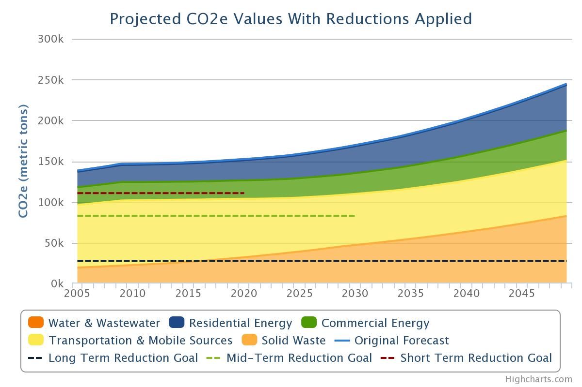

Figure 3: Projected Growth in GHG Emissions from ___ to ___

## [Jurisdiction]’s GHG Reduction Target

**Change the following and figure 4 as necessary to reflect targets.** [Jurisdiction] has set targets to reduce its emissions to [Base Year] levels by [Target Year], or [XX] percent below [Base Year] levels by [Target Year]. Figure 4 compares the reduction target with the business-as-usual forecast. The combination of measures that [Jurisdiction] has already implemented, are currently planned, and are presented through this Climate Action Plan are designed to achieve the [Target Year] targets. Reductions in [Target Year] rely on the best information currently available pertaining to population forecasts, future changes to building codes, and vehicle fuel efficiency standards among other information. **Align previous statement with the specific forecast methodology used.**

**For cities that have signed on to #WeAreStillIn or the Global Covenant of Mayors, ICLEI has produced a guide called** [**Localizing the Paris Agreement**](http://icleiusa.org/localizing-the-paris-agreement/) **in 2017. This guide contains valuable information on how to incorporate the international targets into local policies.**

Figure 4: GHG Reduction Target

[Jurisdiction]’s reduction target is consistent with the statewide target of 26% reduction by 2025 and 80% by 2050 from 2005 levels, as it exceeds its local percentage of the total emissions reduction needed in order to achieve that target (see Appendix I for these calculations).

## The [Jurisdiction] Climate Action Plan

**Consider collapsing specific actions into project categories or inventory sectors such as “Energy” or “Buildings,” “Transportation,” and so on if your plan has not been organized in this way already. These categories might be inspired through the GHG inventory process or other organizing principles and make the plan easier to communicate. Summarize the Plan via table format, laying out all of the sectors in one location.**

**If you feel that some actions do not fit into one particular focus area but instead affect, build on, or are a component of all areas, consider making a “Cross-Cutting Actions” focus area. This optional focus area can help to call out the importance of a cross-cutting objective or group of actions. Although embedded in components of other focus areas, calling out cross-cutting actions or objectives in their own section allows one to set quality thresholds or success metrics for these activities, ensuring that these objectives are observed and done well. Good examples include Public Education and Outreach, Land Use, Climate Adaptation, or Developing a Green Economy.**

The summary table below identifies the sectors within the [Jurisdiction] Climate Action Plan, the number of actions within each sector, and the contribution of each sector toward the GHG reduction goal. Each sector has a dedicated section within this document where objectives and specific actions (both new and those already employed) are described.

While the local government cannot address climate change by itself, government policies and practices can dramatically reduce greenhouse gas emissions from a range of sources and help prepare [Jurisdiction] for the anticipated impacts of climate change. In addition, the [Jurisdiction] will assist residents and businesses in their endeavors to reduce emissions through programs explained in this Plan. By working together, [Jurisdiction] can not only do its part toward achieving a stable climate - we can reap the benefits of healthier air, lower costs for utilities and services, improved transportation and accessibility, a more vibrant local economy, and many other positive side effects of reducing our carbon footprint.

##### [Jurisdiction] Climate Action Plan Summary Table – Sectors

|  |  |  |  |  |
| --- | --- | --- | --- | --- |
| Sector | Description | Number of Distinct Actions | Anticipated MTCO2e Reduction by XXXX | Percentage of Total Reduction at XXXX |
| **Commercial & Industrial Buildings** | Policies and programs to reduce commercial, municipal, and industrial sector energy use. | 9 | ~14,900 | 22% |
| **Residential Buildings** | Policies and programs to reduce residential sector energy use. | 6 | ~12,900 | 19% |
| **Energy Production** | Policies and programs to promote local small-scale renewables. | 7 | ~6,800 | 10% |
| **Waste, Composting and Recycling** | Policies and programs to reduce solid waste generation. | [X] | ~10,200 | 15% |
| **Water and Wastewater Management** | Policies and programs to reduce water demands and corresponding wastewater treatment needs. | [X] | ~8,100 | 12% |
| **Transportation** | Policies and programs to reduce on-road vehicle miles traveled and promote electric or low emission vehicles. | [X] | ~7,450 | 11% |
| **[Other Sector]** | Table provided here as example – to be modified according to local plan/conditions. | [X] | ~7,450 | 11% |

*MTCO2e (Metric tons of CO2 equivalent)

The Impact on Emissions

The figure below depicts historic GHG emissions, forecasted growth in emissions, and target emissions from [Year] to [Year]. The color wedges represent the projected reductions in emissions based on state and local programs.

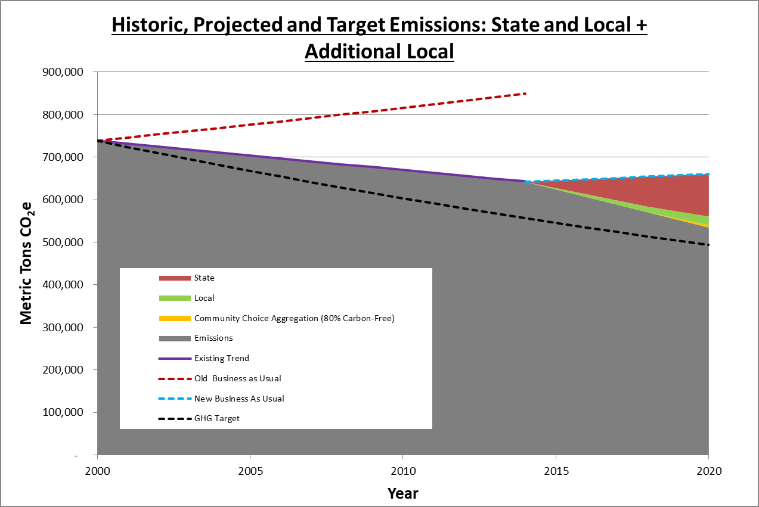

Figure 5: Visualizing GHG Reductions

# Taking Action

In the following chapters, a series of objectives with supporting actions are explored for each emissions sector. An “Objective” is a goal, end result, or target, and an “Action” is a means of realizing the objective. Each sector draws on the actions of the local government, residents, and businesses, although some areas may be largely one or the other.

## Emissions Reduction Potential

Calculating expected emissions reductions for each objective and action requires making assumptions about degree of implementation, technology, and individual behavioral changes several years into the future. The uncertainty associated with these assumptions makes it difficult to assign exact reduction totals to each objective or action. To address this uncertainty and provide a simple but useful reference for reduction potential, a series of symbols and percentage ranges has been devised to represent the emission reductions associated with each objective and its actions:

|  |  |
| --- | --- |
| Symbol | GHG Reduction |
|  | [Small Impact Range] |
|  | [Moderate Impact Range] |
|  | [Significant Impact Range] |

Specific implementation assumptions and GHG reduction estimates are listed in the Appendix.

**Symbols are a good alternative to listing specific reduction figures since results will vary to some degree. Choose the ranges for each symbol depending on the expected emissions reductions from proposed actions. Or, if your local government prefers to display actual values to represent GHG reduction potential, delete this symbol guide. If you choose this approach, it is recommended that you use round figures, so as not to convey a false sense of precision.**

## Evaluating Co-Benefits

In addition to measuring the GHG reduction potential, each objective and action is also evaluated for other benefits such as public health, equity and justice, jobs and prosperity, and environmental conservation. The symbols below will indicate which co-benefits a measure will generate.

**Feel free to use these symbols or create your own.**

|  |  |
| --- | --- |
| Symbol | Co-Benefit |
|  | Supports jobs and economic prosperity |
|  | Advances social equity |
|  | Fosters resource security |
|  | Improves public health and local environmental quality |

## Supporting Actions

Certain actions might be supportive of more than one objective within the same or another sector. These cross-cutting actions will be indicated in the “Supporting Actions” column for each objective.

## New and Existing Actions

This Climate Action Plan includes a combination of existing policies and programs as well as new ideas based on best practices from around the country. Whether an action is new or existing is noted in the action heading.

**It is necessary to detail out the implementation activities, indicators/metrics, and timelines for the strategies. This may be included in this document in the tables below or in an internal implementation plan.**

## Consistency with Statewide Climate Action Plan

The Commonwealth of Pennsylvania’s 2018 Climate Action Plan includes many actions that are meant to be implemented by local governments as well as on the state-level. This Climate Action Plan incorporates as many of those actions as possible and appropriate. The tables in the following chapters will indicate whether an action is adapted from the statewide plan.

## Climate Adaptation

Some of the proposed actions reduce risk to climate hazards as well as greenhouse gas emissions, which is explicitly identified in the “Reduces Climate Risks” column. This Plan does not propose any actions that would foreseeably increase the community’s risk to climate hazards, but some actions are more directly supportive of climate adaptation than others. The “Climate Adaptation” chapter describes climate hazards and related actions in more detail.

**\*\* NOTES ON STATEWIDE CAP CONSISTENCY\*\***

**Read & Delete**

**Pennsylvania’s Climate Action Plan (CAP) was issued in April 2019. For the following chapters, it is highly encouraged to include as many of the** [**statewide CAP**](https://www.dep.pa.gov/citizens/climate/Pages/PA-Climate-Action-Plan.aspx) **objectives and actions from that plan as is feasible and relevant to your community. All of the actions applicable to local government are listed here for your reference. Only select those actions which could be implemented in your community.**

* **Increase end use energy conservation and efficiency**
  + Update building codes
  + Increase adoption of energy efficiency
  + Expand energy assessments and provide more trainings on energy efficiency for industry
  + Expand home weatherization programs
  + Increase support for market trends for energy efficient technologies
  + Replace high carbon and GHG producing fuels or energy sources with less environmentally impactful options
  + Educate consumers about the benefits of occupant performance and low energy usage improvements in building system technologies
* **Implement sustainable transportation planning and practices**
  + Reduce vehicle miles traveled for single-occupancy vehicles
  + Implement a strategic plan and incentives for increasing electric vehicle use
  + Increase the use of clean public transportation through electric municipal bus fleets
  + Develop people-mover systems, such as West Virginia University’s Personal Rapid Transit system
  + Continue and expand efforts to assess climate risks to transportation and land use planning, and incorporate expected future conditions into capital planning, project design, and routine operations, maintenance, and inspection practices
  + Improve preparedness for increased frequency of extreme events by improving coordination between agencies and other stakeholders and by improving real-time monitoring of flooding, traffic, and other conditions
  + Prioritize transportation and land use planning that promotes efficient use of public resources, reduces congestion, and minimizes GHG emissions through multi-modal transportation networks and compact, transit-oriented development that uses smart growth practices and complete streets
  + Educate citizens and business on the benefits of transportation demand-side management measures and clean and efficient transport options
  + Increase adoption of people-powered transportation options such as walking, school buses, or commuter bicycle paths
  + Reduce non-CO2 emissions (hydrofluorocarbons) from truck and stationary refrigeration systems
  + Help develop and implement regional market-based policies that would both reduce carbon pollution from the transportation sector and fund clean transportation investments
* **Develop, promote, and use financing options to encourage energy efficiency**
  + Expand use of performance contracting
  + Create local clean energy tax incentives
  + Evaluate options for and engage in public-private partnerships and capitalize on them
  + Encourage broad implementation of recent commercial PACE legislation
* **Increase use of clean, distributed electricity generation resources**
  + Invest in and promote building-scale solar
  + Incentivize and increase use of combined heat and power (CHP)
  + Support community solar legislation and develop model local ordinances
* **Create a diverse portfolio of clean, utility-scale electricity generation**
  + Further increase local generation and use of renewables
  + Establish a workgroup to help optimize siting of renewables, and to review and streamline permitting and regulations at the local level. Focus on high value, implementable actions such as community choice aggregation and battery storage.
* **Increase production and use of alternative fuels**
  + Increase recovery and use of gas from coal mines, agriculture, wastewater, and landfills for energy
  + Increase sustainable biofuel production
  + Support the sustainable harvest and use of biomass feedstocks for thermal energy
* **Use agricultural best practices**
  + Increase adoption rate of and provide training for no-till farming practices
  + Facilitate information sharing networks for farmers and the agricultural research community to share experiences and best practices
* **Protect ecosystem resilience, including forest systems where species will shift**
  + Conserve and enhance areas representing the full range of wildlife and fish habitats and promote connectivity (e.g., using land exchanges, conservation easements, leases; by removing barriers) to allow species to migrate to suitable habitat
  + Promote forest conservation, reforestation and urban tree canopy expansion on private and public lands through various means, including forest conservation easement programs
  + Restore wetlands and riparian areas, expand or revise current minimum riparian buffer zones, and implement living shoreline programs to provide natural flood abatement, breeding habitat, and improved stream conditions (including improved thermal conditions)
  + Preserve and create open spaces, parks, and trails that allow people to continue to engage in outdoor activities and maintain connectivity to natural resources. Protect wildlife and fish habitat and species that support recreational opportunities like hunting, fishing, and wildlife viewing.
  + Educate recreational land users about the importance of climate change impacts on ecosystems and the dangers of illegal hunting and fishing, pollution, and development
  + Retrofit existing parks and trails and create new parks and trails to strengthen the community, improve habitat connectivity, provide more water sources for human users recreating in higher temperatures, enhance natural stormwater and flood management, and connect paths to schools, workplaces, and retail centers to promote pedestrian use
  + Promote alternatives to mowing, including meadows, native plants, and trees
* **Monitor, identify, and address ecosystem vulnerabilities**
  + Identify and prioritize species, habitat, and ecosystems most vulnerable to climate change and other stressors to better target protection and management actions
* **Help the outdoor tourism industry manage shifting climate patterns**
  + Help public parks adapt to climate change by designing park infrastructure to be adaptable to changes in use, allocating funds to match recreation demand, and expanding operations at ski resorts to allow for warmweather recreation
  + Explore developing new collaboratives with surrounding communities
  + Create a business ombudsman or technical assistance center for affected recreational industries and establish a source of grant funding or tax incentives to help industry and municipalities transition from winter to summer activities
* **Reduce waste generation by citizens and business thereby reducing waste sent to landfills, and WTE facilities, and expand the beneficial use of waste**
  + Implement programs to encourage citizens and business to reduce waste (including food waste) and use recycling and composting programs through reduce, reuse, and recycle actions
  + Encourage the use of digesters for methane capture and recovery
  + Support solar projects on landfill land
* **Use stormwater best management practices**
  + Explore ways to incorporate PA DEP’s Stormwater Best Management Practices Manual as standard operating procedure
  + Provide incentives for the installation and use of gray water and rainwater harvesting and consider existing international guidelines for increased reclaimed, recycled, and gray water use for non-potable applications (e.g., irrigation, toilet flushing)
  + Promote green infrastructure by instituting laws, regulations, and local ordinances requiring implementation of green infrastructure with new development or substantial redevelopment
  + Reduce impervious surfaces by requiring installation of permeable surfaces, buffers, and vegetated filters for all transportation-related projects; developing and enforcing a stormwater retention standard for new development and redevelopment; and/or implementing a fee for impervious surfaces
* **Promote integrated water resources management and water conservation**
  + Assess the impact of climate change on critical water supply and wastewater infrastructure, and encourage the development of facility-specific adaptation plans
  + Include climate change projections and modeling results in water supply and water quality planning to enhance reliability, improve quality, and improve instream flows and fish passage
* **Improve reliability and accessibility of public information about climate-related health risks**
  + Update Community Health Assessments to include climate change and health tracking metrics
  + Help local health departments assess their capacity to respond to health threats and to integrate climate preparedness into their hazard response plans and daily operations
  + Work locally with vulnerable groups to assist at-risk communities with the development, adoption, practice, and evaluation of response, evacuation, and recovery plan
  + Regularly map locations of vulnerable populations and use the information to focus interventions and outreach
* **Bolster emergency preparedness and response**
  + Review existing emergency response, preparedness, evacuation, and management plans
  + Expand the scope of the local hazard mitigation plan to factor in expected vulnerabilities from climate change impacts
  + Evaluate and improve the adequacy, effectiveness, accuracy, and technological capabilities of forecasting, earlywarning, and emergency-preparedness systems
  + Foster collaboration between communication service providers and agencies to provide reliable communications in times of power outages and emergencies
  + Establish heat advisories, increase availability of cooling stations, invest in efficient HVAC systems at targeted Recreation Centers which are provided with renewable energy backup systems, and implement other preventive measures to reduce the impact of extreme heat events
  + Restructure disaster-recovery policies to ensure that redevelopment efforts strive to reduce long-term risk
* **Lead by example in local government practices and assets**
  + Establish a strategic energy management plan for public facilities that includes benchmarking and specific energy, water, and transportation emissions reductions targets and goals
  + Maximize onsite renewable energy generation and purchase additional renewable power through renewable energy certificates (RECs) direct purchasing
  + Incorporate climate change considerations into decision making processes and criteria. For example, add climate change resilience as a prioritization factor for new capital projects.
  + Consider ENERGYSTAR certification, Leadership in Energy and Environmental Design (LEED) Gold, Net Zero Buildings, Zero Energy Codes, Passive House standards, and climate resilience design guidelines as higherperformance basis of design for new construction and major renovation projects in public buildings
  + Inventory public buildings and energy use patterns to identify savings opportunities
  + Implement emissions reduction and climate resilience activities in public facilities, including distributed generation, least impact backup power generation, energy efficiency, water efficiency, climate resilient vegetation, and proper tree maintenanc
  + Require energy efficient and alternative fuels use in fleet vehicles and equipment
  + Conduct more training, education, and outreach for facility managers and the workforce
  + Ensure that key government operations have planned to provide least impact backup power supply on-site to protect important security features in the case of more frequent or prolonged blackouts
* **Incorporate historical and projected climate conditions into siting and design decisions for longterm infrastructure**
  + Implement new or modified policies (e.g., zoning regulations, tax incentives, and rolling easements) that encourage appropriate land use and reduce repetitive losses

**\*\*NOTES ON CLIMATE EQUITY\*\***

**Read & Delete**

The community-driven planning process should generate many solutions that concurrently address GHG emissions and equity. Here are some examples to help conceptualize what those actions might look like:

* **Develop, promote, and use financing options to encourage energy efficiency**

-Some of this work could focus on PA residents living in energy poverty.

-Increase access to affordable, efficient energy options for low-income residents.

* **Implement sustainable transportation planning and practices**

-Financial incentives be provided for municipalities to offer electric vehicle ride sharing options.

* **Monitor, identify, and address ecosystem vulnerabilities**

-In addition, consider monitoring climate vulnerable communities.

# Commercial Buildings

**Provide a summary of the overall vision, types of actions included in the focus area, and its importance to the overall Plan.**

Energy consumed in commercial buildings and industrial processes account for [XX]% of [Jurisdiction]’s total GHG emissions. Improving the efficiency of our commercial building stock and reducing the energy intensity of the local industrial sector will contribute significantly to achieving [Jurisdiction]’s greenhouse gas reduction target. This chapter focuses on opportunities to retrofit existing commercial and industrial buildings and to ensure that future activities in these sectors are compatible with our community’s climate protection goals.

**The following tables contain sample objectives and actions. Please update the text and symbols accordingly.**

|  |  |  |  |
| --- | --- | --- | --- |
| **Objective** | **Supporting Actions** | **Co-Benefits** | **Reduction Potential** |
| CB 1 – Retrofit existing commercial and industrial buildings to achieve a [XX]% reduction in energy use by [Year] | RB 1, EP 1 |  |  |
| CB 2 – Ensure new commercial and industrial construction is built to maximize energy efficiency | CB 1,  RB 2 |  |  |
| [Other Objective] | [X] |  |  |
| [Other Objective] | [X] |  |  |
| [Other Objective] | [X] |  |  |

|  |  |  |
| --- | --- | --- |
| Objective CB 1 – Existing Commercial and Industrial Buildings | | |
| Retrofit existing commercial and industrial buildings to achieve a [XX]% reduction in energy use by [Year] |  |  |

|  |  |  |  |  |  |  |  |
| --- | --- | --- | --- | --- | --- | --- | --- |
| Action Number | Action | New (N) or Existing (E) | Statewide CAP Action | Reduces Climate Risk | Co-Benefits | Lead Actor | Metric |
| CB-1A EXAMPLE | Partner with local utility companies to ensure commercial properties maximize use of energy efficiency rebate programs | N | Y |  |  | Community and Buildings Dept | Number of partnerships |
| CB- 1B EXAMPLE | Require benchmarking and disclosure of energy use in commercial and industrial buildings over [XX] square feet | N | Y |  |  | Utility, Bldgs & Finance Dept | Number of buildings using benchmarking |
| CB-1C  EXAMPLE | Establish PACE program and/or partner with utilities to offer on-bill financing for commercial energy efficiency retrofit projects | N | N |  |  | Utility, Bldgs & Finance Dept | Number of PACE projects |
|  |  |  |  |  |  |  |  |
|  |  |  |  |  |  |  |  |

# Residential Buildings

**Provide a summary of the overall vision, types of actions included in the focus area, and its importance to the overall Plan.**

Energy consumed in residential buildings accounts for [XX]% of [Jurisdiction]’s total GHG emissions. Improving the efficiency of our residential building stock will contribute significantly to achieving [Jurisdiction]’s greenhouse gas reduction target, while saving residents money on utility bills and reducing the need for new infrastructure. This chapter focuses on opportunities to retrofit existing residential buildings, increase the quality of new construction, and to ensure that future activities in these sectors are compatible with our community’s climate protection goals.

**The following tables contain sample objectives and actions. Please update the text and symbols accordingly.**

|  |  |  |  |
| --- | --- | --- | --- |
| **Objective** | **Supporting Actions** | **Benefits** | **Reduction Potential** |
| **RB 1 – Retrofit existing residential buildings and homes to achieve a [XX]% reduction in energy use by [Year]** | [X] |  |  |
| **RB 2 – Ensure new residential buildings and homes are built to maximize energy efficiency** | [X] |  |  |
| **[Other Objective]** | [X] |  |  |
| **[Other Objective]** | [X] |  |  |
| **[Other Objective]** | [X] |  |  |

|  |  |  |
| --- | --- | --- |
| Objective RB 1 – Existing Residential Buildings | | |
| Retrofit existing residential buildings and homes to achieve a [XX]% reduction in energy use by [Year] |  |  |

|  |  |  |  |  |  |  |  |
| --- | --- | --- | --- | --- | --- | --- | --- |
| Action Number | Action | New (N) or Existing (E) | Statewide CAP Action | Reduces Climate Risk | Co-Benefits | Lead Actor | Metric |
| RB-1A | Double the number of homes weatherized through existing programs per year | E | N | Y |  | Community and Buildings Dept | Number of homes weatherized |
| RB- 1B | Offer financing vehicle to residential sector for energy retrofits | N | N | Y |  | Utility, Bldgs & Finance Dept | Financing program finalized |
| RB-1C | Increase residential uptake of utility incentives for energy efficiency | N | N | Y |  | Utility, Bldgs & Finance Dept | Number of residents participating |
|  |  |  |  |  |  |  |  |
|  |  |  |  |  |  |  |  |

|  |  |  |
| --- | --- | --- |
| Objective RB 2 – New Residential Buildings | | |
| Ensure new residential buildings and homes are built to maximize energy efficiency |  |  |

|  |  |  |  |  |  |  |  |
| --- | --- | --- | --- | --- | --- | --- | --- |
| Action Number | Action | New (N) or Existing (E) | Statewide CAP Action | Reduces Climate Risk | Co-Benefits | Lead Actor | Metric |
| RB-2A | Improve building codes to exceed minimum efficiency requirements by XX% | N | Y | Y |  | Community and Buildings Dept | Number of homes weatherized |
| RB- 2B | [strategy description] | - | - | - |  | Utility, Bldgs & Finance Dept | Financing program finalized |
| RB-2C | [strategy description] | - | - | - |  | Utility, Bldgs & Finance Dept | Number of residents participating |

# Energy Production

**Provide a summary of the overall vision, types of actions included in the sector, and its importance to the overall Plan.**

Broadly speaking, the use of fossil fuels for energy (including electricity, heating, transportation, and other uses) is the single largest contributor to greenhouse gas emissions and climate change. Fossil fuels still supply a considerable share of energy for electricity, heating, transportation, and other energy-producing uses. Emissions from fossil fuel combustion for energy, including transportation, represent [XX]% of the community’s total GHG emissions. Energy Production is a cross-cutting sector in that nearly all activities that take place in the community require energy of some sort. While [Local Utility] is working hard to increase the percentage of electricity generated through renewable sources, opportunities also exist for citizens and [Jurisdiction’s] local government to produce small-scale renewable energy or fuels, offsetting the need for fossil fuels. This sector is limited to energy production exclusively – objectives and actions that focus on end use energy efficiency are included in other sectors. The programs and projects within this sector are designed to spur local government and community investment in renewable energy sources including those that produce electricity, heat, and mobile fuels.

**The following tables contain sample objectives and actions. Please update the text and symbols accordingly.**

|  |  |  |  |
| --- | --- | --- | --- |
| **Objective** | **Supporting Actions** | **Benefits** | **Reduction Potential** |
| EP 1 – Enhance support to residents for installing small-scale renewable energy systems | CB 1, RB 1 |  |  |
| EP 2 – Supply [XX]% of [Jurisdiction] local government electricity demand via local renewable generation | CB 1 |  |  |
| EP 3 – Promote local production of biofuels and harness waste energy | WR 1, WW 1 |  |  |
| [Other Objective] | [X] |  |  |
| **[Other Objective]** | [X] |  |  |

|  |  |  |
| --- | --- | --- |
| Objective EP 1 – Small-Scale Renewable Energy Systems | | |
| Enhance support to residents for installing small-scale renewable energy systems |  |  |

|  |  |  |  |  |  |  |  |
| --- | --- | --- | --- | --- | --- | --- | --- |
| Action Number | Action | New (N) or Existing (E) | Statewide CAP Action | Reduces Climate Risk | Co-Benefits | Lead Actor | Metric |
| EP-1A EXAMPLE | Encourage community partners to finance and install renewable systems on large-scale private facilities | N | Y | N/A |  | Community, Economic Dev Committee | Number of partnerships |
| EP- 1B EXAMPLE | Establish a program to offer renewable energy system financing to small commercial properties | N | Y | N/A |  | Community, Local Bank, Bldgs, Finance, Legal Depts, Utility Experts | Program establishment |
| EP-1C  EXAMPLE | [strategy description] | - | - | - |  | - | - |

|  |  |  |
| --- | --- | --- |
| Objective EP 2 – Local Renewable Generation for [Jurisdiction] | | |
| Supply [XX]% of [Jurisdiction] local government electricity demand via local renewable generation |  |  |

|  |  |  |  |  |  |  |  |
| --- | --- | --- | --- | --- | --- | --- | --- |
| Action Number | Action | New (N) or Existing (E) | Statewide CAP Action | Reduces Climate Risk | Co-Benefits | Lead Actor | Metric |
| EP-2A EXAMPLE | Install renewable energy systems on [City/County]-owned facilities such that [20]% of total energy demand of local government buildings is met. | N | Y | N/A |  | PW Dept | Number of RE systems installed; percentage of energy demand met |
| EP- 2B EXAMPLE | Execute renewable power purchase agreement with [Utility] for 30% of total electricity demand of local government buildings | N | Y | N/A |  | PW Dept, Utility | Establishment of RE power purchase |

# Waste, Composting, & Recycling

**Provide a summary of the overall vision, types of actions included in the sector, and its importance to the overall Plan.**

[Jurisdiction]’s solid waste is disposed of, primarily, at [Name of Landfill], **provide description of landfill location**. Emissions from decaying putrescible material directly contribute [XX]% of [Jurisdiction]’s total GHG emissions and contribute to emissions in the Transportation sector via hauling of waste to and from facilities. Additionally, embodied energy within the items that we throw away might be harnessed through reuse and recycling of materials. It is in [Jurisdiction]’s long-term interest to reduce waste at its source, expand recycling facilities, reduce food waste, and enable re-use of materials. This chapter focuses on opportunities to reduce waste, reuse materials, and recycle what cannot be reused.

**The following tables contain sample objectives and actions. Please update the text and symbols accordingly.**

|  |  |  |  |
| --- | --- | --- | --- |
| **Objective** | **Supporting Actions** | **Benefits** | **Reduction Potential** |
| WR 1 – Reduce solid waste generation by [XX]% by [Year] | CB 1, RB 1 |  |  |
| **WR 2 - [objective description]** | CB 1 |  |  |
|  | WR 1, WW 1 |  |  |
|  | [X] |  |  |
|  | [X] |  |  |

|  |  |  |
| --- | --- | --- |
| Objective WR 1 – Reduce Solid Waste | | |
| Reduce solid waste generation by [XX]% by [Year] |  |  |

|  |  |  |  |  |  |  |  |
| --- | --- | --- | --- | --- | --- | --- | --- |
| Action Number | Action | New (N) or Existing (E) | Statewide CAP Action | Reduces Climate Risk | Co-Benefits | Lead Actor | Metric |
| WR-1A EXAMPLE | Establish “Building Materials Reuse Warehouse” for community construction and demolition use. | N | N | N/A |  | Solid Waste, PW, Bldg Depts | Establishment of warehouse |
| WR - 1B EXAMPLE | [Strategy description] | - | - | - |  | - | - |
| WR -1C  EXAMPLE | [Strategy description] | - | - | - |  | - | - |
|  |  |  |  |  |  |  |  |
|  |  |  |  |  |  |  |  |

# Water & Wastewater Management

**Provide a summary of the overall vision, types of actions included in the sector, and its importance to the overall Plan.**

**This section largely pertains to those local governments who own their own water delivery or wastewater services, or are partners in a multi-jurisdictional water delivery and treatment arrangement. It is also possible for local governments to partner with water utilities to accomplish these goals, if privately or otherwise owned or operated.**

This sector does not include the methane collection system; please refer to Energy Production sector for this project.

**The following tables contain sample objectives and actions. Please update the text and symbols accordingly.**

|  |  |  |  |
| --- | --- | --- | --- |
| **Objective** | **Supporting Actions** | **Benefits** | **Reduction Potential** |
| WW 1 – Upgrade the energy efficiency of water delivery and treatment systems by 15% | CB 1, RB 1 |  |  |
| **WW 2 - [objective description]** | CB 1 |  |  |
|  | WR 1, WW 1 |  |  |
|  | [X] |  |  |
|  | [X] |  |  |

|  |  |  |
| --- | --- | --- |
| Objective WW 1 – Energy Efficiency | | |
| Upgrade the energy efficiency of water delivery and treatment systems by 15% by ___ |  |  |

|  |  |  |  |  |  |  |  |
| --- | --- | --- | --- | --- | --- | --- | --- |
| Action Number | Action | New (N) or Existing (E) | Statewide CAP Action | Reduces Climate Risk | Co-Benefits | Lead Actor | Metric |
| WW -1A EXAMPLE | Upgrade the mechanical and electrical systems at [Water or Wastewater Facility] | N | Y | Y |  | Co-owners, PW Dept | Number of systems upgraded |
| WW- 1B EXAMPLE | Participate in [Utility] energy efficiency incentive programs to upgrade pump efficiency | N | N | Y |  | PW Dept | Program participation |
| WW -1C  EXAMPLE | [Strategy description] | - | - | - |  | - | - |
|  |  |  |  |  |  |  |  |
|  |  |  |  |  |  |  |  |

# Transportation

**Provide a summary of the overall vision, types of actions included in the sector, and its importance to the overall Plan.**

Emissions from transportation is a common sight to nearly everyone in [Jurisdiction]. Besides emitting greenhouse gases, transportation fossil fuels also produce a host of criteria air pollutants when combusted, reducing local air quality and affecting our health. Transportation accounts for [X]% of [Jurisdiction]’s total GHG emissions. This chapter focuses on programs and policies to reduce emissions from transportation and includes design-oriented approaches as well as expansion of alternate modes such as walking, biking, or public transportation to and from the most common destinations in [Jurisdiction].

**The following tables contain sample objectives and actions. Please update the text and symbols accordingly.**

|  |  |  |  |
| --- | --- | --- | --- |
| **Objective** | **Supporting Actions** | **Benefits** | **Reduction Potential** |
| TR 1 – **Reduce vehicle miles traveled by single-occupancy vehicles by XX% by XXXX** | CB 1, RB 1 |  |  |
| TR 2 – Electrify all municipal fleet and buses by 2050 | CB 1 |  |  |
| **TR 3 – Build electric vehicle accommodations into development requirements** | WR 1, WW 1 |  |  |
| **TR 4 –** | [X] |  |  |
|  | [X] |  |  |

|  |  |  |
| --- | --- | --- |
| Objective TR 1 – Reduce single-occupancy vehicles | | |
| Reduce vehicle miles traveled by single-occupancy vehicles by XX% by XXXX |  |  |

|  |  |  |  |  |  |  |  |
| --- | --- | --- | --- | --- | --- | --- | --- |
| Action Number | Action | New (N) or Existing (E) | Statewide CAP Action | Reduces Climate Risk | Co-Benefits | Lead Actor | Metric |
| TR-1A EXAMPLE | Expand existing XX bus route to XX street and add XX more stops | - | - | - |  | - | - |
| TR- 1B EXAMPLE | Incorporate designated carpool parking requirements into the development code | - | - | - |  | - | - |
| TR-1C  EXAMPLE | Convert major corridors, including XX street, into complete streets | - | - | - |  | - | - |
|  |  |  |  |  |  |  |  |
|  |  |  |  |  |  |  |  |

# Agriculture & Forestry

**Summary of the overall vision, types of actions included in the sector, and its importance to the overall Plan.**

|  |  |  |  |
| --- | --- | --- | --- |
| **Objective** | **Supporting Actions** | **Benefits** | **Reduction Potential** |
| AG 1 – **[objective description]** | CB 1, RB 1 |  |  |
| **AG 2 - [objective description]** | CB 1 |  |  |
|  | WR 1, WW 1 |  |  |
|  | [X] |  |  |
|  | [X] |  |  |

**Please update the text and symbols accordingly.**

|  |  |  |
| --- | --- | --- |
| Objective AG 1 – | | |
|  |  |  |

|  |  |  |  |  |  |  |  |
| --- | --- | --- | --- | --- | --- | --- | --- |
| Action Number | Action | New (N) or Existing (E) | Statewide CAP Action | Reduces Climate Risk | Co-Benefits | Lead Actor | Metric |
| AG-1A EXAMPLE | [description] | - | - | - |  | - | - |
| AG - 1B EXAMPLE | [description] | - | - | - |  | - | - |
| AG -1C  EXAMPLE | [description] | - | - | - |  | - | - |
|  |  |  |  |  |  |  |  |
|  |  |  |  |  |  |  |  |

# Climate Adaptation

**You can take this section out and turn it into a separate document if your stakeholder committee wants to focus on mitigation or adaptation one at a time, but it is recommended that you consider both mitigation and adaptation in the overall process of climate action planning. If you would like to delve deeper into climate adaptation within your CAP, including a more robust vulnerability assessment and identification of adaptation-focused actions, please contact ICLEI for an integrated CAP template.**

This section provides a high-level assessment of potential climate impacts and highlights those greenhouse gas reduction actions that support adaptation for each type of hazard. While the [Jurisdiction] does not currently have the capacity to complete a more robust climate vulnerability assessment and adaptation action, the following analysis was completed to educate the public on local impacts and inform future efforts.

**If your community would like to identify adaptation-specific actions that are not also GHG measures, feel free to include those in this section and edit the text above as necessary.**

## Anticipated Climate Impacts

Over the last 110 years, the Commonwealth of Pennsylvania has experienced a long-term warming of more than 1.8°F, as well as an increasing number of wet months. The warming and wetting trend is expected to continue at an accelerated rate, especially if the world continues on its current path of greenhouse gas emissions. Under this scenario, Pennsylvania will be about 5.4°F warmer than it was at the end of the 20th century, and the annual precipitation will increase about 8%. While the likelihood of meteorological drought is projected to decrease, months with above-average precipitation will continue to rise. These changes will have a variety of ecological, economic, and social impacts on the Commonwealth, particularly related to agriculture, energy, forests, human health, outdoor recreation, water, wetlands and aquatic ecosystems, and coastal resources (Shortle et al. 2015).

[Jurisdiction] is likely to experience…

**Summarize hazards and vulnerabilities identified in any regional or local climate vulnerability assessments. If your community does not have a regional or local vulnerability assessment, the following resources are available for details and illustrations on regional and local climate impacts:**

* [Pennsylvania Climate Impacts Assessment Update](http://www.depgreenport.state.pa.us/elibrary/GetDocument?docId=5002&DocName=2015%20PENNSYLVANIA%20CLIMATE%20IMPACTS%20ASSESSMENT%20UPDATE.PDF%20) includes projections for the whole commonwealth, and breaks down some information by region. Feel free to pull figures directly from this report.
* [U.S. Climate Explorer](https://toolkit.climate.gov/tools/climate-explorer) provides locationally specific projections for temperature and precipitation in the form of exportable charts
* [Temperate](http://www.temperate.io) is a license-based software that identifies top hazards for your community based on the National Climate Assessment, and allows you to view, customize, and download projection charts. A Temperate license also includes features to help your community do a comprehensive vulnerability assessment and build an adaptation strategy.

**This is also a chance to report concerns you heard when conducting your community meetings.**

The [Jurisdiction] used the [resources used] to identify likely changes from today through [Year]. The following sections discuss the top climate hazards according to those projections. For more information about the science behind climate change, see Appendix II: Climate Change Science.

**EXAMPLE:**

### Rising Temperatures & Heat

The following graph indicates that average daily temperatures have been increasing and will continue to rise through 2090, which could impact agriculture, public health, and other sectors of the community

**This graph is from U.S. Climate Explorer.**

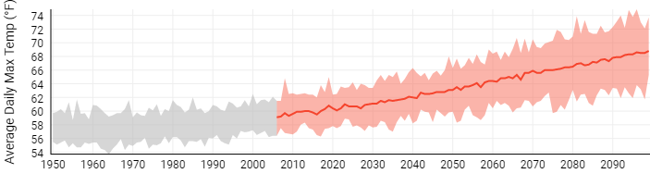

Figure 5: Average Daily Temperature Between 1950-2090

## Adaptive Greenhouse Gas Reduction Measures

Some greenhouse gas reduction measures also reduce risk to climate hazards. The following are a few of many examples of how these outcomes can be related to one another:

**This is not an exhaustive list of potential synergies between mitigation and adaptation, but it presents some of the most common examples. Modify this list according to the types of measures included in your climate action plan, or indicate if an example action is currently not feasible but might be in the future.**

* Actions that improve energy efficiency and distribute renewable energy can (1) reduce pressure on the grid when there is higher energy demand for heating and air conditioning during extreme heat events, and (2) increase energy independence for households and businesses, as opposed to complete reliance on centralized power infrastructure that could fail during a catastrophic event. These types of actions include, but are not limited to:
  + Energy-efficient building design for new construction, and retrofits for existing buildings (e.g. weatherization)
  + Onsite combined heat and power (CHP)
  + Smart grid technologies
  + Microgrids
* Actions that reduce impervious surfaces can reduce the potential for flooding by retaining stormwater in place. These types of actions include, but are not limited to:
  + Expanding or restoring green space
  + Installing green roofs, rain gardens, bioswales, pervious pavers, and other green infrastructure (as well as requiring them for future development)
* Installing green roofs and planting trees adjacent to buildings can regulate indoor temperatures during extreme heat events
* Expanding and protecting alternative transportation routes (bicycle, pedestrian, bus, and rail) provides network redundancies and alternative routes for emergency evacuation
* Water efficiency and conservation actions can (1) reduce pressure on the grid from energy used for pumping, treating, and distributing water, and (2) make the community less vulnerable to drought

The following table identifies specific greenhouse gas reduction actions from the previous chapters that have the potential to reduce risk from climate hazards, and which hazards they address.

**Populate this table with those actions you marked “Y” in the “Reduces Climate Risk” column.**

|  |  |  |  |  |  |
| --- | --- | --- | --- | --- | --- |
| **Action** | **Extreme Temperatures** | **Flooding** | **Drought** | **Seasonal Variations** | **[Other Hazard]** |
| XX-1A **EXAMPLE** | X |  | X |  |  |
|  |  |  |  |  |  |

# Monitoring Plan

**Describe the next steps in the process to implementing and monitoring the progress of your action plan. This may include further outreach efforts to stakeholder groups, additional feasibility studies that may need to be taken, identification of funding sources, and identification of key partners that will be required for successful implementation.**

**Also, the community can decide whether specific implementation details (timeline, etc) should be identified within an appendix or in an internal implementation plan.**

**As necessary, check on the Jurisdiction’s climate commitments for specific requirements for monitoring, implementing, and updating the CAP. For example, if signed on to Global Covenant of Mayors (GCoM) there are specific timelines that the Jurisdiction needs to follow for compliance – e.g. the GHG inventory must be updated every two years.**

**EXAMPLE TEXT:**

Starting in Month, Year, [Jurisdiction] will engage with community members, businesses, institutions, and other stakeholders through a Climate Action Planning Task Force to prepare for any prerequisite or additional actions needed to begin Plan implementation.

These prerequisite actions include:

* Creating citizen advisory groups for programs that require considerable community engagement.
* Gathering bids for contracted services and equipment.
* Making necessary changes to local policies or existing programs, including staffing.
* [Other steps the community intends to take immediately to kick off programs, and provide ways for citizens to become involved with the Climate Action Plan.]

Establishing a monitoring process enables [Jurisdiction] to track the impacts of the actions included in the plan and compare estimated impacts to what is actually achieved in terms of energy savings, renewable energy production, and GHG emissions reduction. Assessing the implementation status of the actions will allow determination of whether the action is performing well and to identify corrective measures. This process is also an opportunity to understand barriers to implementation and identify best practices or new opportunities in moving forward.

The table below describes the components of the monitoring reports. Action reports are to occur every two years and will only include status updates on the overall action, the mitigation action plan, and the adaptation action plan. The full monitoring report will occur every [X] years and in addition to the components in the action report, will include an updated community and municipal GHG inventory. This will help [Jurisdiction] track its GHG emissions reduction progress. With the approval of this Climate Action Plan in [Year], the first monitoring action report will be due in [Year] and the first full monitoring report with the updated GHG inventories will be due in [Year]. Ideally, the most recent GHG inventories should be no more than four years old.

|  |  |  |
| --- | --- | --- |
| Monitoring Report Component | Action Reporting | Full Reporting |
| **Overall Action:**  Reporting any changes to initial action as well as updated information on human and financial resources | Yes | Yes |
| **GHG Emissions Inventories:**  Provide updated energy consumption and GHG emissions data for the reporting year | No | Yes |
| **Climate Action Measures:**  Report the implementation status (completed, in progress, on hold) of key actions and update their impacts | Yes | Yes |

# References

Intergovernmental Panel on Climate Change (IPCC). (2014). Climate Change 2014: Impacts, Adaptation, and Vulnerabilities: Summary for Policymakers. New York, NY: Cambridge University Press.

IPCC. (2014). Climate Change 2014: Synthesis Report. Contribution of Working Groups I, II, and III tothe Fifth Assessment Report of the IPCC [Core Writing Team, R.K. Pachauri, and L.A. Meyer (eds.)]. Geneva, Switzerland.

IPCC. (2014). Summary for Policymakers. In: Climate Change 2014: The Physical Science Basis. Contribution of Working Group I to the Fifth Assessment Report of the Intergovernmental Panel on Climate Change [Solomon, S., D. Qin, M. Manning, Z. Chen, M. Marquis, K.B. Av. Cambridge, U.K. and New York, NY, USA.: Cambridge University Press.

Pennsylvania Department of Environmental Protection (PA DEP). (2019). Climate Change. Retrieved from Pennsylvania Department of Environmental Protection: <https://www.dep.pa.gov/citizens/climate/Pages/default.aspx>

Pennsylvania Department of Environmental Protection (PA DEP). (2019). Pennsylvania Greenhouse Gas Inventory. Retrieved from <https://www.dep.pa.gov/citizens/climate/Pages/GHG-Inventory.aspx>

Shortle, James, David Abler, Seth Blumsack, Aliana Britson, Kuai Fang, Armen Kemanian, Paul Knight,

Marc McDill, Raymond Najjar, Michael Nassry, Richard Ready, Andrew Ross, Matthew Rydzik,

Chaopeng Shen, Shilong Wang, Denice Wardrop, Susan Yetter. 2015. Pennsylvania Climate

Impacts Assessment Update. Pennsylvania State University. Retrieved from Pennsylvania Department of Environmental Protection: [http://www.depgreenport.state.pa.us/elibrary/GetDocument?docId=5002&DocName=2015%20PENNSYLVANIA%20CLIMATE%20IMPACTS%20ASSESSMENT%20UPDATE.PDF%20](http://www.depgreenport.state.pa.us/elibrary/GetDocument?docId=5002&DocName=2015%20PENNSYLVANIA%20CLIMATE%20IMPACTS%20ASSESSMENT%20UPDATE.PDF%20%20)

Appendix I: Methodology

**This appendix details calculation methods and other technical information gathered and used throughout the report. The GHG inventory may be included here or referenced if there is already separate documentation.**

**Document all assumptions made in the quantification of emission reduction potentials.**

Appendix II: Climate Change Science

**For some communities, this section might be unnecessary. An alternative is to simply provide links to scientific articles here for those who would like more information. You could also use information from the National Climate Assessment report, which is just focused on the United States:** <https://nca2018.globalchange.gov/>

**If your community would like to add more details about local/regional climate change projections than what is provided in the Climate Adaptation chapter, feel free to add to the text below as necessary.**

**Note: When IPCC’s 6th report is released in 2021, information and references need to be updated.**

The Intergovernmental Panel on Climate Change (IPCC)’s Fifth Assessment Report affirms that “warming of the climate system is unequivocal, as is now evident from observations of increases in global average air and ocean temperatures, widespread melting of snow and ice and rising global average sea level” (IPCC, 2014, p. 151). Researchers have made progress in their understanding of how the Earth’s climate is changing in space and time through improvements and extensions of numerous datasets and data analyses, broader geographical coverage, better understanding of uncertainties and a wider variety of measurements (IPCC, 2014). These refinements expand upon the findings of previous IPCC Assessments – today, observational evidence from all continents and most oceans shows that “regional changes in temperature have had discernible impacts on physical and biological systems” (IPCC, 2014, p. 151).

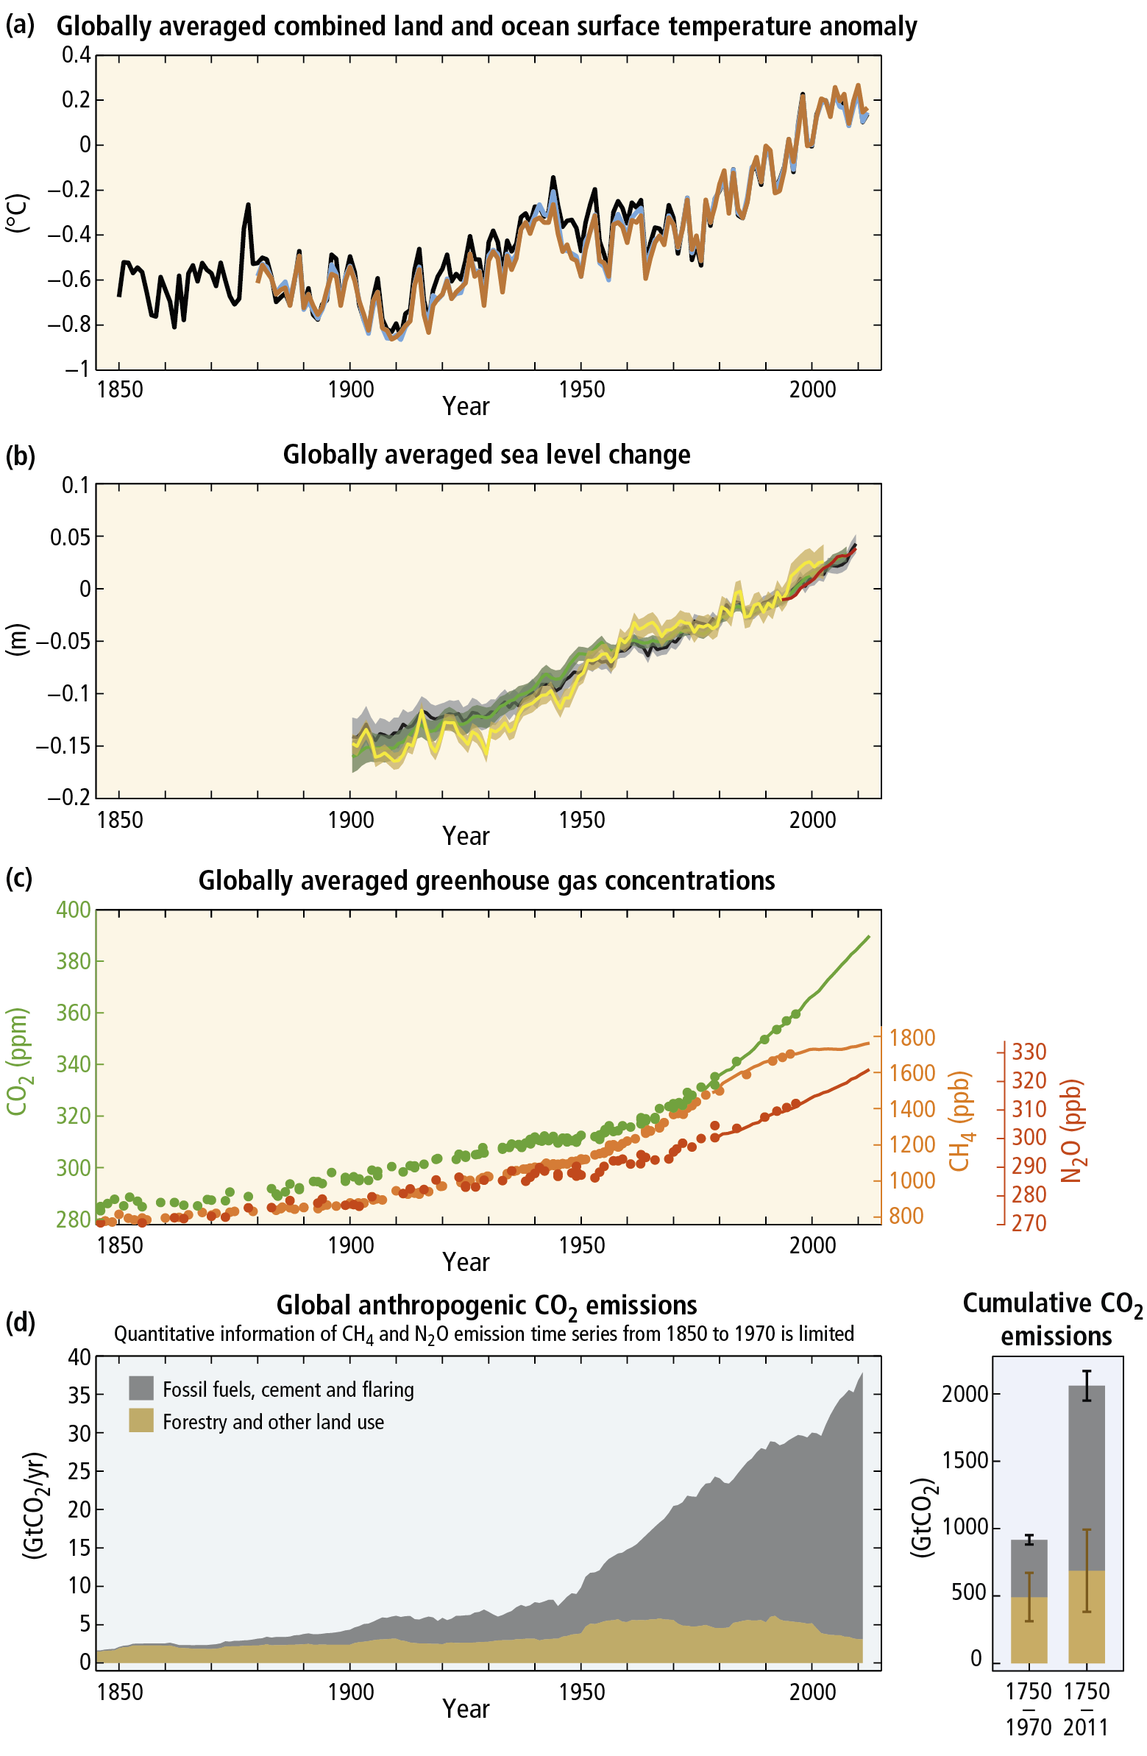

Figure 1 Observations and other indicators of a changing global climate system

The Fifth Assessment also asserts that “it is *extremely likely* that more than half of the observed increase in global average surface temperature from 1951 to 2010 was caused by the anthropogenic increase in GHG concentrations and other anthropogenic forcings together. Globally, economic and population growth continued to be the most important drivers of increases in CO2 emissions from fossil fuel combustion. Changes in many extreme weather and climate events have been observed since about 1950. Some of these changes have been linked to human influences, including a decrease in cold temperature extremes, an increase in warm temperature extremes, an increase in extreme high sea levels and an increase in the number of heavy precipitation events in a number of regions” (IPCC, 2014, p. 151).

In short, the Earth is already responding to climate change drivers introduced by mankind.

### Temperatures and Extreme Events are Increasing Globally

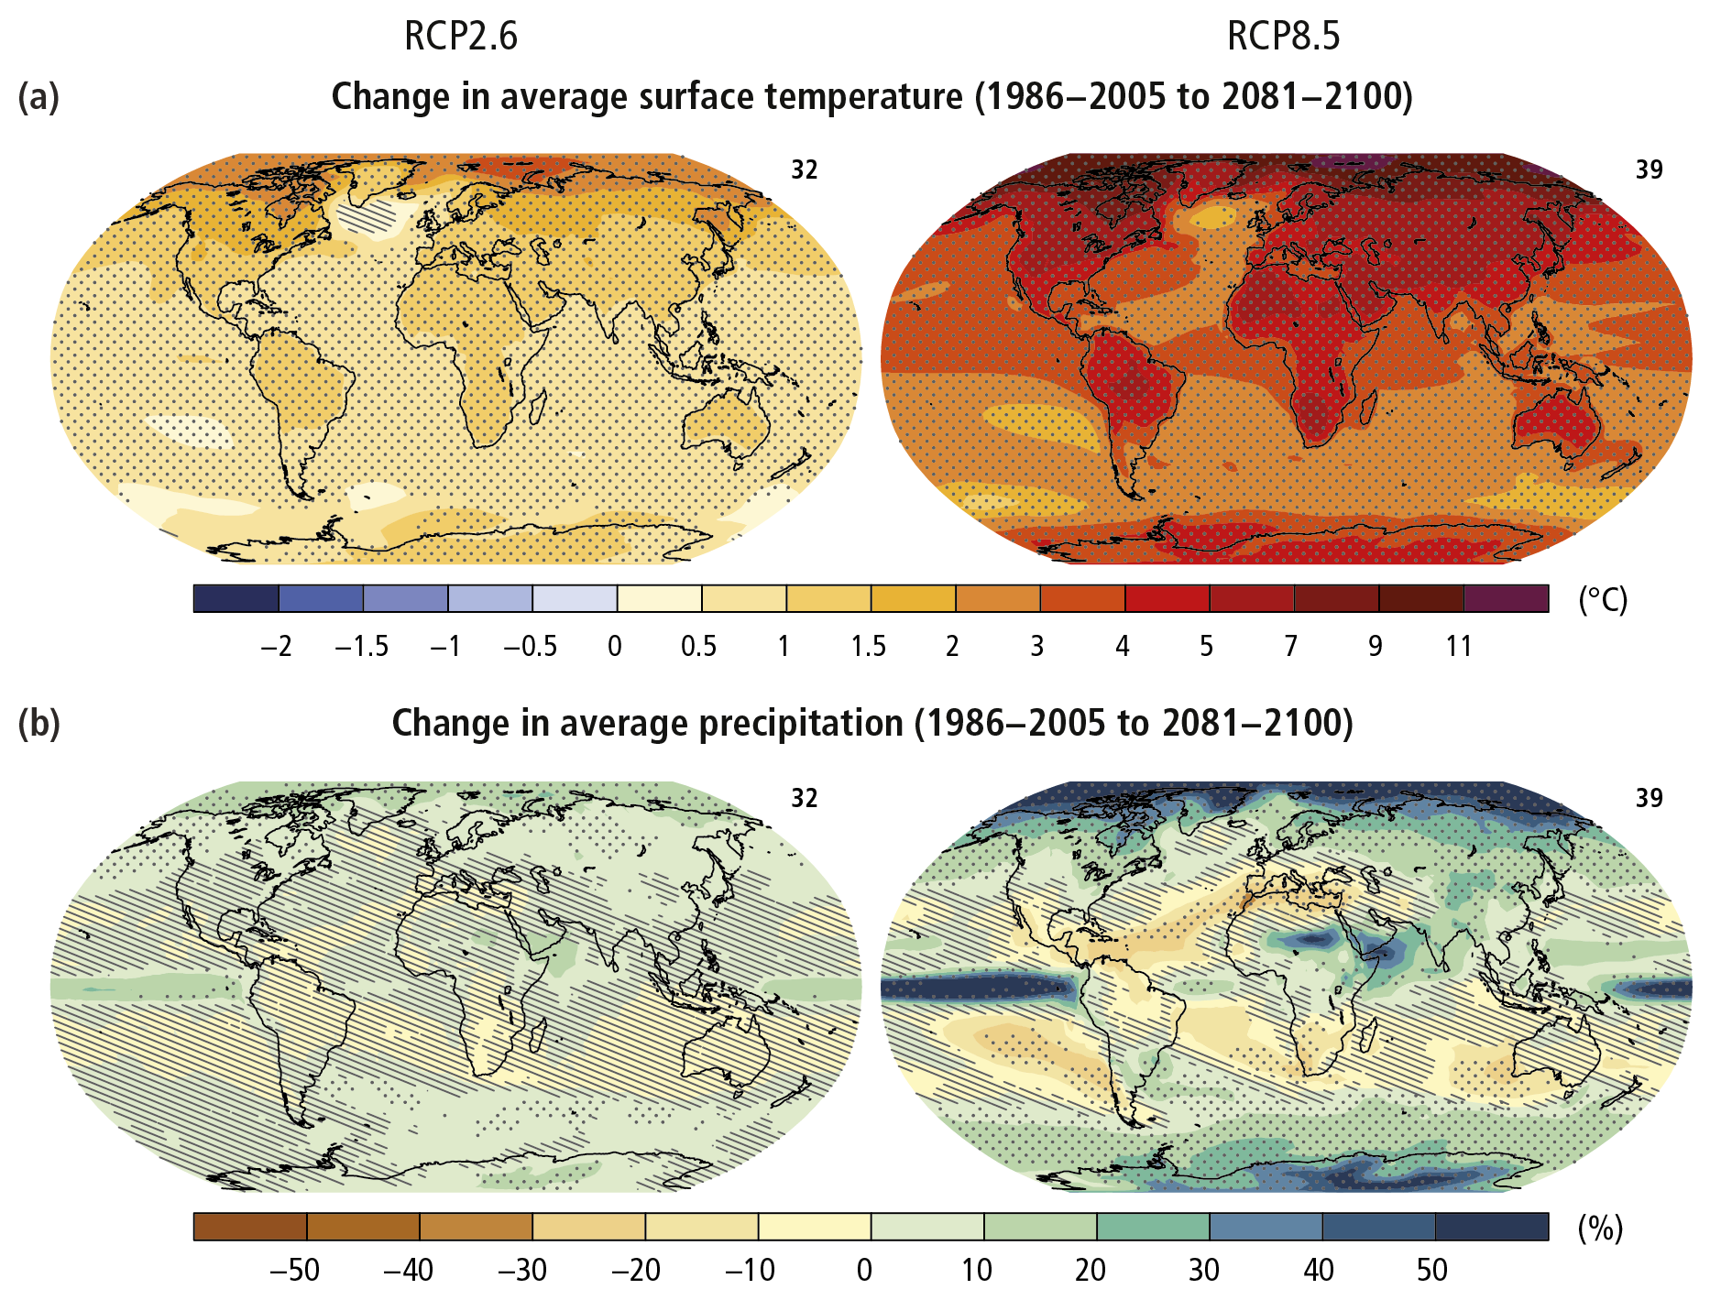

Figure 2 Change in average surface temperature (a) and change in average precipitation (b) based on multi-model mean projections for 2081–2100 relative to 1986–2005 under the RCP2.6 (left) and RCP8.5 (right) scenarios.

Surface temperature is projected to rise over the 21st century under all assessed emission scenarios. It is very likely that heat waves will occur more often and last longer, and that extreme precipitation events will become more intense and frequent in many regions. The ocean will continue to warm and acidify, and global mean sea level to rise. Changes in many extreme weather and climate events have been observed since about 1950. Some of these changes have been linked to human influences, including a decrease in cold temperature extremes, an increase in warm temperature extremes, an increase in extreme high sea levels and an increase in the number of heavy precipitation events in a number of regions (IPCC, 2014).

### Climate Risks

Climate change is projected to undermine food security. Due to projected climate change by the mid-21st century and beyond, global marine species redistribution and marine biodiversity reduction in sensitive regions will challenge the sustained provision of fisheries productivity and other ecosystem services. For wheat, rice and maize in tropical and temperate regions, climate change without adaptation is projected to negatively impact production for local temperature increases of 2°C or more above late 20th century levels, although individual locations may benefit. Global temperature increases of ~4°C or more above late 20th century levels, combined with increasing food demand, would pose large risks to food security globally. Climate change is projected to reduce renewable surface water and groundwater resources in most dry subtropical region, intensifying competition for water among sectors.

Until mid-century, projected climate change will impact human health mainly by exacerbating health problems that already exist. Throughout the 21st century, climate change is expected to lead to increases in ill-health in many regions and especially in developing countries with low income, as compared to a baseline without climate change. Health impacts include greater likelihood of injury and death due to more intense heat waves and fires, increased risks from foodborne and waterborne diseases and loss of work capacity and reduced labor productivity in vulnerable populations. Risks of undernutrition in poor regions will increase. Risks from vector-borne diseases are projected to generally increase with warming, due to the extension of the infection area and season, despite reductions in some areas that become too hot for disease vectors.

In urban areas climate change is projected to increase risks for people, assets, economies and ecosystems, including risks from heat stress, storms and extreme precipitation, inland and coastal flooding, landslides, air pollution, drought, water scarcity, sea level rise and storm surges. These risks are amplified for those lacking essential infrastructure and services or living in exposed areas. Rural areas are expected to experience major impacts on water availability and supply, food security, infrastructure and agricultural incomes, including shifts in the production areas of food and non-food crops around the world.

Climate change is projected to increase displacement of people. Populations that lack the resources for planned migration experience higher exposure to extreme weather events, particularly in developing countries with low income. Climate change can indirectly increase risks of violent conflicts by amplifying well-documented drivers of these conflicts such as poverty and economic shocks (IPCC, 2014).

### Greenhouse Gas Emissions Must be Reduced

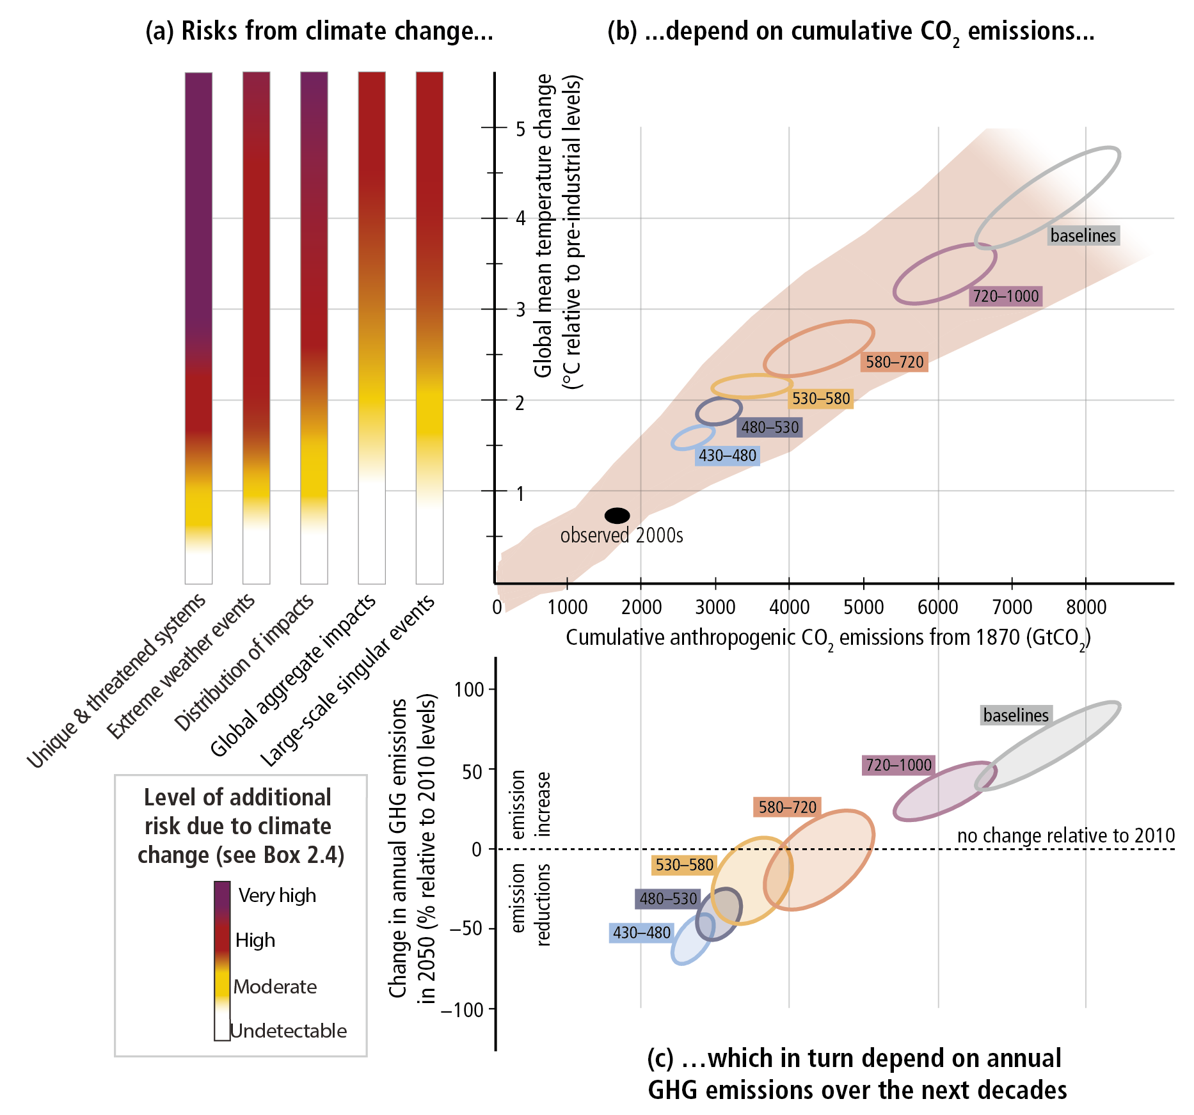

Figure 3 The relationship between risks from climate change, temperature change, cumulative carbon dioxide (CO2) emissions and changes in annual greenhouse gas (GHG) emissions by 2050.

Limiting risks across Reasons For Concern (a) would imply a limit for cumulative emissions of CO2 (b) which would constrain annual GHG emissions over the next few decades (c). Panel A reproduces the five Reasons For Concern. Panel b links temperature changes to cumulative CO2 emissions (in GtCO2) from 1870. They are based on Coupled Model Intercomparison Project Phase 5 simulations (pink plume) and on a simple climate model (median climate response in 2100), for the baselines and five mitigation scenario categories (six ellipses). Panel C shows the relationship between the cumulative CO2 emissions (in GtCO2) of the scenario categories and their associated change in annual GHG emissions by 2050, expressed in percentage change (in percent GtCO2-eq per year) relative to 2010. The ellipses correspond to the same scenario categories as in Panel B, and are built with a similar method (IPCC, 2014).

The recent and massive buildup of greenhouse gases in our atmosphere is conceivably even more extraordinary than changes observed thus far regarding temperature, sea level, and snow cover in the Northern hemisphere in that current levels greatly exceed recorded precedent going back much further than the modern temperature record.

Anthropogenic greenhouse gas emissions have increased since the pre-industrial era driven largely by economic and population growth. From 2000 to 2010 emissions were the highest in history. Historical emissions have driven atmospheric concentrations of carbon dioxide, methane and nitrous oxide to levels that are unprecedented in at least the last 800,000 years, leading to an uptake of energy by the climate system (IPCC, 2014).

In response to the problem of climate change, many communities in the United States are taking responsibility for addressing emissions at the local level. Since many of the major sources of greenhouse gas emissions are directly or indirectly controlled through local policies, local governments have a strong role to play in reducing greenhouse gas emissions within their boundaries. Through proactive measures around land use patterns, transportation demand management, energy efficiency, green building, and waste diversion, local governments can dramatically reduce emissions in their communities. In addition, local governments are primarily responsible for the provision of emergency services and the mitigation of natural disaster impacts. While this Plan is designed to reduce overall emissions levels, as the effects of climate change become more common and severe, local government adaptation policies will be fundamental in preserving the welfare of residents and businesses.