Electricity Subcommittee
Summary of Work Plans Recommended for Quantification

Electricity 2Work Plan  No. | Work Plan Name |  | Annual Results (2020) |  |  |  |  |  | Cumulative Results (2009-2020)
Electricity 2Work Plan  No. |  |  | GHG Reductions  (MMtCO₂e) |  | Costs  (Million $) | Cost-Effectiveness  ($/tCO₂e) |  |  | GHG Reductions  (MMtCO₂e) |  | Costs  (NPV, Million $) |  | Cost-Effectiveness  ($/tCO₂e)
2 | Reduced Load Growth |  | 7 |  | -$432 | -$64 |  |  | 23 |  | -$849 |  | -$36
3 |  | ReducedStabilized Load Growth |  | 79 |  |  | -432$593 | -$64 |  | 2327 |  | -849$990 |  | -$36
Electricity 35 |  | Stabilized Load GrowthHouse Bill 80: Carbon Capture and Sequestration in 2014 |  | 95 |  |  | -593$291 | -64$58 |  | 2713 |  | -990$391 |  | -36$31
Electricity 56 |  | House Bill 80: Carbon Capture and Sequestration in 2014Improve Coal-Fired Power Plant Efficiency by 5% |  | 5 |  |  | 291$82 | 58$1 |  | 1355 |  | 391$903 |  | 31$1
Electricity 67 |  | Improve Coal-Fired Power Plant Efficiency by 5%Sulfur Hexafluoride (SF6) Emission Reductions from the Electric Power Industry |  | 50.1 |  |  | 82$0.1 | 1$0.6 |  | 550.7 |  | 903$0.3 |  | 1$0.4
Electricity 7 |  | Sulfur Hexafluoride (SF6) Emission Reductions from the Electric Power Industry |  | 0.1 |  |  | 0.1 | 0.6 |  | 0.7 |  | 0.3 |  | 0.4
Electricity 8 |  | Analysis to Evaluate Potential Impacts Associated with Joining Regional Greenhouse Gas Initiative |  | See Appendix D
Electricity 98 | Analysis to Evaluate Potential Impacts Associated with Joining Regional Greenhouse Gas Initiative |  | See Appendix D
9 | Promote Combined Heat and Power (CHP) |  | 4 |  | $53 | $12 |  |  | 23 |  | $209 |  | $9
10 |  | Promote Combined Heat and Power (CHP) Nuclear Capacity |  | 415 |  |  | 53$832 | 12$57 |  | 2331 |  | 209$655 |  | 9$21
Electricity 10 |  | Nuclear Capacity |  | 15 |  |  | 832 | 57 |  | 31 |  | 655 |  | 21
Electricity 1111 | Greenhouse Gas Performance Standard for New Power Plants |  | Qualitative Workplan--Not Quantified
12 |  | Greenhouse Gas Performance Standard for New Power PlantsTransmission and Distribution Losses |  | Qualitative Workplan--Not Quantified
Electricity 12 |  | Transmission and Distribution Losses |  | Qualitative Workplan--Not Quantified
1 | Act 129 of 2008 (HB 2200) (Already in Electricity Baseline Forecast) |  | 4 |  | -$258 | -$65 |  |  | 40 |  | -$1,409 |  | -$35
4 |  | Act 129 of 2008 (HB 2200) (Already in Electricity Baseline Forecast)Alternative Energy Portfolio (Act 213 of 2004) Tier I Standard |  | 411 |  |  | -258TBD | -65TBD |  | 4076 |  | -1409TBD |  | -35TBD
Electricity 4 |  | Alternative Energy Portfolio (Act 213 of 2004) Tier I Standard (Already in Electricity Baseline Forecast) |  | 14 |  |  | 402 | 29 |  | 114 |  | 2147 |  | 19
 |  | Total Reductions From State Actions |  | - |  |  | - | - |  | - |  | - |  | -
 |  | Sector Total Plus Recent Actions |  | 32 |  |  | 1080 | 33 |  | 131 |  | 1862 |  | 14

GHG = greenhouse gas; MMtCO₂e = million metric tons of carbon dioxide equivalent; $/tCO₂e = dollars per metric ton of carbon dioxide equivalent; NPV = net present value; TBD = to be determined.
Negative values in the Cost and the Cost-Effectiveness columns represent net cost savings.
The numbering used to denote the above draft work plans is for reference purposes only; it does not reflect prioritization among these important draft work plans.

Figure 1. Contributions to Total Statewide Reductions from Each Electricity Workplan


Electricity 1. Act 129 of 2008 (HB 2200) Work Plan for Potential GHG Reduction Measure

Strategy Name: Act 129 of 2008 (House Bill [HB] 2200)

Lead Staff Contact: Joe Sherrick (717-772-8944)

Summary: This initiative identifies the carbon emissions benefits associated with the reduction of electricity consumption and peak load, as described in Act 129 of 2008. Act 129 requires:
- A reduction in electricity consumption, by May 31, 2011, of 1.0% below consumption levels for the period June 1, 2009, through May 31, 2010.
- A reduction in electricity consumption, by May 31, 2013, of 3.0% below consumption levels for the period June 1, 2009, through May 31, 2010 (additional reduction of 2.0% from the June 2009 through May 2010 baseline for a net total reduction of 3.0%).
- A reduction in peak demand, by May 31, 2013, of 4.5% of the highest 100 hours of demand. Note: The costs and benefits of this aspect of Act 129 have not been quantified. Please seeSee the assumptions section below for the rationale.

Please noteNote that the imposition of requirements of Act 129 is not inclusive of the very modest consumption and associated system losses from municipalities that are service providers or the rural electric cooperatives.

Other Involved Agencies: The Pennsylvania Public Utility Commission (PUC) has implementation responsibility.

Possible New Measure(s):
A report from the American Council for an Energy -Efficient Economy (ACEEE) has been drafted for the PUC and the Pennsylvania Department of Environmental Protection (DEP and ) provides the cost and supply data for the workplan. work plan. Act 129 does not specify how these reductions are to be achieved. Responses will be purely market-driven.

Workplan
Work Plan Costs and Greenhouse Gas (GHG) Reductions:

Table 1.1 Workplan. Work Plan Cost and GHG Results

Annual Results (2020) |  |  | Cumulative Results (2009-2020)
GHG Reductions  (MMtCO₂e) | Costs  (Million $) | Cost-Effectiveness  ($/tCO₂e) | GHG Reductions  (MMtCO₂e) | Costs  (NPV, Million $) | Cost-Effectiveness  ($/tCO₂e)
(MMtCO₂e)4.0 | (Million $)-$258 | ($/tCO₂e)-$65 | (MMtCO₂e)39.8 | (NPV, Million $)-$1,409 | ($/tCO₂e)-$35
4.0 | $ (258) | $ (65) | 39.8 | $ (1,409) | $ (35)

Notes: The cost estimates (colums 3columns 2 and 65) are incremental costs of energy -efficient measures including capital cost, operating and maintenance, O&M, and labor costs, above baseline measure costs. The cost estimates are calculated as the costs less avoided energy expenditures. Also, the difference between the 2020 cost -effectiveness (column 43) and the cumulative cost -effectiveness (column 76) is due, in part, to the effects of discounting the net cash flows over the analysis period of 2009-–2020.

The net present value (NPV) of the cost savings resulting from implementation of Act 129 from 2009- through 2020 is estimated at approximately $1.74 billion. Some of this will be due to peak load reductions that result in lower wholesale energy and capacity charges, but not less energy used. (These are not quantified in this draft). Peak demand reductions are assumed to not have an impact on GHG emissions as noted below. There is the assumption that lower wholesale charges will be passed through to customers. Other savings will result through reducing energy consumption.

Quantification Approach and Assumptions

- Reductions from the workwork plan are assumed to begin in 2009-–2011 and to be implemented at 0.33% per year through 2011 to achieve the 1% target by 2011. Reductions are then assumed to be 1% per %/year for 2012 and 2013, reaching the Act 129 target of 3%.
- GHG mitigation and costs from the peak demand reduction component of Act 129 are not quantified, as recommended by the subcommittee.
  - The costs and GHG reduction compliance pathways are deemed totoo uncertain for us to be able to quantify. quantification. For instance, peak demand reductions could be met with peak shifting from peak periods where the marginal resource is natural gas turbines, to off -peak periods where the baseload resource is coal, which has a higher carbon dioxide (CO₂) emissions intensity (metric tons per megawatt-hour [t/MWh). ]). Other peak reductions might arise from the energy efficiency deployment obtained under the other components of Act 129. The costs of compliance equipment, such as smart meters and associated communications equipment that might also be used to meet the peak demand reduction, are also deemed totoo uncertain to quantify.
- Statewide load forecast from the PUC are used as the basis for the calculations. This includes the load reduction effects of Act 129 (which are already in the baseline), so reductions estimated here are likely to be slightly understated (by 3% of 3%).
- The above efficiency percentage targets are applied to residential, commercial, and industrial loads. The cost and supply of efficiency savings are thus dependent on the customer class load as a percentpercentage of total load. Industrial loads grow more slowly than residential and commercial loads through 2020, and; thus, over time a smaller share of efficiency savings comes from the industrial sector.
- Energy efficiency costs are expressed as levelized costs over the life of the energy efficiency options over the planning period. The incremental costs (typically incurred in the first year of program implementation) are spread over all future years of the life of the energy efficiency measures.
- Efficiency investments installed under Act 129 with expected lifetimes shorter than the planning period are expected to be replaced with equipment with similar cost and performance characteristics. Efficient equipment is cost -effective to install initially, and it is assumed that it will be replaced at the end of its life. Thus, the electricity reductions in 2013 under Act 129 are held steady through 2030.
- The cost of the workwork plan is calculated by estimating the annual costs of energy efficiency less avoided electricity expenditures. These cash flows are then discounted at a real rate of 5%.
  - The net present valueNPV of cash flows is calculated beginning in 2009 through 2020.
- All prices are in $2007 dollars ($2007), as per the Center for Climate Strategies Quantification Memo. [weblink forthcoming]

Table 1.2. Cost of Energy Efficiency Measures
 | 2009
Levelized Cost of Energy Efficiency ($2007)Sector | $/MWh | $/MMBTU | Fixed Cost Rate
Residential | $ $53.70 | $ $5.68 | 13%
Commercial | $ $31.47 | $ $3.52 | 10%
Industrial | $ $26.03 | $ $2.11 | 5%

  - Sum of Capital and Fixed Costs Program fixed costs are assumed to be part of each measure’s capital cost,. These include administrative, marketing, and evaluation costs of 5%.
- Source: ACEEE et al. (2009). Various pages.
- CostThe cost of EEenergy efficiency measures includes program and participant cost costs as is typically used in Total Resource Cost test. [Insert a footnote explaining this test or where an explanation can be found. Also, insert text leading in to Table 1.3.]

Table 1.3. Avoided Cost of Energy for Demand Side Measures Energy in 2009 ($2007)
Costs Associated with Avoided Energy in 2009 ($2007)Sector | $/MWh | $/MMBTU
Residential | 103.37 | 13.14
Commercial | 87.14 | 10.72
Industrial | 65.00 | 7.48

Quantification Approach and Data Sources:

- For electricity, retail end user prices for Jan January 2009 from US EIA Monthly Electricity Profile, increased by 6.2% in 2010 to account for rate caps coming off for last of EDCs. Annual prices in 2011+ adjusted by change in AEO end user prices from table 74 of AEO 2009 supplemental tables. http://www.eia.doe.gov/cneaf/electricity/epm/table5_6_a.html
- For natural gas, retail annual 2008 prices by sector, annual changes from 2009 onwards from Table 12 of AEO 2009 regional tables http://tonto.eia.doe.gov/dnav/ng/ng_sum_lsum_dcu_SPA_m.htm and http://www.eia.doe.gov/oiaf/aeo/supplement/stimulus/regionalarra.html
- The costs to implement Act 129 are recoverable by utilities, so customers will be funding the efficiency deployment.
- Based on the costs of energy efficiency per MWh above, annual spending in 2013 will be approximately $177 million.
- Electricity transmission and distribution (T&D) losses are assumed to be 6.6% over the analysis period. Source: PA Electricity Inventory and Forecast.xls
- To estimate emission reductions from workwork plans that are expected to displace conventional grid-supplied electricity (i.e., energy efficiency and conservation)), a simple, straightforward approach is used. We assume that these policy recommendations would displace generation from an “average thermal” mix of fuel-based electricity sources of coal and gas. This mix is based on 90% coal, 10% gas for all years 2009-–2030 based on U.S. Energy Information Administration (EIA) 2006 State Electricity Profile data.
  - The average thermal approach is preferred over alternatives because sources without significant fuel costs would not be displaced—e.g., hydro, nuclear, or renewables renewable energy generation.
    - Similarly, a “marginal” approach is not possible in Pennsylvania because the natural gas share of the annual generation portfolio (13.5 million (MM) MWh) of total generation (218 millionMM MWh in 2006) is only about 6%. This small amount does not provide enough adequate MWh to be “backed down” due to the energy efficiency deployment in the workwork plan.
  - Given the generation fleet’s coal and gas combustion efficiencies, this equates to a CO₂ intensity of approximately 0.87 tonnesmetric tons (t)/MWh. This compares to the average statewide CO₂ intensity of 0.54 tonnes/MWh (including hydro, nuclear, etc.).
  - This approach provides a transparent way to estimate emission reductions and to avoid double counting (by ensuring that the same MWh from a fossil fuel source are not “avoided” more than once). The approach can be considered a “first-order” approach;. That is, it does not attempt to capture a number of factors, such as the distinction between peak, intermediate, and baseload generation; issues in system dispatch and control; impacts of nondispatchable and intermittent sources, such as wind and solar; or the dynamics of regional electricity markets. These relationships are complex and could mean that policy recommendations affect generation and emissions (as well as costs) in a manner somewhat different from that estimated here. Nonetheless, this approach provides reasonable first-order approximations of emission impacts and offers the advantages of simplicity and transparency that are important for stakeholder processes.
    - Note that some renewable resources, like cofiring biomass with coal or dedicated biomass gasification do have substantial fuel costs. However, because these resources are negligible in the reference case electricity supply forecast, they are not able to be “backed down” in the analysis.

- Cost to DEP - —None.
- Cost to the Commonwealth – —Administrative.
- Cost to the regulated community or consumer – —Act 129 requires only modest reductions in load growth. It is reasonably anticipated that consumers will realize long-term cost savings however, there are . However, the costs of implementation that will be boreborne by the rate base and will be quantified in filings to the PUC. Estimated gross cost savings are provided at the end of this work plan, and will need to be reconciled with the implementation costs.
- Are there Federalfederal funds available? – N/A
- ?—Not applicable.
- Do these costs fund other programs? N/A
- ?—Not applicable.
- Are cost savings realized from this initiative? ?—Yes, as noted above. Market forces will drive compliance options and the path forward. Actual savings will likely vary widely among the electric distribution company (EDC) territories, within the various rate classes and economic sectors and also based on socio-economic factors for residential consumers.

Implementation Steps:
- Act 129 was signed into law on October 15. , 2008.

- By January 15, 2009, the PUC must adopt an energy efficiency and conservation program that requires each electric distribution company (EDC) to develop and implement cost -effective energy efficiency & and conservation plans to reduce consumption and peak load within their service territories, as noted in the Summary section of this work plan. .

- The American Council for an Energy Efficient Economy (ACEEE) has conducted a statewide assessment of cost -effective energy efficiency potential. For potential follow -up workwork plans to build on Act 129, see workwork plans Electricity 2 and 3.

Potential Overlap:
- See Appendix B for Overlap Analysis.

Electricity 2. Reduced Load Growth Work Plan for Potential GHG Reduction Measure

Strategy Name: Reduced Load Growth

Lead Staff Contact: Joe Sherrick (717-772-8944)

Summary: This initiative identifies the carbon emissions benefits associated with curbing the rate of growth in electricity consumption in PA. This strategy builds upon the conservation requirements of Act 129 of 2008, which requiresspecify 1.0% and 2.0% reductions in electricity consumption from 2010, by 2011 and 2013, respectively. Act 129 also requires the PUC to assess the potential for additional cost-effective reductions. The scenario developed in this work plan builds upon Act 129 by requiring biennial reductions in electricity consumption equal to 1.5% per biennial period (0.75% per %/year), beginning in 2015 and carrying through 2025. The Therefore, the energy efficiency investments under this workplan thereforework plan reach 8.25% of load by the end of 2025 (11 years at 0.75% per %/year). These reductions are calculated from the previous yearsyear's estimated consumption.

Please note
Note that this analysis does not include the very modest consumption and associated system losses from municipalities that are service providers or the rural electric cooperatives.

Other Involved Agencies: PUC

Possible New Measure(s): A report from the American Council for an Energy Efficient Economy (ACEEE) has been drafted for the PUC and DEP and provides the cost and supply data for the workplan. work plan. See: http://www.aceee.org/pubs/e093.htm
http://www.aceee.org/pubs/e093.htm.

Workplan
Work Plan Costs and GHG Reductions:

Table 2.1 WorkplanWork Plan Costs and GHG Results ($2007)
Annual Results (2020) |  |  | Cumulative Results (2009-2020)
GHG Reductions  (MMtCO₂e) | Costs  (Million $) | Cost-Effectiveness  ($/tCO₂e) | GHG Reductions  (MMtCO₂e) | Costs  (NPV, Million $) | Cost-Effectiveness  ($/tCO₂e)
(MMtCO₂e)6.7 | (Million $)-$432 | ($/tCO₂e)-$64 | (MMtCO₂e)23.3 | (NPV, Million $)-$849 | ($/tCO₂e)-$36
6.7 | $ (432) | $ (64) | 23.3 | $ (849) | $ (36)

The net present valueNPV of the cost savings resulting from implementation of this workwork plan from 2009- through 2020 is estimated at approximately $930 million. The cost savings and emissions reductions are additional to Act 129. The cost savings are more modest compared to Act 129 because the workwork plan is not implemented until 2015 and has reached efficiency investments equal to 4.5% of sales by 2020. These distant cash flows are then discounted back to the present time.

Notes: The cost estimates (columscolumns 3 and 6) are incremental costs of energy -efficient measures, including capital cost, operating and maintenance, O&M, and labor costs, above baseline measure costs. The cost estimates are calculated as the costs less avoided energy expenditures. Also, the difference between the 2020 cost -effectiveness (column 4) and the cumulative cost -effectiveness (column 7) is due, in part, to the effects of discounting the net cash flows over the analysis period of 2009-–2020.

- Cost to DEP - —None.
- Cost to the Commonwealth – —Act 129 requires the PUC to hire a program administrator to oversee this process and to provide assessments as to the cost-effectiveness and level of additional reductions that may be possible within PA. The cost for this service is unknown.
- Cost to the regulated community or consumer —To the extent that this workwork plan mirrors the funding mechanisms of Act 129, utility costs, up to a portion of revenues, will be recoverable, so customers will be funding the entire cost of the workwork plan up to that level. The ACEEE et al. (2009) report assumes that a portion of the cost of each efficiency measure may be spent by the end user and that utility incentives comprise the balance of the initial costs, but that these incentives will be funded by customers.
- Based on the costs of energy efficiency per MWh (discussed in Electricity 1), annual spending in 2020 will be approximately $300 million.

- Are there Federalfederal funds available? – ?—Federal funding is not required nor is it available at this time. Limited assistance may be available through the U.S. Department of Energy (DOE) State Energy Plan, but this would most likely be limited to policy analysis and possibly technical support.
- Do these costs fund other programs? ?—No. Any costs are expected to result in changes to consumer behavior.

Quantification Approach and Assumptions

- Reductions from the workwork plan are assumed to begin in 2015 and are implemented at 0.75% per %/year through 2025 to achieve a rate of 8.25% by 2025.
- Efficiency investments installed under the workwork plan with expected lifetimes shorter than the planning period are expected to be replaced with equipment with similar cost and performance characteristics. Efficient equipment is cost -effective to install initially, and it is assumed that it will be replaced at the end of its life. Thus, the electricity reductions in 2025 under the workwork plan are held steady through 2030.
- For cost and other assumptions see Electricity #1—Act 129.

Implementation Steps: The following, and other, considerations that could be examined as policy tools to support this measure:
- Act on the authority that Act 129 provides the PUC with the necessary authority to require additional cost-effective reductions in electricity consumption.
- An Conduct an assessment of electricity consumption reduction potential is necessary to determine if the requirements suggested within this work plan conform to Act 129 requisites. requirements.
- A Enact a legislative amendment to the Alternative Energy Portfolio Standards (AEPS) establishing a dedicated market share for energy efficiency credits (new tier or carve out) might facilitatethat facilitates achieving this reduction measure by rewarding over- compliance and providing a cost-effective manner to achieve greater reductions.
- Require electric distribution companies to invest in demand -side response initiatives, including rebates to consumers.
- Recommend that all cost-effective supply side and demand side response initiatives be considered as part of approvals for new generation .
- .
- Consider the recommendations of residential and commercial subcommittee on implementing advanced building standards and benchmarking for the commercial, institutional, state and municipal government sectors. .
- Consider the rate decoupling and incentives language in Appendix A.
- Work with neighboring states on establishing regional efficiency standards for appliances and electronics, where none currently exist or where minimum standards are less than optimal.
- Establish an aggressive phase-out of incandescent lights and/or establish a pricing/tax structure that preferentially treats lighting with a higher lumens -to -watts ratio.
- Rate decoupling and incentives from residential and commercial workplanRC-12.
- ConsumerEliminate consumer barriers to implementing energy efficiency.

Potential Overlap:
- See Appendix B for overlaps.

Electricity 3. Stabilized Load Growth Work Plan for Potential GHG Reduction Measure

Strategy Name: Stabilized Load Growth

Lead Staff Contact: Joe Sherrick (717-772-8944)

Summary: This measure builds upon the very modest reductions required via Act 129 of 2008. Act 129 requires reductions in consumption of 1.0% by 2011 and 2.0% by 2013, for a total of 3%, measured against 2010 consumption. The Stabilized Load Growth (SLG) scenario further investigates the potential impact of annual consumption reductions of 0.75% per %/year in the period 2015 through the end of 2017, followed by a rate of consumption that is held static from 2018 through 2025. Historical annual load growth in PA has been approximately 1.5% per %/year, which is what would be reduced in the 2018 to –2025 period. . The Therefore, the energy efficiency investments under this workplan thereforework plan reach 14.4% of load by the end of 2025 (2015-–2017 at 0.75% per %/year, 2018 at 0.85% per %/year, and 2019-–2025 at 1.6% per %/year). The annual reductions in 2018-–2025 would be based on the previous year’s consumption figures and would allow a subsequent one -year “true-up” for electricity distribution companies to achieve stabilized consumption levels.

Please noteNote that this analysis does not include the very modest consumption and associated system losses from municipalities that are service providers or the rural electric cooperatives.

The demand reductions under this workwork plan can be compared to those occurring in other jurisdictions. Several states are mandating energy savings akin to the higher performers in Figure 3.1. Iowa’s PUC has requested utilities to file plans to achieve savings equal to 1.4% of sales, up from 0.8% currently. New York has a target of 15% savings by 2015, which was started in 2007 equating to new energy efficiency investments equal to nearly 2% per %/year. The following figure shows incremental energy savings as a percentpercentage of sales for surveyed utilities across the country.

Figure 3.1:. Energy Savings as % of First -Year Sales
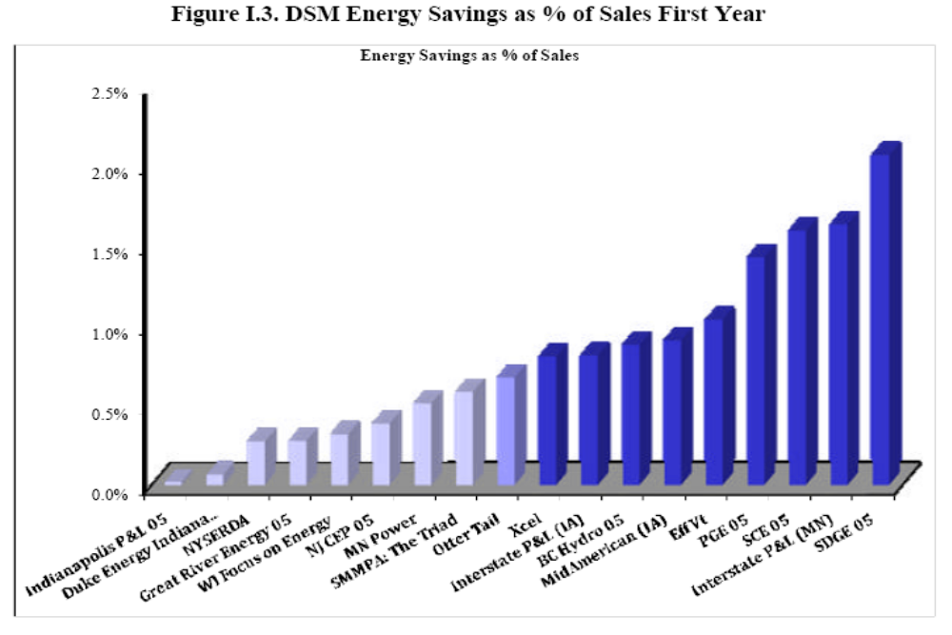
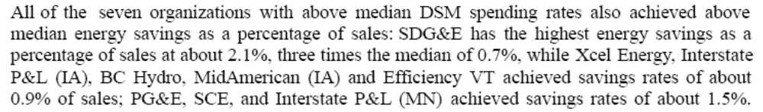

Other Involved Agencies: PUC.

Possible New Measure(s): AAn ACEEE report from the American Council for an Energy Efficient Economy (ACEEE) has been drafted for the PUC and DEP and provides the cost and supply data for the workplan. work plan. See: http://www.aceee.org/pubs/e093.htm.

Workplan
Work Plan Costs and GHG Reductions:

Table 3.1 WorkplanWork Plan Costs and GHG Results ($2007)
Annual Results (2020) |  |  | Cumulative Results (2009-2020)
GHG Reductions  (MMtCO₂e) | Costs  (Million $) | Cost-Effectiveness  ($/tCO₂e) | GHG Reductions  (MMtCO₂e) | Costs  (NPV, Million $) | Cost-Effectiveness  ($/tCO₂e)
(MMtCO₂e)9.2 | (Million $)-$593 | ($/tCO₂e)-$64 | (MMtCO₂e)27.2 | (NPV, Million $)-$990 | ($/tCO₂e)-$36
9.2 | $ (593) | $ (64) | 27.2 | $ (990) | $ (36)

The net present value of the cost savings resulting from implementation of this workplan from 2009-_2020 is estimated at approximately $ 1.4 billion. The cost savings and emissions reductions are additional to Act 129.

Notes: The cost estimates (colums 3columns 2 and 65) are incremental costs of energy -efficient measures including capital cost, operating and maintenance, O&M, and labor costs, above baseline measure costs. The cost estimates are calculated as the costs less avoided energy expenditures. Also, the difference between the 2020 cost -effectiveness (column 43) and the cumulative cost -effectiveness (column 76) is due, in part, to the effects of discounting the net cash flows over the analysis period of 2009-–2020.

- Cost to DEP - —None.
- Cost to the Commonwealth – —Act 129 requires the PUC to hire a program administrator to oversee this process and to provide assessments as to the cost-effectiveness and level of additional reductions that may be possible within PA. The cost for this service is unknown. It is further assumed that the PUC would perform similar services to oversee the reductions that may be required if such a Stabilized Load Growthan SLG initiative were to be implemented.
- Cost to the regulated community or consumer —To the extent that this workwork plan mirrors the funding mechanisms of Act 129, utility costs, up to a portion of revenues will be recoverable, so customers will be funding the entire cost of the workwork plan up to that level. The ACEEE et al. (2009) report assumes that a portion of the cost of each efficiency measure may be spent by the end user, and that utility incentives comprise the balance of the initial costs, but that these incentives will be funded by customers.
- Based on the costs of energy efficiency per MWh (discussed in Electricity 1), annual spending in 2020 will be approximately $415 million.
- Are there Federalfederal funds available? – ?—Federal funding is not required, nor is it available at this time. Limited assistance may be available through the U.S. DOE State Energy Plan, but this would most likely be limited to policy analysis and possibly technical support.
- Do these costs fund other programs? ?—No. Any costs are expected to result in changes to consumer behavior.
- Are cost savings realized from this initiative? ?—Cost savings are expected, but this does requirerequires a detailed analysis. The assumption is that reductions will only be required such that can be sustained through cost-effective measures.

Quantification Approach and Assumptions

- Reductions from the workwork plan are additional to those under Act 129, and are assumed to begin in at the start of 2014 and are implemented through the end of 2017 at 0.75% of sales per year (for a total of 3% of sales). This reduction is expected to reducelower Pennsylvania’s load growth rate from ~1.60%/year to about 0.85%/year. Then required reductions are equal to the load growth rate from the previous year from 2018 through 2025. By 2020, expected reductions are equal to approximately 6.3% of sales, and by 2025 reductions amount to 14.4% of sales.

- Efficiency investments installed under the workwork plan with expected lifetimes shorter than the planning period are expected to be replaced with equipment with similar cost and performance characteristics. Efficient equipment is cost -effective to install initially, and it is assumed that it will be replaced at the end of its life. Thus, the electricity reductions in 2025 under the workwork plan are held steady through 2030.
- For cost and other assumptions, see Electricity #1—Act 129.

Additional Assumptions:
- Adequate cost-effective reductions exist or will exist, through year 2025, to provide the approximate 27 millionMM MWh of curtailment, as compared to the unchecked, projected rate of growth in electricity consumption. The ACEEE report identifies cost -effective efficiency supplies in Table 3.2 of approximately 61 millionMM MWh that, which significantly exceed the reductions projected under this workwork plan.

Table 3.2:. Summary of Cost-Effective Energy Efficiency Potential by Sector (2025)
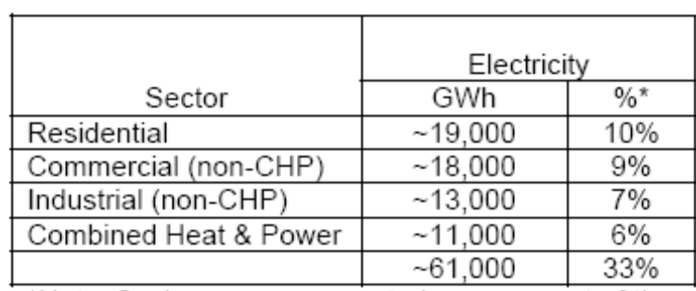

- No reductions would be required if not supported through an analysis of cost-effective measures.

Implementation Steps: The following, and other, considerations should be examined as policy tools to support this measure:
- Act on the authority that Act 129 provides the PUC with the necessary authority to require additional cost-effective reductions in electricity consumption.
- The PUC may have the authority within Act 129 of 2008 that would facilitate realization of this reduction measure.
- A Enact a legislative amendment to the AEPS establishing a dedicated market share for energy efficiency credits (new tier or carve out) might facilitatethat facilitates achieving this reduction measure by rewarding over- compliance and providing a cost-effective manner to achieve greater reductions.
- Require electric distribution companies to invest in demand side response initiatives, including rebates to consumers.

- Recommend that all cost-effective supply side and demand side response initiatives be considered as part of approvals for new generation .

- Consider the recommendations of residential and commercial subcommittee on implementing advanced building standards and benchmarking for the commercial, institutional, state and municipal government sectors.
- Consider the rate decoupling and incentives language in Appendix A.
- Work with neighboring states on establishing regional efficiency standards for appliances and electronics, where none currently exist or where minimum standards are less than optimal.
- Establish an aggressive phase-out of incandescent lights and/or establish a pricing/tax structure that preferentially treats lighting with a higher lumens to watts ratio.
- RateInclude rate decoupling and incentives from residential and commercial the RC-12 workwork plan.
- ConsumerEliminate consumer barriers to implementing energy efficiency

Potential Overlap:
- See Appendix B for list of overlaps between workplans.

Electricity 4. Alternative Energy Portfolio (Act 213 of 2004) Tier I Standard: Work Plan for Potential GHG Reduction Measure

Lead Staff Contact: Joe Sherrick (717-772-8944)

Summary: Identifies GHG reductions associated with the existing AEPS Tier I requirement at 8%.

Other Involved Agencies: PUC and DEP have shared roles in administering the AEPS.

Existing Measure: The AEPS requires that all electricity consumed within PA by 2021 be comprised of at least 0.5% solar photovoltaic (PV) technology, 8% from other renewable (Tier I) sources, and 10% from other alternative energy (Tier II) sources. The AEPS matures in 2021, after which, no further increase in renewable generation is required, but the standards from 2021 remain in effect.

Projected GHG Reduction:

There could be some CO₂ additional CO₂ reductions through Tier II from sources such as large hydro and energy efficiency. The contribution of these resources to meeting the Tier II obligation is somewhat uncertain, because we already know that sufficient credits from waste coal have been generated to meet the entire Tier II requirements through at least 2021. The impact is that little incentive exists for the generation of electricity from new, zero -carbon -emitting sources due to the over-supply created by waste coal. For the 2007/–2008 compliance period, the weighted -average Tier II compliance credit traded for $0.66. This amount is too small to affect plant investment decisions. Because of the minimal value of credits associated with Tier II, it is assumed that the waste coal generation that is used to meet compliance with the AEPS would have happened without the regulation.

Hydroelectric – —Uprates or upgrades to hydroelectric power generation can come from the addition of adding incremental (new) generation at existing plants or simply by making improvements inimproving efficiency to things such as . For example, of turbine design or improvements to the electrical generators. With the enactment of the Alternative Energy Portfolio Standard (AEPS), such improvements are being given serious considerationseriously considered by generating companies. Therefore, it is important to note that if these improvements are made or incremental generation is brought onon line, the resultant emissions reduction emission reductions that might accrue will be accounted for under Tier I of the AEPS, provided that these hydroelectric plants obtain certification from the Low Impact Hydro Institute (LIHI), as required under the AEPS. Any improvements or incremental generation from a hydroelectric plant that does not or can not obtain LIHI certification will earn Tier II credits under the AEPS, but the emissions reductions would not count against our total reductions from the AEPS.

Upgrading older hydropower generating systems is common practice in North America. Through rehabilitation, hydroelectric producers are increasing capacity and efficiency at existing facilities that are several decades old. Rewinding a generator or replacing a turbine runner can result in performance that not only equals, but also surpasses, the capabilities of the equipment when it was new. Rehabilitating existing plants is often a more economical way of adding capacity, when compared to building new facilities.

WorkplanWork Plan Costs and GHG Reductions:

Table 4.1 Workplan. Work Plan Cost and GHG Results

Annual Results (2020) |  |  | Cumulative Results (20072009-2020)
GHG Reductions  (MMtCO₂e) | Costs  (Million $) | Cost-Effectiveness  ($/tCO₂e) | GHG Reductions  (MMtCO₂e) | Costs  (NPV, Million $) | Cost-Effectiveness  ($/tCO₂e)
(MMtCO₂e)11 | (Million $)TBD | ($/tCO₂e)TBD | (MMtCO₂e)76 | (NPV, Million $)TBD | ($/tCO₂e)TBD
13.7 | $ 402 | $ 29 | 114.0 | $ 2,147 | $ 19

Notes: The cost estimates (colums 3columns 2 and 65) are incremental costs of energy -efficient measures including capital cost, operating and maintenance, O&M, and labor costs, above baseline measure costs. The cost estimates are calculated as the costs less avoided energy expenditures. Also, the difference between the 2020 cost -effectiveness (column 43) and the cumulative cost -effectiveness (column 76) is due, in part, to the effects of discounting the net cash flows over the analysis period of 2009-–2020.

Quantification Approach and Assumptions

The costs and GHG reductions from the AEPS are the difference between what is assumed to occur between the AEPS-case and the No AEPS-case. In the No-AEPS case, the new resources that would have been deployed are assumed to be 90% existing pulverized coal, 10% natural gas peaking gas. In the AEPS-case, the resources assumed to be deployed are listed in Table 5.2

- Only the cost costs of and GHG benefits from Tier I resources are quantified under this workwork plan.
  - For the 2007/_2008 compliance period, the weighted -average Tier II compliance credit traded for $0.66. This amount is too small to affect plant investment decisions. Because of the minimal value of credits associated with Tier II, it is assumed that the waste coal generation that is used to meet compliancecomply with the AEPS would have happened without the regulation.

TABLETable 4.2:. Tier One Resources Assumed to beBe Deployed in 2020 underUnder the AEPS
Tier 1 alternative energy gross generation assumptions (% of New Renewable Resources) | 2010 | 2020
Other Gases (CMM) | 0% | 0%
Petroleum | 0% | 0%
Nuclear | 0% | 0%
Hydroelectric (micro, large) | 30%9% | 15%3%
Geothermal | 0% | 0%
Solar/PV | 4%9% | 4%6%
Wind | 39%72% | 68%88%
MSW | 19%0% | 9%0%
Landfill Gas | 5%4% | 2%1%
Biomass | 2%5% | 1%2%
Other wastes | 0% | 0%

- The generation resources that are assumed to be avoided under this workwork plan are 90% existing pulverized coal, and 10% existing peaking gas. The weighted -average cost of generation for the avoided mix is $49.15 in 2020. The avoided CO₂ emissions associated with this mix is 0.86 tonnes CO₂ tCO₂/MWh.
- While the other technologies are large, central station generation sources, the Tier I photovoltaic carve-out is distributed generation. As such, it has a different avoided cost assumption, because PV also avoids new transmission, distribution, and capacity. The PV carve-out assumes an avoided cost based on the weighted -average retail price of electricity for residential, commercial, and industrial customers. PV generation in 2020 to meet the 0.5% target in the AEPS is assumed to be 758 gigawatt hours (GWh), with an avoided cost of $96.67.
- See Appendix C for generation cost assumptions and sources.
- All hydro that is deployed under the AEPS is assumed to be small hydro. This is a conservative assumption, as small hydro costs moreare higher than large hydro costs.
- Cost to DEP – —Administration of programs for the continued support of energy efficiency and renewables, particularly solar PV (ex..g., Energy Harvest, Pennsylvania Economic Development Association (PEDA), Alternative Energy Investment Act, etc.)
- Cost to the Commonwealth – —Continued support of renewables, particularly solar.
- Cost to the regulated community or consumer – —Distribution companies pass compliance costs on to the rate-payers. Until all of the EDC rate caps are removed, the impact will remain uncertain. The removal of the rate caps will have a far more pronounced impact on electricity rates than will the requirements of the AEPS.
- Are there Federal federal funds available? ?—Stimulus funds from the American Recovery and Reinvestment Act (ARRA (2008)) of 2009 are potentially available for renewablesrenewable energy development, as well as federal tax credits production tax credits and investment tax credits. U.S. Department of Agriculture (USDA) Farm Bill appropriations can and have provided limited support. Moreover, as the total appropriations are increasing, the amount available via grant funding is being significantly scaled back in favor of loans.
- Do these costs fund other programs? ?—No.
- Are cost savings realized from this initiative? ?—Not directly. Indirect savings to the Commonwealth will accrue subject to in-state low -carbon electricity development (manufacturing, installation, sales and service, etc.). Indirect costs include displaced coal industry jobs and other fossil fuel -related economic production and consumption.
- Costs quantified in these workplans consider only microeconomic costs and benefits. The macroeconomic costs and benefits of the workplan includes employment impacts, changes in fossil fuel consumption patterns, and other factors.

Implementation Steps:
- Already being implemented.
- Legislation continues to be drafted that would require additional increases in the amount of alternative energy. Pennsylvania has the lowest percentage requirements of any surrounding state renewable portfolio standards. Because the geographic scope from which projects may be considered eligible (Illinois to North Carolina) for Act 213 compliance is much broader than was originally intended, and in order to ensure that more renewable energy and associated new jobs are created in PA, the requirements of the AEPS could be increased.
- Act 1 incentives for renewable resources.
- Federal production tax credit

Potential Overlap:
- See Appendix B for Overlap Analysis.

Electricity 5. Work Plan for House Bill 80 (Print #1000): Workplan for Carbon Capture & Sequestion Carbon Capture and Sequestration in 2014

Note: Replaces Tier 1 at 15%, Tier 1 at 20%, Tier 3: Carbon Capture and Sequestration Workwork plans.

Lead Staff Contact: Joe Sherrick

Summary: Carbon This work plan is a carbon capture retrofit to existing supercritical pulverized coal plants per the requirements in HBHB 80 (as referred to the Committee on Environmental Resources and Energy on March 12, 2009)), starting in 2015 through 2019. In 2020, The work plan calls for installation of Integrated Coal Gasification Combined Cyclean integrated coal gasification combined-cycle (IGCC) plant in the state. in 2020. We assume a an IGCC with a capture schedule of 600 megawatts (MW) beginning in 2020, based on typical IGCC plant capacity proposals in states, such as Minnesota (Excelsior Energy), Washington (Energy Northwest), and the Ohio Valley (AEP).

Other Involved Agencies: Pennsylvania Public Utility CommissionPUC.

Possible New Measure(s):

Retrofits of existing supercritical pulverized coal plants entail amine scrubbing with a CO2 capture rate of 90% and an increase in heat rate requirements of 31.3%. The reduction in efficiency is compensated by an increase in capacity of the existing plant, as the amine -scrubbing system diverts steam for power generation or consumes additional power for CO2 compression.

Integrated Coal Gasification Combined Cycle (IGCC) power plants use coal fuel an input to produce electricity. The technology is based around a gasifier that produces a mixture of hydrogen and carbon monoxide called syngas. This syngas is burned in a gas turbine whichthat is used to drive a generator. Much like in natural gas combined-cycle (NGCC) power plants, the turbine exhaust is used in a heat recovery generator to create steam to drive a steam turbine generator. Below is a block diagram of a 500MWe IGCC plant with CO₂ capture (MIT, 2007).

IGCC technologies with CO₂ capture are equipped with three more processes than the conventional IGCC technology without capture. The first is a process of reacting syngas with steam to produce CO₂ and hydrogen through shift reactors. The second process separates the CO₂ from the remaining gas. The final process compresses and dries the CO2.
Adding CO₂ capture technology to IGCC plants has a significant impact on overall plant efficiency as evidenced in the figure to the right (MIT, 2007).

Workplan
Work Plan Costs and GHG Reductions:

Avoided emissions are calculated on the basis of known potential up-rates and new plant build generation displacing a mix of 90% coal and 10% gas at a combined average of 1,872 pounds (lb)/MWh. We assume a base case in which 90% of CO2 emissions are sequestered, though there is substantial uncertainty regarding the long-term leakage of CO2 in various sequestration configurations. Higher leakage would reduce the cost -effectiveness of carbon capture for reducing greenhouse gas GHG emissions.

Table 5.1: Workplan. Work Plan Costs and GHG Results ($2007)

Annual Results (2020) |  |  | Cumulative Results (2009-2020)
GHG Reductions  (MMtCO₂e) | Costs  (Million $) | Cost-Effectiveness  ($/tCO₂e) | GHG Reductions  (MMtCO₂e) | Costs  (NPV, Million $) | Cost-Effectiveness  ($/tCO₂e)
(MMtCO₂e)5.0 | (Million $)$291 | ($/tCO₂e)$58 | (MMtCO₂e)12.6 | (NPV, Million $)$391 | ($/tCO₂e)$31
5.0 | $ 291 | $ 58 | 12.6 | $ 391 | $ 31

- The avoided generation costs are for a 90% coal/10% gas mix.
- The above analysis assumes a 90% capture (10% leakage) rate consistent with the Congressional Research Service report. However, the electricity subcommitteeElectricity Subcommittee was also interested in a sensitivity analysis of the costs with higher leakage rates.
  - Assuming a 50% capture rate, the 2020 cost per ton of carbon dioxide equivalent (CO₂e) mitigated rises to $104/metric ton, with a 2020 reduction of 2.8 MMTCO2e. million metric tons of carbon dioxide equivalent (MMtCO₂e). Cumulative costs (2009-–2020) are estimated at 7 MMTCO2eMMtCO₂e, with a discounted cost of $56/ton.

Table 5.2:. Carbon Capture Technology Assumptions for Year 2020
IGCC with Carbon Capture Characteristics | $2007 | Source
IGCC with Carbon Capture Characteristics | New Plant | Source
Unit Size MW | 600 MW | Based on numerous IGCC proposals including Excelsior (Minnesota), AEP (Ohio Valley), and Energy Northwest (Washington).
Heat Rate MBTU/MWh | 10,334 | Congressional Research Service, p. 97.
Capacity Factor | 85% | Congressional Research Service, p. 97
Installed Capital Costs $/kW | $ 4,662.61 | Congressional Research Service, p. 97
O&M Costs $/MWh | $11.51 | Congressional Research Service, p. 97
Economic Life/years | 50 | Assumption
Fuel $/MBTU | $ $2.02 | U.S. EIA, AEO 2009 (April 2009 update related to federal stimulus), Table 12
Net Generation Cost $/MWh | $ 98.12 | Calculation
Avoided Price of Power $/MWh | $49.15 | Calculation based on existing 90% new coal and 10% gas plant mix.
MW Capacity | 600
MWh Generation | 4,467,600

The above technology assumptions include the cost of both the IGCC plant as well as carbon capture equipment and operations. The Congressional Research Service study bases IGCC minus carbon capture costs on a survey of five IGCC plant proposals throughout the U.S.nited States, including the Edwardsport plant in Indiana and the Mountaineer plant in West Virginia. Carbon capture equipment costs are based on applying a 43% adder, which in turn is based on U.S. EIA estimates of carbon capture capital costs above those for stand-alone IGCC plants. O&M costs are based on CRS’s review of U.S. EIA’s 2008 long-term forecast.

Given the site-specific nature of sequestration configurations, and given the lack of sufficient operational experience in carbon capture worldwide, the above cost figures may not reflect the actual cost of carbon capture in sites in Pennsylvania.

Table 5.3:. Carbon Capture Retrofit Technology Assumptions for Year 2020
IGCC with Carbon Capture Characteristics | $2007 | Source
IGCC with Carbon Capture Characteristics | New Plant | Source
Unit Size MW | 267 | Based on HB80 load-serving requirements
Heat Rate MBTU/MWh | 15,817 | Congressional Research Service, p. 97.
Capacity Factor | 85% | Congressional Research Service, p. 97
Installed Capital Costs $/kW | $2,141 | Congressional Research Service, p. 97
O&M Costs $/MWh | $13.12 | Congressional Research Service, p. 97
Economic Life/years | 50 | Assumption
Fuel $/MBTU | $ $2.02 | U.S. EIA, AEO 2009 (April 2009 update related to federal stimulus), Table 12
Net Generation Cost $/MWh | $85.52 | Calculation
Avoided Price of Power $/MWh | $ 49.15 | Calculation based on existing 90% new coal and 10% gas plant mix.
MW Capacity | 267 | Based on HB80 load-serving requirements
MWh Generation | 1,987,492

The above costs and heat rate are based on the Congressional Research Service’s review of the 2007 MIT study The Future of Coal. O&M costs are based on a review by CRS of the National Energy Technology Laboratory’s (NETL's) study of the Conesville plant in Ohio.

The assumed capacity of retrofits to existing supercritical pulverized coal plants is based on requirements in HB80HB 80, as referred to the Committee on Environmental Resources and Energy on March 12, 2009. The bill requires that regulated load-serving entities (LSEs) source a maximum of 3% of total electric energy sold to retail customers in the state from coal-fired plants with carbon capture, as a part of the Tier II tranche of resources. The bill’s language does not ramp up the maximum from carbon capture for subsequent years, even through the overall Tier II requirement does go uprises over time. Thus, the energy requirement would grow only based on load growth.

The bill states that acceptable "coal combustion with limited carbon emissions" is a plant that captures 40% of its CO2 from 2015- to 2019, 60% from 2019- to 2024, and 90% from 2024 onwards. We apply those percentages to overall existing coal generation in the state.
The bill contains numerous provisions for load-serving entitiesLSEs, including triggering force majeure if carbon capture does not materialize in the wholesale electricity market. The bill also includes allowance of long-term contracts with carbon capture plants, provided numerous cost-effectiveness tests are met, including overall price of energy, price of capacity, and price of alternative energy credits.

Future Fuels has proposed a 150-MW IGCC plant near Good Spring, Pa.PA (Schuykill County)), to be supplied by anthracite from a nearby mine.

Economic Cost: Market forces will drive Investmentsinvestments into infrastructure, to uprate capacity. These up-front costs will yield greater energy generation capacity and efficiency, leading to increased sales and, eventually, increased profits.

Implementation Steps: The following, and other, considerations could be examined as policy tools to support this measure:
- Leveraging Federalfederal stimulus funds for carbon capture and sequestration (CCS), which amounts to $3.5 billion and when combined with existing Federalfederal funds (primarily from the Energy Policy Act of 2005)), results in $8 billion in total Federalfederal support for CCS.
- CCS portfolio requirements for load-serving entitiesLSEs, similar to what the state of Illinois has supported, which is set at 5% with a cap on overall rate impacts.
- Loan guarantees for early-stage development of CCS infrastructure, to reduce financing costs to bring them closer to government borrowing rates.
- Funding for technicialtechnical assessments of CCS potential in the state.
- Investment tax credits to cover up-front capital costs.
- Production tax credits over a specified period of generation.
- Direct cost sharing of project development costs through appropriations.
- Streamlined permitting for generation and associated transmission.
- This analysis mirrors the language in HB 80 relating to the 2015 start date for deploying carbon capture and sequestration. CCS. Given the long lead times for this and other developing technologies, there is considerable uncertainty regarding the timing, technical issues, permitting, and financing associated with retrofitting existing pulverized coal plants with carbon capture and sequestrationCCS.

Potential Overlap:
- See Appendix B for Overlap Analysis.

Electricity 6.
Improve Coal-Fired Power Plant Efficiency by 5% Work Plan for Potential GHG Reduction Measure

Lead Staff Contact: Krish Ramamurthy (717-772-3369)

Summary: Require a 5% increase in energy efficiency at coal-fired power plants by 2025. Each facility would have the flexibility to meet this efficiency requirement at the least -cost method available to them. Measure . This measure is assumed to be implemented linearly in 2015 following scheduled outage in PJM queue.

Other Involved Agencies: WorkWork plan measures would need to be designed so as not to trigger the “Major Modification” clause in US the EPA New Source Review (NSR) program for major stationary sources in attainment areas. for the National Ambient Air Quality Standards. NSR requires plant owners to undergo review for environmental controls in case of major modifications beyond routine maintenance, repair, and replacements. Determination of what measures trigger NSR is made on a case-by-case basis, with numerous efforts by U.S. EPA to create more broadbroader guidelines to inform plant owners what measures trigger NSR.

One provision that is currently delayed by U.S. EPA until at least 2010 is how numerous physical and operational changes are aggregated in determining whether the measures trigger NSR. The delayed rule, originally issued on January 15, 2009, determined that such changes can be aggregated only if they are “substantially related” and occur within three3 years of the other changes. However, the recent delay points to continued case-by-case determination of if and how numerous changes trigger NSR. This analysis includes design and operational changes that may or may not trigger NSR. The analysis avoids modeling added plant capacity associated with efficiency improvements as one effort to avoid assumptions that would more likely trigger NSR.

The typical methods that could be utilized for compliance with this measure are listed in the table from the Australian Greenhouse Gas Office publication below. [Insert the table number.] This analysis excludes the table’s list of “retrofit improvement” measures as an attempt to screen measures that are more likely to be considered to be “major modifications” under NSR.

Possible New Measure(s): An affected Electricity Generating Unitelectricity generating unit (EGU) may improve efficiency to minimize system losses as a means to reduce CO₂ emissions. For instance, a 15 percent% increase in efficiency at an EGU would result in a 13% decrease in CO₂ emissions. Upgrades can include improvements to the boiler, turbine, and control systems. Examples of turbine improvements include installing high -efficiency turbine blades, which allow for increased power generation and an efficiency improvement of 0.98%. Fuel consumption reduction can occur with improvements to feed water heater material within a turbine system, leading to ana 1%–5% increase in efficiency of between 1% and 5%. . Upgrading the software of the control system that monitors and fine-tunes combustion can improve efficiency betweenby 0.3% to %–3%.

Table 6. Workplan1. Work Plan Cost and GHG Results

Annual Results (2020) |  |  | Cumulative Results (2009-2020)
GHG Reductions  (MMtCO₂e) | Costs  (Million $) | Cost-Effectiveness  ($/tCO₂e) | GHG Reductions  (MMtCO₂e) | Costs  (NPV, Million $) | Cost-Effectiveness  ($/tCO₂e)
(MMtCO₂e)5.4 | (Million $)$82.1 | ($/tCO₂e)$1.5 | (MMtCO₂e)55.4 | (NPV, Million $)$903.4 | ($/tCO₂e)$1.5
5.4 | $82.1 | $1.5 | 55.4 | $903.4 | $1.5

Quantification Approach and Assumptions
- The measures selected in the analysis draw upon the Australian Greenhouse Gas Office study detailed below, with a cross-reference check with the National Energy Technology Laboratory’sNETL's Reducing CO2 Emissions Byby Improving the Efficiency of the Existing Coal-Fired Power Plant Fleet (July 2008), which also lists potential efficiency improvement measures, though without associated cost information. The measures, listed in order of lowest to highest cost on a CO2 reduction basis to highest cost, are:
  - Reducing turbine gland leakage (0.84% efficiency improvement).
  - Refurbishing feedfeed heaters (1% efficiency improvement).
  - Improving combustion control (0.84% efficiency improvement).
  - Reducing steam leaks (1.1% efficiency improvement).
  - Lowering excess air operation (1.22% efficiency improvement).
- The costs of these measures are estimated as follows:

Table 6.2: Assumed Cost of Measures in this Workplan
Measure | Cost in 2008 US dollars
Turbine gland leak | $0.05
Feedheater refurbish | $0.91
Combustion control | $1.05
Steam leak reduction | $1.39
Low excess air | $3.33

- The above costs are small, but higher than a recent McKinsey estimate for “improved heat rates of base-load pulverized coal power plants” of $-15/ton.

- Whether all the above measures can be implemented in a single plant is dependent upon plant-specific physical and operational conditions. Further, whether all measures can be implemented with additive efficiency benefits is also a plant-specific determination. The analysis avoided includingdid not include multiple measures affecting a single aspect of a plant (e.g., numerous feedheater-related measures) to avoid overlapping measures as best as possible.

- The result of the measures is to improve heat rate efficiency, thereby reducing CO2 emissions from existing plant capacity. While the Australian study lists the total efficiency of the above measures at 4.84%, we draw upon NETL’s study, which lists ranges of efficiency improvements from the above measures, and increase the efficiency benefit of feedfeed heater refurbishment from 0.84% (as listed in the Australian study) to 1%, % (which is within the range of potential efficiency improvement cited in the NETL study), to reach a total of 5% efficiency improvement.

- Costs are based on the Australian study’s estimate of cost per unit of reduced CO2 emissions. The Australian study assumes an 8% discount rate over 25 years.

- Implementation is assumed to affect all existing coal-fired generation in the state beginning in 2010.

- Cost to DEP – —The cost to DEP will be in terms of staff man hours invested in developing any new regulation, or guidance document, that will be required for this effort. Also, ifany additional conditions that need to be added to permits this will require additional staff time invested by regional office personnel.

- Cost to the regulated community or consumer – —A study conducted by the Australian Greenhouse Office (January 2000) evaluated the costs and benefits of efficiency improvements to electric generating units. This paper can be found at http://www.environment.gov.au/settlements/ges/publications/pubs/skmreport.pdf.

- The availability of federal funds for such improvement projects is unknown.

- The cost to other programs at the federal level is not unknown.

- The cost of the measures that fall under this workwork plan are potentially understated, should the modifications trigger NSR, which would then require additional pollution control measures at the retrofitted plants.

- Another potential source of information on efficiency improvements at existing coal plants is the McKinsey December 2007 report from Dec 2007 …How muchMuch at what costWhat Cost?

The table below, from the Australian Greenhouse Office (January 2000) Report,report Integrating Consultancy Efficiency Standards for Power Generation, illustrates the cost in terms of tons of CO2 reduced for a variety of power plant efficiency improvement steps. For each efficiency improvement action, the cost can be determined based on the expected ton/CO2e reduction of carbon dioxide in terms of tons of CO2 reduced. . All data in this table isare in terms of Australian dollars and metric tonestons.

Table 6.3. Coal Plant Efficiency Measures
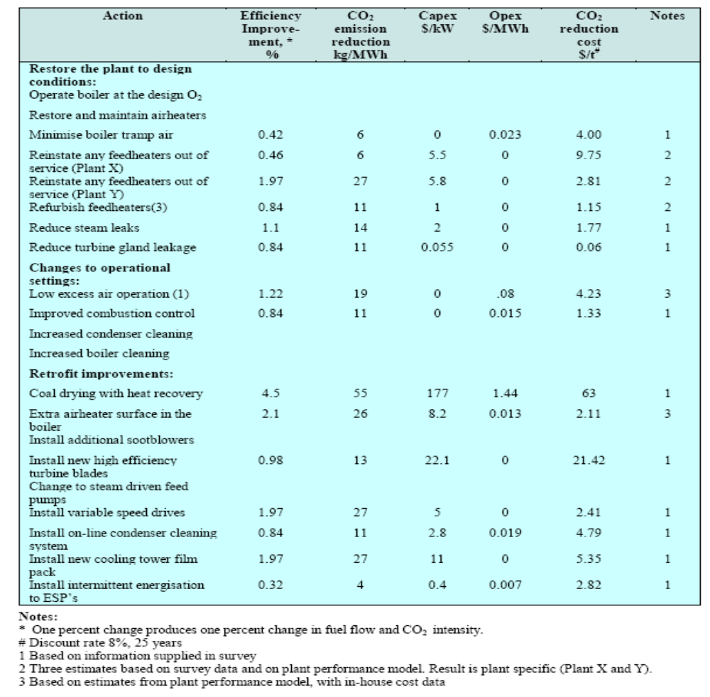

Potential Overlap:

- See Appendix B for Overlap Analysis.

Electricity 7. Sulfur Hexafluoride (SF₆) Emission Reductions fromFrom the Electric Power Industry Work Plan for Potential GHG Reduction Measure
Lead Staff Contact: Krish Ramamurthy (717-783-9476)

Summary: This initiative uses a pollution prevention approach, including a best management practicespractice (BMP) manual and recordkeeping and reporting requirements, to ensure that all SF₆ emission reductions are quantified and permanent.

Other Involved Agencies: United States Environmental Protection Agency
EPA

Possible New Measure(s): SF₆ is identified as the most potent non-CO₂ greenhouse gasGHG, with the ability to trap heat in the atmosphere 23,900 times more effectively than CO₂. Approximately 80% of SF₆ gas produced is used by the electric power industry in high -voltage electrical equipment as an insulator or arc -quenching medium. SF₆ is emitted to the atmosphere during various stages of the equipment’s life cycle. Leaks increase as equipment ages. The gas can also be accidentally released at the time of equipment installation and during servicing.

Emissions Table 7.1 presents SF₆ emission estimates for Pennsylvania include:
.

Table 7.1. SF₆ Emissions Estimates for Pennsylvania
Basis | Year | SF6 Emissions | (MMTCO2e)MMtCO₂e
CIRA-2003 | 1990 | SF6 from Electric Utilities | 0.8 | 87%
CIRA-2003 | 1990 | SF6 from Magnesium | 0.1 | 13%
 |  | Total | 0.9 | 100%
CIRA-2003 | 1999 | SF6 from Electric Utilities | 0.9 | 76%
CIRA-2003 | 1999 | SF6 from Magnesium | 0.3 | 24%
 |  | Total | 1.2 | 100%
PEC-2007 | 1990 | SF6 from Electric Utilities | 1.2
PEC-2007 | 2000 | SF6 from Electric Utilities | 0.6
PEC-2007 | 2020 | SF6 from Electric Utilities | 0.3

A regulatory program could be developed in Pennsylvania that uses a pollution prevention approach, including a best management practicesBMP manual and recordkeeping and reporting requirements to ensure that all SF₆ emission reductions are quantified and permanent. The reduction of SF₆ emissions from the electric power industry is available as one of the offset opportunities for any Cap cap-and Trade Program-trade program established for large emitters under the Northeast Regional Greenhouse Gas Initiative (RGGI).

As part of this regulatory program, a manual could be developed that would identify best management practicesBMPs that would be required of all owners and operators of electric power systems. Best managementBMPs practices could include proper handling techniques, identification and elimination of leaks, and the replacement of equipment that dodoes not meet specific leak rate thresholds. An example of best management practicesBMPs would be the recent Duquesne Light Company decommissioning of an old substation to recover the SF₆ gas and reclaim it to American Society for Testing and Materials (ASTM) standards. The project resulted in the removal of approximately 7,300 lbs of SF₆ that otherwise would have been emitted to the atmosphere. As a part of SF₆ Emission Reduction Partnership for Electric Power Systems, Exelon’s PECO subsidiaries set a SF₆ goal in March 2006, to commit a to an SF₆ leak rate for SF₆ of no more than 10% for 2006. To help achieve this goal, the companies provided additional training to substation personnel to minimize SF₆ gas leaks and revised the gas handling procedures. Annual recordkeeping and reporting requirements would be required to ensure the quantification and reduction of SF₆ emissions.

WorkplanWork Plan Costs and GHG Reductions:

The EPA identifies several categories of reduction measures. The following text is from the EPA webWeb site:

- Recycling Equipment
  - The capital costs of recycling equipment range from around $5,000 to over $100,000 per utility. For this analysis, typical recycling expenditures have been set at $25,500 per utility. However, this capital investment produces O & &M savings of nearly $1,600 per year per utility due to reduced purchases of SF6.
- Leak Detection and Repair
  - There are no capital costs associated with leak detection and repair and O&M costs are estimated to be $2,190 per utility due to the increased labor costs associated with this option.
- Equipment Replacement/Accelerated Capital Turnover
  - The capital costs of this option vary by equipment type. Circuit breakers (below 34.5 kV) may be replaced with vacuum breakers. The replacement cost varies from $25,000 to $75,000 per unit. Medium and high voltage breakers are expected to continue to use SF6 because no other option is currently available. Older breakers are assumed to leak more and are being replaced by new equipment (as part of routine turnover) at a cost of approximately $200,000 to $750,000 per unit. Additional research into the existing equipment stock and potential for replacement will be necessary to develop cost estimates for emission reductions.
- Advanced Leak Detection Technologies
  - The capital cost per GasVue leak detection camera is approximately $100,000. Additional research into the potential emission reductions from this option will be necessary to develop estimates for O&M costs and the total cost of emission reductions.

Summary of Measures and Costs

The most promising options to reduce SF6 emissions from electric power systems are SF6 recycling and
SF6 leak detection and repair. SF6 recycling could reduce emissions by about 10 percent%, and is currently
cost-effective. Leak detection and repair could reduce emissions cost-effectively by 20 percent. %.

Actual EPA partnership experience shows that even greater reductions have been experienced. The 2007
annual report shows that partner emissions rates have declinedeclined by nearly 60 percent%, from overmore than 15 % of consumption to 5.5%.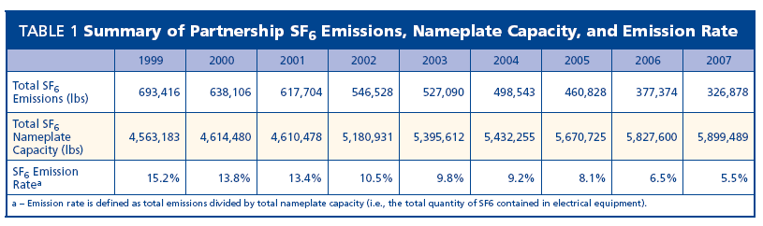

Table 7.1 Workplan. Summary of Emission Mitigation from SF6 Partnership (2007)

Table 7.2. Work Plan Cost and GHG Results

Annual Results (2020) |  |  | Cumulative Results (2009-2020)
GHG Reductions  (MMtCO₂e) | Costs  (Million $) | Cost-Effectiveness  ($/tCO₂e) | GHG Reductions  (MMtCO₂e) | Costs  (NPV, Million $) | Cost-Effectiveness  ($/tCO₂e)
(MMtCO₂e)0.1 | (Million $)$0.1 | ($/tCO₂e)$0.59 | (MMtCO₂e)0.73 | (NPV, Million $)$0.29 | ($/tCO₂e)$0.39
0.1 | $ 0.1 | 0.59 | 0.73 | 0.29 | 0.39

Quantification Approach and Assumptions
- The SF6 program is assumed to be implemented linearly over a 5 -year period beginning in 2012. By the end of 2016, SF6 reductions are assumed to be 30% of forecasted emissions from the electricity sector. The reductions are split into 20% leak detection and 10% recycling.
  - Note that future reductions could be much larger than this, based on actual experiences by SF6 partner utilities between 2000- and 2007.

- The cost estimates employ an 8% discount rate, a ten10-year project lifetime, and an SF6 price of $8.00 per pound. /lb. Mitigation costs for leak detection are estimated at $0.44/ton CO2etCO₂e, and recycling equipment at $0.90/ton CO2e.

- SF6 emissions from the electric power sector are estimated at 0.6 MMTCO2eMMtCO₂e in 2000 and at 0.3 MMTCO2eMMtCO₂e in 2020. Emissions in the interim period are linearly interpolated. Emissions are held constant at 2020 levels through 2030.

Other Costs and Benefits
Industry: Mitigation of—Mitigating emissions are is cheaper than purchasing new SF6 supplies. These benefits are not quantified here for lack of specific cost data.
Department: DEP—No costcosts authorized or anticipated. DevelopmentTherefore, development of any regulatory program would then be required to be accomplished through existing resources and budget.
Funding Sources: US EPAsources—EPA's voluntary cooperative program is implemented under Federalfederal funding independent of Pennsylvania’s budget process.

Implementation Steps: US EPAEPA's voluntary cooperative program is implemented and summarized at http://www.epa.gov/electricpower-sf6/. Pennsylvania’s major power producers are participants.

Potential Overlap: N/A
Not applicable.

Electricity 9. Promote Combined Heat and Power Work Plan for Potential GHG Reduction Measure(CHP)

Strategy Name: Promote combined heat and powerCombined Heat and Power (CHP)

Lead Staff Contact: Maureen Guttman (717-783-8411)

Summary: This initiative encourages distributed CHP systems to reduce fossil fuel use and GHG emissions. Reductions are achieved through the improved efficiency of CHP systems, relative to separate heat and power technologies, and by avoiding transmission and distributionthe T&D losses associated with moving power from central generation stations to distant locations where electricity is used.

Other Involved Agencies: N/A

Possible New Measure(s):
Combined heat and power (CHP) is a term used to describe scenarios in which waste heat from energy production is recovered for productive use. The theory of CHP is to maximize the energy use from fuel consumed and to avoid additional GHG emissions from entities a baseload generating station via additional fossil fuel combustion, so that a reliable source of thermal energy can be provided to the users of GHG’s by the use of reclaimed thermal energy. The reclaimed thermal energy, while can be used by other nearby entities (e.g., within an industrial park or district steam loop) for productive purposes. Generating stations in urban areas may have existing opportunities or may require the co-location of new industry. For Pennsylvania, the largest source of new, cost-effective CHP potential is in industrial facilities that have continuous thermal loads for domestic hot water and process heating (ACEEE, et al., 2009). CHP units are typically sized to the minimum thermal load for the facility.
- Promote use of natural gas-fired CHP.
- Promote use of biomass-fired CHP.
- Create or expand markets for CHP units by incentives designed to promote implementation for residential, commercial and industrial users.
- Promote CHP technologies through provisions for tax benefits, attractive financing, utility rebates and other incentives.
- Remove barriers to CHP development, such as utility rate structures that allow discounted electric rates to compete with CHP. Also, interconnection standards should be designed to facilitate economical and efficient CHP connection to the grid.
- Consider the economic and environmental benefits of CHP as a resource in each electric utility’s Integrated Resource Plan. Potential measures include training and certification of installers and contractors; net metering and other pricing arrangements; clear and consistent interconnection standards; and creation and support for biomass fuel markets.

Potential WorkplanWork Plan Costs and GHG Reductions:

Table 9.1 WorkplanWork Plan Costs and GHG Results ($2007)

Annual Results (2020) |  |  | Cumulative Results (2009-2020)
GHG Reductions  (MMtCO₂e) | Costs  (Million $) | Cost-Effectiveness  ($/tCO₂e) | GHG Reductions  (MMtCO₂e) | Costs  (NPV, Million $) | Cost-Effectiveness  ($/tCO₂e)
(MMtCO₂e)4.4 | (Million $)$53 | ($/tCO₂e)$12 | (MMtCO₂e)23.2 | (NPV, Million $)$209 | ($/tCO₂e)$9
4.4 | $ 53 | $ 12 | 23.2 | $ 209 | $ 9

The composition of the costs presented in Table 9.1 differdiffers according to the type of CHP. Commercial CHP has the highest costs, in part because of the relatively low capacity factor (47% in 2010, rising to 64% in 2020) implied in the ACEEE et al. (2009) report. These low capacity factors are somewhat unusual because CHP units, especially commercial applications, are typically sized to the meet the constant thermal demand of the facility. These units are then run at maximum capacity to generate the required thermal output.
The cost and emissions estimates assume three types of technologies are representative of the CHP portfolio in the future. Table 9.2 reflects the assumptions for each technology.
- Biofuel CHP supply: Ethanol and biodiesel production requires the distillation of separating mixtures based on differences in their volatilities in a boiling liquid mixture and thus require . Thus, it requires significant thermal inputs. The goal of the federal renewable fuels standard of 10.21% for 2009 (11.1 billion gallons of renewable fuel), is required by the Energy Independence and Security Act of 2007 (EISA). The EISA (2007)), which targets 40 billion gallons by 2022.
- Act 78, a state law passed in July 2008, requires that every gallon of gasoline and diesel fuel contain a percentage of ethanol and biodiesel, respectively. The law targets 20% biodiesel and all gasoline sold at retail must contain10 percentcontain 10% ethanol, once in-state cellulosic ethanol production reaches 350 million gallons.
- The Agricultural subcommittee workAgriculture Subcommittee work plan #2 on advanced biofuels targets 545 million gallons of biofuels being produced in PA by 2020. This is the target used for the biofuels CHP component of this workwork plan. This analysis assumes biofuels processing CHP supply is derived from provides useful thermal output equal to the assumption that the heat requirements of processing of the fuels 545 million gallons of biofuels. We assume the biofuels processing requires heat inputs equal to 38% of fuel energy content (an energy balance of 2.62, similar to the energy balance of cellulosic ethanol).
  - The biofuels component of the workwork plan is relatively modest, as exhibited in Table 9.2, installed. Installed capacity in 2020 is only estimated at approximately 180 MW.

- The CHP supply estimates in the ACEEE et al. (2009) report targets the year 2025. For interim years such as 2020, supplies are linearly interpolated. The growth rate for 2026-–2030 is 8.3%, 6.0%, and 0% for commercial, industrial, and biofuels processing, respectively.
- The avoided CO₂ emissions rates are assumed to be the same as in workwork plan #1..
- The fuel for commercial and industrial and biomass processing CHP is 100% natural gas.
- T&D losses are 6.6%.
- Industrial retail electricity prices are the avoided electric prices for industrial and biofuels CHP. CommericalCommercial retail electricity prices are the avoided electric price for commercial CHP. The avoided CO₂ emissions associated with this mix is 0.86 tonnes CO₂ tCO₂/MWh, from a 90% coal, 10% gas mix.

- Estimating the costs of CHP into the distant future is tentative, because cost estimates are highly sensitive to natural gas prices, the cost of avoided power, and the assumption about the CO₂ intensity of displaced electricity.

CHP potentials come from ACEEE et al. (2009) Table E-14. Market Penetration Results for $500/kW Incentive Case. This is the aggressive policy case where clean public energy funds subsidize the capital costs to install CHP at a rate of $500/ per kilowatt (kW. ). This quantification incorporates the total social costs, including private and public costs, into the cost per MMCO2e measure.

Table 9.2:. CHP Technology Assumptions

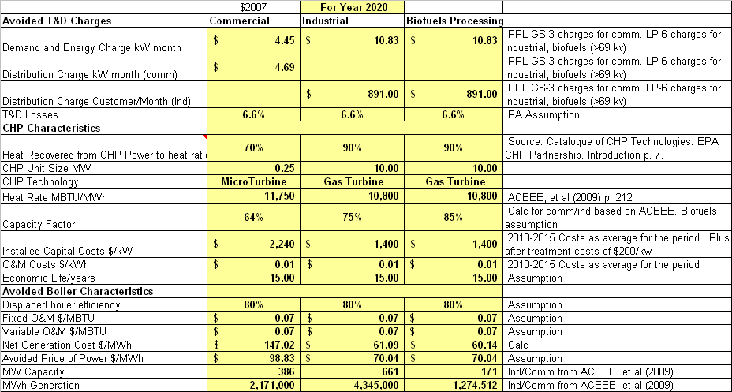

Implementation Steps:
The key to implementing CHP systems is to provide adequate incentives for the development of infrastructure to capture and utilize the waste heat. Such incentives could come in many forms, such as recruiting suitable end users to a centralized location to utilize the waste heat, a feed-in tariff for CHP electricity, including CHP electricity in energy efficiency or renewables targets, tax credits, grants, zoning, and offset credits for avoided emissions.
The following are policies that can potentially increase the installed capacity of CHP in Pennsylvania:
- Create or expand markets for CHP units by using incentives designed to promote implementation for residential, commercial, and industrial users.
- Promote CHP technologies through provisions for tax benefits, attractive financing, utility rebates, and other incentives.
- Remove barriers to CHP development, such as utility rate structures that allow discounted electric rates to compete with CHP. Also, design interconnection standards to facilitate economical and efficient CHP connection to the grid.
- Consider the economic and environmental benefits of CHP as a resource in each electric utility’s Integrated Resource Plan. Potential measures include training and certification of installers and contractors, net metering and other pricing arrangements, clear and consistent interconnection standards, and creation of and support for biomass fuel markets.

Potential Overlap:

- See Appendix B for Overlap Analysis.

Electricity 10. Nuclear Work Plan for Potential GHG Reduction MeasureCapacity

Lead Staff Contact: Dan Griffiths (717-773-0542)

Summary: Capacity This work plan focuses on capacity uprates at existing nuclear plants in PA. DEP estimates 1,050 MW of additional potential capacity at PA nuclear power plants (Limerick, Peach Bottom, Susquehanna, Three Mile Island). Of this total, approximately 150 MW is expected to be available by 2012. Of the remaining 900 MW, we assume that a bit less than half of the remaining MW capacity will be developed (egi.e., ~400 MW) for a total of 550 MW by 2020. Therefore, the nuclear uprate schedule for the state is assumed to be 150 MW in 2012, and an addition of 100 MW of capacity in 2014, 2016, 2018, and 2020.. For new plant build, PPL Electric Utilities is proposing a 1600 -MW Bell Bend plant at the site of the Susquehanna 1 and 2 that is also analyzed under this workwork plan.

Other Involved Agencies: N/A
ot applicable.

Possible New Measure(s):

Nuclear Uprates - —To increase the power output of a reactor, typically a more highly enriched uranium fuel is added. This enables the reactor to produce more thermal energy and therefore more steam, driving a turbine generator to produce electricity. In order toTo accomplish this, such components such as pipes, valves, pumps, heat exchangers, electrical transformers, and generators, must be able to accommodate the conditions that would exist at the higher power level. For example, a higher power level usually involves higher steam and water flow through the systems used in converting the thermal power into electric power. These systems must be capable of accommodating the higher flows.
In some instances, facilities will modify and/or replace components in order to accommodate a higher power level. Depending on the desired increase in power level and original equipment design, this can involve major and costly modifications to the plant, such as the replacement of main turbines. All of these factors must be analyzed by the facility as part of a request for a power uprate, which is accomplished by amending the plant's operating license. The analyses must demonstrate that the proposed new configuration remains safe and that measures continue to be in place to protect the health and safety of the public. Before a request for a power uprate is approved, the Nuclear Regulatory Commission must review these analyses.
Potential GHG Reduction:

Avoided emissions are calculated on the basis of known potential uprates and new plant build displacing a mix of 90% coal and 10% gas at a combined average of 1,872 lb/MWh.

The costs and GHG reductions for this workplan are estimated in Table 10.1. Workplan

Table 10.1. Work Plan Costs and GHG Results
($2007)Annual Results (2020) |  |  | Cumulative Results (2009-2020)
GHG Reductions  (MMtCO₂e) | Costs  (Million $) | Cost-Effectiveness  ($/tCO₂e) | GHG Reductions  (MMtCO₂e) | Costs  (NPV, Million $) | Cost-Effectiveness  ($/tCO₂e)
(MMtCO₂e)14.7 | (Million $)$832 | ($/tCO₂e)$57 | (MMtCO₂e)31.0 | (NPV, Million $)$655 | ($/tCO₂e)$21
14.7 | $ 832 | $ 57 | 31.0 | $ 655 | $ 21

- Nuclear uprate costs are based on FPL Energy’s proposed uprate of its Florida-based Turkey Point and St. Lucie pressurized water reactor units to be completed in 2011.
Pressurized water reactors exist at the Beaver Valley and Three Mile Island plants in Pennsylvania.

- The generation resources that are assumed to be avoided under this workwork plan are 90% existing pulverized coal, and 10% existing peaking gas. The weighted -average cost of generation for the avoided mix is $49.15 in 2020. The avoided CO₂ emissions associated with this mix is 0.86 tonnes CO₂ tCO₂/MWh.

Table 10.2: Nuclear Technology Assumptions
Nuclear Characteristics | $2007 | For Year 2020 | Source
Nuclear Characteristics | New Plant | Uprates | Source
Unit Size MW | 1,600 | varies | New Plant: PPL’s proposed Bell Bend plant. Uprate: staff assumption based on common unit uprate proposals—e.g., FPL’s proposed 378-uprate proposal for 4 units.
Heat Rate MBTU/MWh | 10,400 | 10,400 | ACEEE, et al (2009) p. 212
Capacity Factor | 90% | 90% | Assumption
Installed Capital Costs $/kW | $ $7,310.31 | $ $3,892 | New Plant: Climate Strategies ESD Policy Options Document (September 23, 2008) for the Florida Governor's Action Team on Energy and Climate Change. http://www.flclimatechange.us/ewebeditpro/items/  O12F19875.pdf  Uprate: FPL proposed 2011 uprate for Turkey Point and St. Lucie plants.
O&M Costs $/kWh | $13.33 | $ 3.1 | New Plant: Climate Strategies ESD Policy Options Document (September 23, 2008) for the Florida Governor's Action Team on Energy and Climate Change. Uprate: Same as above, minus fixed O&M costs.
Economic Life/years | 50 | 50 | Assumption
Fuel $/MBTU | $ $1 | $1 | Climate Strategies ESD Policy Options Document (September 23, 2008) for the Florida Governor's Action Team on Energy and Climate Change
Net Generation Cost $/MWh | $ $122.99 | $ $66.20 | Calculation
Avoided Price of Power $/MWh | $49.15 | $49.15 | Calculation based on 90% new coal and 10% new gas plant mix.
MW Capacity | 1,600 | 550 | Described Above
MWh Generation | 12,614,000 | 3,153,600 | Calculation

Implementation Steps:
- Market forces will drive Investmentsinvestments into infrastructure, to uprate capacity. These up-front costs will yield greater energy generation capacity and efficiency, leading to increased sales and, eventually, increased profits.
- These actions are currently being implemented
- Market-driven initiative: .
- Are cost savings realized from this initiative? ?—Not directly. Indirect savings to the commonwealthCommonwealth will accrue subject to in-state low -carbon electricity development (manufacturing, installation, sales and service, etc.). Indirect costs include displaced coal industry jobs and other fossil fuel -related economic production and consumption.

Potential Overlap:

- See Appendix B for Overlap Analysis.
- RGGI Workplan
- work plan.

Appendix A: Incentives Workplan 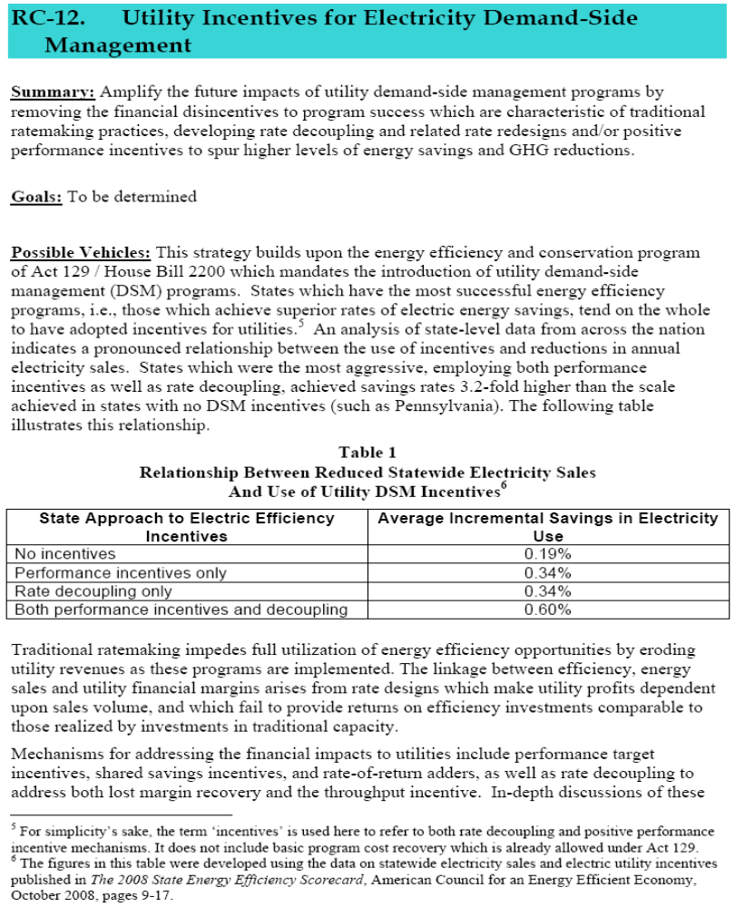
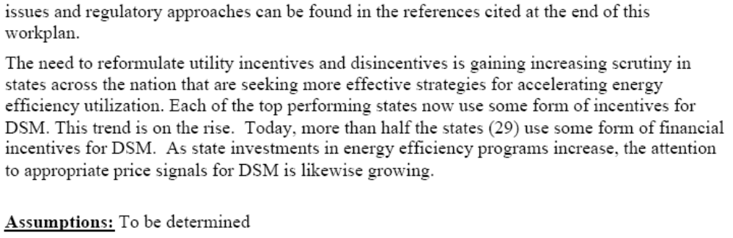
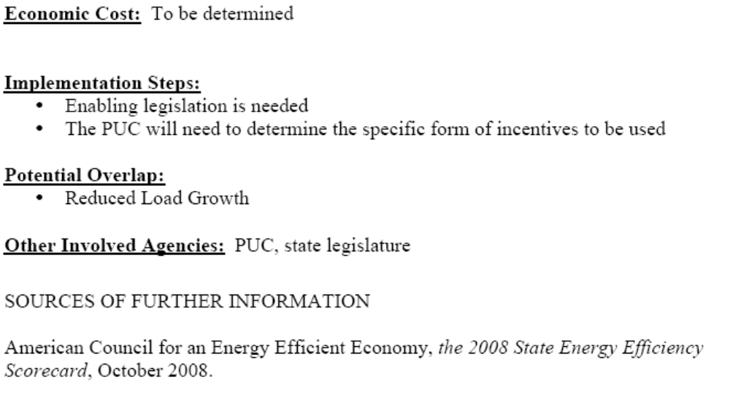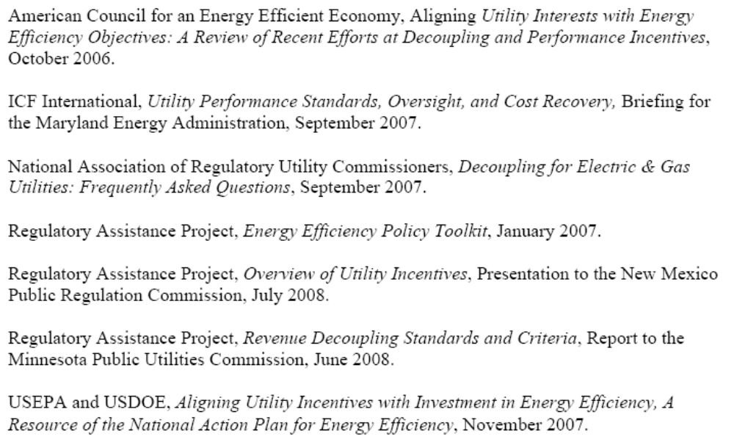

Appendix B: Overlap Analysis

Workplan: | Overlaps With Workplan: | Overlap Adjustment To: | Notes | Resolution
Electricity -3 Stabilized Load Growth | Electricity -2 Reduced Load growth. | Electricity -2, | Electricity 2 and 3 are substitutes for each other. | Reductions from Electricity 2 are eliminated.
Electricity -3 Stabilized Load Growth | Industry-2 Industrial Gas and Electricity | Electricity -3 | Industry 2 targets 9% industrial efficiency by 2020 while Electricity-3 is only 7%. The issue for the interaction between these workplans is not overlaps, but assurance that in combination they do not exceed industrial electric efficiency supplies in PA. By 2020, the combined GWh of both workplans exceeds by approximately 350 GWh the linear implementation of the two 2025 industrial estimates in ACEEE et al (2009) of 9,900 and 13,000 GWh (pp. 14, 30). | 2020 reductions of electric industrial energy efficiency are reduced by 350 GWh (10% of industrial electric efficiency reductions under Electricity 3).
Electricity-8 RGGI | Electricity 3, Electricity-9 CHP, Electricity-6 Nuclear, Industry 2-Industrial gas and Electricity | Electricity-8 RGGI | RGGI analysis utilizes a statewide cost curve using other electricity workplans and the estimated renewables supplies in the state or region | This workplan uses the cost curves developed for the CCAC process as well as estimates of new sources of reductions outside the existing workplans (i.e., new renewables). Biomass requirements for agriculture, forestry and waste are removed from the supplies assumed available for the RGGI analysis.
Electricity -3 Stabilized Load Growth | RC-12 Utility Incentives for Electricity Demand-Side Management | None | It is unclear that decoupling and rate incentives will add incremental reductions to existing targets under Electricity-3. Rather incentives and decoupling are potentially a necessary implementation mechanism for stabilizing load growth. | None required
Electricity -3 Stabilized Load Growth | RC-3, RC-4: High Performance Commercial and High Performance Homes (Residential) (private) Buildings | Electricity-3 | 2020 commercial efficiency reductions under RC-3 are estimated at 9,001 GWh versus only 3,300 for Electricity 3. 2020 residential reductions under RC-4 are estimated at 17,541 GWh versus only 3,400 for Electricity 3. | 100% of residential and commercial reductions from Electricity 3 are eliminated due to overlaps
Electricity -3 Stabilized Load Growth | RC-12 Commissioning and Retrocommissioning | Electricity-3 | Retrocommissioning accounts for 300 of 17,260 GWh commercial reductions in 2025 in ACEEE et al (2009) p. 143 | All residential and commercial reductions in Electricity 3 were eliminated due to overlaps from RC-3 and RC-4. Commissioning reductions kept in RC-12.
Industry-2 Industrial Gas and Electricity | RC-10 Gas DSM | None | RC-10 applies only to residential and commercial buildings | None required
Electricity -3 Stabilized Load Growth | RC-1, RC-2: High Performance State and Local Government Buildings, Schools | None | Typically there is very little overlap between utility/EDC programmatic activity with government green building programs | None required
Electricity -3 Stabilized Load Growth | RC-6 Lighting | Electricity-3 | Lighting accounts for a significant portion of 2025 reductions in ACEEE et al (2009) p. 143 | All residential and commercial reductions in Electricity 3 were eliminated due to overlaps from RC-3 and RC-4. Lighting reductions kept in RC-6.
Electricity -3 Stabilized Load Growth | RC-7 Cool Roofs | Electricity-3 | Cool roofs accounts for 230 of 17,260 GWh commercial reductions in 2025 in ACEEE et al (2009) p. 143 | All residential and commercial reductions in Electricity 3 were eliminated due to overlaps from RC-3 and RC-4. Cool roof reductions kept in RC-7.
RC-8 Appliance Standards | Electricity-3 Stabilized Load Growth | Electricity-3 | Lighting accounts for a significant portion of 2025 reductions in ACEEE et al (2009) p. 143 | All residential and commercial reductions in Electricity 3 were eliminated due to overlaps from RC-3 and RC-4. Appliance reductions kept in RC-8.
Electricity-9 Combined Heat and Power | Industry-2 Industrial Gas and Electricity | None | Industry 2 does not target CHP specifically. In addition, the ACEEE et al (2009) report identifies between 10,000-13,000 GWh of non-CHP electricity efficiency in the industrial sector by 2025. The 2025 target under Industry 2 is only 7,900 GWh. This means that the state can fulfill the targets under Industry 2 without including overlaps for CHP from the electricity CHP workplan. | None Required
Forestry-9 Biomass Thermal Energy Initiatives | Electricity-9 Combined Heat and Power | None | Forestry-9 quantifies the GHG benefits and costs of utilizing biomass to power combined heat and power applications, and also includes Fuels for Schools | The CHP units deployed under Electricity 9 are assumed to operate on natural gas and thus there is no overlap with biomass as a fuel for Forestry-9 CHP.

Appendix C: Generation Cost Assumptions and Sources

SUPPLY SIDE ASSUMPTIONS

Fuel prices: U.S. EIA, AEO 2009 (April 2009 update related to federal stimulus), Table 12 - prices for coal and natural gas for electric generation in the Middle Atlantic region. http://www.eia.doe.gov/oiaf/aeo/supplement/stimulus/regionalarra.html.
- Nuclear fuel prices are based on NYSERDA fuel costs [placeholder].
- Biomass fuel costs assumed to be $5.78 /MMBTU.
- Waste coal prices are based on a study for U.S. EPA (see waste coal assumptions below).
- Municipal solid waste fuel prices are placeholders.
- LFG fuel costs are assumed to be $1/MMBTU for gas collection and treatment.
Equipment life: We assume a 30-year life for all technologies except nuclear which has an estimated 50 year life..

Cost of capital: 10% weighted average cost of capital with a 50% debt and 50% equity proportion. Cost of debt is 8% and cost of equity is 12% for all technologies.

Assumed tax credit over life of technology: Available federal tax credits are assumed to apply to relevant generation units over the life of the plant, though the federal production tax credit applies to different renewable fuels over different periods of generation. We assume 2007-level tax credits. For biomass technologies, we assume the federal tax credit for open-loop biomass. For PV, which receives a federal investment tax credit in lieu of production tax credit eligibility, and the federal government currently permits interchanging the PTC with the ITC, we assume a levelized level of tax support similar to that for wind, which was 2 cents/kWh in 2007. DSIRE database (www.dsireusa.org) for federal tax incentives. For small hydro, we apply the federal production tax credit for small hydropower facilities (irrigation and hydro installation at dams previously without power generation). Federal nuclear tax credit is assumed to be $18 in 2009 and discounted at the estimated inflation rate of 2% per year.

Table 1: Summary of 2020 Costs

Generation Modeling Assumptions | 2020
Generation Modeling Assumptions | Fuel Cost $/MMBTU (Waste coal in $/MWh) | Capital Cost $/kW | Capacity Factor | Tax Credits | Integration Cost | Generation Cost $/MWh
Coal (new supercritical) | $ 2.02 | $ 2,427 | 85% | $ - - | $ - - | $ $61.57
Coal (existing pulverized) | $ 2.02 | $ 801 | 56% | $ - - | $ - - | $ $46.71
Waste Coal | $ 8.92 | $ 2,460 | 85% | $ - - | $ - - | $ $50.10
IGCC | $ 2.02 | $ 3,280 | 85% | $ - - | $ - - | $ $72.37
IGCC with carbon capture | $ 2.02 | $ 4,662 | 85% | $ - - | $ - - | $ $98.12
CCGT | $ 7.27 | $ 1,158 | 85% | $ - - | $ - - | $ $70.77
Combustion NG (peaker) | $ 7.27 | $ 657 | 50% | $ - - | $ - - | $ $84.85
Combustion NG (existing peaker) | $ 7.27 | $ 217 | 50% | $ - - | $ - - | $ $71.14
Nuclear | $ 1.03 | $ 7,310 | 90% | $ (-$13.72) | $ - - | $ $109.21
Biomass Co-Firing | $ 5.78 | $ 461 | 85% | $ (-$10.00) | $ - - | $ $51.44
Biomass Gasification | $ 5.78 | $ 2,104 | 85% | $ (-$20.00) | $ - - | $ $83.11
PV | $ - - | $ 4,218 | 13% | $ (-$20.00) | $ - - | $ $383.24
Hydro repower | $ - - | $ 1,603 | 50% | $ - - | $ - - | $ $45.43
Small hydro | $ - - | $ 2,098 | 30% | $ (-$10.00) | $ - - | $ $34.79
Wind | $ - - | $1,412 | 27% | $ (-$20.00) | $ $4.50 | $ $59.40
Landfill gas | $ 1.00 | $ 1,300 | 80% | ($-$10.00) | $ - - | $ $35.74
Municipal Solid Waste | $ 2.14 | $ 5,950 | 85% | ($-$10.00) | $ - - | $ $144.15
CCS Retrofit Pulv Coal | $1.98 | $2,141 | 85% | $ - - | $ - - | $84.94
Avoided Cost of Generation $/MWh (90% existing coal, 10% existing gas peakers) |  |  |  |  |  | $ $49.15

PULVERIZED COAL (EXISTING)
- Capital cost of $800 Kw means that existing coal fleet is assumed to be nearly fully depreciated (versus $2,400 kw for new coal). Fixed costs include unallocated depreciation, boiler modifications, emissions equipment, or newer coal plants in the PA coal fleet. O&M costs include compliance with New Source Review standards.
- Heat rate: 10,307 for all years. This is the generation weighted average for PA’s coal fleet for 2005. Source: eGrid 2007
- O&M cost: Both fixed and variable based on Congressional Research Service’s Power Plants: Characteristics and Costs, p. 97 (November 2008)..
- Transmission cost: ICF Electric Modeling Assumptions for NYSERDA, p. 83.
- Capacity factor: From Congressional Research Service’s Power Plants: Characteristics and Costs, p. 97 (November 2008).Heat rate: Congressional Research Service’s Power Plants: Characteristics and Costs, p. 97 (November 2008).
PULVERIZED COAL (NEW SUPERCRITICAL)
- Capital and O&M costs include compliance with New Source Review standards
- Capital cost: Overnight total plant cost based on Congressional Research Service’s Power Plants: Characteristics and Costs , p. 97 (November 2008). The CRS study includes data from numerous planned plants as well as U.S. EIA data on operations and future cost trends.
- O&M cost: Both fixed and variable based on Congressional Research Service’s Power Plants: Characteristics and Costs, p. 97 (November 2008)..
- Transmission cost: ICF Electric Modeling Assumptions for NYSERDA, p. 83.
- Capacity factor: From Congressional Research Service’s Power Plants: Characteristics and Costs, p. 97 (November 2008).Heat rate: Congressional Research Service’s Power Plants: Characteristics and Costs, p. 97 (November 2008).
IGCC--Coal
- Capital cost: Total plant cost and interest during construction data from Congressional Research Service’s Power Plants: Characteristics and Costs, p. 97 (November 2008).
- The analysis assumes no IGCC plants until 2015.
- O&M cost: Both fixed and variable based on Congressional Research Service’s Power Plants: Characteristics and Costs, p. 97 (November 2008).
- Transmission cost: ICF Electric Modeling Assumptions for NYSERDA, p. 83.
- Capacity factor: From Congressional Research Service’s Power Plants: Characteristics and Costs, p. 97 (November 2008).
- Heat rate: ICF Congressional Research Service’s Power Plants: Characteristics and Costs, p. 97 (November 2008).
IGCC WITH CARBON CAPTURE—
- Capital cost: Total plant cost and interest during construction data from Congressional Research Service’s Power Plants: Characteristics and Costs, p. 97 (November 2008). The study draws upon work from MIT’s 2007 Future of Coal study.
- The analysis assumes no IGCC with carbon capture plants until 2020. O&M cost: Both fixed and variable based on Congressional Research Service’s Power Plants: Characteristics and Costs, p. 97 (November 2008).Transmission cost: ICF Electric Modeling Assumptions for NYSERDA, p. 83.
- Capacity factor: From Congressional Research Service’s Power Plants: Characteristics and Costs, p. 97 (November 2008).Heat rate: ICF Congressional Research Service’s Power Plants: Characteristics and Costs, p. 97 (November 2008).
NATURAL GAS – COMBINED CYCLE
- Capital cost: Congressional Research Service’s Power Plants: Characteristics and Costs, p. 97 (November 2008).O&M cost: Both fixed and variable based on Congressional Research Service’s Power Plants: Characteristics and Costs, p. 97 (November 2008).
- Transmission cost: ICF Electric Modeling Assumptions for NYSERDA, p. 83.
- Capacity factor: Congressional Research Service’s Power Plants: Characteristics and Costs, p. 97 (November 2008).Heat rate: ICF Electric Modeling Assumptions for NYSERDA, p. 82. ICF's values are for 2010, 2015, 2020 and 2025, with straight-line extrapolation applied in this analysis for interim years Congressional Research Service’s Power Plants: Characteristics and Costs, p. 97 (November 2008)..

NATURAL GAS – COMBUSTION (PEAKER)
Capital cost: Energy and Environmental Economics Inc. GHG Modeling for the California Public Utility Commission, New Natural Gas Combustion Turbine Generation, Resource, Cost, and Performance Assumptions, version 3 (October 2007), p. 3. O&M cost: Both fixed and variable based on Energy and Environmental Economics Inc. GHG Modeling for the California Public Utility Commission, New Natural Gas Combustion Turbine Generation, Resource, Cost, and Performance Assumptions, version 3 (October 2007), p. 3.
- Transmission cost: ICF Electric Modeling Assumptions for NYSERDA, p. 83.
- Capacity factor: Assumption
- Heat rate: Energy and Environmental Economics Inc. GHG Modeling for the California Public Utility Commission, New Natural Gas Combustion Turbine Generation, Resource, Cost, and Performance Assumptions, version 3 (October 2007), p. 3.
NATURAL GAS – COMBUSTION (EXISTING PEAKER)
- Capital cost of $217 kw means that existing gas fleet is assumed to be nearly fully depreciated (versus $650 kw for new peaking gas). Fixed costs include unallocated depreciation, boiler modifications, emissions equipment, or newer gas plants in the PA coal fleet. O&M costs include compliance with New Source Review standards.
- Heat rate: 8,131 is average for all NG plants in PA for 2005. Source: eGrid 2007
- Transmission cost: ICF Electric Modeling Assumptions for NYSERDA, p. 83.
- Capacity factor: Same capacity factor for new peaker.

NEW NUCLEAR PLANT
- Capital cost: Based on Center for Climate Strategies ESD Policy Options Document (September 23, 2008) for the Florida Governor's Action Team on Energy and Climate Change, Energy Supply and Demand Technical Work Group, p. A-32. We assume new nuclear does not come on-line until 2020 per ICF Electric Modeling Assumptions for NYSERDA, p. 82.
- Transmission cost: Lower range of potential interconnection costs from ICF Electric Modeling Assumptions for NYSERDA, p. 83.
- O&M cost: Both fixed and variable based on Based on ESD Policy Options Document (September 23, 2008) for the Florida Governor's Action Team on Energy and Climate Change, Energy Supply and Demand Technical Work Group, p. A-32.
- Capacity factor: Based on Based on ESD Policy Options Document (September 23, 2008) for the Florida Governor's Action Team on Energy and Climate Change, Energy Supply and Demand Technical Work Group, p. A-32.
- Heat rate: ICF Electric Modeling Assumptions for NYSERDA, p. 82.
- Tax credit: Federal tax credit of $18 ($2009) is applied to new advanced nuclear plants applies to the first eight years of plant operation. Because the tax credit is not adjusted for inflation by the US government, its real value is assumed to decline by 2% year starting in 2009.
NUCLEAR UPRATE
- Capital cost: Based on FPL Energy’s proposed uprate of its Turkey Point and St. Lucie pressurized water reactor units to be completed in 2011. http://www.fpl.com/environment/nuclear/power_uprate_faq.shtml
Such reactors exist at the Beaver Valley and Three Mile Island plants in Pennsylvania.

- Transmission cost: Default value of $25/kW.

- O&M cost: Assumes same variable O&M cost as new nuclear plant capacity in this analysis, but no fixed O&M due to addition to existing capacity and low overall O&M cost of uprates.

- Capacity factor: Based on Based on ESD Policy Options Document (September 23, 2008) for the Florida Governor's Action Team on Energy and Climate Change, Energy Supply and Demand Technical Work Group, p. A-32.

- Heat rate: ICF Electric Modeling Assumptions for NYSERDA, p. 82.

BIOMASS CO-FIRING
- Capital cost: Based on Black and Veatch Economic Impact of Renewable Energy in Pennsylvania (2004), p. D-15, for 2-10% co-firing in pulverized coal plant. Costs vary by boiler type and biomass percentage of total generation in a unit.
- Transmission: No additional transmission investment is assumed.
- Fixed O&M Cost: Based on Black and Veatch Economic Impact of Renewable Energy in Pennsylvania (2004), p. D-15, for 2-10% co-firing in pulverized coal plant.
- Variable O&M Cost: Based on Based on Black and Veatch Economic Impact of Renewable Energy in Pennsylvania (2004), p. A-9, for 2-10% co-firing in pulverized coal plant. The $0 value falls between other estimates, including negative costs (PS technology mitigation template summary for NYSERDA) and positive costs (ICF).
- Fuel cost: Assumption of $2/mmBtu.
- Capacity factor: Based on pulverized coal capacity factor in this analysis (85%).
- Heat rate: Assumption based on heat rate for supercritical pulverized coal plant discussed above.
BIOMASS GASIFICATION
- Capital cost: Total plant cost and interest during construction data from ICF Electric Modeling Assumptions for NYSERDA, p. 91. ICF assumes no biomass gasification plants until 2015, and estimates $1,920 in 2015, $1,860 in 2020 and $1,759 in 2025. 2026-2030 costs based on average annual change in cost between 2020-2025.
- O&M cost: Both fixed and variable based on ICF Electric Modeling Assumptions for NYSERDA, p. 91. ICF's values are for 2015, 2020 and 2025, with straight-line extrapolation applied in this analysis for interim years.
- Transmission cost: Assumes same as for a CCGT per ICF Electric Modeling Assumptions for NYSERDA.
- Fuel cost: Assumption of $2/mmBtu.
- Capacity factor: Assumption of 85%.
- Heat rate: ICF Electric Modeling Assumptions for NYSERDA, p. 91.
PV (crystalline)
- Capital cost: ICF Electric Modeling Assumptions for NYSERDA, p. 91. ICF estimates $4,289 in 2010, $4009 in 2015, $3,729 in 2020 and $3,391 in 2025. Interim values are based on straight-line reduction within each 5-year period. 2026-2030 values based on average cost reduction between 2021 and 2025 (1.9%/year).
- Transmission: Assumes distributed solar. Central-station PV will entail more cost.
- O&M: ICF Electric Modeling Assumptions for NYSERDA, p. 91.
- Capacity factor: Based on PV Watts Version 1, using the ACEEE study of PV potential in PA (December 2008) for locations (Pittsburgh = 20% of all capacity, Philadelphia = 32%, rest = 48%). PV Watts estimates a 12.5% capacity factor for Pittsburgh, 13.8% capacity factor for Philadelphia, and we use Williamsport capacity factor of 12.6% for rest of state, with weighted average.
HYDRO REPOWER
- The assumptions below are based on new conventional hydropower. However, the values fall within the range of the high variation in values for "incremental hydro" found in Black and Veatch’s Economic Impact of Renewable Energy in Pennsylvania (2004).
- Capital cost: Based on U.S. EIA's Annual Energy Outlook 2007, Table 39 for new conventional hydropower. 2005 dollars. Capital costs were within the range of hydro upgrades considered in Avista (Washington, Montana) 2007 IRP ($1,478 to $2,168) so we retain it here, recognized the high uncertainty of such costs (as expressed by Avista in its IRP).
- Transmission cost: Default assumption of $25/kW similar to the majority of other technologies analyzed
- O&M cost: U.S. EIA AEO 2007 for new conventional hydropower.
- Capacity factor: Assumption, p. 115, for new conventional hydropower.
SMALL HYDRO
- Capital cost: Based on 2009 capital costs in ESD Policy Options Document (September 23, 2008) for the Florida Governor's Action Team on Energy and Climate Change, Energy Supply and Demand Technical Work Group, p. A-7.
- Transmission cost: Default assumption of $25/kW similar to the majority of other technologies analyzed.
- O&M cost: Based on ESD Policy Options Document (September 23, 2008) for the Florida Governor's Action Team on Energy and Climate Change, Energy Supply and Demand Technical Work Group, p. A-7.
- Capacity factor: ESD Policy Options Document (September 23, 2008) for the Florida Governor's Action Team on Energy and Climate Change, Energy Supply and Demand Technical Work Group, p. A-8.
WIND
- Wind capital cost: ICF Electric Modeling Assumption for NYSERDA, p. 91. Assumes 1% reduction in costs starting in 2010 per ICF study (p. 92)
- Wind O&M cost: ICF Electric Modeling Assumption for NYSERDA, p. 91.
- Wind transmission cost: ICF Electric Modeling Assumption for NYSERDA, p. 95. Assumes "Step 1" transmission which presumes easiest combination of terrain and distance, and which represent 64% (32,411 MW) of modeled resources in PJM by ICF.
- Wind capacity factor: Based on averaging of all Class 3-5 wind resources for PJM in ICF study (p.97) for all levels of transmission difficulty.
- Integration costs: Based on the Midwest Integration Cost Study in 2006 which found a 25% penetration of wind in Minnesota (MISO) leads to $4.5/MWh in total integration costs. Cost is applied to all units of wind in this study, which is conservative for lower penetrations of wind compared to total generation. See http://www.awea.org/newsroom/releases/Groundbreaking_Minnesota_Wind_Integration_Study_121306.html.
COMBINED HEAT-AND-POWER ASSUMPTIONS
See CHP Workplan

WASTE COAL
- We assume that waste coal is consumed by advanced fluidized bed coal plants, which can handle low-grade fuels more effectively compared to pulverized coal.
- Capital cost: Based on advanced fluidized bed coal-fired plant from EPRI Program on Technology Innovation: Integrated Technology Options (November 2008), p. 4-5. ICF relies in Black and Veatch’s Economic Impact of Renewable Energy in Pennsylvania for its data.
- Transmission cost: Default assumption of $25/kW.
- Fixed and Variable O&M: Based on ICF’s Technical Support Document: Waste Coal-Fired Units in the CAIR and CAIR FIP, p. 8. Originally in 1999 dollars.
- Capacity factor: on ICF’s Technical Support Document: Waste Coal-Fired Units in the CAIR and CAIR FIP, p. 9.
- Fuel costs: Based on Technical Support Document: Waste Coal-Fired Units in the CAIR and CAIR FIP. The study uses U.S. EIA waste coal price forecast data and assumes heat content of 8,000 Btu/pound, combined with the heat rate assumption used in this analysis (10,200 Btu/MWh)
- Heat rate: ICF Technical Support Document: Waste Coal-Fired Units in the CAIR and CAIR FIP.

LANDFILL GAS

- Capital cost: Based on U.S. EPA’s Landfill Methane Outreach Program’s LFGE Project Development Handbook, p. 4-5, capital cost for internal combustion engines above 800 kW.
- Transmission cost: Default assumption of $25/kW similar to the majority of other technologies analyzed.
- O&M cost: Based on U.S. EPA’s Landfill Methane Outreach Program’s LFGE Project Development Handbook, p. 4-5, O&M costs for internal combustion engines above 800 kW.
- Capacity factor: Black and Veatch’s Economic Impact of Renewable Energy in Pennsylvania, p. D-18.

MUNICIPAL SOLID WASTE
- Capital cost: Based on Black & Veatch’s Renewable Energy Technology Assessments for Kau’I Island Utility Cooperative, p.7-8. Assumes a combined biomass and trash facility with separate fuel streams, boilers and steam cycles for each feedstock.
- Transmission cost: Default assumption of $25/kW similar to the majority of other technologies analyzed.
- O&M cost: Black & Veatch’s Renewable Energy Technology Assessments for Kau’I Island Utility Cooperative, p.7-8
- Capacity factor: Assumption of 85%.
Fuel cost: Black & Veatch’s Renewable Energy Technology Assessments for Kau’I Island Utility Cooperative, p.7-8. Fuel costs are highly dependent on trash tipping fees, which are not incorporated in this fuel cost assumption.

5% EFFICIENCY UPGRADES FOR EXISTING COAL-FIRED PLANTS
Cost and efficiency improvements: Based on cost estimates on an avoided CO2 emissions basis in the Australian Greenhouse Office (January 2000) Report, Integrating Consultancy Efficiency Standards for Power Generation. The study’s efficiency improvement estimates for several measures (excluding reduction of turbine gland leakage and low excess air operation) was corroborated in National Energy Technology Laboratory’sNETL's Reducing CO2 Emissions By Improving the Efficiency of the Existing Coal-Fired Power Plant Fleet (July 2008).

Appendix D: RGGI Workplan

Electricity 8. Join Analysis to Evaluate Potential Impacts Associated With Joining the Regional Greenhouse Gas Initiative Work Plan for Potential GHG Reduction Measure

Lead Staff Contact: PUC and DEP
Joe Sherrick (717-772-8944)

Initiative Summary: Examine the potential CO2 emissions reductions associated with joining the Regional Greenhouse Gas InitiativeRGGI.

Other Involved Agencies: PUC and DEP.

Possible New Measure(s):
RGGI is composed of individual CO₂ Budget Trading Programs in each participating state. These programs are implemented through state regulations, based on a RGGI Model Rule (http://www.rggi.org/docs/Model%20Rule%20Revised%2012.31.08.pdf), and are linked through CO₂ allowance reciprocity. Regulated power plants are able to use a CO₂ allowance issued by any of the participating states to demonstrate compliance with the state program governing their facility. Taken together, the individual state programs function as a single regional compliance market for trading carbon emissions. The RGGI Model Rule may be found at http://www.rggi.org/docs/Model%20Rule%20Revised%2012.31.08.pdf
. To reduce GHG emissions of greenhouse gases, the RGGI participating states are using a market-based cap-and-trade approach that includes:
- Establishing a multi-state CO₂ emissions budget (cap) that will decrease gradually until it is 10% lower than at the start.
- Requiring electric power generator to hold allowances covering their CO₂ emissions of CO₂.
- Providing a market-based emissions auction and trading system where electric power generators can buy, sell, and trade CO₂ emissions allowances.
- Using the proceeds of allowance auctions to support low-carbon-intensity solutions, including energy efficiency and clean renewable energy, such as solar and wind power.
- Employing offsets (greenhouse gas emissionsGHG emission reduction or sequestration projects at sources beyond the electricity sector) to help companies meet their compliance obligations.
RGGI's phased approach means that reductions in the CO₂ cap provide predictable market signals and regulatory certainty. Electricity generators will be able to plan for and invest in lower-carbon alternatives and avoid dramatic electricity price impacts.
The RGGI target is to hold state CO₂ emissions from the power sector constant at 2009 levels until 2014. Beginning in 2015, aCO₂ emissions will be reduced by 2.5% reduction per %/year below 2009 emissions for four4 years through the end of 2018, at which time capped emissions are targeted at 10% below 2009 emissions.
The following tableTable 8.1 shows the forecasted Pennsylvania business-as-usual (BAU) emissions, and corresponding RGGI target, and in the . The final row of the table shows the required reductions to meet the RGGI target. Note that the effects of energy efficiency investments required under Act 129 (2008) are included in the BAU emissions forecast, as are the renewable energy requirements from Pennsylvania’s Alternative Energy Portfolio Standard (2004)the AEPS.
Table 8.1. Pennsylvania Forecasted Emissions and the RGGI Targets 2009-–2020
Electricity Sector Emissions--Million Metric Tons CO2 Equivalent (MMTCO2e) | 2009 | 2010 | 2011 | 2012 | 2013 | 2014 | 2015 | 2016 | 2017 | 2018 | 2019 | 2020
Total (Production-Based) | 115 | 117 | 120 | 122 | 123 | 125 | 126 | 128 | 129 | 131 | 133 | 134
Total (Consumption-Based—Not used in analysis | 83 | 85 | 86 | 88 | 89 | 90 | 91 | 92 | 93 | 94 | 95 | 97
RGGI CAP | 115 | 115 | 115 | 115 | 115 | 115 | 112 | 109 | 107 | 104 | 104 | 104
Required Reductions From BAU (Production Based Emissions less RGGI Cap) | - - | 2.3 | 4.5 | 6.4 | 8.0 | 9.6 | 14.0 | 18.4 | 22.9 | 27.4 | 29.0 | 30.5

Although the first RGGI compliance target ends in 2018, this analysis considers emissions and reductions out to 2020, because this is the Pennsylvania Climate Change Advisory Council’s terminal analysis year.
Pennsylvania’s BAU emissions are forecasted to grow by over 1.5 million tonnes per MMtCO₂e/year between 2005 and 2020. This equates to an increase in emission emissions of 10 MMTCO2eMMtCO₂e between 2009 and 2014, after which the 2.5% annual reductions are required. Between 2015 and 2020, Pennsylvania’s power sector emissions are forecasted to grow by an additional 9 MMTCO2eMMtCO₂e.
By 2020, the forecast predicts that RGGI compliance would require approximately 30 MMTCO2eMMtCO₂e reductions from the electricity sector. There are two categories of reductions that need to occur to meet the RGGI target:
- Reduce the 2009-–2020 forecasted BAU emissions increase of 19 MMTCO2eMMtCO₂e to hold state emissions constant at 2005 levels.
- Reduce the additional 11 MMTCO2eMMtCO₂e required to reach the 10% below 2005 RGGI target.
Several conclusions can be drawn from this analysis regarding potential RGGI compliance. First, Pennsylvania’s emissions growth needs to begin to slow immediately in order to for the state to realistically meet the RGGI target. Because of their low -cost and short lead times, demand -side management measures are the optimal choice to stabilize emissions emission levels. Second, in the longer term, reductions in the carbon intensity of the electricity generated in Pennsylvania will be required to meet the RGGI targets. Finally, these two considerations should be viewed as a portfolio of reductions in the electricity sectors. Cost savings (negative cost measures) from demand side -options can be viewed to “pay” for higher -cost fuel -switching measures on the supply side. While demand-side management (DSM) requires capital outlays that are typically paid for by consumers, these investments costs cost less than new supply -side investments, and mitigate cost increases from low -carbon generation, as well as transmission and distributionT&D investments.
Potential Costs and Supplies of GHG Emissions Reductions for Pennsylvania
Modeling of the costs to the state from joining RGGI proceeds in a stepwise fashion. The approach is to aggregate the statewide GHG emissions reductions that are grid connected. First, is an analysis of the reductions in GHG emissions from reduced electricity consumption.

Table 8.2:. Demand -Side GHG Reductions Identified in CCAC WorkplansWork Plans

 |  | Annual Results | (2020)
Work Plan No. | Work Plan Name | GHG Reductions (MMtCO2e) | Cost Effectiveness ($/tCO2e)
Electricity 3 | Stabilized Load Growth (Industrial Sector Only) | 3 | $ (-$64.43)
RC-1 | High Performance State and Local Government Buildings | 2 | TBA
RC-2 | High Performance School Buildings | 1 | TBA
RC-3 | High Performance Commercial (private) Buildings | 5 | TBA
RC-4 | High Performance Homes (Residential) | 11 | TBA
RC-5 | Commission Buildings | 1 | TBA
RC-6 | Re-Light PA | 6 | TBA
RC-8 | Appliance Standards | 1 | TBA
RC-9 | Geothermal Heating and Cooling | TBA | TBA
 | Total Demand Side Reductions | 30 | TBA

- The costs of RGGI compliance are likely to be dominated by the negative cost energy efficiency (demand side) measures. A study conducted by the University of Maryland (January 2007) evaluated the costs and benefits of participating in the Regional Greenhouse Gas Initiative. This study can be found at http://www.cier.umd.edu/RGGI/documents/UMD_RGGI_STUDY_Jan07.pdf

The main conclusions of this study indicate that, overall, joining RGGI would only have a limited impact on the economy and electric power markets in Maryland. Similar conclusions hold for the current RGGI region and affected areas outside this region.

Electricity Bill Impacts in MD: Overall, electricity bills are forecast to decrease over $100 million in 2010 and more than $200 million by 2025. This is a result of energy efficiencies, which will lower customers’ demands. Since the heaviest users will save the most, more than half the savings (between 53% and 63%) will go to industrial and commercial customers. On average, a residential ratepayer will see a modest reduction – about $22 savings in 2010 per household.

Overall Economic Impacts in MD: Will have little net impact on the Maryland economy. The positive economic impacts from reduced electricity costs and energy efficiency investments are partially offset by reduced investment and profits in the electricity generating sector. Overall RGGI is predicted to have a positive economic impact on Gross State Product of approximately $100 million in 2010, increasing to about $200 million in 2015 and subsequent years. This impact is expected to create approximately 1200 jobs across the state by 2010, increasing to 2800 jobs by 2025. Such positive impacts are less than 0.1% of overall Maryland gross state product and employment in all years.
  - The costs to Pennsylvania are not necessarily reflective of the above modeled costs to Maryland.

Table 8.3:. Low -Cost Supply -Side GHG Reductions Identified in CCAC WorkplansWork Plans

 |  | Annual Results (2020)
Work Plan No. | Work Plan Name | GHG Reductions (MMtCO2e) | Cost Effectiveness ($/tCO2e)
Waste 1 | Landfill Methane Displacement of Fossil Fuels | 0.1 | $ (-$0.80)
Waste 5 | Waste-to-Energy Digesters | 0.1 | $ $1.00
Waste 6 | Waste-to-Energy MSW | 0.24 | $ (-$34.00)
Forestry 8 | Wood to Electricity | 0.26 | $ $0.67
Forestry 9 | Combined heat and power | 0.47 | –$45.30
Ag-4 | Ag Digesters (Methane) | 0.20 | $ (-$0.25)
Electricity 6 | Improve Coal-Fired Power Plant Efficiency by 5% | 5 | $ $15.21
Electricity 7 | Sulfur Hexafluoride (SF6) Emission Reductions from the Electric Power Industry | 0.1 | $ $0.59
Electricity 9 | Promote Combined Heat and Power (CHP) | 4 | $ $12.20
Electricity 10 | Nuclear (Uprates Only) | 4 | $ $19.72
 | Total Supply Side Reductions | 15 | $ $13.44

These electricity supply options do not include new renewables supplies and fuel switching from coal-to-gas. For instance, HB 80 sets new targets for the AEPS following 2021. This was not quantified because the HB80 requirements begin after the CCAC 2020 planning horizon.

Offsets
Another source of supplies for RGGI compliance comes from offsets. The RGGI program has included flexibility mechanisms to limit costs to the regulated sector. One of these mechanisms creates offset allowances from CO₂ mitigation projects outside of the power sector. Offsets are initially allowed in the program up to 3.3% of an entity’s compliance obligation. If annual average allowance prices exceed $7 (in $2005), then this amount increases to 5%, and if annual allowance prices exceed $10, then this amount increases to 10%. At the 10% level, international CO₂ reduction credits are also allowed. In the reference case 3.3% of obligations, total offsets allowed by Pennsylvania entities in 2020 would be approximately 4.4 MMTCO2eMMtCO₂e.

The following list identifies the categories of offset projects currently allowed, and representative costs/to of CO₂. The costs are approximate and are taken from the relevant CCAC subcommittee workplans dated 6/15/2009 or later:
- Landfill methane capture and destruction (-$1/ton)
- Reduction in emissions of sulfur hexafluoride (SF6) in the electric power sector ($2/ton)
- Sequestration of carbon due to afforestation (-$10/ton)
- Reduction or avoidance of CO2 emissions from natural gas, oil, or propane end-use combustion due to end-use energy efficiency in the building sector (-$25/ton)
- Avoided methane emissions from agricultural manure management operations (-$1/ton)

The offset accreditation process will likely entail some administrative costs that are not included in the above CCAC costs. Given the low or negative costs of the above measures, plus accreditation costs, a generic cost estimate for RGGI offsets is estimated at $5/ton CO₂e. Assuming that the costs of offsets credited in the RGGI program reflect the microeconomic quantification for the CCAC process, then they could exhibit a significant downward cost of compliance for regulated actors.

Summary
The above categories of costs and supplies are summarized in Table 8.4.

Table 8.4. Summary of GHG Reduction Measures
Category of Measures | PA Supply of GHG Reductions (MMtCO2e) | Cost Effectiveness ($/tCO2e) | Comment
Demand Side | 30 | $ (-$10.00) | Placeholders pending overlaps and cost information
Supply Side (CCAC) | 15 | $ $13.44 | Includes overlaps
Offsets | 4.4 | $ $5.00 | 3.3% cap on offsets. See text for cost information
Total | 50 | $ (-$1.58) | Weighted average cost/ton

Limitations and Uncertainties
- As of 2007, Pennsylvania is a large exporter of electricity. The reference case GHG forecast assumes this will continue through 2020 as the growth in electricity generation is equivalent to growth in electricity sales. However, if Pennsylvania cannot site new fossil based generation resources at this rate, then GHG emissions from the power sector will be low than reported here.
- Similarly, the compliance costs estimated above require the timely implementation of policies to develop the GHG reduction measures identified under the CCAC process.
- Other costs: Cost to DEP & PUC – The cost will be in terms of staff man hours invested in developing any new regulation, or guidance document, that will be required for this effort. Also, additional staff time invested by regional office personnel necessary to update permits.

Quantification Approach and Assumptions

- Emissions reductions required to meet RGGI targets are based on PA production-based inventory which includes all electricity generated, including exported electricity.
- Power sector emissions are assumed to be held constant at 2009 levels through the end of 2014. Beginning in 2015, emissions are reduced by 2.5% of 2009 levels.
- The generation resources that are assumed to be avoided under this workplan are 90% existing pulverized coal, and 10% existing peaking gas. The weighted average cost of generation for the avoided mix is $9.15 in 2020. The avoided CO₂ emissions associated with this mix is .86 tonnes CO₂ /MWh

Implementation Steps: Not ApplicableNew legislation and new regulation based on RGGI Model Rule is required.

Potential Overlap: See Appendix B for Overlap Analysis.

Source: ACEEE et al. (2009). Energy Efficiency, Demand Response, and Onsite Solar Energy Potential in Pennsylvania. April. P. 29. page 48. http://www.aceee.org/pubs/e093.htm
Source: Quantec. (2008). Assessment of Energy and Capacity Savings Potential in Iowa Prepared for The Iowa Utility Association. February 15. p. I7-I10 No web link available.
Source: ACEEE et al. (2009). Energy Efficiency, Demand Response, and Onsite Solar Energy Potential in Pennsylvania. April. P. 29. page 48. http://www.aceee.org/pubs/e093.htm
? Source: ACEEE et al. (2009). Energy Efficiency, Demand Response, and Onsite Solar Energy Potential in Pennsylvania. April. P. 14. page 48. http://www.aceee.org/pubs/e093.htm
http://www.puc.state.pa.us/electric/electric_alt_energy.aspx
http://www.puc.state.pa.us/electric/electric_alt_energy.aspx
Reducing Greenhouse Gas Emissions: How Much at What Cost? p.59 http://www.mckinsey.com/clientservice/ccsi/pdf/US_ghg_final_report.pdf
US EPA. Final Report on U.S. High Global Warming Potential (High GWP) Emissions 1990-2010: Inventories, Projections, and Opportunities for Reductions. Chapter 3: Cost And Emission Reduction Analysis Of Sf6 Emissions From Electric Power Transmission And Distribution Systems In The United States. http://www.epa.gov/highgwp/pdfs/chap3_elec.pdf
http://www.epa.gov/highgwp/pdfs/chap3_elec.pdf p. 3-3.
http://www.epa.gov/highgwp/pdfs/chap3_elec.pdf p. 3-3.
http://www.epa.gov/electricpower-sf6/documents/sf6_2007_ann_report.pdf page 3.
http://www.epa.gov/highgwp/pdfs/chap3_elec.pdf Exhibit 3.4.
http://apps1.eere.energy.gov/states/state_news_detail.cfm/news_id=12212/state=PA
From an email from Joe Sherrick at DEP on June 17, 2009.
US EIA. (2001). Biomass for Electricity Generation. Adjusted to $2007. http://www.eia.doe.gov/oiaf/analysispaper/biomass/pdf/biomass.pdfhttp://www.eia.doe.gov/oiaf/analysispaper/biomass/pdf/biomass.pdf
http://www.flclimatechange.us/ee.cfm
The modeling done for the RGGI states cost approximately $1 million. The CCAC does not have the resources to perform this type of analysis.
http://www.rggi.org/docs/program_summary_10_07.pdf. pp. 6-11.

