INSTRUCTIONS FOR THE ON-LINE APPLICATION

The Alternative Fuel Vehicle Rebate Program (AFVR) must be submitted through the Department of Community and Economic Development’s (DCED) Electronic Single Application (ESA) website. Paper and faxed copies will not be accepted. This change allows DEP to expedite the review process. The link to the on-line application can be found at:
https://www.esa.dced.state.pa.us/Login.aspx

This document will provide instructions on how to apply and upload the required documentation in the ESA application. All information needed for your submission will be contained in this online application.

No documentation needs to be mailed to DEP. You do not need to send a copy of the signature page to DEP.

User Tips

- The Electronic Single Application works best when accessed through Internet Explorer or Google Chrome.
- If you allow your screen to sit idle for more than 30 minutes, you will lose the data entered since your last save and will have to re-enter it. Save frequently.
- When completing the application, fields with a “ ” are required fields. If a required field is skipped, you will be notified later in the application to return to that section to complete the field.
- Do not use special characters in the fields such as \, /, *, &, %, #, etc.

If you have questions completing the application, please call the DCED Customer Service Center at 1-800-379-7448. They are open 8:30 am-5:00 pm EST Monday thru Friday.

A video on required information is also available for you to review should you have any questions on the type of documentation that is necessary to be submitted with your application. It is suggested that you also watch this video before completing your application.
TABLE OF CONTENTS

Registration and Login …………………………………………………………………………………………………………… Page 3
Begin a New Application ..……………………………………………………………………………………………………… Page 3
Select a Program …………………………………………………………………………………………………………………… Page 4
Apply ……………………………………………………………………………………………………………………………………. Page 4
Program Requirements……………………………………………………………………………………………………………Page 4-5
Applicant Information Tab …………………………………………………………………………………… Page 6-7
Project Overview Tab …………………………………………………………………………………………… Page 8
Project Site Tab …………………………………………………………………………………………………… Page 9
Project Narrative Tab …………………………………………………………………………………………… Page 10
Program Budget Tab………………………………………………………………………………………………Page 11
Program Addenda Tab …………………………………………………………………………………………. Page 12-14
Certification and Submission ………………………………………………………………………………… Page 15-16
Application Receipt Verification …………………………………………………………………………… Page 17

Reminder: If you have questions completing the electronic application, please call the DCED Customer Service Center at 1-800-379-7448. They are open 8:30 am-5:00 pm EST Monday thru Friday.

Available on the DEP website, Alternative Fuels Incentive Grant (pa.gov), click on Alternative Fuel Vehicles, there is an instructional video on how to submit an AFV rebate application.

Registration and Login
Go to the ESA login page https://www.esa.dced.state.pa.us/Login.aspx and follow the instructions for creating a new account or migrating an existing account.
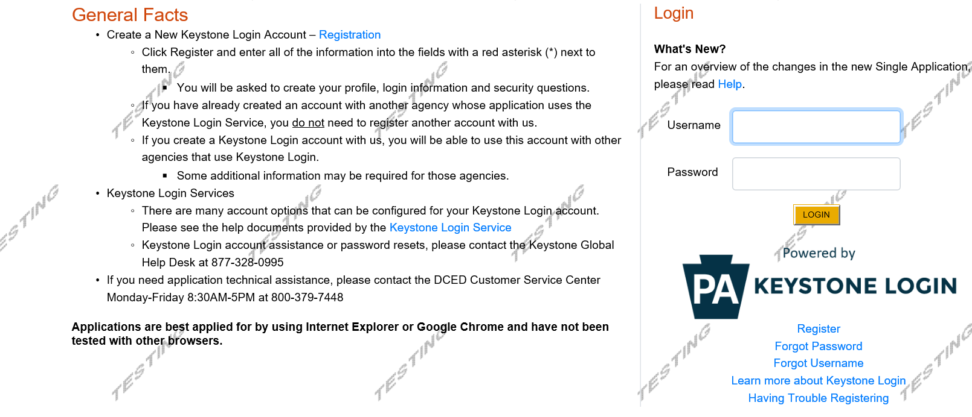

Begin a New Application
- Project Name – Enter a name for your project.
- Do you need help selecting your program – Select “No”.
- Click on “CREATE A NEW APPLICATION”.

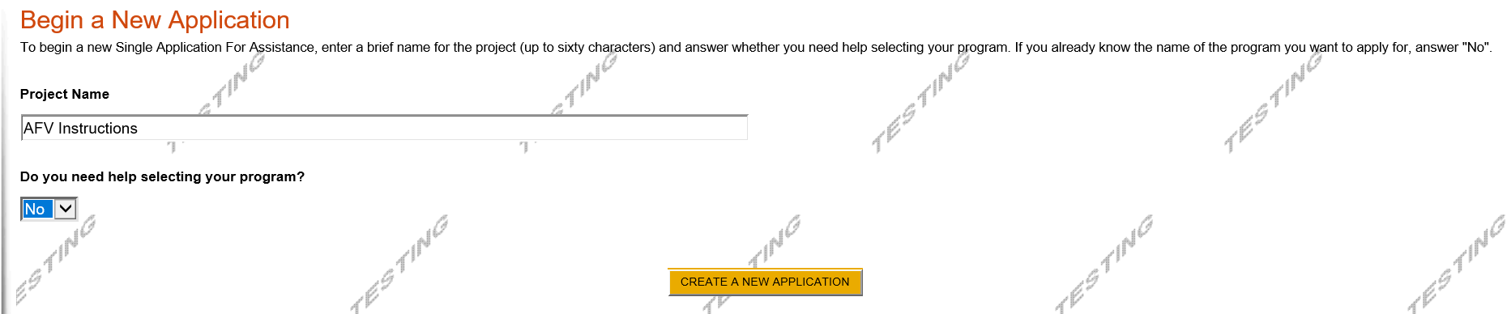

Select Program
- Under Program Name, enter “AFV”.
- Click “SEARCH”. Look for the appropriate grant program offered by DEP.

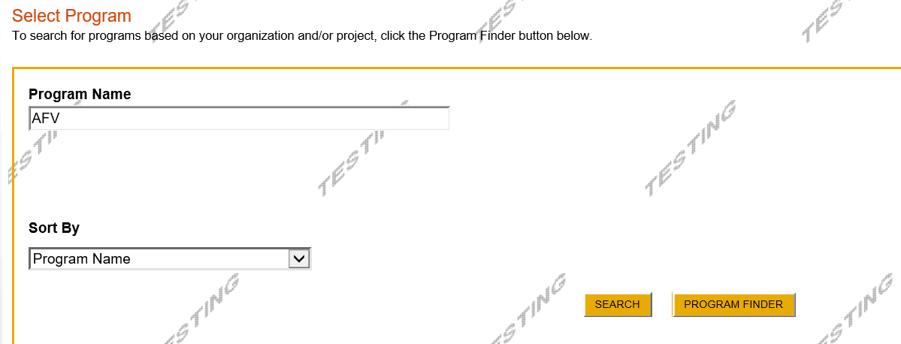

Apply
- Select the program for which you are applying.

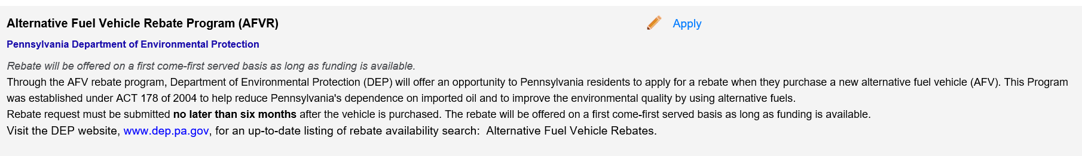
Program Requirements
Before you can apply, you must complete the Pre-Application Requirements.
When finished filling out the program requirements, click “continue”
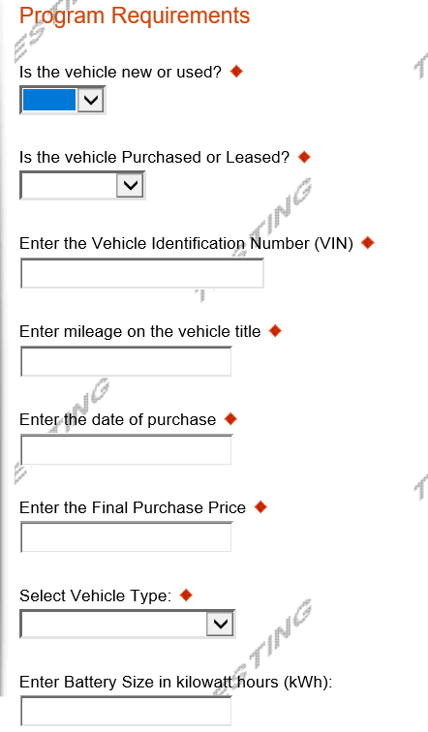

Applicant Information Tab

- The Applicant Information section requires data related to the applicant for which the application is being submitted.
- Applicant Entity Type – select individual.
- Applicant Name – Enter the name of who purchased the vehicle.
- NAICS Code – When Individual is picked as the Applicant Entity Type, NAICS code automatically populates with 8141.
- FEIN/SSN Number - Enter the Social Security number of Applicant.
- DUNS Number – Leave blank.
- CEO – In this block, enter name of Applicant.
- CEO Title – Enter that person’s title.
- SAP Vendor# - Leave blank.
- Contact Name – Enter the Applicant name.
- Contact Title – Enter the Applicant’s title.
- Phone and Fax – Enter the phone and fax numbers for the primary contact for this project.
- E-mail – Enter the e-mail for the primary contact for this project.
- Mailing address, City, State and Zip Code – Enter this information for the Applicant.
- Click “Continue” at the bottom right.
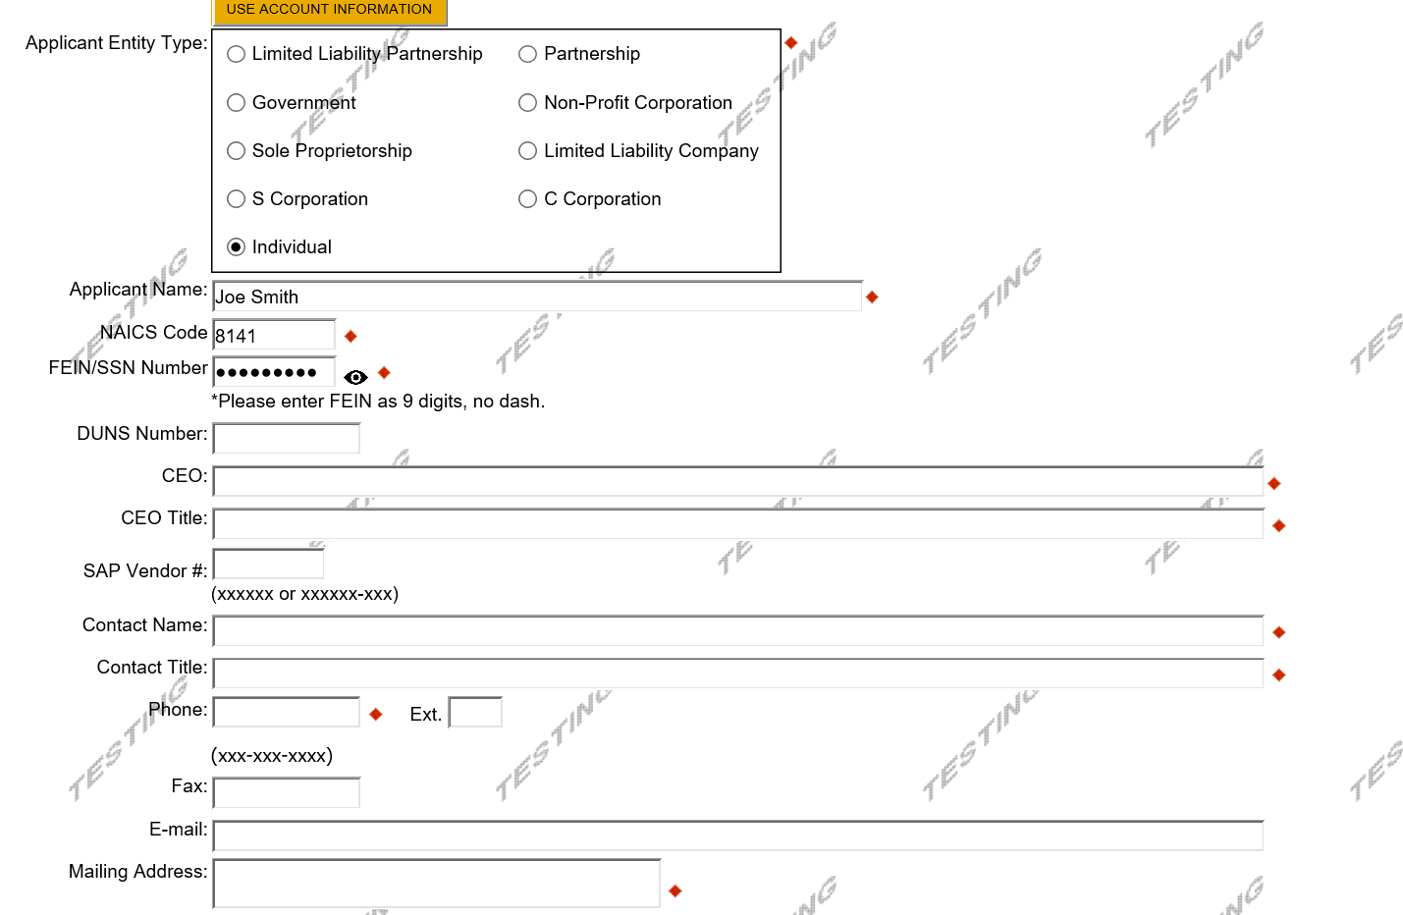
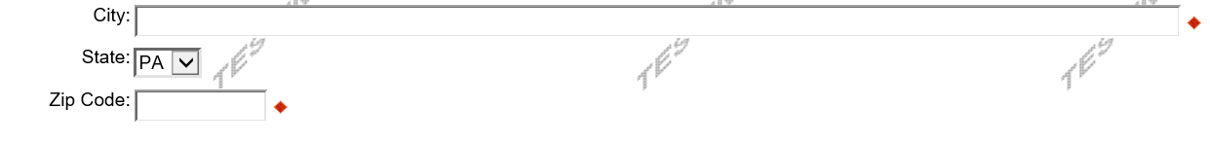
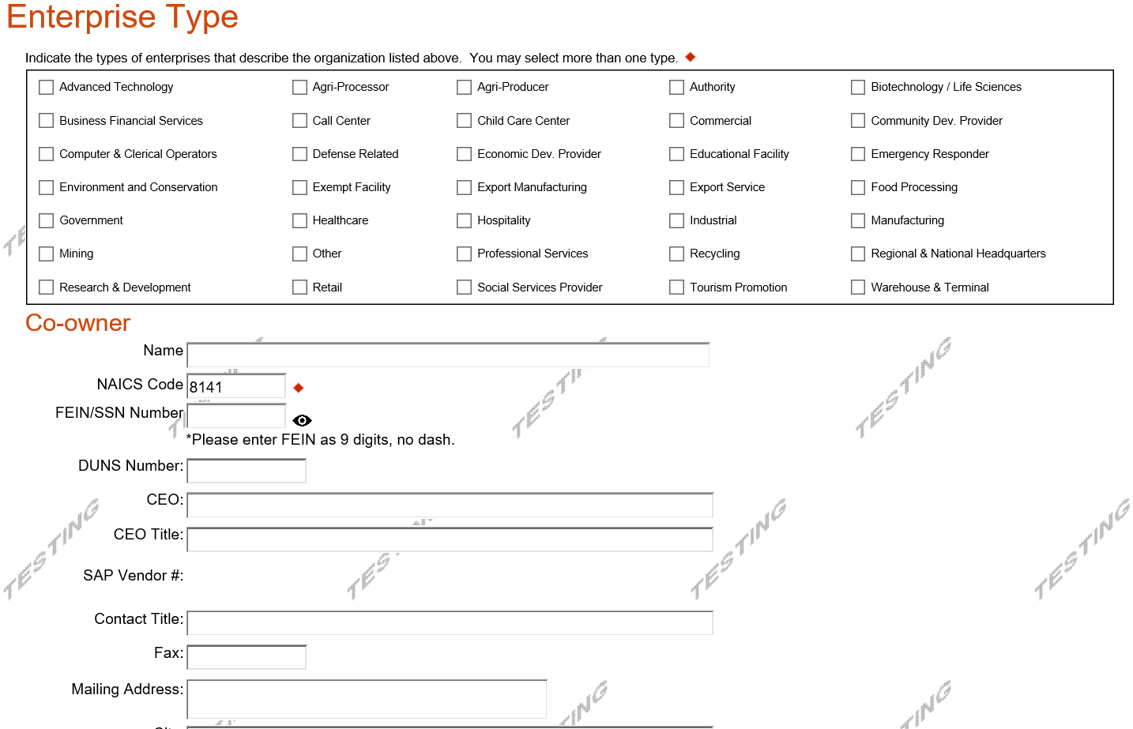
Co-Owner
- In the case of co-owners/co-purchasers, each co-purchaser must be a PA resident and the rebate amount will be divided between the co-purchasers. If the rebate is less than $750.00, the payment will be made out to the applicant.

Project Overview
- Project Name – The project name will auto-populate from the information you filled in at the beginning of the process. You may change the project name at this time.
- Enter the name of the person you spoke with at DEP regarding your application.
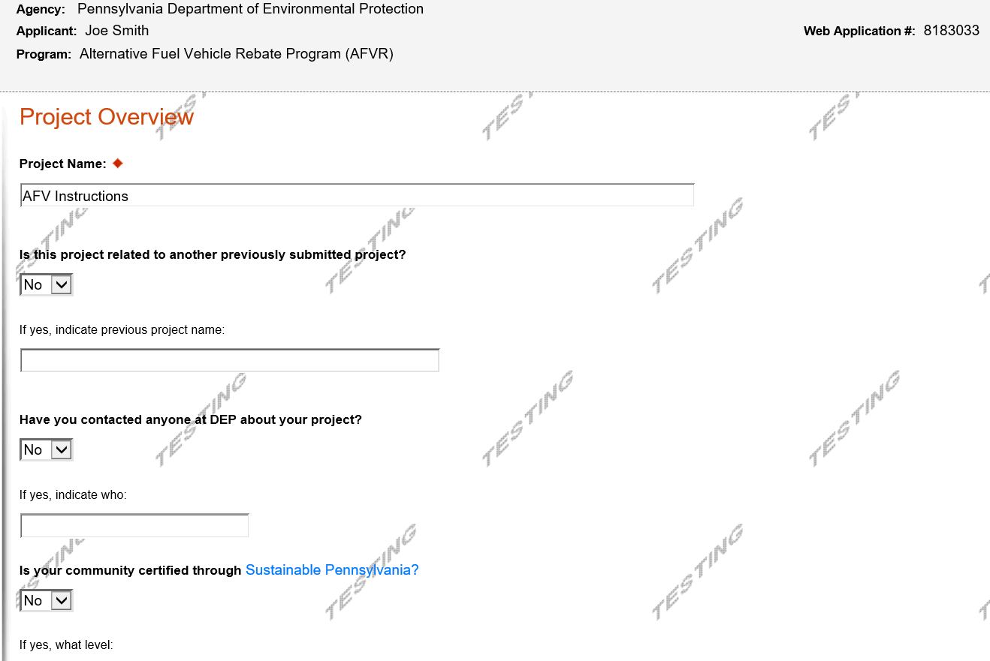

Project Site
- Address – Enter the mailing address (street address). P.O. Boxes are not acceptable.
- City, State and Zip Code – Enter this information. (If you indicated more than one site on the prior tab, you will be requested to complete this information for all sites.) Please add the zip +4 for each project site location.
- County – Select your county from the dropdown box.
- Municipality – Select the Municipality or County-Wide from the dropdown box, as appropriate.
- PA House, PA Senate and US House – These fields will be auto-populate based on the information entered above.
- Designated Areas – Leave blank.
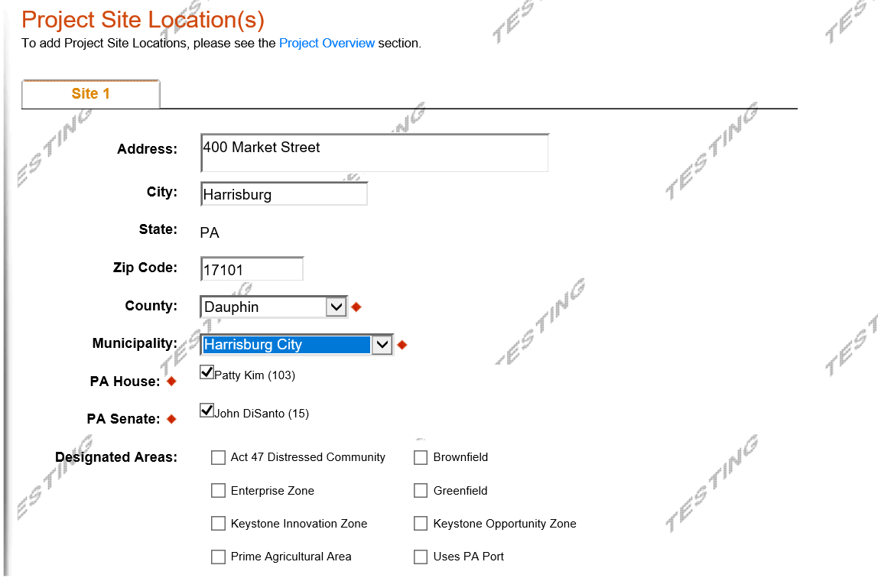
Click “Continue”

Project Narrative
- This section does not need completed. You may skip this tab and move to the next tab.

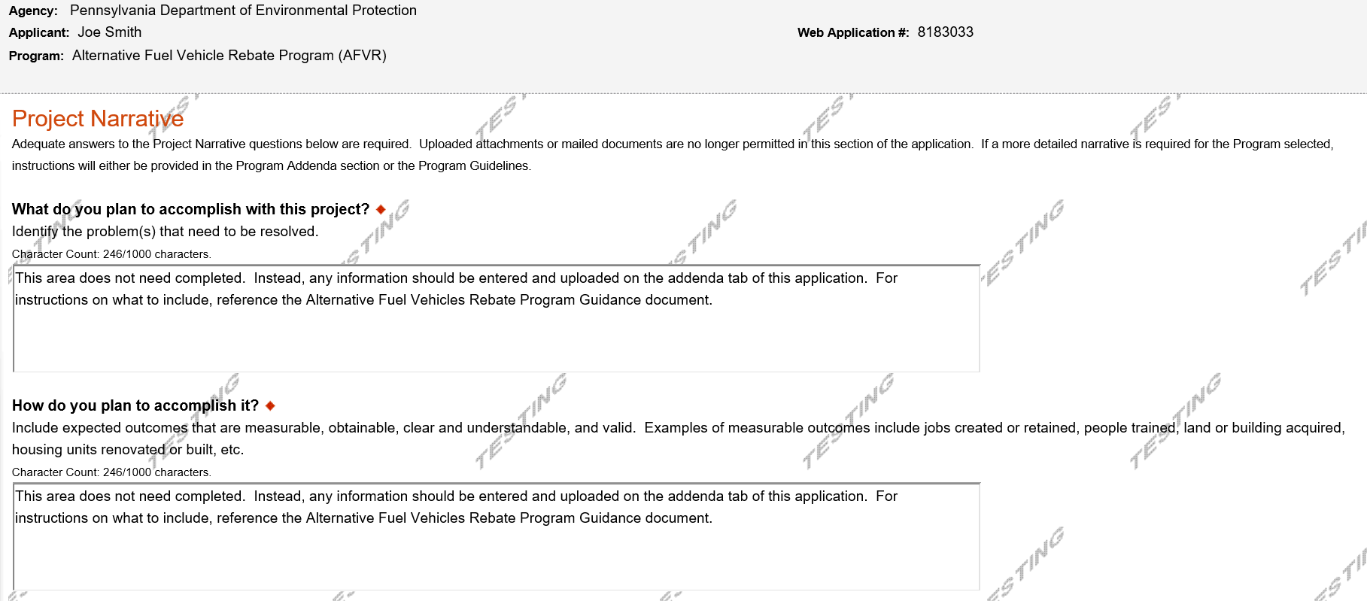
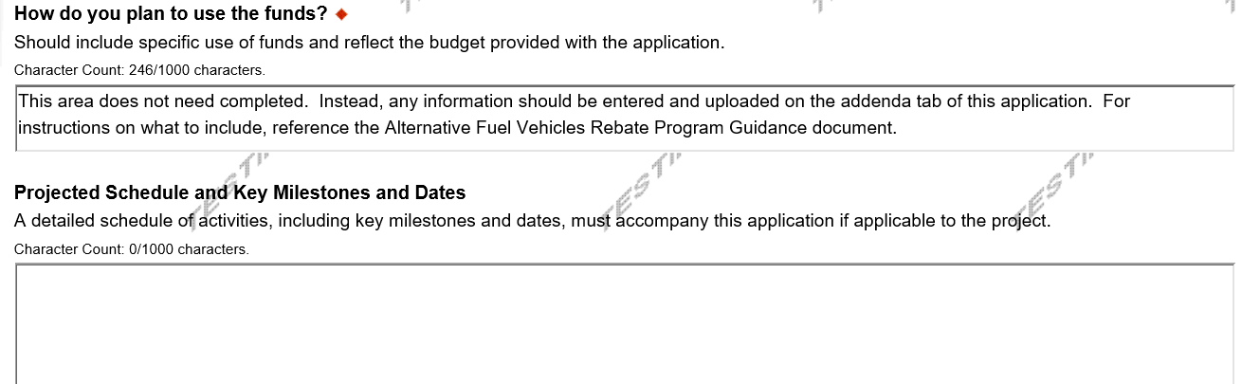
Click “Continue”

Program Budget
- The Program Budget contains two tabs – Spreadsheet and Basis of Cost.
- Only the Spreadsheet tab needs filled out
- Rebate Amount – The amount of rebate you are requesting from DEP.
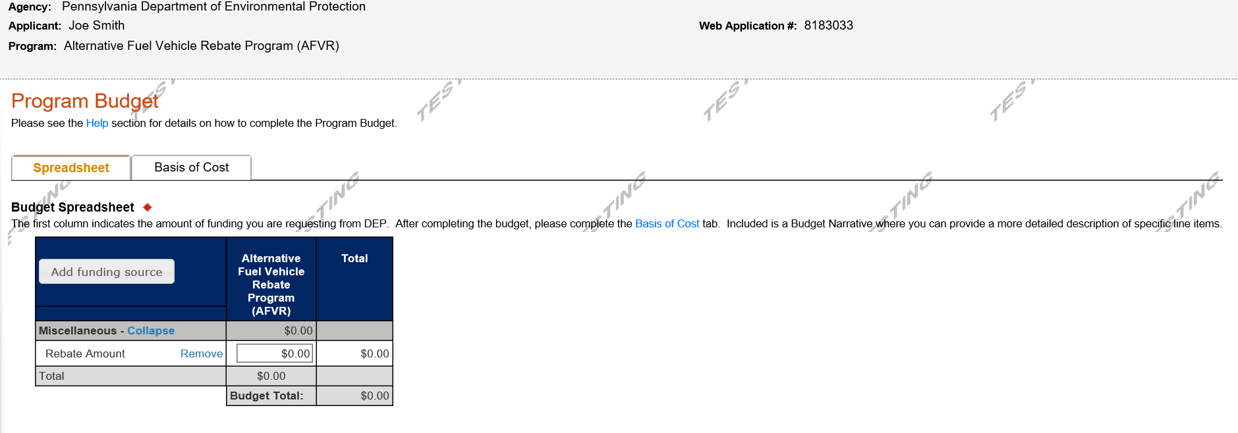
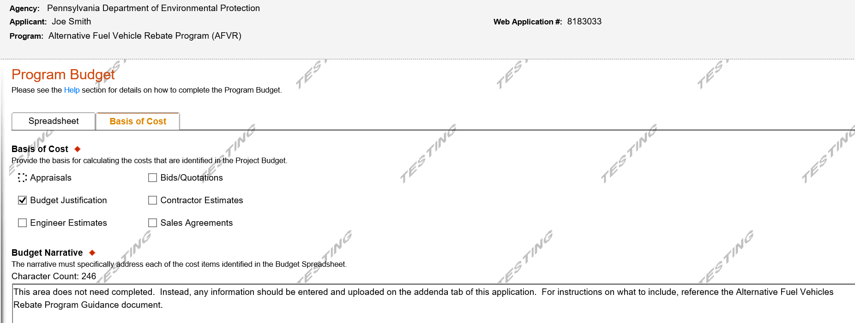

Click “Continue”

Program Addenda
- Complete all fields and upload all required documents on this tab. Once completed, click Continue.
- All questions marked with a red diamond are required to be answered.
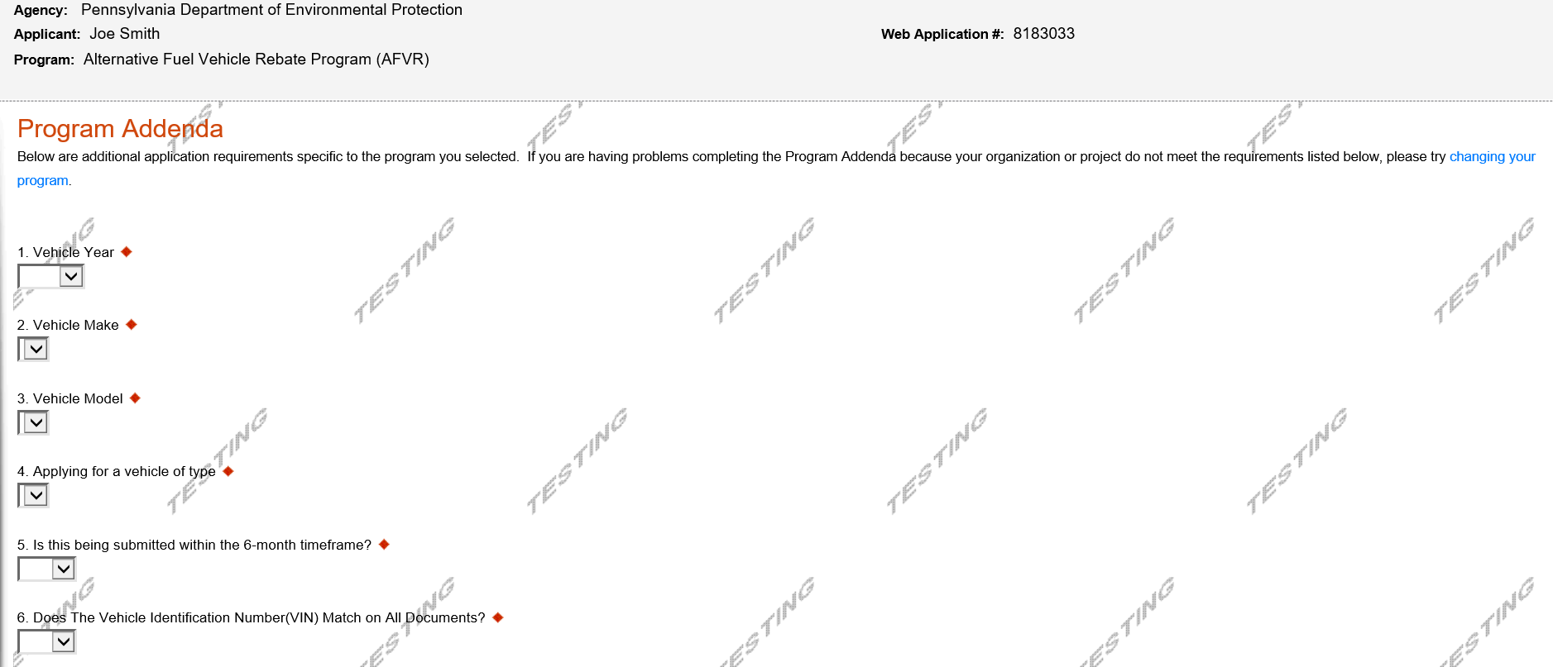
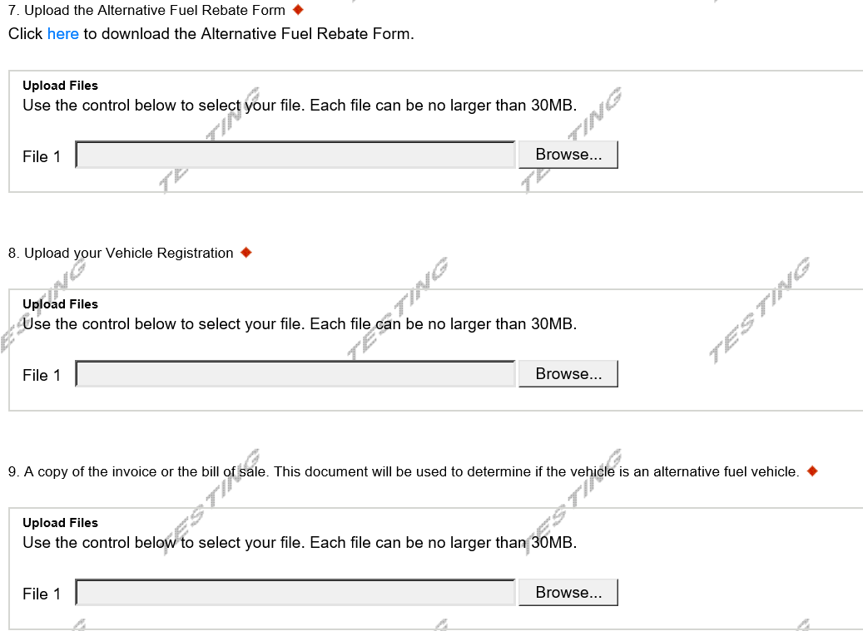
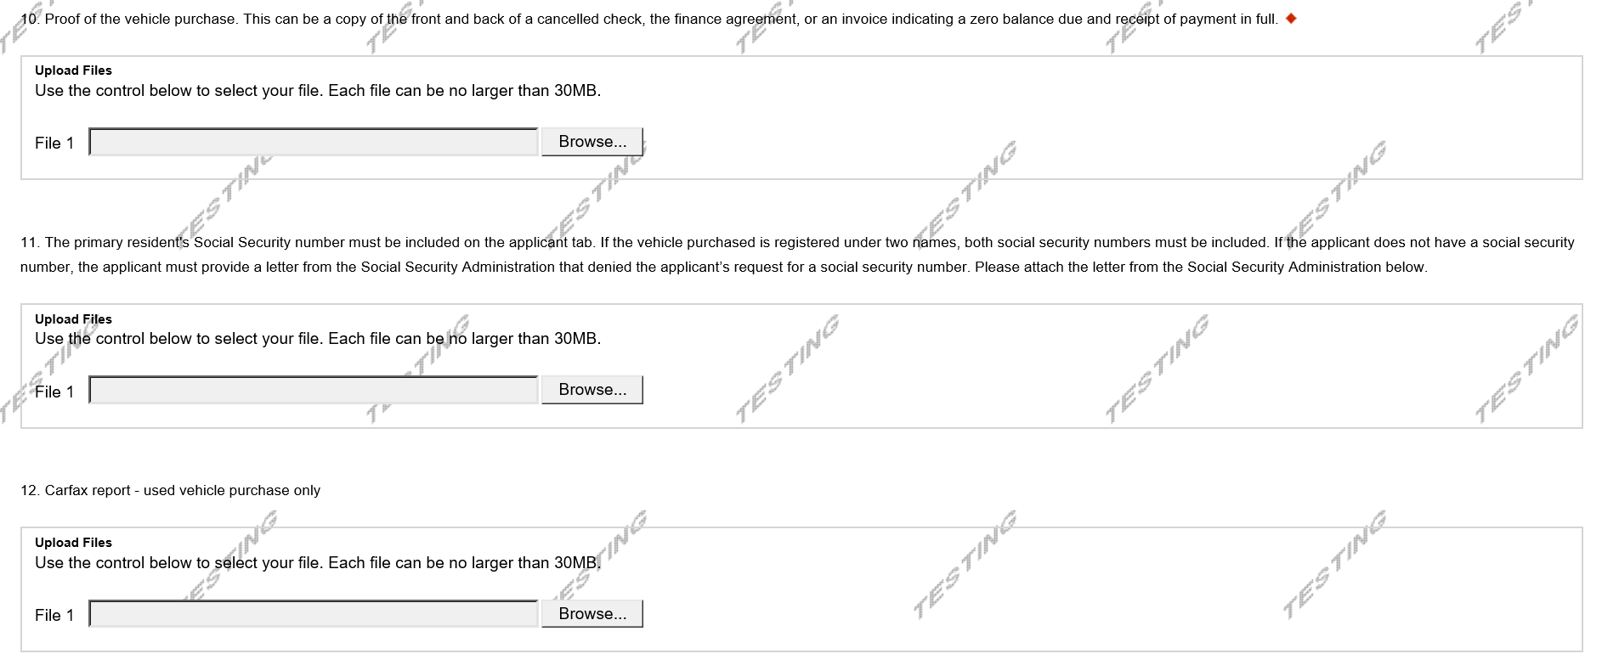
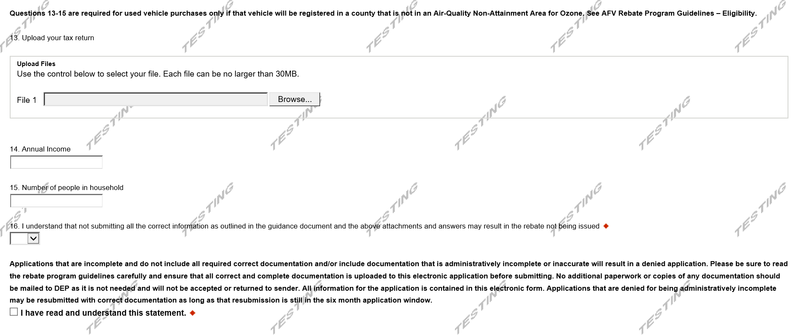

Certification and Submission
- If there is any missing information in your application, your screen will look like the following example.
- Under the orange “Application Certification” heading, it will state, “The following sections are incomplete. All required fields marked with a red diamond must be completed before you are able to submit this application”.
- To add/correct the information on your application, click on the section heading to return to the page.

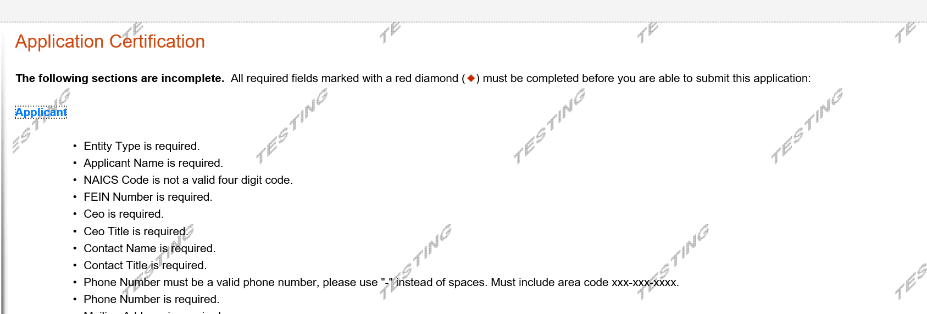
Click here to make the necessary changes

If your application is complete, your screen will look like this:
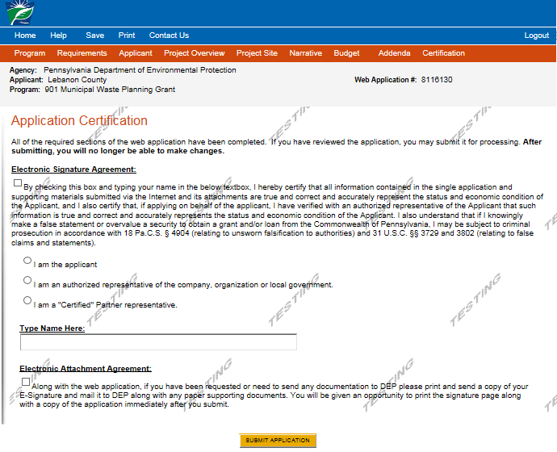
Complete the following fields:
- Indicate certification of application information by checking the related checkbox under the Electronic Signature Agreement.
- Indicate identity as one of the following:
  - I am the applicant.
  - I am an authorized representative of the company, organization or local government.
  - I am a “Certified” Partner representative.
- Type your name in the “Type Name Here” block. This will serve as your official e-signature and authorizes your application.
- Check the “Electronic Attachment Agreement” box.
- Click on “Submit Application”.

Application Receipt Verification
- If you want a copy of your application, click the “Print Entire Applications with Signature Page” link. You will always be able to access your application with the user name and password you created at the beginning of the application.
- Make sure to note the Single Application ID#. All future correspondence from the Department will reference this number.
- You do not need to send the signature page and/or any further documentation to the Grants Center. All the information needed is contained in your on-line submission.
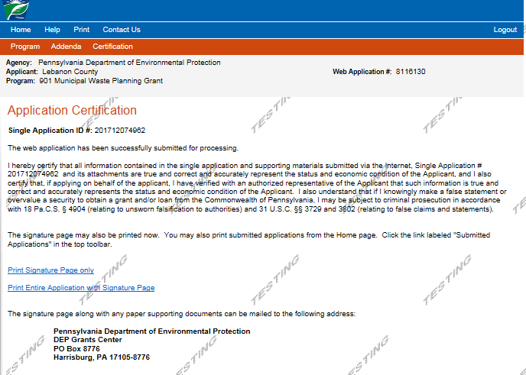
You do not need to mail any documentation to DEP. All information needed is contained in your on-line submission.

- Congratulations! You have completed the on-line application.

