**INSTRUCTIONS FOR THE ON-LINE APPLICATION**

The Pennsylvania Energy Development Authority 2020 Financial Assistance Program Grant must be submitted through the Department of Community and Economic Development’s (DCED) Electronic Single Application (ESA) website. **Paper and faxed copies will not be accepted.**  This change allows DEP to expedite the review process. The link to the on-line application can be found at:

<https://www.esa.dced.state.pa.us/Login.aspx>

This document will provide instructions on how to apply and upload the required documentation in the ESA application. All information needed for your submission will be contained in this online application.

**No documentation needs to be mailed to DEP.**

**User Tips**

* The Electronic Single Application works best when accessed through Internet Explorer or Google Chrome.
* If you allow your screen to sit idle for more than 30 minutes, you will lose the data entered since your last save and will have to re-enter it. Save frequently.
* When completing the application, fields with a “ ” are required fields. If a required field is skipped, you will be notified later in the application to return to that section to complete the field.
* Do not use special characters in the fields such as \, /, *, &, %, #, etc.

**If you have questions completing the application, please call the DCED Customer Service Center at 1-800-379-7448. They are open 8:30 am-5:00 pm EST Monday thru Friday.**

**Registration and Login**

Go to the ESA login page <https://www.esa.dced.state.pa.us/Login.aspx> and follow the instructions for creating a new account or migrating an existing account.

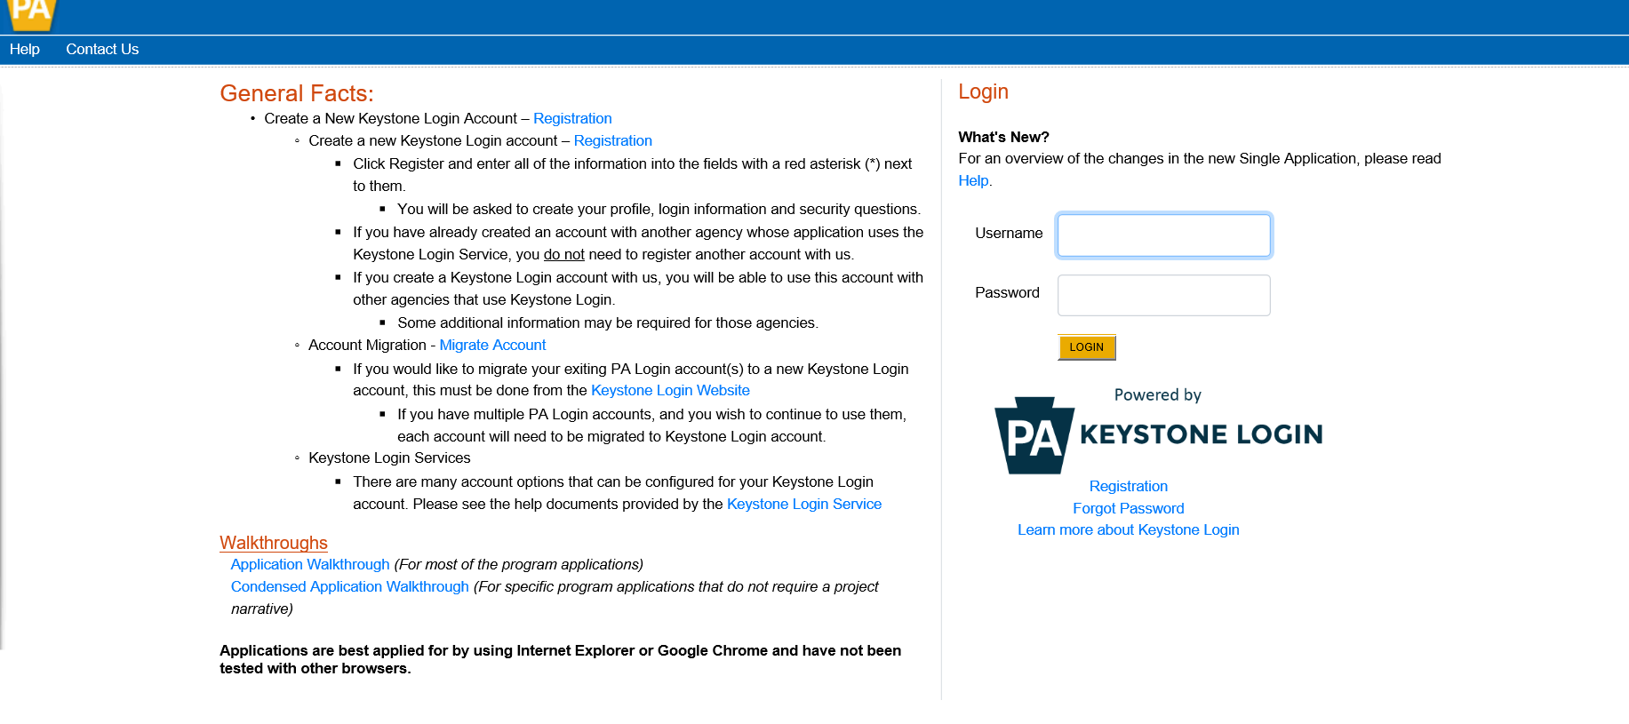

**Begin a New Application**

* Project Name – Enter a name for your project.
* Indicate whether you are applying for your or another’s organization.
* Do you need help selecting your program – Select “No”.
* Click on “CREATE A NEW APPLICATION”.

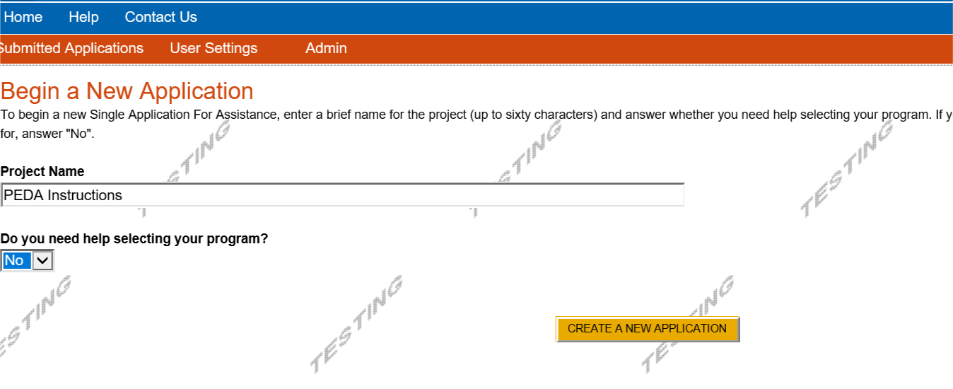

**Select Program**

* Under Program Name, enter “Pennsylvania Energy Development Program ”.
* Click “SEARCH”. Look for the appropriate grant program offered by DEP.

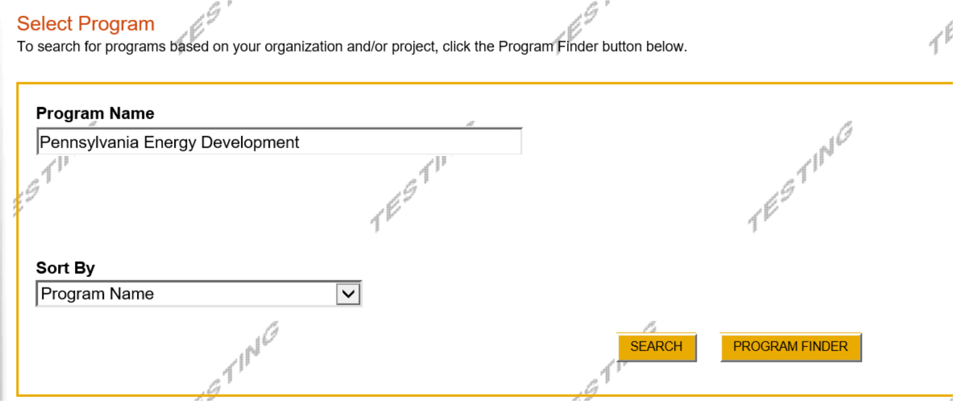

**Apply**

* Select the program for which you are applying.

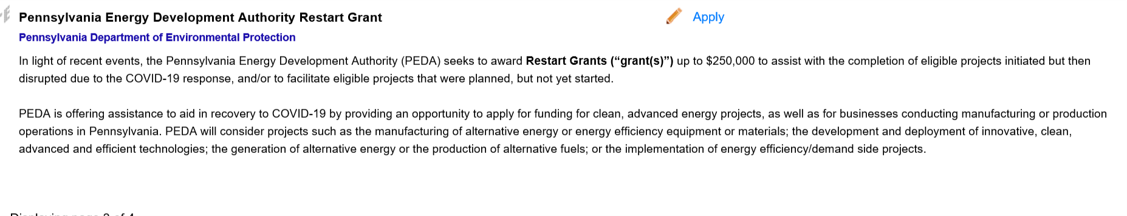

**Applicant Information Tab**

* The Applicant Information section requires data related to the applicant or sponsor for which the application is being submitted.
* Applicant Entity Type – select the appropriate type for your organization.
* Applicant Name – Enter the organization’s name, the name under which the applicant or sponsor legally conducts business.
* NAICS Code - From the dropdown box, select the appropriate type.The NAICS code will auto-populate for you.
* FEIN/SSN Number - Enter the Federal Tax ID number for the legal County name (no dashes).
* CEO – In this block, enter the head of the organization’s name.
* CEO Title – Enter that person’s title.
* SAP Vendor# - Fill in if known.
* Contact Name – Enter the primary contact name for this project.
* Contact Title – Enter the primary contact’s title for this project.
* Phone and Fax – Enter the phone and fax numbers for the primary contact for this project.
* E-mail – Enter the e-mail for the primary contact for this project.
* Mailing address, City, State and Zip Code – Enter this information for the organization and primary contact for this project.
* Click “Continue” at the bottom right.

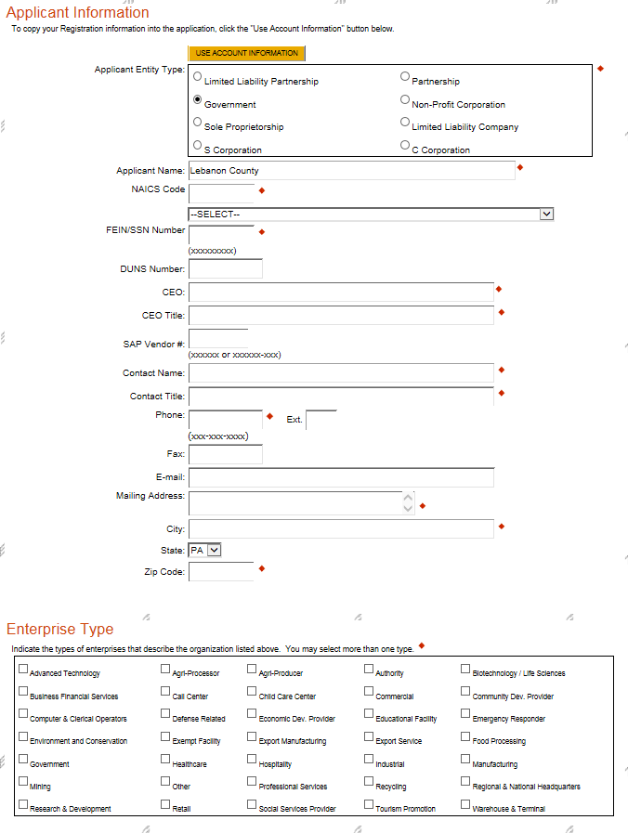

**Project Overview**

* Project Name – The project name will auto-populate from the information you filled in at the beginning of the process. You may change the project name at this time.
* Enter the name of the person you spoke with at DEP regarding your application (if applicable).
* Be sure to enter the number of sites if there is more than one project site.

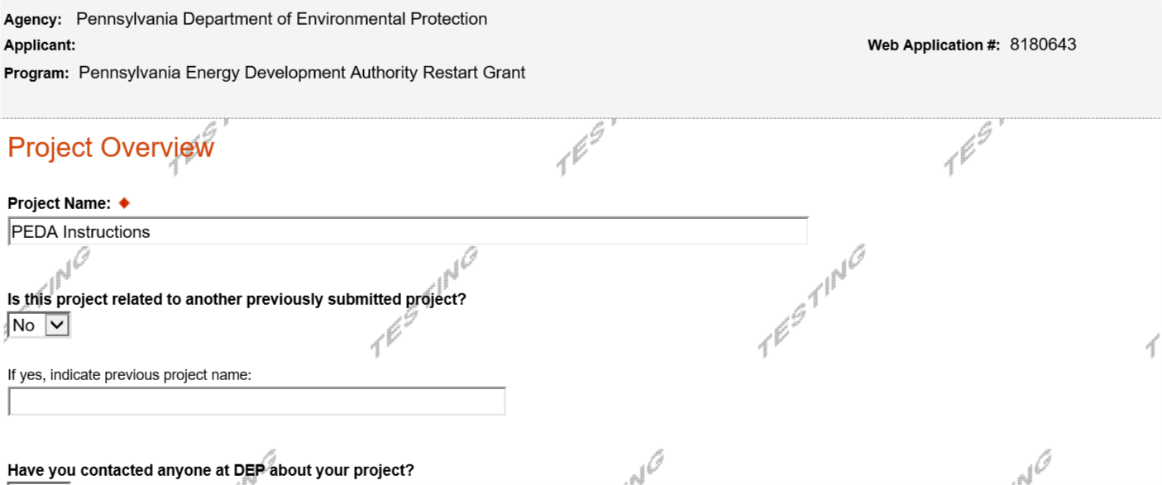

Click “Continue”

**Project Site**

* Address – Enter the mailing address (street address). **P.O. Boxes are not acceptable.**
* City, State and Zip Code – Enter this information. (If you indicated more than one site on the prior tab, you will be requested to complete this information for all sites.)
* County – Select your county from the dropdown box.
* Municipality – Select the Municipality or County-Wide from the dropdown box, as appropriate.
* PA House, PA Senate and US House – These fields will be auto-populate based on the information entered above.
* Designated Areas – Leave blank.

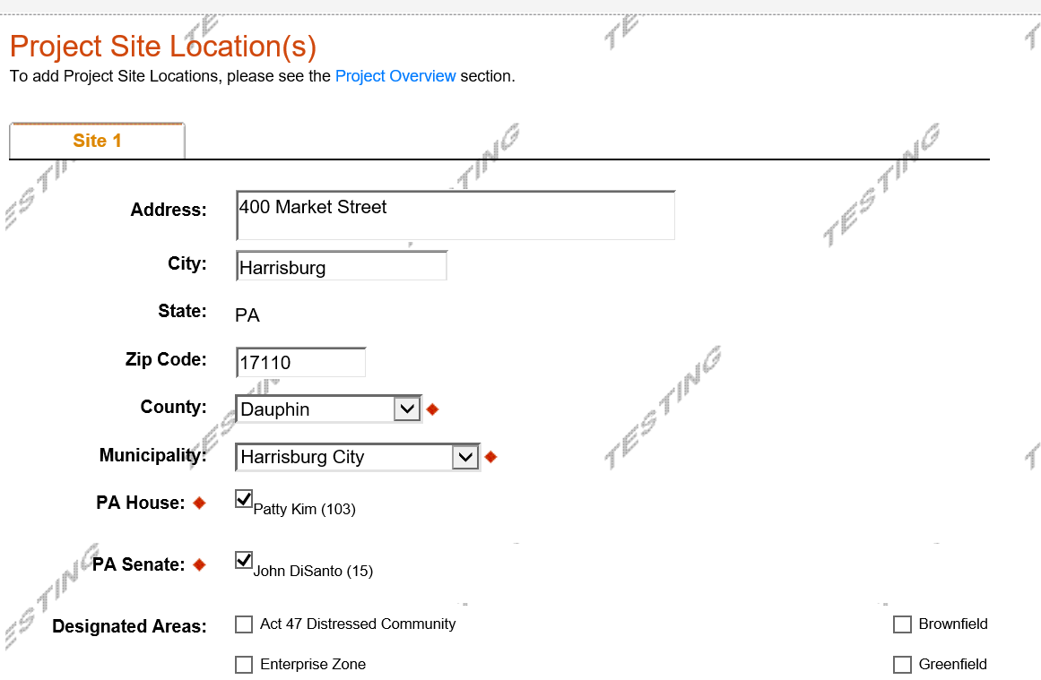

Click “Continue”

**Project Narrative**

* Complete the project narrative section. Please refer to the 2020 PEDA Grant Instructions for step-by-step instructions and a list of items that should be included in the Project Narrative.

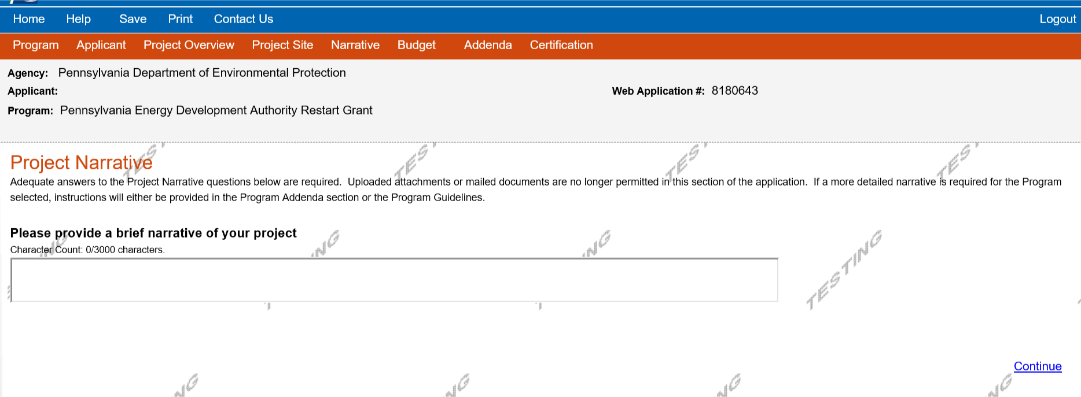

Click “Continue”

**Program** **Budget**

* There are two tabs on this page, Spreadsheet and Basis of Cost.

**Spreadsheet Tab**

* Click on the Spreadsheet tab. Enter the amount of funding you are requesting from DEP.

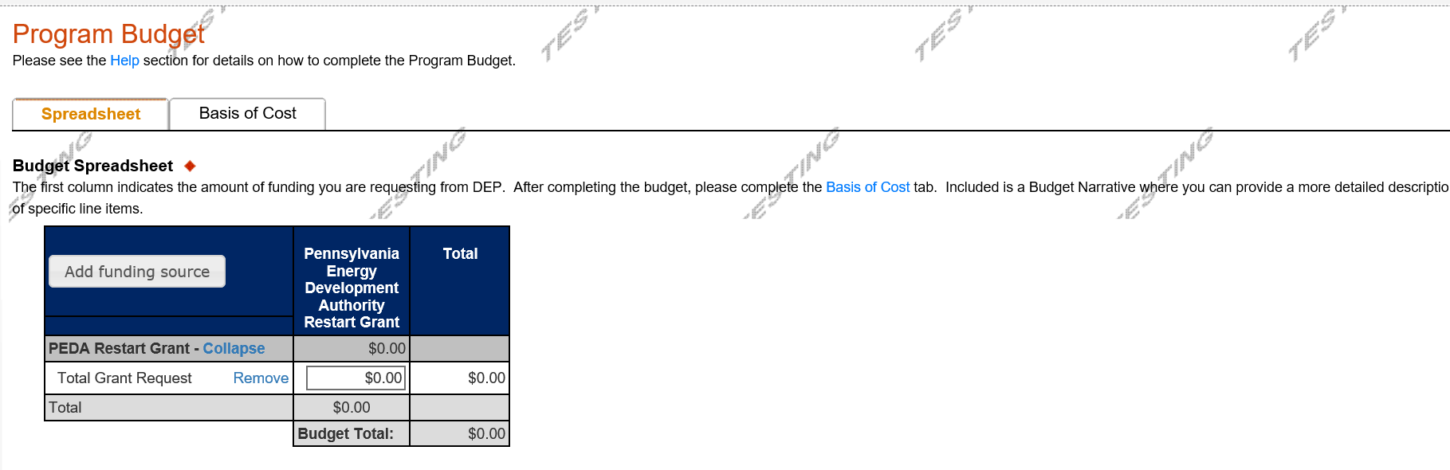

Click “Continue”

**Basis of Cost Tab**

This tab does not need completed and has been prepopulated. You may ignore this tab.

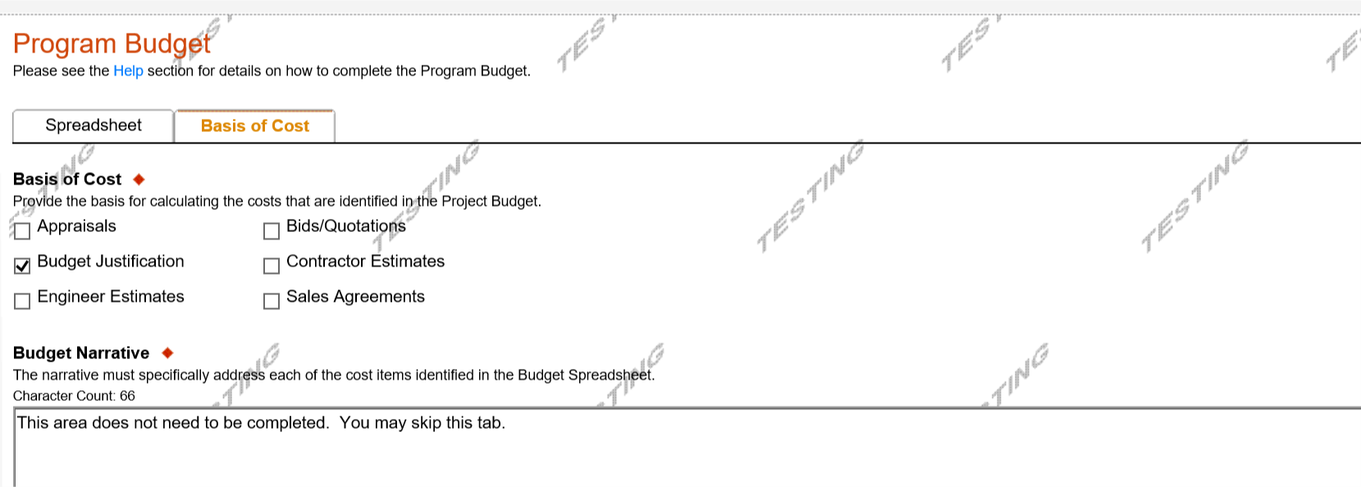

Click “Continue”

**Program Addenda**

• Please refer to the 2020 PEDA Grant instructions for the required forms for your application.

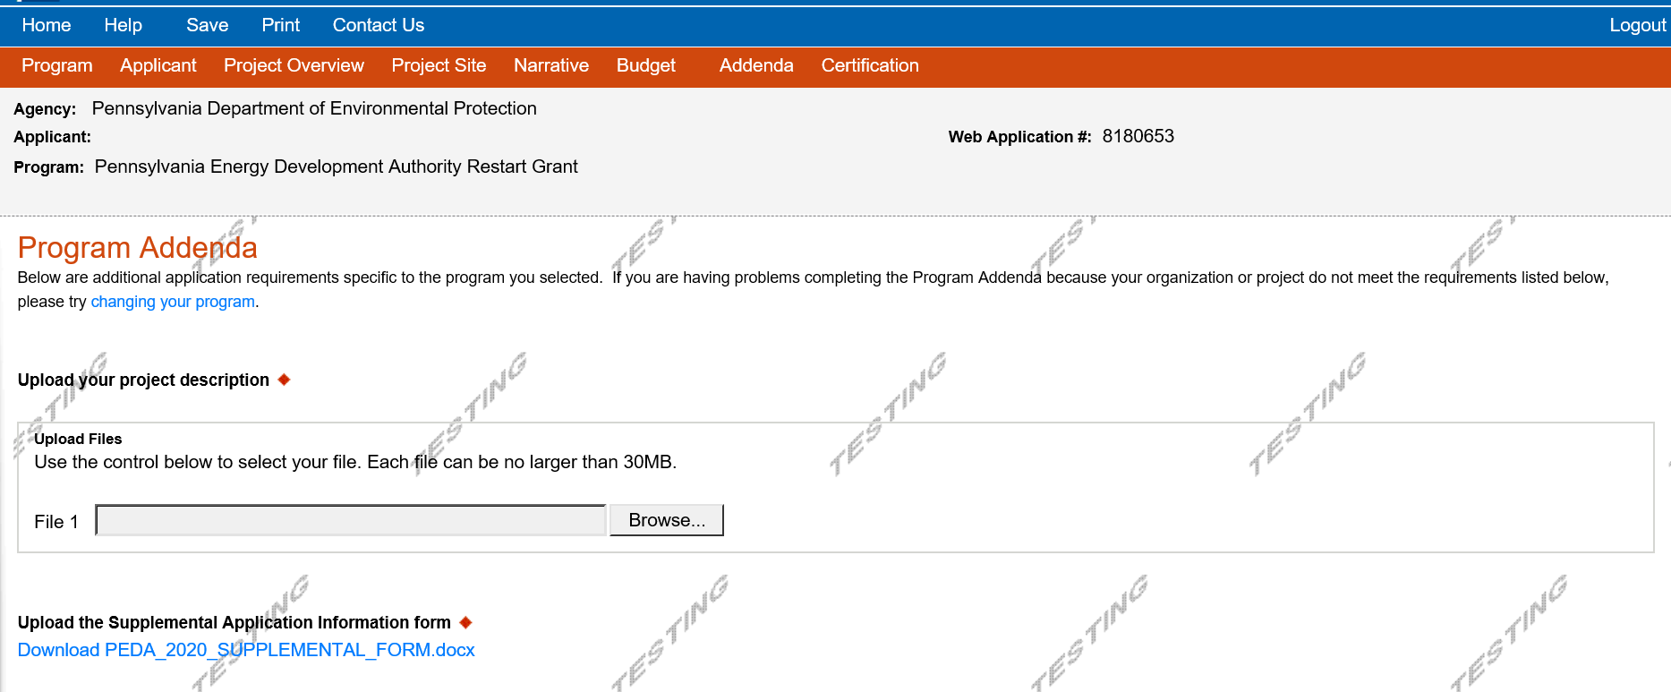

**Certification and Submission**

* If there is any missing information in your application, your screen will look like the following example.
* Under the orange “Application Certification” heading, it will state, “The following sections are incomplete. All required fields marked with a red diamond must be completed before you are able to submit this application”.
* To add/correct the information on your application, click on the section heading to return to the page.

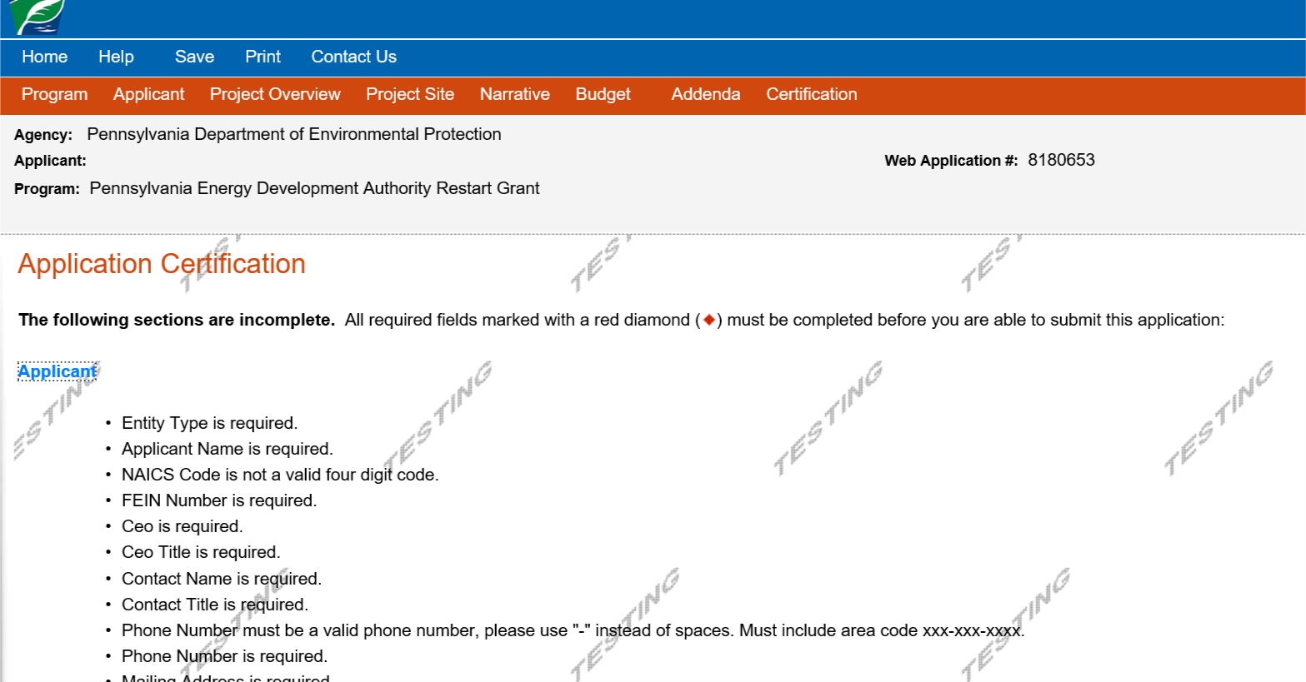

Click here to make the necessary changes

If your application is complete, your screen will look like this:

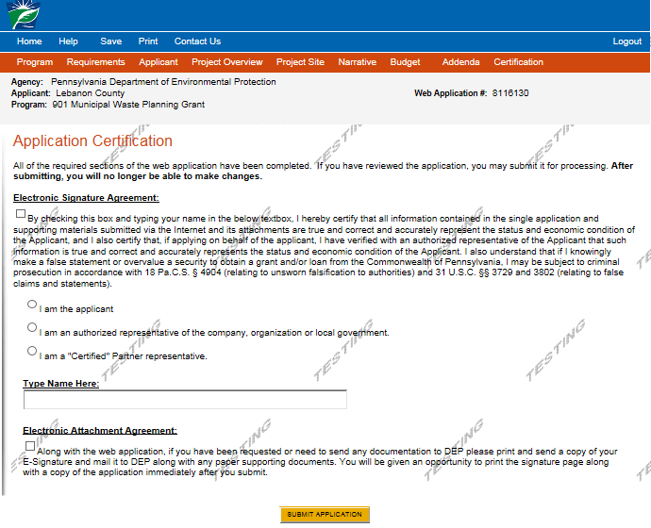

Complete the following fields:

* Indicate certification of application information by checking the related checkbox under the Electronic Signature Agreement.
* Indicate identity as one of the following:
  + I am the applicant.
  + I am an authorized representative of the company, organization or local government.
  + I am a “Certified” Partner representative.
* Type your name in the “Type Name Here” block. This will serve as your official e-signature and authorizes your application.
* Check the “Electronic Attachment Agreement” box.
* Click on “Submit Application”.

**Application Receipt Verification**

* If you want a copy of your application, click the “Print Entire Applications with Signature Page” link. You will always be able to access your application with the user name and password you created at the beginning of the application.
* Make sure to note the Single Application ID#. All future correspondence from the Department will reference this number.
* **You do not need to send the signature page and/or any further documentation to the Grants Center.** All the information needed is contained in your on-line submission.

need to mail 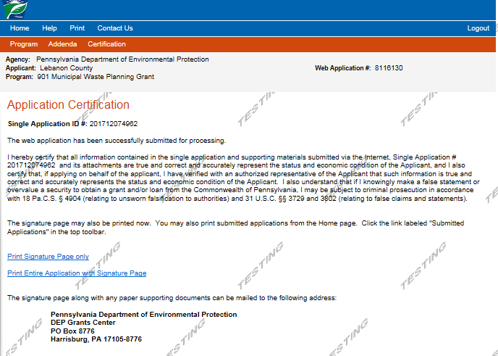

You do not any documentation to DEP. All information needed is contained in your on-line submission.

* **Congratulations!** You have completed the on-line application. **You do not need to mail anything additional to DEP.**

**PA Energy Development Grant Program**

**Application Step-by-Step Guide**

**Required Attachments** Download available forms from the Program Addenda page. Then complete them and save them on the computer. Upload forms and any additional required attachments

Project Description

Supplemental Application Information

Summary of Measurable Results

Budget Summary

Detailed Budget Worksheet

Letters of Commitment

Surety Bond Information

**Upload Attachments**

Attachments:

* Click on **Browse…** for each file that is required to be uploaded and locate complete the form. Click on ***Upload this file.*** Upload the files one at a time. Ensure files are not open on the computer when uploading them.
* **NOTE: It is required for this grant program that the applicant must upload ALL attachments for the submission of this application, including letters documenting commitment of matching funds. No hard copy or emailed materials will be accepted. Confirm that the correct files have been uploaded before submitting the application.**

**PROJECT DESCRIPTION [REQUIRED]**

**Provide a detailed Project Description. Please refer to “Application and Evaluation Criteria” as a guide regarding the appropriate information to include.** **Suggested maximum length of the Project Description should be limited to 10 pages total. This suggested length does not include additional reference material such as maps, business plan and letter(s) of support, and financial commitments etc. The Project Description should include the following:**

* **Executive Summary:** Provide an abstract of the proposal that briefly describes the issue, proposed steps to address the issue and the expected results or benefits. It should be clear, concise, specific and no longer than 500 words.
* **Goals and Objectives:** Describe the project’s goals and objectives, including energy, economic and environmental benefits.
* **Business Plan:** Applicants must show their ability to complete the project through a written business plan as well as show their need for funding through economic analysis and demonstration of cost-effectiveness. These elements should be provided in a concise manner that relates directly to the project.
* **Technical Feasibility:** Applicants must demonstrate project readiness and whether the applicant can complete the project within 24 months from date of award approval.
* **Environmental and Energy Benefits:** Applicants should include a clear description of expected environmental and energy benefits. This includes the quantity of alternative energy or alternative fuel generated or produced by the project or the amount of conventional energy saved or peak electric load reduced by the project. Such enumeration of benefits should include careful estimates and calculations. Estimates and calculations include the economics (e.g., the cost per unit of energy) and the environmental improvements (e.g., pounds of pollutant reduction). Provide information and data to demonstrate the project’s potential payback. Emphasis should be placed on reductions in air and water pollutants. There are many websites that can help you determine the environmental benefits of reducing conventional energy use.

Applicants should also describe the potential of the proposed project to make a significant contribution to alternative energy development or use.

* **Research Component:** Applicants must show whether the research component of the project is sound and has the potential for the return of significant benefits relative to PEDA’s mission.
* **Need for the Grant:** Applicants should identify the problem or need the proposal is intended to address. Explain why the problem or need exists, and how the proposal addresses the problem or need. Explain why the proposal should be funded and elaborate on its cost-effectiveness and environmental and energy benefits. Provide literature references where appropriate.
* **Economic benefits:** Applicants should identify the potential economic benefits of the project for the state including future growth potential, new investment, savings to consumers and/or revenue generation for other beneficiaries such as agricultural businesses, local governments or other landowners. Applicants should also identify the number of jobs created by the project or the potential to create jobs. Such enumeration of benefits should include careful estimates and calculations.
* **Level of support:** Applicants should identify the potential level of support provided to a new business or venture engaging in the demonstration of new applications of or next phase clean advanced energy technology deployment with potential for widespread applicability in the state;
* **Collaborations:** Applicants should identify any other organizations that will help to complete the project and specify the nature of their participation. Discuss the level of non-PEDA investment in the project, including in-kind services or match contributions.
* **Work Plan with Schedule:** Applicants should provide an implementation schedule identifying sub-tasks, schedule for their completion, and naming parties responsible for their accomplishment. If DEP or other permits will be required, include a schedule for applying and receiving these permits in the work plan.
* **Equipment Disposition:** If applicable, Applicants should describe how property or equipment acquired with PEDA funds will be disposed of or converted for continued use. The grantee agrees that, for the term of the period of performance, including any extensions thereto, the grantee will not lease, sell, transfer or assign any and all property and/or equipment, whether real or personal, that is purchased in whole or in part with grant funds provided by DEP. The grantee agrees to obtain the prior written approval of DEP prior to leasing, selling, transferring or assigning such property and/or equipment, in whole or in part, during the period of performance, including any extensions thereto.

**SUPPLEMENTAL APPLICATION FORM [REQUIRED]**

* **Select Project Type:** Select whether the project is an Advanced Energy Project or a Clean Alternative Fuels, Alternative Energy Manufacturing and Alternative Energy Research project.
* **Outstanding Obligations:** Confirm that the applicant has no outstanding obligations to the commonwealth. If there are outstanding obligations, please describe the nature and status in project narrative.
* **Unresolved Compliance Issues:** Confirm that the applicant has no unresolved compliance issues with DEP. If there are compliance issues, please describe the nature and status in the project narrative.
* **Building Permits:** Indicate whether any federal, state or local permit(s) will be required for the project.
* **Other Funding Sources:** Indicate other sources of funding applied for and the anticipated award dates, if applicable. Indicate other sources of funding awarded and the award date, if applicable.
* **Other Potential Funding:** Indicate whether DEP is permitted to share this proposal with other potential public or private funding sources.
* **Federal Funding:** Indicate whether the applicant will accept federal funding for this project if it becomes available.
* **Project Duration:** Identify the project duration in months. NOTE Project period of performance cannot be greater than 24 months.
* **PA Economic Development Measures:** Identify whether or not the manufacturer(s), installers(s) and/or the supplier/dealer(s) of the project components/equipment are located in Pennsylvania. If yes, list the name and address of each.
* **Summary Statistics:** Provide the expected energy, economic and environmental results or benefits and define measures of success in quantitative terms in the Proposed Annual Project Summary Statistics tables.
* **Environmental Justice:** Indicate whether the project will be completed in an Environmental Justice area. An EJ area is any census tract where 20% or more of individuals live in poverty, and/or 30% or more of the population is minority, based on the most current census data and the Federal guidelines for poverty.

**SUMMARY OF MEASURABLE RESULTS [REQUIRED]**

* Provide an explanation of how the values provided in the Supplemental Application Information form were calculated. Refer to and attach other documents, such as spreadsheets, PDFs and other files under Additional Attachments. Name and describe any attached files in this document (e.g. environmental benefit data, see “environmental benefit data.xls” attached under Additional Attachments).

**DETAILED BUDGET INFORMATION [REQUIRED]**

* Complete the Budget Summary and Detailed Budget Information Worksheet included with the application form. The worksheet included as part of the application form must be used. Please include sheets that provide additional clarification. The worksheet must be completed in full; and the Detailed Budget Information Worksheet must be consistent with the Budget Summary. The Detailed Budget Information Worksheet is intended to support and provide detail to the budget summary. Please provide sufficiently detailed budget information to illustrate the cost effectiveness of the proposal.
* Only monies being requested of the PEDA are included under the heading of “Grant Request” on the Budget Summary and items 1-5 on the Detailed Budget Worksheet. Matching funds are to be placed in the second column of the Budget Summary and the source of any matching funds identified on part 6 of the Detailed Budget Worksheet. All in-kind and cash match contributions must be substantiated by commitment letters. Match cannot include funds or in-kind services provided by DEP. All match funds must be expended during the period of performance. Funds expended prior to the period of performance cannot be claimed as match.
* All costs incurred directly should be identified in the Detailed Budget worksheet in items 1-5.
* Refer to Appendix A of the Guidelines for detailed descriptions of all allowable costs.

**LETTERS OF COMMITMENT [REQUIRED]**

* Attach any letters of financial commitment for all funding sources. This includes all third party funding and commitment of match funding from the applicant. These must be uploaded as attachments to the electronic application; hardcopies will not be accepted.

**SURETY BOND INFORMATION [REQUIRED]**

* Attach the surety bond for the project. The surety bond must be for the total amount of the grant award and matching funds plus a 10% maintenance surety as a condition of receipt of the grant funds and to ensure that the project is completed within 24 months of grant award. Projects completed before the publication date of these guidelines are ineligible.

**ADD MORE ATTACHMENTS:**

Browse for any additional files the applicant would like to submit and upload these files. Ensure files are closed on the computer before attempting to upload them. After uploading, confirm that the uploads were successful and that the correct documents were uploaded.

For questions regarding the online application process, refer to the Help tab on the grant application website or contact:

PA Department of Community and Economic Development (DCED)

Customer Service

800-379-7448 8:30 am-5:00 pm

[ra-dcedcs@state.pa.us](mailto:ra-dcedcs@state.pa.us)

For PEDA specific questions, contact the appropriate individual listed on the DEP Contacts Page.

|  |  |  |
| --- | --- | --- |
| **Grants Customer Service Center**  **800-379-7448** | **COMMONWEALTH OF PENNSYLVANIA**  Supplemental Application Information  PA Energy Development Financial Assistance Program  *Indicates required information | **DEP Logo**  **DEP**  **Electronic Single Application (ESA)**  **http://www.esa.dced.state.pa.us/** |
| **Application Information** | | |
| Web Application ID:* | | |
| Applicant Legal Name:* | | |
| Project Title:* | | |
| **Supplemental Application Information** | | |
| Select Project Type  Advanced Energy Projects  Projects which deploy: solar energy, wind, low-impact hydropower, geothermal, biomass, biologically derived methane gas including landfill gas, fuel cells, coal-mine methane, waste coal, coal liquefaction, coal polygeneration, integrated gasification combined cycle, and demand management measures including recycled energy and energy recovery, energy efficiency, and load management.  Clean Alternative Fuels, Alternative Energy Manufacturing, and Alternative Energy Research   * + Construction of new facilities to produce alternative fuels for transportation   + Construction of new facilities to provide alternative fuels refueling infrastructure   + Projects which support manufacture of component parts of the alternative energy sector   + Projects which support research to advance or commercialize alternative energy projects | | |
| Does applicant have any outstanding obligations to the commonwealth?  Yes  No | | |
| Does applicant have any unresolved compliance issues with DEP?  Yes  No | | |
| Please provide the name of the DEP staff person with whom you discussed your application, if any: | | |
| Does this project require a building permit?  Yes  No  If so, and a copy of a permit has been received, include it as an Attachment. If a permit has not been received, it will need to be submitted to DEP prior to request for payment. | | |
| Has this proposal been submitted to another source for funding?  Yes  No  Name of other source and anticipated award date: | | |
| May DEP share this proposal with other potential public or private funding sources?  Yes  No | | |
| Would the applicant accept federal funding to complete the project, if available?  Yes  No | | |
| Identify the project duration in months  **Please note: Project period of performance cannot be greater than 24 months.** | | |

|  |  |  |  |  |  |  |
| --- | --- | --- | --- | --- | --- | --- |
| **Pennsylvania Economic Development Measures** | | | | | | |
|  | **YES/No** | | **If yes, list name and address** | | | |
| Is the manufacturer of the primary project components / equipment in Pennsylvania? | Yes  No | |  | | | |
| Is the installer of the primary project components / equipment in Pennsylvania? | Yes  No | |  | | | |
| Is the supplier/dealer of the primary project components / equipment in Pennsylvania? | Yes  No | |  | | | |
| Are there any secondary project components / equipment manufactured in Pennsylvania? | Yes  No | |  | | | |
| **Indicate the Proposed Annual Project Summary Statistics your project will return when completed. Applicants should enter as much data as possible. Must be consistent with detailed statistics provided in the detailed project description.** | | | | | | | | |
| **Estimated Energy Performance outcomes of the project(s)** | | | | | | | | |
| **A. Energy and Fuel Savings as a result of project deployment.** | | | | | | | | |
| ***(Insert more rows if necessary)*** | **Specify Type** | | | **Quantity** | **Quantity Produced over Lifetime of Project** | | | |
| electricity saved |  | | | Kwh/yr | Kwh | | | |
| liquid fuel saved |  | | | Gals/yr | Gals | | | |
| solid fuel saved |  | | | Tons/yr | Tons | | | |
| gaseous fuel saved |  | | | Mcf/yr | Mcf | | | |
| **B. Energy and Fuel Generation as a result of project deployment.** | | | | | | | | |
| ***(Insert more rows if necessary)*** | **Specify Type** | | | **Quantity** | **Quantity Produced over Lifetime of Project** | | | |
| electricity generated |  | | | Kwh/yr | Kwh | | | |
| liquid fuel generated |  | | | Gals/yr | Gals | | | |
| solid fuel generated |  | | | Tons/yr | Tons | | | |
| gaseous fuel generated |  | | | Mcf/yr | Mcf | | | |
| **C. Energy Saving or Generating Components manufactured, sold or deployed in PA** | | | | | | | | |
| ***(Insert more rows if necessary)*** | | **Specify Type** | | | | **Quantity** | |
| Units/components manufactured | |  | | | |  | |
| Units/components sold | |  | | | |  | |
| Units/components deployed | |  | | | |  | |
| **D. Cost Saving and Economic benefit as a result of project deployment.** | | | | | | | |
| 1. Energy/fuel cost savings ($/yr) | | | | | | | |
| 2. Energy/fuel cost savings over life of project ($). | | | | | | | |
| 3. Energy/fuel generation/production Value ($/yr) | | | | | | | |
| 4. Energy/fuel generation production value over life of project ($) | | | | | | | |
| 5. Value of units/energy components manufactured, sold or deployed in PA ($/yr) | | | | | | | |
| 6. Value of units/energy components over life of project ($) | | | | | | | |
| 7. Revenue generated ($/yr) | | | | | | | |
| 8. Revenue generated over life of project | | | | | | | |

|  |  |  |  |  |  |
| --- | --- | --- | --- | --- | --- |
| **E. Other economic development benefits** | | | | | |
| 1. Savings to Pennsylvania consumers ($/yr) | | | | | |
| 2. Revenue generated for other Pennsylvania companies and beneficiaries ($/yr) | | | | | |
| 3. Revitalization of Communities or blighted properties (# acres) | | | | | |
| 4. Revitalization of Communities or blighted properties (building sq. footage) | | | | | |
|  | | | | | |
| **Environmental Benefit Data: If applicable, provide the answers to the following statements in the format of a table. Add additional rows if necessary. Fill in all blanks. Enter NA if not applicable.** | | | | | |
|  | *(Insert more rows if necessary)* | | **Specify Type** | **Quantity** | |
|  | Air pollutant reduced | | NOx | (lbs/yr) | |
|  | Air pollutant reduced | | SOx | (lbs/yr) | |
|  | Air pollutant reduced | | CO2 | (lbs/yr) | |
|  | Air pollutant reduced | | Hg | (mg/yr) | |
|  | Air pollutant reduced | |  | lbs/yr) | |
|  | Water pollutant reduced | |  | (lbs/yr) | |
|  | Water pollutant reduced | |  | (lbs/yr) | |
|  | Water conserved as a result of the Project | |  | (gals/yr) | |
|  | Solid residual or hazardous waste reduced – not disposed of per year | |  | (lbs/yr) | |
|  | Solid residual or hazardous waste reduced – not disposed of per year | |  | (lbs/yr) | |
|  | Number of PA Citizens directly educated | |  | (persons/yr) | |
| Estimated Job Creation Measures | | | | | |
| **A.** **Jobs directly created – number of temporary and permanent jobs created by the project and for how long (# years). Add more rows if needed.** | | | | | |
|  | **List Job (Full-time/part-time temporary/permanent** | **Type (Describe)** | | | **Duration (# years)** |
|  |  |  | | |  |
|  |  |  | | |  |
|  |  |  | | |  |
| Is the project located in an area designated as an Environmental Justice area?  Yes  No | | | | | |
| If so, please identify the location: | | | | | |

|  |  |  |
| --- | --- | --- |
| **Grants Customer Service Center**  800-379-7448 | **COMMONWEALTH OF PENNSYLVANIA**  Summary of Measurable Results  2020 PEDA Financial Assistance Program  *Indicates required information | **DEP Logo**  **DEP**  **Electronic Single Application (ESA)**  **http://www.esa.dced.state.pa.us/** |
| **Application Information** | | | |
| Web Application ID:* | | | |
| Applicant Legal Name:* | | | |
| Project Title:* | | | |
| **[Summary of Measurable Results]** | | | |
|  | | | |

|  |  |  |
| --- | --- | --- |
| **Grants Customer Service Center**  800-379-7448 | **COMMONWEALTH OF PENNSYLVANIA**  Budget Summary  2020 PEDA Financial Assistance Program  *Indicates required information | DEP Logo  **DEP**  **Electronic Single Application (ESA)**  **http://www.esa.dced.state.pa.us** |
| **Application Information** | | | |
| Web Application ID:* | | | |
| Applicant Legal Name:* | | | |
| Project Title:* | | | |
| **[Budget Summary]** | | | |

|  |  |  |  |  |  |
| --- | --- | --- | --- | --- | --- |
| **Category** | **Grant Request**  **(from DEP)** | **+** | **Match**  **(from Applicant)** | **=** | **Project Cost**  **(Total)** |
| Personnel |  | + |  | = |  |
| Equipment and Supplies |  | + |  | = |  |
| Contractual |  | + |  | = |  |
| Construction |  | + |  | = |  |
| Other |  | + |  | = |  |
| **Total for each column:** |  |  |  |  |  |

|  |  |  |  |
| --- | --- | --- | --- |
| |  |  |  | | --- | --- | --- | | **Grants Customer Service Center**  800-379-7448 | **COMMONWEALTH OF PENNSYLVANIA**  Detailed Budget Worksheet  2020 PEDA Financial Assistance Program  *Indicates required information | DEP Logo  **DEP**  **Electronic Single Application (ESA)**  **http://www.esa.dced.state.pa.us** | |
| **Application Information** |
| Web Application ID:* |
| Applicant Legal Name:* |
| Project Title:* |
| **Detailed Budget Worksheet** |

1. **PERSONNEL**

|  |  |  |  |  |  |
| --- | --- | --- | --- | --- | --- |
| **INDIVIDUAL** | **POSITION** | **HOURLY RATE** | **HOURS** | **BENEFITS** | **TOTAL COST** |
|  |  |  |  |  |  |
|  |  |  |  |  |  |
|  |  |  |  |  |  |
|  |  |  |  |  |  |
|  |  |  |  |  |  |
|  |  |  |  |  |  |
|  |  |  |  |  |  |
| **TOTAL PERSONNEL** |  |  |  |  |  |

**2. EQUIPMENT and SUPPLIES (Non-Construction-Related Costs)**

|  |  |  |  |
| --- | --- | --- | --- |
| **ITEM** | **QUANTITY** | **COST PER ITEM** | **TOTAL COST** |
|  |  |  |  |
|  |  |  |  |
|  |  |  |  |
|  |  |  |  |
|  |  |  |  |
|  |  |  |  |
|  |  |  |  |
|  |  |  |  |
| **TOTAL EQUIPMENT & SUPPLIES** |  |  |  |

**3. CONTRACTUAL**

**A. CONTRACTOR SALARIES (List billing rate by task. Salary ranges are not acceptable, see instructions)**

|  |  |  |  |  |  |
| --- | --- | --- | --- | --- | --- |
| **TASK** | **CONTRACTOR** | **HOURLY RATE** | **HOURS** | **BENEFITS** | **TOTAL COST** |
|  |  |  |  |  |  |
|  |  |  |  |  |  |
|  |  |  |  |  |  |
|  |  |  |  |  |  |
|  |  |  |  |  |  |
|  |  |  |  |  |  |
|  |  |  |  |  |  |
| **TOTAL CONTRACTUAL SALARIES** |  |  |  |  |  |

1. **OTHER CONTRACTUAL EXPENSES**

|  |  |
| --- | --- |
| **ITEM** | **COST** |
| **Permitting Application Fees (List FEE only)**  **Other (List specific item)** |  |
|  |  |
|  |  |
|  |  |
|  |  |
| **TOTAL OTHER CONTRACTUAL EXPENSES** |  |

1. **TOTAL CONTRACTUAL (=A+B)**

|  |  |  |
| --- | --- | --- |
| **CONTRACTOR SALARIES** | **OTHER CONTRACTUAL EXPENSES** | **TOTAL CONTRACTUAL** |
|  |  |  |

**4. CONSTRUCTION (List time and materials)**

**A. MATERIALS**

|  |  |  |
| --- | --- | --- |
| **TYPE OF MATERIAL** | **COST PER UNIT** | **COST** |
|  |  |  |
|  |  |  |
|  |  |  |
|  |  |  |
|  |  |  |
|  |  |  |
|  |  |  |
| **MOBILIZATION COSTS** |  |  |
| **TOTAL MATERIALS** |  |  |

1. **LABOR**

|  |  |  |  |
| --- | --- | --- | --- |
| **JOB** | **TOTAL HOURS** | **HOURLY RATE** | **COST** |
|  |  |  |  |
|  |  |  |  |
|  |  |  |  |
|  |  |  |  |
|  |  |  |  |
|  |  |  |  |
| **CONSTRUCTION OVERSIGHT COST** | | |  |
| **TOTAL LABOR** | | |  |

1. **TOTAL CONSTRUCTION (=A+B)**

|  |  |  |
| --- | --- | --- |
| **TOTAL MATERIALS** | **TOTAL LABOR** | **TOTAL CONSTRUCTION** |
|  |  |  |

**5. OTHER**

|  |  |
| --- | --- |
| **ITEM** | **COST** |
|  |  |
|  |  |
|  |  |
| **TOTAL OTHER** |  |

1. **MATCH**

Please use the following table to calculate matching contributions of cash, goods and services to be entered on the application form. Do not include other DEP provided funds or in-kind services. All items listed must be accompanied by a letter of commitment.

|  |  |  |  |  |
| --- | --- | --- | --- | --- |
| **CONTRIBUTOR** | **BUDGET CATEGORY** | **DESCRIPTION** | **STATUS (applied for, pledged or in-hand)** | **VALUE in DOLLARS** |
|  |  |  |  |  |
|  |  |  |  |  |
|  |  |  |  |  |
|  |  |  |  |  |
|  |  |  |  |  |