Electricity Subcommittee
Summary of Work Plans Recommended for Quantification
Work Plan  No. | Work Plan Name | Annual Results (2020) |  |  | Cumulative Results (2009-2020)
Work Plan  No. | Work Plan Name | GHG Reductions  (MMtCO₂e) | Costs  (Million $) | Cost-Effectiveness  ($/tCO₂e) | GHG Reductions  (MMtCO₂e) | Costs  (NPV, Million $) | Cost-Effectiveness  ($/tCO₂e)
1 | Act 129 of 2008 (HB 2200) (Already in Electricity Baseline Forecast) | 4 | -270 | -62 | 43 | -1739 | -40
2 | Reduced Load Growth | 7 | -447 | -62 | 25 | -933 | -38
3 | Stabilized Load Growth | 11 | -690 | -62 | 37 | -1408 | -38
4 | Alternative Energy Portfolio (Act 213 of 2004) Tier I Standard | TBD | TBD | TBD | TBD | TBD | TBD
5 | House Bill 80: Carbon Capture and Sequestration in 2014 | TBD | TBD | TBD | TBD | TBD | TBD
6 | Improve Coal-Fired Power Plant Efficiency by 5% | TBD | TBD | TBD | TBD | TBD | TBD
7 | Sulfur Hexafluoride (SF6) Emission Reductions from the Electric Power Industry | TBD | TBD | TBD | TBD | TBD | TBD
8 | Analysis to Evaluate Potential Impacts Associated with Joining Regional Greenhouse Gas Initiative | TBD | TBD | TBD | TBD | TBD | TBD
9 | Promote Combined Heat and Power (CHP) | 5.7 | $ 37 | $ 7 | 28.4 | $ 115 | $ 4
10 | Nuclear Capacity | TBD | TBD | TBD | TBD | TBD | TBD
11 | Greenhouse Gas Performance Standard for New Power Plants | Qualitative Workplan--Not Quantified
12 | Transmission and Distribution Losses | Qualitative Workplan--Not Quantified
Sector Total After Adjusting for Overlaps |  | TBD | TBD | TBD | TBD | TBD | TBD
Reductions From Recent Actions |  | TBD | TBD | TBD | TBD | TBD | TBD
Sector Total Plus Recent Actions |  | TBD | TBD | TBD | TBD | TBD | TBD
GHG = greenhouse gas; MMtCO₂e = million metric tons of carbon dioxide equivalent; $/tCO₂e = dollars per metric ton of carbon dioxide equivalent; NPV = net present value; TBD = to be determined.
Negative values in the Cost and the Cost-Effectiveness columns represent net cost savings.
The numbering used to denote the above draft work plans is for reference purposes only; it does not reflect prioritization among these important draft work plans.

Electricity 1. Act 129 (HB 2200) Work Plan for Potential GHG Reduction Measure

Strategy Name: Act 129 of 2008 (HB 2200)

Lead Staff Contact: Joe Sherrick (717-772-8944)

Summary: This initiative identifies the carbon emissions benefits associated with the reduction of electricity consumption and peak load, as described in Act 129 of 2008. Act 129 requires:
- A reduction in electricity consumption, by May 31, 2011 of 1.0% below consumption levels for the period June 1, 2009 through May 31, 2010.
- A reduction in electricity consumption, by May 31, 2013 of 3.0% below consumption levels for the period June 1, 2009 through May 31, 2010 (additional reduction of 2.0% from the June 2009 through May 2010 baseline for a net total reduction of 3.0%).
- A reduction in peak demand, by May 31, 2013 of 4.5% of the highest 100 hours of demand. Note: The costs and benefits of this aspect of Act 129 have not been quantified. Please see the assumptions section below for rationale.

Please note that the imposition of requirements of Act 129 is not inclusive of the very modest consumption and associated system losses from municipalities that are service providers or the rural electric cooperatives.

Other Involved Agencies: PUC has implementation responsibility

Possible New Measure(s):
A report from the American Council for an Energy Efficient Economy (ACEEE) has been drafted for the PUC and DEP and provides the cost and supply data for the workplan. Act 129 does not specify how these reductions are to be achieved. Responses will be purely market-driven.

Potential Workplan Costs and GHG Reductions:

Table 1.1 DRAFT Workplan Cost and GHG Results DRAFT (RESULTS HAVE NOT BEEN THOROUGHLY REVIEWED BY SUBCOMMITTEE)

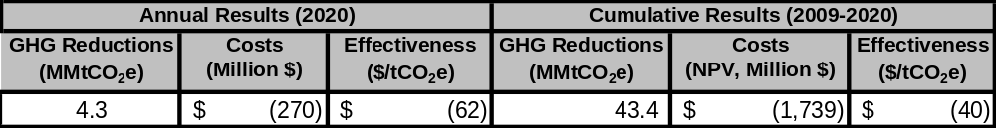
Notes: The cost estimates (colums 3 and 6) are incremental costs of energy efficient measures including capital cost, operating and maintenance, and labor, above baseline measure costs. The cost estimates are calculated as the costs less avoided energy expenditures. Also, the difference between the 2020 cost effectiveness (column 4) and the cumulative cost effectiveness (column 7) is due, in part, to the effects of discounting the net cash flows over the analysis period of 2009-2020.

The net present value of the cost savings resulting from implementation of Act 129 from 2009-2020 is estimated at approximately $1.7 billion. Some of this will be due to peak load reductions that result in lower wholesale energy and capacity charges but not less energy used. (These are not quantified in this draft). Peak demand reductions are assumed to not have an impact on GHG emissions as noted below. There is the assumption that lower wholesale charges will be passed through to customers. Other savings will result through reducing energy consumption.

Quantification Approach and Assumptions

- Reductions from the workplan are assumed to begin in 2009-2011 and implemented at 0.33% per year through 2011 to achieve the 1% target by 2011. Reductions are then assumed to be 1% per year for 2012 and 2013 reaching the Act 129 target of 3%.
- GHG mitigation and costs from the peak demand reduction component of Act 129 are not quantified as recommended by the subcommittee.
  - The costs and GHG reduction compliance pathways are deemed to uncertain for us to be able to quantify. For instance, peak demand reductions could be met with peak shifting from peak periods where the marginal resource is natural gas turbines, to off peak periods where the baseload resource is coal which has a higher CO₂ emissions intensity (tons/MWh). Other peak reductions might arise from the energy efficiency deployment obtained under the other components of Act 129. The costs of compliance equipment such as smart meters and associated communications equipment that might also be used to meet the peak demand reduction are also deemed to uncertain to quantify.
- Statewide load forecast from the PUC are used as the basis for the calculations. This includes the load reduction effects of Act 129 (which are already in the baseline), so reductions estimated here are likely to be slightly understated (by 3% of 3%).
- The above efficiency percentage targets are applied to residential, commercial and industrial loads. The cost and supply of efficiency savings are thus dependent on the customer class load as a percent of total load. Industrial loads grow more slowly than residential and commercial through 2020, and thus over time a smaller share of efficiency savings comes from the industrial sector.
- Energy efficiency costs are expressed as levelized costs over the life of the energy efficiency options over the planning period. The incremental costs (typically incurred in the first year of program implementation) are spread over all future years of the life of the energy efficiency measures.
- Efficiency investments installed under Act 129 with expected lifetimes shorter than the planning period are expected to be replaced with equipment with similar cost and performance characteristics. Efficient equipment is cost effective to install initially, and it is assumed that it will be replaced at the end of its life. Thus the electricity reductions in 2013 under Act 129 are held steady through 2030.
- The cost of the workplan is calculated by estimating the annual costs of energy efficiency less avoided electricity expenditures. These cash flows are then discounted at a real rate of 5%.
  - The net present value of cash flows is calculated beginning in 2009 through 2020.
- All prices are in $2007 as per the Center for Climate Strategies Quantification Memo.

 | 2009
Levelized Cost of Energy Efficiency ($2007) | $/MWh | $/MMBTU | Fixed Cost Rate
Residential | $ 53.70 | $ 5.68 | 13%
Commercial | $ 31.47 | $ 3.52 | 10%
Industrial | $ 26.03 | $ 2.11 | 5%
  - Sum of Capital and Fixed Costs Program fixed costs are assumed to be part of each measure’s capital cost, These include administrative, marketing, and evaluation costs of 5%.
- Source: ACEEE et al. (2009).Various pages
- Cost of EE measures includes program and participant cost as is typically used in Total Resource Cost test.
Costs Associated with Avoided Energy in 2009 ($2007) | $/MWh | $/MMBTU
Residential | 103.37 | 13.14
Commercial | 87.14 | 10.72
Industrial | 65.00 | 7.48
- For electricity, retail end user prices for Jan 09 from US EIA Monthly Electricity Profile, increased by 6.2% in 2010 to account for rate caps coming off for last of EDCs. Annual prices in 2011+ adjusted by change in AEO end user prices from table 74 of AEO 2009 supplemental tables. http://www.eia.doe.gov/cneaf/electricity/epm/table5_6_a.html
- For natural gas, retail annual 2008 prices by sector, annual changes from 2009 onwards from Table 12 of AEO 2009 regional tables http://tonto.eia.doe.gov/dnav/ng/ng_sum_lsum_dcu_SPA_m.htm and http://www.eia.doe.gov/oiaf/aeo/supplement/stimulus/regionalarra.html

- Electricity transmission and distribution losses are assumed to be 6.6% over the analysis period. Source: PA Electricity Inventory and Forecast.xls
- To estimate emission reductions from workplans that are expected to displace conventional grid-supplied electricity (i.e., energy efficiency and conservation) a simple, straightforward approach is used. We assume that these policy recommendations would displace generation from an “average thermal” mix of fuel-based electricity sources of coal and gas. This mix is based on the sources of forecasted generation in PA over the planning period. PLACEHOLDER 90% coal, 10% gas for all years 2009-2030 based on EIA 2006 State Electricity Profile data.
  - The average thermal approach is preferred over alternatives because sources without significant fuel costs would not be displaced—e.g., hydro, nuclear, or renewables generation.
    - Similarly, a “marginal” approach is not possible in Pennsylvania because the natural gas share of the annual generation portfolio (13.5 million MWh) of total generation (218 million MWh in 2006) is only about 6%. This small amount does not provide enough be “backed down” due to the energy efficiency deployment in the workplan.
  - Given the generation fleet’s coal and gas combustion efficiencies, this equates to a CO₂ intensity of approximately 0.87 tonnes/MWh. This compares to the average statewide CO₂ intensity of 0.54 tonnes/MWh (including hydro, nuclear, etc.)
  - This approach provides a transparent way to estimate emission reductions and to avoid double counting (by ensuring that the same MWh from a fossil fuel source are not “avoided” more than once). The approach can be considered a “first-order” approach; it does not attempt to capture a number of factors, such as the distinction between peak, intermediate, and baseload generation; issues in system dispatch and control; impacts of nondispatchable and intermittent sources, such as wind and solar; or the dynamics of regional electricity markets. These relationships are complex and could mean that policy recommendations affect generation and emissions (as well as costs) in a manner somewhat different from that estimated here. Nonetheless, this approach provides reasonable first-order approximations of emission impacts and offers the advantages of simplicity and transparency that are important for stakeholder processes.

- Cost to DEP - None
- Cost to the Commonwealth – Administrative
- Cost to regulated community or consumer – Act 129 requires only modest reductions in load growth. It is reasonably anticipated that consumers will realize long-term cost savings however, there are costs of implementation that will be bore by the rate base and will be quantified in filings to the PUC. Estimated gross cost savings are provided at the end of this work plan and will need to be reconciled with the implementation costs.
- Are there Federal funds available? – N/A
- Do these costs fund other programs? N/A
- Are cost savings realized from this initiative? Yes, as noted above. Market forces will drive compliance options and the path forward. Actual savings will likely vary widely among the EDC territories, within the various rate classes and economic sectors and also based on socio-economic factors for residential consumers.

Implementation Steps:
- Act 129 was signed into law on October 15.

- By January 15, 2009, the PUC must adopt an energy efficiency and conservation program that requires each electric distribution company (EDC) to develop and implement cost effective energy efficiency & conservation plans to reduce consumption and peak load within their service territories, as noted in the Summary section of this work plan.

- The American Council for an Energy Efficient Economy (ACEEE) has conducted a statewide assessment of cost effective energy efficiency potential. Building on this assessment, a more ambitious plan with several, periodic, load-reduction steps could be implemented and which would actually change the projected rate of consumption instead of simply slowing the rate.
Potential Overlap:
- Transmission and Distribution Loss Work Plan
- Industry #1 Industrial Electricity and Natural Gas Best Practices
- Any additional work plans that cut electricity consumption

Electricity 2. Reduced Load Growth Work Plan for Potential GHG Reduction Measure

Strategy Name: Reduced Load Growth

Lead Staff Contact: Joe Sherrick (717-772-8944)

Summary: This initiative identifies the carbon emissions benefits associated with curbing the rate of growth in electricity consumption in PA. This strategy builds upon the conservation requirements of Act 129 of 2008, which requires 1.0% and 2.0% reductions in electricity consumption from 2010, by 2011 and 2013, respectively. Act 129 also requires the PUC to assess the potential for additional cost-effective reductions. The scenario developed in this work plan builds upon Act 129 by requiring biennial reductions in electricity consumption equal to 1.5% per period (.75% per year), beginning in 2015 and carrying through 2025. The energy efficiency investments under this workplan therefore reach 8.25% of load by the end of 2025 (11 years at 0.75% per year). These reductions are calculated from the previous years estimated consumption.

Please note that this analysis does not include the very modest consumption and associated system losses from municipalities that are service providers or the rural electric cooperatives.

Other Involved Agencies: PUC

Possible New Measure(s): A report from the American Council for an Energy Efficient Economy (ACEEE) has been drafted for the PUC and DEP and provides the cost and supply data for the workplan. See: http://www.aceee.org/pubs/e093.htm

Potential Workplan Costs and GHG Reductions: DRAFT (RESULTS HAVE NOT BEEN THOROUGHLY REVIEWED BY ELECTRICITY SUBCOMMITTEE)

Table 2.1 DRAFT Workplan Costs and GHG Results ($2007)
Annual Results (2020) |  |  | Cumulative Results (2009-2020)
GHG Reductions | Costs | Cost-Effectiveness | GHG Reductions | Costs | Cost-Effectiveness
(MMtCO₂e) | (Million $) | ($/tCO₂e) | (MMtCO₂e) | (NPV, Million $) | ($/tCO₂e)
7.2 | $ (447) | $ (62) | 24.8 | $ (933) | $ (38)

The net present value of the cost savings resulting from implementation of this workplan from 2009-2020 is estimated at approximately $930 million. The cost savings and emissions reductions are additional to Act 129. The cost savings are more modest compared to Act 129 because the workplan is not implemented until 2015 and has reached efficiency investments equal to 4.5% of sales by 2020. These distant cash flows are then discounted back to the present time.

Notes: The cost estimates (colums 3 and 6) are incremental costs of energy efficient measures including capital cost, operating and maintenance, and labor, above baseline measure costs. The cost estimates are calculated as the costs less avoided energy expenditures. Also, the difference between the 2020 cost effectiveness (column 4) and the cumulative cost effectiveness (column 7) is due, in part, to the effects of discounting the net cash flows over the analysis period of 2009-2020.

- Cost to DEP - None
- Cost to the Commonwealth – Act 129 requires the PUC to hire a program administrator to oversee this process and to provide assessments as to the cost-effectiveness and level of additional reductions that may be possible within PA. The cost for this service is unknown.
- Cost to regulated community or consumer – Not quantified, as of yet. Short-term capital costs may be experienced, depending on a host of issues but short and long-term savings are anticipated. Requires detailed analysis. The ACEEE et al (2009) report assumes that a portion of the cost of each efficiency measure may be spent by the end user and that utility incentives comprise the balance of the initial costs.
- Are there Federal funds available? – Federal funding is not required nor is it available at this time. Limited assistance may be available through the U.S. DOE State Energy Plan but this would most likely be limited to policy analysis and possibly technical support.
- Do these costs fund other programs? No. Any costs are expected to result in changes to consumer behavior.

Quantification Approach and Assumptions

- Reductions from the workplan are assumed to begin in 2015 and implemented at 0.75% per year through 2025 to achieve a rate of 8.25% by 2025.
- Efficiency investments installed under the workplan with expected lifetimes shorter than the planning period are expected to be replaced with equipment with similar cost and performance characteristics. Efficient equipment is cost effective to install initially, and it is assumed that it will be replaced at the end of its life. Thus, the electricity reductions in 2025 under the workplan are held steady through 2030.
- For cost and other assumptions see Electricity #1—Act 129.

Implementation Steps: The following, and other, considerations should be examined as policy tools to support this measure:
- Act 129 provides the PUC with the necessary authority to require additional cost-effective reductions in electricity consumption.
- An assessment of electricity consumption reduction potential is necessary to determine if the requirements suggested within this work plan conform to Act 129 requisites. Such a study is underway by ACEEE.
- A legislative amendment to the AEPS establishing a dedicated market share for energy efficiency credits (new tier or carve out) might facilitate achieving this reduction measure by rewarding over-compliance and providing a cost-effective manner to achieve greater reductions.
- Require electric distribution companies to invest in demand side response initiatives, including rebates to consumers.
- Require that all cost-effective supply side and demand side response initiatives have been identified and acted upon before approvals for new generation are granted. In a February 5, 2007 press release http://www.aceee.org/press/e072pr.htm ACEEE reported that, “States from Texas to Vermont are finding energy efficiency resources available at less than 4 cents per kilowatt-hour, compared to the expected cost of power from new plants of 5 to 10 cents.”
- Implementing advanced building standards for the commercial, institutional, state and municipal government sectors that establish minimum green building practices and energy efficiency standards.
- Coupled with the advanced building standard, consider a requirement that all commercial, institutional, state and municipal government buildings perform annual benchmarking, similar to that established by the U.S. EPA that documents the gains or losses in energy consumption on a per square foot basis, based on the type of activity occurring. This information is publicly accessible. It educates and encourages building owners and operators to achieve higher performance.
- Work with neighboring states on establishing regional efficiency standards for appliances and electronics where none currently exist or where minimum standards are less than optimal.
- Establish an aggressive phase-out of incandescent lights and/or establish a pricing/tax structure that preferentially treats lighting with a higher lumens to watts ratio.
- Rate decoupling

Potential Overlap:
- Act 129 Work Plan
- Stabilized Load Growth Work Plan
- Industry #2: Industrial Natural Gas and Electricity Best Management Practices

Electricity 3. Stabilized Load Growth Work Plan for Potential GHG Reduction Measure

Strategy Name: Stabilized Load Growth

Lead Staff Contact: Joe Sherrick (717-772-8944)

Summary: This measure builds upon the very modest reductions required via Act 129 of 2008. Act 129 requires reductions in consumption of 1.0% by 2011 and 2.0% by 2013, for a total of 3%, measured against 2010 consumption. The Stabilized Load Growth (SLG) scenario further investigates the potential impact of annual consumption reductions of 0.75% per year in the period 2014 through the end of 2017 followed by a rate of consumption that is held static from 2018 through 2025. Historical annual load growth in PA has been approximately 1.5% per year which is what would be reduced in the 2018 to 2025 period. . The energy efficiency investments under this workplan therefore reach 15% of load by the end of 2025 (2014-2017 at 0.75% per year, 2018 at .85% per year, 2019-2025 at 1.6% per year). The annual reductions in 2018-2025 would be based on the previous year’s consumption figures and would allow a subsequent one year “true-up” for electricity distribution companies to achieve stabilized consumption levels.
Please note that this analysis does not include the very modest consumption and associated system losses from municipalities that are service providers or the rural electric cooperatives.

The demand reductions under this workplan can be compared to those occurring in other jurisdictions. Several states are mandating energy savings akin to the higher performers in Figure 3.1. Iowa’s PUC has requested utilities file plans to achieve savings equal to 1.4% of sales, up from 0.8 currently. New York has a target of 15% savings by 2015, which was started in 2007 equating to new energy efficiency investments equal to nearly 2% per year. The following figure shows incremental energy savings as a percent of sales for surveyed utilities across the country.

Figure 3.1: Energy Savings as % of First Year Sales
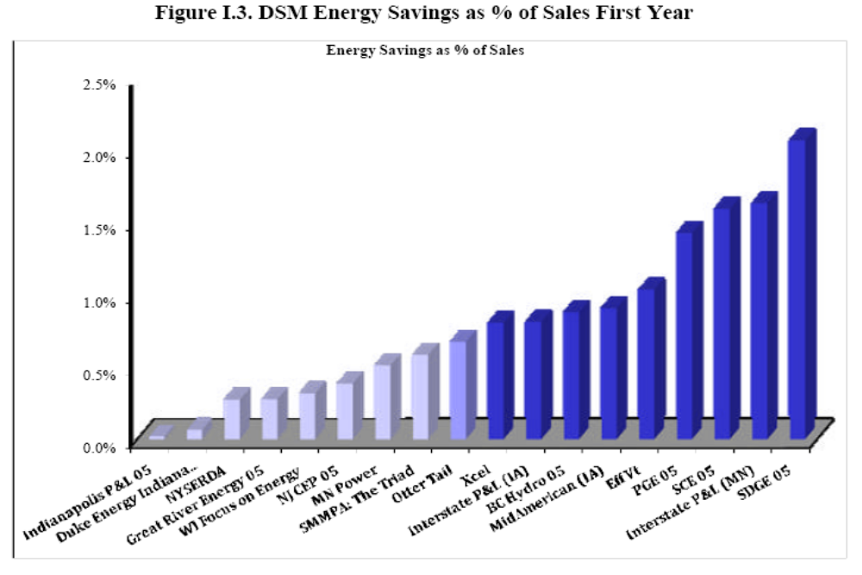
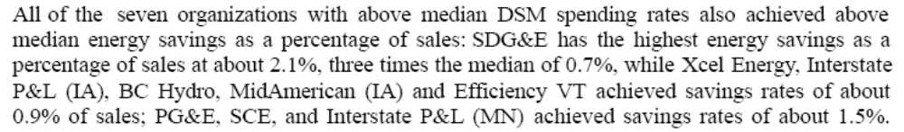

Other Involved Agencies: PUC

Possible New Measure(s): A report from the American Council for an Energy Efficient Economy (ACEEE) has been drafted for the PUC and DEP and provides the cost and supply data for the workplan. See: http://www.aceee.org/pubs/e093.htm

Potential Workplan Costs and GHG Reductions: DRAFT (RESULTS HAVE NOT BEEN THOROUGHLY REVIEWED BY ELECTRICITY SUBCOMMITTEE)

Table 3.1 DRAFT Workplan Costs and GHG Results ($2007)
Annual Results (2020) |  |  | Cumulative Results (2009-2020)
GHG Reductions | Costs | Cost-Effectiveness | GHG Reductions | Costs | Cost-Effectiveness
(MMtCO₂e) | (Million $) | ($/tCO₂e) | (MMtCO₂e) | (NPV, Million $) | ($/tCO₂e)
11.0 | $ (690) | $ (62) | 37.1 | $ (1,408) | $ (38)

The net present value of the cost savings resulting from implementation of this workplan from 2009-2020 is estimated at approximately $ 1.4 billion. The cost savings and emissions reductions are additional to Act 129.

Notes: The cost estimates (colums 3 and 6) are incremental costs of energy efficient measures including capital cost, operating and maintenance, and labor, above baseline measure costs. The cost estimates are calculated as the costs less avoided energy expenditures. Also, the difference between the 2020 cost effectiveness (column 4) and the cumulative cost effectiveness (column 7) is due, in part, to the effects of discounting the net cash flows over the analysis period of 2009-2020.

- Cost to DEP - None
- Cost to the Commonwealth – Act 129 requires the PUC to hire a program administrator to oversee this process and to provide assessments as to the cost-effectiveness and level of additional reductions that may be possible within PA. The cost for this service is unknown. It is further assumed that the PUC would perform similar services to oversee the reductions that may be required if such a Stabilized Load Growth initiative were to be implemented.
- Cost to regulated community or consumer – Not quantified, as of yet. Short-term capital costs may be experienced, depending on a host of issues but short and long-term savings are anticipated. Requires detailed analysis. The ACEEE et al (2009) report assumes that a portion of the cost of each efficiency measure may be spent by the end user and that utility incentives comprise the balance of the initial costs.
- Are there Federal funds available? – Federal funding is not required nor is it available at this time. Limited assistance may be available through the U.S. DOE State Energy Plan but this would most likely be limited to policy analysis and possibly technical support.
- Do these costs fund other programs? No. Any costs are expected to result in changes to consumer behavior.
- Are cost savings realized from this initiative? Cost savings are expected but this does require a detailed analysis. The assumption is that reductions will only be required such that can be sustained through cost-effective measures.

Quantification Approach and Assumptions

- Reductions from the workplan are additional to those under Act 129, and are assumed to begin in at the start of 2014 and are implemented through the end of 2017 at 0.75% of sales per year (for a total of 3% of sales). This reduction is expected to reduce Pennsylvania’s load growth rate from ~1.60%/year to about 0.85%/year. Then required reductions are equal to the load growth rate from the previous year from 2018 through 2025. By 2020, expected reductions are equal to approximately 7% of sales, and by 2025 reductions amount to 15% of sales.

- Efficiency investments installed under the workplan with expected lifetimes shorter than the planning period are expected to be replaced with equipment with similar cost and performance characteristics. Efficient equipment is cost effective to install initially, and it is assumed that it will be replaced at the end of its life. Thus, the electricity reductions in 2025 under the workplan are held steady through 2030.
- For cost and other assumptions see Electricity #1—Act 129.

Additional Assumptions:
- Adequate cost-effective reductions exist or will exist, through year 2025, to provide the approximate 27 million MWh of curtailment, as compared to the unchecked, projected rate of growth in electricity consumption. The ACEEE report identifies cost effective efficiency supplies in Table 3.2 of approximately 61 million MWh that significantly exceed the reductions projected under this workplan.

Table 3.2: Summary of Cost-Effective Energy Efficiency Potential by Sector (2025)
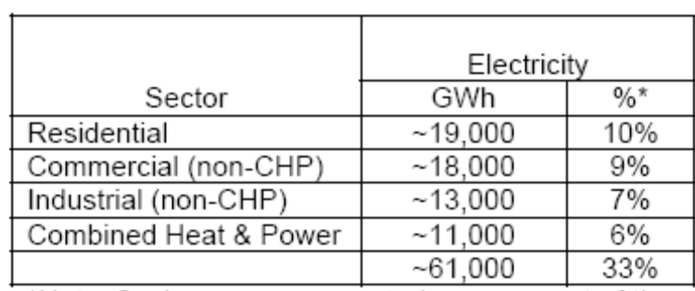

- No reductions would be required if not supported through an analysis of cost-effective measures.

Implementation Steps: The following, and other, considerations should be examined as policy tools to support this measure:
- Act 129 provides the PUC with the necessary authority to require additional cost-effective reductions in electricity consumption.
- The PUC may have the authority within Act 129 of 2008 that would facilitate realization of this reduction measure.
- A legislative amendment to the AEPS establishing a dedicated market share for energy efficiency credits (new tier or carve out) might facilitate achieving this reduction measure by rewarding over-compliance and providing a cost-effective manner to achieve greater reductions.
- Require electric distribution companies to invest in demand side response initiatives, including rebates to consumers.
- Require that all cost-effective supply side and demand side measures have been identified and acted upon before approvals for new generation are granted. In a February 5, 2007 press release http://www.aceee.org/press/e072pr.htm ACEEE reported that, “States from Texas to Vermont are finding energy efficiency resources available at less than 4 cents per kilowatt-hour, compared to the expected cost of power from new plants of 5 to 10 cents.”
- Implementing advanced building standards for the commercial, institutional, state and municipal government sectors that establish minimum green building practices and energy efficiency standards.
- Coupled with the advanced building standard, consider a requirement that all commercial, institutional, state and municipal government buildings perform annual benchmarking, similar to that established by the U.S. EPA that documents the gains or losses in energy consumption on a per square foot basis, based on the type of activity occurring. This information is publicly accessible. It educates and encourages building owners and operators to achieve higher performance.
- Work with neighboring states on establishing regional efficiency standards for appliances and electronics where none currently exist or where minimum standards are less than optimal.
- Establish an aggressive phase-out of incandescent lights and/or establish a pricing/tax structure that preferentially treats lighting with a higher lumens to watts ratio.
- Rate decoupling

Potential Overlap:
- Act 129 Work Plan
- Reduced Load Growth Work Plan
- Industry #2: Industrial Natural Gas and Electricity Best Management Practices

Electricity 4. Alternative Energy Portfolio (Act 213 of 2004) Tier I Standard: Work Plan for Potential GHG Reduction Measure

Lead Staff Contact: Joe Sherrick (717-772-8944)

Summary: Identifies GHG reductions associated with the existing AEPS Tier I requirement at 8%.

Other Involved Agencies: PUC and DEP have shared roles in administering the AEPS

Existing Measure: The AEPS requires that all electricity consumed within PA by 2021 be comprised of at least 0.5% solar PV, 8% from other renewable (Tier I) sources and 10% from other alternative energy (Tier II) sources. The AEPS matures in 2021 after which, no further increase in renewable generation is required but the standards from 2021 remain in effect.

Projected GHG Reduction:

The CO2 emissions reductions associated with this AEPS structure was calculated by first establishing a consumption-based load growth projection for each electric distribution company (EDC) and applying that factor to the 2006 actual consumption for each EDC, projecting out to 2025. The total estimated electricity consumption was multiplied by a five-year (2000 through 2004) statewide, grid average, CO2 emissions factor of 1,279 pounds per MWH. This was then converted to million metric tons of carbon dioxide (MMTCO2).

There will be some additional reductions through Tier II from sources such as large hydro and energy efficiency. The contribution of these resources to meeting the Tier II obligation is somewhat uncertain because we already know that sufficient credits from waste coal have been generated to meet the entire Tier II requirements through at least 2021. The impact is that little incentive exists for the generation of electricity from new, zero carbon emitting sources due to the over-supply created by waste coal. It also needs to be noted that any energy efficiency work plans that reduce the overall consumption of electricity within PA will result in a direct reduction of the emissions associated with the AEPS.

Hydroelectric – Uprates or upgrades to hydroelectric power generation can come from the addition of incremental (new) generation at existing plants or simply by making improvements in efficiency to things such as turbine design or improvements to the electrical generators. With the enactment of the Alternative Energy Portfolio Standard (AEPS), such improvements are being given serious consideration by generating companies. Therefore, it is important to note that if these improvements are made or incremental generation is brought online, the resultant emissions reduction that might accrue will be accounted for under Tier I of the AEPS, provided that these hydroelectric plants obtain certification from the Low Impact Hydro Institute (LIHI), as required under the AEPS. Any improvements or incremental generation from a hydroelectric plant that does not or can not obtain LIHI certification will earn Tier II credits under the AEPS but the emissions reductions would not count against our total reductions from the AEPS. Upgrading older hydropower generating systems is common practice in North America. Through rehabilitation, hydroelectric producers are increasing capacity and efficiency at existing facilities that are several decades old. Rewinding a generator or replacing a turbine runner can result in performance that not only equals, but also surpasses the capabilities of the equipment when it was new. Rehabilitating existing plants is often a more economical way of adding capacity, when compared to building new facilities.

Economic Cost:
- Cost to DEP – Administration of programs for the continued support of energy efficiency and renewables, particularly solar PV (ex. Energy Harvest, PEDA, Alternative Energy Investment Act, etc.)
- Cost to the Commonwealth – Continued support of renewables, particularly solar
- Cost to regulated community or consumer – Distribution companies pass compliance costs on to the rate-payers. Until all of the EDC rate caps are removed the impact will remain uncertain. The removal of the rate caps will have a far more pronounced impact on electricity rates than will the requirements of the AEPS.
- Are there Federal funds available? USDA Farm Bill appropriations can and have provided limited support. Moreover, as the total appropriations are increasing, the amount available via grant funding is being significantly scaled back in favor of loans.
- Do these costs fund other programs? No.
- Are cost savings realized from this initiative? Not directly. Indirect savings to the Commonwealth will accrue subject to in-state renewables development (manufacturing, installation, sales and service, etc.)

Implementation Steps:
- Already being implemented.
- Legislation continues to be drafted that would require additional increases in the amount of alternative energy. Pennsylvania has the lowest percentage requirements of any surrounding state renewable portfolio standards. Because the geographic scope from which projects may be considered eligible (Illinois to North Carolina) for Act 213 compliance is much broader than was originally intended and in order to ensure that more renewable energy and associated new jobs are created in PA, the requirements of the AEPS could be increased.
- Act 1 incentives for renewable resources
- Federal production tax credit

Potential Overlap:
- HB 2200
- Reduced Load Growth
- Al Electricity Efficiency Initiatives
- Transmission and Distribution Loss Reductions
- High Performance Building Standards
- Energy Audits
- Others
AEPS Requirements |  |  |  |  |  |  |  |  |  | AEPS CO2 Reductions
Compliance Year | Tier I | PV | Tier II | Projected PA Consumption (MWH) | Tier I MWH | PV MWH | Tier II MWH | Total AEPS MWH |  | Total Tier I + PV MWH | Total MMTCO₂
2007 | 1.50% | 0.0013% | 4.2% | 147,237,195 | 2,208,558 | 1,914 | 6,183,962 | 8,394,434 |  | 2,210,472 | 1.28
2008 | 1.50% | 0.0030% | 4.2% | 149,562,879 | 2,243,443 | 4,487 | 6,281,641 | 8,529,571 |  | 2,247,930 | 1.30
2009 | 2.00% | 0.0063% | 4.2% | 151,928,332 | 3,038,567 | 9,571 | 6,380,990 | 9,429,128 |  | 3,048,138 | 1.77
2010 | 2.50% | 0.0120% | 4.2% | 154,334,271 | 3,858,357 | 18,520 | 6,482,039 | 10,358,916 |  | 3,876,877 | 2.25
2011 | 3.00% | 0.0203% | 6.2% | 156,781,428 | 4,703,443 | 31,827 | 9,720,449 | 14,455,718 |  | 4,735,269 | 2.75
2012 | 3.50% | 0.0325% | 6.2% | 159,270,547 | 5,574,469 | 51,763 | 9,874,774 | 15,501,006 |  | 5,626,232 | 3.26
2013 | 4.00% | 0.0510% | 6.2% | 161,802,389 | 6,472,096 | 82,519 | 10,031,748 | 16,586,363 |  | 6,554,615 | 3.80
2014 | 4.50% | 0.0840% | 6.2% | 164,377,726 | 7,396,998 | 138,077 | 10,191,419 | 17,726,494 |  | 7,535,075 | 4.37
2015 | 5.00% | 0.1440% | 6.2% | 166,997,346 | 8,349,867 | 240,476 | 10,353,835 | 18,944,179 |  | 8,590,343 | 4.98
2016 | 5.50% | 0.2500% | 8.2% | 169,662,052 | 9,331,413 | 424,155 | 13,912,288 | 23,667,856 |  | 9,755,568 | 5.66
2017 | 6.00% | 0.2933% | 8.2% | 172,372,662 | 10,342,360 | 505,569 | 14,134,558 | 24,982,487 |  | 10,847,929 | 6.29
2018 | 6.50% | 0.3400% | 8.2% | 175,130,010 | 11,383,451 | 595,442 | 14,360,661 | 26,339,553 |  | 11,978,893 | 6.95
2019 | 7.00% | 0.3900% | 8.2% | 177,934,944 | 12,455,446 | 693,946 | 14,590,665 | 27,740,058 |  | 13,149,392 | 7.63
2020 | 7.50% | 0.4433% | 8.2% | 180,788,329 | 13,559,125 | 801,435 | 14,824,643 | 29,185,202 |  | 14,360,559 | 8.33
2021 | 8.00% | 0.5000% | 10.0% | 183,691,047 | 14,695,284 | 918,455 | 18,369,105 | 33,982,844 |  | 15,613,739 | 9.06
2022 | 8.00% | 0.5000% | 10.0% | 186,643,996 | 14,931,520 | 933,220 | 18,664,400 | 34,529,139 |  | 15,864,740 | 9.20
2023 | 8.00% | 0.5000% | 10.0% | 189,648,091 | 15,171,847 | 948,240 | 18,964,809 | 35,084,897 |  | 16,120,088 | 9.35
2024 | 8.00% | 0.5000% | 10.0% | 192,704,264 | 15,416,341 | 963,521 | 19,270,426 | 35,650,289 |  | 16,379,862 | 9.50
2025 | 8.00% | 0.5000% | 10.0% | 195,813,466 | 15,665,077 | 979,067 | 19,581,347 | 36,225,491 |  | 16,644,145 | 9.65

Electricity 5. Work Plan for House Bill 80

TBD—PLACEHOLDER

Note: Replaces Tier 1 at 15%, Tier 1 at 20%, Tier 3: Carbon Capture and Sequestration Work plans

Electricity 6. Improve Coal-Fired Power Plant Efficiency by 5% Work Plan for Potential GHG Reduction Measure

Lead Staff Contact: Krish Ramamurthy (717-772-3369)

Summary: Require a 5% increase in energy efficiency at coal-fired power plants by 2025. Each facility would have the flexibility to meet this efficiency requirement at the least cost method available to them. Measure is assumed to be implemented linearly in 2015 following scheduled outage in PJM que.

Other Involved Agencies: Workplan measures would need to be designed so as not to trigger “Major Modification” clause in US EPA New Source Review program for major stationary sources in attainment areas. This eliminates the option of repowering existing resources in the quantification. The typical methods that could be utilized for compliance with this measure are listed in the table from the Australian Greenhouse Gas Office publication below.

Possible New Measure(s): An affected Electricity Generating Unit (EGU) may improve efficiency to minimize system losses as a means to reduce CO₂ emissions. For instance, a 15 percent increase in efficiency at an EGU would result in a 13% decrease in CO₂ emissions. Upgrades can include improvements to the boiler, turbine, and control systems. Examples of turbine improvements include installing high efficiency turbine blades, which allow for increased power generation and an efficiency improvement of 0.98%. Fuel consumption reduction can occur with improvements to feed water heater material within a turbine system, leading to an increase in efficiency of between 1% and 5%. Upgrading the software of the control system that monitors and fine-tunes combustion can improve efficiency between 0.3% to 3%.

Additionally, the average U.S. pulverized coal-fired plant operates at a heat rate of about 10,500 Btu/kWh. Yet a sub-critical (2,400 psi/1,000F/1,000F) unit is capable of operating at least 10% more efficiently, at a heat rate of 9,500 Btu/kWh. Using a minimum of 5% efficiency expectation, a total of 5.9 million tons of CO₂ could be reduced while producing existing levels of electricity.

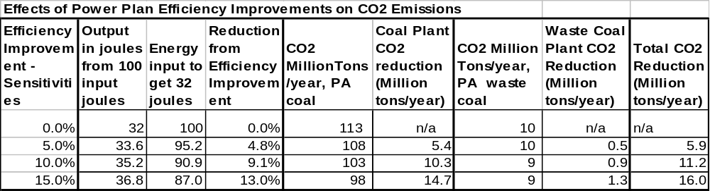
Potential GHG Reduction: 5.8 MMT CO2e

Economic Cost:

- Cost to DEP – The cost to DEP will be in terms of staff man hours invested in developing any new regulation, or guidance document, that will be required for this effort. Also, if additional conditions need to be added to permits this will require additional staff time invested by regional office personnel.

- Cost to regulated community or consumer – A study conducted by the Australian Greenhouse Office (January 2000) evaluated the costs and benefits of efficiency improvements to electric generating units. This paper can be found at http://www.greenhouse.gov.au/ges/publications/pubs/skmreport.pdf

They found that based on a range of efficiency improvement measures for bituminous and sub-bituminous coal plants, the cost effectiveness for those improvements ranged from a savings of $11/ton to a cost of $9/ton. This is based on an average of all plants in the study. As indicated not all plants achieved a net cost savings.

- The net present value (NPV) after fuel savings was found to be $5/ton of greenhouse gas saved for the bituminous and sub-bituminous coal plants. At the NPV of $5/ton it was found that the Average Simple Payback period was five years. This study found that the fuel savings due to these efficiency improvements ranged from $21 to $30 per ton depending on the plant.

- These improvements were found to result in an expected reduction in the cost of electricity generated for bituminous and sub-bituminous coal. A 0.3% reduction in the price of electricity generated from bituminous and sub-bituminous coal is expected.

This means that, on average, it was found that efficiency improvements, when applied to an existing coal fired power plant, will pay for themselves over the lifetime of operation of the facility. Since the cost of coal has increased since 2000, and is projected to increase further, the projected savings from efficiency increases will be greater.

- The availability of federal funds for such improvement projects is unknown.

- The cost to other programs at the federal level is not known.

- Cost savings will be realized by coal fired power plants, according to the Australian study, over the lifetime of the efficiency improvement project.

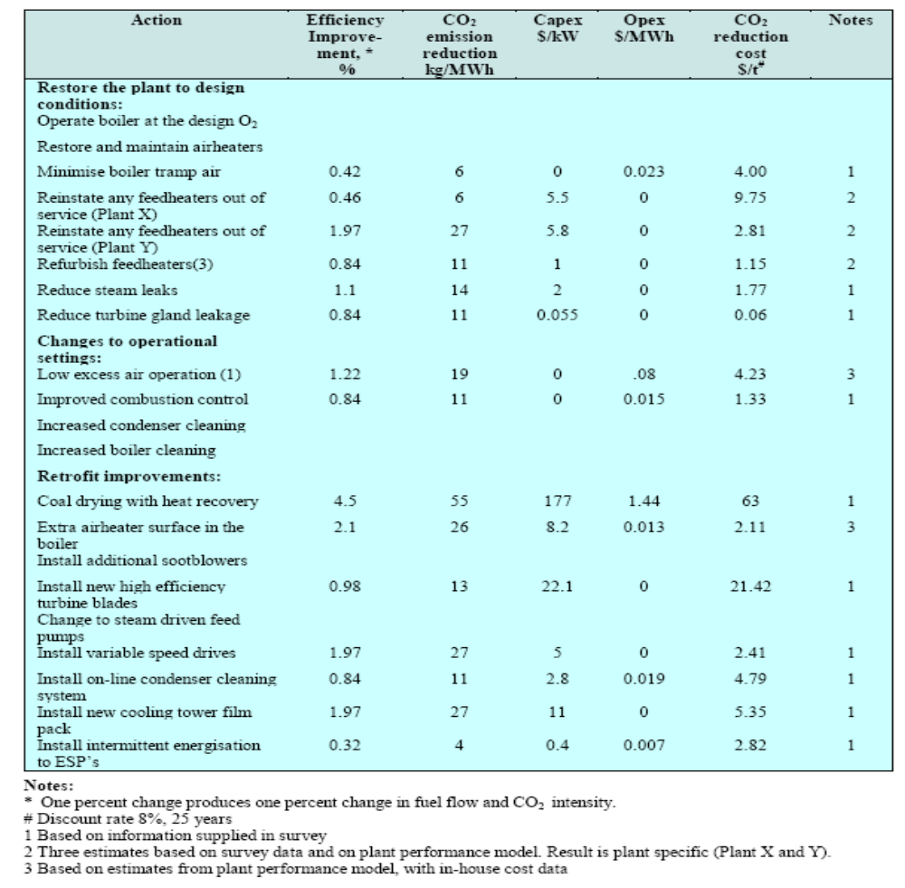
The table below, from the Australian Greenhouse Office (January 2000) Report, Integrating Consultancy Efficiency Standards for Power Generation, illustrates the cost in terms of tons of CO2 reduced for a variety of power plant efficiency improvement steps. For each efficiency improvement action the cost can be determined based on the expected reduction of carbon dioxide in terms of tons of CO2 reduced. All data in this table is in terms of Australian dollars and metric tones.

Potential Overlap:

- HB 2200, AEPS Tier I (@ 8%, 15%, 20%), Alternative Energy Investment Act, Reduced Load Growth, Reduced Transmission and Distribution Losses

eGRID2007 Version 1.0 Plant File (Year 2005 Data)
This plant-level file has 4,998 records and 158 data elements.
eGRID2007 2005 file plant sequence number | State abbreviation | Plant name | Plant primary coal/oil/gas/ other fossil fuel category | Plant capacity factor | Plant nameplate capacity (MW) | Plant annual CO2 combustion output emission rate (lb/MWh) | Plant nominal heat rate (Btu/kWh)
SEQPLT05 | PSTATABB | PNAME | PLFUELCT | CAPFAC | NAMEPCAP | PLCO2CRT | PLHTRT
4024 | PA | WPS Westwood Generation LLC | COAL | 0.7415 | 36.0 | 3,885.96 | 16,030.2209
3936 | PA | Hunlock Power Station | COAL | 0.5400 | 49.9 | 2,967.42 | 13,825.9943
3914 | PA | Eddystone Generating Station | COAL | 0.2523 | 1,568.8 | 2,665.63 | 13,780.4404
4011 | PA | Sunbury | COAL | 0.3781 | 490.6 | 2,837.00 | 13,153.5252
3909 | PA | Cromby Generating Station | COAL | 0.2746 | 420.2 | 2,416.80 | 12,663.3937
3915 | PA | Elrama Power Plant | COAL | 0.3564 | 510.0 | 2,524.28 | 12,301.5871
3906 | PA | Colver Power Project | COAL | 0.7805 | 118.0 | 2,331.24 | 11,203.6493
3964 | PA | New Castle Plant | COAL | 0.4236 | 354.4 | 2,278.17 | 11,102.2345
3987 | PA | PPL Martins Creek | OIL | 0.1756 | 2,112.8 | 1,972.54 | 11,009.6136
4003 | PA | Seward | COAL | 0.5480 | 585.0 | 2,228.36 | 10,859.4505
4014 | PA | Titus | COAL | 0.5572 | 261.0 | 2,207.05 | 10,757.9030
4005 | PA | Shawville | COAL | 0.5780 | 632.0 | 2,127.68 | 10,368.9321
3980 | PA | Portland | COAL | 0.4094 | 621.0 | 2,038.81 | 9,997.0281
3890 | PA | Armstrong Power Station | COAL | 0.7045 | 326.4 | 2,050.16 | 9,991.0172
3957 | PA | Mitchell Power Station | COAL | 0.5295 | 373.9 | 2,044.76 | 9,970.6387
3904 | PA | Cheswick Power Plant | COAL | 0.5179 | 637.0 | 2,021.75 | 9,866.1064
3933 | PA | Hatfields Ferry Power Station | COAL | 0.5730 | 1,728.0 | 2,022.00 | 9,853.7903
3935 | PA | Homer City Station | COAL | 0.7716 | 2,012.0 | 1,972.02 | 9,610.2445
3907 | PA | Conemaugh | COAL | 0.7845 | 1,883.2 | 1,948.57 | 9,496.8466
3943 | PA | Keystone | COAL | 0.8173 | 1,884.0 | 1,920.42 | 9,359.0154
3898 | PA | Bruce Mansfield | COAL | 0.7639 | 2,741.1 | 1,885.11 | 9,186.6796
3995 | PA | PPL Montour | COAL | 0.7231 | 1,641.7 | 1,843.32 | 8,983.0377
3983 | PA | PPL Brunner Island | COAL | 0.7408 | 1,566.8 | 1,774.50 | 8,647.9775
Total |  |  |  |  | 22,554

Electricity 7. Sulfur Hexafluoride (SF₆) Emission Reductions from the Electric Power Industry Work Plan for Potential GHG Reduction Measure
Lead Staff Contact: Krish Ramamurthy (717-783-9476)

Summary: This initiative uses a pollution prevention approach, including a best management practices manual and recordkeeping and reporting requirements, to ensure that all SF₆ emission reductions are quantified and permanent.

Other Involved Agencies: United States Environmental Protection Agency

Possible New Measure(s): SF₆ is identified as the most potent non-CO₂ greenhouse gas with the ability to trap heat in the atmosphere 23,900 times more effectively than CO₂. Approximately 80% of SF₆ gas produced is used by the electric power industry in high voltage electrical equipment as an insulator or arc quenching medium. SF₆ is emitted to the atmosphere during various stages of the equipment’s life cycle. Leaks increase as equipment ages. The gas can also be accidentally released at the time of equipment installation and during servicing.

U.S. EPA has established a voluntary reduction program entitled “SF₆ Emission Reduction Partnership for Electric Power Systems.” Under this program the collective SF₆ emission rate has been reduced from 17% in 1999 to 8.3% in 2005 or a reduction of 6.88 MMTCO₂e. Avoided purchases to replace gas losses to the atmosphere from this reduction are approximately $3.8 to $5.7 million. Emissions estimates for Pennsylvania include:

Basis | Year | SF6 Emissions | (MMTCO2e)
CIRA-2003 | 1990 | SF6 from Electric Utilities | 0.8 | 87%
CIRA-2003 | 1990 | SF6 from Magnesium | 0.1 | 13%
 |  | Total | 0.9 | 100%
CIRA-2003 | 1999 | SF6 from Electric Utilities | 0.9 | 76%
CIRA-2003 | 1999 | SF6 from Magnesium | 0.3 | 24%
 |  | Total | 1.2 | 100%
PEC-2007 | 1990 | SF6 from Electric Utilities | 1.2
PEC-2007 | 2000 | SF6 from Electric Utilities | 0.6
PEC-2007 | 2020 | SF6 from Electric Utilities | 0.3

A regulatory program could be developed in Pennsylvania that uses pollution prevention approach including a best management practices manual and recordkeeping and reporting requirements to ensure that all SF₆ emission reductions are quantified and permanent. The reduction of SF₆ emissions from the electric power industry is available as one of the offset opportunities for any Cap and Trade Program established for large emitters.

As part of this regulatory program, a manual could be developed that would identify best management practices that would be required of all owners and operators of electric power systems. Best management practices could include proper handling techniques, identification and elimination of leaks, and the replacement of equipment that do not meet specific leak rate thresholds. An example of best management practices would be the recent Duquesne Light Company decommissioning of an old substation to recover the SF₆ gas and reclaim it to ASTM standards. The project resulted in the removal of approximately 7,300 lbs of SF₆ that otherwise would have been emitted to the atmosphere. As a part of SF₆ Emission Reduction Partnership for Electric Power Systems, Exelon’s PECO subsidiaries set a SF₆ goal in March 2006, commit a leak rate for SF₆ of no more than 10% for 2006. To help achieve the companies provided additional training to substation personnel to minimize SF₆ gas leaks and revised the gas handling procedures. Annual recordkeeping and reporting requirements would be required to ensure the quantification and reduction of SF₆ emissions.

Potential GHG Reduction: 0.1 MMT CO2e
This program might reduce SF₆ emissions from electric utilities in 2025 from 0.3 to 0.2 MMT CO2e, for an overall reduction of 0.1 MMT CO2e.

Economic Cost:
Industry: Savings by avoiding purchases to replace gas losses to the atmosphere, are approximately $3.8 to $5.7 million.
Department: No cost authorized or anticipated. Development of any regulatory program would then be required to be accomplished through existing resources and budget.
Funding Sources: US EPA voluntary cooperative program is implemented under Federal funding independent of Pennsylvania’s budget process.

Implementation Steps: US EPA voluntary cooperative program is implemented and summarized at http://www.epa.gov/electricpower-sf6/. Pennsylvania’s major power producers are participants.

Potential Overlap:
- N/A

Electricity 8. Join Regional Greenhouse Gas Initiative Work Plan for Potential GHG Reduction Measure

Lead Staff Contact: PUC and DEP

Initiative Summary: Examine the potential CO2 emissions reductions associated with joining the Regional Greenhouse Gas Initiative.

Other Involved Agencies: PUC and DEP

Possible New Measure(s):
RGGI is composed of individual CO₂ Budget Trading Programs in each participating state. These programs are implemented through state regulations, based on a RGGI Model Rule, and are linked through CO₂ allowance reciprocity. Regulated power plants are able to use a CO₂ allowance issued by any of the participating states to demonstrate compliance with the state program governing their facility. Taken together, the individual state programs function as a single regional compliance market for carbon emissions.
To reduce emissions of greenhouse gases, the RGGI participating states are using a market-based cap-and-trade approach that includes:
- Establishing a multi-state CO₂ emissions budget (cap) that will decrease gradually until it is 10% lower than at the start
- Requiring electric power generator to hold allowances covering their emissions of CO₂
- Providing a market-based emissions auction and trading system where electric power generators can buy, sell and trade CO₂ emissions allowances
- Using the proceeds of allowance auctions to support low-carbon-intensity solutions, including energy efficiency and clean renewable energy, such as solar and wind power
- Employing offsets (greenhouse gas emissions reduction or sequestration projects at sources beyond the electricity sector) to help companies meet their compliance obligations
RGGI's phased approach means that reductions in the CO₂ cap will initially be modest, providing predictable market signals and regulatory certainty. Electricity generators will be able to plan for and invest in lower-carbon alternatives and avoid dramatic electricity price impacts.
The RGGI Model Rule may be found at http://www.rggi.org/docs/Model%20Rule%20Revised%2012.31.08.pdf

Potential GHG Reduction (Million Metric Tons of CO2 Equivalents):
RGGI is set up to reduce CO2 emissions 10% below 2005 by 2018. According to EIA data, CO2 emissions from the PA electric sector in 2005 were 215 million tons, therefore, a 10% reduction would be 12.5 million tons.

Economic Cost: [Identify the costs associated with this initiative. Some things to consider and identify could include:
- Cost to DEP & PUC – The cost will be in terms of staff man hours invested in developing any new regulation, or guidance document, that will be required for this effort. Also, additional staff time invested by regional office personnel necessary to update permits.

- Cost to Commonwealth – A study conducted by the University of Maryland (January 2007) evaluated the costs and benefits of participating in the Regional Greenhouse Gas Initiative. This study can be found at http://www.cier.umd.edu/RGGI/documents/UMD_RGGI_STUDY_Jan07.pdf

The main conclusions of this study indicate that, overall, joining RGGI would only have a limited impact on the economy and electric power markets in Maryland. Similar conclusions hold for the current RGGI region and affected areas outside this region.

Electricity Bill Impacts: Overall, electricity bills are forecast to decrease over $100 million in 2010 and more than $200 million by 2025. This is a result of energy efficiencies, which will lower customers’ demands. Since the heaviest users will save the most, more than half the savings (between 53% and 63%) will go to industrial and commercial customers. On average, a residential ratepayer will see a modest reduction – about $22 savings in 2010 per household.

Overall Economic Impacts: Will have little net impact on the Maryland economy. The positive economic impacts from reduced electricity costs and energy efficiency investments are partially offset by reduced investment and profits in the electricity generating sector. Overall RGGI is predicted to have a positive economic impact on Gross State Product of approximately $100 million in 2010, increasing to about $200 million in 2015 and subsequent years. This impact is expected to create approximately 1200 jobs across the state by 2010, increasing to 2800 jobs by 2025. Such positive impacts are less than 0.1% of overall Maryland gross state product and employment in all years.

Implementation Steps: New legislation and new regulation based on RGGI Model Rule is required.

Potential Overlap: Reduced load growth, efficiency at coal plants, and new plant plans

Electricity 9. Promote Combined Heat and Power Work Plan for Potential GHG Reduction Measure

Strategy Name: Promote combined heat and power (CHP)

Lead Staff Contact: Maureen Guttman (717-783-8411)

Summary: This initiative encourages distributed CHP systems to reduce fossil fuel use and GHG emissions. Reductions are achieved through the improved efficiency of CHP systems, relative to separate heat and power technologies, and by avoiding transmission and distribution losses associated with moving power from central generation stations to distant locations where electricity is used.

Other Involved Agencies:

Possible New Measure(s):
Combined heat and power (CHP) is a term used to describe scenarios in which waste heat from energy production is recovered for productive use. The theory of CHP is to maximize the energy use from fuel consumed and to avoid additional GHG emissions from entities a baseload generating station via additional fossil fuel combustion, so that a reliable source of thermal energy can be provided to the users of the reclaimed thermal energy. The reclaimed thermal energy, while can be used by other nearby entities (e.g., within an industrial park or district steam loop) for productive purposes. Generating stations in urban areas may have existing opportunities or may require the co-location of new industry. For Pennsylvania, the largest source of new, cost-effective CHP potential is in industrial facilities that have continuous thermal loads for domestic hot water and process heating (ACEEE, et al, 2009). CHP units are typically sized to the minimum thermal load for the facility.
- Promote use of natural gas-fired CHP.
- Promote use of biomass-fired CHP.
- Create or expand markets for CHP units by incentives designed to promote implementation for residential, commercial and industrial users.
- Promote CHP technologies through provisions for tax benefits, attractive financing, utility rebates and other incentives.
- Remove barriers to CHP development, such as utility rate structures that allow discounted electric rates to compete with CHP. Also, interconnection standards should be designed to facilitate economical and efficient CHP connection to the grid.
- Consider the economic and environmental benefits of CHP as a resource in each electric utility’s Integrated Resource Plan. Potential measures include training and certification of installers and contractors; net metering and other pricing arrangements; clear and consistent interconnection standards; and creation and support for biomass fuel markets.

Potential Workplan Costs and GHG Reductions: DRAFT

Table 9.1 DRAFT Workplan Costs and GHG Results ($2007)

 | Work Plan Name | Annual Results (2020) |  |  | Cumulative Results (2009-2020)
Work Plan | Work Plan Name | GHG Reductions | Costs | Cost-Effectiveness | GHG Reductions | Costs | Cost-Effectiveness
No. | Work Plan Name | (MMtCO₂e) | (Million $) | ($/tCO₂e) | (MMtCO₂e) | (NPV, Million $) | ($/tCO₂e)
Electricity #9 | CHP | 5.7 | $ 37 | $ 7 | 28.4 | $ 115 | $ 4

The cost and emissions estimates assume three types of technologies are representative of the CHP portfolio in the future. Table 9.2 reflects the assumptions for each technology.
- Biofuel CHP supply [PLACEHOLDER]: Ethanol and biodiesel production requires the distillation of separating mixtures based on differences in their volatilities in a boiling liquid mixture and thus require significant thermal inputs. The goal of the federal renewable fuels standard of 10.21% for 2009 (11.1 billion gallons of renewable fuel), is required by the Energy Independence and Security Act of 2007 (EISA). The EISA (2007) targets 40 billion gallons by 2022. FUEL
- This analysis assumes biofuels processing CHP supply is derived from the assumption that biofuels produced in the state will be 15% of total transportation fuel by 2020 and that the processing of the fuels requires heat inputs equal to 38% of fuel energy content (an energy balance of 2.62).
- Act 78, a state law passed in July 2008, requires that every gallon of gasoline and diesel fuel contain a percentage of ethanol and biodiesel, respectively. The law targets 20% biodiesel and all gasoline sold at retail must contain10 percent ethanol, once in-state cellulosic ethanol production reaches 350 million gallons.
- The avoided CO₂ emissions are assumed to be the same as in workplan #1..
- The fuel for new commercial and industrial and biomass processing CHP is 100% gas.
- T&D losses are 6.6%.
- Retail electricity prices are the avoided electric prices.
- Estimating the costs of CHP into the distant future is tentative, because cost estimates are highly sensitive to natural gas prices, the cost of avoided power, and the assumption about the CO₂ intensity of displaced electricity.

- CHP potentials come from ACEEE et al (2009) Table E-14. Market Penetration Results for $500/kW Incentive Case. This is the aggressive policy case where clean public energy funds subsidize the capital costs to install CHP at a rate of $500/kW. This quantification incorporates the total social costs, including private and public costs, into the cost per MMCO2e measure.
- Table 9.2: CHP Technology Assumptions
 | $2007 | For Year 2020
Avoided T&D Charges | Commercial | Industrial | Biofuels Processing
Demand and Energy Charge kW month | $ 4.45 | $ 10.83 | $ 10.83 | PPL GS-3 charges for comm. LP-6 charges for industrial, biofuels (>69 kv)
Distribution Charge kW month (comm) | $ 4.69 |  |  | PPL GS-3 charges for comm. LP-6 charges for industrial, biofuels (>69 kv)
Distribution Charge Customer/Month (Ind) |  | $ 891.00 | $ 891.00 | PPL GS-3 charges for comm. LP-6 charges for industrial, biofuels (>69 kv)
T&D Losses | 6.6% | 6.6% | 6.6% | PA Assumption
CHP Characteristics
Heat Recovered from CHP Power to heat ratio | 70% | 90% | 90% | Source: Catalogue of CHP Technologies. EPA CHP Partnership. Introduction p. 7.
CHP Unit Size MW | 0.25 | 10.00 | 10.00
CHP Technology | MicroTurbine | Gas Turbine | Gas Turbine
Heat Rate MBTU/MWh | 11,750 | 10,800 | 10,800 | ACEEE, et al (2009) p. 212
Capacity Factor | 64% | 75% | 85% | Calc for comm/ind based on ACEEE. Biofuels assumption
Installed Capital Costs $/kW | $ 2,240 | $ 1,400 | $ 1,400 | 2010-2015 Costs as average for the period. Plus after treatment costs of $200/kw
O&M Costs $/kWh | $ 0.01 | $ 0.01 | $ 0.01 | 2010-2015 Costs as average for the period
Economic Life/years | 15.00 | 15.00 | 15.00 | Assumption
Avoided Boiler Characteristics
Displaced boiler efficiency | 80% | 80% | 80% | Assumption
Fixed O&M $/MBTU | $ 0.07 | $ 0.07 | $ 0.07 | Assumption
Variable O&M $/MBTU | $ 0.07 | $ 0.07 | $ 0.07 | Assumption
Net Generation Cost $/MWh | $ 147.02 | $ 61.09 | $ 61.09 | Calc
Avoided Price of Power $/MWh | $ 98.83 | $ 70.04 | $ 70.04 | Calc
MW Capacity | 386 | 661 | 389 | Ind/Comm from ACEEE, et al (2009)
MWh Generation | 2,171,000 | 4,345,000 | 2,893,972 | Ind/Comm from ACEEE, et al (2009)

Implementation Steps:
The key to implementing CHP systems is to provide adequate incentives for the development of infrastructure to capture and utilize the waste heat. Such incentives could come in many forms, such as recruiting suitable end users to a centralized location to utilize the waste heat, a feed-in tariff for CHP electricity, including CHP electricity in energy efficiency or renewables targets, tax credits, grants, zoning, and offset credits for avoided emissions.

Potential Overlap:

- Industry #2: Industrial Natural Gas and Electricity Best Management Practices

Electricity 10. Nuclear Work Plan for Potential GHG Reduction Measure

Lead Staff Contact: Dan Griffiths (717-773-0542)

Summary: Capacity uprates at existing nuclear plants in PA. The nuclear uprate schedule for the PA is assumed to be: XXXX. PPL is proposing a 1600 MW Bill Bend plant at the site of the Susquehanna 1 and 2 that is also analyzed under this workplan.

Other Involved Agencies: N/A

Possible New Measure(s):

Nuclear Uprates - To increase the power output of a reactor, typically a more highly enriched uranium fuel is added. This enables the reactor to produce more thermal energy and therefore more steam, driving a turbine generator to produce electricity. In order to accomplish this, components such as pipes, valves, pumps, heat exchangers, electrical transformers and generators, must be able to accommodate the conditions that would exist at the higher power level. For example, a higher power level usually involves higher steam and water flow through the systems used in converting the thermal power into electric power. These systems must be capable of accommodating the higher flows.
In some instances, facilities will modify and/or replace components in order to accommodate a higher power level. Depending on the desired increase in power level and original equipment design, this can involve major and costly modifications to the plant such as the replacement of main turbines. All of these factors must be analyzed by the facility as part of a request for a power uprate, which is accomplished by amending the plant's operating license. The analyses must demonstrate that the proposed new configuration remains safe and that measures continue to be in place to protect the health and safety of the public. Before a request for a power uprate is approved, the Nuclear Regulatory Commission must review these analyses.
Potential GHG Reduction:

Avoided emissions are calculated on the basis of known potential uprates displacing gas at 1,137.75 lb/MWh (four year average 2002-2005). Exelon was not included in the total since no information was available.

Planned Nuclear and Hydro Uprates in Pennsylvania
Owner | Unit | Potential Upgrade & Upgrades Post 2000 (MW) | Capacity Factor | MWH | Avoided CO2 (Tons) - assuming displaces gas at 1,137.75 lb/mwh | CO2 - MM Tons
PPL | Susquehanna I | 74 | 0.9 | 583,416 | 331,891 | 0.30
PPL | Susquehanna II | 69 | 0.9 | 543996 | 309,466 | 0.28
FE | Beaver Valley I | 81 | 0.9 | 638,604 | 363,286 | 0.33
FE | Beaver Valley II* | 73 | 0.9 | 575,532 | 233,090 | 0.21
Exelon | Peach Bottom II | 70 | 0.9 | 551,880 | 313,951 | 0.28
 |  |  |  |  | 1,738,559 | 1.57

Economic Cost: Market forces will drive Investments into infrastructure, to uprate capacity. These upfront costs will yield greater energy generation capacity and efficiency, leading to increased sales and eventually, increased profits.

Implementation Steps:
- These actions are currently being implemented
- Market-driven initiative

Potential Overlap:
- HB 2200, AEPS Tier I (@ 8%, 15%, 20%), Alternative Energy Investment Act, Reduced Load Growth, Reduced Transmission and Distribution Losses

Source: ACEEE et al. (2009). Energy Efficiency, Demand Response, and Onsite Solar Energy Potential in Pennsylvania. April. P. 29. page 48. http://www.aceee.org/pubs/e093.htm
Source: Quantec. (2008). Assessment of Energy and Capacity Savings Potential in Iowa Prepared for The Iowa Utility Association. February 15. p. I7-I10 No web link available.
Source: ACEEE et al. (2009). Energy Efficiency, Demand Response, and Onsite Solar Energy Potential in Pennsylvania. April. P. 29. page 48. http://www.aceee.org/pubs/e093.htm
? Source: ACEEE et al. (2009). Energy Efficiency, Demand Response, and Onsite Solar Energy Potential in Pennsylvania. April. P. 14. page 48. http://www.aceee.org/pubs/e093.htm
http://apps1.eere.energy.gov/states/state_news_detail.cfm/news_id=12212/state=PA

