Commonwealth of Pennsylvania

SQL Server Reporting Services
Functional Specification

Land Recycling Program

PROGRAM MEASURES

Prepared by: | Data Process Improvement and Quality Management Team
Report Id: | SSRS_LRP_062

Disclosure Information
The information in this document may not be changed without the express written agreement of the Department of Environmental Protection.

Change History
Version | Date | Revision Description
1.0 | March 3, 2016 | User review and approval version
APPROVAL:

Approval of this document signifies that the report and information are acceptable, and delivery of the report as herein specified will comply with and be a complete, quality implementation of the relevant requirements.

Department of Environmental Protection Representative Approvals:
Troy Conrad, LRP Representative |  | Date
Tammy Dodson, SSRS Representative |  | Date
Sharon Rozema, SSRS Representative |  | Date

Table of Contents

1 Description 1
2 Report Parameters 1
2.1 Parameters 1
2.2 Parameter Special Criteria 1
3 Report 1
3.1 Report Level Special Function 2
3.2 Grouping and Sorting 2
3.3 Report Details Section 2
3.3.1 Milestone Details 2
3.3.2 Special Functions 5
4 TECHNICAL DETAILS 5
4.1 SERVERS 5
5 Report Layout 5
6 Appendix A 8

Description

This report provides the Land Recycling Program (LRP) counts by Region for documents received, approved/disapproved as well as the average time (days) taken for a decision for Act2 milestones and Environmental Covenants.
The parameters include Begin Date and End Date.
The reports will be generated using Microsoft (MS) SQL Server Reporting Services (SSRS).

Report Parameters

Parameters
- Parameters will be available based on the report requested via the SSRS tool.
- The default for all the parameters is % (All), unless otherwise noted. If all parameters are defaulted, the report runs automatically when opened.
- The user may enter specific parameters, or accept the default values to run the report.

The following are the parameters that can be entered by the user:

Item Name | Type | Selection Criteria
Begin Date | Calendar Picker | Begin Date of either the Act2_Milestones.Event Date, Act2_Milestones.Response_Date, Initiations.Date_Recieve or Aul_Documents.Received_Date  See milestone criteria below.
End Date | Calendar Picker | End Date of either the Act2_Milestones.Event Date, Act2_Milestones.Response_Date, Initiations.Date_Recieve or Aul_Documents.Received_Date  See milestone criteria below.

Parameter Special Criteria
- None.

Report

- For an example of the report layout see the Report Layout section.
- All date formats will be in the month, day and year (MM/DD/YYYY).
- All fields will be wrapped unless otherwise noted.
- All codes will be in upper case; all other characters in mixed case, unless otherwise noted.
- Print page numbers as “Page 1 of 1” at the bottom of the page.
- Print the Execution Date to the center of the page under the report title.
- Print the DEP logo on the top left corner of every page.
- The layout of the report will be Landscape, and Multi-page.
- List the parameters repeat one time at the top of the first page.
- The report column header will be centered and bottom justified.
- All data will be centered within the column header or as specified.

Report Level Special Function
- None.

Grouping and Sorting
- The data is sorted by Milestones in the order specified by the Program.

Report Details Section

Details

Milestone | Description | Count | Criteria
Counts for the following Milestones are using Initiation Type Codes 1, 4, 7, 9, 10 (LRP90, NIR, SIA, OGLRP, OGL90). Additional Criteria is noted below as well as the date column used for the parameter.
NIRS | Act 2 NIRS Filed | LRPINIT_ID | INITIATIONS.DATE_RECEIVE
Counts are displayed for each milestone listed below.  BFRS, WFRS, SRIS, SRAS, SCPS, SFRS, IBES  (ACT2_MILESTONES.ACT2MLCD_ID = 8, 73, 65, 58, 36, 43, 17) | Received | LRPACT_ID | ACT2_MILESTONES.DATE_EVENT
 | Approved | LRPACT_ID | ACT2_MILESTONES.ACT2DECCD_ID = 1,2 (APP, DEEM)  ACT2_MILESTONES.DATE_DECISION
 | Disapproved | LRPACT_ID | ACT2_MILESTONES.ACT2DECCD_ID = 3,5 (DIS, TD)  ACT2_MILESTONES.DATE_DECISION
 | Average Review Time | Average of ACT2_MILESTONES.DATE_DECISION MINUS ACT2_MILESTONES.DATE_EVENT | ACT2_MILESTONES.ACT2DECCD_ID = 1,2,3,5 (APP, DEEM, DIS, TD)  ACT2_MILESTONES.DATE_DECISION
ICOA  (ACT2_MILESTONES.ACT2MLCD_ID = 18 ) | Approved | LRPACT_ID | ACT2_MILESTONES.DATE_EVENT
Counts for the following Milestones are using Initiation Type Codes 11 (OGALT). Additional Criteria is noted below as well as the date column used for the parameter.
Counts are displayed for each milestone listed below.  OSCRS, ORCRS, ORAPS  ACT2_MILESTONES.ACT2MLCD_ID = 81, 82, 83 | Received | LRPACT_ID | ACT2_MILESTONES.DATE_EVENT
 | Approved | LRPACT_ID | ACT2_MILESTONES.ACT2DECCD_ID = 1,2 (APP, DEEM)  ACT2_MILESTONES.DATE_DECISION
 | Disapproved | LRPACT_ID | ACT2_MILESTONES.ACT2DECCD_ID = 3,5 (DIS, TD)  ACT2_MILESTONES.DATE_DECISION
 | Average Review Time | Average of ACT2_MILESTONES.DATE_DECISION MINUS ACT2_MILESTONES.DATE_EVENT | ACT2_MILESTONES.ACT2DECCD_ID = 1,2,3,5 (APP, DEEM, DIS, TD)  ACT2_MILESTONES.DATE_DECISION
Total  This is a total of the following milestones.  BFRS, WFRS, SRIS, SRAS, SCPS, SFRS, IBES  (ACT2_MILESTONES.ACT2MLCD_ID = 8, 73, 65, 58, 36, 43, 17) | Received | LRPACT_ID | ACT2_MILESTONES.DATE_EVENT
 | Approved | LRPACT_ID | ACT2_MILESTONES.ACT2DECCD_ID = 1,2 (APP, DEEM)  ACT2_MILESTONES.DATE_DECISION
 | Disapproved | LRPACT_ID | ACT2_MILESTONES.ACT2DECCD_ID = 3,5 (DIS, TD)  ACT2_MILESTONES.DATE_DECISION
 | Withdrawn | LRPACT_ID | ACT2_MILESTONES.ACT2DECCD_ID = 4 (WD)  ACT2_MILESTONES.DATE_DECISION
 | Received (Exceed statutory timeframe) | LRPACT_ID | DATE_EVENT MINUS DATE_DECISION > 90  ACT2_MILESTONES.DATE_EVENT
Counts for the following are for the Environmental Covenants (EC) section.
AUL_DOCUMENTS.AUL_CODE_ID = 5 (ec)
EC | Received | AUL_DOCUMENT_ID | AUL_DOCUMENTS.RECEIVED_DATE
 | Approved | AUL_DOCUMENT_ID | AUL_ACTION = 'DEP SIGNED'  AUL_DOCUMENTS.RECEIVED_DATE
 | Disapproved | AUL_DOCUMENT_ID | AUL_ACTION = 'Disapproved'  AUL_DOCUMENTS.RECEIVED_DATE
 | Average Review Time | Average of the AUL_DOCUMENTS.ACTION_DATE MINUS AUL_DOCUMENTS.RECEIVED_DATE | AUL_DOCUMENTS.RECEIVED_DATE

Special Functions
- There is a function in the report to populate the first part of the description based on the Milestone Code. See appendix A.
- Display a “Total” column for all Regions.

TECHNICAL DETAILS

SERVERS

Environment | Database Server | Report Server | Report Link
Production | REPORT | EPENSQLS07 | http://epensqls07/Reportserver?%2fLRP%2fLRP_Measures
Stage/Test | STAGE | EPENSSQLS06 | http://epenssqls06/Reportserver?%2fLRP%2fLRP_Measures
Development | DEV | EPENDSQLS04 | http://ependsqls04/Reportserver?%2fLRP%2fLRP_Measures
Stored Procedures |  | Stored Procedures:  SSRS_DBA.DBP_SSRS_LRP_MEASURES  SSRS_DBA.DBP_SSRS_LRP_MEASURES_EC

Report Layout

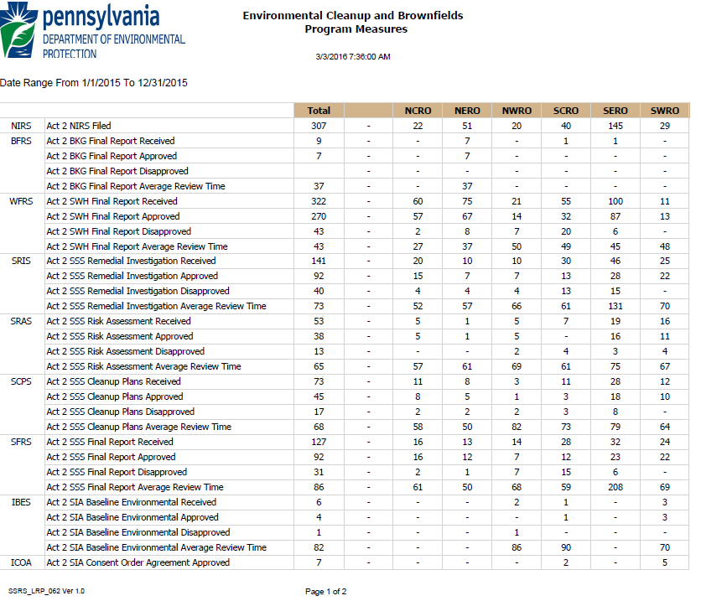

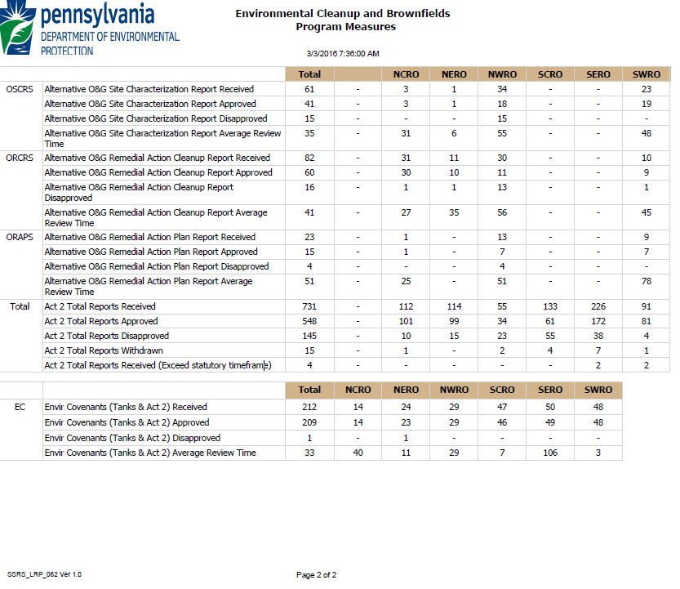

Appendix A

Function Milestone(byVal strVal as string)
dim retVal

Select Case strVal
Case "WFRS"
retVal = "Act 2 SWH Final Report"
Case "BFRS"
retVal = "Act 2 BKG Final Report"
Case "SRIS"
retVal = "Act 2 SSS Remedial Investigation"
Case "SRAS"
retVal = "Act 2 SSS Risk Assessment"
Case "SCPS"
retVal = "Act 2 SSS Cleanup Plans"
Case "SFRS"
retVal = "Act 2 SSS Final Report"
Case "IBES"
retVal = "Act 2 SIA Baseline Environmental"
Case "ICOA"
retVal = "Act 2 SIA Consent Order Agreement"
Case "OSCRS"
retVal = "Alternative O&G Site Characterization Report"
Case "ORAPS"
retVal = "Alternative O&G Remedial Action Plan Report"
Case "ORCRS"
retVal = "Alternative O&G Remedial Action Cleanup Report"
Case "NIRS"
retVal = "Act 2 NIRS Filed"
Case "EC"
retVal = "Envir Covenants (Tanks & Act 2)"
Case "Total"
retVal = "Act 2 Total Reports"

Case Else
retVal = ""

End Select

return retVal
End Function

