The files on this CD are for two types of applications:
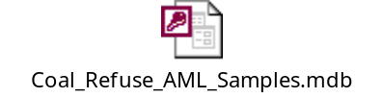

The file is access data base file. You want to open the data base click on "Tables", then click on "Refuse_Sample_Results" to view the coal sample analysis data along with its’ latitude and longitude location for you to then determine were area is located.

For a GIS application, you would want to load the remaining files to an ArcMap or Arc View file. After doing this below is a demonstration of what the information would look like. Because of file size issues, I can’t give you the USGS topo map layer background.

The potential sites that you would be looking for are illustrated in the magenta color for the Refuse_Sample and Refuse_Piles locations:

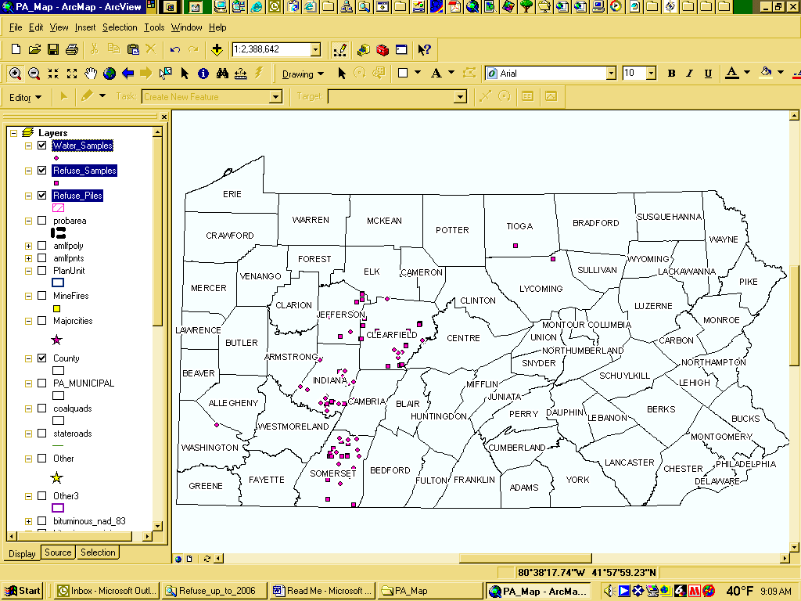

The potential of the saved data in GIS format when you “zoom” up to an area in interest would be illustrated as follows:


