

**Office of Oil and Gas Management**

**ePermitting Electronic Filing Administrator (EFA)Enrollment Guide**

**December 16, 2021**

**Version 1.0**

Table of Contents

**Contacting the Office of Oil and Gas Planning and Program Management** 2

**Purpose** 2

**GreenPort Account New User Registration** 3

**How to Enroll in ePermitting** 3

**SCREEN CONTROLL PROCESSING BUTTONS** 6

**Step 1: Identify Program Area** 6

**Step 2: Submitter Type** 7

**Step 3: Organizational Information** 7

**Step 4: Review the Security Agreement** 8

**Step 5: Organization Electronic Signature** 9

**Step 6: REVIEW, SUBMIT AND GET STARTED** 10

**Change History** 11

# **Contacting the Office of Oil and Gas Planning and Program Management**

If you have any questions or issues regarding granting User Access to the ePermitting Application please contact the Office of Oil and Gas Management.

Number: (717) 772-2199

Hours: Monday to Friday 8:00am to 4:00pm

Email: [RA-ep-BOGMOGRE@pa.gov](mailto:RA-EP-BOGMOGRE@pa.gov)

# **Purpose**

This guide is intended to assist the Electronic Filing Administrator (EFA) to gain access to the ePermitting application. Once the EFA has submitted their request, DEP will be notified via email to process the EFA’s access request for the assigned Operator or Company.

With the new updated enrollment process, an EFA can begin working on a draft permit application while awaiting DEP approval on their EFA request.

# **GreenPort Account New User Registration**

To access the ePermitting application you must have a registered Keystone GreenPort account. If you need to register for a GreenPort Account go to [https://greenport.uat.pa.gov/gpl](https://greenport.uat.pa.gov/gpl%20) and click on the Register button and enter the required information as prompted.

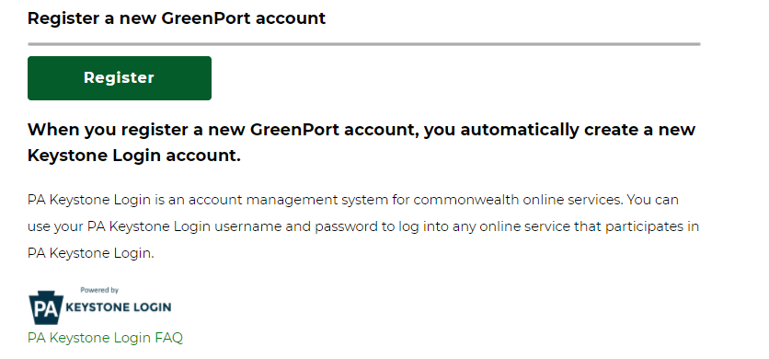

When you have registered your GreenPort account or already have a GreenPort account, enter your Username and Password and click Login!

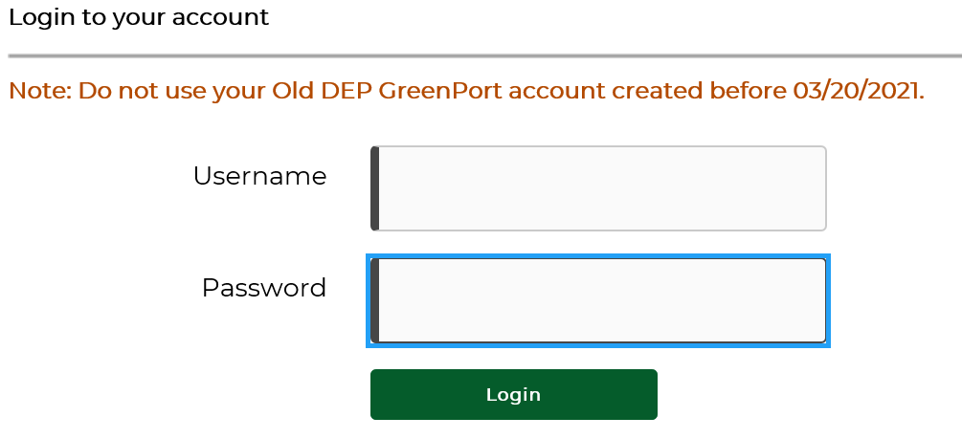

# **How to Enroll in ePermitting**

Once a GreenPort account has been successfully registered, you will log into GreenPort using the Username and Password you created during the registration process. Once logged in, select the Request Access button to begin if you are not currently enrolled.

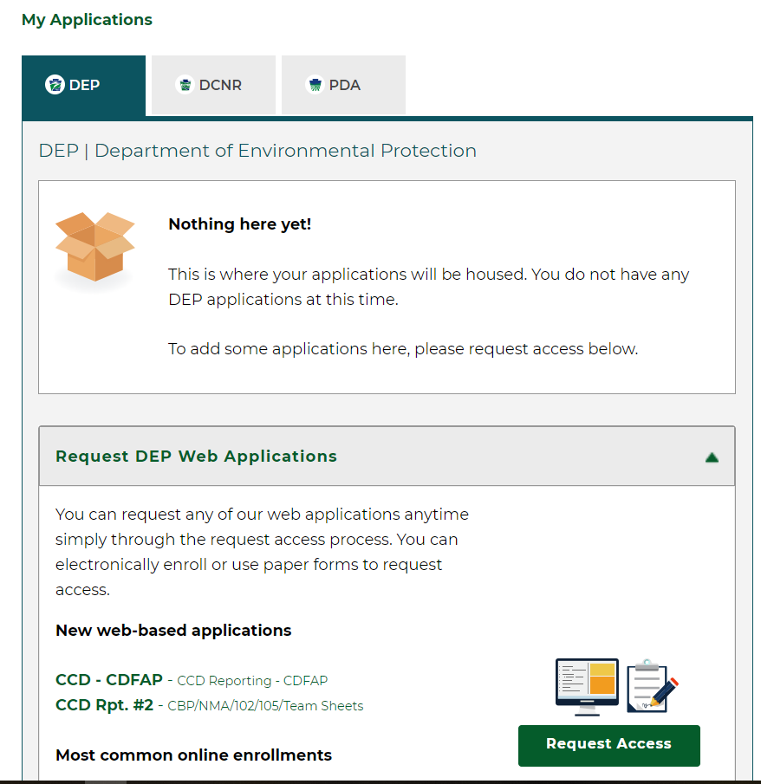

On the Online Enrollment tab, Click the Enroll button for ePermitting

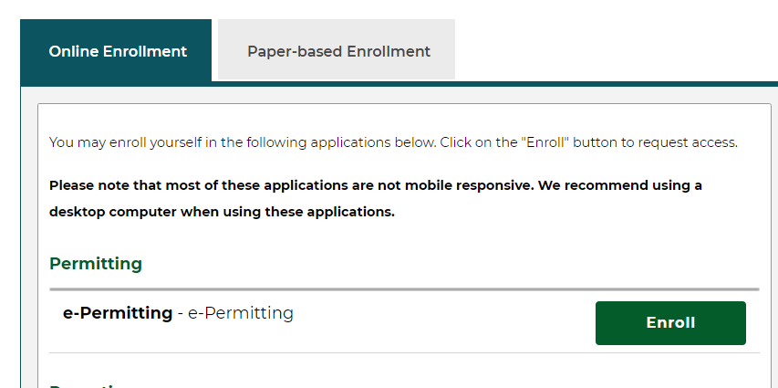

The ePermitting Home Page will open, the EFA will click on the Enrollment Dashboard Icon to start a New Enrollment or to view current requested enrollment.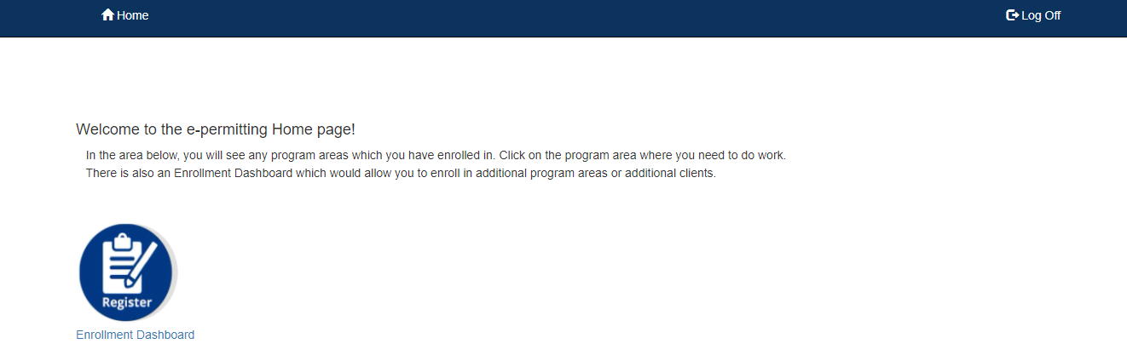

To start a new enrollment, click the Start a New Enrollment button.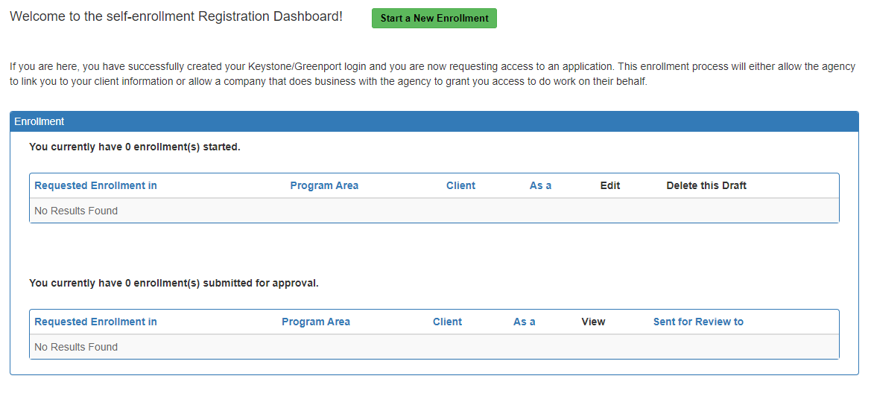

The Start a New EFA Enrollment is a 6 Step Wizard process. All 6 steps must be completed and submitted to gain proper access to the ePermitting application.

**The following guidance outlines the steps necessary to complete and submit an Electronic Filing Administrator (EFA) ePermitting enrollment request.**

# **SCREEN CONTROLL PROCESSING BUTTONS**

 will continue enrollment, all previously entered data will be saved

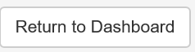 Will return user to Start new enrollment screen

 will return user to previous screen, all previously entered data will be saved

# **Step 1: Identify Program Area**

Select Office of Oil and Gas Management Program. A list of permits that can be submitted will display under the Program Area you are requesting access for. If the permit you wish to gain access to is not listed, you may need to request access to a different Program Area.

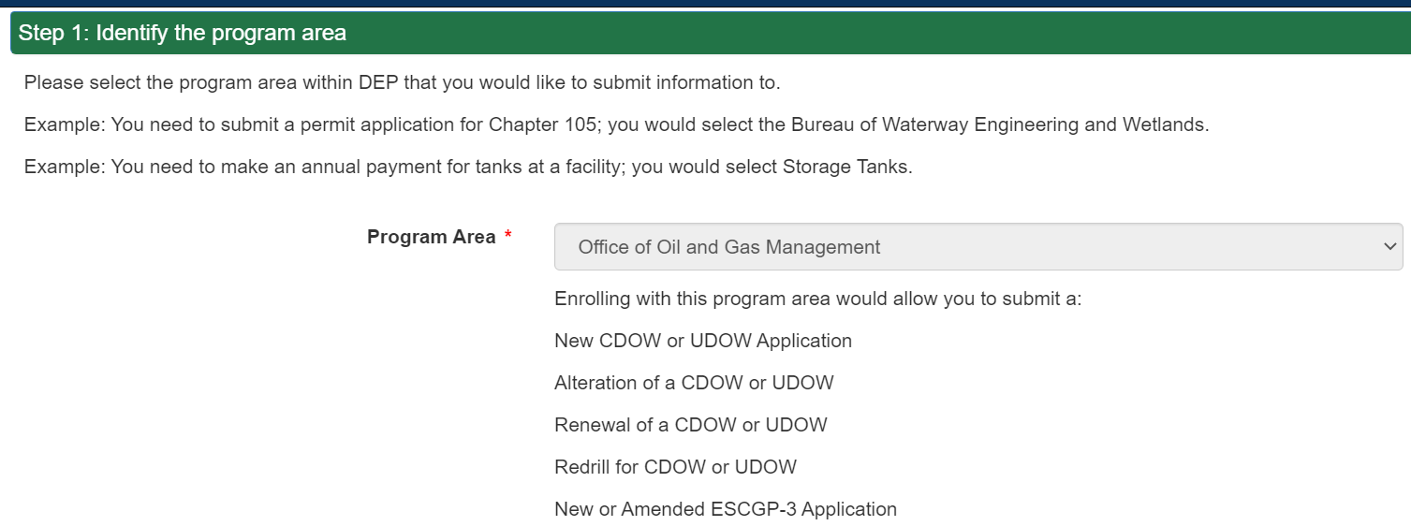



# **Step 2: Submitter Type**

Select the relationship to DEP that best describes your access.

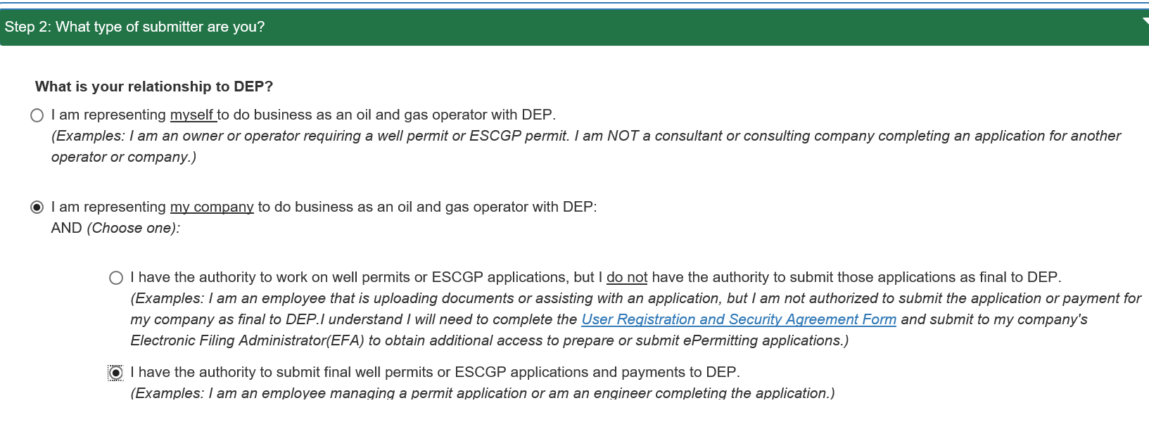

# **Step 3: Organizational Information**

Please provide the information requested. Fields that are required are marked with an asterisk *. Providing additional information such as associated known DEP Client ID will help to not cause possible delay in processing the request.

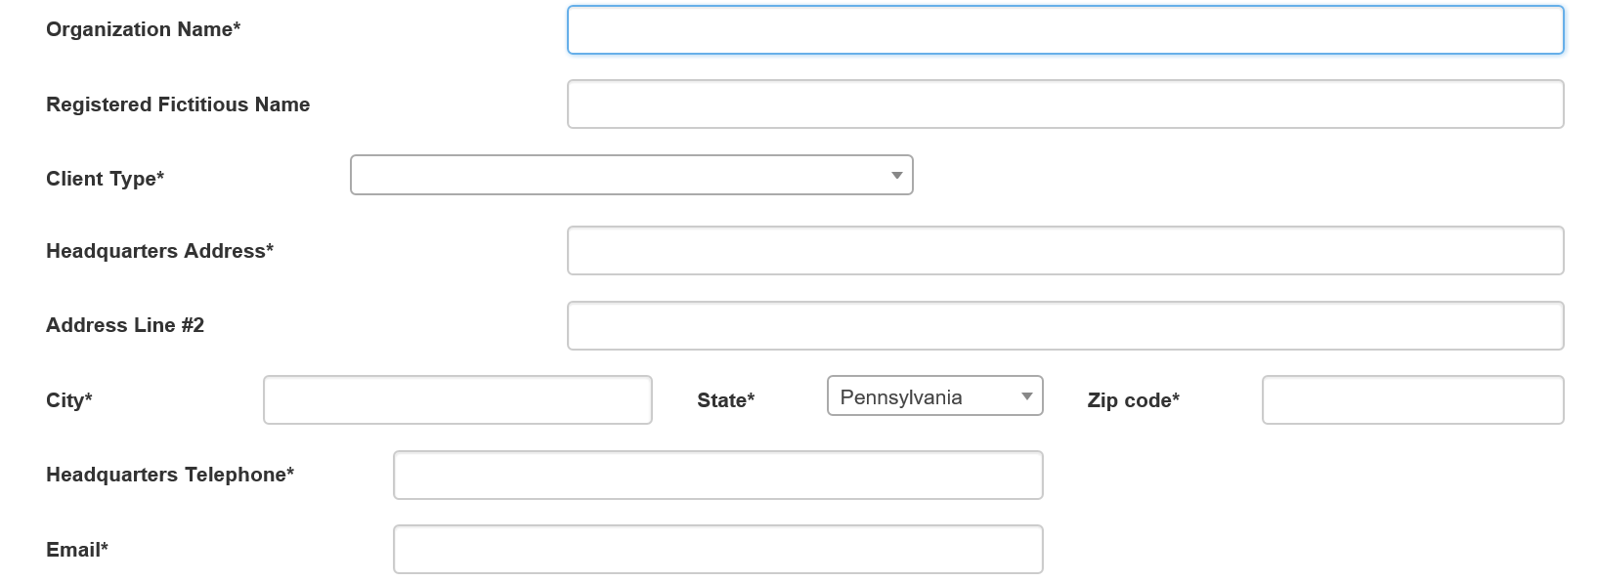

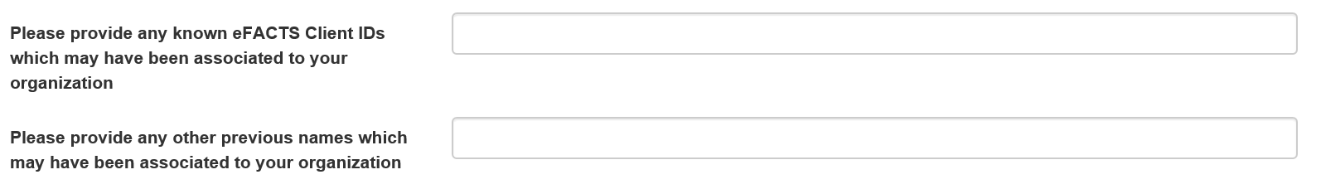

# **Step 4: Review the Security Agreement**

Review the Security Agreement to understand the terms and conditions of your access to the Department of Environmental Protection (DEP’s) ePermitting system.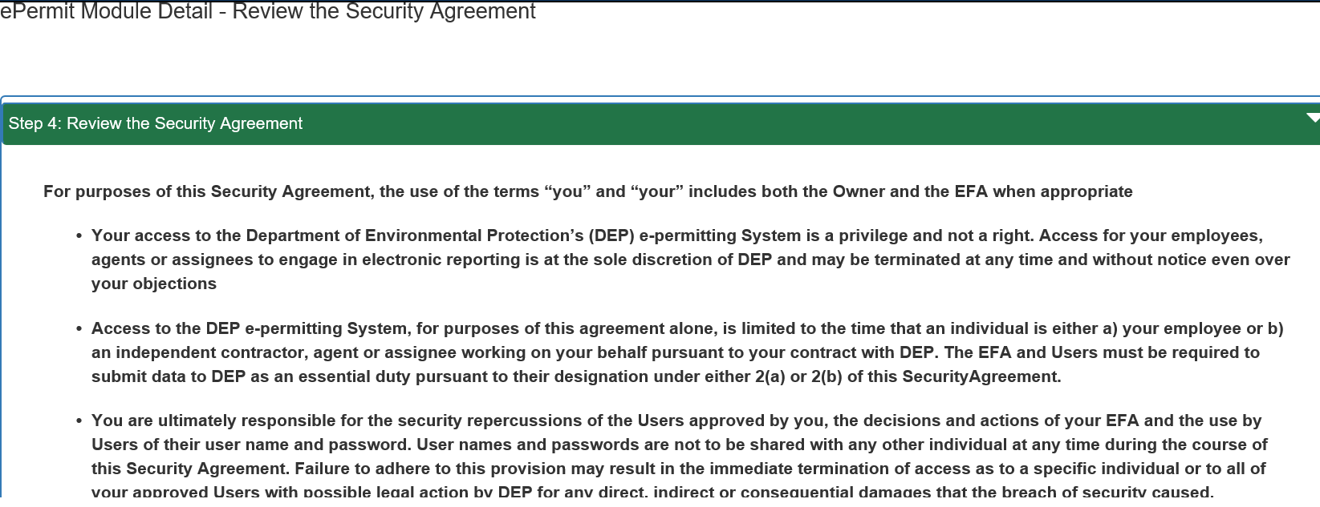

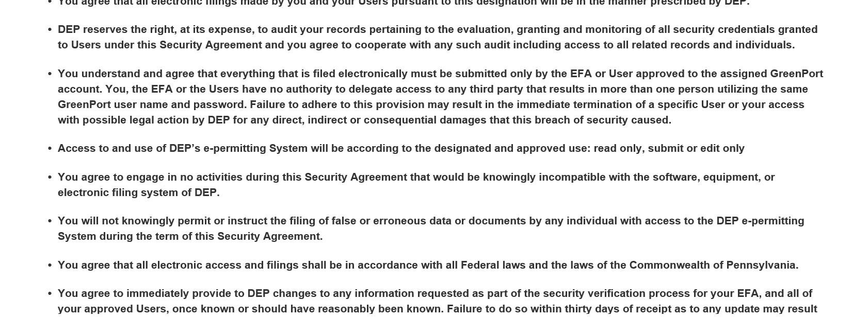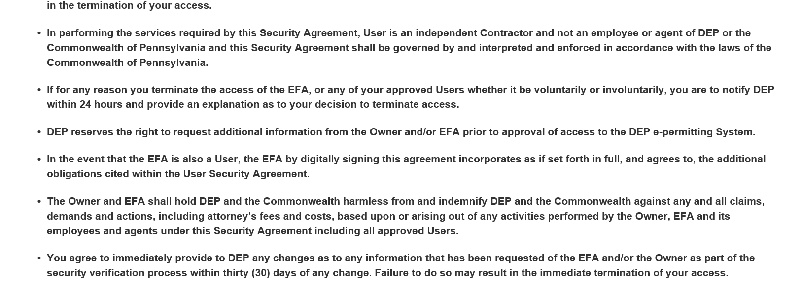

# **Step 5: Organization Electronic Signature**

Be sure to check the block that you understand and agree to the terms outlined within the Security Agreement.

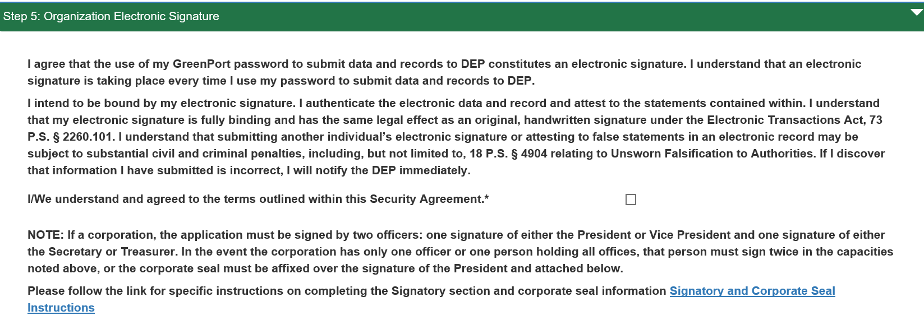

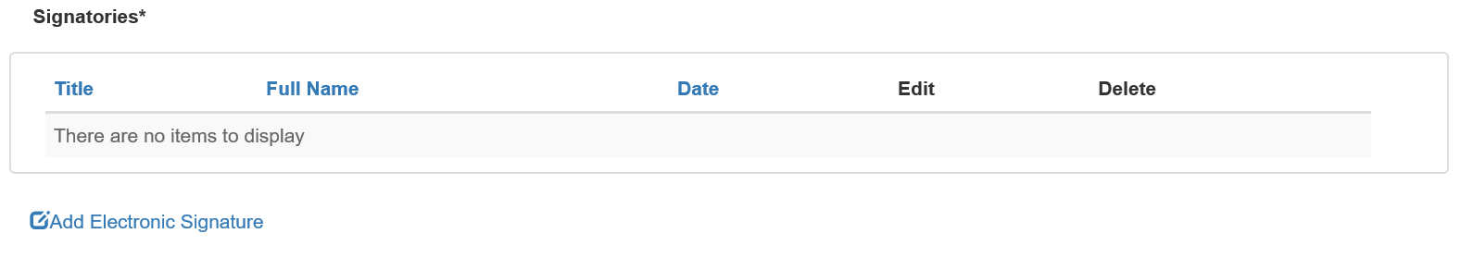

Select Electronic Signature or click Add Electronic Signature to create a new one.

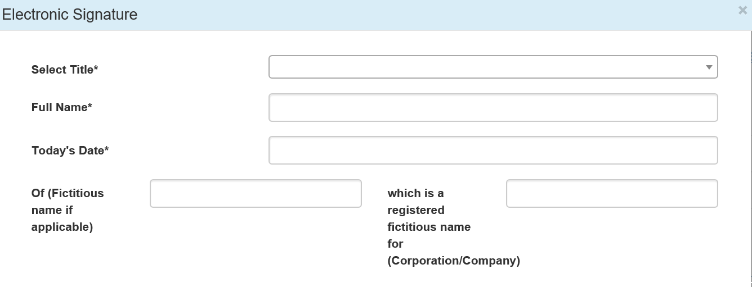

# **Step 6: REVIEW, SUBMIT AND GET STARTED**

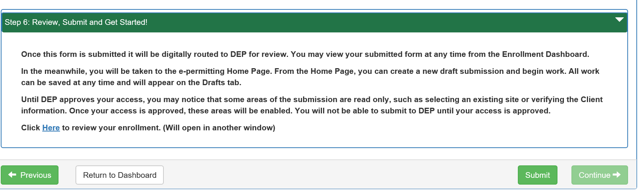

You can review all your information by clicking the hyper link in the box. If your information appears correct click  .

After submitting your EFA ePermitting enrollment, the information you entered will be sent to the

DEP’s Instant access / New client registration program for DEP Approval. Once your request is reviewed and approved you will receive a notification email. If your request is rejected, you will also receive an e-mail containing an explanation of why the request was rejected.

With the new updated Wizard enrollment process, the EFA can begin working on a draft permit application while awaiting DEP approval.

The ePermitting Home page should be displayed. To being a permit in ePermitting click the Program icon to get started!

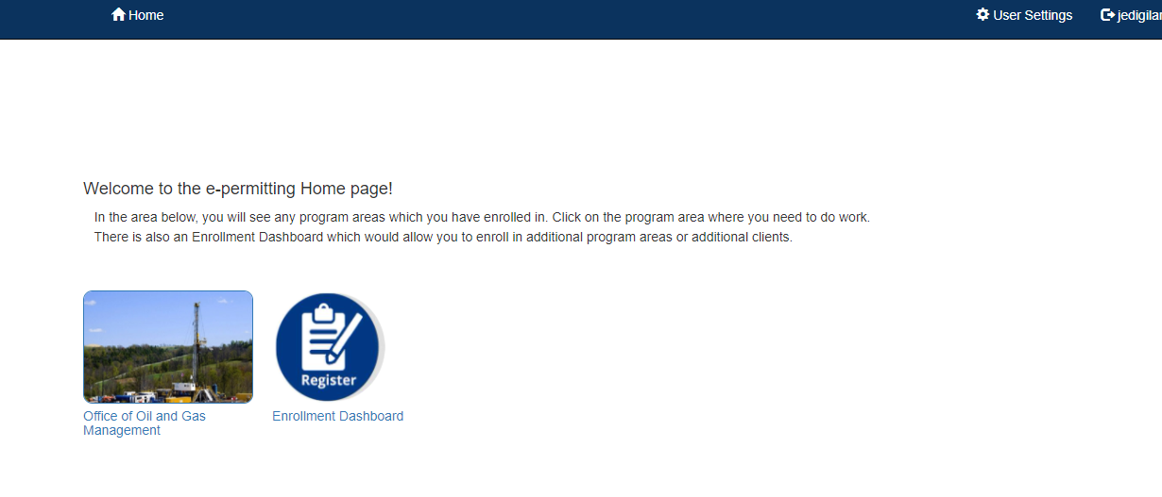

# **Change History**

|  |  |  |
| --- | --- | --- |
| **Version** | **Date** | **Revision Description** |
| 1 | December 3, 2021 | Creation of EFA Enrollment Guide |