August 24, 2016
Mr. Domenic Rocco
Program Manager, Waterways & Wetlands
PA Department of Environmental Protection
2 E. Main Street.
Norristown, PA 19401
Dear Mr. Rocco:
I write to you today on behalf of The Chamber of Commerce for Greater Philadelphia and the Greater Philadelphia Energy Action Team (GPEAT) to respectfully request the Pennsylvania Department of Environmental Protection (DEP) grant the permitting necessary for the Mariner East II Pipeline to proceed.
GPEAT is a multi-industry energy consortium of 90+ business, public sector, labor and academic leaders working to promote pipeline development from PA shale wells to the Greater Philadelphia region, attract more energy-intensive manufacturing companies to the region and build a demand center by increasing the consumption of natural gas and natural gas liquids (NGLs) in the region and increase the economic value.
In March of 2016, GPEAT issued a report, “A Pipeline for Growth” outlining GPEAT’s strategy to create a regional energy hub through further development of pipeline capacity into the Greater Philadelphia region from the Marcellus and Utica shale regions. Upon release of the report, GPEAT announced a shared goal to double the amount of natural gas flowing into our region—an additional 3Bcf/day of natural gas.
Projects like the Mariner East II Pipeline will bring additional volumes of natural gas liquids (NGLs) directly into the Greater Philadelphia region allowing for communities and businesses to start to see the economic benefit of connectivity to shale resources which provide feedstock for petrochemical and manufacturing operations and low cost fuel sources.
Economic analysis by Econsult Solutions, Inc. and KPMG conducted for the GPEAT report, estimates that an additional 3 Bcf/day of gas to establish a regional energy hub will account for $10 billion/year investment in manufacturing and result in 10,000 jobs created. Our region’s proximity and access to a steady long-term supply of NGLs (ethane, propane, and butane) is the key to expanding our petrochemical, chemical, and manufacturing sectors and attracting new business to our region and the Commonwealth of Pennsylvania.
The world markets are focused on the opportunities that can be derived from the abundant shale resources within Pennsylvania. GPEAT supports the construction of the Mariner East II Pipeline and believes it is the first of many steps we can take to reach and maintain energy independence and regain our region’s and nation’s position as an energy leader.

Sincerely,
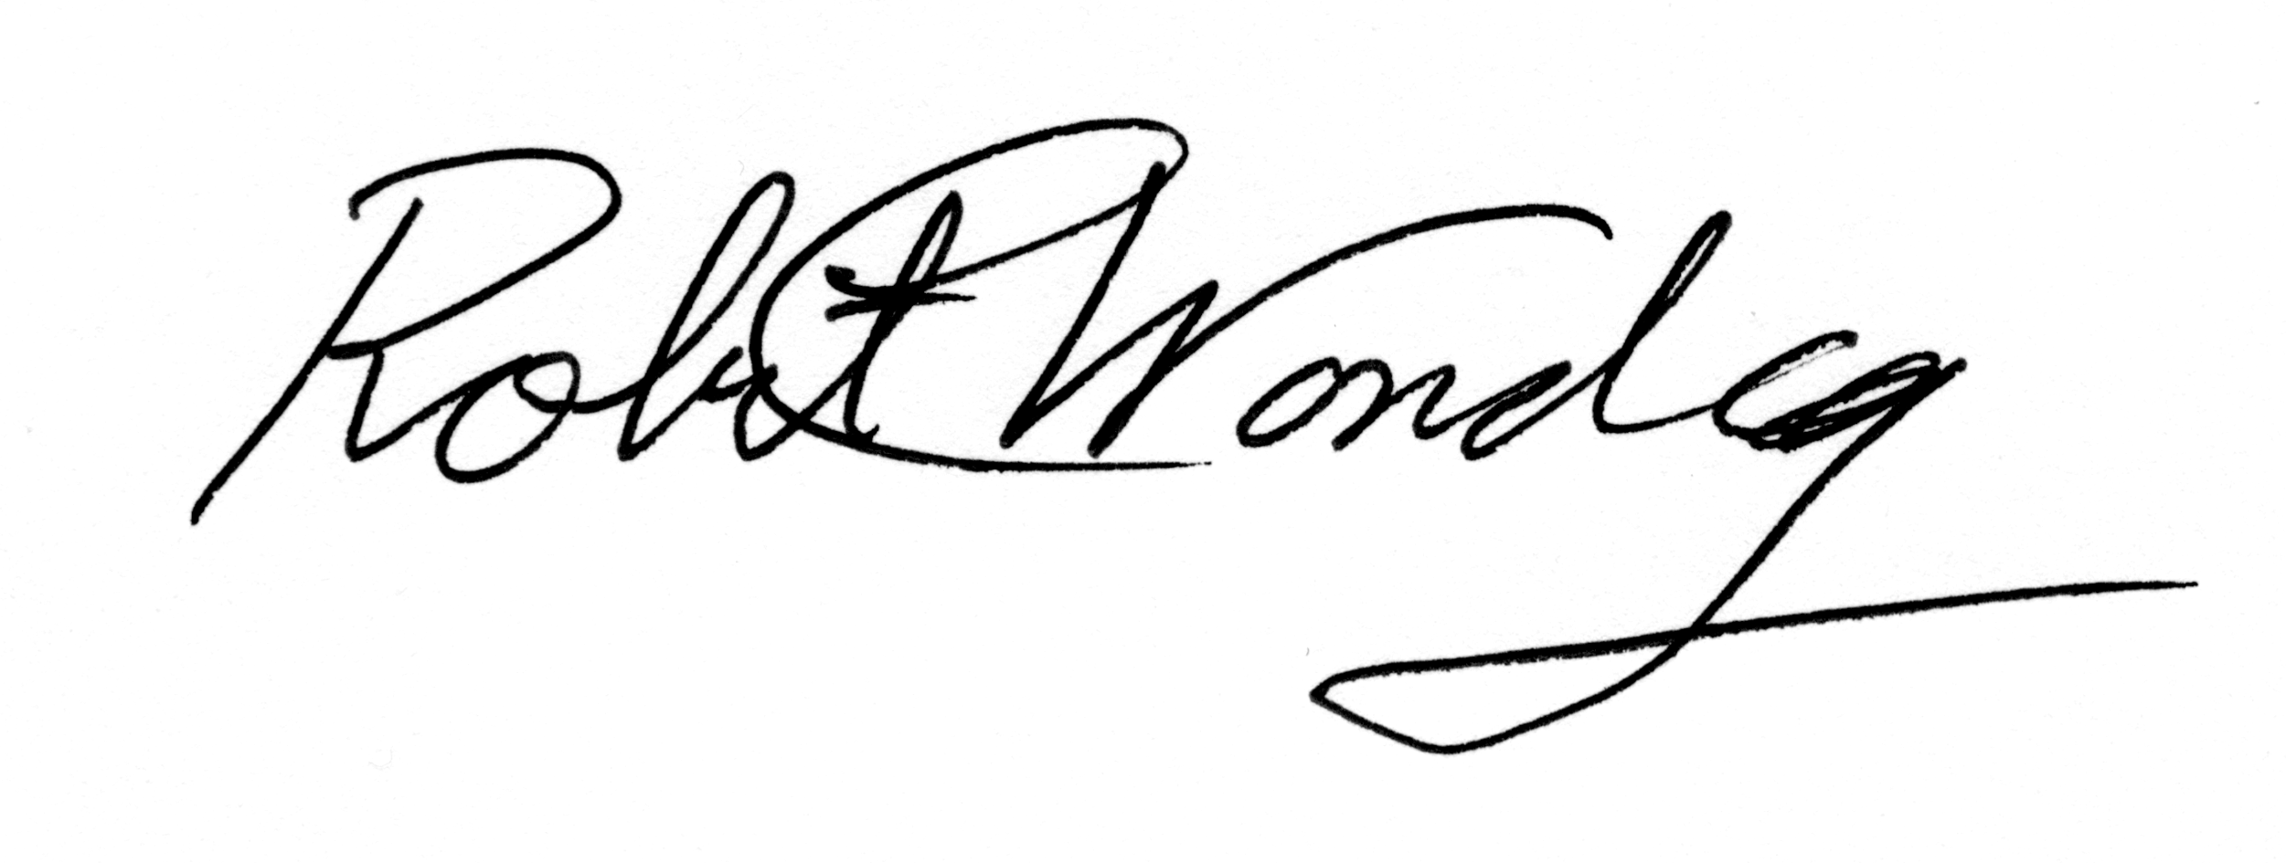

Rob Wonderling
President & CEO

