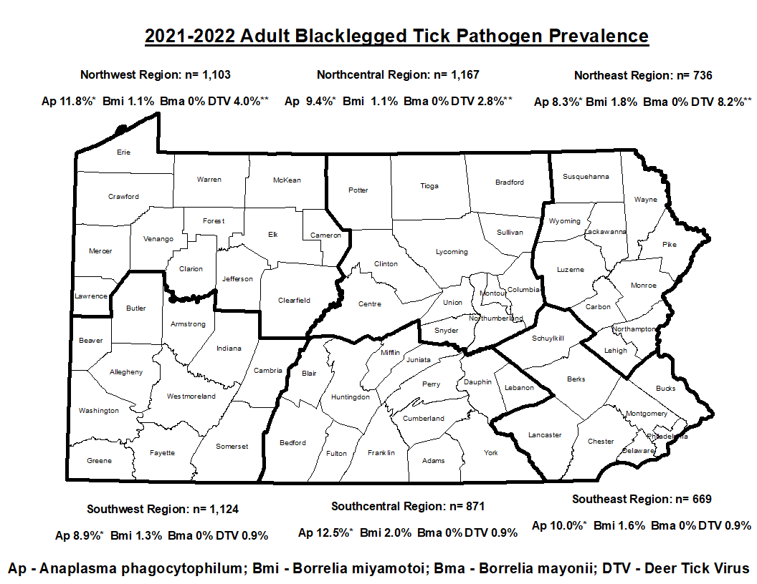
*Anaplasma phagocytophilum infection rates do not differentiate between deer and human variant.
**DTV infection rates are inflated in the northern part of the state due to the 3 “hotspots” that were identified in Clearfield, Centre, and Wyoming Counties.
These are the results for the most recent Ixodes scapularis adult statewide survey that was completed in the spring of 2022 delineated by PA Department of Health Regions. A minimum of 50 adult Blacklegged ticks were tested from each county. The total number of specimens collected in the region are denoted by the “n.” Individual ticks were tested for the presence of 4 pathogens, including Anaplasma phagocytophilum, Borrelia miyamotoi, Borrelia mayonii, and Deer Tick Virus (Powassan Virus lineage II).

