Social Media Toolkit: EJ Policy Revision
EJ Policy Revision
After years of preparation and collaboration, an updated Department of Environmental Protection (DEP) Environmental Justice Policy is available for official public comment from now until May 11th. DEP will host four virtual public hearings in April to accept verbal public comment. Written public comment is also always welcome.
Read the updated policy, view the public hearing dates, and learn how to comment at dep.pa.gov/EJPolicyRevision
All pa.gov website pages can be translated into a variety of languages using the “Translate” button at the top right of the website.
Four Live Virtual Hearings | April 5, 12, 28, and May 4.
The Department will hold four virtual public hearings to accept comments on the Draft Environmental Justice Policy. Each hearing will include a brief presentation about the policy. The hearings will be held on the following dates:
Tuesday, April 5, 2022 at 5 p.m.
Tuesday, April 12, 2022 at 6 p.m.
Thursday, April 28, 2022 from 12 p.m.
Wednesday, May 4, 2022 at 6 p.m.

DEP accounts to tag:

Facebook: https://www.facebook.com/PennsylvaniaDEP/
LinkedIn: https://www.linkedin.com/company/pennsylvaniadep
Twitter: https://twitter.com/PennsylvaniaDEP
Instagram: https://www.instagram.com/pennsylvaniadep/

Newsletter text
Press Release:
A full press release is posted here.
Short:
After years of preparation and collaboration, an updated Department of Environmental Protection (DEP) Environmental Justice Policy is available for official public comment from now until May 11th. DEP will host four virtual public hearings in April to accept verbal public comment. Written public comment is also always welcome. Read the updated policy, view the public hearing dates, and learn how to comment at the EJ Policy Revision webpage.
Long:
After years of preparation and collaboration, an updated Department of Environmental Protection (DEP) Environmental Justice Policy is available for official public comment from now until May 11th. The draft policy moves beyond the public participation in the permitting process – it looks at ways DEP can further environmental justice goals in compliance, enforcement, grantmaking, and other aspects of DEP’s work. DEP will host four virtual public hearings in April to accept verbal public comment. Written public comment is also always welcome. Read the updated policy, view the public hearing dates, and learn how to comment at the EJ Policy Revision webpage. All pa.gov website pages can be translated into a variety of languages using the “Translate” button at the top right of the website.
The changes that we have been discussing and devising with stakeholders for years are now assembled in a draft policy that has eight sections.
- General Information includes definitions, history and background, a description of the Office of Environmental Justice (OEJ), and the Environmental Justice Advisory Board (EJAB).
- Permit Review Process is the process around implementing additional public input around particular permits when they are submitted.
- Community Input describes a range of opportunities for public input throughout and before the permit review process.
- Oil and Gas Public Engagement was a major need identified by community members and was included in the fourth section.
- Inspections, Compliance, and Enforcement guidance helps the policy move beyond public participation in the permitting process and are covered in the fifth section.
- Climate Initiatives spells out ways that EJ can be included in the climate action plan and other efforts.
- Community Development and Investments look to ways to financially assist communities facing environmental justice issues in the seventh section.
- Policy Updates, the final section, specifies that the policy should be reviewed for updates regularly to ensure that the policy continues to address community concerns.
At the request of stakeholders, this policy goes beyond the current policy’s scope of public participation and meetings during the review of permit applications. This policy integrates environmental justice into more of the Department’s functions including climate initiatives, penalties (Inspections, Compliance, and Enforcement), and grantmaking (Community Development and Investments).
Visit the policy revision webpage to review the policy today and learn how to comment.
Four virtual public hearings will be held to provide an opportunity to learn more about the policy and provide an opportunity to give verbal public comment. Virtual public hearing times and information on how to sign up can be found on the EJ policy revision webpage. All pa.gov website pages can be translated into a variety of languages using the “Translate” button at the top right of the website.

Social Media Posts

We need you! DEP has listened to stakeholder feedback, drafted a policy based on input, and now it’s your turn to comment on the draft Environmental Justice Policy. Learn more about the policy, sign up to participate in one of three virtual public hearings, or submit public comment on the website.
➡️ dep.pa.gov/EJPolicyRevision
DEP’s Environmental Justice Policy has been revised. Did DEP hit or miss the mark? 🎯 Let them know at one of three virtual public hearings. Learn more ➡️ dep.pa.gov/EJPolicyRevision
Is your community facing environmental burdens like lead exposure, poor air quality, or pollution from industry? Did you know that DEP has updated their Environmental Justice Policy to expand its impact? Learn more about draft Environmental Justice Policy and how to comment at DEP’s website.
➡️ dep.pa.gov/EJPolicyRevision
Did you know that DEP has updated their Environmental Justice Policy to expand its impact? Learn more about draft Environmental Justice Policy and how to comment at DEP’s website.
➡️ dep.pa.gov/EJPolicyRevision

Graphics

(right click and save As Picture)
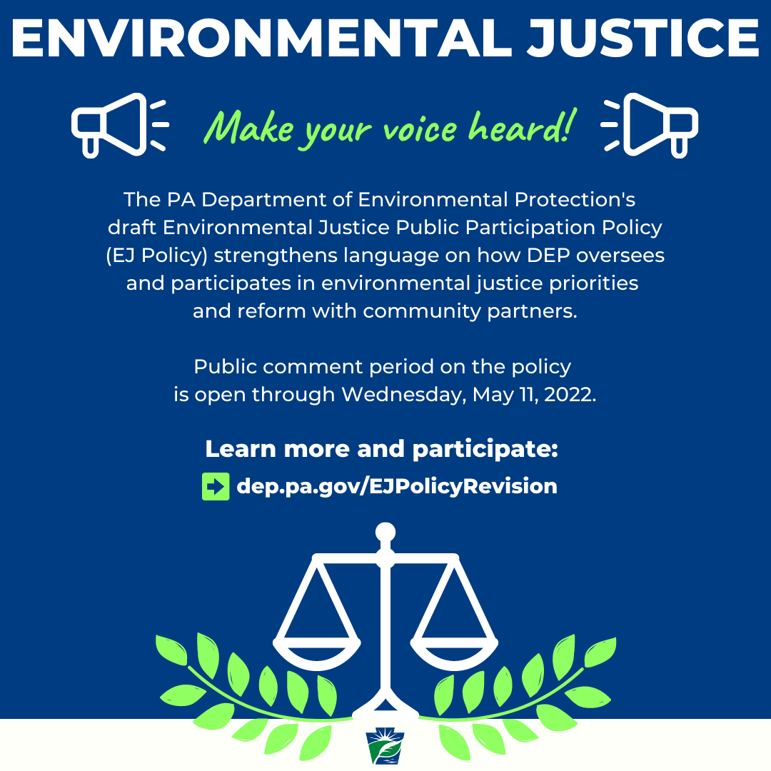

Video

(Click here to download and share)
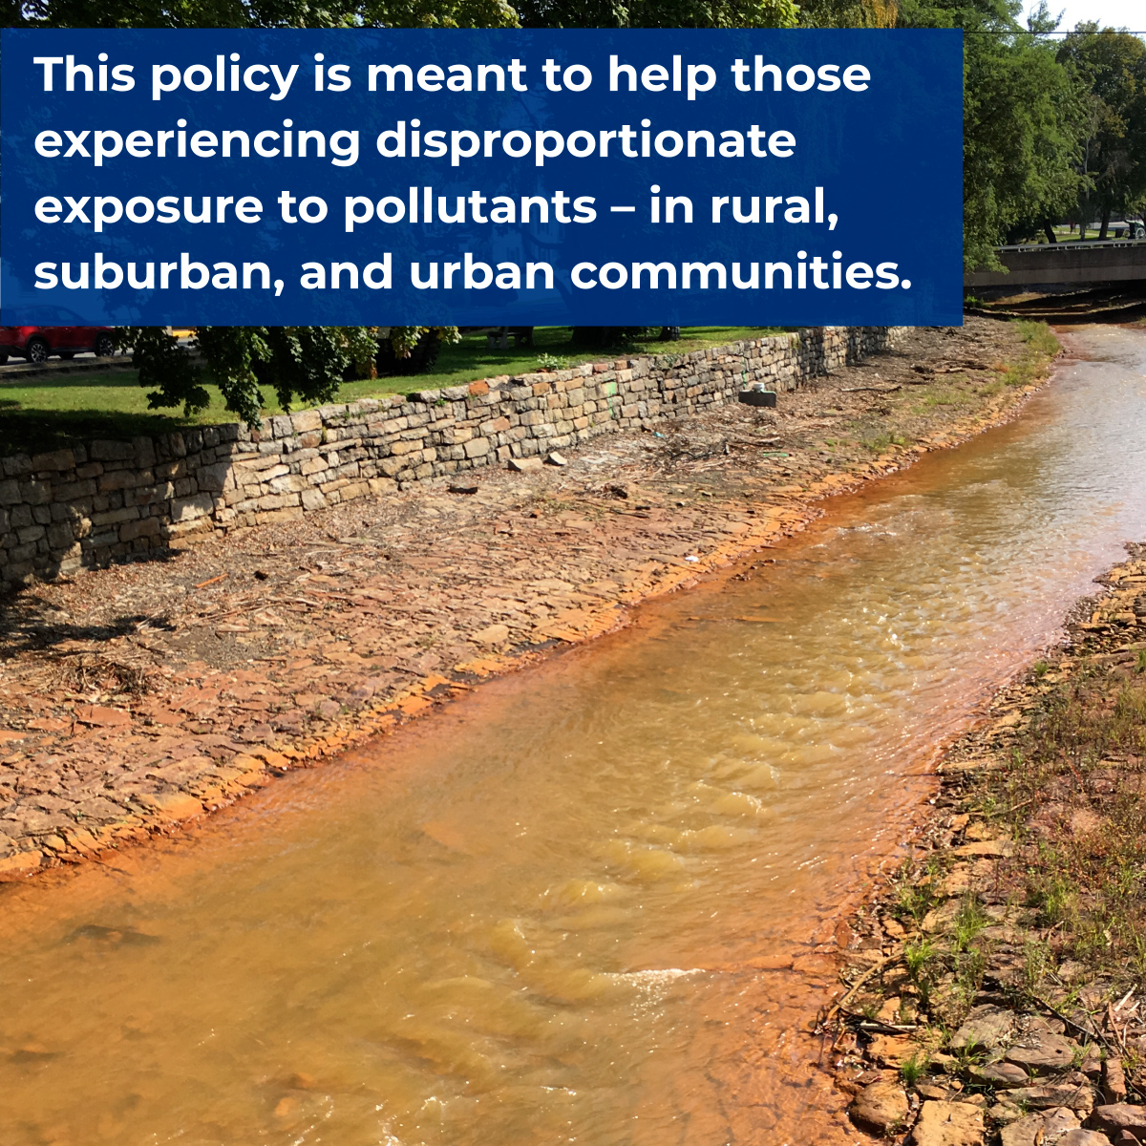
Download Video

