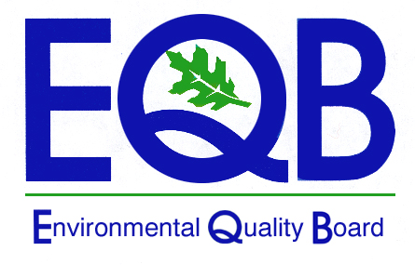

PROPOSED RULEMAKING

MEASUREMENT AND REPORTING OF

CONDENSABLE PARTICULATE MATTER EMISSIONS

(25 Pa. Code Chapters 121 and 139)

ENVIRONMENTAL QUALITY BOARD MEETING

APRIL 17, 2012

