COMMONWEALTH OF PENNSYLVANIA
Department of Environmental Protection
Bureau of Laboratories
(717) 346-7200
September 2, 2015
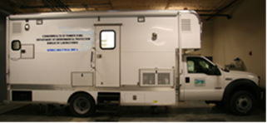
SUBJECT: Analysis Report for June15-18, 2015

TO: Roger Bellas, Waste Management Program Manager
Northeast Regional Office
Department of Environmental Protection
2 Public Square
Wilkes-Barre, PA 18701-1915

FROM: Linda Hreha, Supervisor
Mobile Laboratory Group
Bureau of Laboratories
P.O. Box 1467
Harrisburg, PA 17105

The following text outlines results obtained from air analysis performed June 15-18, 2015 at and near the Keystone Landfill Facility. The instrumentation utilized in the testing was a RAM 2000 Open Path Fourier Transform Infrared Spectrometer (OPFTIR). The analytical method performed was EPA Compendium Method TO-16.

*****The results of the analysis provided in this laboratory report relate only to the sample(s) identified in the report. *****
Unless otherwise noted, the results presented on this laboratory report meet all the requirements of the NELAC Institutes (TNI).
*****This test report shall not be reproduced except in full without the written approval of the laboratory.*****
Analytical Report

Sampling Locations and Weather Conditions for Analysis
Date | Sample  ID | Location | Time  (24 hr) | Average Wind Direction | Average  Wind  Speed (mph) | Weather  Conditions
6/15/2015 | 15JUN15UPWIND1551 | Lackawana County Safety Center  Latitude: 41’ 27” 22.52 N  Longitude: 75’ 33” 21.15 W | 15:51-16:25 | S/SW | 3 | Cloudy/Rain
6/16/2015 | 16JUN15MLG0756 | Leachate Lagoon  Latitude: 41°26'5.63"N  Longitude:75°35'45.97"W | 07:56-12:01 | SE | 8 | Cloudy/Rain
6/16/2015 | 16JUN15MLG1314 | Landfill -Working Face  Latitude: 41°25'30.66"N  Longitude: 75°35'2.97"W | 13:14-17:16 | SW | 10 | Cloudy
6/17/2015 | 17JUN15MLG0756 | Sherwood Park  Latitude: 41°25'17.63"N Longitude:75°36'56.00"W | 07:56-12:00 | SW/W | 1 | Partly Cloudy
6/17/2015 | 17JUN15MLG1247 | Swinick Neighborhood  Latitude: 41°25'29.93"N Longitude:75°36'46.66"W | 12:47-16:47 | SW/W | 2 | Partly Cloudy
6/18/2015 | 18JUN15MLG0804 | Mid- Valley High School  - Athletic Field  Latitude: 41°26'53.62"N  Longitude:75°36'20.49"W | 08:04-12:05 | S\SE | 2 | Rainy/ Cloudy
6/18/2015 | 18JUN15MLG1255 | Mid Valley HS -Parking Lot  Latitude: 41°26'50.91"N  Longitude: 75°36'9.99"W | 1255-1700 | E/SE | 4 | Cloudy

Terms:

Time Weighted Average (TWA)- the average concentration during the specified analysis time.
Max- Maximum concentration observed during the specified analysis time.
Time of Maximum- Specific time during the analysis session that the maximum concentration
is observed.

*****The results of the analysis provided in this laboratory report relate only to the sample(s) identified in the report. *****
Unless otherwise noted, the results presented on this laboratory report meet all the requirements of the NELAC Institutes (TNI).
*****This test report shall not be reproduced except in full without the written approval of the laboratory.*****
Analytical Report
DEP Bureau of Laboratories
P.O. Box 1467
Harrisburg, PA 17105

Sample ID: 15JUN15UPWIND1551

Date of Analysis: 06/15/2015

Locations for sampling as determined by DEP Northeast Regional Office Staff

Upwind Spectrum*: 15JUN15UPWIND1551

Sampling Location: Lackawana County Safety Center
Latitude: 41’ 27” 22.52 N
Longitude: 75’ 33” 21.15 W

Client: Roger Bellas, Waste Management Program Manager
Northeast Regional Office
Department of Environmental Protection
2 Public Square
Wilkes-Barre, PA 18701-1915

Method: EPA Compendium Method TO-16 Atmospheric Gases

Sample medium: Atmospheric Gas

* The upwind spectrum obtained is representative of ambient atmospheric conditions near the analysis site but upwind of the specific analysis site. This upwind spectrum does not represent a zero concentration for constituents, only a representation of constituents in the air upwind of analysis site. All subsequent sampling was compared to this upwind spectrum. The format in which this upwind spectrum is obtained does not allow for concentration derivation. DEP Regional Staff directed the Mobile Laboratory Group Staff as to where this upwind spectrum was to be obtained.

*****The results of the analysis provided in this laboratory report relate only to the sample(s) identified in the report. *****
Unless otherwise noted, the results presented on this laboratory report meet all the requirements of the NELAC Institutes (TNI).
*****This test report shall not be reproduced except in full without the written approval of the laboratory.*****

Analytical Report

DEP Bureau of Laboratories
P.O. Box 1467
Harrisburg, PA 17105

Sample ID: 16JUN15MLG0756

Date of Analysis: 6/16/2015

Locations for sampling as determined by DEP Northeast Regional Office Staff

Upwind Spectrum*: 15JUN15UPWIND1551

Sampling Location: Leachate Lagoon
Latitude: 41°26'5.63"N
Longitude: 75°35'45.97"W

Client: Roger Bellas, Waste Management Program Manager
Northeast Regional Office
Department of Environmental Protection
2 Public Square
Wilkes-Barre, PA 18701-1915

Method: EPA Compendium Method TO-16 Atmospheric Gases

Sample medium: Atmospheric Gas

* The upwind spectrum obtained is representative of ambient atmospheric conditions near the analysis site but upwind of the specific analysis site. This upwind spectrum does not represent a zero concentration for constituents, only a representation of constituents in the air upwind of analysis site. All subsequent sampling was compared to this upwind spectrum. The format in which this upwind spectrum is obtained does not allow for concentration derivation. DEP Regional Staff directed the Mobile Laboratory Group Staff as to where this upwind spectrum was to be obtained.

*****The results of the analysis provided in this laboratory report relate only to the sample(s) identified in the report. *****
Unless otherwise noted, the results presented on this laboratory report meet all the requirements of the NELAC Institutes (TNI).
*****This test report shall not be reproduced except in full without the written approval of the laboratory.*****
Analytical Report 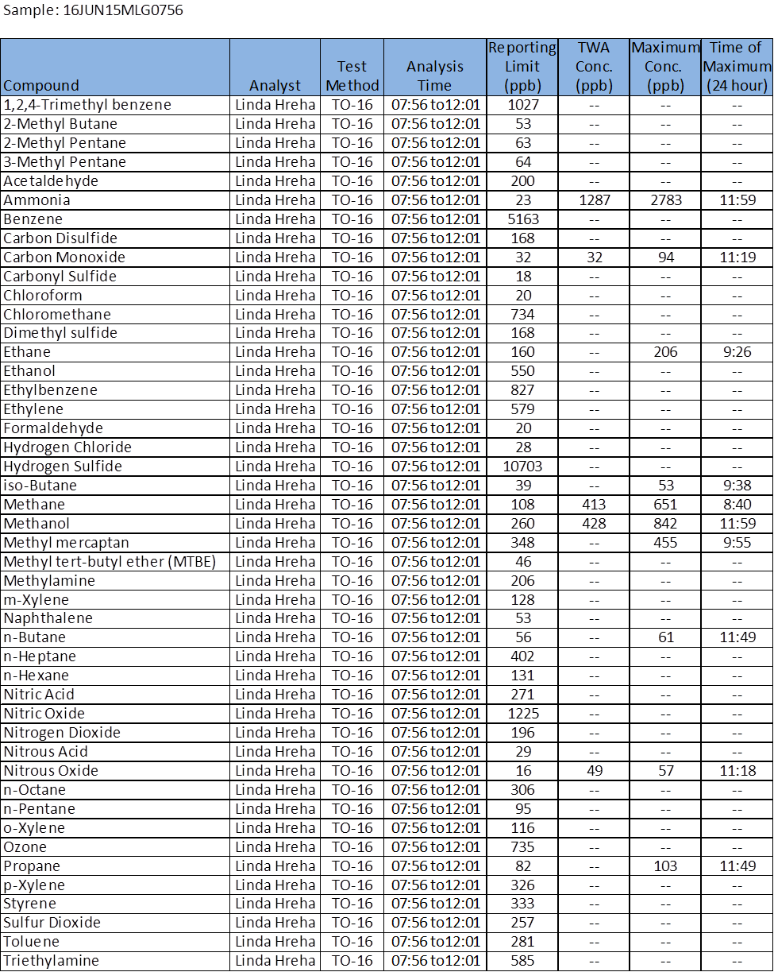

*****The results of the analysis provided in this laboratory report relate only to the sample(s) identified in the report. *****
Unless otherwise noted, the results presented on this laboratory report meet all the requirements of the NELAC Institutes (TNI).
*****This test report shall not be reproduced except in full without the written approval of the laboratory .*****
Analytical Report

DEP Bureau of Laboratories
P.O. Box 1467
Harrisburg, PA 17105

Sample ID: 16JUN15MLG1314

Date of Analysis: 6/16/2015

Locations for sampling as determined by DEP Northeast Regional Office Staff

Upwind Spectrum*: 15JUN15UPWIND1551

Sampling Location: Landfill -Working Face
Latitude: 41°25'30.66"N
Longitude: 75°35'2.97"W

Client: Roger Bellas, Waste Management Program Manager
Northeast Regional Office
Department of Environmental Protection
2 Public Square
Wilkes-Barre, PA 18701-1915

Method: EPA Compendium Method TO-16 Atmospheric Gases

Sample medium: Atmospheric Gas

* The upwind spectrum obtained is representative of ambient atmospheric conditions near the analysis site but upwind of the specific analysis site. This upwind spectrum does not represent a zero concentration for constituents, only a representation of constituents in the air upwind of analysis site. All subsequent sampling was compared to this upwind spectrum. The format in which this upwind spectrum is obtained does not allow for concentration derivation. DEP Regional Staff directed the Mobile Laboratory Group Staff as to where this upwind spectrum was to be obtained.

*****The results of the analysis provided in this laboratory report relate only to the sample(s) identified in the report. *****
Unless otherwise noted, the results presented on this laboratory report meet all the requirements of the NELAC Institutes (TNI).
*****This test report shall not be reproduced except in full without the written approval of the laboratory.*****
Analytical Report
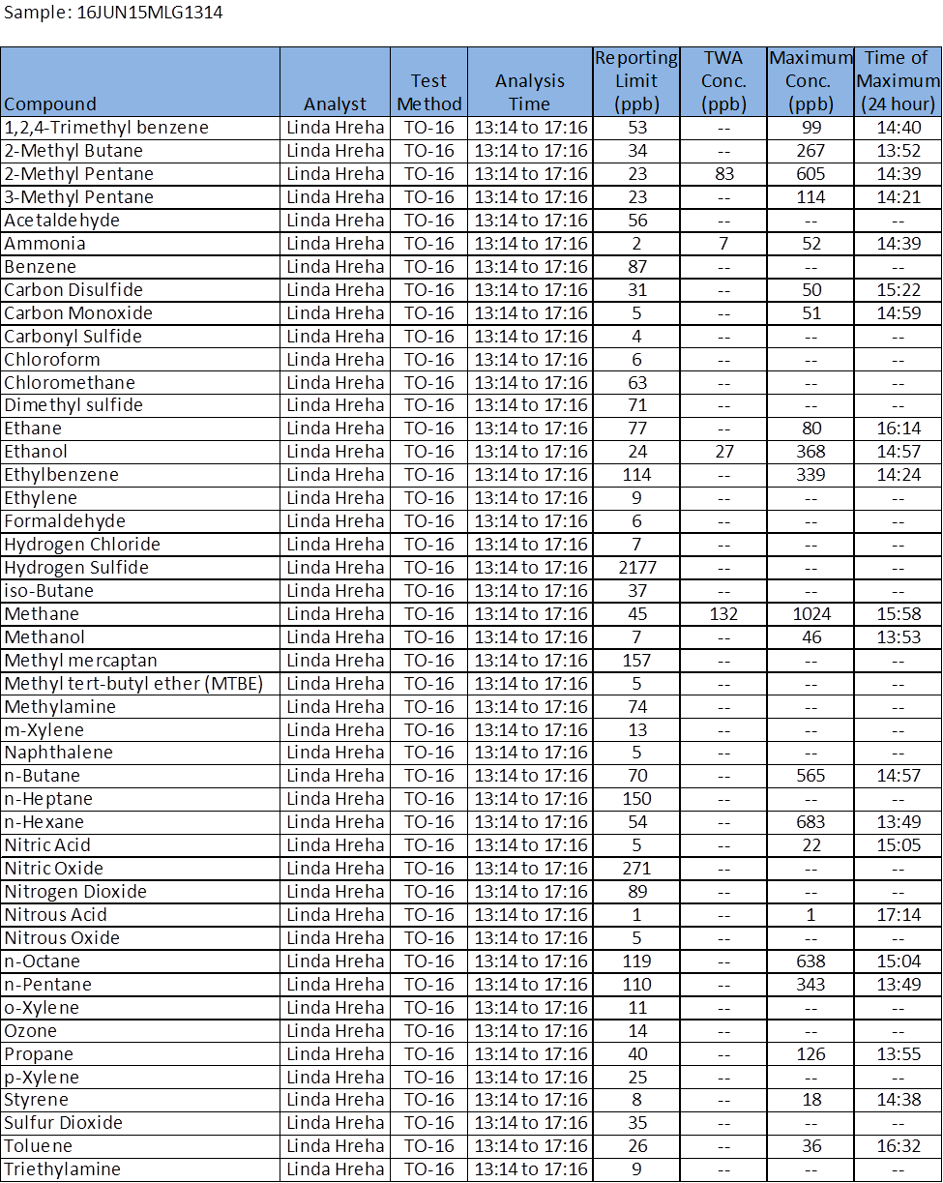

*****The results of the analysis provided in this laboratory report relate only to the sample(s) identified in the report. *****
Unless otherwise noted, the results presented on this laboratory report meet all the requirements of the NELAC Institutes (TNI).
*****This test report shall not be reproduced except in full without the written approval of the laboratory.*****
Analytical Report

DEP Bureau of Laboratories
P.O. Box 1467
Harrisburg, PA 17105

Sample ID: 17JUN15MLG0756

Date of Analysis: 6/17/2015

Locations for sampling as determined by DEP Northeast Regional Office Staff

Upwind Spectrum*: 15JUN15UPWIND1551

Sampling Location: Sherwood Park
Latitude: 41°25'17.63"N
Longitude:75°36'56.00"W

Client: Roger Bellas, Waste Management Program Manager
Northeast Regional Office
Department of Environmental Protection
2 Public Square
Wilkes-Barre, PA 18701-1915

Method: EPA Compendium Method TO-16 Atmospheric Gases

Sample medium: Atmospheric Gas

* The upwind spectrum obtained is representative of ambient atmospheric conditions near the analysis site but upwind of the specific analysis site. This upwind spectrum does not represent a zero concentration for constituents, only a representation of constituents in the air upwind of analysis site. All subsequent sampling was compared to this upwind spectrum. The format in which this upwind spectrum is obtained does not allow for concentration derivation. DEP Regional Staff directed the Mobile Laboratory Group Staff as to where this upwind spectrum was to be obtained.

*****The results of the analysis provided in this laboratory report relate only to the sample(s) identified in the report. *****
Unless otherwise noted, the results presented on this laboratory report meet all the requirements of the NELAC Institutes (TNI).
*****This test report shall not be reproduced except in full without the written approval of the laboratory.*****

Analytical Report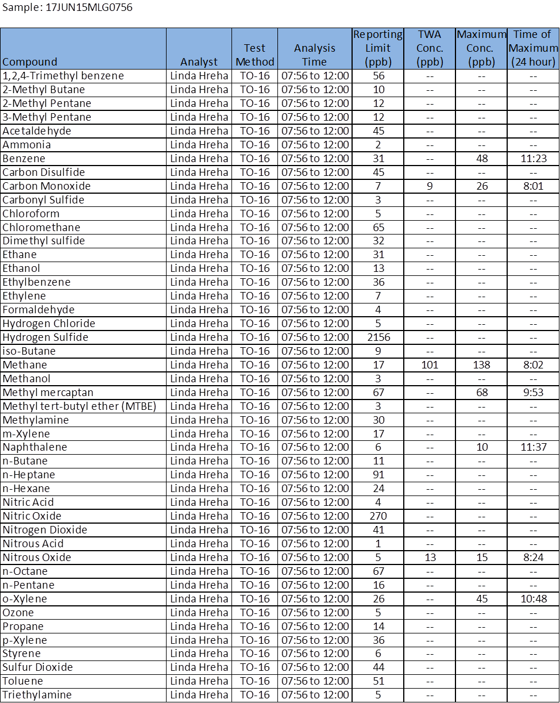
*****The results of the analysis provided in this laboratory report relate only to the sample(s) identified in the report. *****
Unless otherwise noted, the results presented on this laboratory report meet all the requirements of the NELAC Institutes (TNI).
*****This test report shall not be reproduced except in full without the written approval of the laboratory.*****
Analytical Report

DEP Bureau of Laboratories
P.O. Box 1467
Harrisburg, PA 17105

Sample ID: 17JUN15MLG1247

Date of Analysis: 6/17/2015

Locations for sampling as determined by DEP Northeast Regional Office Staff

Upwind Spectrum*: 15JUN15UPWIND1551

Sampling Location: Swinick Neighborhood
Latitude: 41°25'29.93"N
Longitude:75°36'46.66"W

Client: Roger Bellas, Waste Management Program Manager
Northeast Regional Office
Department of Environmental Protection
2 Public Square
Wilkes-Barre, PA 18701-1915

Method: EPA Compendium Method TO-16 Atmospheric Gases

Sample medium: Atmospheric Gas

* The upwind spectrum obtained is representative of ambient atmospheric conditions near the analysis site but upwind of the specific analysis site. This upwind spectrum does not represent a zero concentration for constituents, only a representation of constituents in the air upwind of analysis site. All subsequent sampling was compared to this upwind spectrum. The format in which this upwind spectrum is obtained does not allow for concentration derivation. DEP Regional Staff directed the Mobile Laboratory Group Staff as to where this upwind spectrum was to be obtained.

*****The results of the analysis provided in this laboratory report relate only to the sample(s) identified in the report. *****
Unless otherwise noted, the results presented on this laboratory report meet all the requirements of the NELAC Institutes (TNI).
*****This test report shall not be reproduced except in full without the written approval of the laboratory.*****
Analytical Report 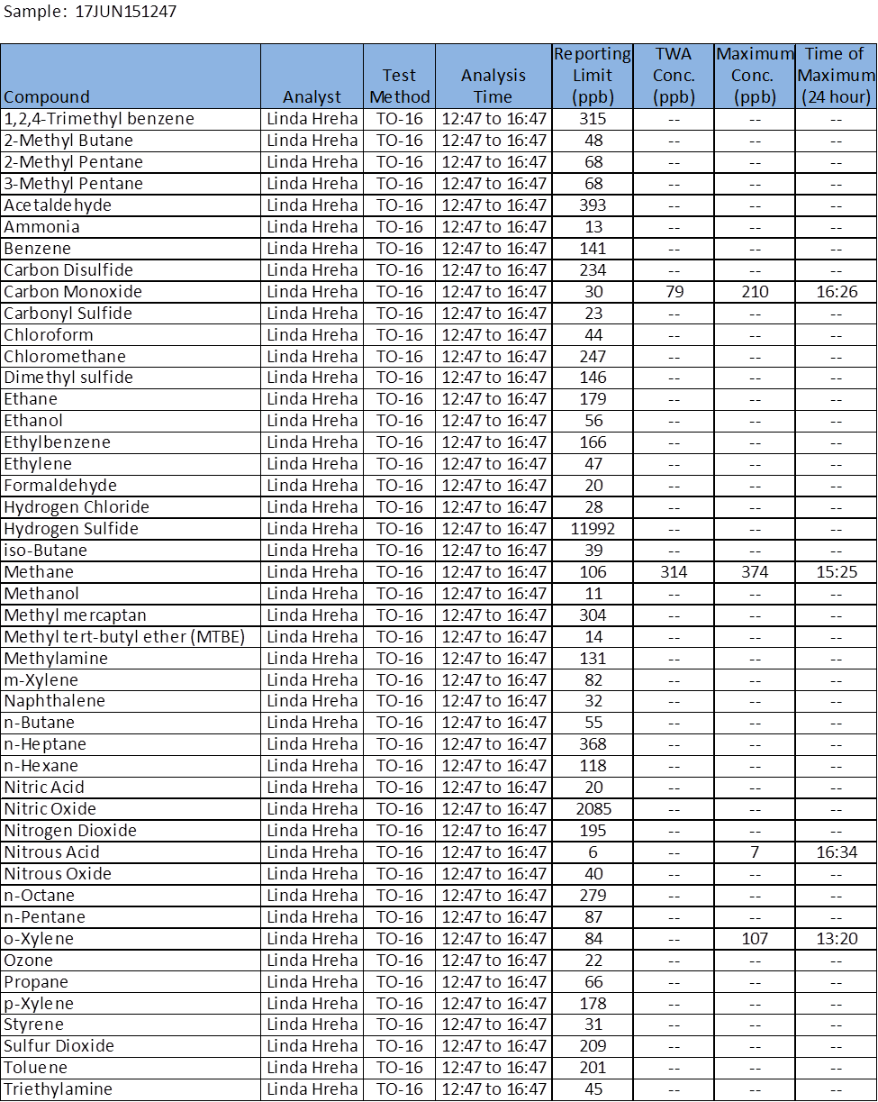
*****The results of the analysis provided in this laboratory report relate only to the sample(s) identified in the report. *****
Unless otherwise noted, the results presented on this laboratory report meet all the requirements of the NELAC Institutes (TNI).
*****This test report shall not be reproduced except in full without the written approval of the laboratory.*****
Analytical Report

DEP Bureau of Laboratories
P.O. Box 1467
Harrisburg, PA 17105

Sample ID: 18JUN15MLG0804

Date of Analysis: 6/18/2015

Locations for sampling as determined by DEP Northeast Regional Office Staff

Upwind Spectrum*: 15JUN15UPWIND1551

Sampling Location: Mid- Valley High School- Athletic Field
Latitude: 41°26'53.62"N
Longitude:75°36'20.49"W

Client: Roger Bellas, Waste Management Program Manager
Northeast Regional Office
Department of Environmental Protection
2 Public Square
Wilkes-Barre, PA 18701-1915

Method: EPA Compendium Method TO-16 Atmospheric Gases

Sample medium: Atmospheric Gas

* The upwind spectrum obtained is representative of ambient atmospheric conditions near the analysis site but upwind of the specific analysis site. This upwind spectrum does not represent a zero concentration for constituents, only a representation of constituents in the air upwind of analysis site. All subsequent sampling was compared to this upwind spectrum. The format in which this upwind spectrum is obtained does not allow for concentration derivation. DEP Regional Staff directed the Mobile Laboratory Group Staff as to where this upwind spectrum was to be obtained.

*****The results of the analysis provided in this laboratory report relate only to the sample(s) identified in the report. *****
Unless otherwise noted, the results presented on this laboratory report meet all the requirements of the NELAC Institutes (TNI).
*****This test report shall not be reproduced except in full without the written approval of the laboratory.*****

Analytical Report
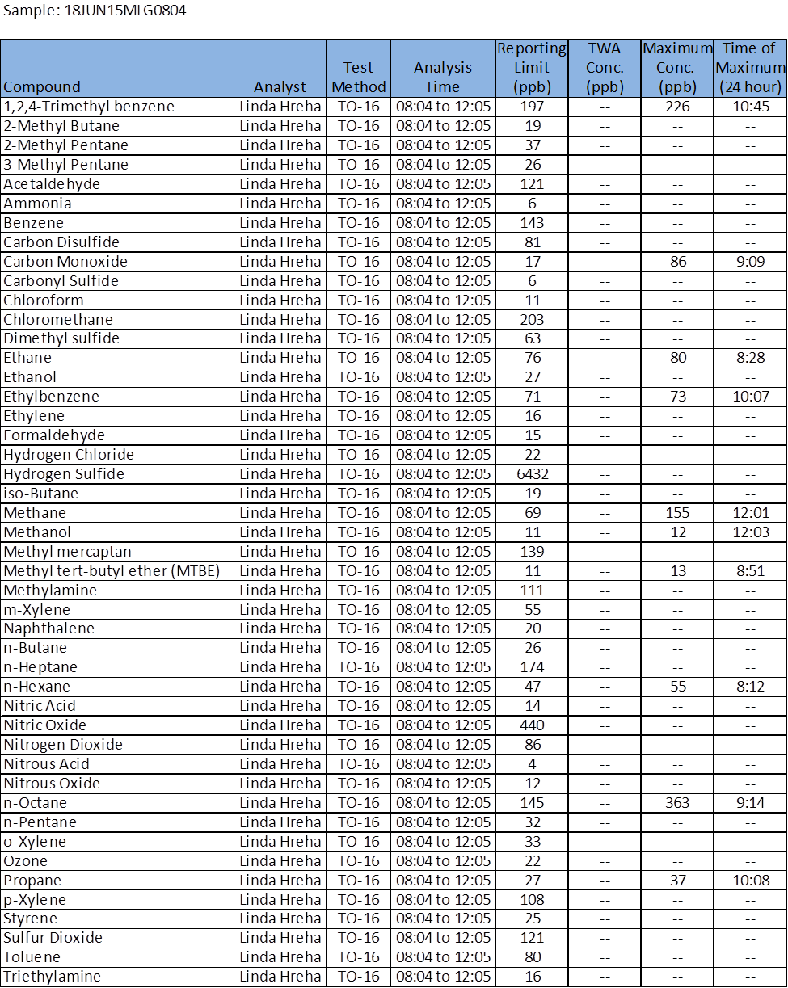
****The results of the analysis provided in this laboratory report relate only to the sample(s) identified in the report. *****
Unless otherwise noted, the results presented on this laboratory report meet all the requirements of the NELAC Institutes (TNI).
*****This test report shall not be reproduced except in full without the written approval of the laboratory.****

Analytical Report
DEP Bureau of Laboratories
P.O. Box 1467
Harrisburg, PA 17105

Sample ID: 18JUN15MLG1255

Date of Analysis: 6/18/2015

Locations for sampling as determined by DEP Northeast Regional Office Staff

Upwind Spectrum*: 15JUN15UPWIND1551

Sampling Location: Mid Valley High School-Parking Lot
Latitude: 41°26'50.91"N
Longitude: 75°36'9.99"W

Client: Roger Bellas, Waste Management Program Manager
Northeast Regional Office
Department of Environmental Protection
2 Public Square
Wilkes-Barre, PA 18701-1915

Method: EPA Compendium Method TO-16 Atmospheric Gases

Sample medium: Atmospheric Gas

* The upwind spectrum obtained is representative of ambient atmospheric conditions near the analysis site but upwind of the specific analysis site. This upwind spectrum does not represent a zero concentration for constituents, only a representation of constituents in the air upwind of analysis site. All subsequent sampling was compared to this upwind spectrum. The format in which this upwind spectrum is obtained does not allow for concentration derivation. DEP Regional Staff directed the Mobile Laboratory Group Staff as to where this upwind spectrum was to be obtained.

*****The results of the analysis provided in this laboratory report relate only to the sample(s) identified in the report. *****
Unless otherwise noted, the results presented on this laboratory report meet all the requirements of the NELAC Institutes (TNI).
*****This test report shall not be reproduced except in full without the written approval of the laboratory.*****

Analytical Report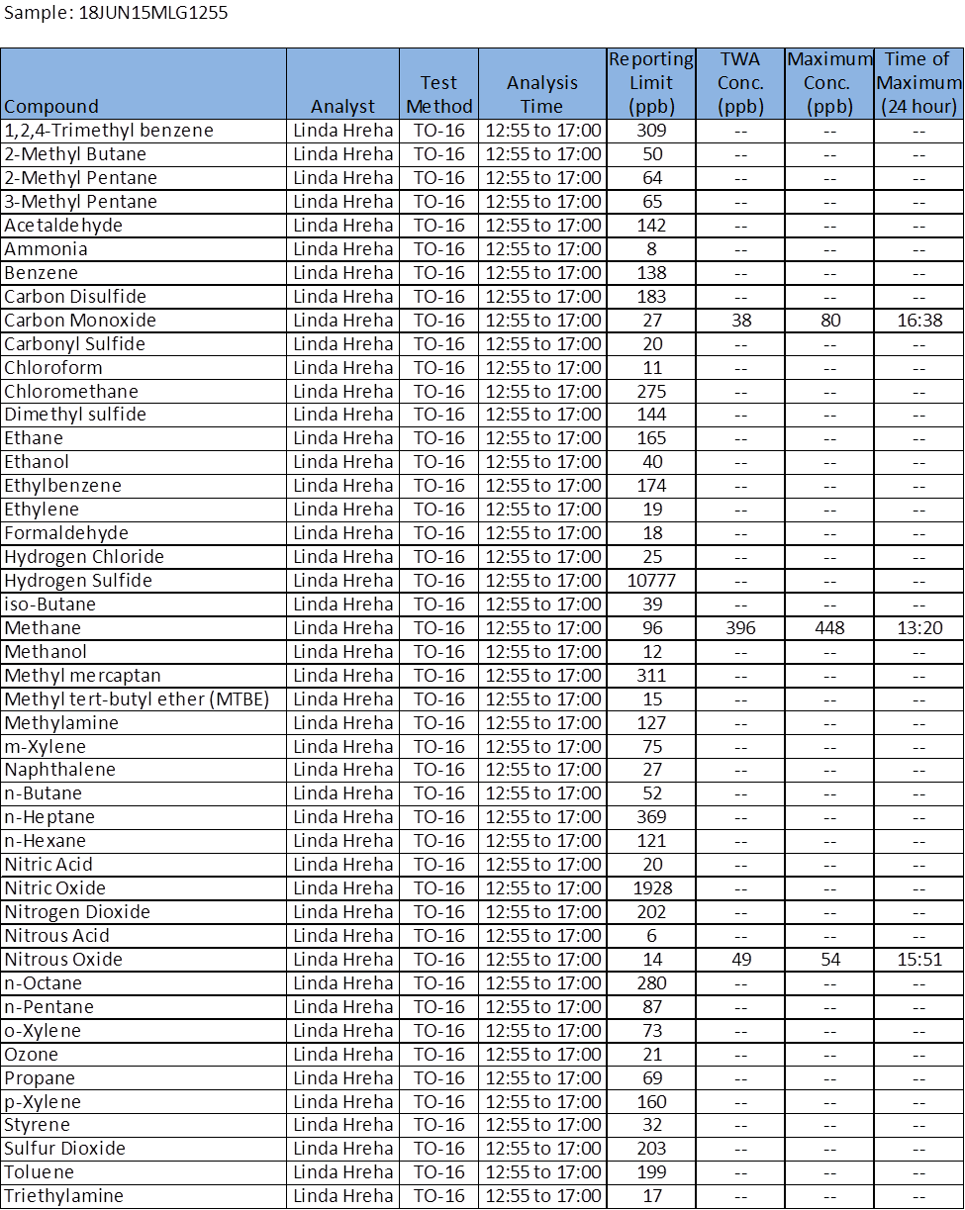
*****The results of the analysis provided in this laboratory report relate only to the sample(s) identified in the report. *****
Unless otherwise noted, the results presented on this laboratory report meet all the requirements of the NELAC Institutes (TNI).
*****This test report shall not be reproduced except in full without the written approval of the laboratory.*****

