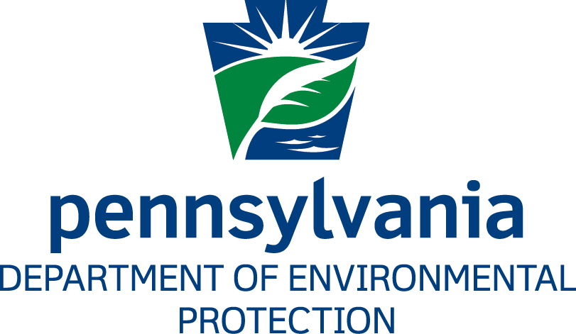

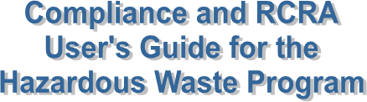

Prepared by: | Business Support Help Desk
Version: | 1.12
Date: | October 26, 2018

[THIS PAGE LEFT INTENTIONALLY BLANK]
Change History
Version | Date | Revision Description
1.0 | December 31, 2013 | Document created.
1.1 | January 9, 2014 | Updated with program feedback.
1.2 | February 28, 2014 | Updated “Maintaining HW Facility Details” sections and “Inspection Result Codes” descriptions.
1.3 | March 28, 2014 | Revised “Maintaining HW Facility Details” section.
1.4 | April 25, 2014 | Added section “Using HW Violation Codes vs. RW/MW Violation Codes”
1.5 | June 23, 2014 | Added section “Adding and Viewing Documents”
1.6 | August 4, 2014 | Updated content under “Maintaining HW Facility Details”
1.7 | December 17, 2015 | Updated Comprehensive Monitoring Evaluation (CME) to Groundwater Monitoring Evaluation (GME) throughout document.
1.8 | September 15, 2016 | Updates received from Hazardous Waste Program.
1.9 | September 27, 2016 | Help Desk reviews updates from Hazardous Waste Program.
1.10 | March 14, 2018 | Updates received from Hazardous Waste Program.
1.11 | March 23, 2018 | Business Support Help Desk reviews updates from Hazardous Waste Program.
1.12 | October 26, 2018 | Added “Caution” under “Closing Enforcement”

[THIS PAGE LEFT INTENTIONALLY BLANK]

Table of Contents
Purpose 3
Business Support Help Desk Team 3
Screen Examples 4
General Information 8
Security Roles 8
What is a Primary Facility? 8
What is a Sub-facility? 8
Basic Query Rules 9
Common Questions About Querying 9
RCRA/HW Inspections and Violations 10
Inspection Business Rules 10
Violation Business Rules 11
Valid Inspection Types 11
Valid Inspection Result Codes 12
Using HW Violation Codes vs. RW/MW Violation Codes 13
Inserting Inspections and Violations 13
Closing Violations 15
RCRA/HW Enforcements and Penalties 16
Enforcement Business Rules 16
Valid Enforcement Type Codes 16
Inserting an Enforcement 17
Inserting Penalties 17
Closing an Enforcement 18
Closing Penalties 19
Significant Non-Complier (SNC) Data Entry 20
SNY Inspection Type 20
Entering an SNY Inspection 20
Linking an Enforcement to an SNY Inspection 21
SNN Inspection Type 21
Entering an SNN Inspection 22
Maintaining HW Facility Details 23
Obtaining an EPA ID Number 24
Verifying Facility Details 24
Inactivating a Facility 26
Adding and Viewing Documents 28
Adding Documents to a Record 28
Viewing Documents Linked to an Inspection 29
Running a Compliance Report 30
Report Descriptions 31
Appendix I – Valid Inspection Types 33
Appendix II – FCI Inspection Focus Areas 37

Purpose
This guide provides instructions on how field staff with the Bureau of Waste Management’s (WM) Division of Hazardous Waste (HW) should use the Environment Facility Application Compliance Tracking System (eFACTS) to enter inspection records and enforcement activities as they relate to the Resource Conservation and Recovery Act (RCRA).

Business Support Help Desk

Contact:

Phone: (717) 787-HELP
Hours: Monday to Friday 8:00 am to 4:30 pm
Business Support Help Desk
The Business Support Help Desk team is composed of members from our business partners and the DEP. The team includes help desk specialists, trainers, web masters, on-line help developers and testing engineers working together to provide complete end-user support for eFACTS and other applications.

Business Support Help Desk Services
- Applications training
  - Formalized classroom training
  - Small group training
  - One-on-one training
- Participate in meetings to provide application guidance
- Telephone support help desk
- Application web page development and maintenance
- Publish articles identifying solutions to common problems
- Application testing
- Documentation development
- Application on-line help development and maintenance

Screen Examples
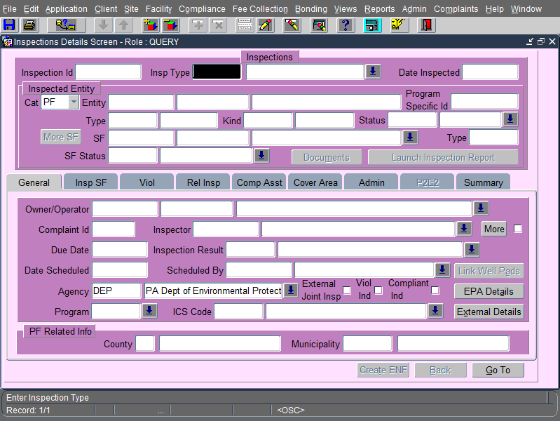
Figure 1: The inspection details screen.
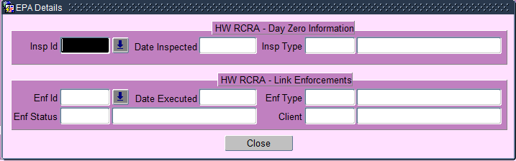
Figure 2: The EPA details pop-up window.
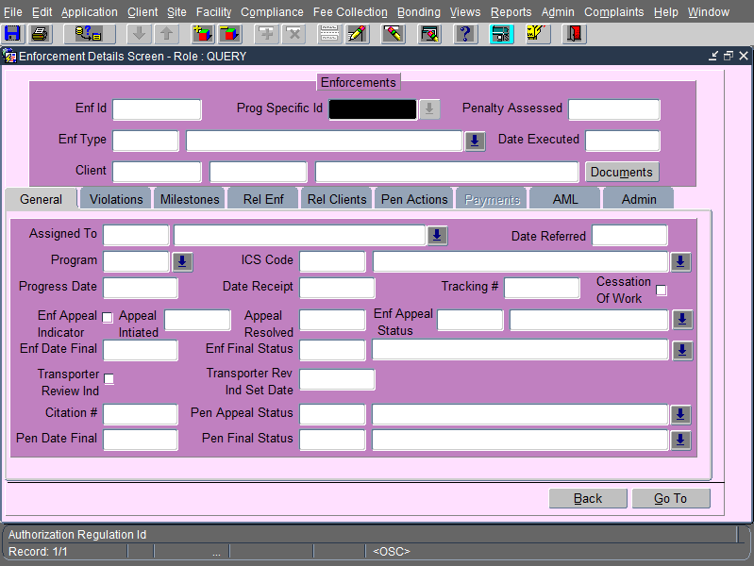
Figure 3: The enforcement details screen.
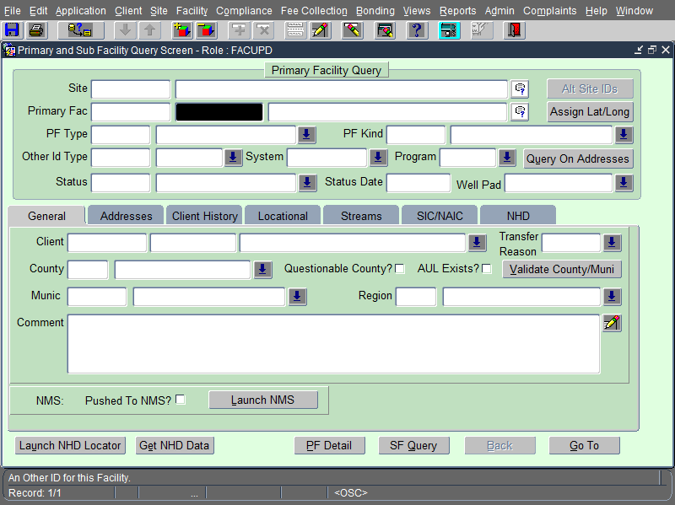
Figure 4: The PF/SF query screen.
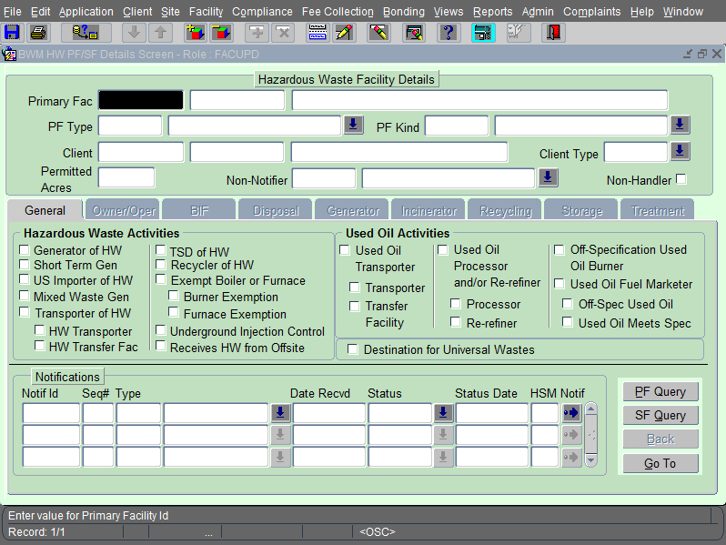Figure 5: The Hazardous Waste facility details screen.

General Information

Security Roles
Security roles determine which records a user insert, update, and delete in eFACTS.
Inspector (INSP)
- Can insert or update an inspection and its detail records within the inspector’s region and program as determined by the assigned security profile ICS code(s) and program code.
- Can delete an inspection or any record associated to the inspection (e.g. violations, compliance assistance codes, inspected sub-facilities) if they were the user that created the inspection record.
Facility Updater (FACUPD)
- Can insert or update an inspection and its detail records within the facility updater’s region and program as determined by the assigned security profile ICS code(s) and program code.
- Can delete an inspection or any record associated to the inspection (e.g. violations, compliance assistance codes, inspected sub-facilities) if they were the person that created the inspection.
- Can update primary facility and sub-facility details if the facility updater has access to the ICS code and program for the primary facility.
Enforcement (ENF)
- Can insert, update, or delete enforcement and violation details for enforcement records.
- Cannot insert, update, or delete penalty details.
- Cannot delete an enforcement record if penalty details exist for the enforcement.
Compliance (COMP)
- Can insert, update, or delete enforcement, violation, and penalty details.
- Can delete an enforcement record, including the associated violations and penalties, within their region and program.

What is a Primary Facility?
A primary facility represents a physical entity created to serve a particular function or achieve a business goal for an applicant. In eFACTS, a primary facility is a record created to group specific regulated entities under one heading. Each DEP program uses specific primary facility types. For example, the HW program uses the Captive Hazardous Waste Operation (CAHWO) and Commercial Hazardous Waste Operation (COHWO) primary facility types.

What is a Sub-facility?
A sub-facility is a record created for a specific regulated entity that exists at a primary facility. Examples of sub-facilities used by the HW program include:
- Administrative Facility
- Boiler Industrial Furnace
- Disposal Facility
- Incinerator
- Recycling Facility
- Storage Facility
- Treatment Facility
- Hazardous Generator, Captive
- Hazardous Generator, Commercial
- In-Transit Storage Facility

Basic Query Rules
A query is a question asked to retrieve specific information from the eFACTS database. eFACTS answers the question by retrieving records. Asking a question is referred to as “executing a query.” Execute a query to retrieve any records that match a specific set of criteria. A query can retrieve a specific record or any number of records that match the query criteria.
- To retrieve a specific record, execute a query using a unique identifier such as a primary facility ID, permit number, or inspection ID.
- If a unique identifier is not known, execute a query using information that is known. For example, find a primary facility by executing a query using the primary facility type and the county where the primary facility is located to retrieve all matching records.
- The amount of information supplied in a query affects the number of records retrieved. Executing a query to find a primary facility using the county as the only query criteria typically returns many records. However, entering the county and municipality returns significantly fewer results.

Common Questions About Querying
How do I determine which fields I can use to create a query?
Enter query mode by clicking the ENTER QUERY button on the toolbar or by pressing the [F7] key. Any field that permits text entry or allows the selection of a value using the List of Values (LOV) buttons can be used to construct a query.
Where should I position my cursor before entering query mode?
Before entering query mode, click in one of the fields that will be used for entering query criteria and then click the ENTER QUERY button on the toolbar or press the [F7] key.
What if I have incomplete information to query with, such as a partial address or the beginning of a name?
Use the wildcard symbol (%) to indicate additional letters may be missing. Enter a wildcard in front of, in the middle of, or at the end of the criteria wherever one or more letters may be missing. For example, to search for clients with a name that begins with Brown enter BROWN% as the query criteria.
How do I determine the number of records that will be retrieved?
Before executing the query, click the COUNT QUERY button or press the [SHIFT] + [F2] keys. The number of records that will be retrieved displays in the hint line.

RCRA/HW Inspections and Violations

Inspection Business Rules
- For all HW inspections, violations, and enforcements the program selected in eFACTS must be Waste Management Hazardous Waste (WMHW).
- An inspection is considered to be a HW inspection ONLY IF
  - the PF Type of the PF being inspected is categorized as a “Captive Hazardous Waste Operation” (CAHWO),
  - the PF Type is categorized as a “Commercial Hazardous Waste Operation” (COHWO) or
  - the PF being inspected has (or is supposed to have) an EPA ID number.
- In eFACTS the field for the EPA ID number is “PF Other Id” where the ID# starts with “PAD” or “PAR” and is followed by 9 digits (e.g. PAD000555777).
- Caution: Field staff does not create or assign EPA ID numbers in eFACTS. Doing so will create data errors that cannot be resolved unless the entire record is deleted and then re-entered with the EPA ID number provided by the Central Office.
To obtain the EPA ID number from Central Office, field staff can (a) provide the facility representative with the EPA Notification Form (EPA 8700-12) to complete and submit to Chris Gilmore in Central Office or (b) complete it themselves and submit it to Chris.
Many times Chris will accept a FAX of the Notification Form and the EPA ID number can be obtained within a very short time.

- When an inspection is conducted at a VSQG facility that has chosen not to obtain an EPA ID, the inspector should check the “Non-Notifier” box on the Hazardous Waste Inspection Report –Very Small Quantity Generator (2510-FM-BWM0275). Upon receipt of the inspection report, Chris will identify the facility in eFACTS as a “Non-Notifier” which will allow the creation of an EPA ID without notification – for data tracking purposes only. She will then create a PF/SF entry for the facility utilizing the newly generated EPA ID. Upon notice from Central Office, the inspector may then enter the inspection into eFACTS under the facility’s new PF/SF identification.

- For HW inspections, only inspection types listed on the “Valid Inspection Types” list can be selected and entered into eFACTS (see “Valid Inspection Types” list in this document).
- A “Follow-Up Inspection” (FUI) must have a prior completed non-follow up type of HW inspection, for example, a CEI or COMPL which has already been entered into eFACTS.
- A “Focus Area” code must be entered for all “Focus Area Inspections” (FCI).
- “EPA Details” must be entered for all FCIs.
- A “Significant Non-complier, Yes” (SNY) inspection must have a Day Zero inspection associated with it via the EPA Details window in eFACTS.
- Violations cannot be entered in a SNY inspection in eFACTS (Use the “OUTNO” inspection result).
- A “Significant Non-complier, No” (SNN) inspection can be entered only after all violations, penalties, and payments are closed in an enforcement (Use the “NOVIO” inspection result).

Violation Business Rules
- If an inspection results in violations, there must be at least one violation type (related to the HW program) entered into a HW inspection record in order for the record to be valid.
- The violation date must equal the inspection date.
- If a Resolution Date is entered, a Resolution Code must be entered, as well.

Valid Inspection Types
eFACTS only permits the selection of specific inspection types for WMHW inspections. The valid inspection types are (see Appendix I for complete descriptions):
- ADMIN – Administrative File Review
- CEI – Compliance Evaluation
- GME – Groundwater Monitoring Evaluation
- COMPL – Complaint Inspection (will translate as CEI)
- CSE – Compliance Scheduling Evaluation
- FCI – Focus Area Inspections
- FUI – Follow-up Inspections
- INCDT – Incident-Response to Accident or Event (will translate as FCI)
- RTNC – Routine/Complete Inspection (will translate as CEI)
- RTNF – Routine Final Inspection (will translate as CEI)
- RTPT - Routine/Partial Inspection (will translate as CEI)
- SNN – Significant Non-complier, No
- SNY – Significant Non-complier, Yes

Valid Inspection Result Codes
The inspection result codes in the table below are the only codes used by the HW program.
Code | Description
ICS | In Compliance with Schedule –  An inspection to check on progress of work according to a compliance schedule shows that the work is proceeding on or ahead of schedule. Used in conjunction with a CEI inspection type or used if all violations noted are addressed in an agreement with a schedule to be in compliance.
NOVIO | No Violations Noted –  There were no violations noted during the inspection.
NVFIA | No Violations, Facility was Inactive During Inspection –  There were no violations observed during the inspection and the facility was not operating during the inspection (i.e. an after-hours inspection).
NVPSD | No Violations, Facility is Permanently Shut Down –  There were no violations observed during the inspection and the facility is closed (e.g. an old landfill).
OUTNO | Outstanding Violations, No New Violations Required –  Violation noted during previous inspection still needs to be corrected. No new violations found or need to be created in eFACTS.
OUTST | Outstanding Violations, Violations Required –  Violation noted during previous inspection still needs to be corrected. New violations found and need to be created in eFACTS.
PEND | Pending –  Use this for a “delayed” observation such as where no obvious violation was noted in the field, but may be disclosed by analysis of a sample that was sent to the lab.
RECUR | Recurring Violations –  Recurring means a previously corrected violation type has occurred again as observed in the inspection.
VOV | Violation(s) & Outstanding Violations –  Outstanding or continuing violation types were noted at this site, and one or more new violations were also discovered.
VRV | Violation(s) & Recurring Violations –  Some violation type that was documented before, and had been corrected is now happening again, and some other new violation type was also observed.
VIOLS | Violation(s) Noted –  A particular violation type(s) were observed or discovered at this location.
VIOIC | Violation Corrected Onsite –  Violations were noted and corrected during the inspection.

Using HW Violation Codes vs. RW/MW Violation Codes
A site may have multiple facility records in eFACTS corresponding to different types of generated waste (hazardous, residual, municipal). To ensure records entered into eFACTS translate to the EPA’s RCRA system, only violations associated with the Hazardous Waste Program can be recorded under inspections for hazardous waste facilities. Enter violations related to residual or municipal waste generators under an inspection for the correct primary facility type in eFACTS.
If an inspector finds violations of the Solid Waste Management Act related to a hazardous waste inspection, the following violation codes may apply and would translate to the RCRA system.
6018.610-1 Person or municipality dumps solid waste unlawfully.
6018.610-2 Person or municipality operates a facility without a permit.
6018.610-3 Person or municipality burns solid waste without a permit.
6018.610-4 Improper management of hazardous waste.
6018.610-5 Transporting hazardous waste without a license.
6018.610-6 Transport or permit the transportation of solid waste to an unpermitted facility.
6018.610-8 Unlawful transfer of hazardous waste.
6018.610-9 There is a violation of Act 97, Department regulation, order, or term of permit.
A full description of these codes can be found in Act 97 on the on the Pennsylvania Legislative Bureau website:
http://www.palrb.us/pamphletlaws/19001999/1980/0/act/0097.pdf

Inserting Inspections and Violations
- Access the INSPECTIONS DETAILS Screen by clicking the INSPECTIONS & VIOLATIONS button on the eFACTS MAIN Screen.
- Select the appropriate inspection type by using the LOV button to the right of the Insp Type field or pressing the [F9] key. Press the [TAB] key.
- Enter the date the inspection began. Press the [TAB] key.
- The category defaults to PF. Press the [TAB] key twice.
- Enter the EPA ID number for the facility into the Other ID/AKA field. Press the [TAB] key.
- The EPA ID number, also known as a RCRA or handler ID, is a 12-digit identifier beginning with the letters PA assigned to those who generate or transport hazardous waste or who operate a facility for recycling, treating, storing, or disposing of hazardous waste.
- If only one sub-facility exists for the primary facility, it will automatically display in the SF field. If more than one sub-facility exists, click the LOV button to the right of the SF field and select the inspected sub-facility from the list.
- If the inspection was the result of a complaint received by the department enter the Complaint ID from the Complaints Tracking System (CTS) in the Complaint ID field.
- Click the LOV button next to the Inspection Result field and select an inspection result code.
- When selecting an inspection result, make note of the Viol Ind column. The letter ‘Y’ in this column indicates saving this record requires at least one violation associated with it.
- If the selected inspection type is FCI (Focus Area Inspection) then specify a focus area by completing the following steps:
  - Click the EPA DETAILS button and the EPA DETAILS pop-up window displays.
  - Select any checkboxes that apply:
    - Multimedia – Choose multimedia if the inspection was part of a multi-program inspection.
    - Sampling – Choose sampling if samples were collected during the inspection.
    - Not Subtitle C – Choose “not subtitle C” if the inspection was conducted pursuant to RCRA 3007 or equivalent.
  - Select a focus area to identify the subject of a focused compliance inspection.
  - Click the CLOSE button to return to the INSPECTION DETAILS Screen.
- A focus area is required for all FCI inspections. For a complete description of all FCI inspection focus areas, see Appendix II.
- If the selected inspection type is INCDT (Incident – Response to Accident or Event), the inspection will translate to RCRAInfo as FCI. However, in all cases the focus area of IND (Incident – Response to Accident or Event) must be chosen. No other focus area type may be used with the INCDT inspection type.
- To record violations identified during the inspection complete the following steps:
  - Click the Viol TAB.
  - The violation date defaults to the inspection date. Update if necessary.
  - Click the LOV button to the right of the Viol Type Description field to select the violation type.
  - If the sub-facility does not display, click the LOV button next to the Sub Fac ID field and select a sub-facility to associate with the violation.
  - If the violation was noted on a previous inspection, select the Continuing Viol checkbox to indicate this is a continuing violation.
  - If more than one violation was identified during the inspection, click the CREATE RECORD button on the toolbar or press the [F6] key and repeat steps b through e.
- Click the SAVE button on the toolbar or press the [F10] key to save the record.

Closing Violations
- Access the INSPECTIONS DETAILS Screen by clicking the INSPECTIONS & VIOLATIONS button on the eFACTS MAIN Screen.
- Query the inspection during which the violation(s) to be closed were identified.
- Click on the Viol TAB.
- Use the scrollbar to locate the violation to be closed.
- Click in the Date Resolved field.
- Enter the date the violation was resolved. Press the [TAB] key.
- Select a resolution reason by using the LOV button or pressing the [F9] key.
- Click the SAVE button on the toolbar or press the [F10] key to save the record RCRA/HW Enforcements and Penalties

RCRA/HW Enforcements and Penalties

Enforcement Business Rules
- If a “Date Resolved” is entered, a “Resolution Reason” must be entered, as well.
- On the “Milestones and Payments” TAB, the date defaulted cannot be greater than the current date.
- “Defaulted Milestones” must be marked “Completed” to close the Enforcement Action.
- When closing “Defaulted Milestones”, the date in the “Date Defaulted” field must be deleted in order to enter the “Date Completed”.
- Only an enforcement code of 211 or above can be associated with a SNY inspection (via the EPA Details window in eFACTS).
- The “Date Executed” must be equal to or greater than the “SNY Inspection Date”.
- All violations, penalties and payments must be closed before an enforcement action can be associated with/linked to an SNY inspection.

Valid Enforcement Type Codes
The enforcement types selected in eFACTS correspond to enforcements recorded in the EPA database and displayed on the RCRAInfo website. Enforcements with an EPA code of 211 or greater are considered formal enforcements.
eFACTS Description | eFACTS Code | EPA Code
Verbal Violation Notice | VVN | 111
Field Notice of Violation | FLNOV | 121
Notice of Proposed Assessment | NOPA | 121
Notice of Violation | NOV | 121
Memorandum of Understanding | MOU | 122
Case in Progress | PROG | 131
Fee Delinquent Letter | FEEDL | 141
Enforcement Conference-Follows NOPA | ECONF | 142
Equity Action | EQTY | 211
Civil Complaint | COMP | 212
Field Order | FDORD | 251
Consent Assessment of Civil Penalty | CACP | 311
Consent Order and Agreement | COA | 312
Permit Suspension Order | SUSPM | 313
License Suspension Order | SUSLI | 314
Administrative Order | ADORD | 315
Civil Penalty Assessment | CPA | 316
Permit Revocation Order | REVPM | 317
License Revocation Order | REVLI | 318
Petition to Enforce | PTNEN | 511
Compliance Order | CMPOR | 512
Petition for Contempt | PTCON | 512
Bond Forfeiture | BDFT | 513
Consent Adjudication | CADJ | 514
Consent Decree | CDEC | 515
Cessation Order | CESOR | 516
Summary Citation | SUMM | 517
Court Order | CTORD | 611
Environmental Hearing Board Order | EHBO | 612
Final Non-DEP Criminal Enforcement Action | FICEA | 613
Cessation Order - Failure to Abate | COFTA | 614

Inserting an Enforcement
- Access the ENFORCEMENT DETAILS Screen by clicking the ENFORCEMENTS & PENALTIES button on the eFACTS MAIN Screen.
- Select an enforcement type by clicking the LOV next to the Enf Type field. Press the [TAB] key.
- Enter the date the enforcement was officially executed. Press the [TAB] key twice.
- Enter the EPA ID of the client.
- Click the Violations TAB.
- Click the LINK OPEN VIOLATIONS button. The open violations for the client will display with all open violations selected by default (as indicated by the checkmark in the Link field).
- Remove the checkmark next to any violations that should not be linked and then click the LINK button.
- To link resolved or closed violations, enter the related inspection ID or violation ID on the Viol TAB.
- Click the SAVE button on the toolbar or press the [F10] key to save the record.

Inserting Penalties
A penalty amount for the enforcement frequently follows a series of penalty actions. For example, the DEP may first perform a proposed assessment (first penalty action) with an amount identified as $30,000. An appeal (second penalty action) may then reduce the amount to $25,000. Record the various actions and adjust the penalty amount using the Pen Actions TAB as needed.
- Access the ENFORCEMENTS DETAILS Screen by clicking the INSPECTIONS & VIOLATIONS button on the eFACTS MAIN Screen.
- Query an enforcement ID to create penalty actions associated with it.
- Click the Pen Actions TAB.
- Click the CREATE RECORD button on the toolbar or press the [F6] key to go to a blank line.
- Select the penalty action taken by the DEP by using the LOV button or pressing the [F9] key. Press the [TAB] key.
- Enter the date that a meeting was held or a notice was sent regarding the penalty action (cannot be greater than the current date). Press the [TAB] key.
- Enter a due date for the penalty action. Press the [TAB] key 2 times.
- Enter the amount assessed by the penalty action. Press the [TAB] key.
- Caution: This field does not indicate the receipt of payment. It only identifies the amount associated with the penalty action.
- Enter any additional information (comments).
- Click the SAVE button on the toolbar or press the [F10] key to save the record.
- A pop-up window displays requesting a response to the question, “Should the penalty action amount entered (for the new penalty action) replace the current penalty amount (top of the screen)?”
- If the amount entered for the “new” penalty action is the new penalty amount, click the YES button to update the Penalty Amount field.
- If the Penalty Amount field should remain unchanged, click the NO button.
- A pop-up window displays requesting a response to the question, “Do you wish to create a Payment record?”
- Click the YES button to create a payment record on the Payments TAB equal to the amount identified in the penalty action. This assists in recording lump sum or one-time payments.
- Repeat Steps 4 through 12 to enter any additional penalty actions.
- Click the SAVE button on the toolbar or press the [F10] key to save the record.

Closing an Enforcement
- Open the ENFORCEMENT DETAILS Screen by clicking the ENFORCEMENTS & PENALTIES button on the eFACTS MAIN Screen.
- Query the enforcement to be closed.
- Click the Violations TAB.
- Verify that the appropriate violations contain a date resolved. See the Closing Violations Section for step-by-step procedure on closing violations.
- Click the General TAB.
- Click in the Enf Date Final field.
- Enter the date the enforcement was finalized. Press the [TAB] key.
- Select the final status of the enforcement by using the LOV button or pressing the [F9] key.
- Click the SAVE button on the toolbar or press the [F10] key to save the record.
- Caution: When an enforcement action has milestones (as shown on the Milestones TAB) and associated stipulated penalties, the enforcement may not be closed and the Enf Date Final, Pen Date Final, and Enf Final Status fields must remain open until all milestones and penalties are complete.

Closing Penalties
- Open the ENFORCEMENT DETAILS Screen by clicking the ENFORCEMENTS & PENALTIES button on the eFACTS MAIN Screen.
- Query the enforcement that contains the associated penalty to finalize.
- Click the Pen Actions TAB.
- Verify the listed penalty actions include a date in the Date Return/Compl field.
- Click the Payments TAB.
- Verify the listed payments include an amount received.
- Click the General TAB.
- Click in the Pen Date Final field and enter the finalized date for the penalty. Press the [TAB] key.
- Select the final status of the penalty by using the LOV button or pressing the [F9] key.
- Click the SAVE button on the toolbar or press the [F10] key to save the record.

Significant Non-Complier (SNC) Data Entry
SNY and SNN are special inspection types in eFACTS that exist to trigger SNC notifications to the EPA. Only the HW program uses these inspection types.

SNY Inspection Type
Entering an SNY inspection type triggers a notification to the EPA that the facility is in the significant non-complier status. This requires identifying a “day zero” inspection using the EPA DETAILS button on the INSPECTION DETAILS Screen.
- When creating an SNY inspection, a “day zero” inspection must exist to indicate when the facility first became an SNC. This can be any HW inspection with violations that occurred after the last recorded SNN inspection for the facility.

Entering an SNY Inspection
- Access the INSPECTIONS DETAILS Screen by clicking the INSPECTIONS & VIOLATIONS button on the eFACTS MAIN Screen.
- Select the SNY inspection type in the Insp Type field. Press the [TAB] key.
- Enter the date the facility became an SNC in the Date Inspected field. Press the [TAB] key.
- The category defaults to PF. Press the [TAB] key twice.
- Enter the EPA ID number for the facility into the Other ID/AKA field. Press the [TAB] key.
- If only one sub-facility exists for the primary facility, it will automatically display in the SF field. If more than one sub-facility exists, click the LOV button to the right of the SF field and select the inspected sub-facility from the list.
- Select the OUTNO code in the Inspection Result field.
- Click the EPA DETAILS button to display the EPA Details pop-up window.
- Click the LOV button to the right of the Insp ID field and select the “day zero” inspection.
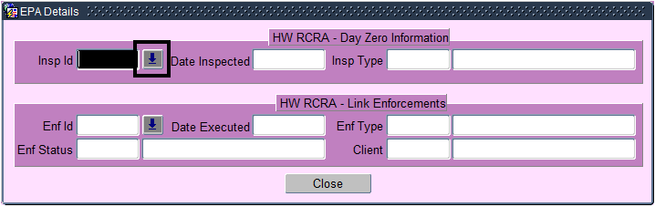
Figure 6: The LOV button to the right of the Insp ID field.
- Click the CLOSE button to return to the INSPECTION DETAILS Screen.
- Click the SAVE button on the toolbar or press the [F10] key to save the record.

Linking an Enforcement to an SNY Inspection
Removing a facility from the SNC status requires linking a “formal” enforcement action to the SNY inspection. Link an existing enforcement record to an SNY inspection to indicate an action occurred to address the SNC status. eFACTS only allows linking enforcements that meet the following conditions:
- The date executed on the enforcement record must be greater than the date of the SNY inspection.
- Any penalty payments associated with the enforcement must be paid in full.
- The enforcement record must have a final status code.
- If the SNY inspection is not displayed, query for it on the INSPECTION DETAILS Screen in eFACTS.
- Click the EPA DETAILS button and the EPA Details pop-up window displays.
- Click on the LOV button to the right of the Enf ID field and select an enforcement ID to link.
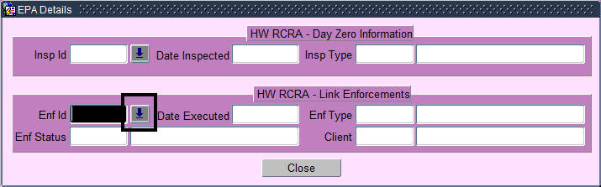
Figure 7: The LOV button to the right of the Enf ID field.
- Click the OK button.
- Click CLOSE button to return to the INSPECTION DETAILS Screen.
- Click the SAVE button on the toolbar or press the [F10] key to save the inspection record.

SNN Inspection Type
Entering an SNN inspection type triggers a notification to the EPA that the facility is no longer in the SNC status.
Details about SNN Inspection Types:
- SNN inspection date should be greater than the SNY inspection date for the same facility.
- SNN inspection cannot be created without creating an SNY inspection.
- The system will raise an error alert if an attempt is made to create an SNN prior to SNY inspection.
- SNN inspections cannot be created without linking an enforcement action to the previous SNY inspection.
- Caution: After creating an SNN inspection for a facility, only limited updates can occur to the enforcement record linked to the SNY inspection. Specifically, the client ID, program, and date executed cannot be updated. If necessary, the enforcement type and final status allow updates as well as information about the penalty payments as long as no amount due is shown.

Entering an SNN Inspection
- Access the INSPECTIONS DETAILS Screen by clicking the INSPECTIONS & VIOLATIONS button on the eFACTS MAIN Screen.
- Select the SNN inspection type in the Insp Type field. Press the [TAB] key.
- Enter the date that the SNC status no longer applied to the facility in the Date Inspected field. Press the [TAB] key.
- The category defaults to PF. Press the [TAB] key twice.
- Enter the EPA ID number for the facility into the Other ID/AKA field. Press the [TAB] key.
- If only one sub-facility exists for the primary facility, it will automatically display in the SF field. If more than one sub-facility exists, click the LOV button to the right of the SF field and select the inspected sub-facility from the list.
- Select the NOVIO code in the Inspection Result field.
- Click the SAVE button on the toolbar or press the [F10] key to save the record.

Maintaining HW Facility Details
All persons who generate, transport, recycle, treat, store, or dispose of hazardous waste are required to notify the EPA (or their state agency if the state is authorized to operate its own hazardous waste program) of their hazardous waste activities. Hazardous waste handlers in Pennsylvania notify PA DEP by submitting a Notification Form (EPA 8700-12) to the Hazardous Waste Division.
The Central Office Bureau of Waste Management (Chris Gilmore) processes Notification Forms (EPA 8700-12) for hazardous waste facilities. Initial and subsequent notifications are received either by Central Office (Chris) or by Regional Office program staff. All Notification Forms (EPA 8700-12) received by the Regional Offices should be sent to Chris Gilmore.
eFACTS data/records must be accurate and kept up-to-date. Both Regional and Central Office staff can create, update, and correct HW facility information in eFACTS. It is very important to enter correct and complete data into eFACTS. The table below lists commonly updated fields in eFACTS and identifies whether the regional staff should update those fields.
For new and/or changes to: | Regional  Staff  input? | Central  Office  input? | Method
Generator Name | NO | YES | Notification Form (EPA 8700-12) submitted by Handler or Field Staff
Generator Address (any/all addresses) | ↓ | ↓ | Notification Form (EPA 8700-12) ↓
Generator Type (LQG, SQG) | ↓ | ↓ | Notification Form (EPA 8700-12) ↓
Owner/Operator Info | ↓ | ↓ | Notification Form (EPA 8700-12) ↓
Contact Info (for any/all contacts) | ↓ | ↓ | Notification Form (EPA 8700-12) ↓
Waste Code | Yes | Yes | Notification Form (EPA 8700-12) or email Chris Gilmore
Generator Status (Closed/Active/Inactive) | Yes | Yes | Notification Form (EPA 8700-12) or email Chris Gilmore
TO OBTAIN EPA ID# (PF Other ID) | NO | YES | Notification Form (EPA 8700-12) submitted by Handler or Field Staff
During a facility inspection,
- if the inspector finds changes to the generator name, ownership/operator information, contact information, or generator type, the inspector should give the facility owner/operator the Notification Form (EPA 8700-12) at the time of the inspection or AS SOON AS POSSIBLE afterwards. The owner/operator should complete and send the form to Chris Gilmore in Central Office. Central Office staff will enter the data into eFACTS. If the facility is a VSQG, and the owner chooses not to submit a Notification Form, the inspector should check the “Non-Notifier” box on the Hazardous Waste Inspection Report – Very Small Quantity Generator (2510-FM-BWM0275). Upon receipt of the inspection report, Chris will identify the facility in eFACTS as a “Non-Notifier” which will allow the creation of an EPA ID without notification – for data tracking purposes only. She will then create a PF/SF entry for the facility utilizing the newly generated EPA ID. Upon notice from Central Office, the inspector may then enter the inspection into eFACTS under the facility’s new PF/SF identification.

- if the inspector finds that a facility is closed, the inspector should update the sub-facility status and mark it as “inactive”. The SITE Screen should be marked “inactive” if HW is the priority program and all of the primary facilities are marked as inactive. The inspector should notify Chris Gilmore (by email) that the facility is closed/out of business.
Regional program staff can perform data updates for facilities OR the Regional staff can send the changes via email to Chris in Central Office.

Obtaining an EPA ID Number
- Caution: Field staff does not create or assign EPA ID numbers in eFACTS. Doing so will create data errors that cannot be resolved unless the entire record is deleted and then re-entered with the EPA ID number provided by the Central Office.
To obtain the EPA ID number from Central Office,
  - field staff can provide the facility representative with the Notification Form (EPA 8700-12) to complete and submit to Chris Gilmore in Central Office.
  - field staff can complete an EPA Notification Form (EPA 8700-12) themselves and submit it to Chris.
- Many times Chris will accept a FAX of the Notification Form and the EPA ID number can be obtained within a very short time.

Verifying Facility Details
Access the PF/SF QUERY Screen in eFACTS to view facility details that are translated to RCRAInfo. If any of details are incorrect in eFACTS, the inspector should give the facility owner/operator a Notification Form (EPA 8700-12) at the time of the inspection or as soon as possible afterwards. The owner/operator should complete and send the form to Chris Gilmore in Central Office. Central Office staff will enter the data into eFACTS.
If the county, municipality, or status fields for the facility are not populated or if the waste codes are not current, an inspector with the FACUPD security role can update these details by accessing the PF/SF QUERY Screen.
- Access the PF/SF QUERY Screen by clicking the PRIMARY FACILITIES button on the eFACTS MAIN Screen.
- Enter into query mode by clicking the ENTER QUERY button on the toolbar or by pressing the [F7] key.
- Enter the eFACTS PF ID into the Primary Facility ID field or enter the EPA ID into the Other ID field.
- Click the EXECUTE QUERY button or press the [F8] key to display the Primary Facility record.
Verifying Primary Facility Information
  - If the Status field is empty or inaccurate, click the LOV button to update the facility status.
- The primary facility status should remain active unless all of the sub-facilities are also inactive.
  - If the County field or Muni field is empty, click the LOV button and select a county or municipality value for the facility. If making any updates, click the SAVE button on the toolbar or press the [F10] to save changes.
- If eFACTS displays the message, “List of Values contains no entries,” in the hint line then the Site record for the facility needs to be updated prior to selecting a municipality. Take note of the Site ID displayed at the top of the screen and update the “Resp ICS” TAB on the RECORD/VERIFY SITE Screen. Refer to the Sites Abbreviated User’s Guide for additional information.
  - Click the Address TAB to view and verify the location address for the facility.
- Make sure there is a location address listed for the facility. If a location address is not listed, contact the Central Office.
  - Click the SAVE button on the toolbar or press the [F10] key to save any changes.
- Click the PF DETAIL button to display the HAZARDOUS WASTE FACILITY DETAILS Screen.
Verifying Hazardous Waste Facility Details
  - The General TAB displays by default and shows the hazardous waste activities identified on the most recent Notification Form (EPA 8700-12) as well as the history of previously received notification forms.
  - Click the Generator TAB to display the generator type. If the Gen Type field is not completed, give the facility owner/operator the Notification Form (EPA 8700-12) to complete.
- There should always be a “Gen Type” listed or the information will not get processed or translated to RCRAInfo. If a “Gen Type” is not listed, contact the Central Office.
  - Click the “Waste/Proc Cd” TAB to display the waste codes associated with the facility. If the Waste Codes fields are not completed or up-to-date, give the facility owner/operator the Notification Form (EPA 8700-12) to complete.
- There should always be a “Waste Code” listed or the information will not get processed or translated to RCRAInfo.
- Click the SF QUERY button to display the SUB FACILITY QUERY Screen.
Verifying Sub-Facility Information
  - If the Status field is empty or inaccurate, click the LOV button to update the facility status.
  - Click the Locational TAB. If coordinates are listed, verify the following fields are also populated:
    - Hor Ref Datum
    - Hor Coll Method
    - Reference Point
- The fields listed above are required when coordinates are listed. If they are empty, enter the code UNK for “Unknown” value.
  - Click the SAVE button on the toolbar or press the [F10] key to save any updates to the facility.
If the following message displays, revisit the section on “Verifying Sub-Facility Information” and complete step B:
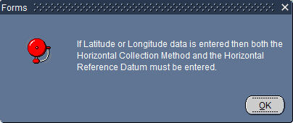
- When finished click the EXIT button on the toolbar or press [CTRL] + [Q] to close the screen.

Inactivating a Facility
If a facility is inactive or closed, change the status as follows:
- Access the PF/SF QUERY Screen by clicking the PRIMARY FACILITIES button on the eFACTS MAIN Screen.
- Enter into query mode by clicking the ENTER QUERY button on the toolbar or by pressing the [F7] key.
- Enter the eFACTS PF ID into the Primary Facility ID field or enter the EPA ID into the Other ID field. Click the EXECUTE QUERY button or press the [F8] key.
- Click the PF DETAIL button and the HAZARDOUS WASTE FACILITY DETAILS Screen displays.
- Select the Non-Handler checkbox.
- Enter a closure date and update the waste codes as follows:
  - Click on a sub-facility detail TAB (e.g. Generator, Recycling, Storage, or Treatment) and enter the date of closure in the Closure Date field.
- The Gen Type field must be populated or the information will not be processed or translated into RCRAInfo. If the Gen Type field is not populated, contact the Central Office.
  - Click the “Waste/Proc Cd” TAB and enter the waste code(s).
- There should always be a “Waste Code” listed or the information will not be processed or translated to RCRAInfo.
  - Repeat the previous steps for any additional closed sub-facilities.
  - Click the SAVE button on the toolbar or press the [F10] key.
- Click on the SF QUERY button and the SUB FACILITY QUERY Screen displays.
- To change the sub-facility status to inactive:
  - Locate the appropriate sub-facility by clicking the NEXT RECORD or PREVIOUS RECORD buttons.
  - Click the LOV button next to the Status field to select the “Inactive” status.
  - Repeat the previous steps to update the status for any additional sub-facilities.
  - Click the SAVE button on the toolbar or press the [F10] key.
- Click the PF QUERY button and the PRIMARY FACILITY QUERY Screen displays.
- Click the LOV button next to the Status field and select the “Inactive” status.
- A pop-up window displays if any of the sub-facilities are still active. The primary facility cannot be inactivated if any sub-facilities are active.
- In the “Comments” field make note of the changes to the facility status.
- Click the SAVE button on the toolbar or press the [F10] key.
- Send an email to Central Office (Chris Gilmore) with the Facility Name and EPA ID Number stating that the facility was inactivated or closed.

Adding and Viewing Documents
Use the Documents LOV to link files, such as images from a digital camera or digital copies of signed documents, to a record. The Any user with the Query security role can view the documents stored in the eFACTS database. The maximum file size is 5 megabytes. The following file types are currently allowed:
- Images (BMP, GIF, JPG, PNG, TIF)
- Office Files (DOC, DOCX, MDB, PPT, XLS, XLSX)
- Others (CSV, HTM, HTML, PDF, RTF, TXT, WPD, XML, ZIP)

Adding Documents to a Record
- Query an inspection or enforcement record to add a document to it.
- Click the DOCUMENTS button. The Documents LOV screen displays.
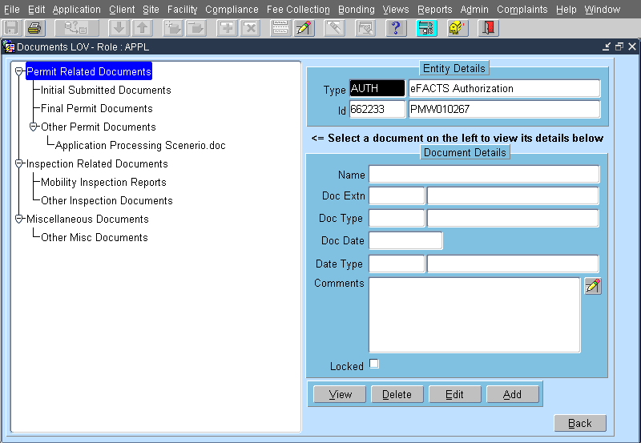
Figure 8: The Documents LOV Screen.
- Click the ADD button. The Add/Edit Documents Screen displays.
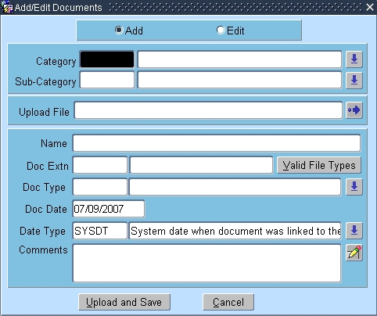
Figure 9: The Add/Edit Documents Screen.
- Select a category by using the LOV button next to the Category field.
- Select a sub-category by using the LOV button next to the Sub-Category field.
- Select a file to upload by using the button next to the Upload File field. The Open pop-up window displays.
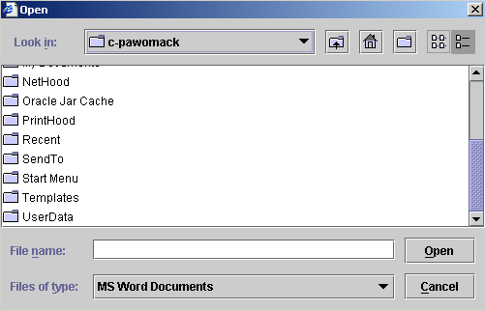
Figure 10: The Open pop-up window for selecting a file.
- Locate the folder in which the file is contained.
- Click on the file to select it.
- Click the OPEN button.
- Click the UPLOAD AND SAVE button.
- If finished, click the BACK button to exit the window.

Viewing Documents Linked to an Inspection
- Query an inspection or enforcement record to add a document to it.
- Click the DOCUMENTS button.
- Highlight the document name in the navigation tree.
- Click the VIEW button.

Running a Compliance Report
- Access the eFACTS MAIN Screen.
- Click the Reports Menu.
- Click the Compliance command and the REPORT SELECTION Screen displays.
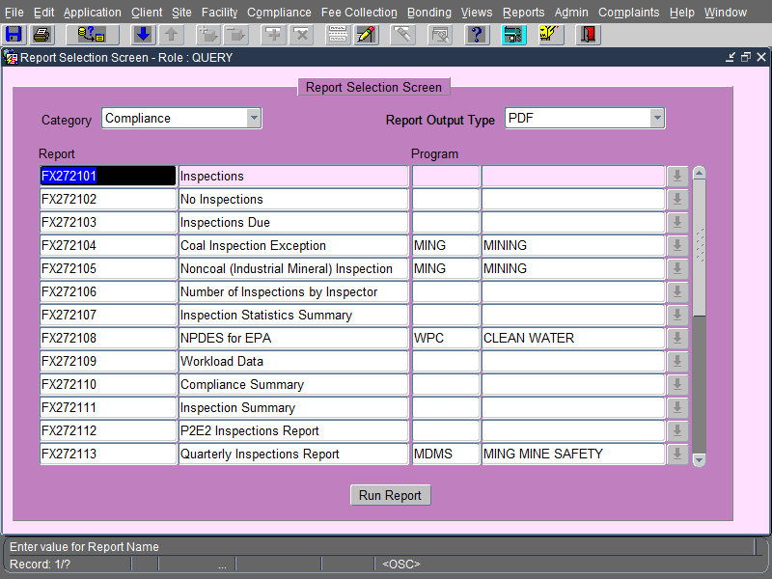
Figure 11: The report selection screen.
- Select a report in the list by clicking on a line to highlight it.
- Click the RUN REPORT button. The RUNTIME PARAMETER Screen displays with the cursor positioned in the first parameter field.
- Select the appropriate criteria by using the LOV button to the right of the parameter fields or by entering the appropriate code. Press the [TAB] key.
- If you do not wish to use a parameter to restrict the report output, verify that the field contains the wildcard ‘%’.
- If the parameter field is a date range, enter the begin date in the first field and the end date in the second field. Dates must be in the format MM/DD/YYYY.
- Repeat steps 6 and 7 until all report criteria has been selected.
- Click the RUN REPORT button to generate and display the report.

Report Descriptions
RCRA Compliance QA/QC Report

This RCRA COMPLIANCE QA/QC Report lists all Compliance, Monitoring, and Enforcement (CME) data inserted, updated, or deleted within the date range specified by the user. The report retrieves data used to update the EPA’s RCRAInfo system. Use this report to verify the accuracy of compliance data entered into eFACTS and ensure the submission of valid and complete data to RCRAInfo.
RCRA Compliance Transaction Report
The RCRA COMPLIANCE TRANSACTION Report displays HW compliance data matching criteria entered by the user. The report output displays the compliance data values as entered into eFACTS with the corresponding EPA data equivalents submitted to, or ready to submit to, RCRAInfo.
Changes in Enforcements Report
The CHANGES IN ENFORCEMENTS Report retrieves a list of enforcements that have changed within the specified time frame. The report displays an enforcement if the date executed, progress date, appeal indicator, modified date, enforcement type, tracking number, enforcement date final, or appeal status is updated.
Compliance History Report
The COMPLIANCE HISTORY Report retrieves a listing of enforcement and violation information concerning a client and, if desired, any related clients within the client’s hierarchy. A related client may be full owners (100%) of the current client, fully owned (100%) by the current client, partial owners of the current client, partially owned by the current client, officers of the current client, or contractors of primary facilities owned by the current client.
Compliance Milestones Report
The COMPLIANCE MILESTONES Report displays milestones associated with an enforcement. Based on a due date range, the report will display all milestones due within the time period. Use this report to view the milestones due next month and milestones with pending due dates for a specific region or program.
Compliance Summary Report
The COMPLIANCE SUMMARY REPORT retrieves a summary of compliance information for a specific region, program, and/or enforcement date range. Use this report to retrieve a total of penalty payments collected for the enforcements initiated during a specific date range. If the enforcement was not initiated during the date range, the payment will not be included in the total.
Enforcement Status Summary Report
The ENFORCEMENT STATUS SUMMARY Report retrieves a summary of enforcements initiated or completed for a program and/or region. For each enforcement type, the report displays the number of enforcements initiated and the number of enforcements for each final status.
Timely and Appropriate Enforcements Report
The TIMELY AND APPROPRIATE VIOLATIONS/ENFORCEMENTS Report is used to retrieve hazardous waste violations that are unresolved. Use this report to view unresolved HW violations for a date range.
Civil Penalties Report
The CIVIL PENALTIES Report retrieves enforcements with penalty actions initiated and/or finalized within the specified date range.
Civil Penalties Activity Report
The CIVIL PENALTIES ACTIVITY Report retrieves penalty action milestones and/or payment schedules with due dates during a specific due date range.
Penalty Action Summary Report
The PENALTY ACTION SUMMARY Report retrieves a summary of penalty information for a specific program, ICS organization, and/or date range. Use this report to identify by penalty type the number of penalty actions received and the total penalty amount collected within a region or for a date range.
Penalty Payments Overdue Report
The PENALTY PAYMENTS OVERDUE Report retrieves a listing of information regarding overdue penalty payments. The report displays penalties that have payments that were due for the identified date range and program but not received.

Appendix I – Valid Inspection Types

Type | Name | Description
ADMIN | Administrative File Review | An evaluation conducted in the Agency office involving a detailed review of non-financial records.
CEI | Compliance Evaluation Inspection | A CEI evaluation is primarily an on-site evaluation of the compliance status of the site with regard to all applicable RCRA Regulations and Permits (with the exception of groundwater monitoring and financial assurance requirements). Although portions of a CEI evaluation may routinely be conducted in a DEP office setting, such “office” evaluations are considered an integral part of a CEI in terms of completing an evaluation. The overall evaluation of a site’s compliance status may take place over multiple days necessitating multiple site visits and activities. The entire set of activities and associated effort is considered a single CEI.  The major function of a CEI is an overall review of the site's performance. The inspection includes an on-site examination of records and other documents maintained by the site and an evaluation of the site's compliance with all applicable requirements and adequate sampling, when necessary. Where appropriate, it includes groundwater monitoring assessment outlines or plans, closure/post-closure plans, contingency plan reviews, waste analysis plan reviews, and preparedness and prevention plan reviews. Specifically excluded from the CEI type of evaluation are financial assurance requirements and inspections of groundwater monitoring systems. A review of financial assurance requirements is coded as a Financial Assurance Inspection (FAI) evaluation. Inspections of groundwater monitoring systems are coded as a GME.
GME | Groundwater Monitoring Evaluation | A detailed evaluation of the adequacy of the design and operation of a facility's groundwater monitoring system in accordance with EPA's Final RCRA Compliance Groundwater Monitoring Evaluation Guidance Document. Evaluation of the groundwater monitoring system design should be conducted by a hydro geologist and includes the review of the owner/operator's (o/o's) characterization of the hydro geology beneath hazardous waste management units, monitoring well placement and depth/spacing, and well design and construction. It is essential that the GME ensure that the o/o has designed an adequate groundwater monitoring system. In addition, an integral part of the GME is the review of the operation of the groundwater monitoring system through an evaluation of the o/o's sampling and analysis plan and its implementation. GMEs should be scheduled, to the maximum extent possible, to coincide with o/o sampling events to permit the field evaluation of sampling techniques. Inspectors should collect samples as a random check of groundwater quality data at any wells which may have indicated releases to support enforcement of corrective action.
COMPL | Complaint Inspection | An inspection that is based upon a complaint or tip about possible violations of RCRA requirements at the facility.
CSE | Compliance Schedule Evaluation | An evaluation conducted to verify compliance with an enforceable compliance schedule associated with a formal enforcement action. When a CSE is conducted as part of another inspection type (CEI, GME, etc.), a separate CSE entry should be made in eFACTS for the CSE component.
FCI | Focused Compliance Inspection | An FCI is an on-site inspection that addresses only a specific portion or Subpart of the RCRA regulations or authorized State regulations/programs. Some examples of an FCI are a Subpart CC inspection, BIF inspection, Universal Waste Rule inspection, closure verification inspection, training inspections, etc. Nationally defined Focus Areas may be used with this evaluation type to further define the specific scope of the FCI. For complete descriptions of all available Focus Areas, see Appendix II.
FUI | Follow-Up Inspection | A partial on-site inspection conducted to verify the status of violations cited during a previous evaluation. An FUI code value should only be used if the effort involved, or the extent of areas inspected, are insufficient to qualify as one of the more comprehensive evaluation types. Includes inspections following up to formal/informal actions where no enforceable compliance schedule has been established. Does not include any inspections involving an enforceable compliance schedule associated with a formal enforcement action. When an FUI inspection is conducted as part of another inspection type (CEI, GME, etc.), a separate FUI entry should be made in eFACTS for the FUI component. Please note that new violations may be cited as a result of an FUI evaluation, and those new violations would be linked to the FUI.
INCDT | Incident-Response to Accident or Event | An inspection in response to an accident or other type of unforeseen event at a facility, possibly involving a waste release or RCRA violations.
RTNC | Routine/Complete Inspection | The “Routine Inspection” types RTNC, RTNF, RTPT are considered to be functionally identical to a CEI, and can be used interchangeably with that type.
RTNF | Routine Final Inspection | The last CEI inspection to be carried out at a facility.
RTPT | Routine/Partial Inspection | An inspection that has not been completed and will be concluded at another time.
SNN | Significant Non-Complier, No | A determination has been made to remove the SNC designation for a facility. This can be as a result of the facility returning to full physical compliance with regulatory and/or statutory requirements or with a compliance schedule.  Note: This is an orphan evaluation record that is not linked to any specific violation or enforcement action. An SNN record should be entered to supersede an SNY record when all outstanding violations have returned to full physical compliance.
SNY | Significant Non-Complier, Yes | A determination has been made to classify a facility as a SNC using the following guidelines as set forth in EPA’s March 15, 1996 Hazardous Waste Civil Enforcement Response Policy (ERP). A SNC is a facility, which has caused actual exposure or a substantial likelihood of exposure to hazardous waste or hazardous waste constituents; is a chronic or recalcitrant violator; or deviates substantially from the terms of a permit, order, agreement or from RCRA statutory or regulatory requirements. The actual or substantial likelihood of exposure should be evaluated using facility specific environmental and exposure information whenever possible. This may include evaluating potential exposure pathways and the mobility and toxicity of the hazardous waste being managed. However, it should be noted that environmental impact alone is sufficient to cause a facility to be a SNC, particularly when the environmental media affected require special protection (e.g., wetlands or sources of underground drinking water). Facilities should be evaluated on a multi-media basis; however, a facility may be found to be a chronic or recalcitrant violator based solely on prior RCRA violations and behavior. Note: This is an orphan evaluation record that is not linked to any specific violation or enforcement action. This determination should be entered into eFACTS within 30 days after the determination is made since the SNC designation will be made publicly available.

Appendix II – FCI Inspection Focus Areas

Value | Description | Definition
Regulation Specific
BIF | Boiler/Industrial Furnace Inspection | Inspection focused on compliance with regulatory requirements for boilers and industrial furnaces.
CCI | Subpart CC Inspection | Inspection focused on compliance with air emission standards for tanks, surface impoundments, and containers as covered in 40 CFR 264 and 265, subparts CC.
CFI | Commercial Facility Inspection | Focused inspection at a commercial facility that does not constitute a CEI.
INC | Hazardous Waste Incinerator Inspection | Inspection/observation of the other incinerator activities.
FAI | Financial Assurance Inspection | An extensive detailed review of a handler's compliance with financial responsibility requirements. Financial Record Reviews are conducted in the Agency office and not on-site.
PTB | Performance Test (Trial Burns) | Inspection to evaluate trial burn performance.
PTX | Performance Test (Subpart X) | Inspection to evaluate performance under Subpart X requirements.
THI | TSD HWMU Inspection | Compliance monitoring inspections focused on specific regulatory requirements of Hazardous Waste Management Units (tanks, surface impoundments, drip pads, etc.).
UIC | Underground Injection Control | Evaluation of compliance with underground injection control requirements.
UOI | Used Oil Inspection | Inspections focused on compliance with Used Oil regulations as covered by 40 CFR 279.
UWR | Universal Waste Rule Inspection | Inspections focused on compliance with the Universal Waste Rule as covered by 40 CFR 273 and 25 PA Code Chapter 266b.
Routine/Standardized
CAR | Corrective Action/Remediation Oversight | Inspection focused on the oversight of corrective action or remediation activities. Use this code only when the oversight does not represent an evaluation of the site’s compliance with the corrective action requirements present in a permit or order (definition of CAO Evaluation type).
CPC | Closure/Post-Closure Inspection | Inspection focused on oversight of closure/post-closure activities, including certification of closure/post-closure.
DOS | Definition of Solid Waste | Inspections to verify information related to variance requests, delisting, solid/hazardous waste determination, speculative accumulation, etc.
EMR | Emergency Response Activity | RCRA activities related to emergency response and subsequent clean-up.
IEI | Import/Export Inspection | Inspections to evaluate regulatory compliance for hazardous waste imports and exports.
ISI | Inactive Site Inspection | Inspections to verify the status of a site. This code should only be used when the site’s status was verified as inactive.
RTI | Remote Transporter Inspection | Inspections of a transporter’s vehicle and associated manifesting documentation from a remote location (i.e., in transit).

