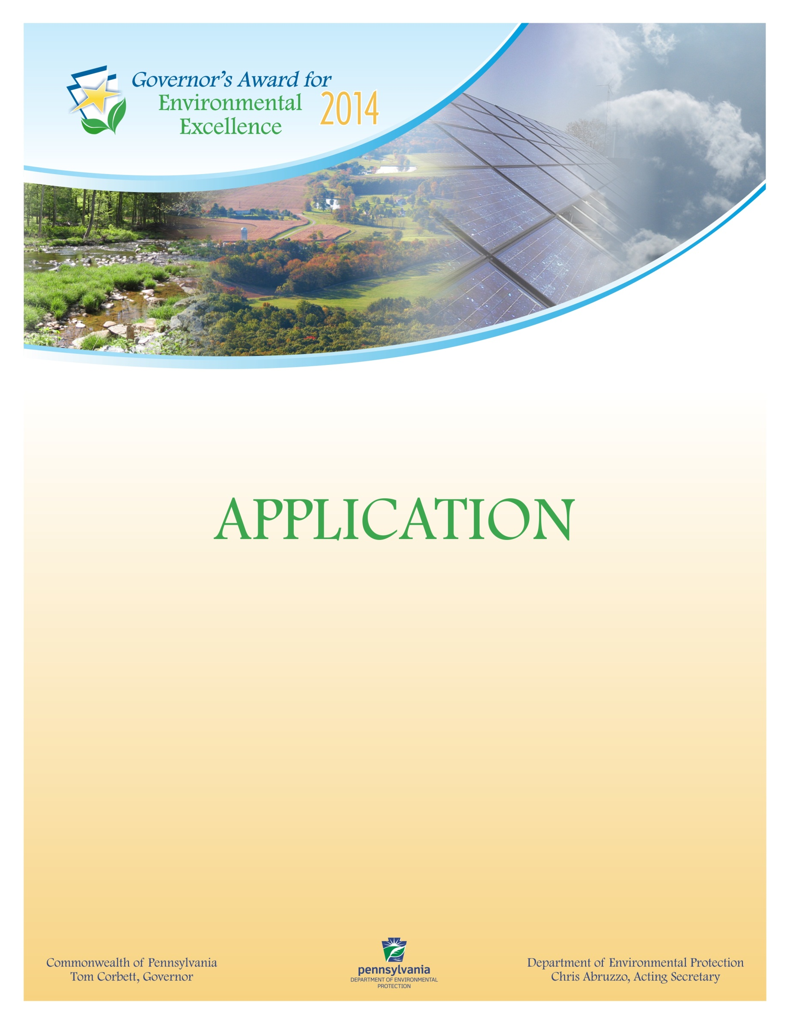
0120-FM-PO0015 10/2013 COMMONWEALTH OF PENNSYLVANIA
DEPARTMENT OF ENVIRONMENTAL PROTECTION
POLICY OFFICE

GOVERNOR’S AWARD FOR ENVIRONMENTAL EXCELLENCE
2014

Award Application
All applications must be typed in the format outlined below. Incomplete applications will not be considered. The applicant is the individual, business, governmental agency, non-profit organization, educational institution, farm or agribusiness that owns the project or was instrumental in implementing the project. Identify the applicant using the format below:
Name of the Project:
Implementation Date:
Completion Date:
APPLICANT INFORMATION:
Company Name:
Name (CEO President, Owner):
Contact: | Contact Title:
Address:
Phone Number: | Fax Number:
Email: | Website:
County/Municipality:
List any related trade associations or similar professional or industry-related groups to which you or your business or organization belong:

Does your organization have any unresolved compliance issues with U.S. EPA, DEP, other state, federal or local authority?
Yes (Please include brief explanation on an attached sheet) No
APPLICANT TYPE
Large Business (more than 100 employees) | Educational Institution
Small Business (less than 100 employees) | Governmental Agency
Individual | Trade/Professional Organization
Media | Farm or Agribusiness
Technical Assistance Provider | Nonprofit/Civic Organization
Other

*Please submit all documents electronically to RA-EPgovenviroawards@pa.gov no later than
5 p.m. on Friday, January 17, 2014.


Project Summary

- Project Name:

- Brief paragraph about the organization:

- Project Description:

- Characteristics, objectives, goals, benefits and outstanding attributes of the project:

- Environmental results achieved by the project:

- Overview of the project’s commitment to improving Pennsylvania’s environment:

- Explanation project partnerships:

- Overview of any innovative technologies and approaches used to achieve results:

- Explanation any environmental education components of the project (if applicable):
- Economic Impact:

