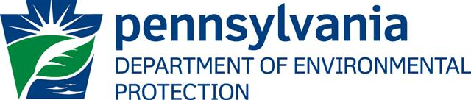

Engineering Scientific and Technical Positions

The Pennsylvania Department of Environmental Protection (DEP) has openings for Oil and Gas Inspectors, Environmental Engineering Trainees, Environmental Engineering Specialists, Environmental Engineers, and Environmental Trainees in the northwestern, southwestern, northcentral and northeastern regions of Pennsylvania. Work assigned to these positions relates to oil and gas drilling and underground storage operations. Duties involve the issuance of permits, inspection of sites, and development of policies and regulations.

DEP is a state government agency responsible for administering Pennsylvania’s environmental laws and regulations related to air, water, waste, mineral resources, radiation, energy, and community revitalization. Many DEP positions are civil service; therefore, applicants must participate in civil service exams to be considered for employment. Visit the State Civil Service Commission website at www.scsc.state.pa.us for a complete listing of job titles open for application.

Most positions require an undergraduate degree and/or experience in an engineering, scientific or technical field. Annual salaries vary depending on the job title and range from approximately $35,364 to $79,257. Benefits include comprehensive health insurance; liberal retirement/pension plan; paid vacation, personal and sick leave; paid holidays; prescription, vision and dental coverage; paid group life insurance; and more.

For specific information on necessary qualifications, contact the Bureau of Human Resources at 717-783-6220 or by email at DEPJobs@state.pa.us .

The Commonwealth of Pennsylvania is an Equal Opportunity Employer
Supporting Workforce Diversity

www.depweb.state.pa.us

