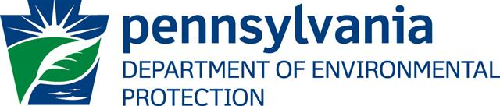

Oil and Gas Inspector

The Pennsylvania Department of Environmental Protection (DEP) has multiple openings for Oil and Gas Inspectors in the northwestern, southwestern and northcentral regions of Pennsylvania. Duties include inspecting oil and gas drilling and underground storage operations within an assigned area of the state to determine and enforce compliance with state laws and regulations. The employee will inspect operating wells, underground gas storage reservoirs, Marcellus Shale reserves and abandoned wells; and inspect the methods used in plugging abandoned wells and reconditioning old wells. Additionally, the employee will provide assistance to representatives of the oil and gas industry on technical matters.

DEP is a state government agency responsible for administering Pennsylvania’s environmental laws and regulations related to air, water, waste, mineral resources, radiation, energy, and community revitalization. Many DEP positions are civil service; therefore, applicants must participate in civil service examinations to be considered for employment.

In order to qualify, applicants must possess five years of technical experience in the oil and natural gas extraction industry, at least one of which has been in the oil or natural gas extraction industry in the Commonwealth within the last three years, or any equivalent combination of experience and training. Salary ranges vary and will be listed on the test announcement. Benefits include comprehensive health insurance; liberal retirement/pension plan; paid vacation, personal and sick leave; paid holidays; prescription, vision and dental coverage; paid group life insurance; and more.

Questions should be referred to the Bureau of Human Resources (BHR) at (717) 783-6220 or by email at DEPJobs@state.pa.us . Apply now at www.scsc.state.pa.us .

There are a number of other employment opportunities with DEP. Most positions require an undergraduate degree and/or experience in an engineering, scientific or technical field. Interested applicants should contact BHR for a complete listing of employment opportunities.

The Commonwealth of PA is an Equal Opportunity Employer
Supporting Workforce Diversity

www.depweb.state.pa.us

