User’s Manual for the Quick Domenico Groundwater Fate-and-Transport Model
28 Feb 2014

A4.2. Example Problem: Source Decay

A4.2.1. Synopsis
This example illustrates the importance of accounting for source decay when modeling fate and transport. Quick Domenico assumes the source concentration does not change with time. A QD simulation will only show increasing concentrations at a point until steady state is reached. Therefore, if there is evidence of source decay then QD may not be an acceptable model. EPA’s Bioscreen or Papadopulos and Associates’ Bioscreen-AT are alternatives.

A4.2.2. Site Description and Background
The example site was formerly a gas station with regulated underground storage tanks. The USTs were removed in 1990, at which time a release was discovered. Soil and groundwater contamination was observed, but no LNAPL. Impacted soils were excavated and removed, and the owner operated a soil vapor extraction system over the tank field in 1990–1992. Twelve monitoring wells were installed, with one offsite upgradient well and one offsite downgradient well (Figure A4.2-1). Periodic sampling for petroleum constituents was performed from 1990 until 2009. No drinking water wells are present within 1000′ of the facility.

Sandy clay soil 4–9 ft thick overlies sandstone bedrock. The depth to water in the unconfined aquifer is ~7–11 ft, in the weathered bedrock. The groundwater flow direction is inferred to the west, with a gradient of ~0.03 ft/ft. The nearest surface water is a stream located ~1000′ northwest. Slug testing performed at four wells yielded an average hydraulic conductivity of 0.47 ft/day. Contaminants of concern (those currently exceeding Statewide health standard MSCs) are benzene, ethylbenzene, and naphthalene. The downgradient offsite well has had nondetect concentrations of these substances.

A consultant performed QD modeling of the plume. The purpose of their modeling was to determine if contaminants exceeded SHS MSCs at the property line (the point of compliance). They used the maximum historic concentrations at MW-7, located in the former tank field, as the source concentrations. The models were calibrated to 2009 data at MW-3, located 35′ downgradient. Only dispersivities were varied to calibrate the models. The consultant selected ASTM values for λ, and they kept K constant using the slug test average. Their conclusion was that there would be no future offsite impacts.

DEP noted several concerns with the QD models that were submitted.

• Supporting data for the hydraulic conductivity were not provided. An average value was used, which is not necessarily conservative. There were no sensitivity tests for K.

• Because only the dispersivities were varied when calibrating the models, the solutions derived different values of α for each contaminant. The range of variation was more than a factor of 10. Dispersivity is a characteristic of the aquifer, and it should not be a function of the solute.

• The modeling was predicated on only two rounds of sampling: one for the source concentrations (1997) and one for the calibration point concentrations (2009). However, there was a large variability in the groundwater concentrations, and selecting a single data point introduces a sensitivity that was not tested.

• There was clear evidence of source decay, likely a consequence of remediation, natural source mass dissolution, and biological degradation. For example, benzene decreased in MW-7 by more than two orders of magnitude in 12 yr.

• There was no sensitivity testing for λ, an important variable.

• Fate-and-transport modeling may not be used to demonstrate attainment of the SHS.

The deficiencies in the submitted analysis call for more rigorous modeling. A key problem is the application of QD to a site with a decaying source. QD is not an appropriate model in this circumstance.

Figure A4.2-1. Site map. The USTs were in the vicinity of MW-7. Potentiometric surface contours are shown. Wells are color-coded with respect to the 2009 level of contamination, decreasing from red to orange to yellow to green. Green wells are below Statewide health standard MSCs.

A4.2.3. Data Analysis
In a case like this, with a long history of groundwater monitoring and signs of source decay, the first step is to graph contaminant trends over time. Visualizing the data allows us to interpret whether there has been source decay and how concentrations have changed downgradient.

Figure A4.2-2 shows benzene data for MW-7 (the source well), MW-3 (35′ downgradient), and MW-10 (53′ downgradient). The concentrations (C) are on a logarithmic scale. All three wells show an approximately linear decline in log(C), consistent with first-order decay. The decreasing concentrations at MW-7 demonstrate that the source is not constant. Furthermore, the trends at MW-7, MW-3, and MW-10 are roughly parallel, implying that the decline in concentrations at downgradient points also reflect source decay. The concentration offsets of MW-3 and MW-10 are a consequence of processes that attenuate the contamination with transport, such as dispersion, adsorption, and biodegradation. Therefore, this figure illustrates two effects: (1) source decay and (2) transport decay of the plume.

We can determine linear least squares regressions for the well data. As suggested by Newell et al. [2002], it is beneficial to derive lower and upper confidence levels for the best-fit slopes. (This can be accomplished by using the LINEST function in Microsoft Excel. The (1 – α) confidence interval of the slope is given by ±t_{α/2}σ_{m}, where t_{α/2} is the student’s t probability (Excel function TINV) and σ_{m} is the standard error of the slope (m).) These results are given below.

Table A4.2-1. Best-fit parameters to monitoring well benzene data
Well | N | Best-Fit  Slope (yr^{–1}) | Lower 90%  CL (yr^{–1}) | Upper 90%  CL (yr^{–1}) | r²
MW-7 | 33 | 0.35 | 0.30 | 0.40 | 0.82
MW-3 | 33 | 0.26 | 0.21 | 0.30 | 0.77
MW-10 | 15 | 0.49 | 0.23 | 0.74 | 0.47
N: number of data points
CL: confidence level
r: sample correlation coefficient

The regression lines are shown on Figure A4.2-2 (dashed for MW-3 and MW-10). The trends are nearly parallel. Based on these data we will assume that the source decay rate is 0.35 yr^{–1} (equivalent to a 1.96-yr half-life), with an uncertainty of ±0.05 yr^{–1}.

In addition, for purposes of conceptualizing the contaminant trends and calibrating the model, we define the benzene concentration (C) at each well using a constant slope of 0.35 yr^{–1}, yielding the following equations:
C_{MW-7}(t) = (46 mg/L)exp[–(0.35 yr^{–1})(t – t₀)]
C_{MW-3}(t) = (12 mg/L)exp[–(0.35 yr^{–1})(t – t₀)]
C_{MW-10}(t) = (7.0 mg/L)exp[–(0.35 yr^{–1})(t – t₀)]
Here the baseline time, t₀, is set to 1 January 1989. Therefore, assuming a release at this time, somewhat before the tank closure, the initial source concentration is given by the intercept value (46 mg/L). (The initial concentrations of the other wells are calculated for lines of slope 0.35 yr^{–1} passing through the average of the data for each well.)

The equations for the lower and upper 90% confidence levels of the MW-7 benzene trend are:
C_{MW-7 lo}(t) = (22 mg/L)exp[–(0.30 yr^{–1})(t – t₀)]
C_{MW-7 hi}(t) = (99 mg/L)exp[–(0.40 yr^{–1})(t – t₀)]
Similar equations are determined for MW-3 and MW-10.

By representing the contaminant concentrations at each monitoring well with the above equations, we can avoid using isolated data points in the models. We don’t want to use individual concentration measurements because of the large quarter-to-quarter variability, which will introduce bias to the model results. For the calibration of the fate-and-transport model, we choose two times at which to evaluate the results at the two downgradient wells, 10 yr and 20 yr after the starting time in 1989.

Table A4.2-2. Selected calibration point benzene concentrations (μg/L)
Well | Distance (ft) | k = 0.30 yr^{–1} |  | k = 0.35 yr^{–1} |  | k = 0.40 yr^{–1}
Date |  | 1/1/1999 | 1/1/2009 | 1/1/1999 | 1/1/2009 | 1/1/1999 | 1/1/2009
Time |  | 10 yr | 20 yr | 10 yr | 20 yr | 10 yr | 20 yr
MW-7 | 0 | 1027 | 49 | 1336 | 39 | 1739 | 30
MW-3 | 35 | 276 | 13 | 359 | 10 | 427 | 8
MW-10 | 53 | — | 2 | — | 6 | — | 1

Figure A4.2-2. Benzene data for three monitoring wells. The dashed lines for MW-3 and MW-10 are least squares fits, whereas the solid lines force the slope to be the same as for the MW-7 regression (0.35 yr^{–1}).

A4.2.4. Model Parameter Values
We select the following baseline parameter values for the QD and Bioscreen-AT benzene models.

Table A4.2-3. Bioscreen-AT model input parameters
Parameter | Symbol | Value | Comments
Source concentration | C₀ | 46.28 mg/L | best fit initial concentration 1 Jan 1989
Source decay coefficient | k | 0.3545 yr^{–1} | from linear regression to data
Longitudinal dispersivity | α_{x} | ~7.5′ | variable
Transverse dispersivity | α_{y} | α_{x}/10 | estimate
Vertical dispersivity | α_{z} | 0.001′ | minimized for two-dimensional transport
Source width | Y | 75′ | site characterization
Source depth (thickness) | Z | 10′ | site characterization
Hydraulic conductivity | K | ~0.472 ft/day | variable
Hydraulic gradient | i | 0.035 ft/ft | based on well data
Effective porosity | n_{e} | 0.35 | estimate
Density | ρ_{b} | 1.7 g/cm³ | estimate
Organic carbon coefficient | K_{oc} | 58 L/kg | DEP Ch. 250 Table 5A value
Fraction of organic carbon | f_{oc} | 0.005 | estimate
Time | t | 0–30 yr
Transport decay coefficient | λ | 0.35 yr^{–1} | variable

Note that necessary unit conversions for QD and Bioscreen are:
K: 2835 (ft/day)/(cm/s)
λ: 365.25 (yr^{–1})/(day^{–1}).

We focus on three variables in the modeling: α_{x}, K, and λ.

• The initial value of the longitudinal dispersivity is set to 10% of the distance from the source to the point of compliance, which is the property boundary. This is the location where we want to assess potential exceedences, so it is the scale of interest. The variation from this baseline value can be an order of magnitude.

• The initial value of the hydraulic conductivity is taken from the average slug test results. It, too, can vary by a factor of 10.

• The initial degradation rate is DEP’s Ch. 250 Table 5A value. This is uncertain by at least an order of magnitude, and it is the primary variable for calibrating the models.

Therefore, we model the following parameter space, varying λ in each simulation to best fit the MW-3 and MW-10 calibration points at two times, t = 10 yr and 20 yr. The source decay rate, k, is constant for these first nine models.

Table A4.2-4. Model parameter ranges
Model | α_{x} (ft) | K (ft/day)
01 | 7.5 | 0.472
02 | 0.75 | 0.472
03 | 75 | 0.472
04 | 0.75 | 0.047
05 | 7.5 | 0.047
06 | 75 | 0.047
07 | 0.75 | 4.7
08 | 7.5 | 4.7
09 | 75 | 4.7

Figure A4.2-3 illustrates the input screen for Model 01.

In addition, we run two models with the alternate formulas for the minimum and maximum source concentrations (C_{MW-7 lo} and C_{MW-7 hi} above), Models 10 and 11. They have the same values of α_{x} and K as the baseline Model 01. (Note that the calibration point concentrations are redefined for these models using the alternate slopes.)
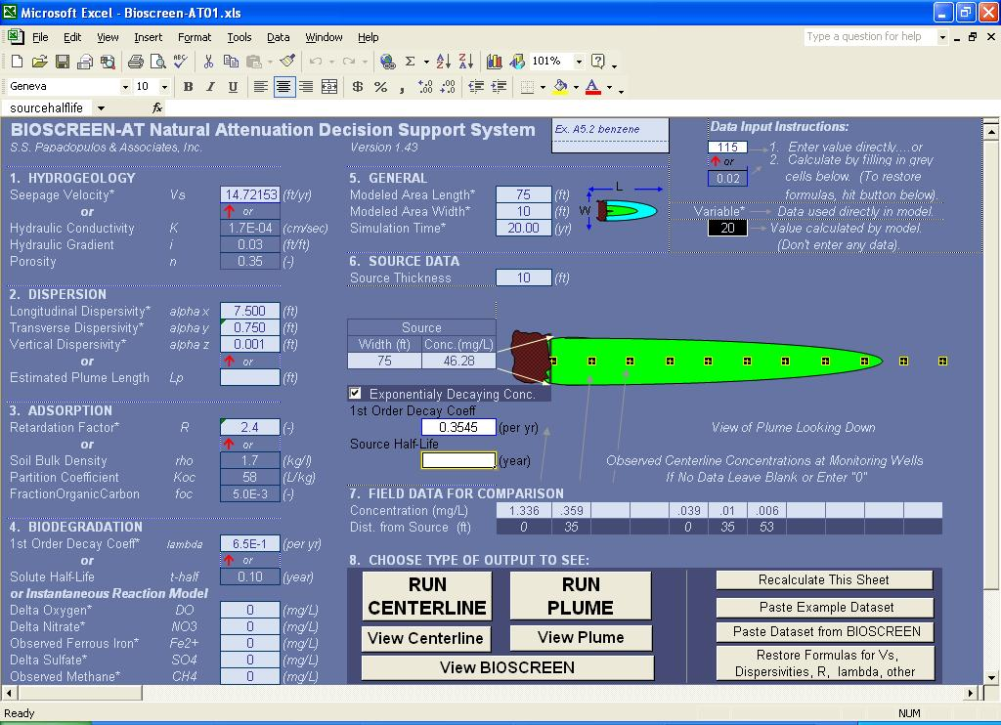
Figure A4.2-3. Bioscreen-AT screenshot of data input worksheet for Model 01.

Important Bioscreen-AT Tips
• Be certain to enter parameter values with the correct units, as some units are different than QD.
Parameter | Bioscreen Units | Conversion
Hydraulic conductivity | cm/sec | (cm/sec)/(2835 ft/day)
Decay rates | yr^{–1} | (365.25 yr^{–1})/(day^{–1})
Time | yr | (yr)/(365.25 day)
For example,

• When changing input values, check carefully that other dependent variables are recalculated. For instance, when entering a new value of hydraulic conductivity, make sure that the seepage velocity is also updated. If it isn’t, click the “Restore Formulas” button in the lower right corner of the screen. Then you must check all other calculated variables (e.g., dispersion, first-order decay, source decay) and reenter them if they have inadvertently changed.

• In the “Field Data for Comparison” area of the input screen, you can enter up to 11 distance–concentration pairs. In fact, you can enter data at the same distance more than once. This allows you to see the field data at different times, making the calibration easier.

• On the centerline results screen, you are unable to display the graph with a logarithmic vertical scale. However, you can change the scale range if you wish by right clicking on the axis and selecting “Format Axis…”.

A4.2.5. Bioscreen Model Calibration and Results
We visually calibrate the model for the selected parameter space of K and α_{x} defined in Table A4.2-4. The best-fit values of λ and the resulting benzene concentration at the property boundary (x = 75′) are as follows. A solution at 10 yr is depicted in Figure A4.2-4.

Table A4.2-5. Benzene modeling results for t = 20 yr (1 Jan 2009)
Model | α_{x} (ft) | K (ft/day) | λ (yr^{–1}) | C(x = 75′) (μg/L) | Comments
01 | 7.5 | 0.472 | 0.65 | 2 | Baseline model. Figure A4.2-4.
02 | 0.75 | 0.472 | 0.59 | 2
03 | 75 | 0.472 | 1.25 | 2
04 | 7.5 | 0.255 | 0.49 | 3 | Lower values of K won’t calibrate.
05 | 0.75 | 0.312 | 0.49 | 3 | Lower values of K won’t calibrate.
06 | 75 | 0.071 | 0.46 | 3 | Lower values of K won’t calibrate.
07 | 7.5 | 4.7 | 3.35 | 2
08 | 0.75 | 4.7 | 2.75 | 2
09 | 75 | 4.7 | 9.2 | 2
10 | 7.5 | 0.472 | 0.60 | 3 | k = 0.30 yr^{–1}
11 | 7.5 | 0.472 | 0.72 | 2 | k = 0.40 yr^{–1}

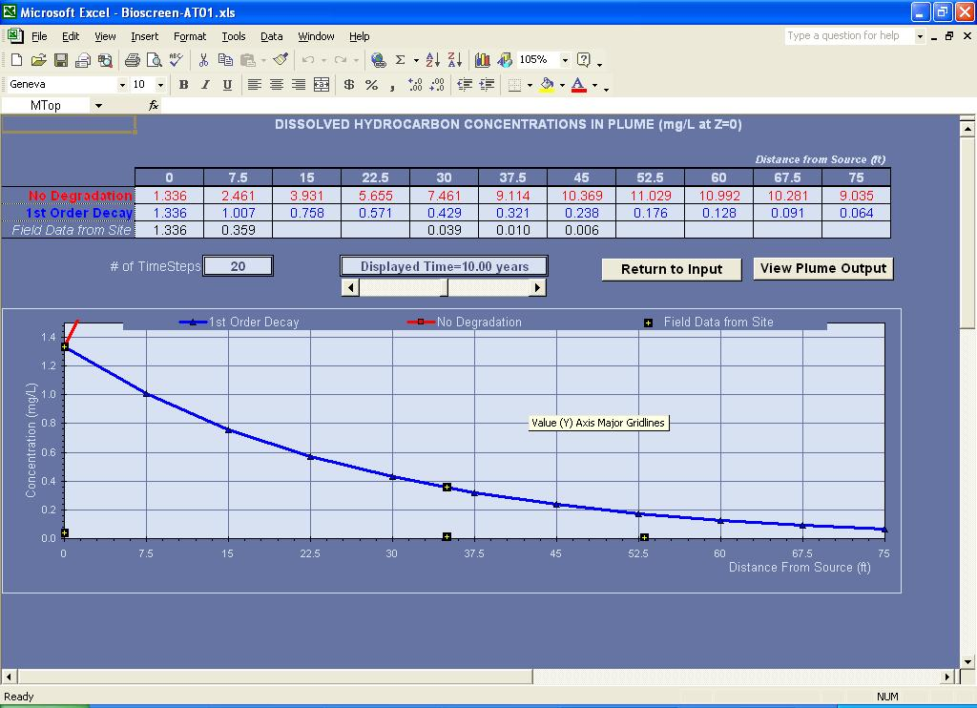
Figure A4.2-4. Bioscreen-AT centerline results screen at 10 yr for Model 01.

A4.2.6. Bioscreen Model Findings
Here’s what we can conclude from these model runs.

• The plume advances until ~5 yr, and then concentrations begin to decline as source decay overcomes advective transport.

• Within the modeled parameter space, there is a large range of best-fit λ (over a factor of 10), but the predictive results at the property boundary vary very little. This is because the two calibration wells tightly constrain the model curves.

• Benzene is predicted to be below the SHS MSC of 5 μg/L at the property boundary for all model scenarios, as of 2009.

• However, in the past the standard was exceeded at the property boundary. For the baseline model, benzene attains 5 μg/L only beginning in 2007, and a maximum past concentration of ~100 μg/L is calculated at the property line.

In this example we determined that there are no present or future exceedences at the property boundary. However, this does not qualify as a demonstration of attainment for the Statewide health standard. This must be accomplished with monitoring well data (Section 250.704(b)). Modeling can guide the remediator’s decision to install point-of-compliance wells. The results can also be used under the site-specific standard to demonstrate that there would be no receptors beyond the property line.

A4.2.7. Comparison to QD
Recall that the consultant originally didn’t account for source decay and modeled the site with Quick Domenico. How do the QD predictions compare to Bioscreen-AT?

As is commonly done with QD, we will define the maximum measured benzene concentration as the source concentration (3.92 mg/L at MW-7 in January 1997) for the QD model. The other input parameters are the same as in Bioscreen-AT Model 01, and we calibrate to the same MW-3 and MW-10 concentrations by varying λ. We obtain the following results for QD (Figure A4.2-5).

Table A4.2-6. QD baseline model results
Model | Year | α_{x} (ft) | K (ft/day) | λ (yr^{–1}) | C(x = 75′) (μg/L) | Comments
01QD | 1999 | 7.5 | 0.472 | 0.0 | 2414
01QD | 2009 | 7.5 | 0.472 | 2.1 | 0 | Poor calibration

We obtain inconsistent values of λ for the two calibration times. The 2009 calibration cannot match both the MW-3 and MW-10 calibration points. Neither the 1999 nor the 2009 QD model reproduces the more physically realistic Bioscreen simulations.

The planform shape of the Bioscreen and QD plumes are quite different (Figure A4.2-6). The Bioscreen plume is longer, but the QD plume is wider. This is apparently because a constant source concentration causes greater mass loading that disperses perpendicular to the flow direction during the simulation time.

The key lesson from this comparison is that QD can significantly underpredict concentrations downgradient of the calibration wells when there is source decay. Whereas the end result is similar in this example (benzene does not exceed at the property boundary), this is not true at other times, and it certainly may not be true in other cases.

A user might be able to manipulate QD to better match the Bioscreen results with source decay. But the only way to know if this approach succeeds is to run both Bioscreen and QD, and this effort is hardly justified, given that Bioscreen alone will satisfactorily model the problem. QD is an invalid model for source decay problems, and the user should always employ a model that can properly simulate the critical parameters and conditions of the site.

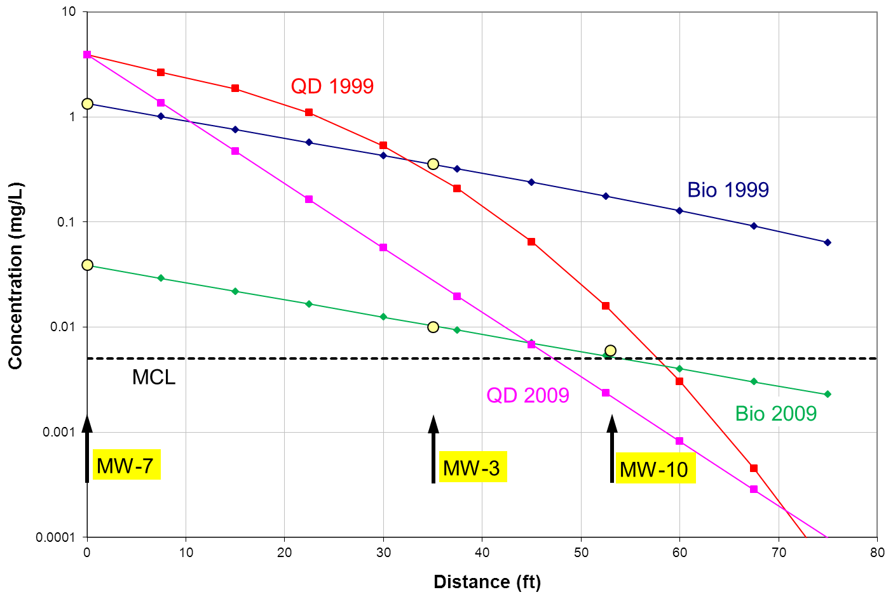Figure A4.2-5. Centerline benzene results for Bioscreen-AT Model 01 compared to Quick Domenico in years 1999 and 2009.

Figure A4.2.6. Planview results for Bioscreen-AT Model 01 compared to Quick Domenico in the year 2009.

A4.2.8. Bioscreen-AT Modeling Procedure
The steps taken to model a fate-and-transport problem with Bioscreen-AT are outlined below.

- Graph the contaminant data for the source and downgradient wells as a time series.
- Determine if there is source decay.
Calculate the decay rate (k) and its uncertainty.
- Use the best-fit lines to the data for calibration point concentrations.
- Define the release time.
Calculate the initial source concentration.
- Run Bioscreen-AT.
Calibrate the model by varying a combination of source concentration (C₀ and k), λ, K, and/or α.
- Validate the calibrated model at other times.
- Repeat steps 1–6 for other contaminants.
Attempt to find consistent values of K and α for all substances.
- Run calibrated sensitivity tests for appropriate ranges of the variables λ, K, and/or α.
- Run predictive models for present/future contaminant transport.

A4.2.9. Evaluating Stream Impacts With Bioscreen-AT
DEP’s SWLOAD spreadsheet uses the Domenico solution to estimate the groundwater flux and average contaminant concentration entering a stream. These values are input into PentoxSD to determine if diffuse groundwater flow will cause exceedences of surface water criteria. For the same reasons that QD will not give accurate solutions for a decaying source, SWLOAD also will not be applicable. But similar calculations can be done within Bioscreen-AT.

Here we use the above example to demonstrate this, imagining that a stream is 75′ downgradient from the source in place of a road. We’ll consider the year 1999. The procedure for estimating the parameter values for input to PentoxSD follows. (Also see DEP’s Technical Guidance Manual, Section IV.A.3.)

- Run Bioscreen-AT for the source–stream distance (75′) and time of concern (10 yr). Click the “Run Plume” button and choose “Show ‘1st Order Decay’ Model.”
- Iteratively “Run Plume” by varying the modeled area width until the concentration at the downgradient corners of the grid is approximately equal to the applicable edge criterion (e.g., 1.2 μg/L for benzene). A width of 110′ gives concentrations of 1 μg/L at the corners. See Figure A4.2-7.
- Calculate the average five-point plume concentration at the stream (“Run Plume” output):
(1 + 57 + 64 + 57 + 1)/5 = 36 μg/L benzene.
This is roughly equivalent to the “maximum average” concentration that would be calculated by SWLOAD.
- Determine the groundwater plume flow rate diffusing into the stream using Darcy’s Law
Q = KiA
= (0.472 ft/day)(0.035 ft/ft)(110 ft x 10 ft)
= 18.2 ft³/day
= 2.10 x 10^{–4} ft³/sec
= 1.36 x 10^{–4} million gallons per day.
- The average concentration and discharge rate are input to PentoxSD.
- If the maximum concentration (here 64 μg/L benzene) is less than the edge criterion, then no PentoxSD analysis is needed.

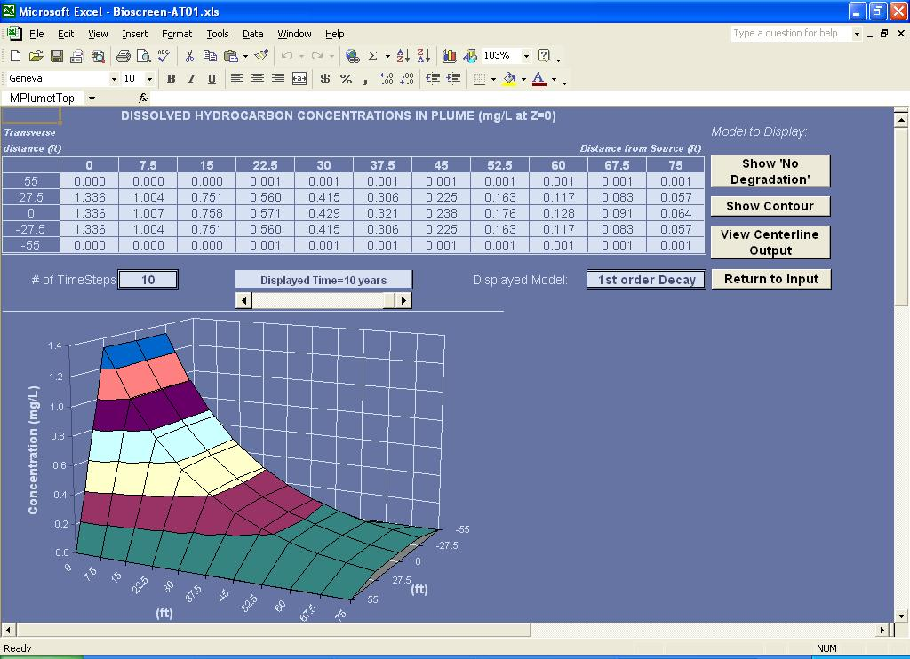
Figure A4.2-7. Bioscreen-AT plume output for Model 01 at 10 yr. The solution at the five points at x = 75′ are used to approximate the average concentration entering the stream.

