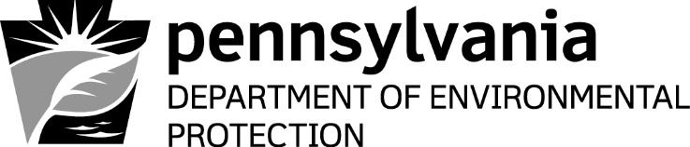
AGGREGATE ADVISORY BOARD
Regulatory, Legislative and Technical Committee
Friday, May 5, 2017

Meeting Location:
14th Floor Conference Room
Rachel Carson State Office Building

Conference Call Information:
Access Code: 640 749 002
Password: EarthEnviroEd$50
Call-in Toll Number: 1-650-479-3208

10:00 a.m. Meeting Called to Order Mark Snyder, Committee Chair

10:05 a.m. Introduction of Members and
Others in Attendance

10:15 a.m. Acknowledgement of PACA
Anti-Trust Statement

10:20 a.m. Discussion of the Non-Coal Mining Permit Committee Members Application Modules, Sinkhole Issues
Paper and Karst Issues Site List

11:45 a.m. Discussion of Additional Items Committee Members

12:00 p.m. Adjourn

