Instructions for the On-line Application

The MERP Small Operator application must be submitted online through the Electronic Single Application (ESA) website. Paper and faxed copies will not be accepted. This change allows DEP to expedite the review process. The link to the ESA website is: https://grants.pa.gov/

No documentation should be mailed to DEP.

User Tips
- Electronic Single Application works best when accessed through Microsoft Edge or Google Chrome
- If you allow your screen to sit idle for 30 minutes or more, you will lose the data entered since your last save and will have to re-enter it.
- Save frequently.
- When completing the application, fields with a “” are required fields. If a required field is skipped, you will be notified later in the application to return to the affected section to complete the field.
- Do not use special characters such as \,/,*,&,%,#, etc.
- If you have questions completing the application, please contact Enterprise eGrants Customer Service Center at 1-833-448-0647 or email at egrantshelp@pa.gov. Operating hours are Monday through Friday from 8:00 am to 6:00 pm EST.

Table of Contents

1. Registration and Login Page 3

2. Begin a New Application Page 4

3. Select a Program Page 5

4. Apply Page 5

5. Requirements Page 5

6. Applicant Information Tab Pages 6-7

7. Project Overview Tab Page 8

8. Project Site Tab Page 9

9. Narrative Tab Page 10

10. Program Addenda Tab Pages 11-14

11. Certification and Submission Pages 15-16

12. Application Receipt Verification Page 17

Reminder: If you have questions completing the application, please contact Enterprise eGrants Customer Service Center at 1-833-448-0647 or email at egrantshelp@pa.gov. Operating hours are Monday through Friday from 8:00 am to 6:00 pm EST.

- Registration and Login
- Go to ESA login page https://grants.pa.gov/ and follow the instructions for creating a new account, or login with your existing account.
- Write down and save the Username and Password you have chosen. You will need this for later your grant documents.

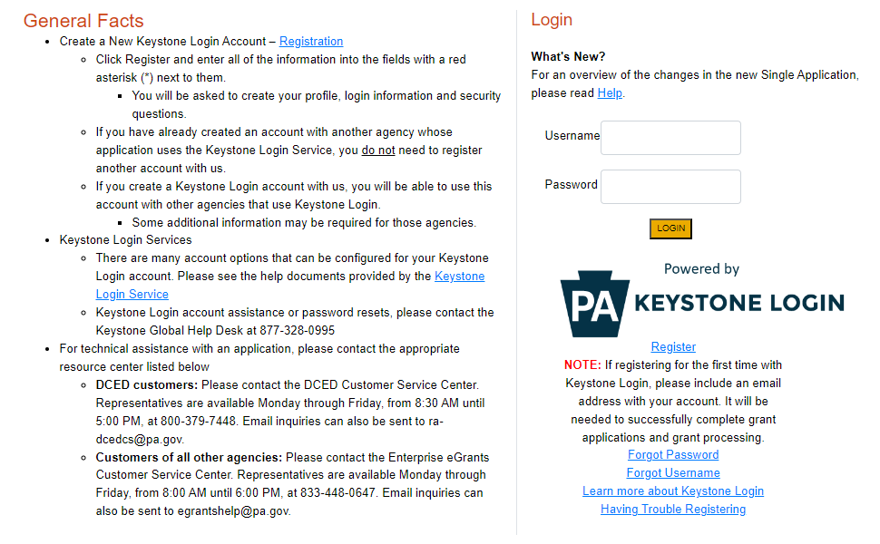

- Begin a New Application
- Project Name – Choose and enter a name for your project.
- Do you need help selecting your program – Select “No”
- Click on “Create a New Application”

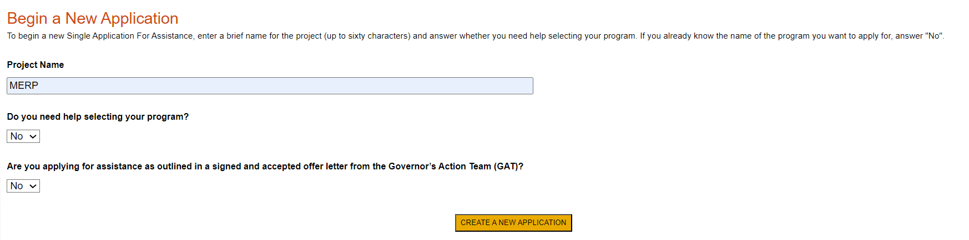

- Select Program
- Under “Agencies,” click DEP
- Scroll down and click “Search”

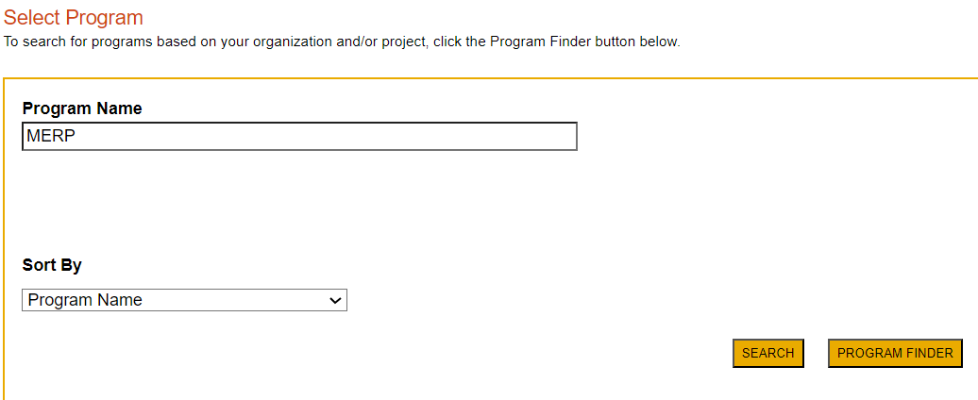

- Apply
- Scroll down through the various grant offerings, locate the “ MERP Small Operator Grant Program and click on “Apply.”

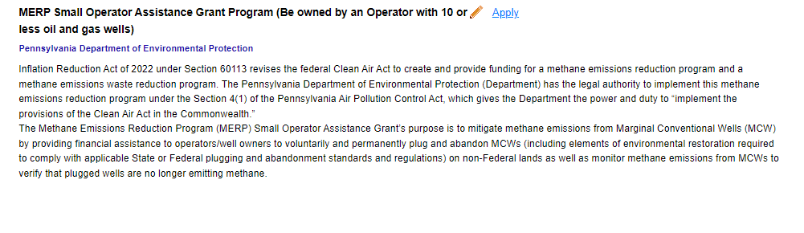

- Requirements

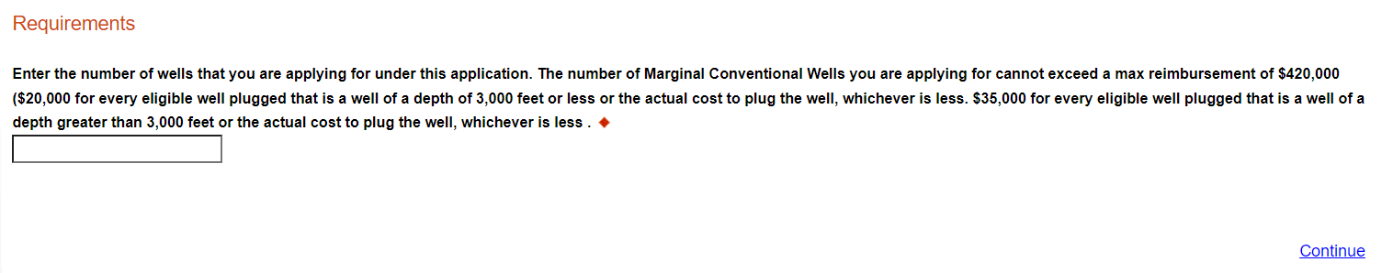

- Applicant Information

- The Applicant Information section requires data related to the entity for which the application is being submitted.
- Applicant Entity Type – select the appropriate type for your organization
- Applicant Name – Enter the legal name, the name under which the entity legally conducts business.
- NAICS Code – enter the appropriate code for your organization
- FEIN/SSN Number - Enter the Federal Tax ID number for the legal name (no dashes).
- UEI Number – Unique Entity Identifier. Enter the applying organization’s unique, 12-character alphanumeric identifier which is assigned to all entities that conduct business with the federal government. This is required.
- Top Official/Signing Authority – In this block, enter the authorized representative of the organization.
- Title – Enter the title of the authorized representative.
- SAP Vendor# - Enter, if known.
- Contact Name – Enter the primary contact name for this project.
- Contact Title – Enter the primary contact title for this project.
- Phone and Fax – Enter the phone and fax numbers for the primary contact title for this project.
- E-mail – Enter the e-mail for the primary contact title for this project.
- Mailing address, City, State and Zip Code – Enter this information for the primary contact for this project.
- Enterprise Type – Select appropriate type.
- Click “Continue”

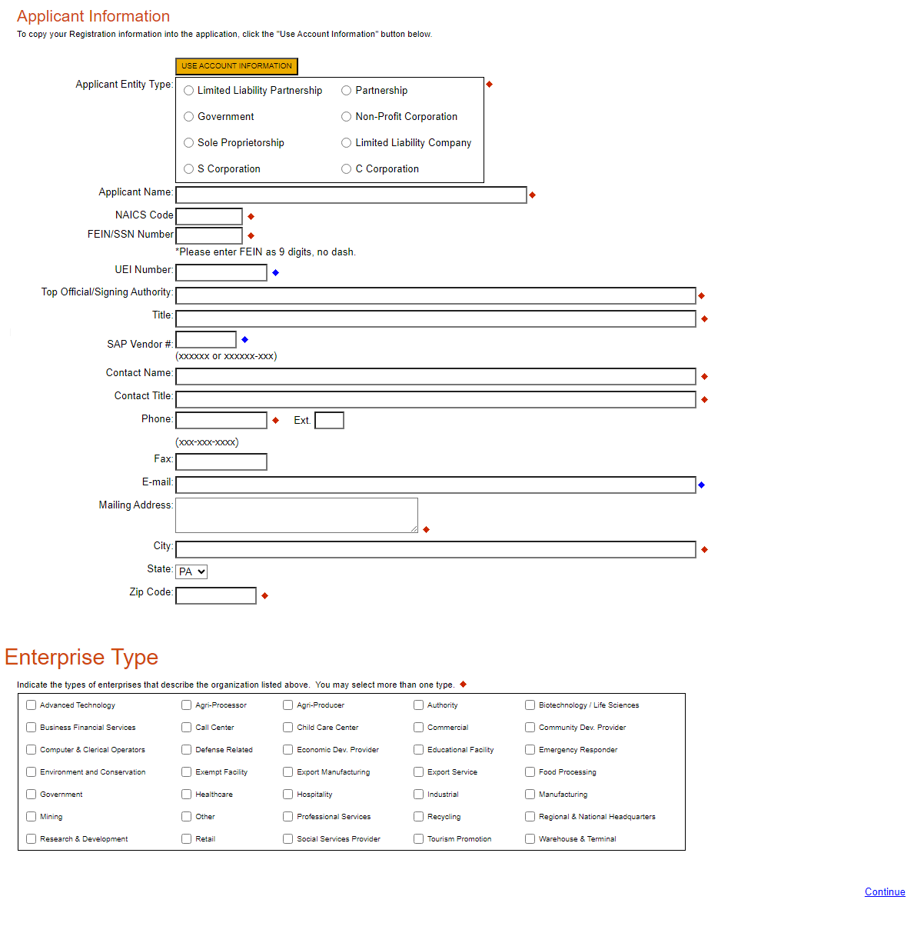

- Project Overview

- Project Name – The project name will auto-populate.

The rest of the information in the Project Overview section is not required and does not need to be filled out.

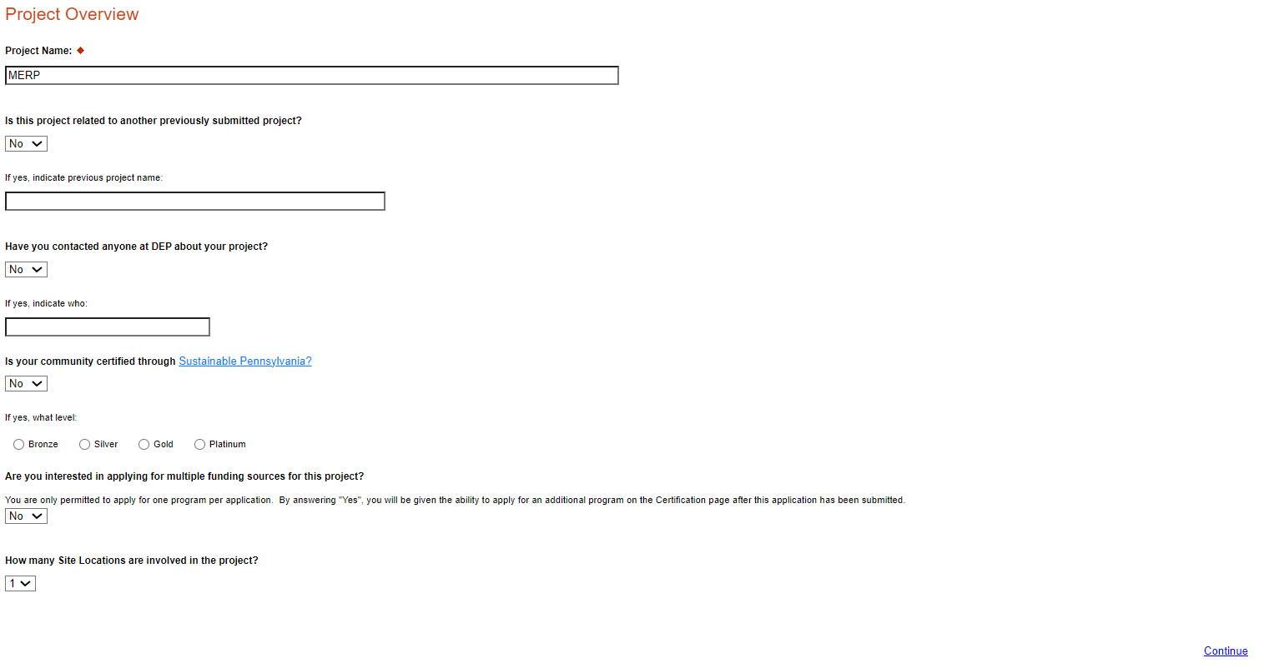

Click on “Continue”

- Project Site

- Address – Enter the applicant’s mailing address (street address). P.O. Boxes are not acceptable.
- City, State and Zip Code – Enter this information.
- County – Select “Statewide Project”
- Designated Areas – Leave blank.

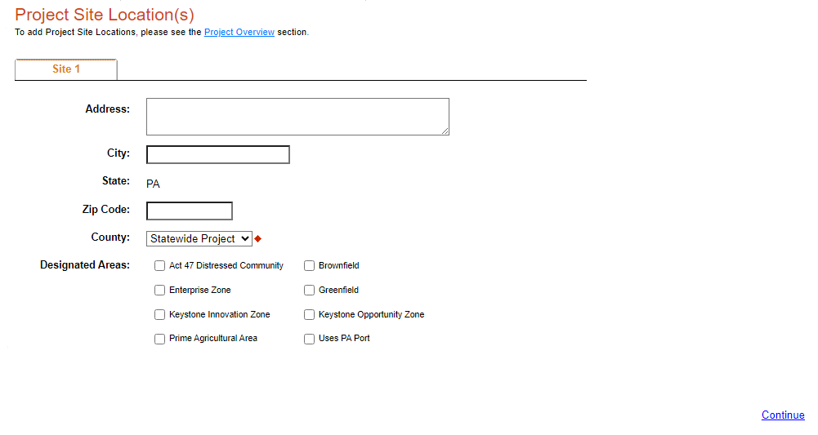

Click on “Continue”

- Project Narrative
- This section does not need to be completed.

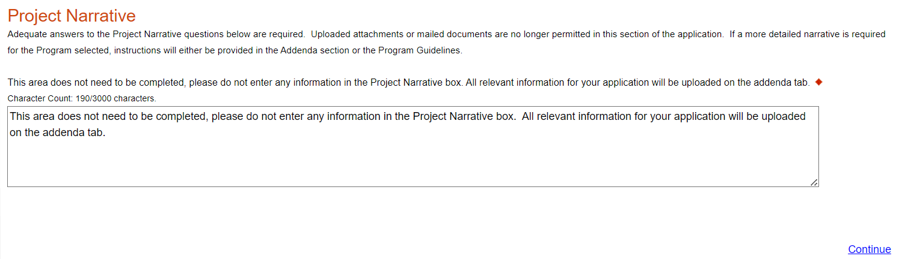
Click on “Continue”

- Program Addenda
- Complete all fields in this section.

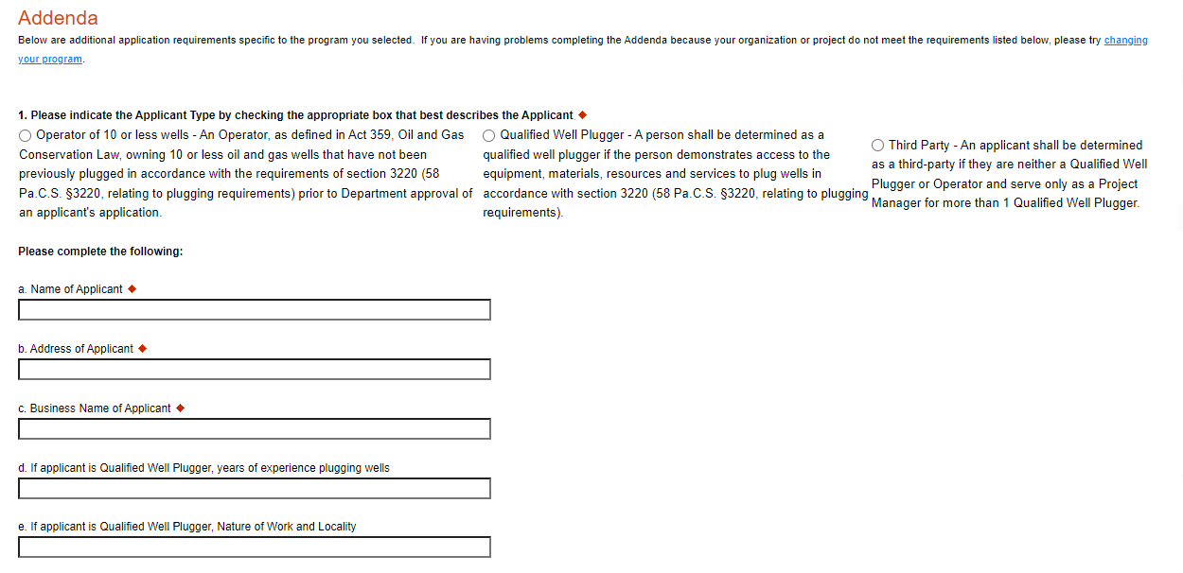
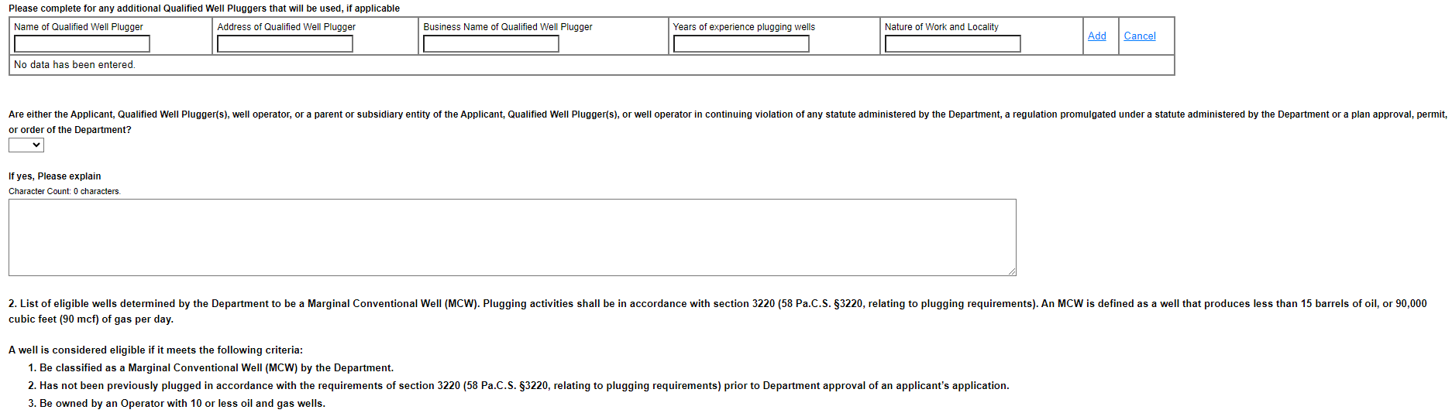
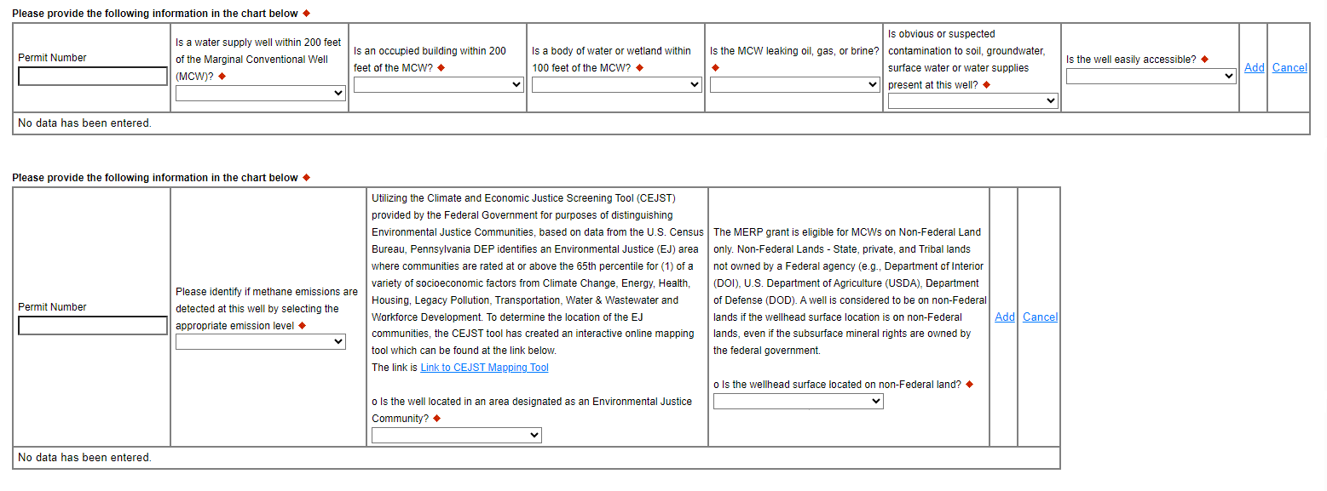
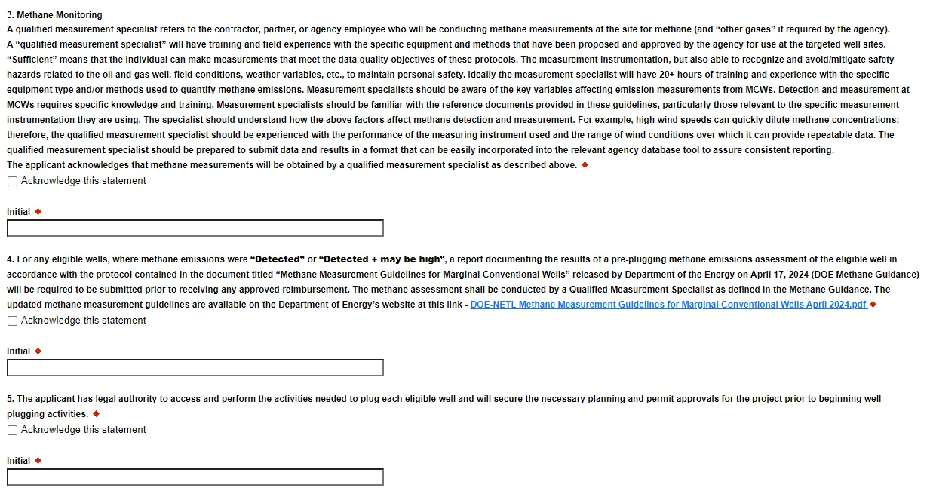
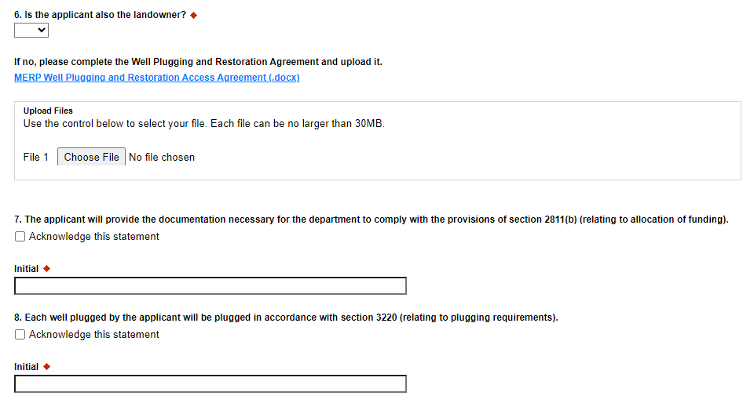
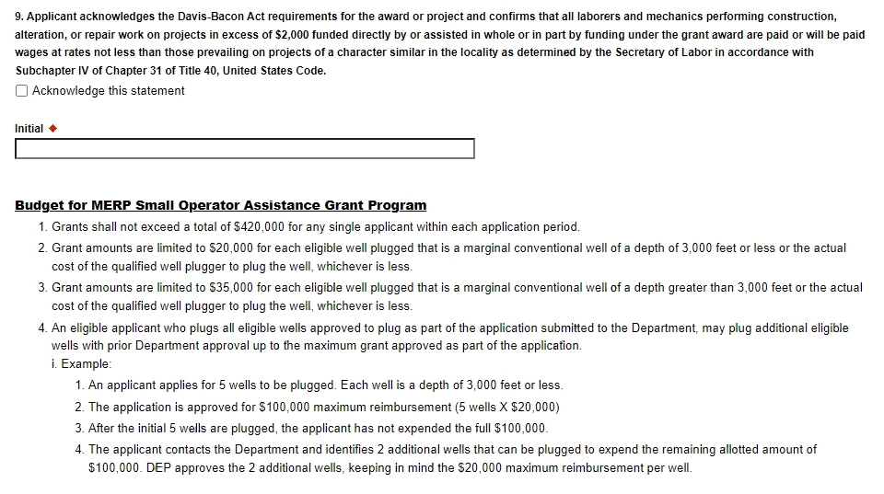
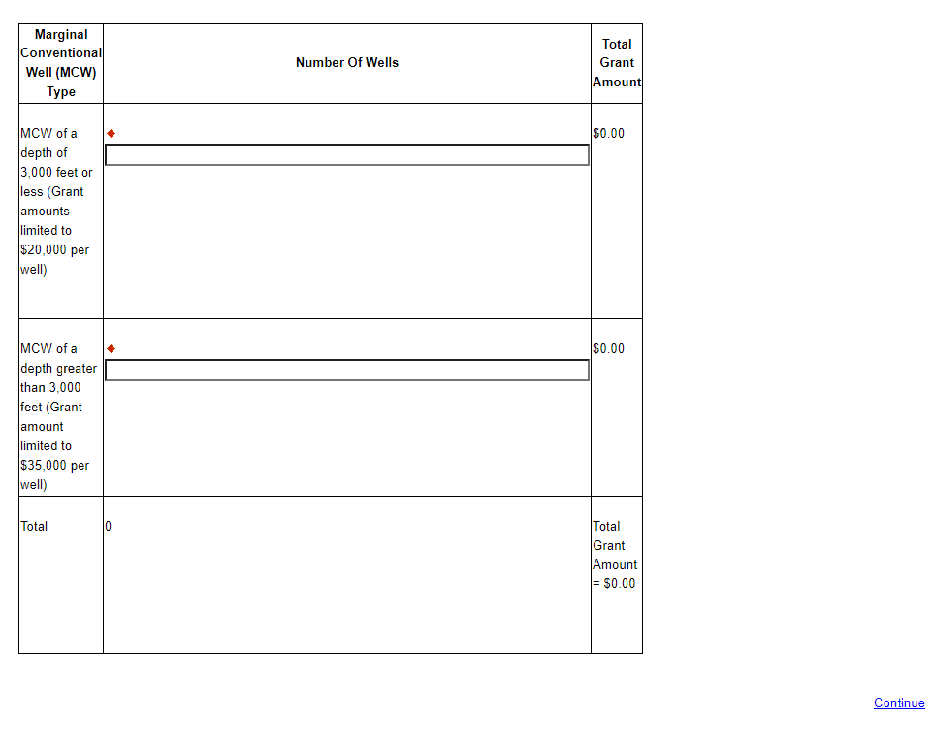

Click “Continue”

- Certification and Submission
- If there is any missing information in your application, your screen will look similar to the following example.
- Under the orange “Application Certification” heading, it will state, “The following sections are incomplete. All required fields marked with a red diamond must be completed before you are able to submit this application”.
- To add/correct the information on your application, click on the section heading to return to the page.

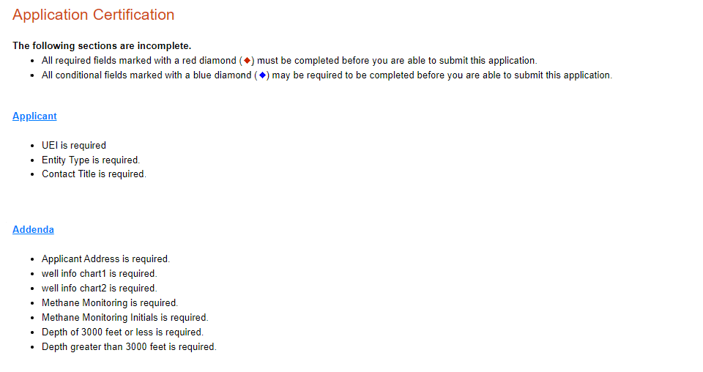

- Complete the following fields:
- Indicate certification of application information by checking the related checkbox under the Electronic Signature Agreement.
- Indicate identity as one of the following:
  - I am the applicant.
  - I am an authorized representative of the company, organization or local government.
  - I am a “Certified” Partner representative.
- Type your name in the “Type Name Here” block. This will serve as your official e-signature and authorizes your application.
- Check the “Electronic Attachment Agreement” box.
- Click on “Submit Application.”

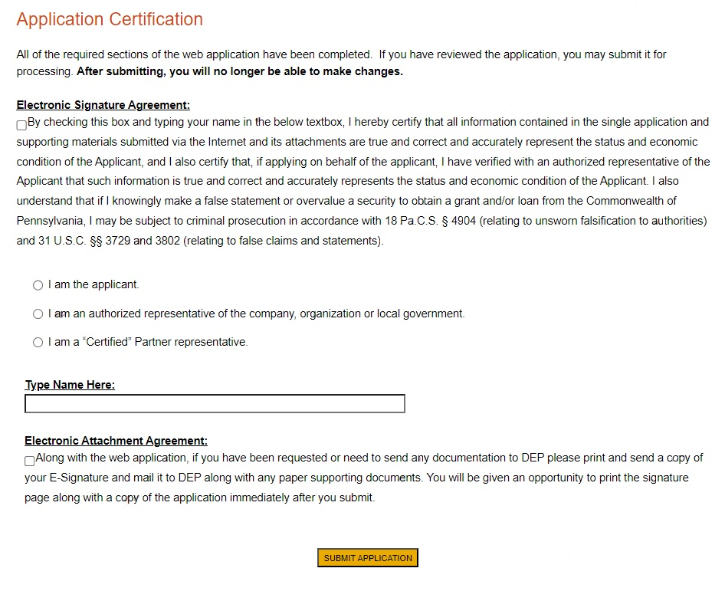

- Application Receipt Verification
- If you want a copy of your application, click the “Print Entire Applications with Signature Page” link. You will always be able to access your application with the username and password you created at the beginning of the application.
- Make sure to note the Single Application ID#. All future correspondence from the Department will reference this number.
- You do not need to send the signature page and/or any further documentation to the Grants Center. All the information needed is contained in your online submission.

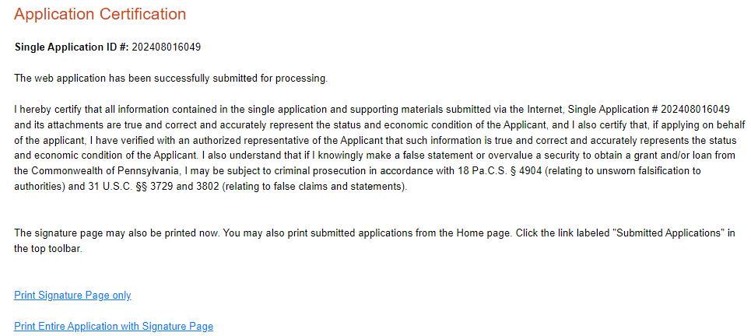

- Congratulations! You have completed the online application.

