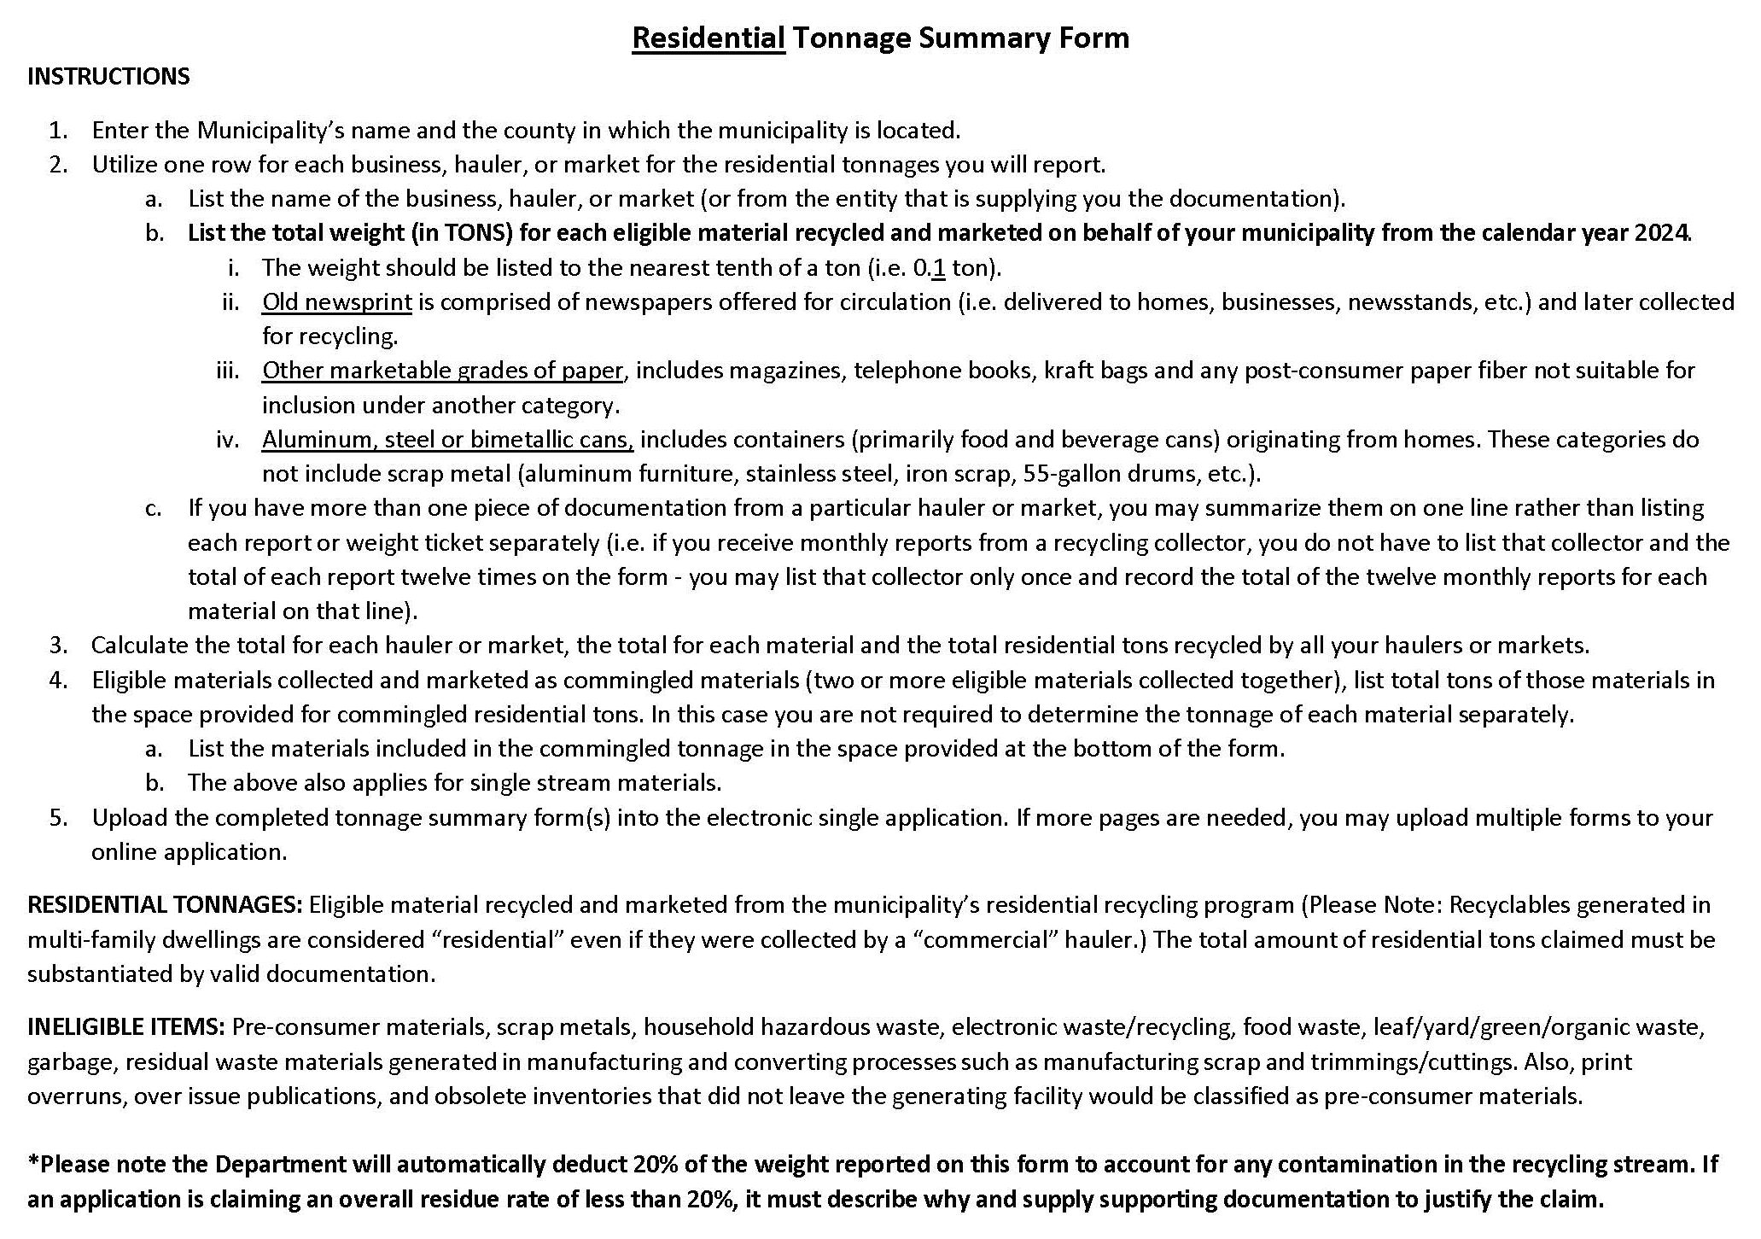
2024 / Municipality, County: Click here to enter text.
RESIDENTIAL TONNAGE SUMMARY FORM
Business  Hauler/Market | Old Newsprint | High Grade  Office Paper | Corrugated | Other Marketable  Grades of Paper | Mixed Paper | Aluminum Cans | Steel Cans or  Bimetallic Cans | Mixed Cans  (Not Scrap metals) | Amber Glass | Clear Glass | Green Glass | Mixed Glass | PET Plastics | HDPE Plastics | Other Plastics | Mixed Plastics | Dual Stream**  (Commingled) | Single Stream** | Total
TOTALS

Total Residential Tons:
**If claiming residential commingled or single stream tonnage, use the space below to list the materials included in the tonnage: Click here to enter text.

2024 / Municipality, County: Click here to enter text.
RESIDENTIAL TONNAGE SUMMARY FORM
Business  Hauler/Market | Old Newsprint | High Grade  Office Paper | Corrugated | Other Marketable  Grades of Paper | Mixed Paper | Aluminum Cans | Steel Cans or  Bimetallic Cans | Mixed Cans  (Not Scrap metals) | Amber Glass | Clear Glass | Green Glass | Mixed Glass | PET Plastics | HDPE Plastics | Other Plastics | Mixed Plastics | Dual Stream**  (Commingled) | Single Stream** | Total
TOTALS

Total Residential Tons:
**If claiming residential commingled or single stream tonnage, use the space below to list the materials included in the tonnage: Click here to enter text.

