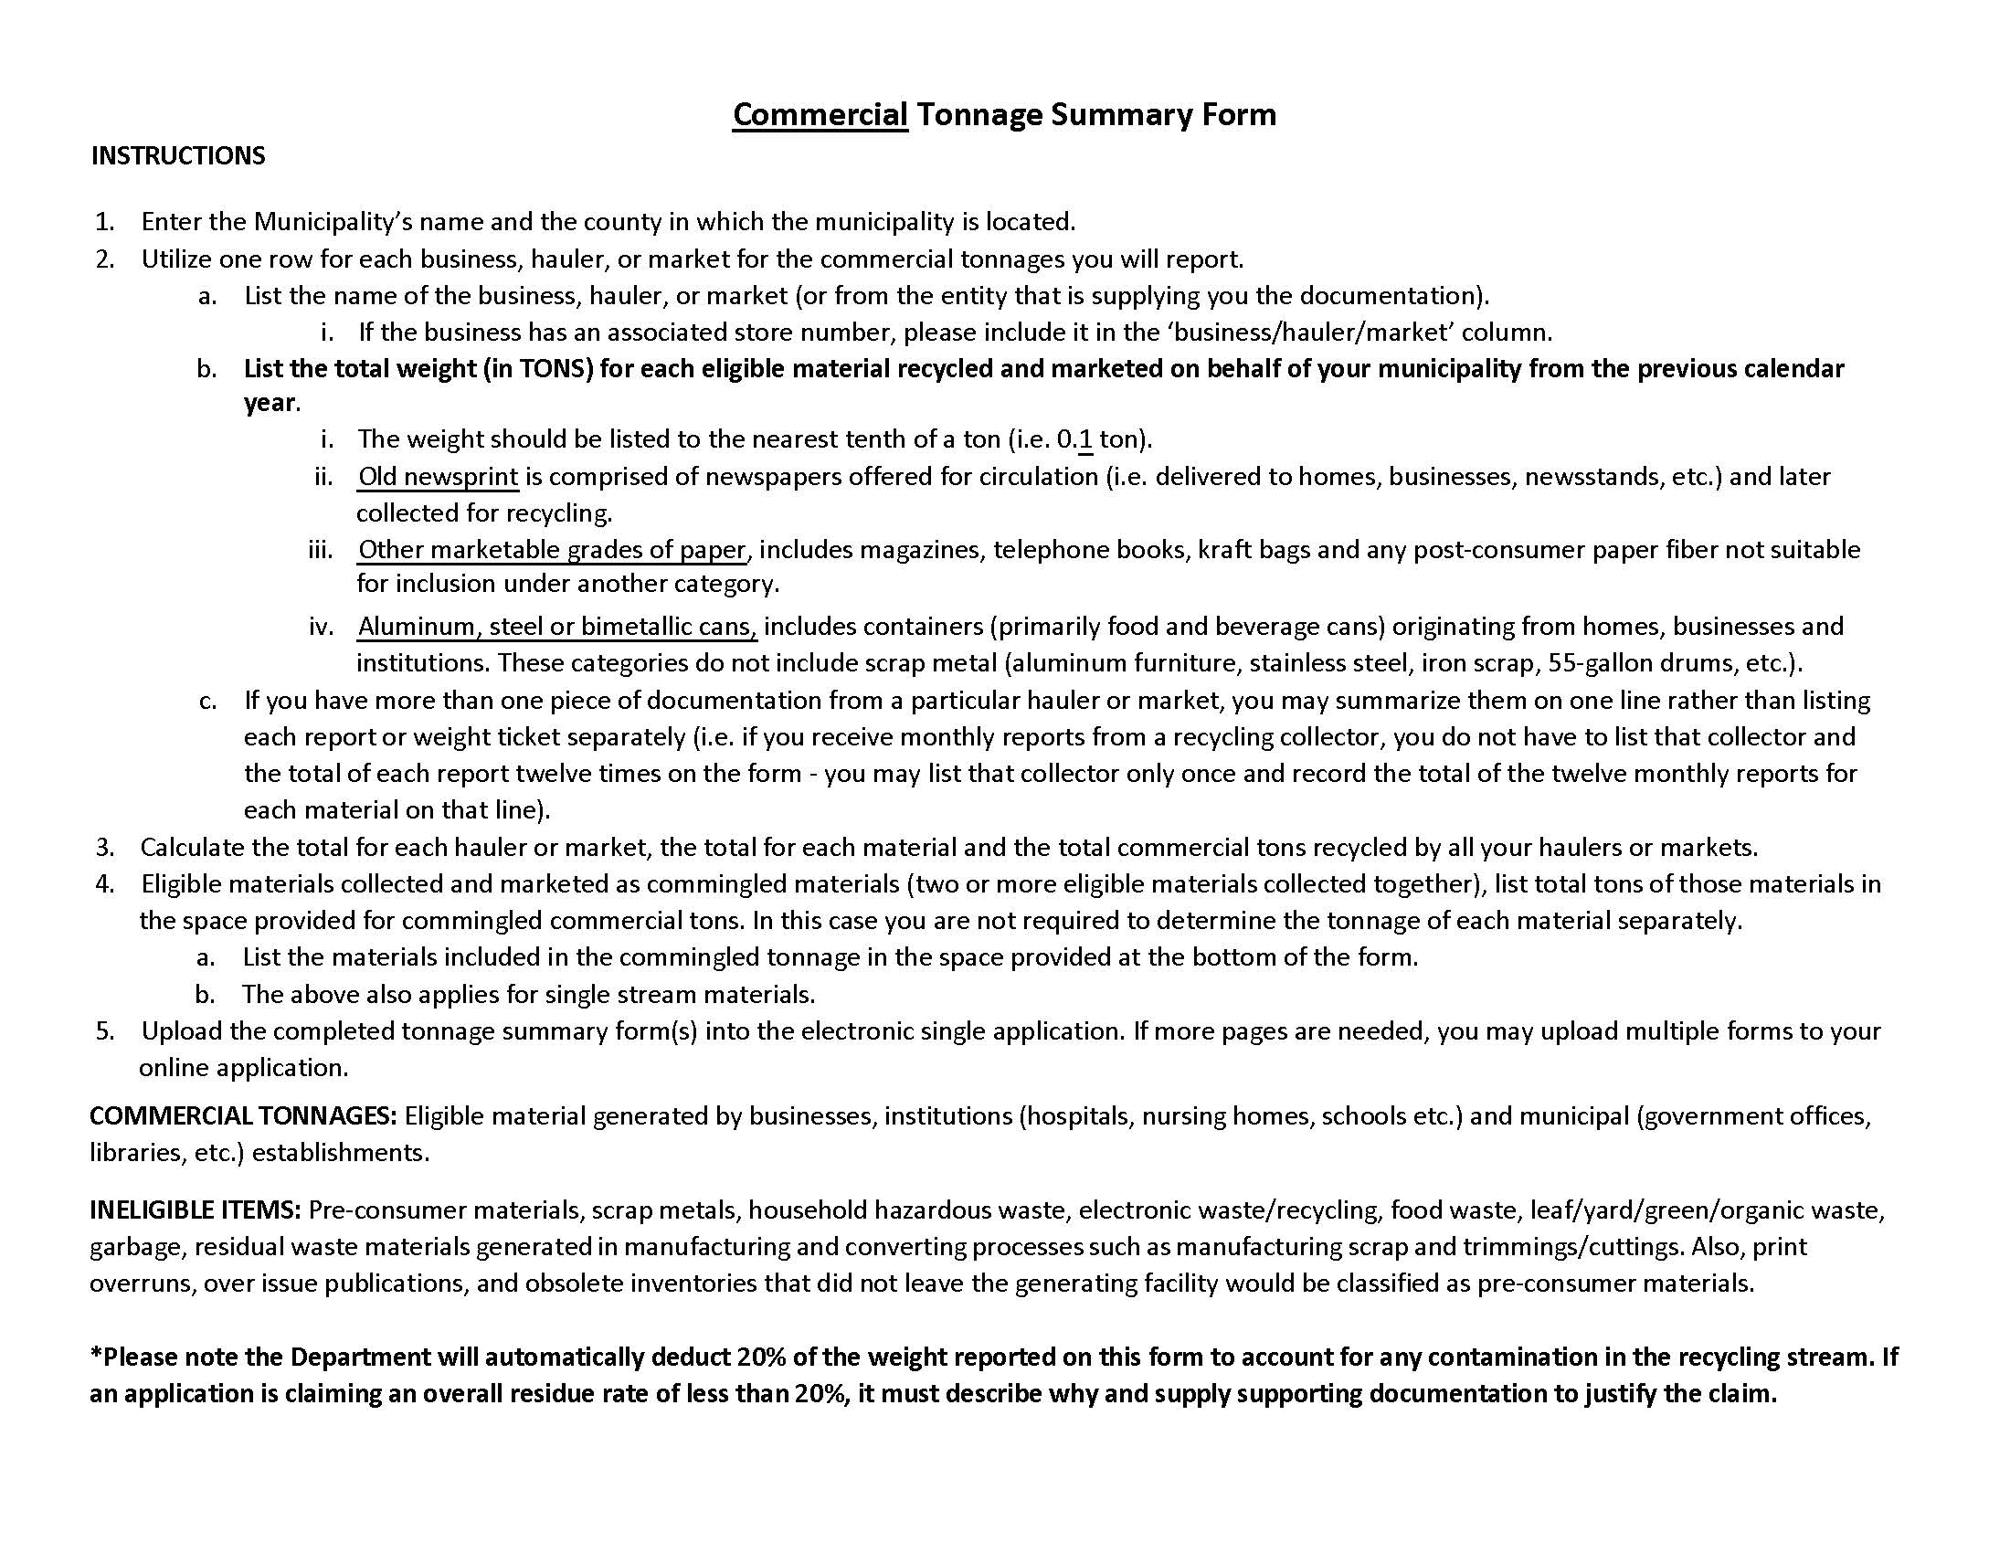
2025 / Municipality, County: Click here to enter text.
COMMERCIAL TONNAGE SUMMARY FORM
Business  Hauler/Market Store Number* | Old Newsprint | High Grade  Office Paper | Corrugated | Other Marketable  Grades of Paper | Mixed Paper | Aluminum Cans | Steel Cans or  Bimetallic Cans | Mixed Cans  (Not Scrap metals) | Amber Glass | Clear Glass | Green Glass | Mixed Glass | PET Plastics | HDPE Plastics | Other Plastics | Mixed Plastics | Dual stream**  (Commingled) | Single Stream** | Total
TOTALS

0
Total Commercial Tons:
*Please include the store number or address if claiming tonnages from one of the following: Acme Markets; Advance Auto; ALDI; Auto Zone; BB’s Grocery Outlet; Best Buy; Boscov’s; Burlington Stores; COSTCO; Dollar General; First National Bank; Giant Eagle; Giant Foods/Food Lion/Stop&Shop (AHOLD USA); Grocery Outlet; Home Depot; JC Penney; Kohl’s; Lowes; Marshalls/TJMAXX; Ocean State Job Lot; Ollie’s Bargain Outlet, Inc; Price Chopper; Recycle Inc. East (Mauser Packaging Solutions); Redner’s Markets & Quick Shop’s; Sheetz; Staples; Target; Tractor Supply; UPMC; Vital Records Control (VRC); Walgreens; Walmart/Sam's Club; WAWA; Wegmans; Weis; Whole Foods. (List provided by PROP Data Management Committee)

**If claiming commercial commingled or single stream tonnage, use the space below to list the materials included in the tonnage: Click here to enter text.
2025 / Municipality, County: Click here to enter text.
COMMERCIAL TONNAGE SUMMARY FORM
Business  Hauler/Market Store Number* | Old Newsprint | High Grade  Office Paper | Corrugated | Other Marketable  Grades of Paper | Mixed Paper | Aluminum Cans | Steel Cans or  Bimetallic Cans | Mixed Cans  (Not Scrap metals) | Amber Glass | Clear Glass | Green Glass | Mixed Glass | PET Plastics | HDPE Plastics | Other Plastics | Mixed Plastics | Dual stream**  (Commingled) | Single Stream** | Total
TOTALS

0
Total Commercial Tons:
*Please include the store number or address if claiming tonnages from one of the following: Acme Markets; Advance Auto; ALDI; Auto Zone; BB’s Grocery Outlet; Best Buy; Boscov’s; Burlington Stores; COSTCO; Dollar General; First National Bank; Giant Eagle; Giant Foods/Food Lion/Stop&Shop (AHOLD USA); Grocery Outlet; Home Depot; JC Penney; Kohl’s; Lowes; Marshalls/TJMAXX; Ocean State Job Lot; Ollie’s Bargain Outlet, Inc; Price Chopper; Recycle Inc. East (Mauser Packaging Solutions); Redner’s Markets & Quick Shop’s; Sheetz; Staples; Target; Tractor Supply; UPMC; Vital Records Control (VRC); Walgreens; Walmart/Sam's Club; WAWA; Wegmans; Weis; Whole Foods. (List provided by PROP Data Management Committee)

**If claiming commercial commingled or single stream tonnage, use the space below to list the materials included in the tonnage: Click here to enter text.

