Act 167 Phase II Stormwater Management Plan Development

Grant Guidance

Overview 2
Eligible Applicants 2
Amount of Grants 2
Allowable Costs 2
Ineligible Costs 3
Application Deadlines 3
Funding Priorities 3
Application Process 3
User Tips 3
Application Steps 4
1. Registration and Login 4
2. Begin a New Application 5
3. Select Program 5
4. Apply 5
5. Applicant Information Tab 6
6. Project Site 7
7. Project Narrative 8
8. Project Budget 9
9. Addenda 10
10. Certification and Submission 11
11. Application Receipt Verification 13

Grant Name
Act 167 (Phase II) Stormwater Management Plan Development or Revision

Overview
The Storm Water Management Act (Act 167 of 1978) requires counties to prepare and adopt a watershed stormwater management plan (also known as an Act 167 Plan) for each watershed located in the county in consultation with the municipalities located within each watershed. Each county must periodically review and revise their Act 167 Plan at least every five years. Under Section 17 of the Storm Water Management Act, the Department is authorized to award grants to counties for reimbursement of costs in preparing and revising stormwater management plans when funds are appropriated by the General Assembly for this purpose.

Grants to counties for preparation and revision of watershed stormwater plans are governed by 25 Pa. Code § 111.

This grant opportunity is the second phase of the grant program to reimburse counties for costs associated with preparation or revision of Act 167 Plans. The first phase of this funding was for preparation of Act 167 Plan scopes of study and was included in the 2023 Growing Greener Plus Grants Program, as noticed at 53 Pa.B. 1868 (April 1, 2023). This second phase of funding will provide funding to eligible counties for Act 167 Plan development or revision.

Eligible Applicants
Counties that have completed a Phase I scope of study in accordance with 25 Pa. Code § 111.14 are eligible to apply for Phase II funding. Counties that have completed a Phase I scope of study through a prior grant agreement with the Department and counties that have completed a Phase I scope of study outside of a grant agreement with DEP are eligible to apply for Phase II funding. Counties that completed a Phase I more than five years ago are encouraged to review, and update if needed, their Phase I prior to requesting Phase II funding to ensure that the costs identified for each task are still accurate. Applications submitted by ineligible applicants or sponsors will not be considered.

Amount of Grants
The amount of grant award shall equal 75% of the allowable costs. If other state or federal funding is used by a county for watershed stormwater plan development or revision, the grant funding awarded by the Act 167 Program shall be limited so that the total of State and Federal grants to the county does not exceed 75% of the total allowable costs. Where the total of other State and Federal grants exceeds 75% of the allowable costs, the county shall be ineligible for additional funding through the Act 167 Program.

Allowable Costs
Allowable costs are reasonable expenses actually incurred in the preparation and completion of watershed stormwater plans and plan revisions or reasonable expenses incurred in complying with the Act. Allowable costs include, but are not limited to, costs of data collection and analysis; surveys and inventories; planning and engineering analyses; administration, enforcement and implementation; and ordinance preparation and review.

Ineligible Costs
The Department will not reimburse municipalities for: legal fees resulting from appeals or suits against the Commonwealth; allowances for the purchase of clothing; the printing or reproduction of regulations, forms or maps; costs which are offset by permit or review fees imposed by a municipality; costs incidental to routine municipal operations; or costs for activities or expenses which are not solely required by the Act and the watershed stormwater management plan.

Application Deadlines
Grant applications and all attachments must be submitted online through the Commonwealth's Electronic Single Application website at http://www.esa.dced.state.pa.us. Applications will be accepted beginning at 8:00 a.m. on Wednesday May 1, 2024, through 11:59 p.m. on Friday, August 30, 2024. Hard copy applications and late submissions will not be considered.

Funding Priorities
In the event that the Act 167 funding requests received exceeds the funding available, a system of prioritizing designated watersheds for preparation of watershed stormwater plans will be used to determine which counties receive funding. The prioritization system will consider, but may not be limited to, the following factors:
- County endorsement of need, including expressed willingness to undertake stormwater planning;
- Existing and potential stormwater and flood damage problems associated with current and future development; and
- Number of stormwater management complaints.
Additional consideration will also be given to counties developing stormwater management plans for designated environmental justice (EJ) areas and counties with municipalities that are listed as approved distressed municipalities under Act 47, Financially Distressed Municipalities Act of 1987.

Application Process
Grant applications must be submitted through the Electronic Single Application website. Paper and faxed copies will not be accepted. The link to the on-line application can be found at: https://www.esa.dced.state.pa.us/Login.aspx.

User Tips
- Electronic Single Application works best when accessed through Microsoft Edge or Google Chrome.
- If you allow your screen to sit idle for more than 30 minutes, you will lose the data entered since your last save and will have to re-enter it. Save frequently.
- When completing the application, fields with a red diamond are required fields. If a required field is skipped, you will be notified later in the application to return to that section to complete the field.
- Do not use special characters in the fields such as \, /, *, &, %, #, etc.
- You do not need to send the signature page and/or any further documentation to the Grants Center. All the information needed is contained in your on-line submission.
- If you have questions completing the application, please contact Enterprise eGrants Customer Service Center at 1-833-448-0647 or email at egrantshelp@pa.gov. Operating hours are Monday through Friday from 8:30 a.m. to 6:00 p.m. EST.

Application Steps
- Registration and Login
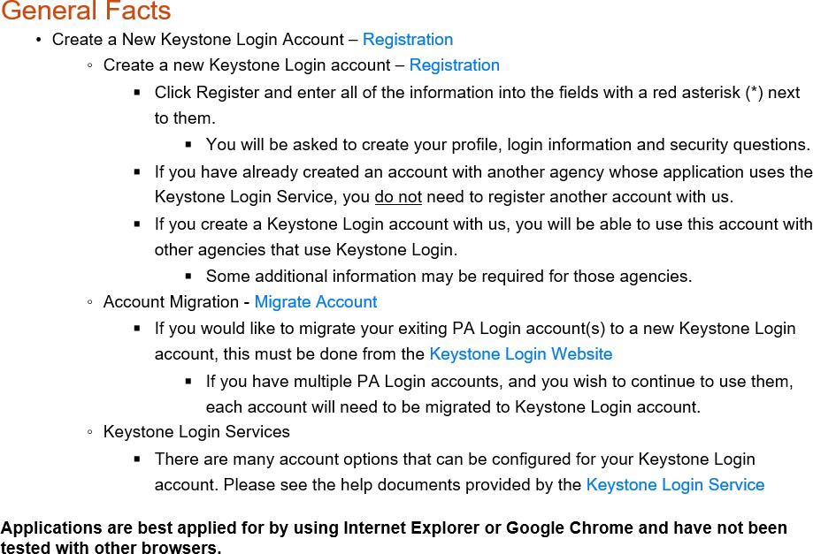
- If you are a first-time user, click the “REGISTER” button on the left.

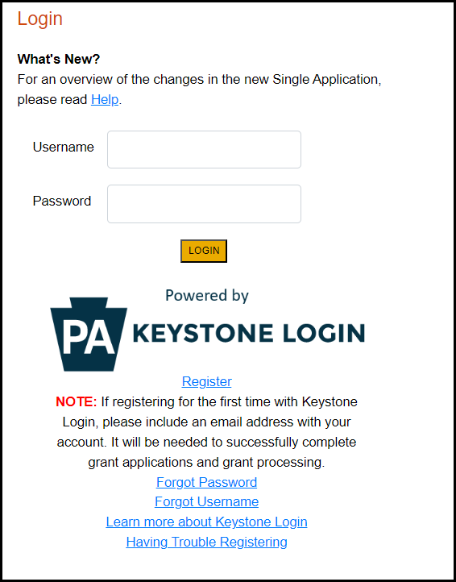
- Be sure to save the Username and Password you have chosen for future grant applications and other grant-related use.

- Begin a New Application
  - Project Name – Enter a name for your project.
  - Do you need help selecting your program – Select “No.”
  - Click on “CREATE A NEW APPLICATION.”
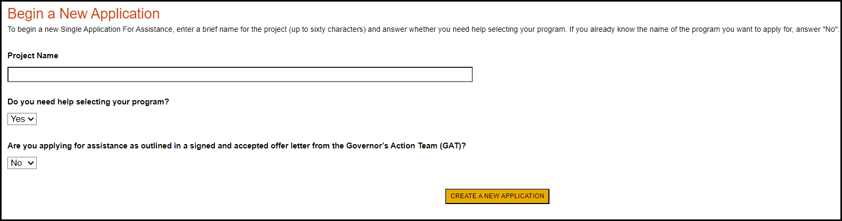
- Select Program
  - Under Program Name, enter “Act 167 (Phase II) Stormwater Management Plan Development or Revision.”
  - Click “SEARCH” and look for the Program Name.
  - Click Apply.
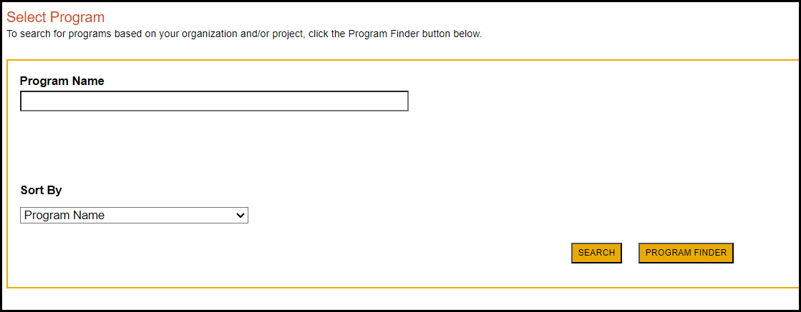
- Apply
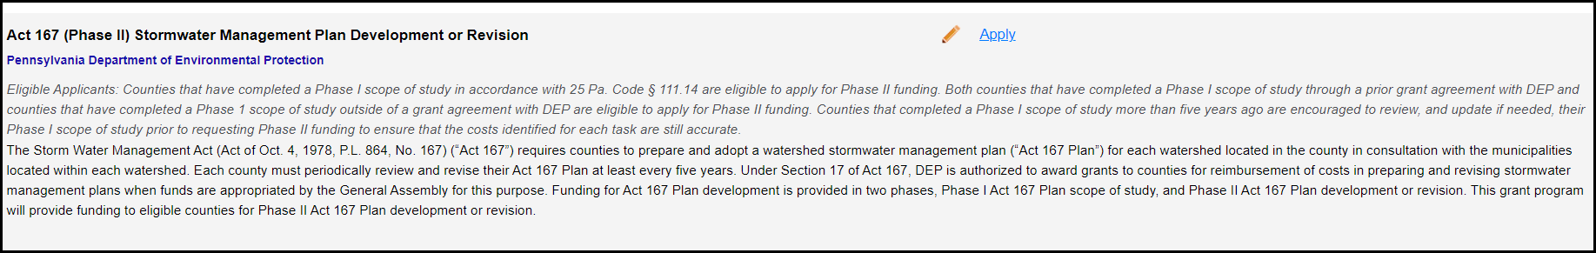
  - Select the program for which you are applying, “Act 167 (Phase II) Stormwater Management Plan Development or Revision.”
- Applicant Information Tab
  - The Applicant Information section requires data related to the applicant for which the application is being submitted.
  - Applicant Entity Type – select the appropriate type for your organization.
  - Applicant Name – Enter the organization’s name, the name under which the applicant or sponsor legally conducts business.
  - NAICS Code - From the dropdown box, select the appropriate type. The NAICS code will auto-populate for you.
  - FEIN/SSN Number - Enter the Federal Tax ID number for the legal County name (no dashes).
  - UEI Number – Unique Entity ID. Enter the applying organization’s unique, 12-character alphanumeric identifier assigned to all entities that conduct business with the federal government.
  - Top Official/ Signing Authority – Enter the name of the individual at your organization who has the authority to enter into a grant agreement with DEP (e.g. the name of President, Chairperson, CEO, etc., of the organization).
  - Title – Enter that individual’s title.
  - SAP Vendor # - Fill in if known.
  - Contact Name – Enter the primary contact’s name for this project.
  - Contact Title – Enter the primary contact’s title for this project.
  - Phone and Fax – Enter the phone and fax numbers for the primary contact for this project.
  - E-mail – Enter the e-mail for the primary contact for this project (required field).
  - Mailing address, City, State and Zip Code – Enter this information for the organization and primary contact for this project.
  - Click “Continue” at the bottom right.
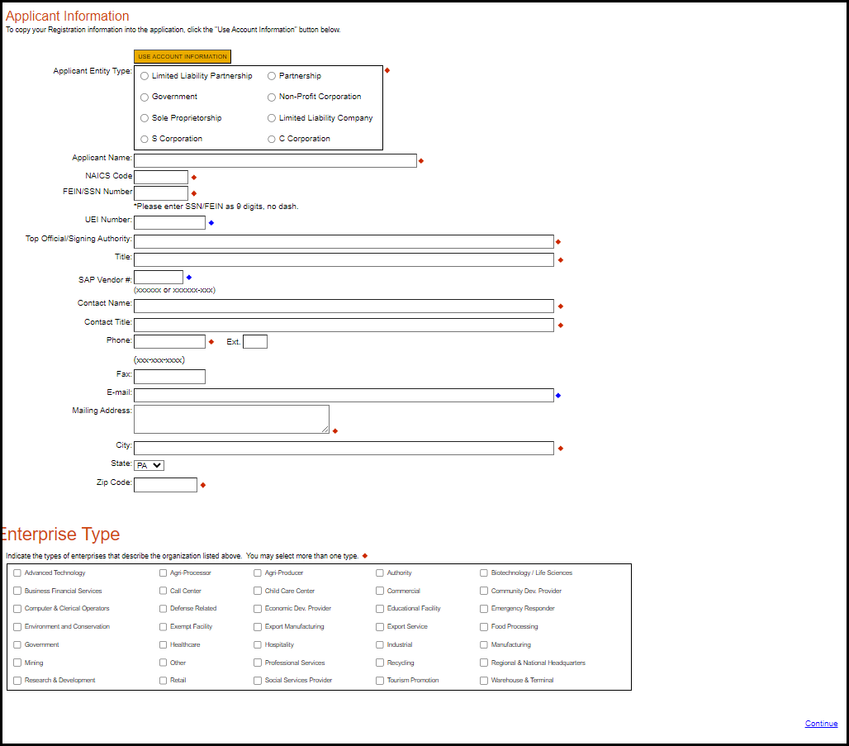

- Project Site
  - Address – Enter the mailing address (street address). P.O. Boxes are not acceptable.
  - City, State and Zip Code – Enter this information. (If you indicated more than one site on the prior tab, you will be requested to complete this information for all sites.)
  - County – Select your county from the dropdown box.
  - Municipality – Select County-Wide from the dropdown box.
  - PA House and PA Senate – These fields will auto-populate based on the information entered above.
  - Designated Areas – Leave blank.
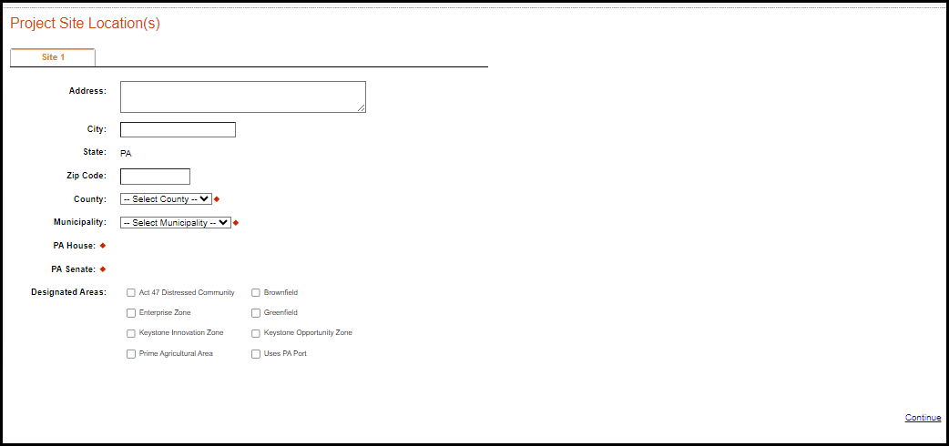
  - Click “Continue.”

- Project Narrative
  - Complete questions in this section. Be as specific and concise as possible. The response for each question is limited to 1,000 characters. Responses to all questions are required. Additional documentation to support the responses provided is optional and may be uploaded in the Addenda section of the application.
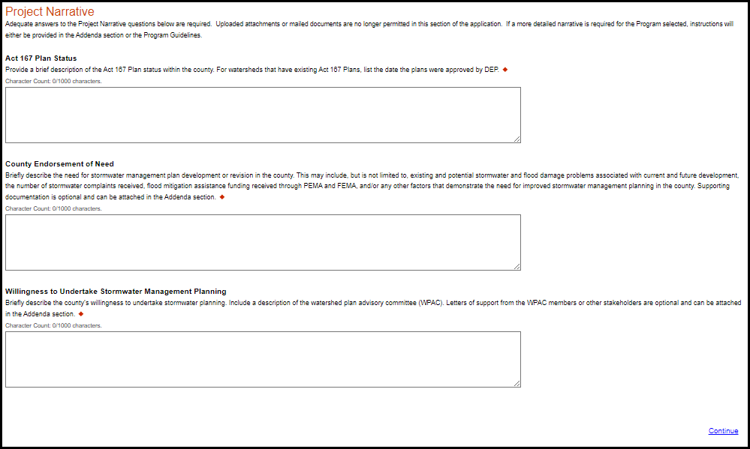
  - Click “Continue.”
Addenda
- Part 1 - Project Budget
- Complete the budget spreadsheet by listing all tasks identified in the Phase 1 scope of study. For each task, list the entity that will be completing the task and the cost for completing the task. Applicants should list all tasks to be completed as part of the Act 167 Plan development or revision even if an alternative funding source has been identified for the task and the applicant is not requesting funding to complete the task. When an alternative funding source will fully or partially fund a task, list the total cost for task completion in the cost column, identify the funding source in the alternative funding source column, provide the amount of the funding being provided by the alternative funding source, and indicate the funding category (state, federal, other).

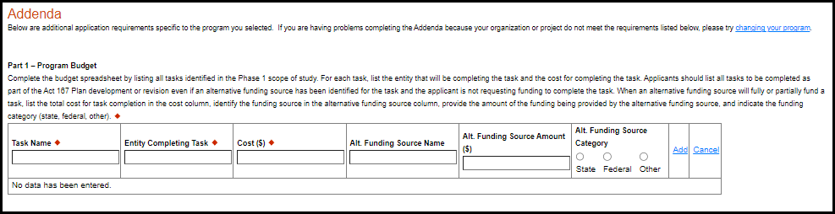

- When all tasks have been entered into the budget spreadsheet, sum the cost column and enter this number as the total project cost in the grant request spreadsheet. The total project cost should include the cost for completion of all project tasks including those tasks that are being fully or partially funded by alternative funding sources. If alternative funding sources are being used, sum the funding provided from all state and federal sources and enter this total into the grant request spreadsheet.

- Grants authorized by Act 167 are limited such that the total of all state and federal grants may not exceed 75% of the allowable costs incurred by the county. To determine the limit of state and federal funding, multiply the total project cost by 75%.
- If no alternative funding sources, or only non-state and non-federal alternative funding sources are identified in the budget spreadsheet, 75% of the project cost may also be entered in the grant request spreadsheet as the DEP funding request. If state and federal alternative funding sources are identified in the budget spreadsheet, the total of all other state and federal funding must be subtracted from the calculated 75% of total project cost to determine the maximum DEP funding request.
- For example, County A, County B, and County C all have 10 tasks totaling $500,000 that need to be completed for each county to develop their Act 167 Plans.
  - County A has no alternative funding sources identified in their budget spreadsheet, the maximum funding that can be requested by County A is $375,000.
  - County B has a local funding source that will provide $50,000 towards the implementation of Task 1 of their Act 167 Plan. As this funding is not from a state or federal source, this will not impact the funding that can be requested from DEP. The maximum funding that can be requested by County B is also $375,000.
  - County C has a federal funding source that will contribute $100,000 towards the implementation of Task 2 of their Act 167 Plan. As this funding is from a federal source, these funds must be subtracted from the DEP funding request. The maximum funding that can be requested by County C is $300,000.
  - Click “Continue.”

- Part 2 – Project Details
  - County – Select your county from the dropdown box.
  - County Population – enter the county population according to the 2020 Census.
  - Major Watershed – select the major watershed within which the county (or the majority of the county) is located from the dropdown menu.
  - DEP Region or Office – select the region the county is located in from the dropdown menu.
  - Applicant Contact – enter the name, job title, organization, email, and phone number for the contact who will be responsible for managing the grant funds.
  - Phase I Scope of Study - Upload a copy of the county’s completed Phase I scope of study. In order to be eligible for Phase II funding, the Phase I scope of study must be consistent with the requirements listed in 25 Pa. Code § 111.14. Each file can be no larger than 30 MB. If the Phase I document is larger than 30 MB, split the file into multiple files prior to upload.
  - Additional supporting documentation (optional) - Upload any supporting documents, including letters of support, that demonstrate the need for stormwater management plan development and/or revision in the county. Each file can be no larger than 30 MB.
  - Click the checkbox to acknowledge that you have read the following statement:
DEP reserves the right to request additional information after the grant application has been submitted. If the Act 167 funding requests received exceed the funding available, more information from grant applicants may be requested and a ranking system implemented to determine funding awards.
  - Click “Continue.”
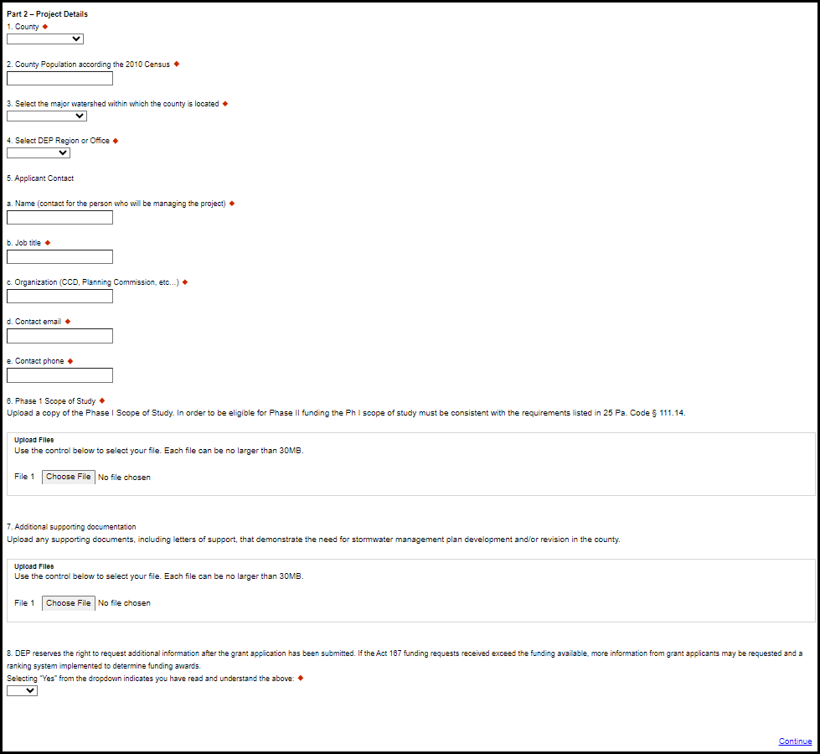

- Certification and Submission
• If there is any missing information in your application, your screen will look like the following example.
• Under the orange “Application Certification” heading, it will state, “The following sections are incomplete. All required fields marked with a red diamond must be completed before you are able to submit this application”.
• To add/correct the information on your application, click on the section heading to return to the page.
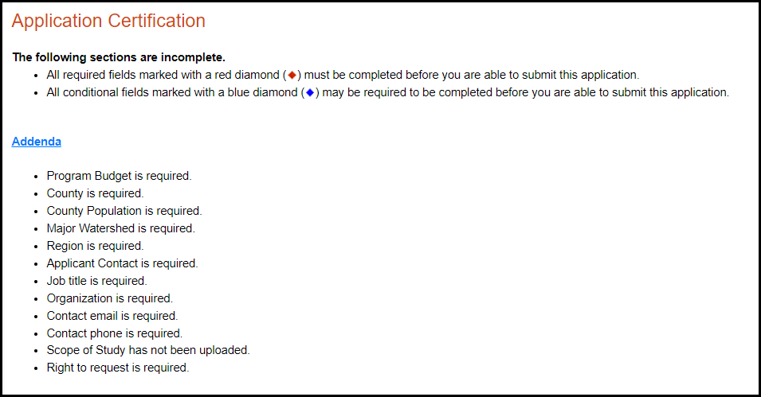

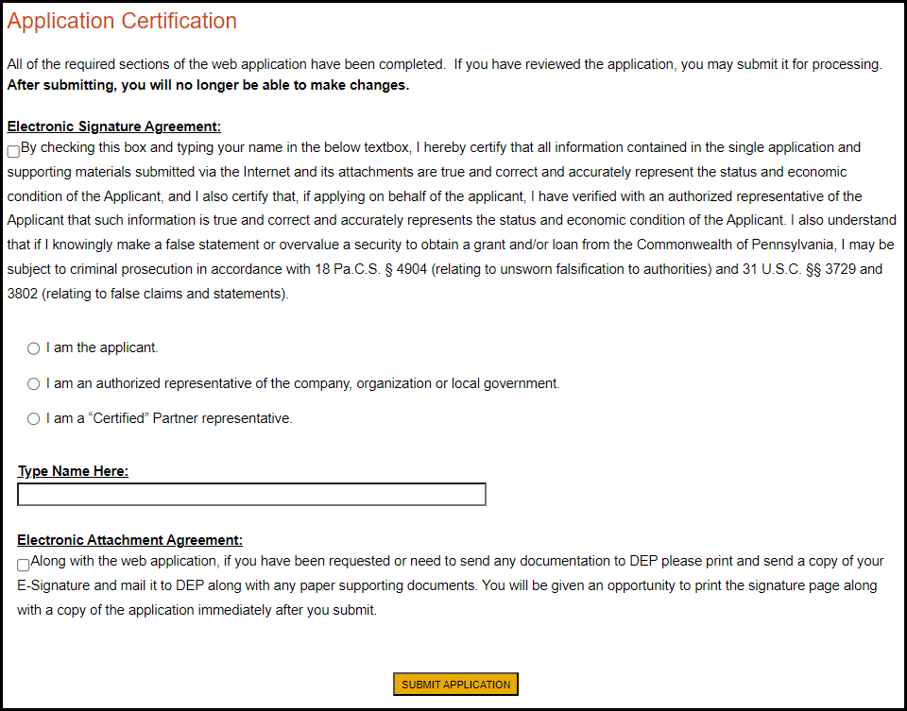
- If your application is complete, your screen will look like this:
- Indicate certification of application information by checking the related checkbox under the Electronic Signature Agreement.
- Indicate identity as one of the following:
  - I am the applicant.
  - I am an authorized representative of the company, organization or local government.
  - I am a “Certified” Partner representative.
- Type your name in the “Type Name Here” block. This will serve as your official e-signature and authorizes your application.
- Check the “Electronic Attachment Agreement” box.
- Click on “Submit Application.”

- Application Receipt Verification
  - If you want a copy of your application, click the “Print Entire Application with Signature Page” link. You will always be able to access your application with the username and password you created at the beginning of the application.
  - Make sure to note the Single Application ID#. All future correspondence from the Department will reference this number.
  - You do not need to send the signature page and/or any further documentation to the Grants Center. All the information needed is contained in your on-line submission.
- You have completed the on-line application.

