

**BUREAU OF POINT AND NON-POINT SOURCE MANAGEMENT**

**NUTRIENT IMPACT ASSESSMENT PROTOCOL**

**FOR WADEABLE STREAMS**

**OCTOBER 2015**

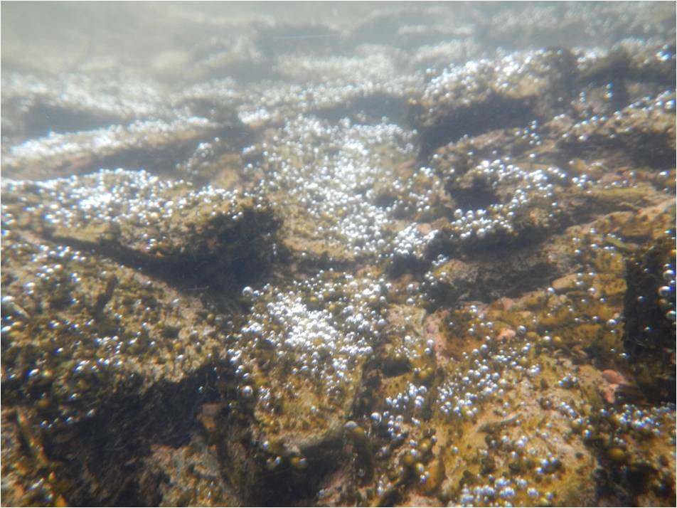

Prepared by:

Charles McGarrell

PA Department of Environmental Protection

Bureau of Point and Non-Point Source Management

11th Floor: Rachel Carson State Office Building

Harrisburg, PA 17105

**INTRODUCTION**

The overall effect of nutrient enrichment on stream biological communities occurs through a complex series of relationships involving numerous abiotic and biotic factors. In general, nutrient enrichment can lead to increased productivity of heterotrophic microbes (fungi and bacteria) and aquatic plants (algae and macrophytes) (Chambers and Prepas,1994; Biggs, 2000; Dodds et al., 2002; Carr et al., 2005). Increased productivity of heterotrophic microbes and aquatic plants modifies rates of photosynthesis and respiration, and can lead to wide diel fluctuations in dissolved oxygen (DO) concentrations, low DO levels, and an overall shift to biological communities that are more tolerant of low DO conditions (Miltner and Rankin, 1998; Dodds and Welch, 2000; Slavik et al., 2004; Miltner, 2010; Yuan, 2010).

Determining the impact of nutrient enrichment on the biological condition of a given stream is complicated by the fact that the relative impact of nutrient enrichment on the productivity of heterotrophs and aquatic plants is influenced by a number of factors such as scour regime, substrate composition, water temperature, and factors such as turbidity, shading, and water depth that influence the light conditions. Thus, a wide range of factors influence how nutrient levels ultimately affect the biological integrity of a given waterway.

PADEP’s Nutrient Impact Assessment (NIA) Protocol is based on the conceptual model diagram shown in Figure 1. This model focuses on diel DO fluctuations as the proximate stressor ultimately affecting stream biological condition in response to nutrient enrichment. Nutrient, diel DO fluctuation, and benthic macroinvertebrate **c**ommunity data from Pennsylvania wadeable streams (drainage areas <750 mi2)

were analyzed within the context of the conceptual model shown in Figure 1. The results of these analyses were used to develop a two-tiered assessment procedure for determining if nutrients are a cause of aquatic life use (ALU) impairment, after an ALU impairment decision is made and Department staff view nutrients as a potential cause of the impairment. The full assessment methodology document provides technical documentation of the process that was used to develop the Nutrient Impact Assessment Protocol and is available at:

<http://www.depweb.state.pa.us/portal/server.pt/community/water_quality_standards/10556/technical_documentation_macroinvertebrate_stream_protocols/554005>

The remainder of this document describes the NIA protocol.

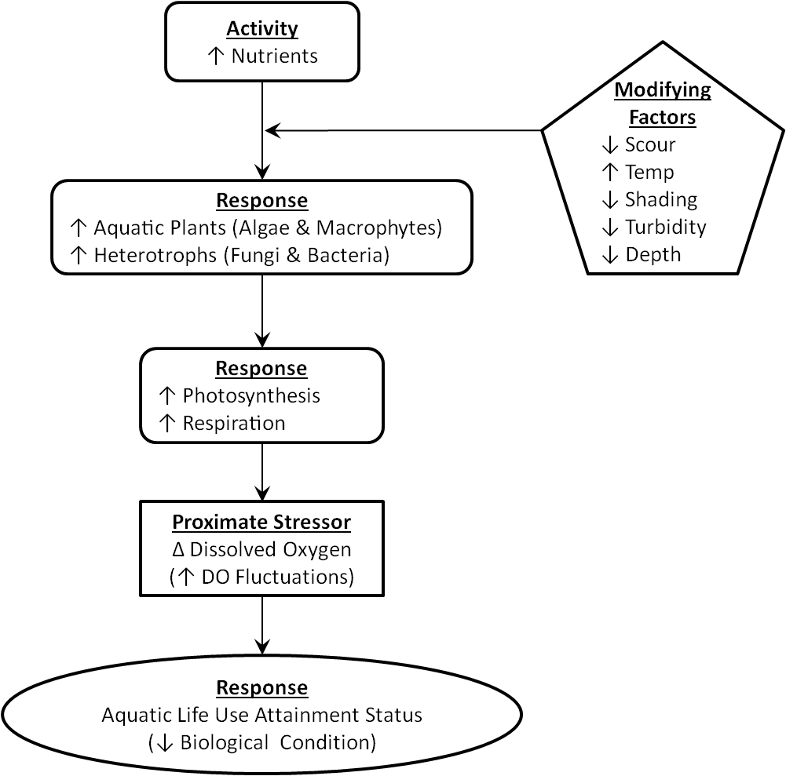

**Figure 1. Conceptual Model Used in the Development of PADEP’s Nutrient**

**Impact Assessment Protocol.**

**NUTRIENT IMPACT ASSESSMENT (NIA) PROTOCOL**

The intended use of the NIA protocol is for determining if nutrients are a cause of impairment after a given wadeable stream is determined to be ALU-impaired, based on benthic macroinvertebrate data collected and processed in accordance with methods described in PADEP’s sampling protocol (2013-a). If PADEP staff view nutrients as a potential cause of the ALU-impairment, based on the presence of known potential point and/or non-point sources of nutrients or field indicators such as excessive algal or macrophyte growth (Figure 2), the protocol is to be used to confirm or reject nutrients as a cause of the ALU-impairment.

The protocol consists of two tiers of data evaluation. Tier 1 consists of evaluating three screening parameters (total phosphorus (TP), total nitrogen (TN), and Hilsenhoff Biotic Index score) against screening benchmark values. If one or more Tier-1 screening parameter values equals or exceeds the screening benchmark values shown below, the waterway fails the Tier 1 screening process, and is targeted for additional data collection and evaluation (Tier 2). The second tier of the protocol involves the collection and evaluation of continuously monitored DO data. Ultimately, continuously monitored DO data are used to determine if nutrients are a cause of ALU impairment, by comparing DO values to Tier 2 nutrient impairment benchmark values.

Chemical water quality samples are to be collected in accordance with PADEP’s monitoring protocol (2013-b), and continuously monitored DO data are to be collected in accordance with PADEP’s sampling protocol (2013-c). PADEP’s macroinvertebrate sampling, surface water collection, and continuous instream monitoring protocols can be accessed at:

<http://www.depweb.state.pa.us/portal/server.pt/community/water_quality_standards/10556/2013_assessment_methodology/1407203>

**TIER 1 NUTRIENT SCREENING BENCHMARK VALUES**

Tier 1 nutrient screening benchmark values are as follows:

* Hilsenhoff Index Score ≥ 4.60, or
* Total Phosphorus ≥ 0.06 mg/l, or
* Total Nitrogen ≥ 2.6 mg/l

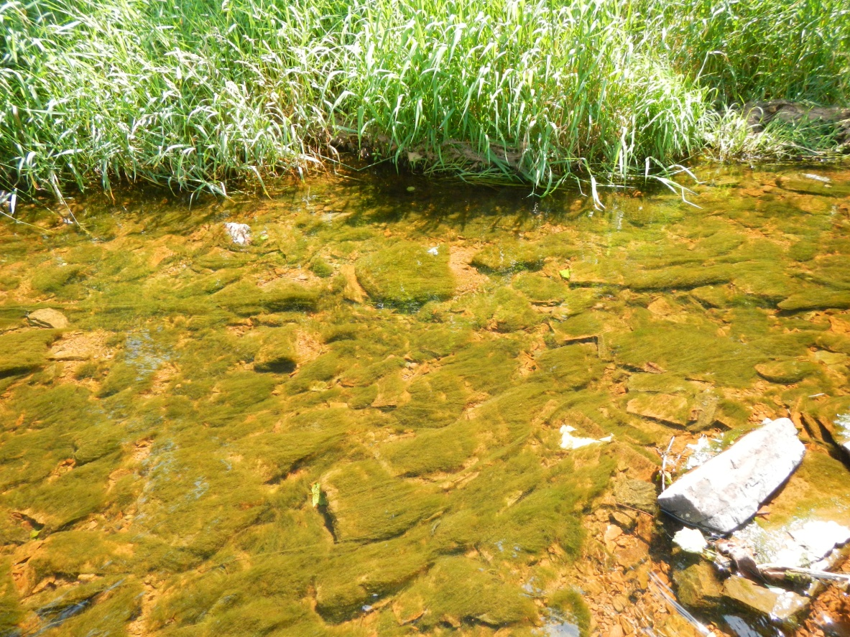

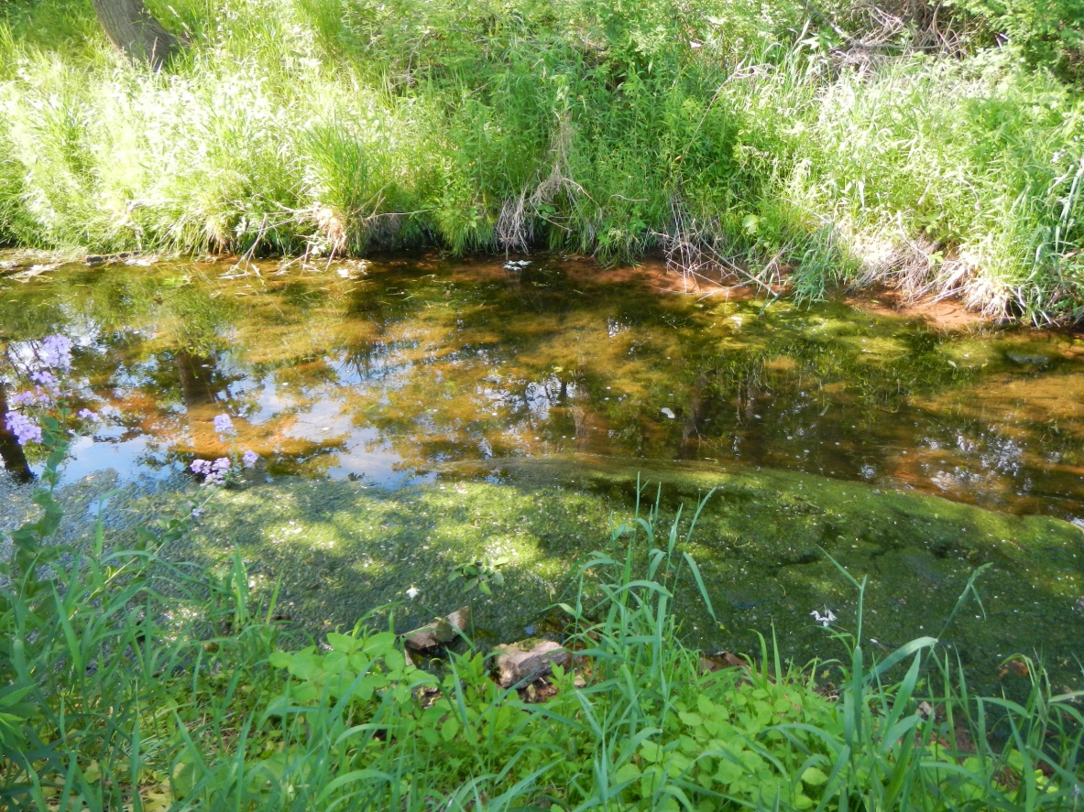

**Figure 2. Photographs of Excessive Algal Growth in a Southeastern Pennsylvania Stream.**

If one or more of the screening parameters equals or exceeds the screening benchmark value, the waterway fails the Tier 1 screening process, and is targeted for the collection and evaluation of continuously monitored DO data (Tier 2).

**TIER 2 NUTRIENT IMPAIRMENT BENCHMARK VALUES**

Based on seasonal patterns in diel DO range conditions observed in Pennsylvania wadeable streams, separate nutrient impairment benchmarks were developed for the warm season (July 15 – September 15) and cool season (the remainder of the year).

For each season, there are separate nutrient impairment benchmarks, one for maximum diel DO range, and one for maximum 7-day average diel DO range.

Nutrient impairment benchmark values are as follows:

* Cool Season Maximum Diel DO Range ≥ 4.8 mg/l, or
* Cool Season Maximum 7-Day Average Diel DO Range ≥ 4.2 mg/l, or
* Warm Season Maximum Diel DO Range ≥ 6.1 mg/l, or
* Warm Season Maximum 7-Day Average Diel DO Range ≥ 5.4 mg/l

If one or more of the nutrient impairment parameters equals or exceeds the benchmark value for that parameter, nutrients are identified as a cause of aquatic life use impairment.

The data shown in Figure 3 provide an example of how “approved” continuously monitored diel DO range data are used to determine that nutrients are a cause of ALU-impairment. This example shows data from a 31-day period in the cool season, with numerous diel DO range values greater than or equal to the 4.8 mg/l cool season benchmark, and numerous 7-Day average diel DO range values that equaled or exceeded 4.2 mg/l cool season benchmark. Thus, based on this data, nutrients would be identified as a cause of ALU impairment.

**SUMMARY**

PADEP used a stressor-response approach, based on known relationships between nutrient concentrations and biological responses, to develop a two-tiered protocol for assessing nutrient impacts to wadeable streams. The intended use of the protocol is for identifying where nutrients are a cause of impairment in ALU-impaired streams. The protocol takes into consideration that there may be cases where a given waterbody may be subject to elevated nutrient levels, but due to characteristics such as scour conditions, substrate composition, temperature, shading, turbidity, depth, etc., elevated nutrient levels may, or may not, affect the photosynthesis, respiration, and dissolved



**Figure 3. Example of Continuously Monitored Diel DO Range Data Indicating Nutrients Are a Cause of ALU-Impairment.**

oxygen characteristics of the waterway to a degree that ultimately results in non-attainment of aquatic life use (ALU).

After a given wadeable stream is determined to be ALU-impaired and PADEP staff view nutrients as a potential cause of the impairment, stream nutrient (TP and TN) and macroinvertebrate information (Hilsenhoff Biotic Index Score) are compared to nutrient screening benchmark values (Tier 1) to determine if additional data should be collected and evaluated (Tier 2). Waterways that fail one or more of the Tier 1 screening parameters are targeted for the collection and evaluation of continuously monitored dissolved oxygen data (Tier 2), which are ultimately used to confirm if nutrients are a cause of the ALU impairment. The nutrient impact assessment protocol for determining if nutrients are a cause of ALU impairment is summarized in Figure 4.

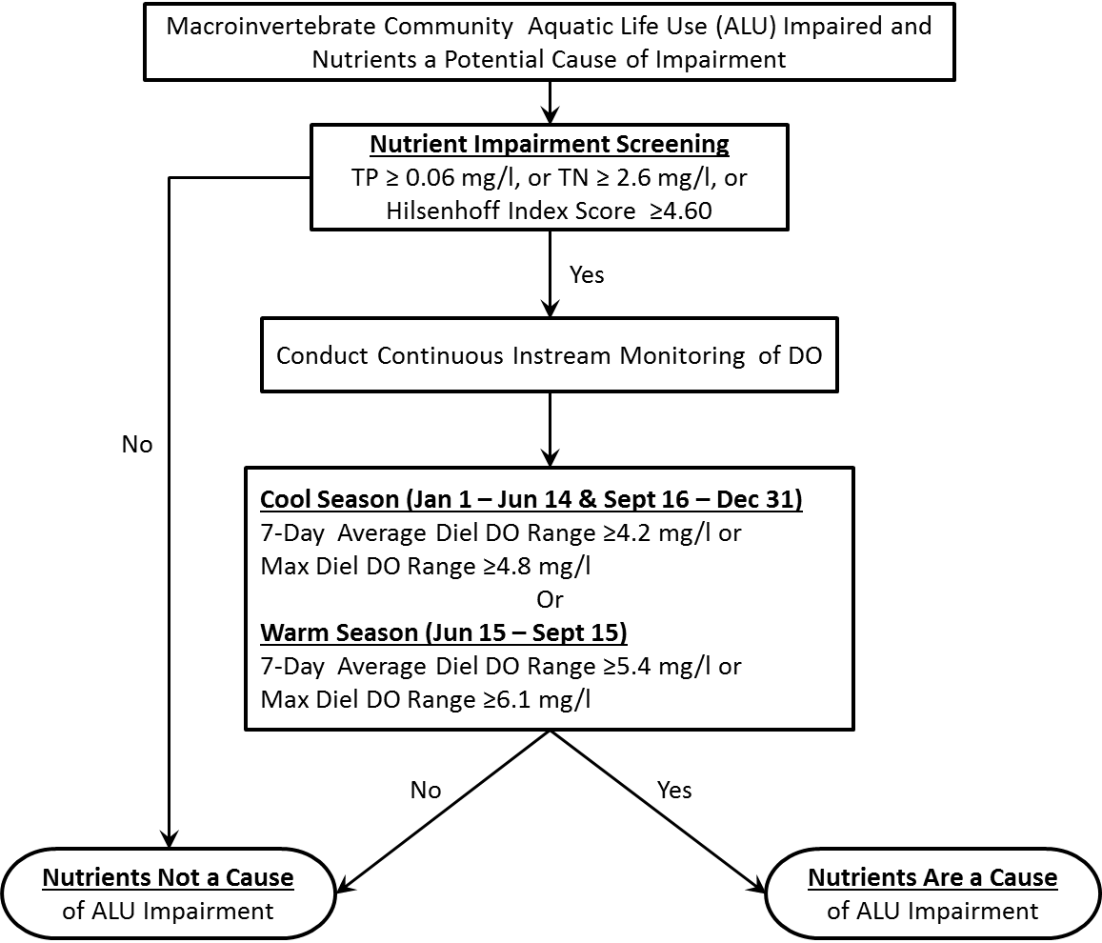

**Figure 4. Summary of the PADEP Nutrient Impact Assessment Protocol.**

**LITERATURE CITED**

Biggs, B. J. F. 2000. Eutrophication of streams and rivers: dissolved nutrient

chlorophyll relationships for benthic algae. Journal of the North American Benthological Society 19:17-31.

Carr, G. M., A. Morin, and P. A. Chambers. 2005. Bacteria and algae in stream

periphyton along a nutrient gradient. Freshwater Biology 50:1337-1350.

Chambers, P.A. and E.E. Prepas. 1994. Nutrient dynamics in riverbeds: the impact of

sewage effluent and aquatic macrophytes. Water Res. 28:453-464.

Dodds, W.K. and E.B. Welch. 2000. Establishing nutrient criteria in streams. Journal

of the North American Benthological Society 19:186-196.

Dodds, W.K., V.H. Smith, and K. Lohman. 2002. Nitrogen and phosphorus

relationships to benthic algal biomass in temperate streams. Canadian Journal of Fisheries and Aquatic Sciences 59:865-874.

Miltner, R.J. 2010. A method and rationale for deriving nutrient criteria for small rivers

and streams in Ohio. Environmental Management 45:842-855.

Miltner, R.J. and E.T. Rankin. 1998. Primary nutrients and the biotic integrity of rivers

and streams. Freshwater Biology 40:145-158.

PADEP. 2013-a. An Index of Biotic Integrity for Benthic Macroinvertebrate

Communities in Pennsylvania’s Wadeable, Freestone, Riffle-Run Streams.

Pennsylvania Department of Environmental Protection, Bureau of Point and Non-

Point Source Management. Harrisburg, Pennsylvania.

_____. 2013-b. Surface Water Collection Protocol. Pennsylvania Department of

Environmental Protection, Bureau of Point and Non-Point Source Management.

Harrisburg, Pennsylvania.

_____. 2013-c. Continuous Instream Monitoring Protocol. Pennsylvania Department

of Environmental Protection, Bureau of Point and Non-Point Source

Management. Harrisburg, Pennsylvania.

Slavik, K., B. J. Peterson, L. A. Deegan, W. B. Bowden, A. E. Hershey, and J. E.

Hobbie. 2004. Long-term responses of the Kuparuk River ecosystem to phosphorus fertilization. Ecology 85:939-954.

U.S. Environmental Protection Agency. 2010. Using Stressor-response Relationships

to Derive Numeric Nutrient Criteria. EPA-820-S-10-001. Office of Water, United

States Environmental Protection Agency. Washington, D.C.

Yuan, L.L. 2010. Estimating the effects of excess nutrients on stream invertebrates

from observational data. Ecological Applications 20:110-125.