

**BUREAU OF POINT AND NON-POINT SOURCE MANAGEMENT**

**DEVELOPMEMT OF A NUTRIENT IMPACT ASSESSMENT PROTOCOL FOR IDENTIFYING NUTRIENTS AS A CAUSE OF AQUATIC LIFE USE IMPAIRMENT IN PENNSYLVANIA WADEABLE STREAMS**

**August 2015**

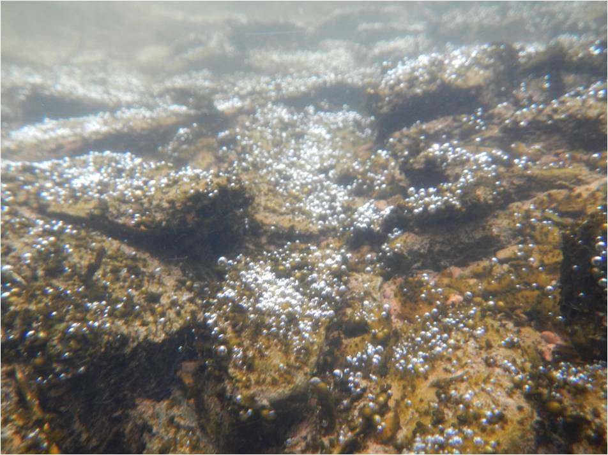

Prepared by:

Charles McGarrell

PA Department of Environmental Protection

Bureau of Point and Non-Point Source Management

11th Floor: Rachel Carson State Office Building

Harrisburg, PA 17105

**INTRODUCTION**

This document provides technical documentation of the process that Pennsylvania Department of Environmental Protection (PADEP) used to develop its Nutrient Impact Assessment Protocol for identifying nutrients as a cause of aquatic life use (ALU) impairment in wadeable streams. The full assessment methodology document is available at:

<http://www.portal.state.pa.us/portal/server.pt/community/water_quality_standards/10556/2013_assessment_mehtodology/1407203>

The overall effect of nutrient enrichment on stream biological communities occurs through a complex series of relationships involving numerous abiotic and biotic factors. In general, nutrient enrichment can lead to increased productivity of heterotrophic microbes (fungi and bacteria) and aquatic plants (algae and macrophytes) (Chambers and Prepas,1994; Biggs, 2000; Dodds et al., 2002; Carr et al., 2005). Increased productivity of heterotrophic microbes and aquatic plants modifies rates of photosynthesis and respiration, and can lead to wide diel fluctuations in dissolved oxygen (DO) concentrations, low DO levels, and an overall shift to biological communities that are more tolerant of low DO conditions (Miltner and Rankin, 1998; Dodds and Welch, 2000; Slavik et al., 2004; Miltner, 2010; Yuan, 2010).

Determining the impact of nutrient enrichment on the biological condition of a given stream is complicated by the fact that the relative impact of nutrient enrichment on the productivity of heterotrophs and aquatic plants is influenced by a number of factors such as scour regime, substrate composition, water temperature, and factors such as turbidity, shading, and water depth that influence the light conditions. Thus, a wide range of factors influence how nutrient levels ultimately affect the biological integrity of a given waterway. The conceptual model diagram shown in Figure 1 is a visual representation of relationships among human activities, stressors such as nitrogen /phosphorus pollution, biotic responses, and designated uses in aquatic systems. This diagram is from the U.S. Environmental Protection Agency (US EPA) document entitled: Using Stressor-response Relationships to Derive Numeric Nutrient Criteria, and describes the known causal pathways connecting nitrogen/phosphorus pollution to impacts on the designated uses of streams (US EPA, 2010).

The conceptual model diagram shown in Figure 1 includes both nutrient-related and non-nutrient pathways linking human activities to designated uses. The model diagram depicts relationships between anthropogenic activities that both generate and affect the



**Figure 1. Conceptual Model Diagram Describing the Known Causal Pathways**

**Connecting Nitrogen/Phosphorus Pollution to Impacts on the Designated Use in Streams (Figure 2-2 from Using Stressor-response Relationships to Derive Numeric Nutrient Criteria (US EPA, 2010)).**

transport of pollutants, the key intermediate steps linking increased nitrogen and phosphorus concentrations and other stressors, and the proximate stressors that

ultimately affect designated use responses. Interacting or confounding factors that modify or influence the effect of stressors or steps along the stressor-response pathway are also depicted. US EPA (2010) mentions that all relevant pathways are not included in the model diagram, and that it is expected that analysts would modify the diagram by adding or removing concepts and pathways and adapt the diagram to activities that are relevant to a particular location or system being studied.

PADEP’s Nutrient Impact Assessment (NIA) Protocol is based on the conceptual model diagram shown in Figure 2. This model focuses on diel DO fluctuations as the proximate stressor ultimately affecting stream biological condition in response to nutrient enrichment. Nutrient, diel DO fluctuation, and benthic macroinvertebrate

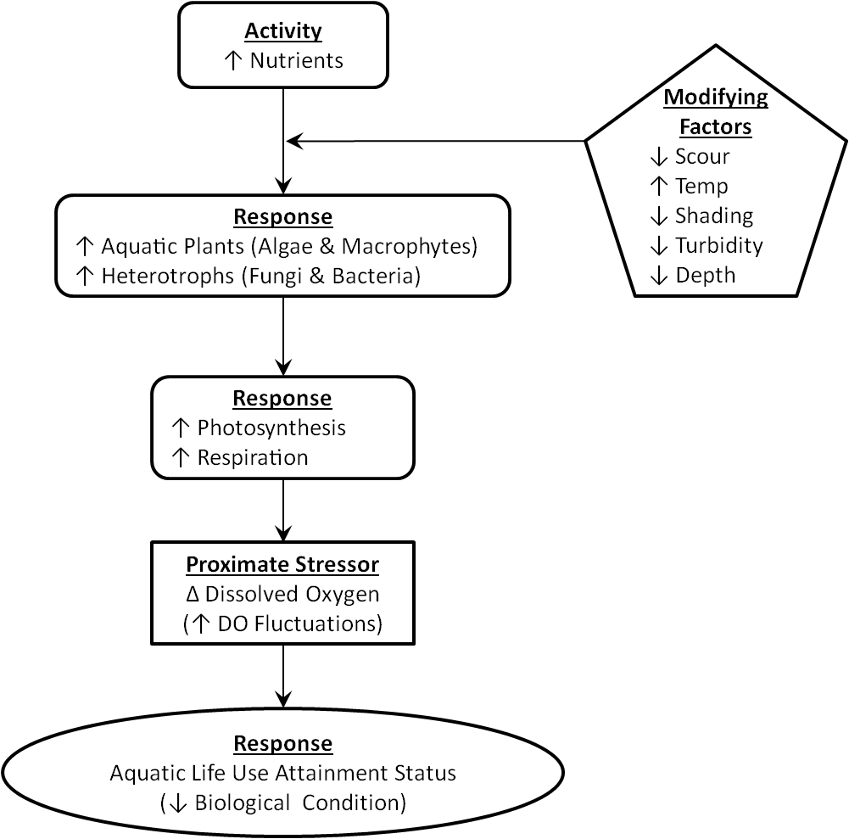

**Figure 2. Conceptual Model Used in the Development of PADEP’s Nutrient**

**Impact Assessment Protocol.**

**c**ommunity data from Pennsylvania wadeable streams were analyzed within the context of the conceptual model shown in Figure 2. The results of these analyses were used to develop a two-tiered assessment procedure for determining if nutrients are a cause of aquatic life use (ALU) impairment, after an ALU impairment decision is made and Department staff view nutrients as a potential cause of the impairment. The remainder of this document describes the NIA protocol and the technical basis upon which it was developed.

**DATA USED**

Nutrient, continuously monitored DO, and benthic macroinvertebrate data from 40 wadeable stream sampling events were used to develop the NIA protocol. Each of the 40 samples consisted of data collected during a given year. For example, the dataset includes two samples from the Buffalo Creek sample station, one sample in 2013 and one sample in 2014. The 2013 sample consists of five nutrient samples, 175 approved diel DO values, and one benthic macroinvertebrate sample. The 2014 sample consists of four nutrient samples, 144 approved diel DO values, and one benthic macroinvertebrate sample (Table 1).

Chemical water quality samples were collected in accordance with PADEP’s sampling protocol (2013-a), and the number of chemical water quality samples collected at a given station in a given year ranged from 1 to 15 samples. Continuously monitored DO data were collected in accordance with PADEP’s monitoring protocol (2013-b), and the number of days of diel DO values collected at a given station in a given year ranged from 23 to 263 days. At each sample station, a single 200-organism benthic macroinvertebrate sample was collected in accordance with methods described in PADEP’s sampling protocol (2013-c) during each year DO was continuously monitored. PADEP’s surface water collection, continuous instream monitoring, and macroinvertebrate sampling protocols can be accessed at:

<http://www.portal.state.pa.us/portal/server.pt/community/water_quality_standards/10556/2013_assessment_mehtodology/1407203>

The 40 samples were collected from 33 sample stations on 26 streams distributed among USEPA Nutrient Ecoregions VII, VIII, IX, and XI (Figure 3). Drainage areas ranged from 1.41 to 738 mi2 and from 0 to 35% carbonate geology. Watershed land use ranged from 9 to 99% forested, 0 to 86% urban, and from 0 to 46% impervious cover (Table 2).

**CONFIRMATION OF CONCEPTUAL MODEL RELATIONSHIPS**

Linear regression analysis was used to provide empirical support for and to confirm the key relationships shown in the conceptual model used to develop the NIA protocol (Figure 2). Linear regression models were developed for the relationships among the maximum total phosphorus (TP), total nitrogen (TN), and diel dissolved oxygen range value recorded at each sample station in each year, and benthic macroinvertebrate index of biological integrity (IBI) and Hilsenhoff biotic index scores. Outliers (samples

**Table 1. Wadeable Stream Dataset of 40 Samples Consisting of Total Phosphorus (TP) and Total Nitrogen (TN) Values, Continuously Monitored DO Data, and Benthic Macroinvertebrate Data.**



Station Map 2.tif

**Figure 3. Map of Sample Site Locations.**

**Table 2. Map ID Numbers and Watershed Characteristics of Sample Stations.**



with relatively large residual values) were removed from some datasets, prior to generating the regression models discussed below. The nutrient, diel DO, and benthic macroinvertebrate data used in regression analysis are summarized in Table 3.

**Table 3.** **Nutrient, Diel DO, and Benthic Macroinvertebrate Data from 40**

**Sample Dataset.**



Linear regression analysis results demonstrate clear relationships between elevated nutrient levels (TP and TN) and macroinvertebrate communities with elevated levels of tolerance to low-DO conditions (i.e., elevated Hilsenhoff biotic index scores), and lower macroinvertebrate IBI scores (Table 4 and Figures 4 - 7). These results provide empirical support for the conceptual model used to develop the NIA protocol, and confirm the relationships between nutrients, diel DO fluctuations, and biological condition depicted in the conceptual model diagram (Figure 2).

**NUTRIENT IMPACT ASSESSMENT (NIA) PROTOCOL**

The intended use of the NIA protocol is for determining if nutrients are a cause of impairment after a given wadeable stream is determined to be ALU-impaired and PADEP staff view nutrients as a potential cause of the impairment, based on the presence of known point and/or non-point sources of nutrients or field indicators such as excessive algal or macrophyte growth (Figure 8). The protocol is based on the relationships between nutrients, DO characteristics, and benthic macroinvertebrate integrity, depicted in the conceptual model diagram, Figure 2.

The protocol consists of two tiers of data evaluation. Tier 1 consists of evaluating three screening parameters (TP, TN, and Hilsenhoff Biotic Index score) against screening benchmark values. If one or more Tier 1 screening parameter value equals or exceeds the screening benchmark value, the waterway fails the Tier 1 screening process, and is targeted for additional data collection and evaluation (Tier 2). The second tier of the protocol involves the collection and evaluation of continuously monitored DO data. Continuously monitored DO data are used to determine if nutrients are a cause of ALU impairment, by comparing DO values to Tier 2 nutrient impairment benchmark values.

**Table 4. Linear Regression Analysis Results.**



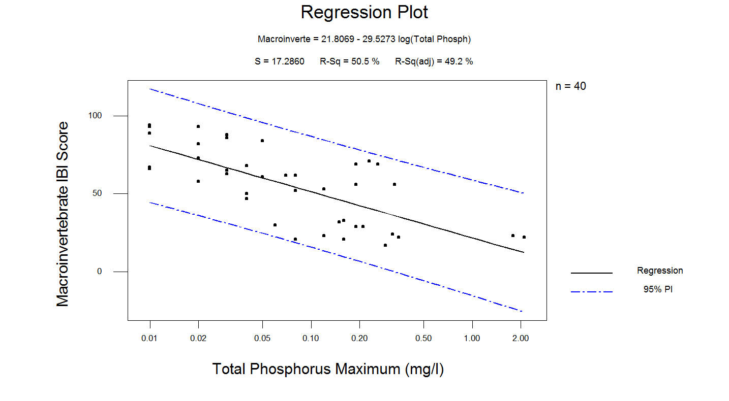

**(A)**

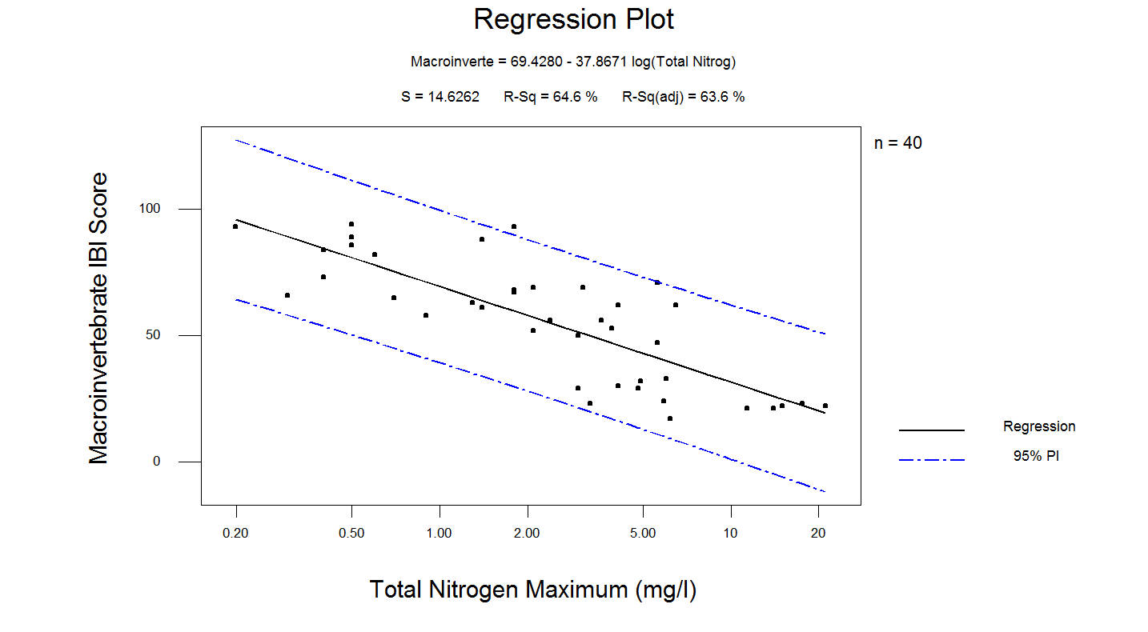

**(B)**

**Figure 4. Linear Regression Model of Macroinvertebrate IBI Score vs. Total Phosphorus Maximum (A) and Total Nitrogen Maximum (B).**

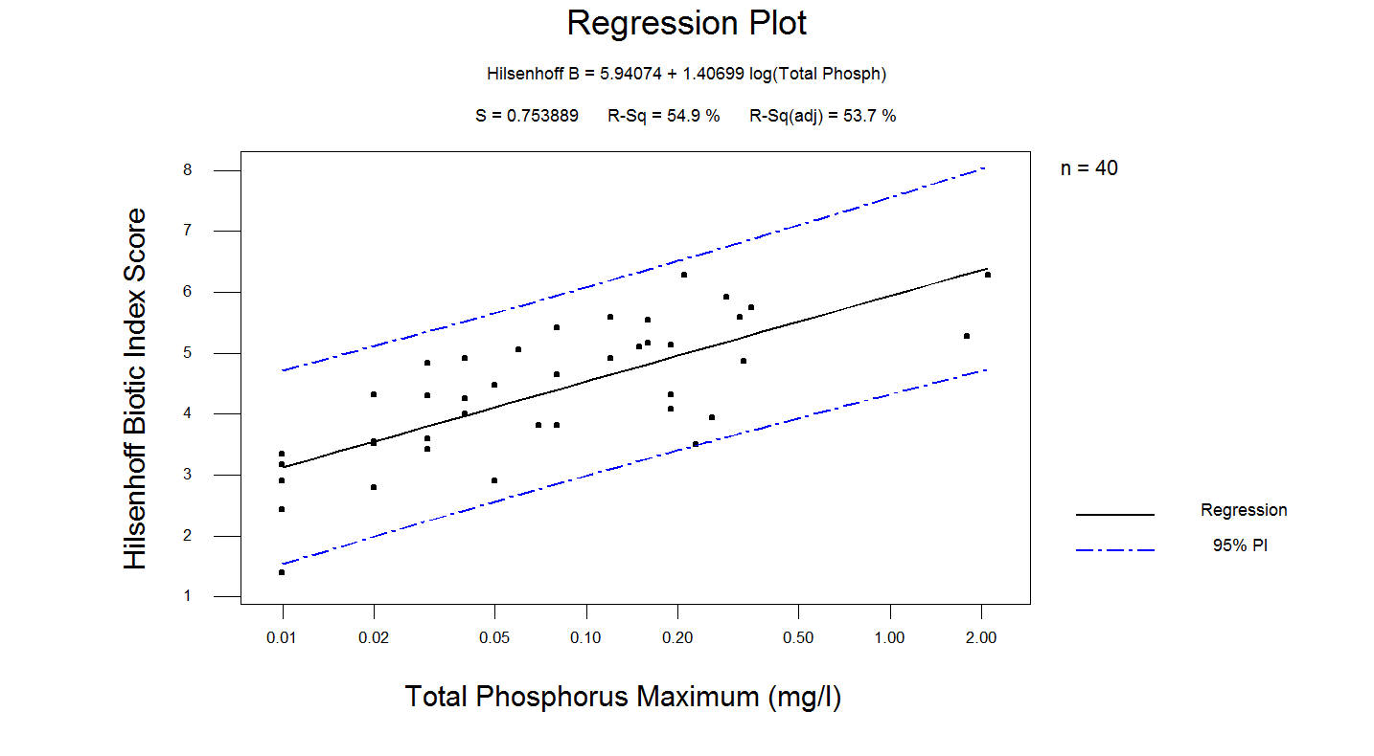

(A)

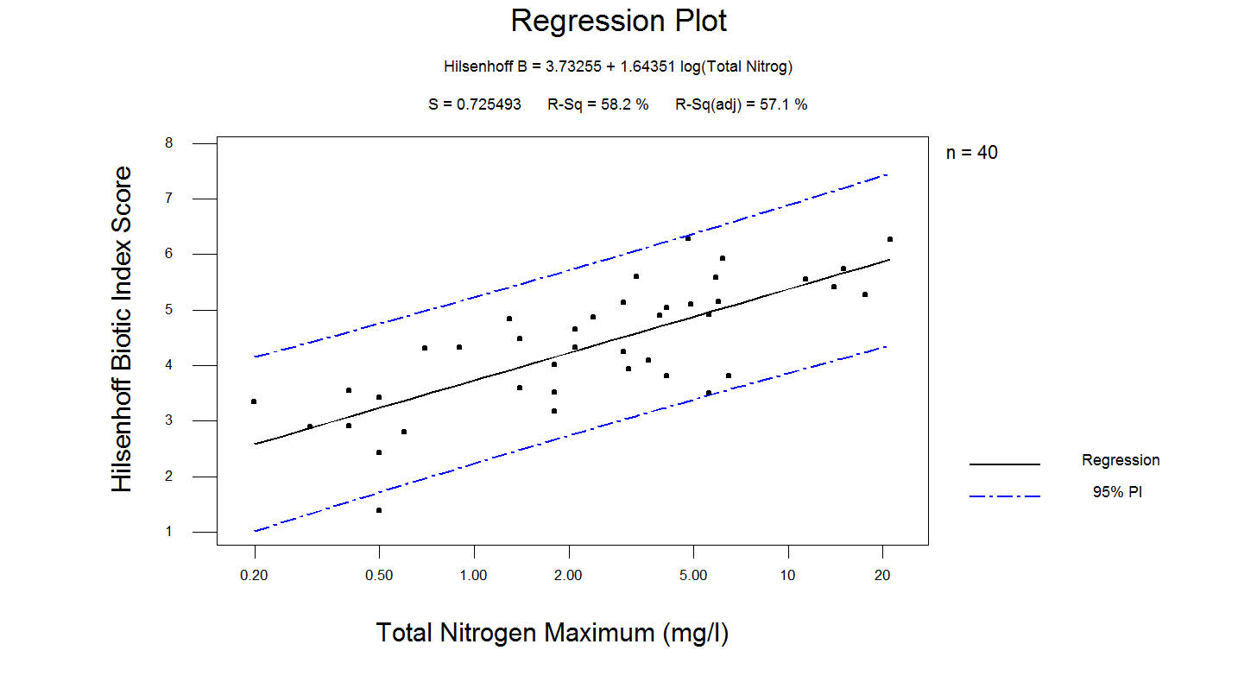

**(B)**

**Figure 5. Linear Regression Model of Hilsenhoff Biotic Index Score vs. Total Phosphorus Maximum (A) and Total Nitrogen Maximum (B).**

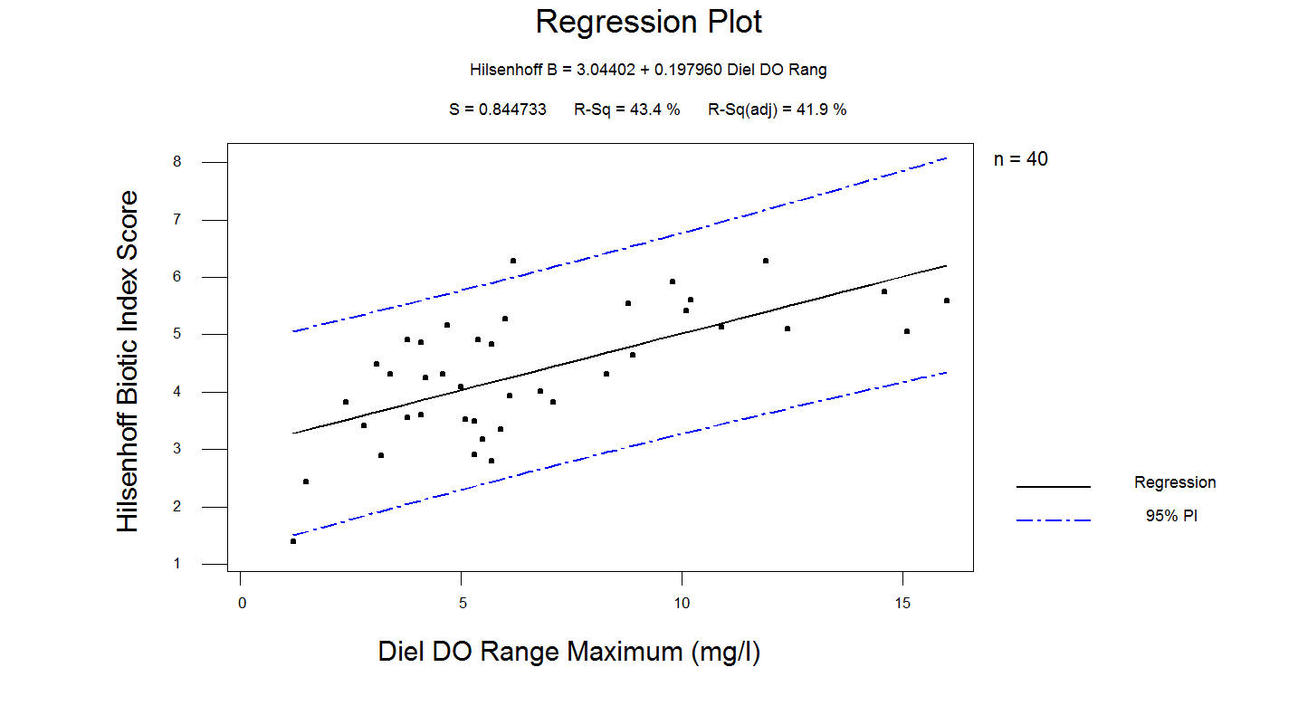

**(A)**

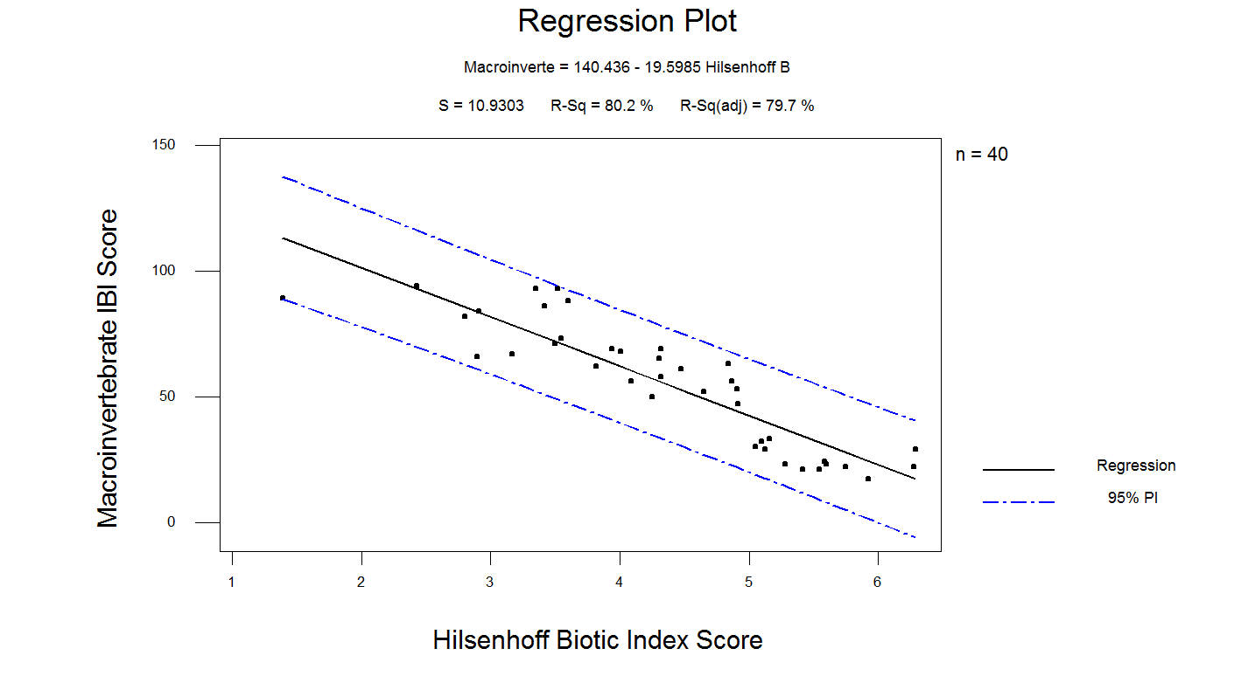

**(B)**

**Figure 6. Linear Regression Model of Hilsenhoff Biotic Index Score vs. Diel DO Range Maximum (A) and Macroinvertebrate IBI Score vs. Hilsenhoff Biotic Index Score (B).**

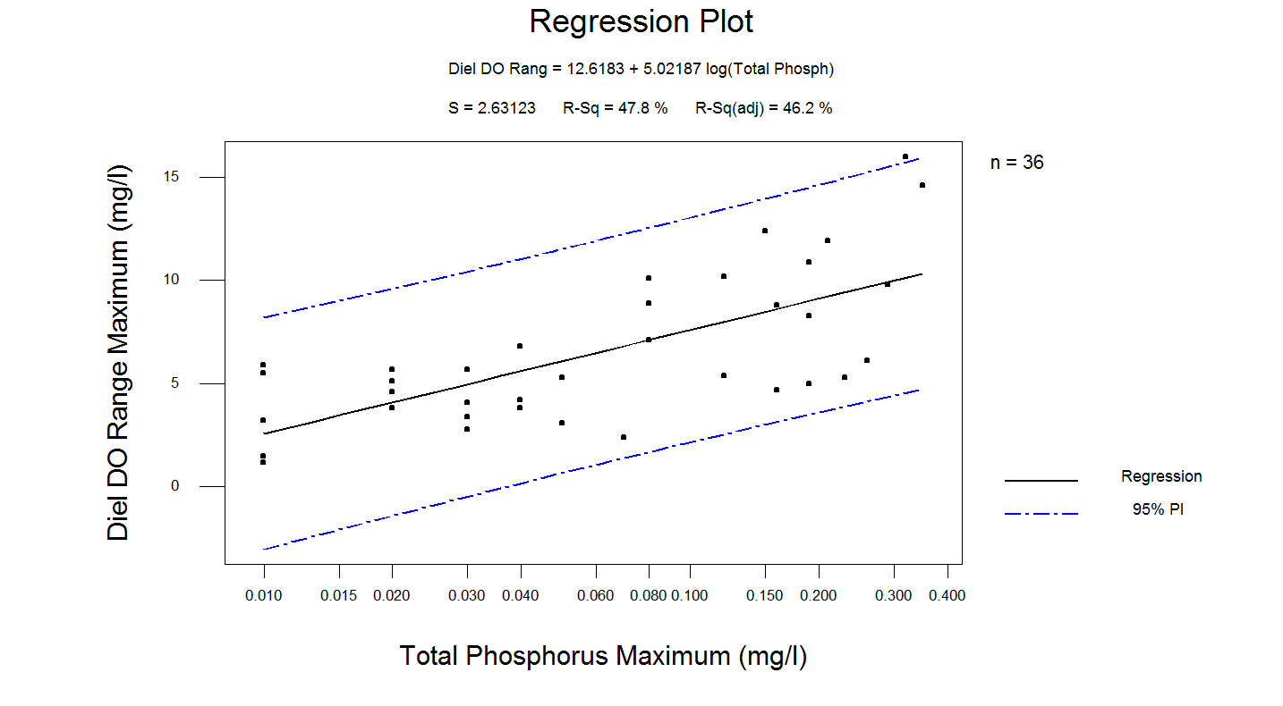

**(A)**

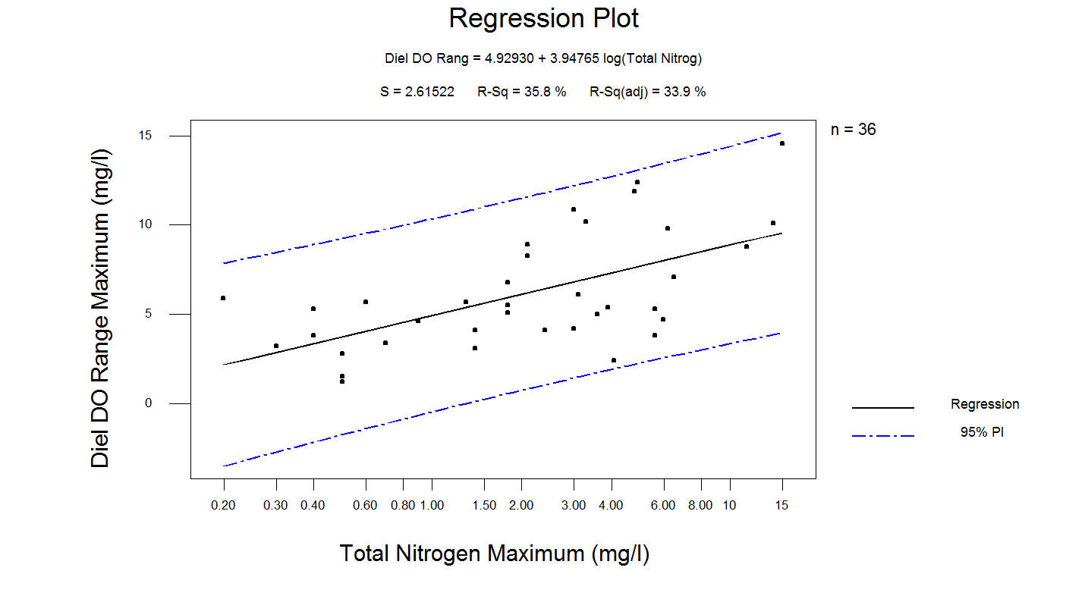

**(B)**

**Figure 7. Linear Regression Model of Diel DO Range Maximum vs. Total Phosphorus Maximum (A) and Total Nitrogen Maximum (B).**

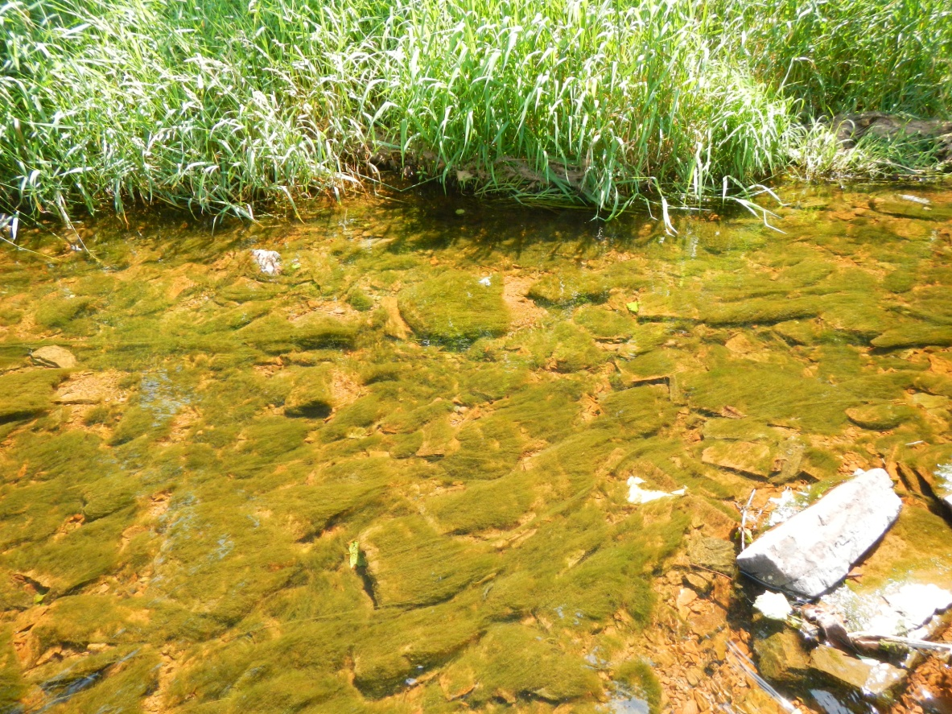

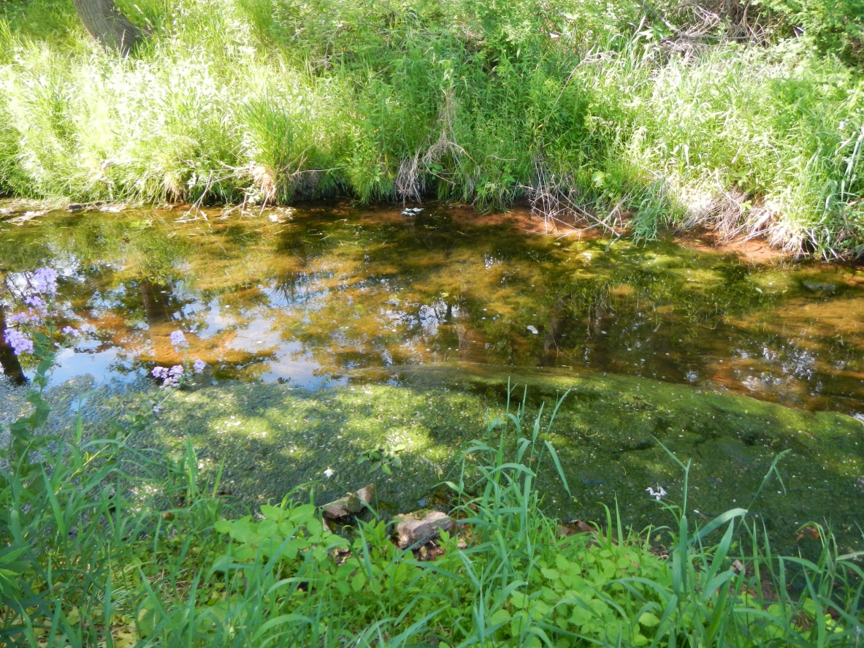

**Figure 8. Photographs of Excessive Algal Growth in a Southeastern Pennsylvania Stream.**

**TIER 1 NUTRIENT SCREENING BENCHMARK VALUES**

Tier 1 nutrient screening parameters include TP, TN, and Hilsenhoff biotic index scores. TP and TN screening benchmark values were derived using PADEP Water Quality Network (WQN) data. The average TP and average TN values for the months of April through September were calculated for each wadeable, WQN station and year, and the 90th percentile value of the average values was used as the screening benchmark value for each of the nutrient parameters. Data from mining-impaired WQN stations were not used in the analysis. This analysis yielded a TP screening value of 0.06 mg/l and a TN screening value of 2.6 mg/l.

The Hilsenhoff biotic index screening benchmark value was derived using values from the 40-sample dataset shown in Table 3. The dataset was divided into two groups based on ALU-attainment status, and the highest Hilsenhoff biotic index score recorded at an ALU-attaining station was used to set the benchmark value of 4.60 (Figure 9).

Tier 1 nutrient screening benchmark values are shown in Figure 10, and summarized as follows:

* Hilsenhoff Index Score ≥ 4.60, or
* Total Phosphorus ≥ 0.06 mg/l, or
* Total Nitrogen ≥ 2.6 mg/l

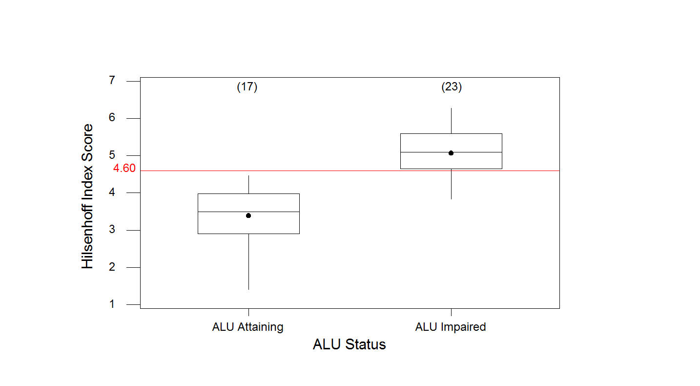

**Figure 9. Hilsenhoff Biotic Index Scores of ALU-Attaining and ALU-Impaired Stations.**

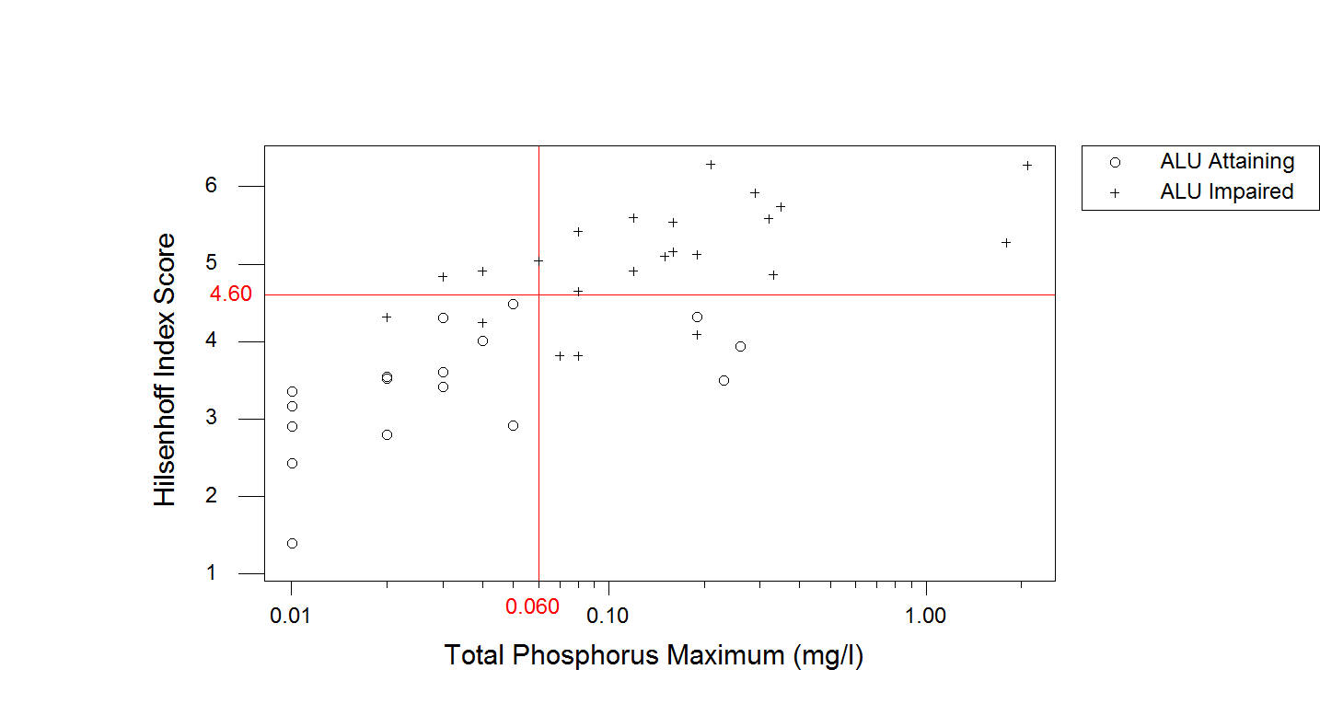

**(A)**

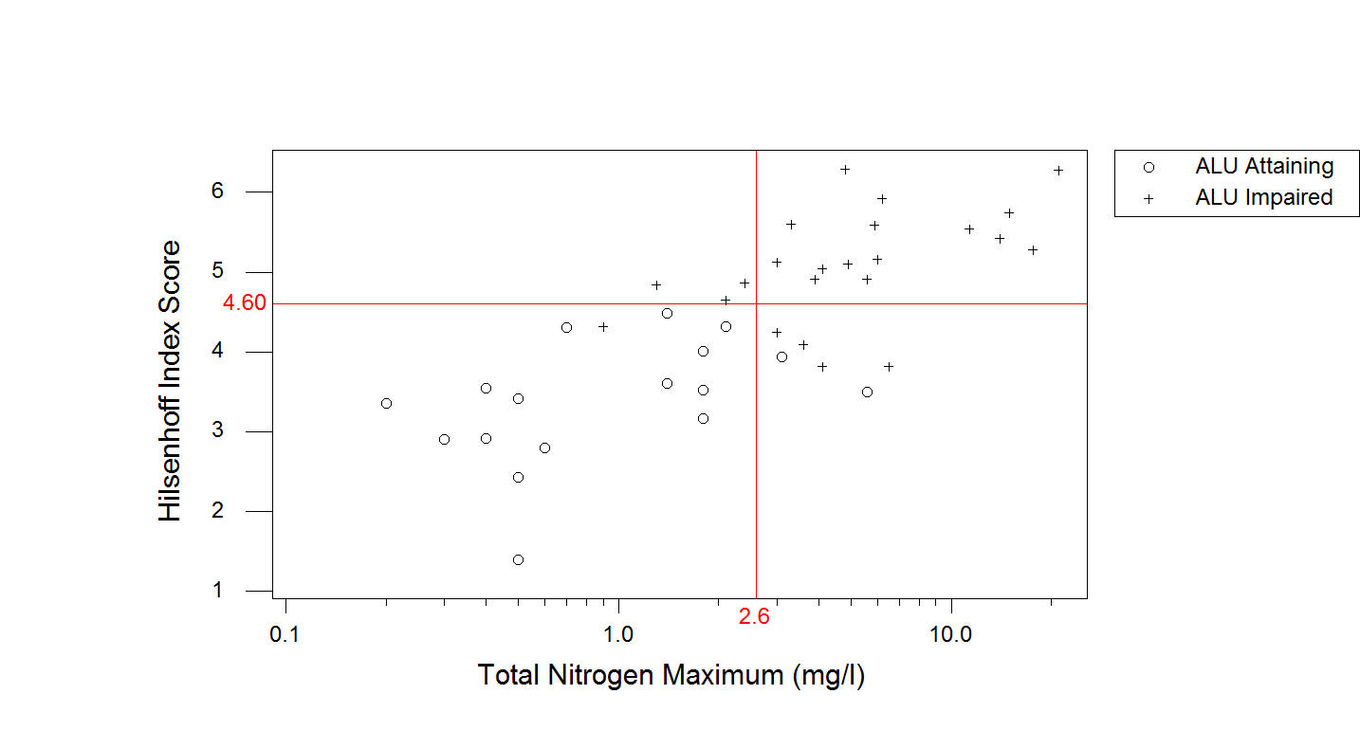

(B)

**Figure 10. Hilsenhoff Biotic Index Score vs. Total Phosphorus Maximum (A) and**

**vs. Total Nitrogen Maximum (B) of 40-Sample Dataset, by Aquatic Life Use Attainment Status.**

If one or more of the screening parameters equals or exceeds the screening benchmark value, the waterway fails the Tier 1 screening process, and is targeted for the collection and evaluation of continuously monitored DO data (Tier 2).

**TIER 2 NUTRIENT IMPAIRMENT BENCHMARK VALUES**

Nutrient impairment benchmark values were developed for maximum diel DO range and maximum 7-day average diel DO range, based on the diel DO characteristics of ALU-attaining stations that passed the Tier 1 screening. Applying the Tier 1 screening benchmark values of:

* Hilsenhoff Index Score ≥ 4.60, or
* TP Max ≥ 0.06 mg/l, or
* TN Max ≥ 2.6 mg/l

in conjunction with the ALU attainment status, the samples in the 40-sample dataset were classified into one of the four categories below, and shown in Table 5 :

* Category 1- ALU-Attaining and Passed Screening (n = 14)
* Category 2 – ALU-Attaining and Failed Screening (n = 3)
* Category 3- ALU-Impaired and Passes Screening (n = 1)
* Category 4- ALU-Impaired and Failed Screening (n = 22)

The maximum diel DO range data from Category 1 and Category 4 sample stations were reviewed for potential seasonal patterns in diel DO fluctuations. A graphical examination of the maximum diel DO range value recorded at a Category 1 sample station on a given day of the year, and the same information recorded at Category 4 sample stations, shows clear, and opposing, seasonal patterns in the diel DO fluctuations of these two groups of streams Figure 11. Diel DO range values tend to peak in the mid- to late-summer in Category 1 streams, and these values tend to peak in the spring and fall in Category 4 streams. Based on the seasonality pattern observed in Category 1 streams, separate nutrient impairment benchmarks were developed for the warm season (July 15 – September 15) and cool season (the remainder of the year) (Figure 12).

For each season, nutrient impairment benchmarks were developed for two diel DO fluctuation parameters, one for the maximum diel DO range, and one for the maximum 7-day average diel DO range. The 90th percentile values of the maximum diel DO range and the maximum 7-day average diel DO range recorded at each Category 1 sample station during a given season, were used as benchmark values (Figure 13).

**Table 5. Aquatic Life Use Attainment and Tier 1 Screening Status of Samples in the 40-Sample Dataset.**



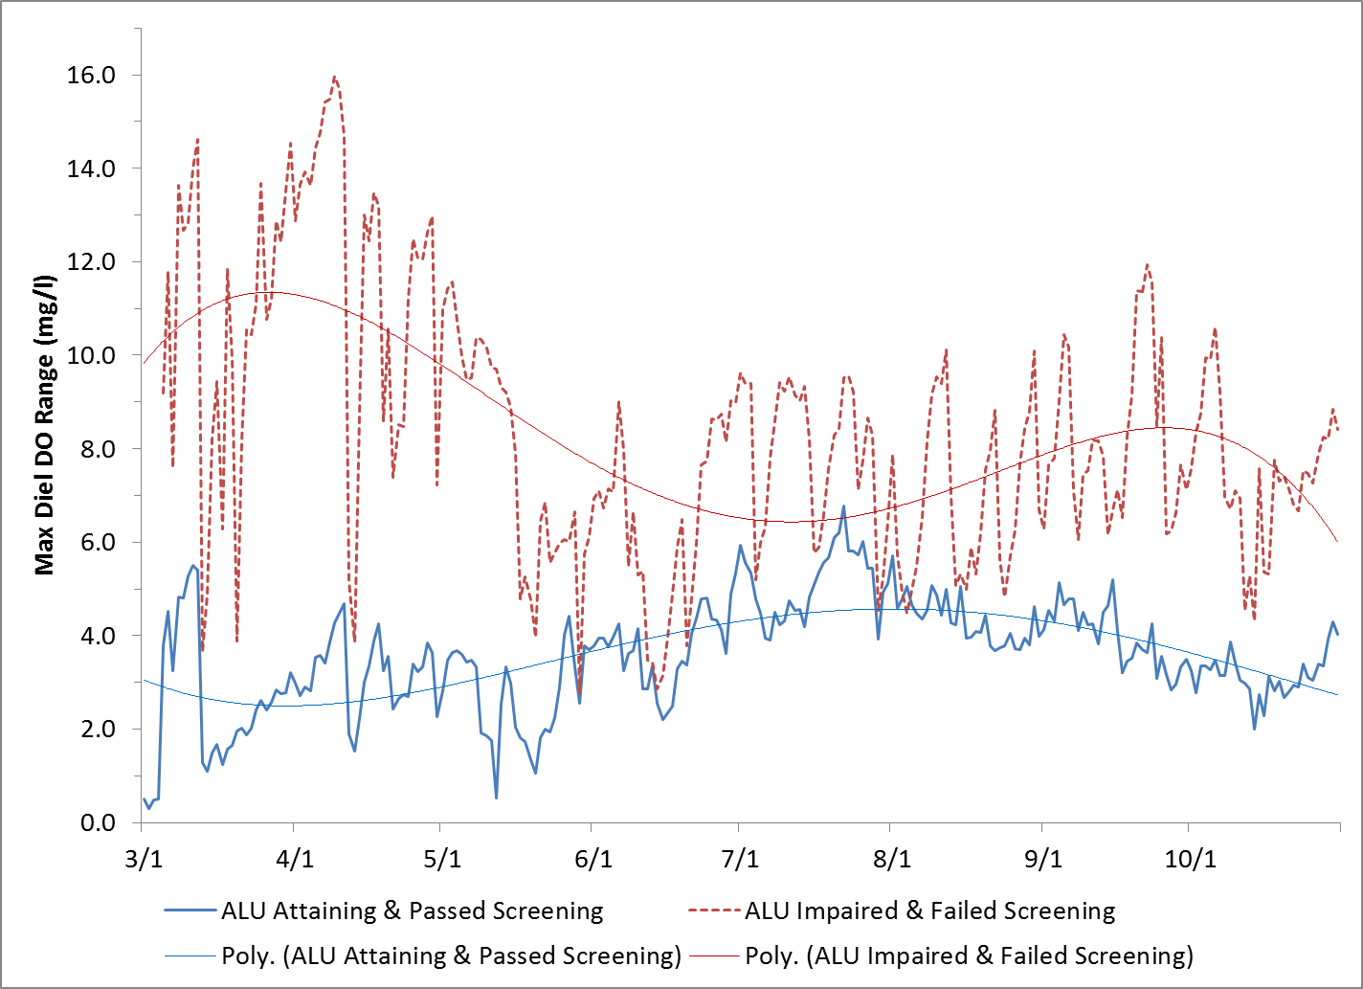

**Figure 11. Maximum Diel DO Range Values Recorded at Category 1 and Category 4 Sample Stations, on a Given Day of the Year.**

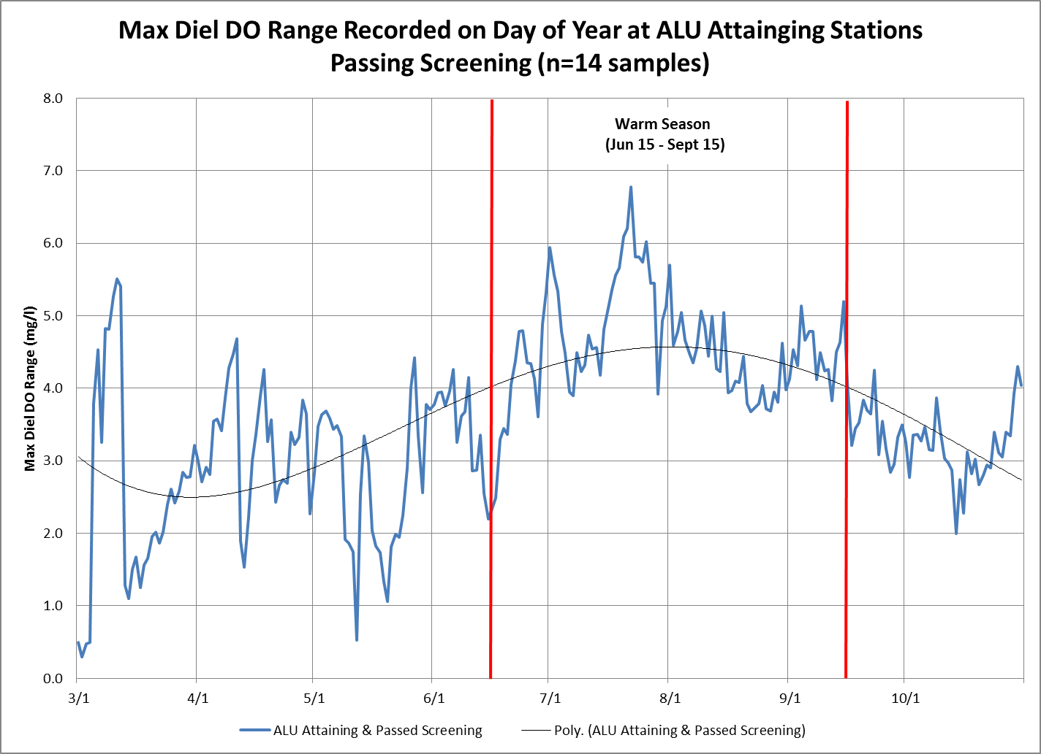

**Figure 12. Seasonality Pattern Observed in Maximum Diel DO Range Values Recorded at Category 1 Sample Stations and the Delineation of the Warm (July 15 – September 15) and Cool Seasons.**

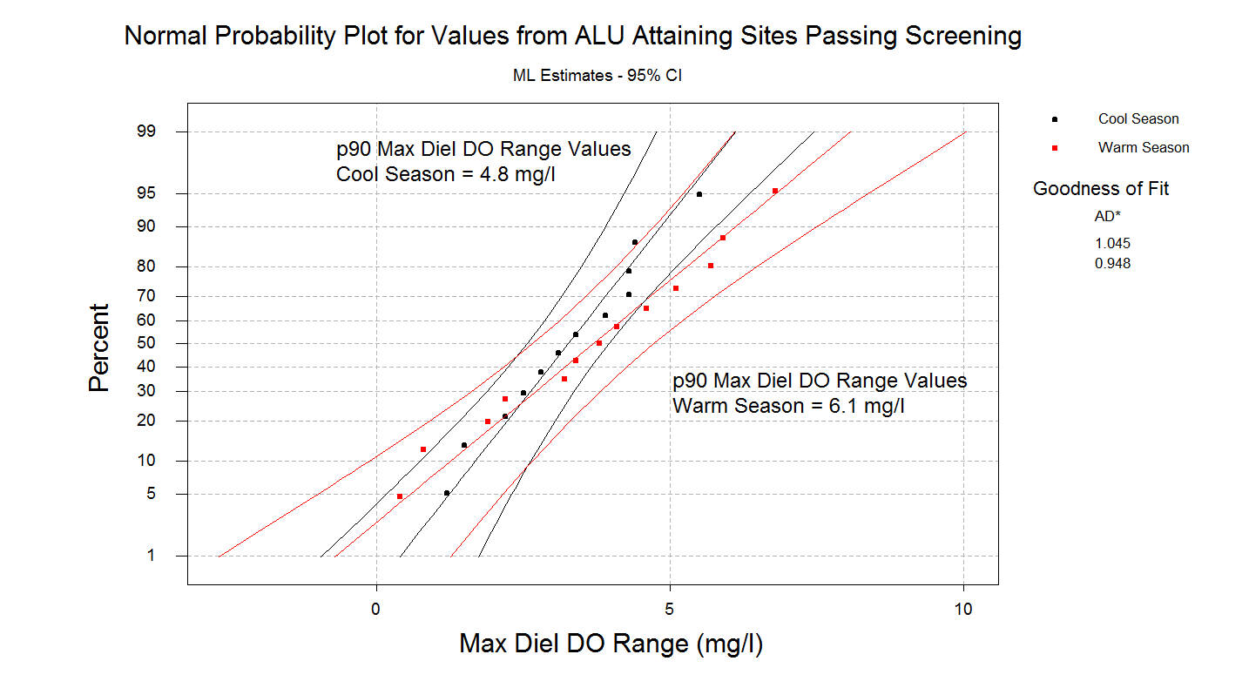

**(A)**

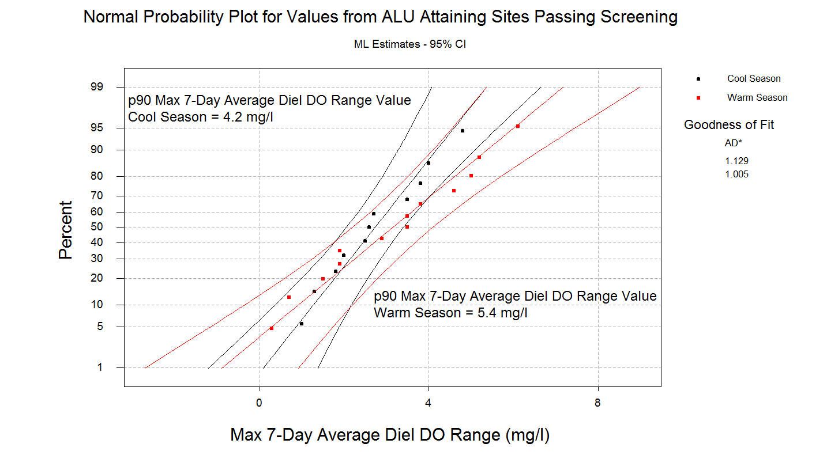

**(B)**

**Figure 13. Normal Probability Plots of the Maximum Diel DO Range and the Maximum 7-Day Average Diel DO Range Recorded at Each Category 1 Sample Station During a Given Season.**

This process yielded the benchmarks summarized below, and shown graphically in Figure 14.

* Cool Season Maximum Diel DO Range ≥ 4.8 mg/l, or
* Cool Season Maximum 7-Day Average Diel DO Range ≥ 4.2 mg/l, or
* Warm Season Maximum Diel DO Range ≥ 6.1 mg/l, or
* Warm Season Maximum 7-Day Average Diel DO Range ≥ 5.4 mg/l

If a Tier 1 nutrient screening benchmark is exceeded, and one or more of the Diel DO fluctuation parameters equals or exceeds the impairment benchmark values, then nutrients are identified as a cause of aquatic life use impairment. Applying the nutrient impairment benchmarks to the ALU-impaired stations that failed the Tier 1 screening in the 40-sample dataset produced the nutrient impairment decisions summarized in Table 6.

**SUMMARY**

PADEP used a stressor-response approach, based on known relationships between nutrient concentrations and biological responses, to develop a two-tiered protocol for assessing nutrient impacts to wadeable streams. The intended use of the protocol is for identifying where nutrients are a cause of impairment in ALU-impaired streams. The protocol takes into consideration that there may be cases where a given waterbody may be subject to elevated nutrient levels, but due to characteristics such as scour conditions, substrate composition, temperature, shading, turbidity, depth, etc., elevated nutrient levels may, or may not, affect the photosynthesis, respiration, and dissolved oxygen characteristics of the waterway to a degree that ultimately results in non-attainment of aquatic life use (ALU).

After a given wadeable stream is determined to be ALU-impaired and PADEP staff view nutrients as a potential cause of the impairment, stream nutrient (TP and TN) and macroinvertebrate information (Hilsenhoff Biotic Index Score) are compared to screening benchmark values (Tier 1) to determine if additional data should be collected and evaluated (Tier 2). Waterways that fail one or more of the Tier 1 screening parameters are targeted for the collection and evaluation of continuously monitored dissolved oxygen data (Tier 2), which are ultimately used to confirm if nutrients are a cause of the ALU impairment. The nutrient impact assessment protocol is summarized in Figure 15.

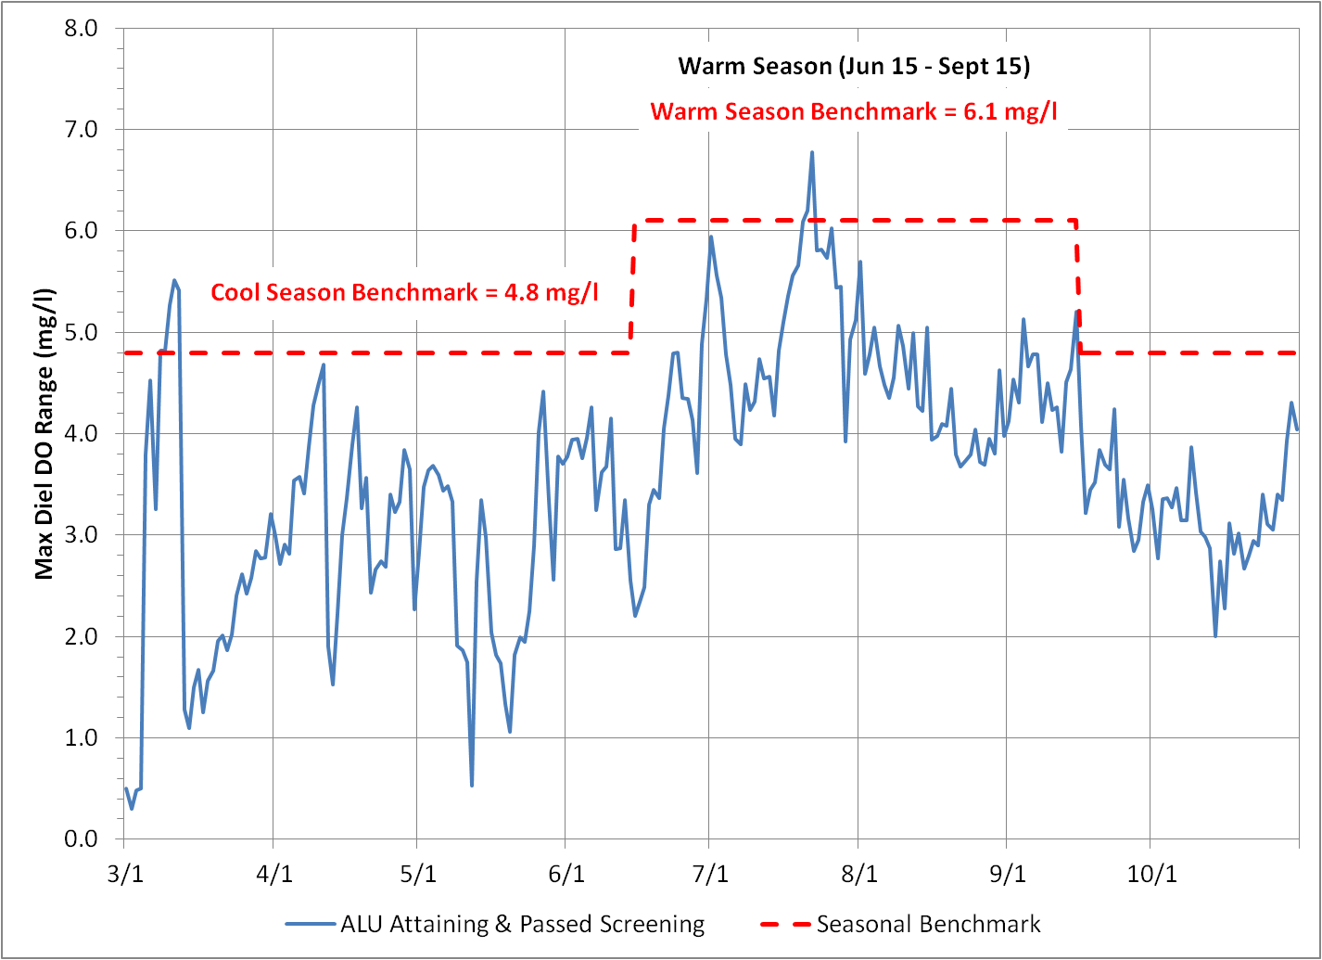

**(A)**

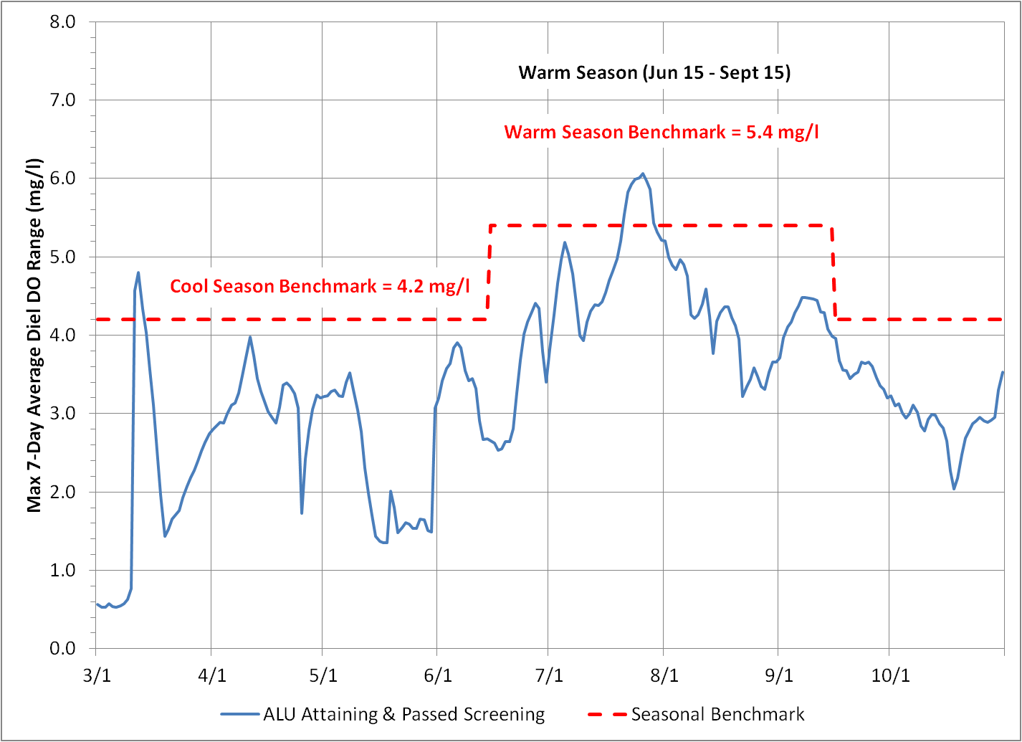

**(B)**

**Figure 14. Seasonal Nutrient Impairment Benchmark Values and Maximum Diel DO Range Values (A) and Maximum7-Day Average Diel DO Range Values Recorded at Category 1 Sample Stations.**

**Table 6. Nutrient Impairment Status of Aquatic Life Use-Impaired Sample Stations in the 40-Sample Dataset that Failed Tier 1 Screening.**



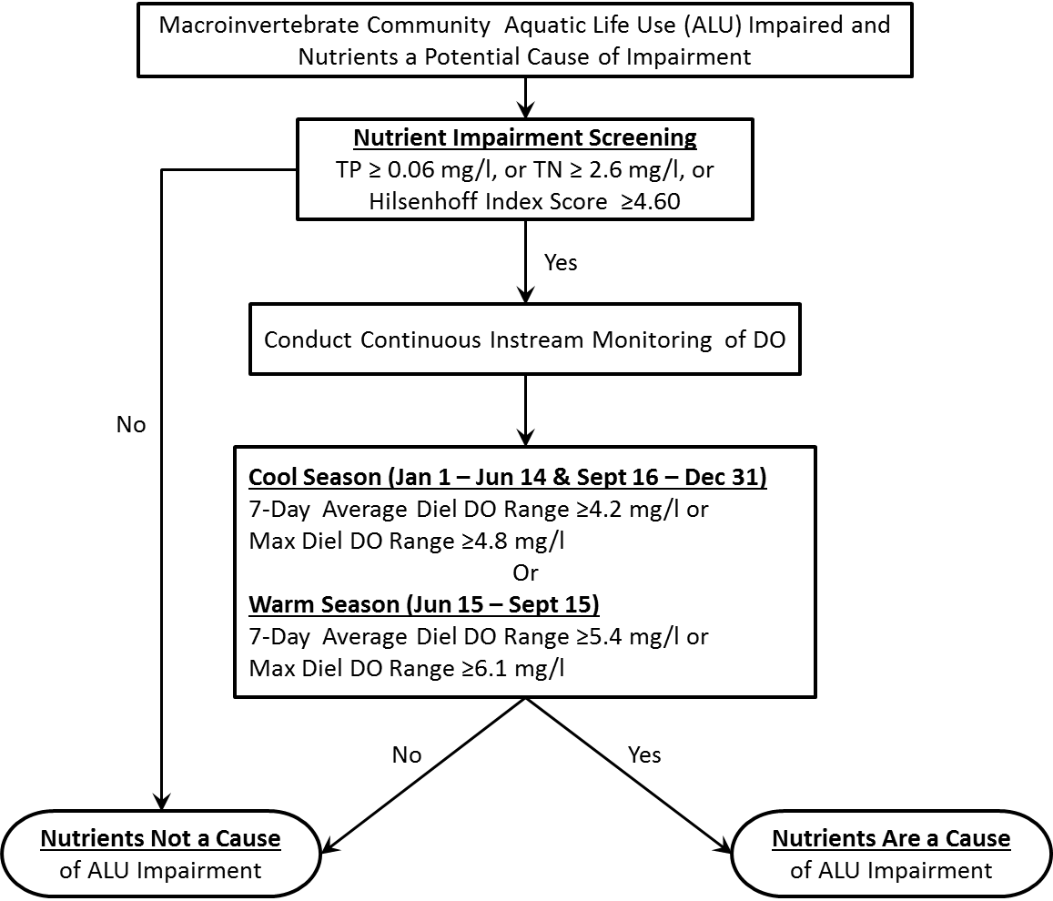

**Figure 15. Summary of the PADEP Nutrient Impact Assessment Protocol.**

**LITERATURE CITED**

Biggs, B. J. F. 2000. Eutrophication of streams and rivers: dissolved nutrient

chlorophyll relationships for benthic algae. Journal of the North American Benthological Society 19:17-31.

Carr, G. M., A. Morin, and P. A. Chambers. 2005. Bacteria and algae in stream

periphyton along a nutrient gradient. Freshwater Biology 50:1337-1350.

Chambers, P.A. and E.E. Prepas. 1994. Nutrient dynamics in riverbeds: the impact of

sewage effluent and aquatic macrophytes. Water Res. 28:453-464.

Dodds, W.K. and E.B. Welch. 2000. Establishing nutrient criteria in streams. Journal

of the North American Benthological Society 19:186-196.

Dodds, W.K., V.H. Smith, and K. Lohman. 2002. Nitrogen and phosphorus

relationships to benthic algal biomass in temperate streams. Canadian Journal of Fisheries and Aquatic Sciences 59:865-874.

Miltner, R.J. 2010. A method and rationale for deriving nutrient criteria for small rivers

and streams in Ohio. Environmental Management 45:842-855.

Miltner, R.J. and E.T. Rankin. 1998. Primary nutrients and the biotic integrity of rivers

and streams. Freshwater Biology 40:145-158.

PADEP. 2013-a. Surface Water Collection Protocol. Pennsylvania Department of

Environmental Protection, Bureau of Point and Non-Point Source Management.

Harrisburg, Pennsylvania.

_____. 2013-b. Continuous Instream Monitoring Protocol. Pennsylvania Department

of Environmental Protection, Bureau of Point and Non-Point Source

Management. Harrisburg, Pennsylvania.

_____. 2013-c. An Index of Biotic Integrity for Benthic Macroinvertebrate

Communities in Pennsylvania’s Wadeable, Freestone, Riffle-Run Streams.

Pennsylvania Department of Environmental Protection, Bureau of Point and Non-

Point Source Management. Harrisburg, Pennsylvania.

Slavik, K., B. J. Peterson, L. A. Deegan, W. B. Bowden, A. E. Hershey, and J. E.

Hobbie. 2004. Long-term responses of the Kuparuk River ecosystem to phosphorus fertilization. Ecology 85:939-954.

U.S. Environmental Protection Agency. 2010. Using Stressor-response Relationships

to Derive Numeric Nutrient Criteria. EPA-820-S-10-001. Office of Water, United

States Environmental Protection Agency. Washington, D.C.

Yuan, L.L. 2010. Estimating the effects of excess nutrients on stream invertebrates

from observational data. Ecological Applications 20:110-125.