INSTRUCTIONS FOR THE ON-LINE APPLICATION

The 319 Nonpoint Source (NPS) Management Grant Application must be submitted through the Department of Community and Economic Development’s (DCED) Electronic Single Application website. Paper and faxed copies will not be accepted. This change allows DEP to expedite the review process. The link to the on-line application can be found at:
https://www.esa.dced.state.pa.us/Login.aspx

This document will provide instructions on how to apply and upload the required documentation in the eGrants application. See the 319 NPS grant program guidance document for instructions on filling out the forms associated with your application that must be uploaded on the addenda tab of the eGrants application.

The instructions contained in this document will assist you in applying for any program offered under the 319 NPS Management Grant solicitation. All information needed for your submission will be contained in this online application.

No documentation needs to be mailed to DEP.

User Tips

- The Electronic Single Application works best when accessed through Internet Explorer.
- If you allow your screen to sit idle for more than 30 minutes, you will lose the data entered since your last save and will have to re-enter it. Save frequently.
- When completing the application, fields with a “ ” are required fields. If a required field is skipped, you will be notified later in the application to return to that section to complete the field.
- Do not use special characters in the fields such as \, /, *, &, %, #, etc.
- You do not need to send the signature page and/or any further documentation to the Grants Center. All the information needed is contained in your on-line submission.
- The application round opens April 22, 2022 at 8:00 a.m. Application deadline is on June 24, 2022 at 5:00 p.m. Early applications or those submitted after the deadline will not be accepted.
- If you have questions completing the application, please call the DCED Customer Service Center at 1-800-379-7448 or by email at ra-dcedcs@pa.gov. They are open 8:30 am-5:00 pm EST Monday through Friday.

TABLE OF CONTENTS

Registration and Login …………………………………………………………………………………………………………………… Page 3
Begin a New Application ……………………………………………………………………………………………………………….. Page 4
Select a Program ……………………………………………………………………………………………………………………………. Page 4
Apply ……………………………………………………………………………………………………………………………………………… Page 5
Applicant Information Tab …………………………………………………………………………………………... Page 5
Company Tab ……………………………………………………………………………………………………………….. Page 7
Project Overview Tab …………………………………………………………………………………………………… Page 9
Project Site Tab …………………………………………………………………………………………………………… Page 10
Project Narrative Tab …………………………………………………………………………………………………… Page 11
Program Budget Tab …………………………………………………………………………………………………….. Page 12
Program Addenda Tab ………………………………………………………………………………………………….. Page 14
Certification and Submission ………………………………………………………………………………………… Page 19
Application Receipt Verification ………………………………………………………………………………….. Page 21

Reminder: If you have questions completing the electronic application, please call the DCED Customer Service Center at 1-800-379-7448. They are open 8:30 am-5:00 pm EST Monday thru Friday.

- Registration and Login
  - If you are a first-time user, click the “REGISTER” button on the left.
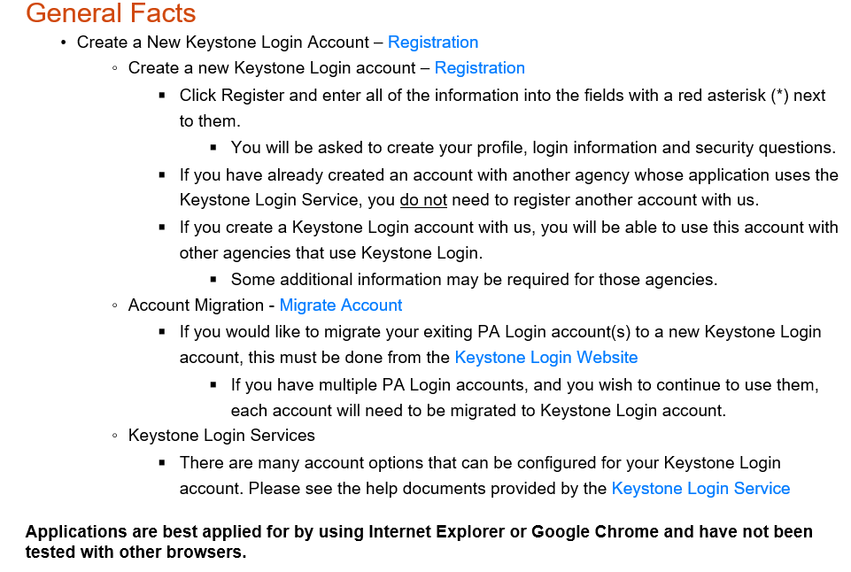
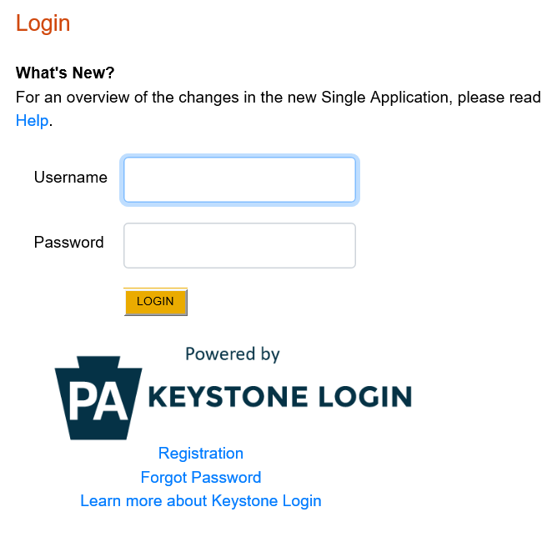
Be sure to save the Username and Password you have chosen for future grant applications and other grant-related use.
Click to Register

- Begin a New Application
- Project Name – Enter a name for your project.
- Do you need help selecting your program – Select “No”.
- Click on “CREATE A NEW APPLICATION”.

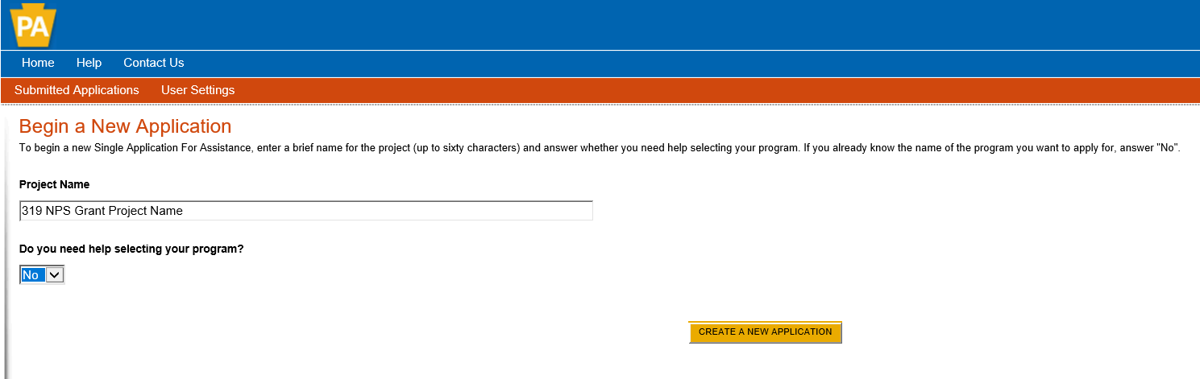

- Select Program
- Under Program Name, enter “319”.
- Click “SEARCH”. Look for the 319 NPS Grant program offered by DEP.
  - Click Apply.
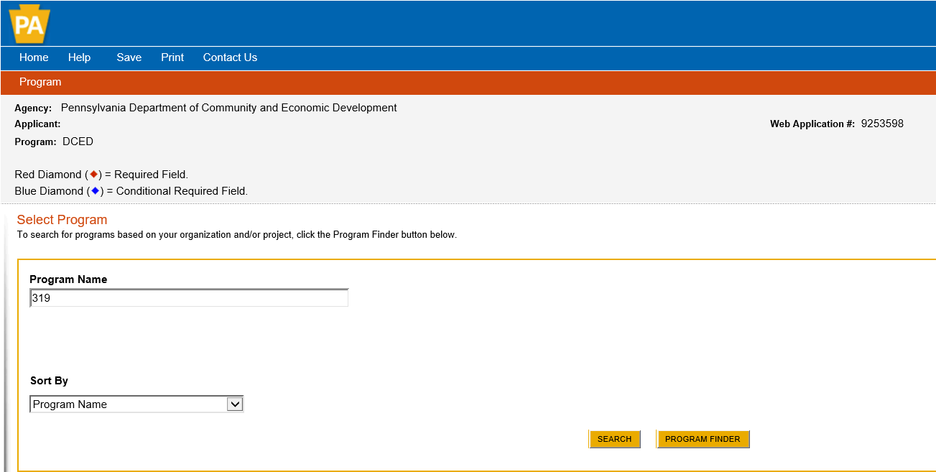

- Apply
- You will be given the option of choosing one of the three programs offered under Growing Greener Plus – Growing Greener (Watershed Restoration and Protection), SMCRA (Bond Forfeiture) or AMD Set-Aside grants. Select the program for which you are applying.

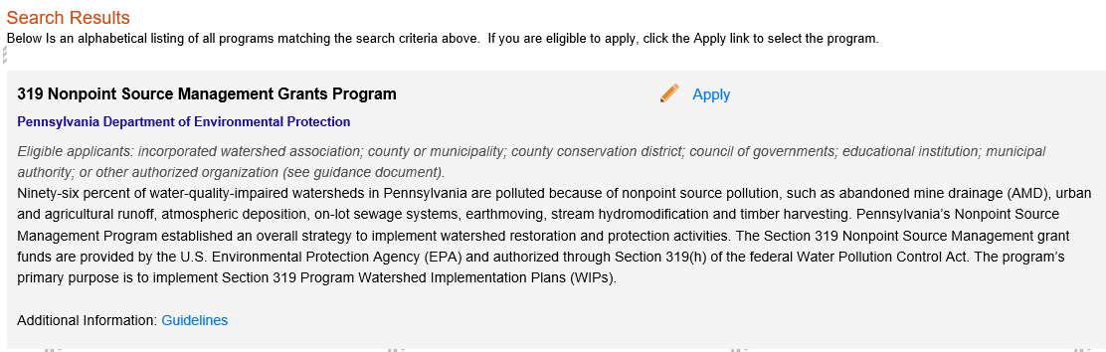

- Applicant Information Tab

*If your application has a need for a sponsor, the sponsor’s information should be filled in on this tab. Your organization’s information will be completed on the “Company Tab.”
- The Applicant Information section requires data related to the applicant or sponsor for which the application is being submitted.
- Applicant Entity Type – select the appropriate type for your organization.
- Applicant Name – Enter the organization’s name, the name under which the applicant or sponsor legally conducts business.
- NAICS Code - From the dropdown box, select the appropriate type. The NAICS code will auto-populate for you.
- FEIN/SSN Number - Enter the Federal Tax ID number for the legal County name (no dashes).
- DUNS Number – Enter the applying organization’s nine-digit number.
- UEI Number (Required) – Unique Entity ID. Enter the applying organization’s unique, 12-character alphanumeric identifier assigned to all entities that conduct business with the federal government.
- Top Official/ Signing Authority – Enter the name of the individual at your organization who has the authority to enter into a grant agreement with DEP (e.g. the name of President, Chairperson, CEO, etc., of the organization).
- Title – Enter that individual’s title.
- SAP Vendor# - Fill in if known.
- Contact Name – Enter the primary contact name for this project.
- Contact Title – Enter the primary contact’s title for this project.
- Phone and Fax – Enter the phone and fax numbers for the primary contact for this project.
- E-mail (Required)– Enter the e-mail for the primary contact for this project.
- Mailing address, City, State and Zip Code – Enter this information for the organization and primary contact for this project.
- Click “Continue” at the bottom right.

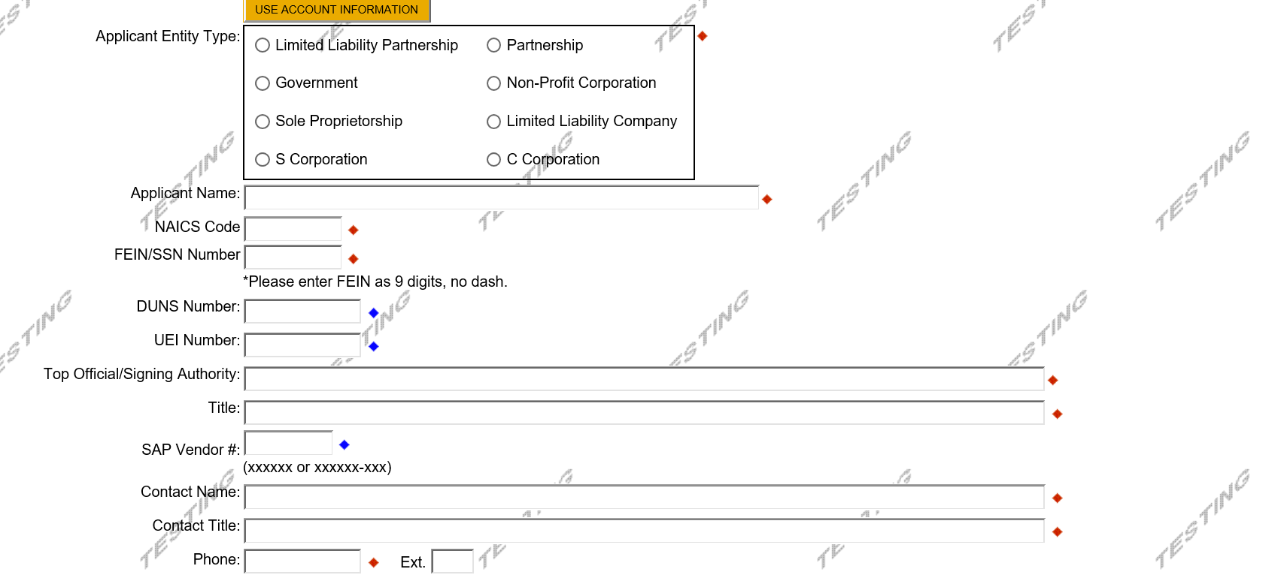

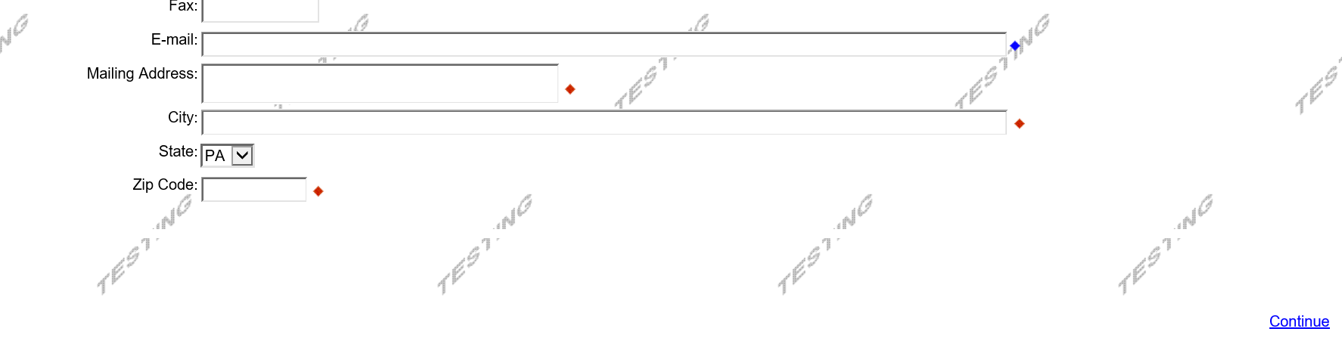
6. Company Tab
- If your application requires a sponsor, enter your organization’s information on this tab.

- If your application does not require a sponsor, click the “Copy from Applicant” button to copy your information over to this tab.

- For information on which applications require a sponsor, see the grant program guidance document.

- Business Specifics – Answer optional questions.

- Enterprise Type - Select most appropriate type for your application.

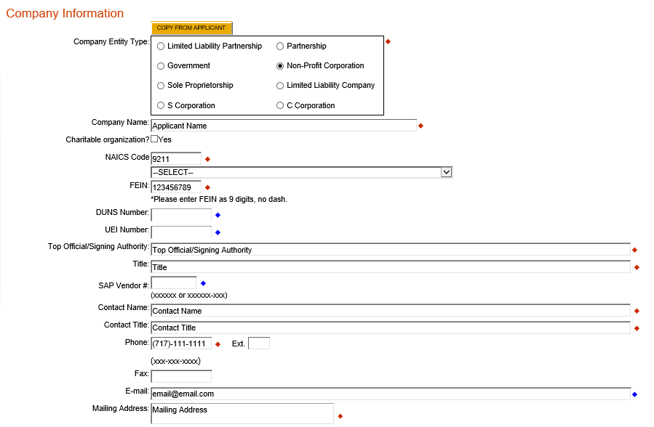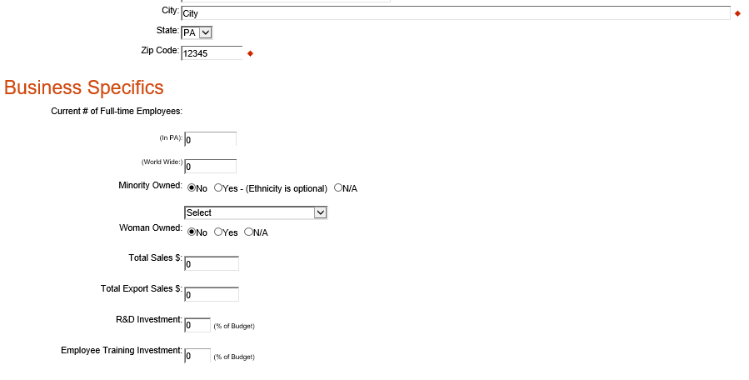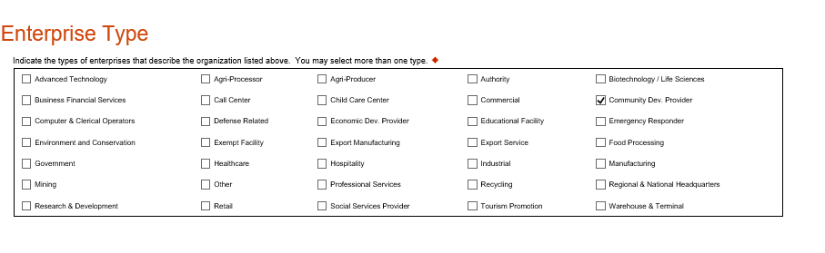

7. Project Overview
- Project Name – The project name will auto-populate from the information you filled in at the beginning of the process. You may change the project name at this time.
- Answer whether or not the project is related to a previously-submitted project and the project’s name.
- Enter the name of the person you spoke with at DEP regarding your application.
- If your community is certified through Sustainable Pennsylvania, enter what level.
- Answer whether or not you are interested in applying for more than one funding source.
- Be sure to enter the number of sites if there is more than one project site.
- Click “Continue”

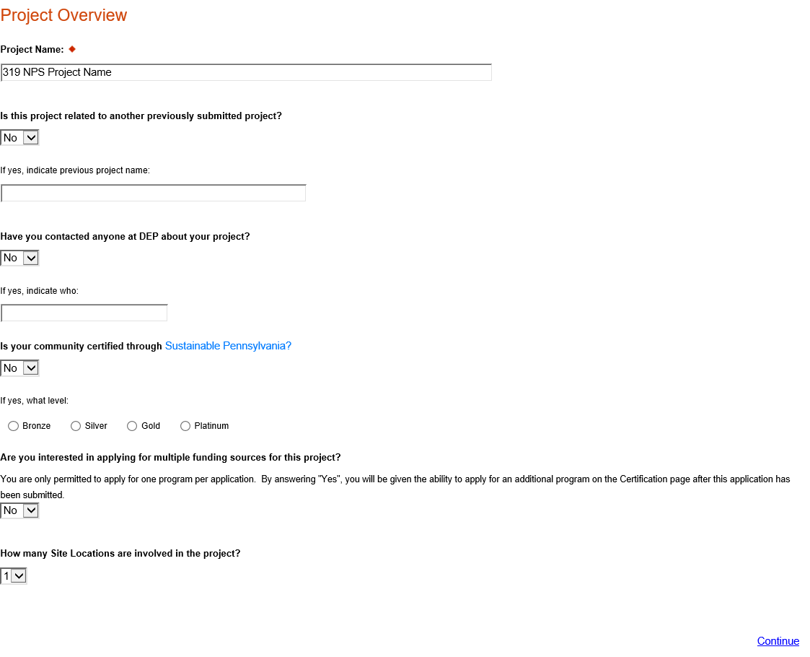

8. Project Site
- Address – Enter the mailing address (street address). P.O. Boxes are not acceptable.
- City, State and Zip Code – Enter this information. (If you indicated more than one site on the prior tab, you will be requested to complete this information for all sites.)
- County – Select your county from the dropdown box.
- Municipality – Select the Municipality or County-Wide from the dropdown box, as appropriate.
- PA House, PA Senate and US House – These fields will be auto-populate based on the information entered above.
- Designated Areas – Leave blank.

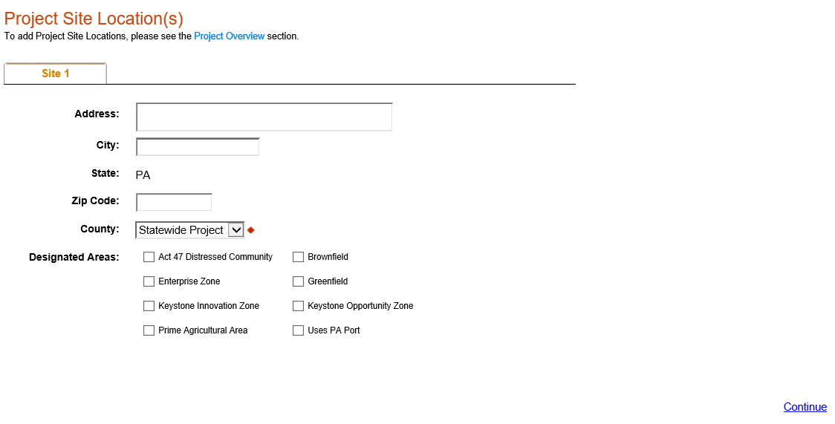
Click “Continue”

9. Project Narrative
- Complete questions in this section. Be as specific and concise as possible. Responses to all questions are required.

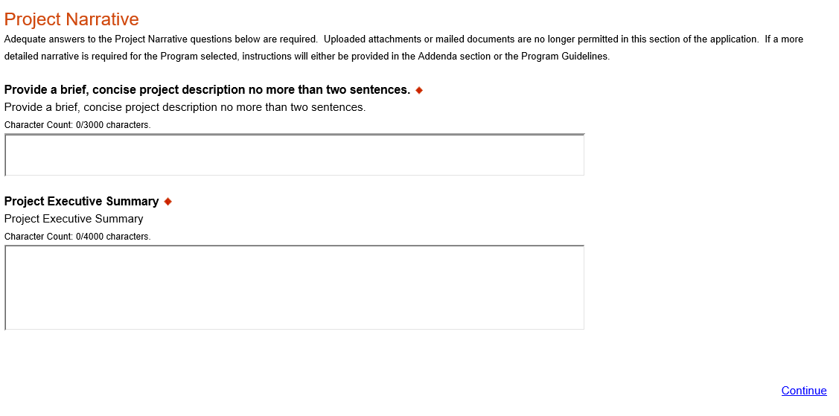
Click “Continue”
10. Program Budget
- There are two tabs on this page, Spreadsheet and Basis of Cost.
Spreadsheet Tab
- Click on the Spreadsheet tab. Enter the amount of funding you are requesting from DEP in the appropriate categories.
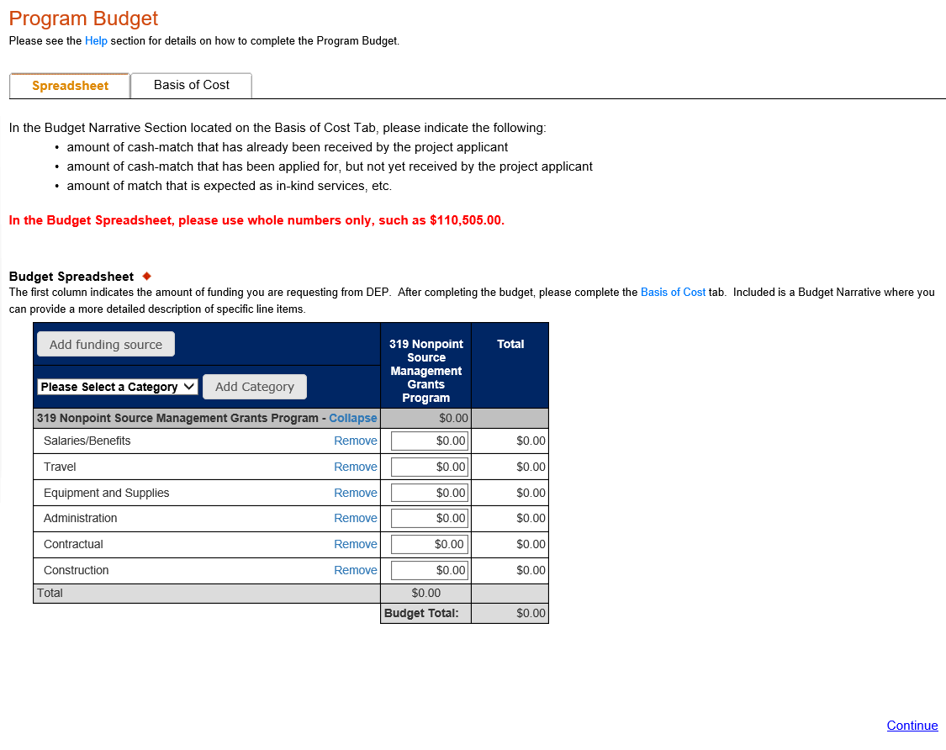
Click “Continue”

Basis of Cost Tab
- Choose Budget Justification.
- In the Budget Narrative Section located on the Basis of Cost Tab, The narrative must specifically address each of the cost items identified in the Budget Spreadsheet.

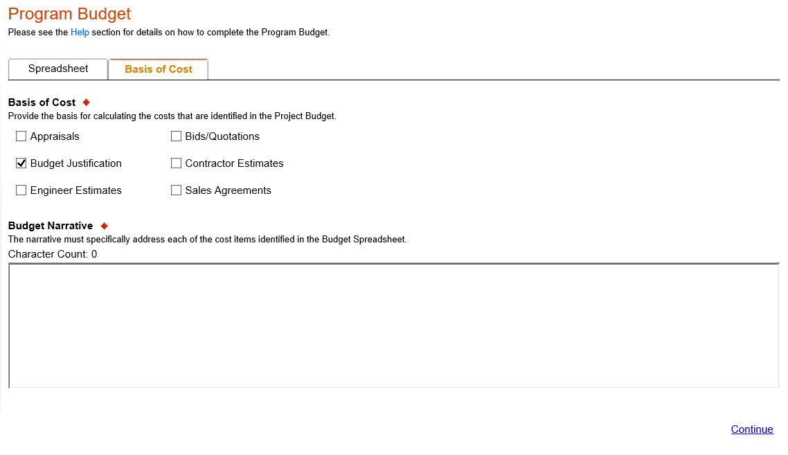
Click “Continue”
11. Program Addenda
- Complete all fields and upload all required documents on this tab. Once completed, click Continue.
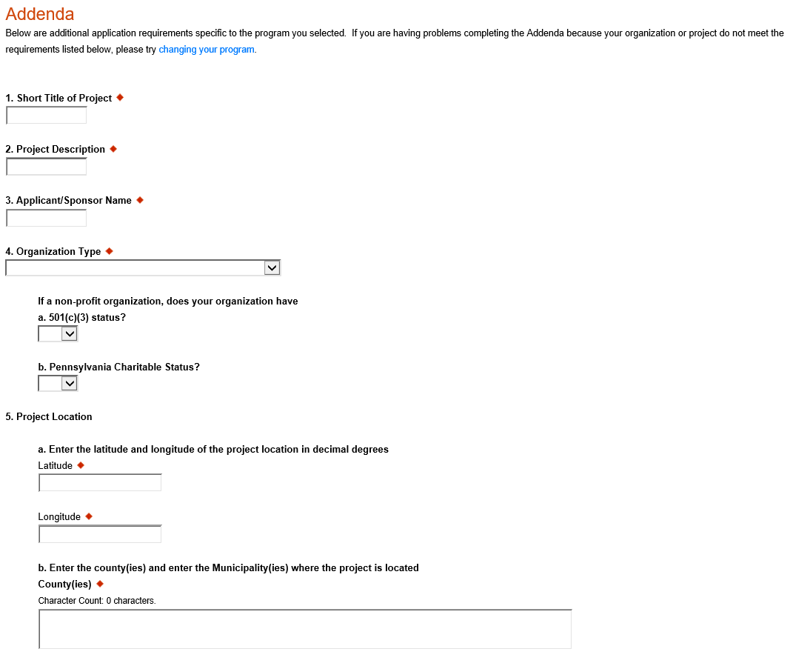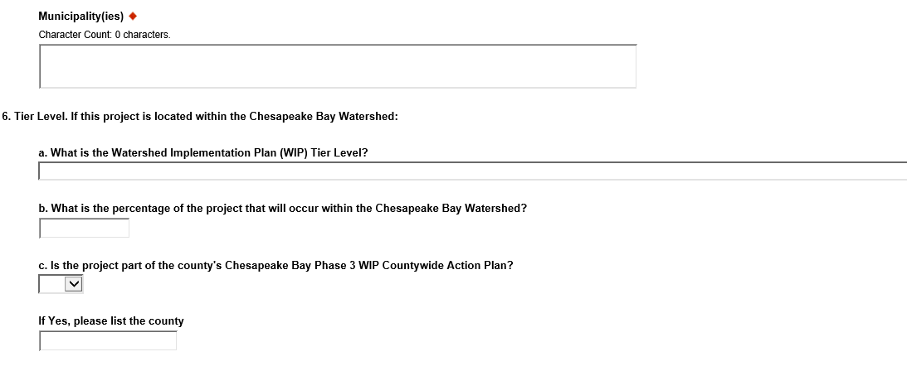
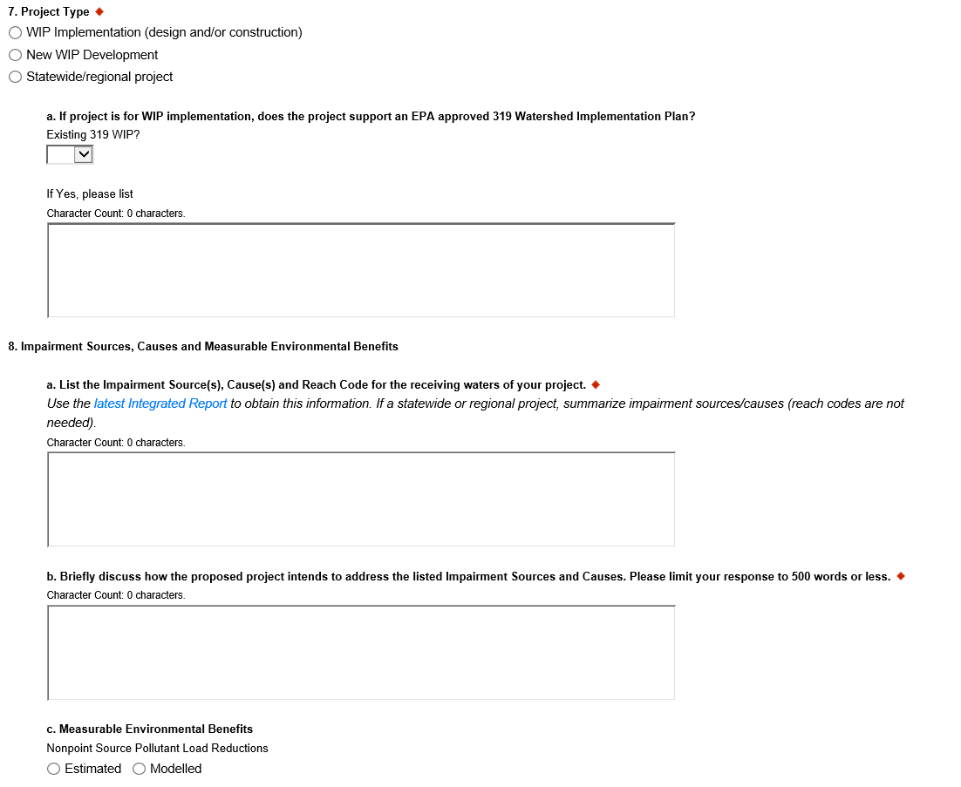
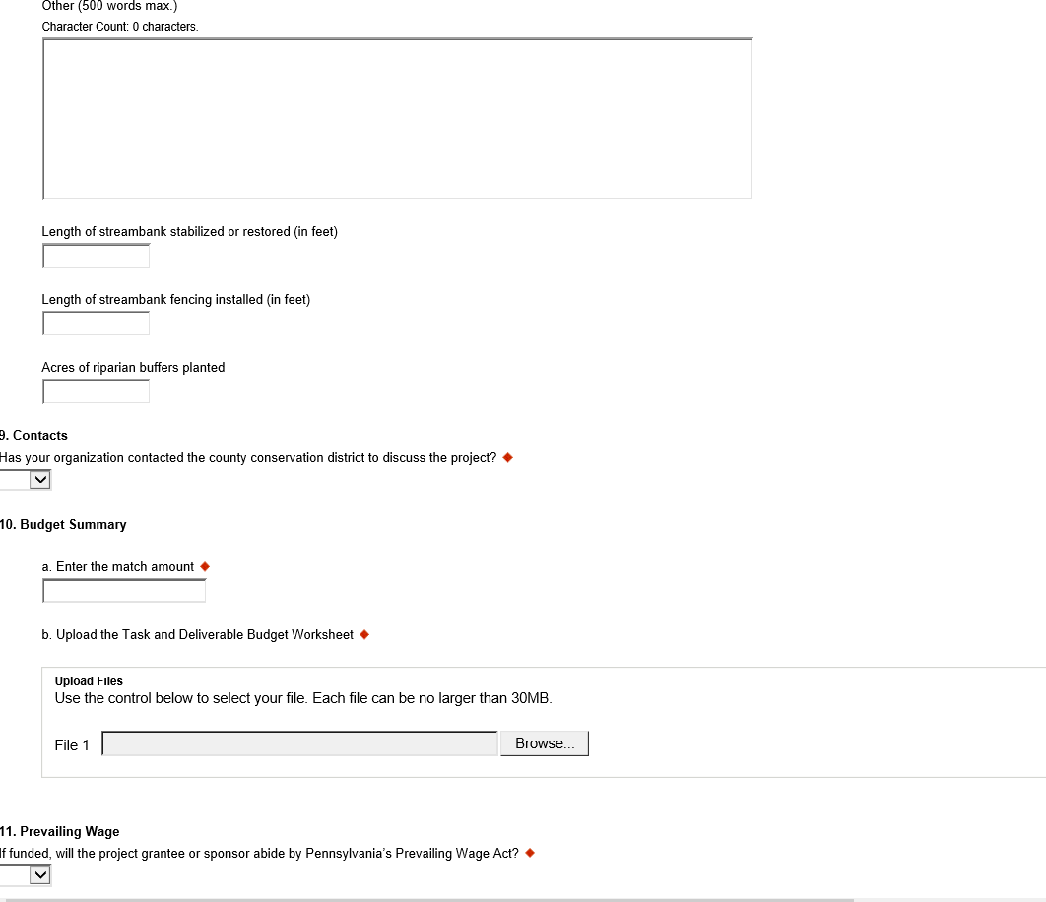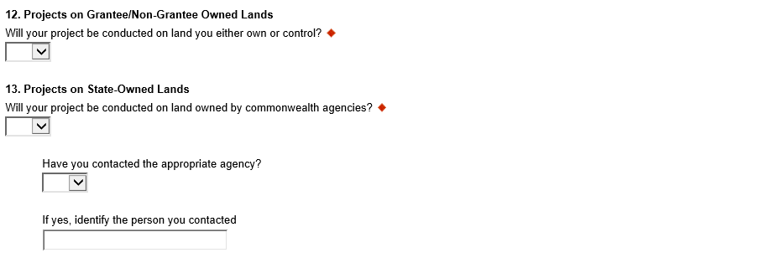

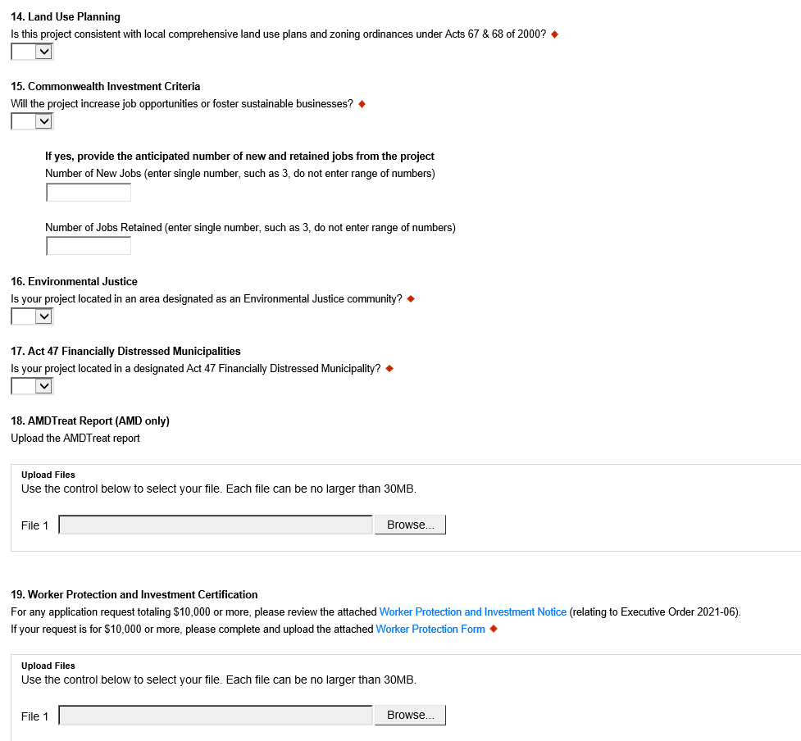
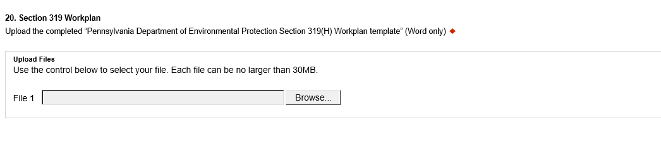

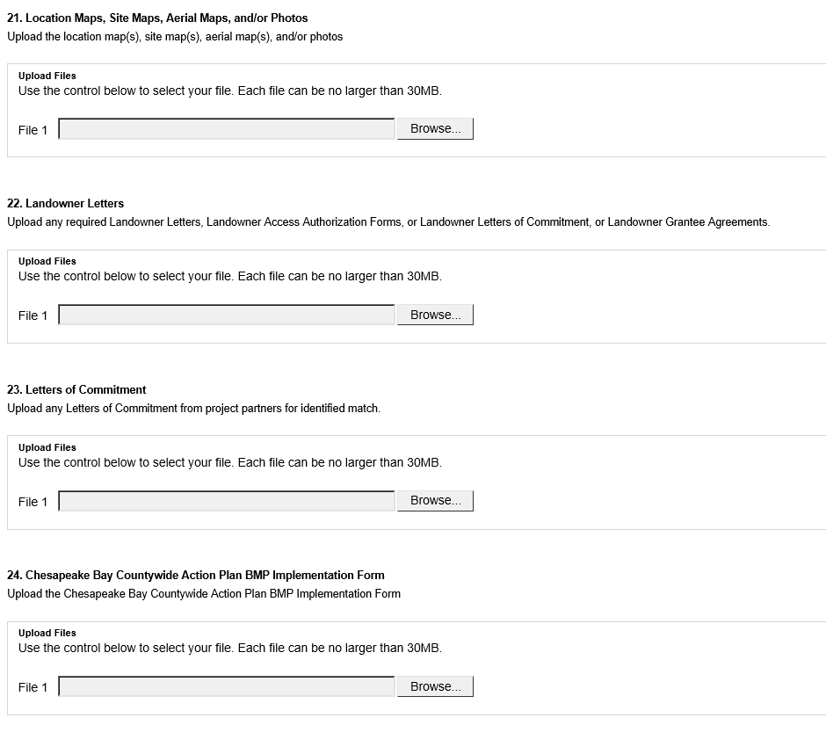
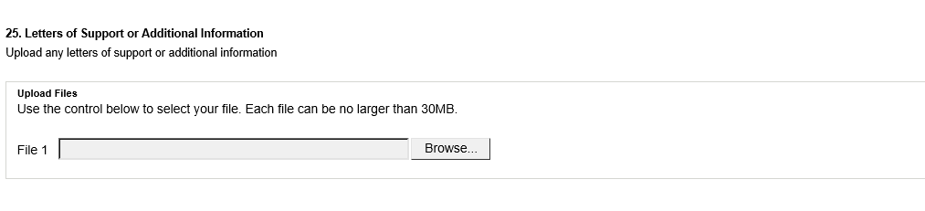

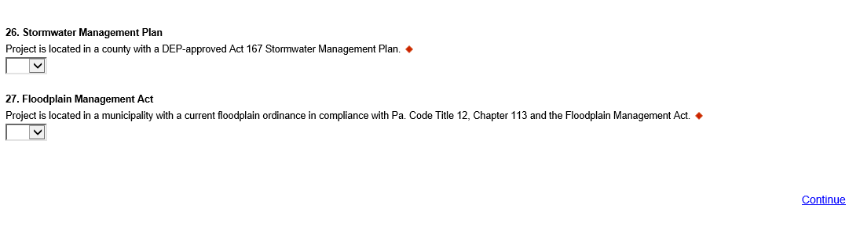
You may download required documents from DEP’s 319 Nonpoint Source Management website to obtain a copy of the complete grant guidance document and related application forms, including all required documentation.
12. Certification and Submission
- If there is any missing information in your application, your screen will look like the following example.
- Under the orange “Application Certification” heading, it will state, “The following sections are incomplete. All required fields marked with a red diamond must be completed before you are able to submit this application”.
- To add/correct the information on your application, click on the section heading to return to the page.

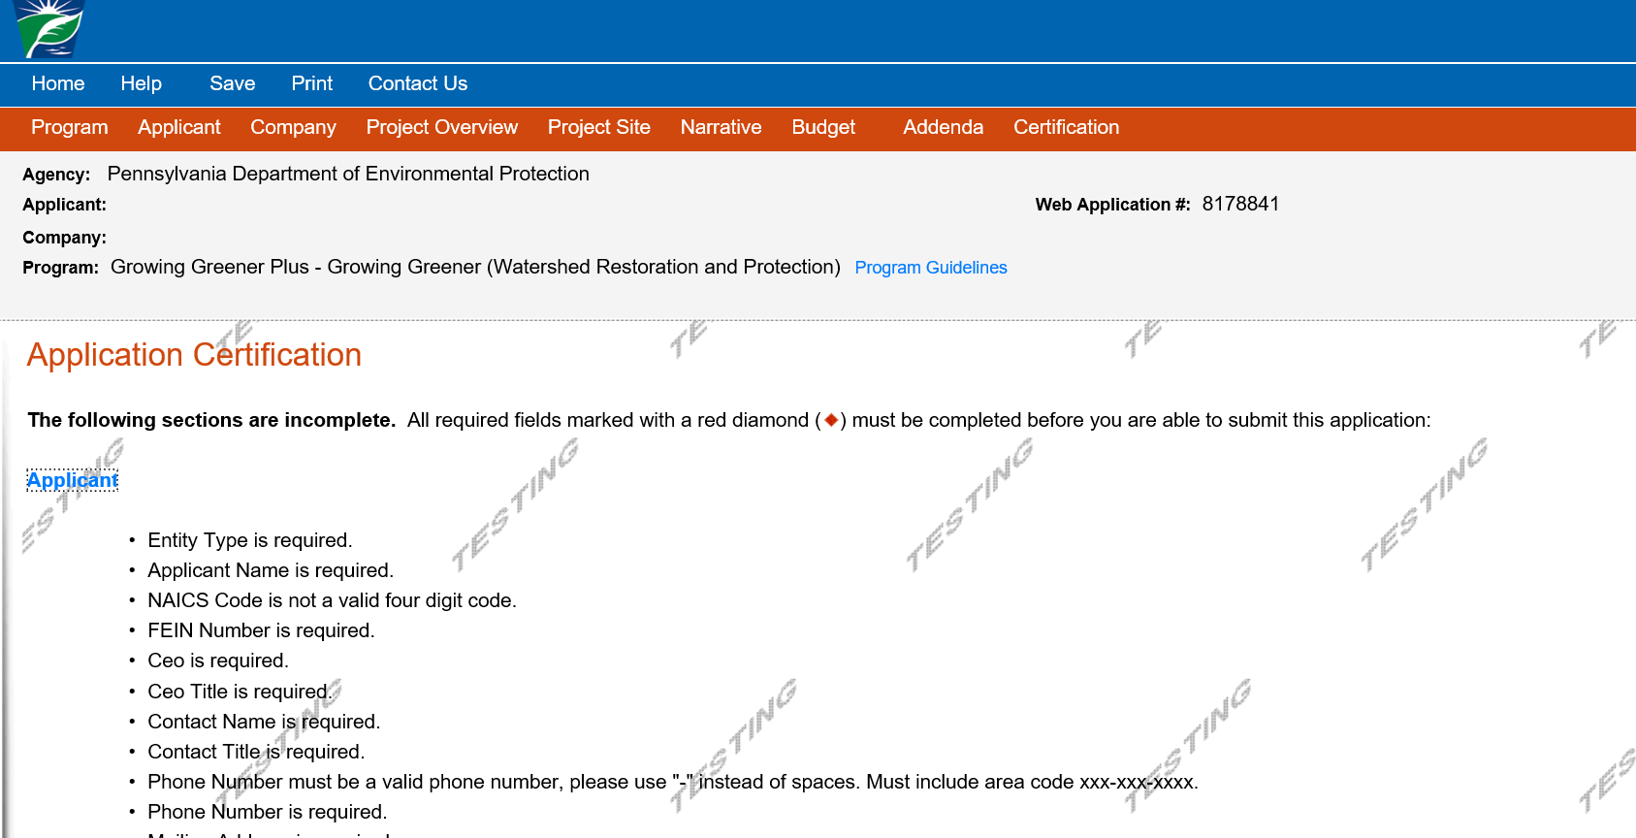
Click here to make the necessary changes

If your application is complete, your screen will look like this:
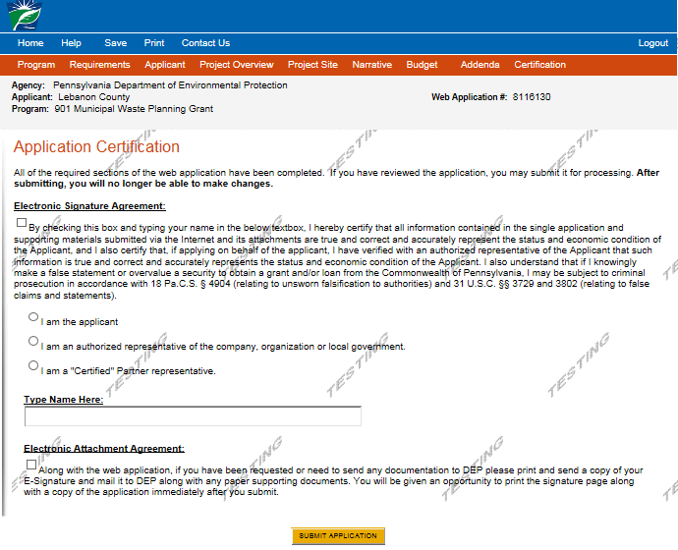
Complete the following fields:
- Indicate certification of application information by checking the related checkbox under the Electronic Signature Agreement.
- Indicate identity as one of the following:
  - I am the applicant.
  - I am an authorized representative of the company, organization or local government.
  - I am a “Certified” Partner representative.
- Type your name in the “Type Name Here” block. This will serve as your official e-signature and authorizes your application.
- Check the “Electronic Attachment Agreement” box.
- Click on “Submit Application.”

13. Application Receipt Verification
- If you want a copy of your application, click the “Print Entire Applications with Signature Page” link. You will always be able to access your application with the user name and password you created at the beginning of the application.
- Make sure to note the Single Application ID#. All future correspondence from the Department will reference this number.
- You do not need to send the signature page and/or any further documentation to the Grants Center. All the information needed is contained in your on-line submission.
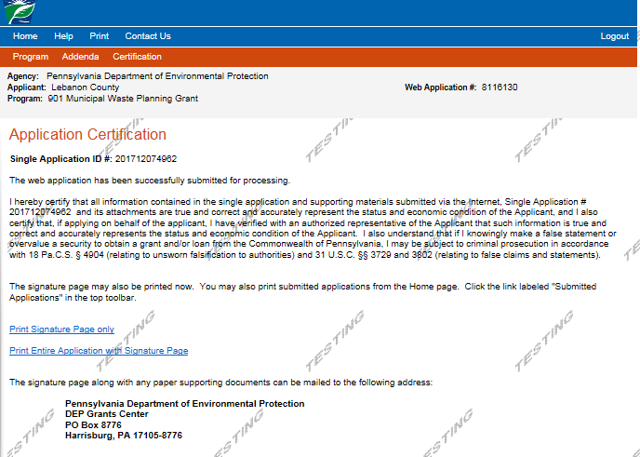
You do not need to mail any documentation to DEP. All information needed is contained in your on-line submission.

- Congratulations! You have completed the on-line application.

