DRAFT Water Quality Assessment Software (WQAS) Instructions
INTRODUCTION
The WQAS is designed to assist all public drinking water systems required to monitor for disinfection byproducts (DBPs) under the Stage 2 Disinfectant and Disinfection Byproducts Rule (DBPR). This software can be used by the water supplier to track and trend DBP data, including total trihalomethanes (TTHMs) and haloacetic acids (HAAs), parameters associated with DBP formation (i.e., chlorine residual, pH, temperature and HACH THM Plus©), system specific parameters, as well as and raw and plant effluent TOC and UV254 values and coagulation parameters. The software is designed to be used for optimization purposes, including tracking and trending the data for better interpretation and measuring the impacts of process control on chlorine maintenance and DBP formation. Although the software will run a calculation for the location running average for the each monitoring location, the WQAS is not designed for compliance monitoring and tracking. Compliance with the Stage 2 DBPR is calculated by the Pennsylvania Department of Environmental Protection (DEP) based on the data submitted by the certified laboratory conducting the analysis.
However, the WQAS does include a calculation for the Operation Evaluation Level (OEL), which is required to be calculated by public water systems monitoring quarterly, in accordance with the PA Safe Drinking Water Regulations subparagraph §109.701(g)(2)(iii). The OEL must be calculated for both TTHMs and HAAs at each monitoring location on a quarterly basis and is the sum of the two previous quarterly results plus twice the current quarter’s result, divided by four. If 0.060 mg/L, for HAAs, or 0.080 mg/L, for TTHMs, is exceeded, then the DEP must be notified within 10 days of the end of the quarter that the OEL is exceeded. An operational evaluation must be conducted no later than 90 days after being notified of the analytical result that causes the system to exceed the OEL. For more information on the OEL requirements, please refer to subparagraph §109.701(g)(2)(iii) and (iv).
Since this spreadsheet may be used to calculate the OEL, it is important the instructions contained in the document are followed completely and the data entered accurately.
As stated previously, the software also looks at distribution water quality in terms of optimization. The following optimization goals are incorporated into this software:
DISTRIBUTION SYSTEM GOALS
Performance Goals
Disinfection
- Maintain ≥ 0.20 mg/L free chlorine at all monitoring sites in the distribution system, at all times.
Disinfection Byproducts
- Treatment Plant Entry Point Goal: LRAA TTHM/ HAA5 values not to exceed 20/15 ppb.
- Individual Site Goal: Quarterly Maximum Locational Running Annual Average (LRAA) TTHM/HAA5 values not to exceed 70/50 ppb.
- Long-Term System Goal: Average of Maximum LRAA TTHM/HAA5 values not to exceed 60/40 ppb (the average of the last 8 quarterly Maximum LRAA values cannot exceed 60/40 ppb).
These goals are designed to provide additional protection through the disinfection barrier, while minimizing DBP formation through enhanced treatment and distribution operations. The DBP goals are also designed to provide an additional cushion in relation to the Stage 2 DBPR regulatory levels, which equates to improved public health protection.
Although these goals are incorporated into this software, the system may wish to establish their own system specific goals and incorporate them as part of this software. To make the optimization goals system specific, follow the attached instructions.
INSTRUCTIONS
Main Page
- Open the file entitled “WQAS_2013.xls”.
- Ensure that macros have been enabled once opened. This spreadsheet will only work if macros are enabled!
- Enter the “Plant / System Name”, “Plant PWS #” and “Comments” in the space provided to the right of each of these categories. Comments may include items such as start dates, portions of the distribution system being tracked with this file or any other comments that may be relevant to interpreting the data.
- Enter the “Site Description” in the space provided to the right of each Site ID number for each site (up to 30) being tracked using this software. This may include the system site ID number or description or the DEP ID number. It is important to note that this software is not limited to only Stage 2 monitoring locations. It may be used to track and trend additional DBP locations being monitored for optimization purposes, including the Entry Point, or to track and trend chlorine residual and other water quality data at coliform sample locations or other optimization sample locations.
- Once all the sample site information is entered, the water quality data can then be entered for each sample site. Use the “Select Data Entry” drop down menu to select the site for data entry. If entering Plant TOC & UV data, select this option at the bottom of the drop down list.
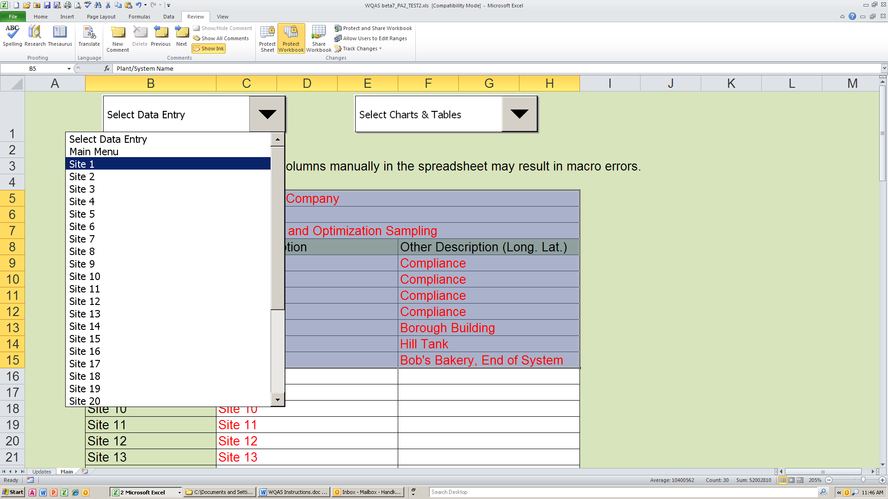
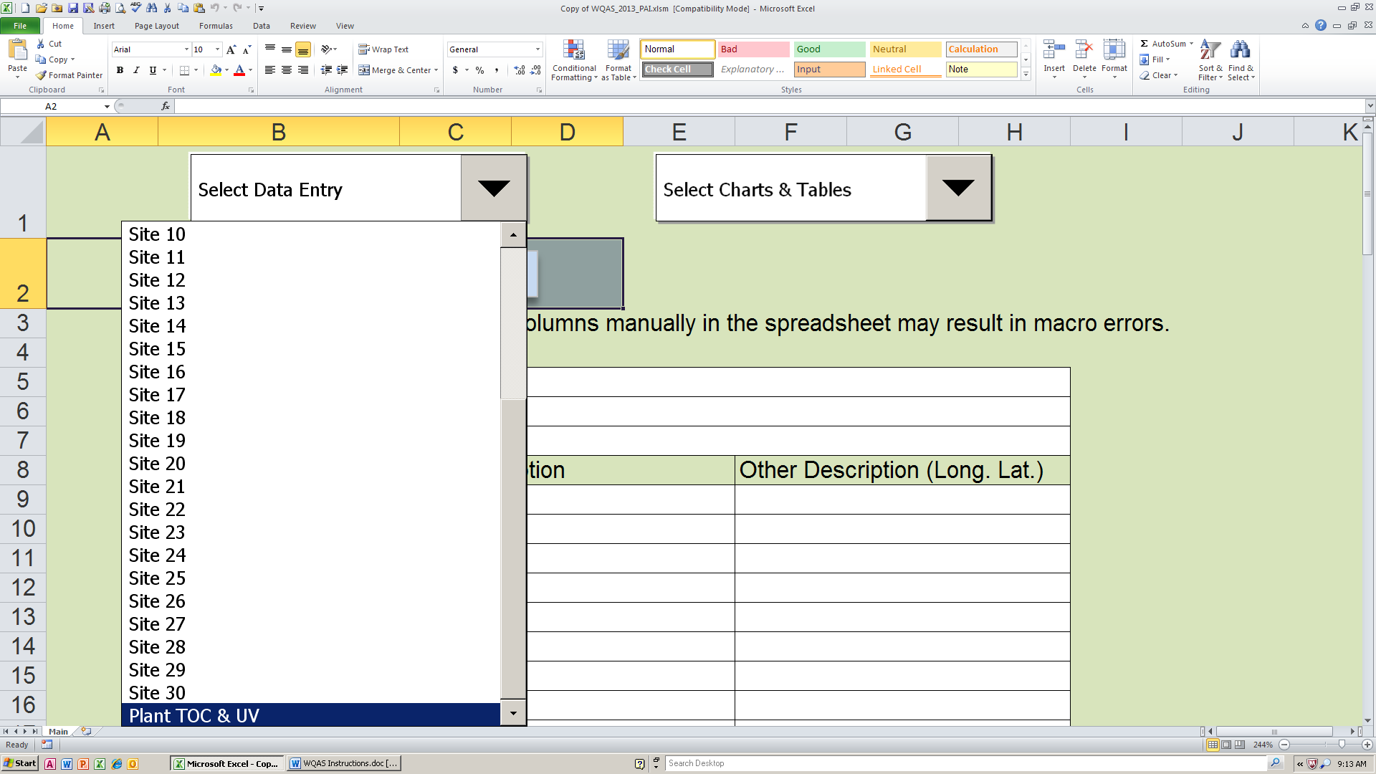
Site Sample Data Entry
- Indicate whether the site is a compliance monitoring location for TTHMs and HAAs. Enter “Y” if it is a compliance monitoring location. This only has to be entered the first time the sheet is used, or if a monitoring location becomes a compliance location at some point after monitoring started.
- Indicate any system specific goals which may have been established for the sample location. (The goals below are only examples. These should be system specific. All goals should be at or more stringent than any associated regulatory requirements.)
- If only entering data from one sample event, enter the date the sample was collected and the data under the correct column header. (Note that the TTHM and HAA5 data should be entered as ppb not mg/L (e.g. 60 ppb, not. 0.060 mg/L)).
- After the first set of data is entered, a new data entry row must be inserted in order for subsequent data to be entered. This is done by clicking on the “Insert New Row (enter new data at top of database)” button. This will be done each time the data entry sheet is opened to enter new data.
- If multiple historical sample data is going to be entered, then click on the “Insert New Row (enter new data at top of database)” button until a suitable number of rows are present (e.g. 10 samples = 10 rows). The data must be entered with the most recent in the top row and then descending to the oldest.
- Once data is entered, the graphs at the top of each data entry worksheet show the water quality trends at that location.
- After the data is entered and trends reviewed, click on the “Return to Main Menu” button in the upper left corner.
- Repeat steps 1 through 7 for each site where data needs to be entered.
- If DBP data was entered into one or more site worksheets, click on the “Import DBP Data To Charts & Tables” button, located to the right of the site description table, either after each site is completed or after all the data entry has been completed. This step is necessary to ensure that all the charts and tables are updated. The update will be completed once the screen returns to the Main Page. Do not click on any other drop down boxes or buttons until this has occurred.
If chlorine data was entered into one or more site worksheets, click on the “Update Chlorine Chart Data” buttons located to the right of the site description table, either after each site is completed or after all the data entry has been completed. Only the top button “(Sites 1 – 15)” will need to be clicked if data entry is limited to the first 15 sites. If more than 15 sites are used then both buttons will need to be clicked. This step is necessary to ensure that all the charts and tables are updated. The update will be completed once the screen returns to the Main Page. Do not click on any other drop down boxes or buttons until this has occurred.
- To ensure that the data is not lost, make sure the file is saved after the data has been entered for each site or, at a minimum, after data has been updated for all sample sites.
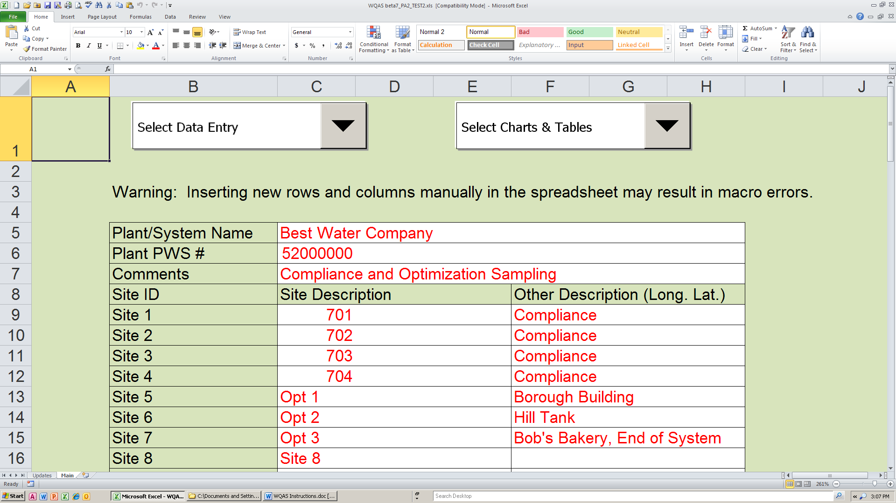
Plant TOC & UV Data
- Indicate system specific goal for TOC Performance Ratio Goal. (The goal below is only an example. This goal should be system specific, but should be at or above the regulatory requirement.)
- If only entering data from one sample event, enter the date the sample was collected and the data under the correct column header (white cells only). At a minimum, the source water alkalinity and TOC, as well as the settled water TOC should be entered in order to calculate the TOC Performance Ratio. For additional data tracking and analysis, coagulant dose and pH can be entered, as well as associated UV254 results that may have been collected in conjunction with the TOC samples.
- If multiple historical sample data is going to be entered, then enter the data with the oldest data top row and then descending to the most recent.
- Once the data has been entered or updated, click on the “Update TOC RAA” button.
- After the TOC RAA has been updated, the graphs at the top of the data entry worksheet will show TOC concentrations and associated water quality trends within the treatment plant.
- After the data is entered and trends reviewed, click on the “Return to Main Menu” button in the upper left corner.
Charts & Tables
There are various charts and tables included in this spreadsheet for tracking and interpreting the water quality parameters entered. In order to access these charts and tables, from the Main Page, use the “Select Charts & Tables” drop down menu to select a specific chart or table.
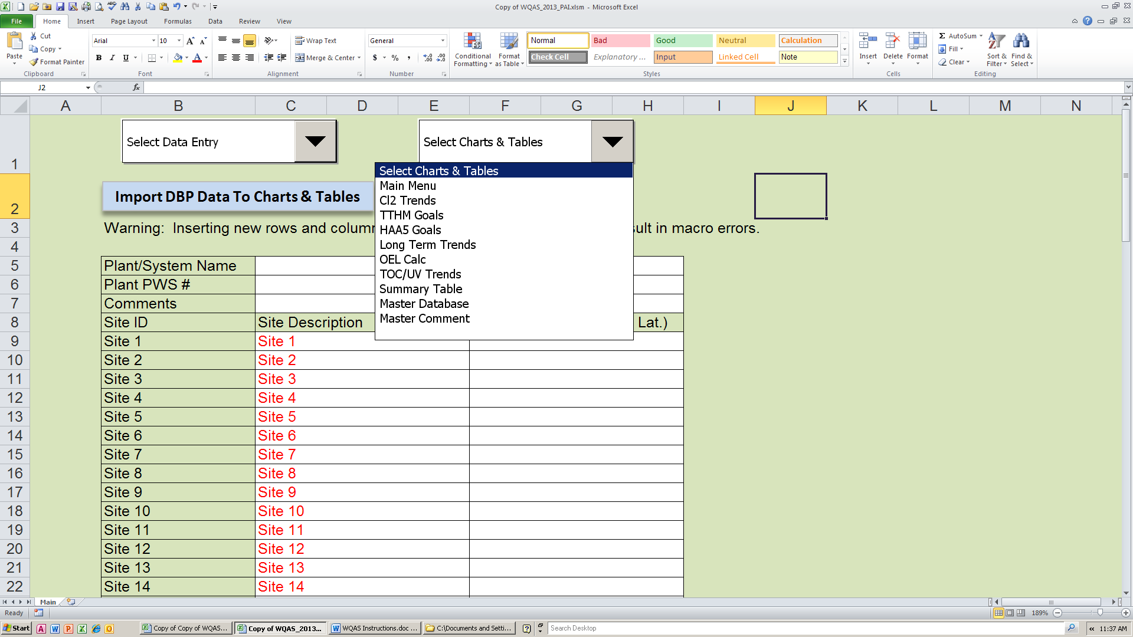
It is important to note that these tables are populated by the spreadsheet and data should NOT be entered in any of these charts and tables, unless otherwise noted in the following instructions. If data is entered in an area where it should not be, it may render the database unusable.
After reviewing the selected chart or table, click on the “Return to Main Menu” button to return to the Main Page.
A brief description of each chart and table is as follows:
Cl2 Trends: This graph provides an overview of all the distribution system free chlorine data entered into the database, on a monthly basis, showing: , the maximum, minimum and average free chlorine value for each month, over a 12-month period. The graph also indicates how many samples were below the distribution optimization goal of 0.20 mg/L in each month. This graph can help operators identify seasonal trends as well as impacts of operational changes on system-wide chlorine residual concentrations.
TTHM Goals: The table at the top of this sheet is pre-populated with the distribution system optimization goals for TTHMs, which are discussed at the beginning of these instructions. This table may be updated (red text only) with system-specific optimization goals. These goals are needed for this table and the “Long Term Trend” chart to function properly.
The main table on this sheet summarizes the individual sample results entered for each site over the past 11 quarters. The bottom portion of the table provides the LRAA for each site for the past eight quarters.
Refer to the top of the table if highlighting in a cell has occurred. The highlight will indicate the following:
Note: The WQAS is not designed for compliance monitoring and tracking. Compliance with the Stage 2 DBPR is calculated by the Pennsylvania Department of Environmental Protection (DEP) based on the data submitted by the certified laboratory conducting the analysis.
HAA Goals: The table at the top of this sheet is pre-populated with the distribution system optimization goals for HAAs, which are discussed at the beginning of these instructions. This table may be updated (red text only) with system-specific optimization goals. These goals are needed for this table and the “Long Term Trend” chart to function properly.
The main table on this sheet summarizes the individual sample results entered for each site over the past 11 quarters. The bottom portion of the table provides the LRAA for each site for the past eight quarters.
Refer to the top of the table if highlighting in a cell has occurred. The highlight will indicate the following:
Note: The WQAS is not designed for compliance monitoring and tracking. Compliance with the Stage 2 DBPR is calculated by the Pennsylvania Department of Environmental Protection (DEP) based on the data submitted by the certified laboratory conducting the analysis.
Long Term Trends: The graphs on this sheet provide the quarterly maximum LRAA for both TTHMs and HAAs. A solid red line on each graph indicates the individual site goal for each parameter. The dotted line indicates the current calculated long-term value, using the calculation described in the Introduction. The sites, where the maximum LRAAs occurred, are also indicated on the graph.
These graphs can be used to determine if any of the past eight quarters exceeded the individual site goal or if the long term goal was exceeded. The graphs are also useful in determining any trends, seasonal or otherwise, as well as impacts of operational changes on DBP concentrations.
OEL Calculation: This table provides the calculated OEL, which is required to be calculated by public water systems monitoring quarterly, for both TTHMs and HAAs at each monitoring location on a quarterly basis, according to the PA Safe Drinking Water Regulations subparagraph §109.701(g)(2)(iii). The table will indicate whether a site is a compliance monitoring location and will highlight any location that has exceeded the OEL value.
If the OEL is exceeded at a compliance monitoring location, then the DEP must be notified within 10 days of the end of the quarter that the OEL is exceeded. An operational evaluation must be conducted no later than 90 days after being notified of the analytical result that causes the system to exceed the OEL. For more information on the OEL requirements, please refer to subparagraph §109.701(g)(2)(iii) and (iv).
TOC/UV Trends: This graph provides an overview of the TOC and UV254 data entered into the database. The trending provided by this graph is useful in determining the relationship between TOC and UV254 (both raw and settled), and to review seasonal trends as well as impacts of plant operational changes on TOC concentrations (removal) and UV254 values.
Summary Table: This table provides a current summary, by site, of all the sites being tracked using this database; including the current TTHM and HAA LRAAs, the % of each LRAA compared to the system long-term goal, current average free chlorine residual at each site, over the past 12 months, and total number of samples with free chlorine values below 0.20 mg/L, for the past 12 months.
Master Database: This table can be used to track and store all the data that has been entered for the various sites. This may be done for various purposes, including to maintain an overall spreadsheet of all the data or to share the data with others. To populate this table, click on the “Update Database” button.
Make sure the file has been saved once the Master Database has been updated.
Master Comment: This table can be used to track operational changes that may have occurred during the timeframe that is represented by the data entered. This will further assist in documenting and analyzing impacts of changes on water quality.
Make sure the file has been saved once data has been entered in the Master Comment table.

