
Pennsylvania Department of Environmental Protection (DEP)
Small Drinking Water Systems Engineering Services Program (ESP)

GUIDELINES FOR PARTICIPATION

The Department is pleased to offer engineering assistance through the ESP. alfred benesch & company (benesch) is the firm under contract to the Department to provide engineering assistance. ESP assistance is provided in three phases: Phase I will consist of a feasibility study, engineering assessment, or technical assistance; Phase II will consist of engineering design of the selected alternative from Phase I; and Phase III will consist of limited construction administration during the construction phase of the project. Once a PWS is accepted into the ESP, it is the intent of the ESP to provide assistance through all three phases of the project (as needed and upon available funding).

Following are guidelines to be used throughout the course of the ESP assistance:

- After being accepted into the ESP, the PWS is expected to cooperate fully with the Department’s contractor (benesch) in completing all three phases of the ESP. The PWS shall be responsible for providing a copy of all existing information (reports, operating data, mapping, etc.) to benesch for evaluation and use in any work product.

- Any work products (Feasibility Studies, Engineering Assessments, Design Plans and Specs, etc.) completed through the ESP are the property of the Commonwealth. The Department may include project success stories on the ESP website or release to other publications as projects are complete.

- With ESP assistance, all necessary permits and approvals must be obtained before commencing with any work. The PWS shall be responsible for providing all permit application fees, bid advertisement fees, etc. The PWS is also responsible for any costs associated with new source sampling and/or lab fees.

- The PWS shall complete the ESP Information Request form and a water system self-assessment with assistance from the Department’s Capability Enhancement Facilitator.

- The PWS is responsible for funding the construction of any project; however the ESP will assist the PWS in obtaining funding from various funding agencies. ESP services may include completion and submittal of funding applications and processing of payment applications.

- The PWS shall provide a Resident Project Representative (RPR, i.e., inspector) to work with benesch and be on-site full-time to conduct all inspection work during the Phase III construction portion of the project.

- The PWS shall be responsible for providing their own legal council where needed for such items as preparing closing documents for funding or preparation/processing of legal documents.

- The PWS shall review and comment on any ESP Draft Work Plan and sign the Final Work Plan for each Phase as an acceptance of the scope of work to be provided by the ESP. No work will be completed without the PWS acceptance of the scope. Any change in scope must be requested through the Department’s ESP Program Manager.

- The PWS will consider participation in other Technical Assistance Programs to improve their technical, managerial, and financial viability.

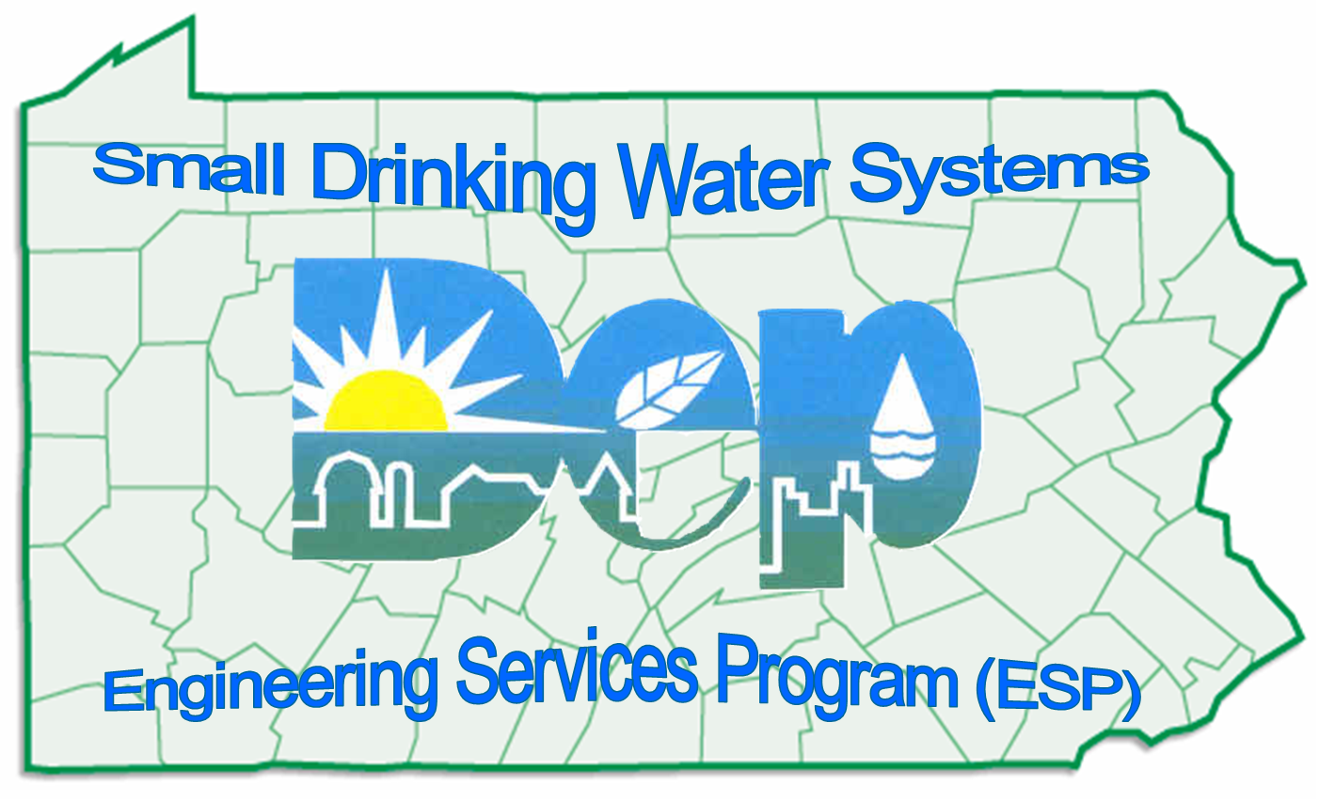
The Department and benesch are looking forward to completing a successful project. If you have any questions or concerns at any time throughout the duration of the project, please don’t hesitate to contact the Department’s ESP Program Manager, Walt Harner, at 717-787-0122 or by e-mail at wharner@state.pa.us You can also contact the benesch ESP Project Manager, James J. Rhoades, Jr., P.E. at 570-622-4055 or by e-mail at jrhoades@benesch.com

