Public Notification (PN) Certification Form

Name of PWS: PWSID Number:

I am a representative of the public water system (PWS) indicated above. I certify that public notification has been provided to consumers in accordance with the content, format and delivery requirements and deadlines found in Title 25 Pa. Code Chapter 109 Subchapter D of the Department of Environmental Protection (DEP)'s regulations.

Description of Violation:
Date of Violation:

Please check all that apply and provide information as indicated below:

1. Notified DEP within 1 hour (if required). Date:

2. Consulted with DEP within 24 hours (if required). Date:

3. Distributed the notice by the following method(s), and on the following date(s):

Method: Date:
Method: Date:
Method: Date:
Method: Date:

4. Met content requirements.

5. Attach a copy of the notice(s) to this certification form.

Certified by: Signature:

Print Name:

Title:

Phone Number: Date:

Complete and submit this form to your local DEP office
(see a list of DEP's regional offices on the back of this form).

For DEP use only. Checked by: Date:

For more information,
call the DEP regional office in your area or contact:

Department of Environmental Protection
Bureau of Water Standards and Facility Regulation
P.O. Box 8467
Harrisburg, PA 17105-8467
(717) 787-5017

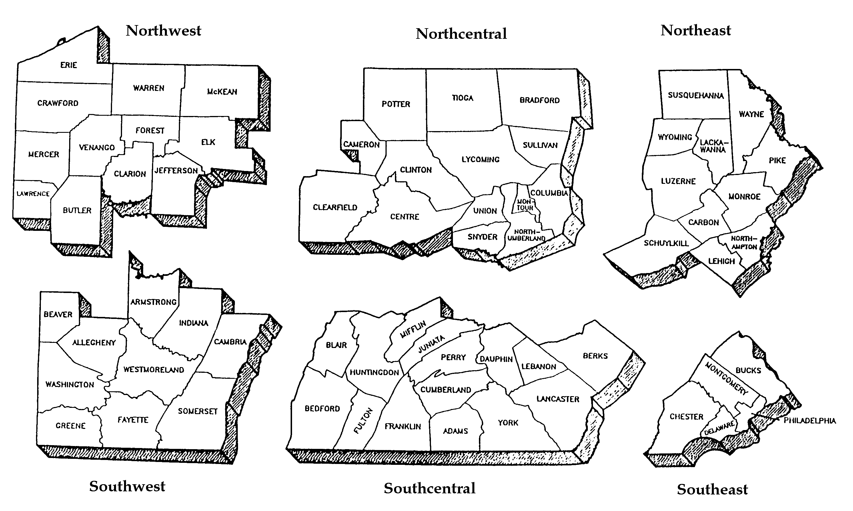

DEP REGIONAL OFFICES

Northwest Region  230 Chestnut St.  Meadville, PA 16335-3481  Main Telephone: 814-332-6945  24-Hour Emergency: 1-800-373-3398  Counties: Butler, Clarion, Crawford, Elk, Erie, Forest, Jefferson, Lawrence, McKean, Mercer, Venango and Warren | Northcentral Region  208 W. Third St., Suite 101  Williamsport, PA 17701  Main Telephone: 570-327-3636  24-Hour Emergency: 570-327-3636  Counties: Bradford, Cameron, Clearfield, Centre, Clinton, Columbia, Lycoming, Montour, Northumberland, Potter, Snyder, Sullivan, Tioga and Union | Northeast Region  2 Public Square  Wilkes-Barre, PA 18711-0790  Main Telephone: 570-826-2511  24-Hour Emergency: 570-826-2511  Counties: Carbon, Lackawanna, Lehigh, Luzerne, Monroe, Northampton, Pike, Schuylkill, Susquehanna, Wayne and Wyoming
Southwest Region  400 Waterfront Drive  Pittsburgh, PA 15222-4745  Main Telephone: 412-442-4000  24-Hour Emergency: 412-442-4000  Counties: Allegheny, Armstrong, Beaver, Cambria, Fayette, Greene, Indiana, Somerset, Washington and Westmoreland | Southcentral Region  909 Elmerton Ave.  Harrisburg, PA 17110  Main Telephone: 717-705-4700  24-Hour Emergency: 1-877-333-1904  Counties: Adams, Bedford, Berks, Blair, Cumberland, Dauphin, Franklin, Fulton, Huntingdon, Juniata, Lancaster, Lebanon, Mifflin, Perry and York | Southeast Region  2 E. Main St.  Norristown, PA 19401  Main Telephone: 484-250-5900  24-Hour Emergency: 484-250-5900  Counties: Bucks, Chester, Delaware, Montgomery and Philadelphia

For more information, visit www.depweb.state.pa.us, keyword: Drinking Water.

